Supplement S3

Additional information on the study area
The plots were located between 159 to 615 m above sea level and covered a chrono-sequence of forest recovery, including i) active pastures and cacao plantations; ii) formerly used pastures and plantations, which were secondary forests regrowing for 1 to 38 years at the time of the study, and iii) old-growth forests, with no indication of recent use by humans.
We separated the second-growth sites into four categories: former pastures and cacao plantations with recovery between 1-20 years and former pastures and cacao plantations with recovery between 21-38 years (Fig. 1). Recently recovering pastures were covered by a dense grass layer. In contrast, former cacao plantations already had a tree layer composed of cacao trees. In the cacao plantations the ground was mostly bare or covered with a very sparse grass and shrub layer, due to shading by cacao trees and the use of herbicides. Both pastures and cacao plantations were characterized by remnant trees and sometimes small groups of trees, typical for the smallholder agricultural landscapes in this area (Fig. S3.2 - S3.4). All recovery processes occurred naturally after abandonment, without active planting. The different categories and the according sites are spatially independent in their species communities (Müller et al., 2023). Location of the study plots is shown in Figure S3.1.
Figure S3.1. Location of the different study plots in the lowland Ecuadorian Chocó (Esmeraldas Province). The seven categories include currently managed pasture and cacao (Agriculture), secondary forest on former pasture and on former cacao 1-20 years old (Regeneration I), secondary forest on former pasture and cacao 21-38 years old (Regeneration II), and old-growth forest (Old-growth).

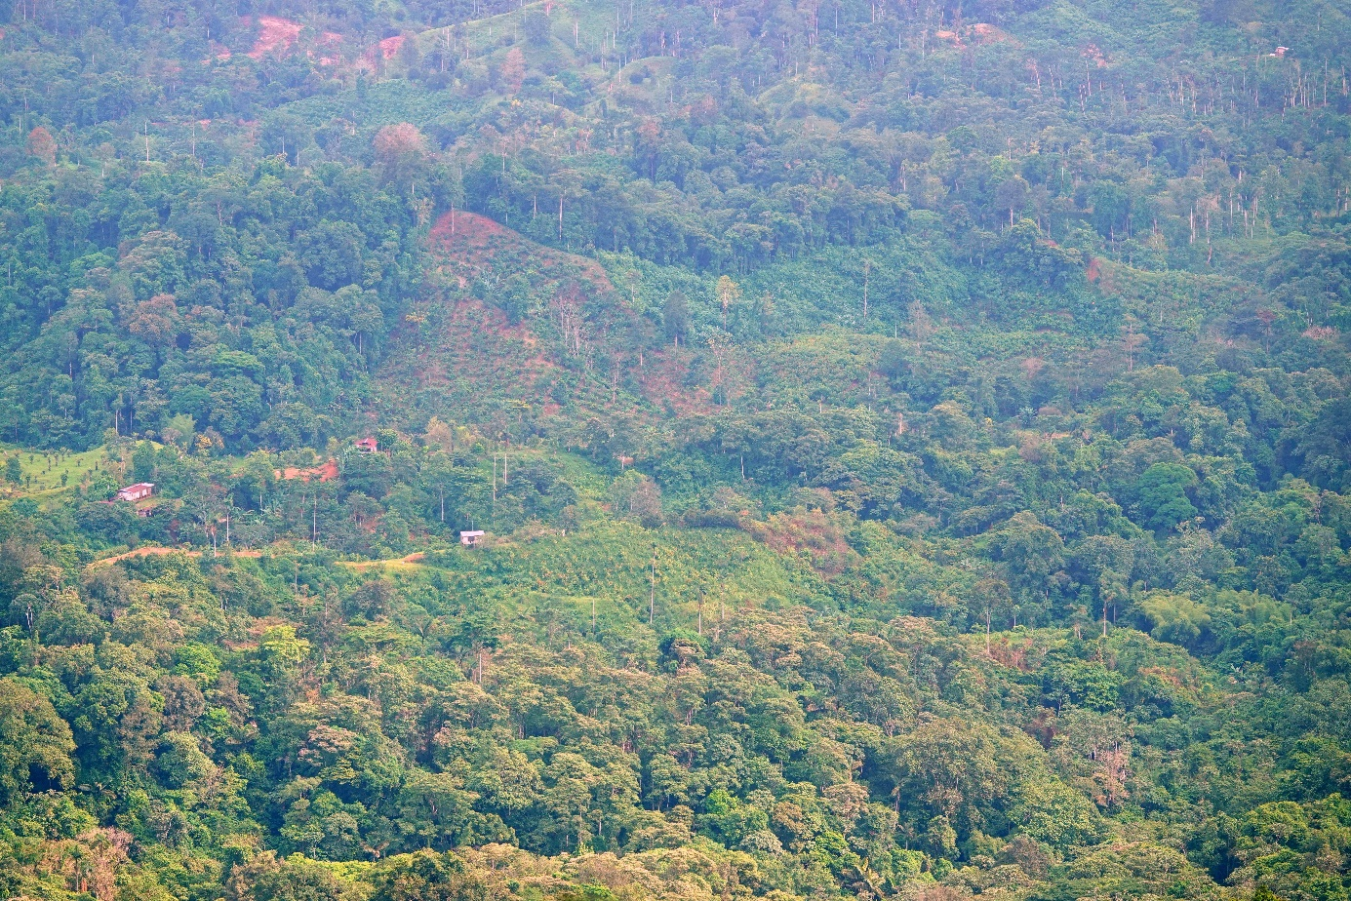
Figure S3.2. Typical smallholder agricultural landscape embedded in a forest matrix in the lowland Ecuadorian Chocó.

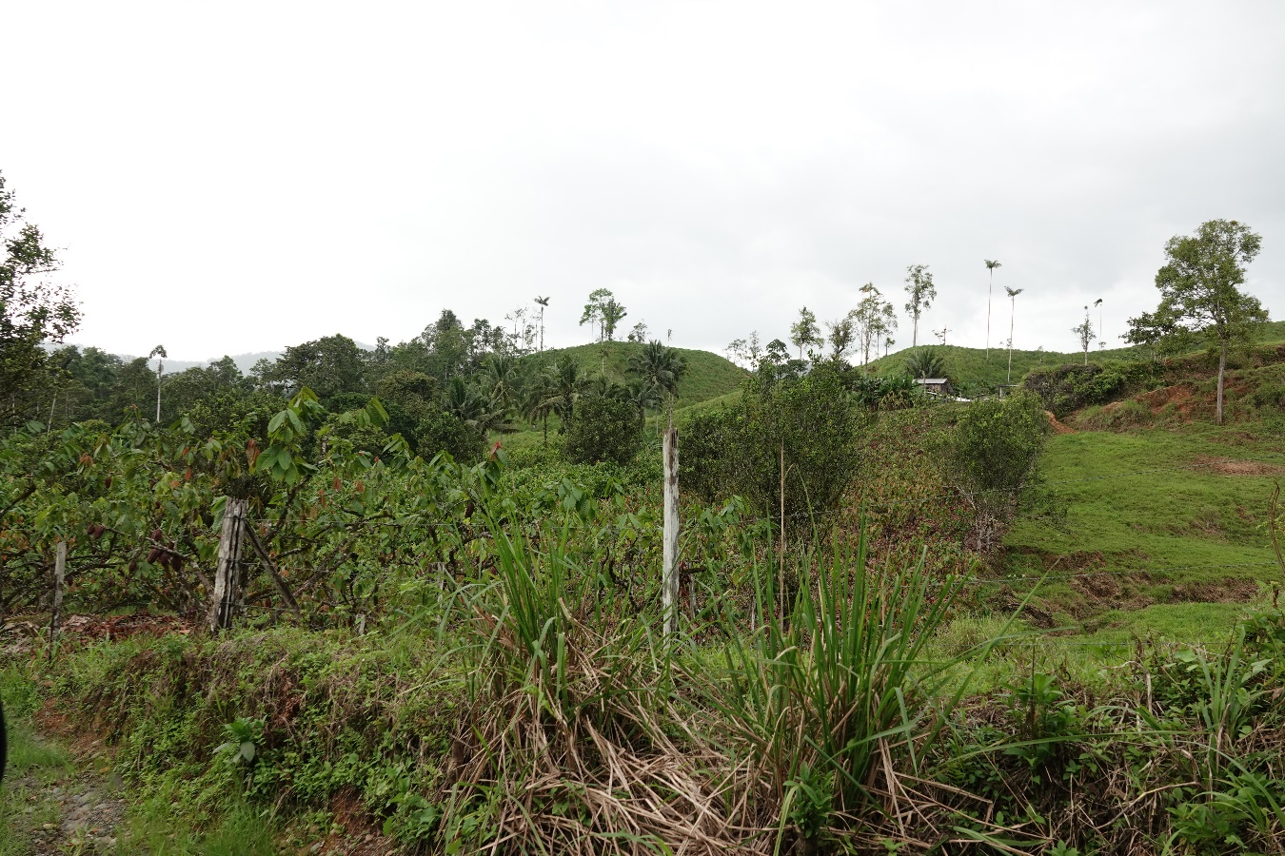
Fig. S3.3. Pasture (right side of the picture) and cacao plantation (on the left side) in our study area in the Ecuadorian Chocó, both with numerous remnant trees.

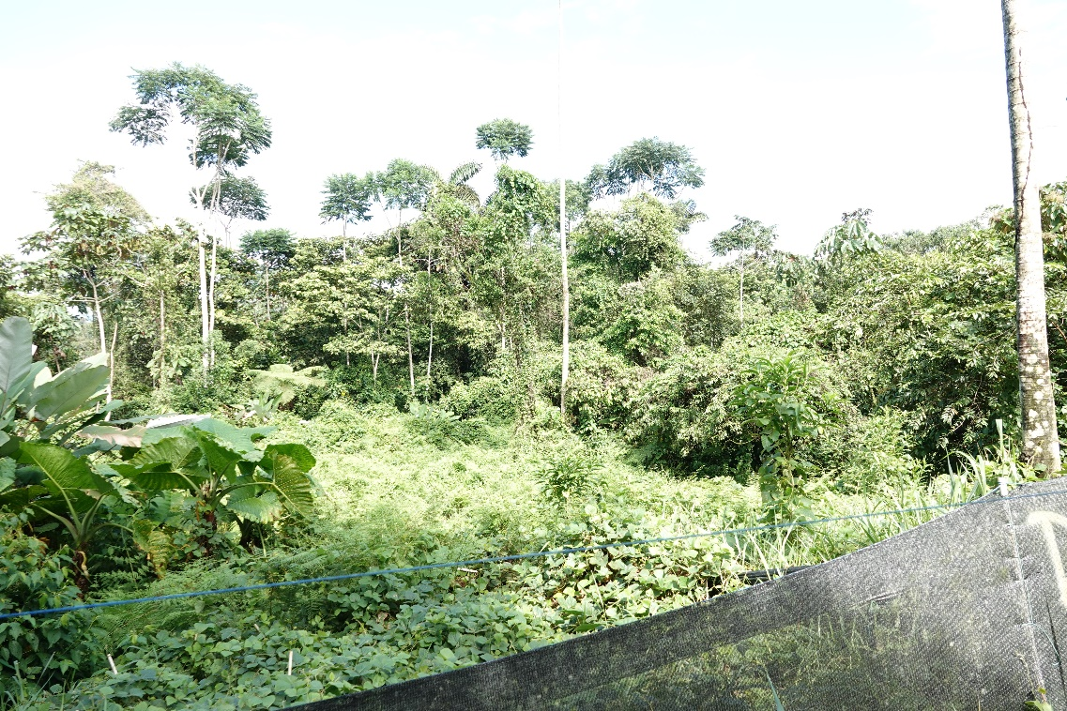
Fig. S3.4. Pasture regeneration with heterogenous vegetation due to remnant trees and different pathways of succession.

Bird traits
To control for correlations of morphological traits with body size, we fitted linear models for log-transformed values of beak length, beak width, tarsus length, wing length and tail length with log-transformed values for body mass as predictor and extracted the model residuals for further calculations (Hagge et al., 2021). As an additional morphological trait we included hand wing index, which is a standardized measure of wing elongation independent of body size (Sheard et al., 2020). The selected traits have been shown to reflect functional differences in avian foraging and locomotion (Tobias et al., 2022). For instance, insectivorous species are characterized by relatively longer beaks than fruit- or seed-feeding species and birds foraging in the understorey are characterized by more rounded wings than canopy species. As ecological traits we selected habitat density, migratory status, trophic niche and primary lifestyle. A table with all traits and species can be found in Supplement 2.

Bird recordings
Within our small-scale study area, active pastures and cacao plantations included remnant trees and small groups of trees, but forest cover within a radius of 100 m around each recorder was minimal (~ 10%). This radius covers most of the birds in the recordings, even if some can be heard over larger distances. The recorders were programmed to record for 2 minutes every 15 minutes throughout the day for two weeks starting at the end of October in 2021 and 2022, with a sampling rate of 44.1 kHz. By setting up the recorders in October before the rainy season, we were able to avoid extensive background noise from heavy rainfall and covered a time window of high territoriality of many species. We sampled 43 of the study plots in 2021 and 23 of the study plots in 2022, covering all seven categories (Fig. 1) in both years. We selected two days from the recordings without heavy rain as far apart as possible from each other.
An ornithologist with two decades of experience in this region (Rudy Gelis) identified birds from 2-minute files recorded at 06:00, 06:15, 06:30, 06:45, 07:00, 07:15, 12:00, 12:15, 16:00, 16:15, 17:00, 17:15, 18:00 and 18:15, across two days, covering the high activity phases of birds around dusk and dawn, as well as flock activity during the day. The recording times are based on the experience of RG and a subset of the audio files from each habitat category, which were used to identify all the time points necessary to detect the bird community as well as possible. As a result, the time points cover not only the times when we have peaks in overall bird activity, but also additional times during the day when we have a high chance of detecting flocks. We have also included time slots that are independent of the overall peaks of bird activity, in order to detect species with unusual behaviour, such as tree creepers that are active just before the majority of birds begin their activity. In total 14 files were analysed per plot, resulting in 28 minutes per plot. The expert listened to the recorded soundscapes and looked at the spectrogram, blinded to the spatial location and habitat type of the analysed audio files. The detection of bird species per audio file was classified as 1 if they were present and 0 if they were not present in the specific file.

Phylogenetic tree
The phylogenetic tree was built with the U.PhyloMaker package in R (Jin & Qian, 2023) based on the bird-megatree by Jetz et al. (2012). We marked species with a limited range size in our phylogenetic tree, which are considered to be endemic and more prone to extinction risk (Fig. 2). The definition of BirdLife International (http://datazone.birdlife.org/eba) for endemic birds is a range size of 50,000 km². To include species like the Berlepsch's tinamou (Crypturellus berlepschi, Rothschild, 1897), which is also known to have a decreasing population trend and to be dependent on forest habitat, we also included species with a range size < 60,000 km² in our selection.

iNEXT3D calculations
For phylogenetic and functional diversity, we calculated distance matrices based on trait data and phylogeny, respectively, which were then used in the iNEXT3D function. For phylogenetic diversity, the iNEXT3D function calculates the branch lengths between all species. Those branch segments are defined as phylogenetic attributes. Phylogenetic diversity is interpreted as the effective total number of phylogenetic attributes (Chao et al., 2021). The functional diversity in iNEXT3D is based on the Gower distances. On the basis of the distance matrices, all species are placed in a functional space and classified into virtual functional groups. (Chao et al., 2021). We used the data type ‘incidence_raw’ (based on detection/non-detection in each audio file) and 999 bootstraps for assessing sampling uncertainty.
To analyse changes in sample coverage over the recovery gradient, we extracted sample coverage values for each study plot from the iNEXT calculations and fitted linear models with the seven habitat types as ordered factors. To control for differences in sample coverage, we calculated estimated taxonomic, phylogenetic, und functional diversity for all Hill numbers with the estimate3D function for a standardized sample coverage of 90%, which can reliably be extrapolated for 40% of the samples. To test the robustness of this approach, we also calculated diversity values for a sample coverage of 64%, the lowest sample coverage of twice the sample size (2n) in our data. The results are in Supplement S1 (Table S1.3) and the results are qualitatively identical to the results for a sample coverage of 90%.

Additional analyses of potential effects of surrounding habitats
As our study region is characterized by small-scale agricultural areas within a forest matrix, we must also consider potential spillover effects, i.e., the movement of species among habitat types. For example, species that predominantly use forest patches may also occur in agricultural patches for foraging or other reasons. Remnant trees, which are common in agricultural plots, further support such a spillover. To analyse potential spill-over effects, we created a subset of species that occurred in pasture and cacao patches and a subset of species that occurred in old-growth patches. The agricultural subset included species that could also occur in any other site but had to occur in at least one of the cacao and pasture sites. The same rule was applied to the old-growth subset. Furthermore, we classified species as old-growth or agriculture specialists with the Classification Method (CLAM) (Chazdon et al., 2011) with a significance level of 0.005 and a specialisation threshold of 0.667. We modelled the species numbers of both subsets along the recovery gradient with linear models to analyse the occurrence of species using forest and agricultural patches, respectively, along the recovery gradient. Furthermore, to analyse the impact of very loud species that could be heard from adjacent patches (Supplement S2), we repeated our analyses after exclusion of 21 species that were classified as 'loud', that is, species that can be heard over a couple of hundred metres. The exclusion of these loud species did not have noticeable impact on the observed patterns (Supplement S1, Fig. S1.6).
The number of species in the pasture and cacao subset decreased significantly along the recovery gradient with a median of 41 species in pasture and 47 in cacao, and only 18 in old growth (Fig. S1.2 a). The number of species in the old-growth subset increased slightly along the gradient with a median of 20 and 21 species in pasture and cacao, respectively, and 22 in old growth (Fig. S1.2 b). The number of forest species based on AVONET showed no significant change along the gradient (Fig. S1.3). We classified five species as old-growth specialists and 18 species as agriculture specialists (Fig. S1.4) showing that avian preferences for specific habitats were comparatively low despite the turnover in community composition along the recovery gradient. A table with species incidences per habitat category can be found in Supplement 2 below the bird traits.

REFERENCES
Chao, A., Henderson, P. A., Chiu, C. H., Moyes, F., Hu, K. H., Dornelas, M., & Magurran, A. E. (2021). Measuring temporal change in alpha diversity: A framework integrating taxonomic, phylogenetic and functional diversity and the iNEXT. 3D standardization. Methods in Ecology and Evolution, 12(10), 1926-1940. https://doi.org/10.1111/2041-210X.13682
Chazdon, R. L., Chao, A., Colwell, R. K., Lin, S. Y., Norden, N., Letcher, S. G., Clark, D. B., Finegan, B., & Arroyo, J. P. (2011). A novel statistical method for classifying habitat generalists and specialists. Ecology, 92(6), 1332–1343. https://doi.org/10.1890/10-1345.1
Hagge, J., Müller, J., Birkemoe, T., Buse, J., Gossner, M. M., Gruppe, A., ... & Drag, L. (2021). What does a threatened saproxylic beetle look like? Modelling extinction risk using a new morphological trait database. The Journal of Animal Ecology, 90(8), 1934-1947. https://doi.org/10.1111/1365-2656.13512
Jetz, W., Thomas, G. H., Joy, J. B., Hartmann, K., & Mooers, A. O. (2012). The global diversity of birds in space and time. Nature, 491(7424), 444–448. https://doi.org/10.1038/nature11631
Jin, Y., & Qian, H. (2023). U.PhyloMaker: An R package that can generate large phylogenetic trees for plants and animals. Plant Diversity, 45(3), 347–352. https://doi.org/10.1016/j.pld.2022.12.007
Müller, J., Mitesser, O., Schaefer, H. M., Seibold, S., Busse, A., Kriegel, P., ... & Buřivalová, Z. (2023). Soundscapes and deep learning enable tracking biodiversity recovery in tropical forests. Nature communications, 14(1), 6191. https://doi.org/10.1038/s41467-023-41693-w
Sheard, C., Neate-Clegg, M. H., Alioravainen, N., Jones, S. E., Vincent, C., MacGregor, H. E., ... & Tobias, J. A. (2020). Ecological drivers of global gradients in avian dispersal inferred from wing morphology. Nature communications, 11(1), 2463. https://doi.org/10.1038/s41467-020-16313-6
Tobias, J. A., Sheard, C., Pigot, A. L., Devenish, A. J. M., Yang, J., Sayol, F., Neate-Clegg, M. H. C., Alioravainen, N., Weeks, T. L., Barber, R. A., Walkden, P. A., MacGregor, H. E. A., Jones, S. E. I., Vincent, C., Phillips, A. G., Marples, N. M., Montaño-Centellas, F. A., Leandro-Silva, V., Claramunt, S., … Schleuning, M. (2022). AVONET: morphological, ecological and geographical data for all birds. Ecology Letters, 25(3), 581–597. https://doi.org/10.1111/ele.13898

