DNA choreography: correlating mobility and organization of DNA across different resolutions from loops to chromosomes
Maruthi K. Pabba¹*, Janis Meyer²*, Kerem Celikay²*, Lothar Schermelleh³, Karl Rohr²#, M. Cristina Cardoso¹#
1. Department of Biology, Technical University of Darmstadt, Germany
2. Biomedical Computer Vision Group, BioQuant, IPMB, Heidelberg University, Germany
3. Department of Biochemistry, University of Oxford, United Kingdom
* these authors have contributed equally
# corresponding authors
Requests should be directed to cardoso@bio.tu-darmstadt.de and k.rohr@dkfz-heidelberg.de

Supplementary figures
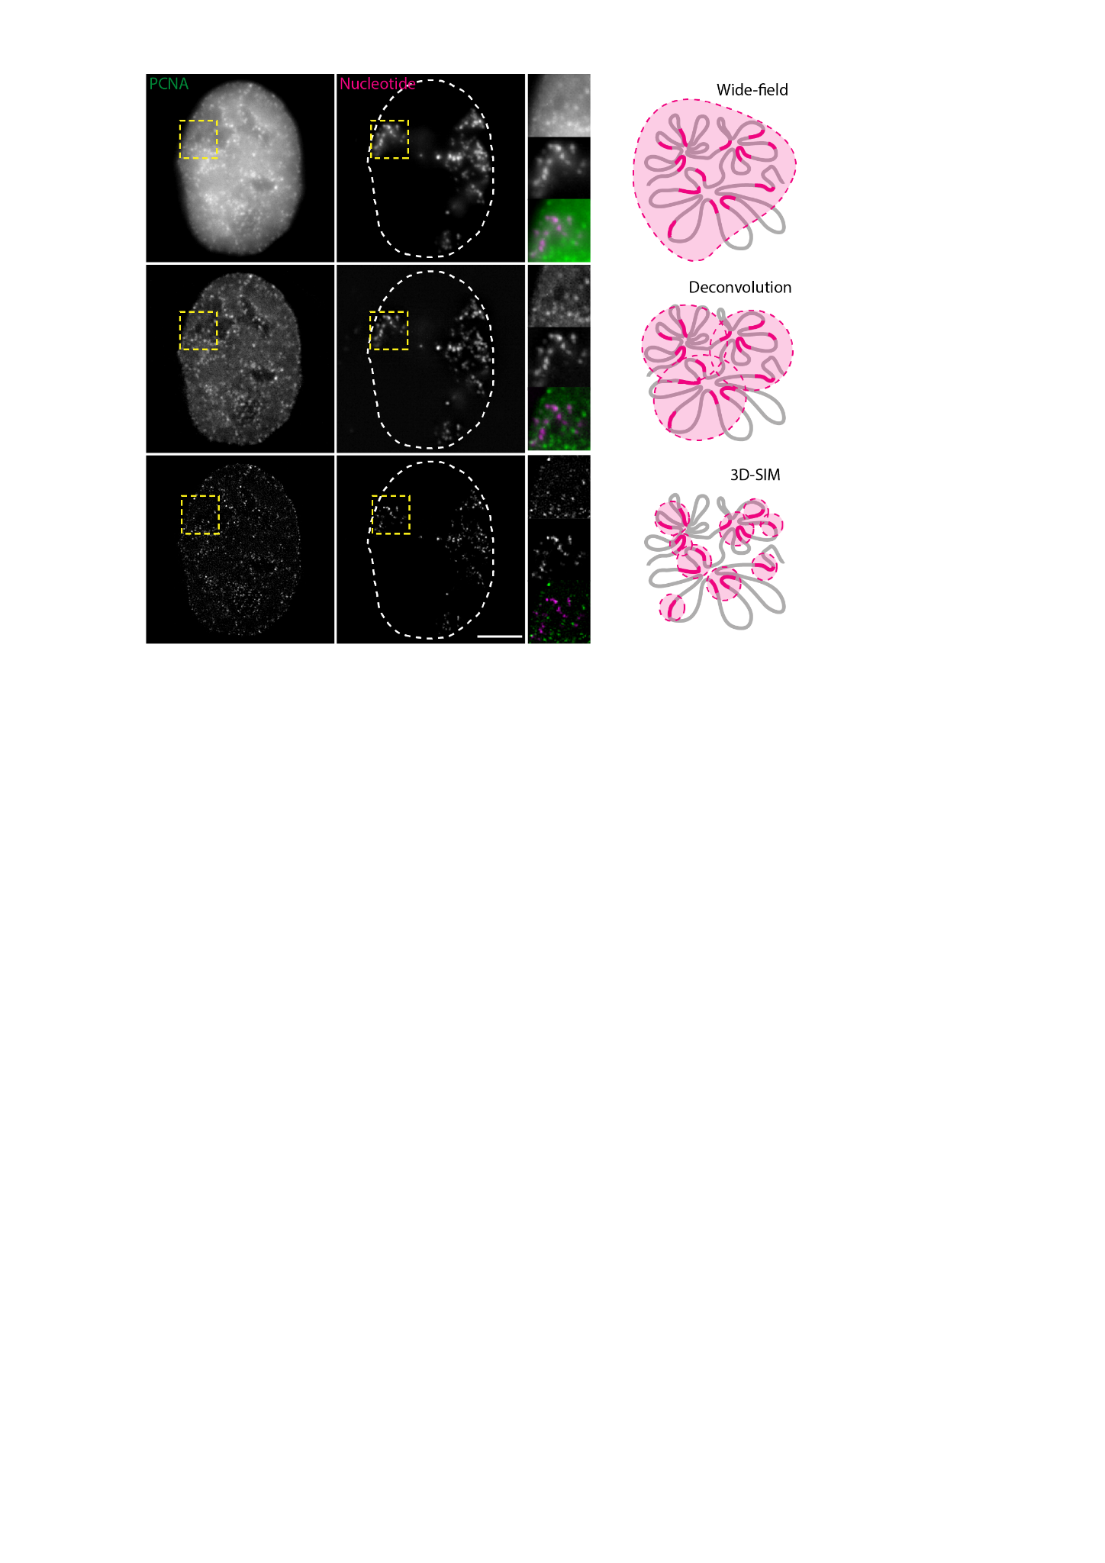

Supplementary figure 1: Live cell simultaneous correlative imaging of HeLa K GFP-PCNA cells with fluorescently labeled chromatin at different modes of resolution.
The GFP-PCNA (green) and labeled DNA/chromatin (magenta) channels were imaged in 3D using simultaneous acquisition in Wide-Field (WF), deconvolved Wide-Field (deconv WF) and Structured Illumination Microscopy (SIM). The yellow inserts show the zoomed region for all channels. Scale bar: 5 µm.

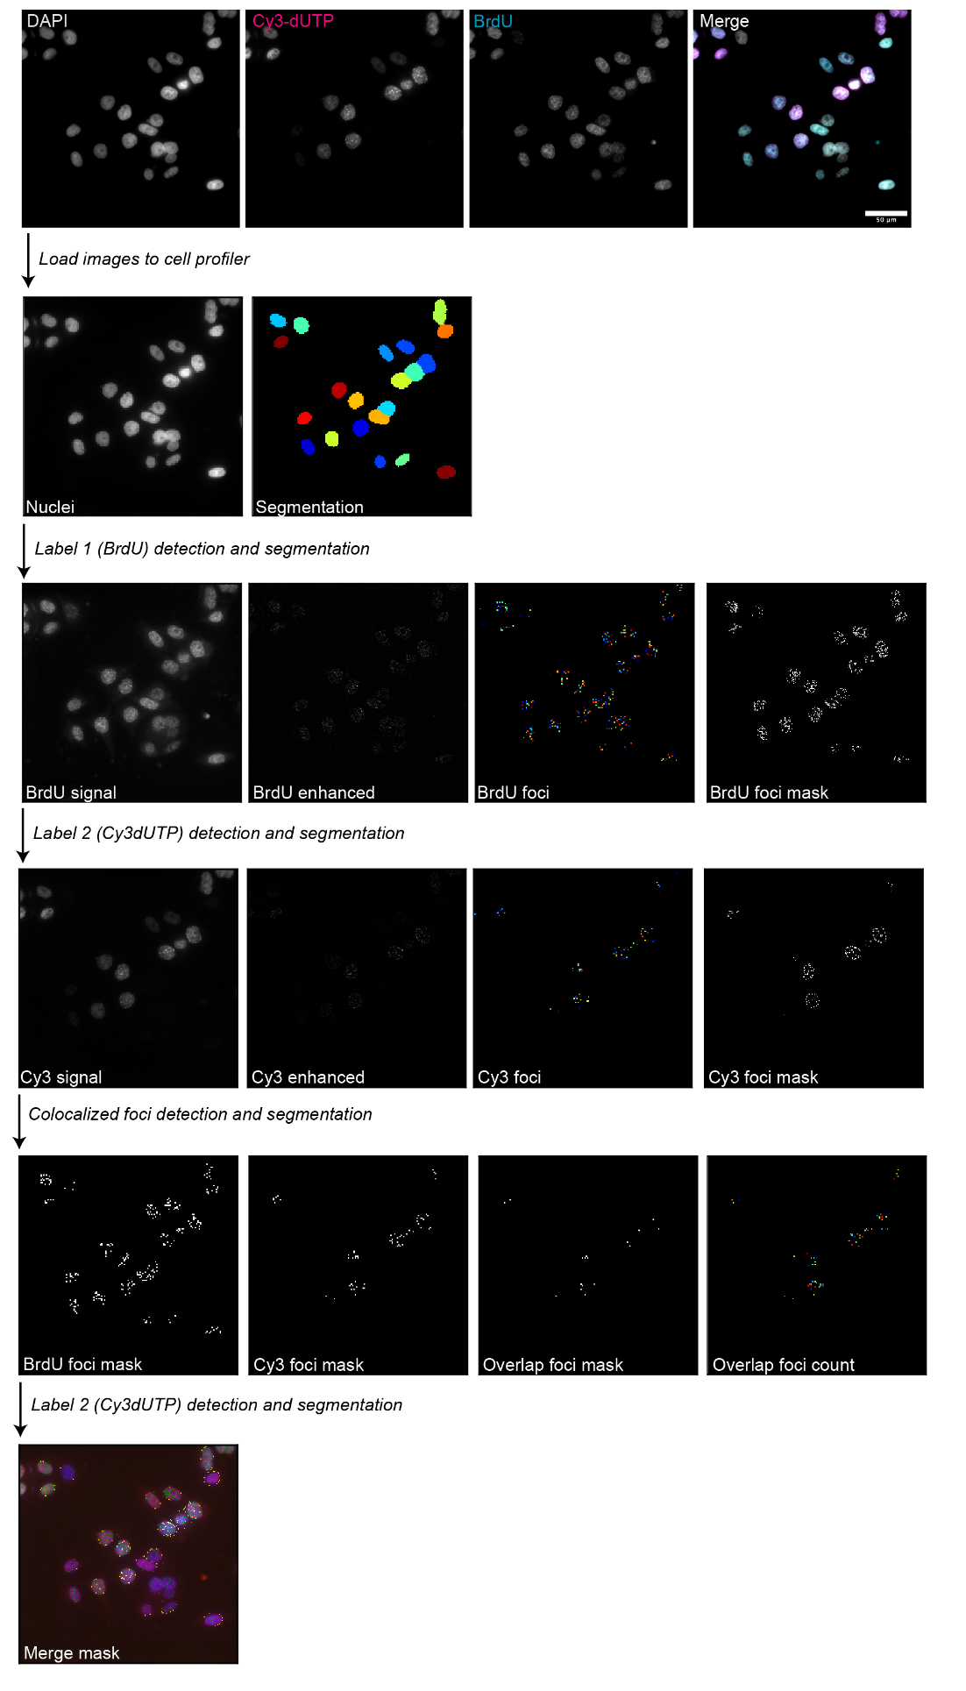

Supplementary figure 2: Colocalization analysis to determine the nucleotide pulse length

(A) Step by step description of analysis pipeline using cell profiler to calculate the percentage of colocalized nucleotides. (B) The labeling scheme to determine the DNA labeling duration using scratch loading, we first labeled cells with Cy3-dUTP (magenta) using scratch loading followed by different chase times (0’/10’/15’/20’/25’/30’), which was then followed by a second nucleoside pulse (BrdU - 40 µM) for 5 minutes to label cells. The cells were then fixed after a few hours and BrdU detection was performed (Methods, Supplementary table 3). (C) The cells were then imaged using a high throughput wide-field microscope (Supplementary table 4). We performed colocalization analysis of both labels to determine the overlap percentage over time, which was then plotted as bar plots. Scale: 10 µm.

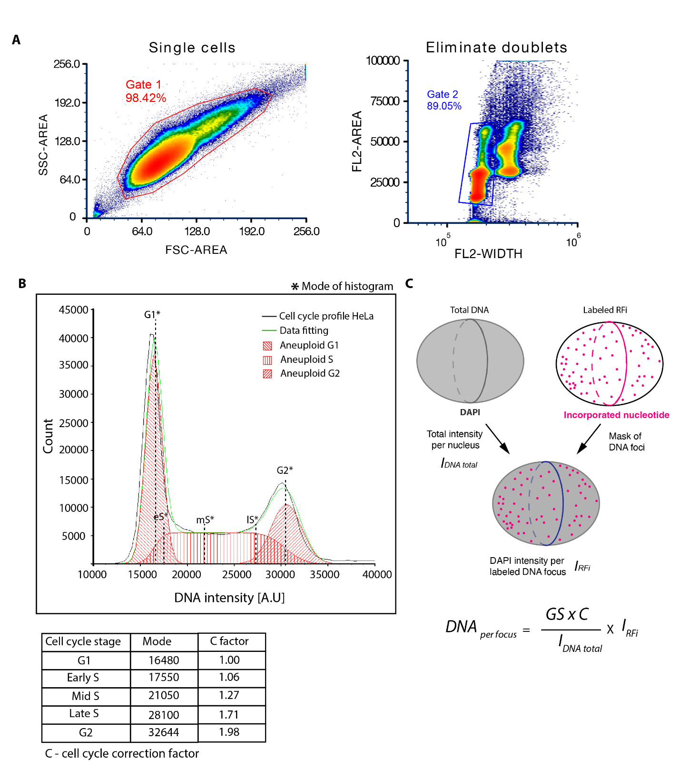

Supplementary figure 3: Flow cytometry analysis of fixed HeLa K GFP-PCNA cells to determine the relative genome size (correction factor) during DNA replication using DNA intensity (methods, flow cytometry).

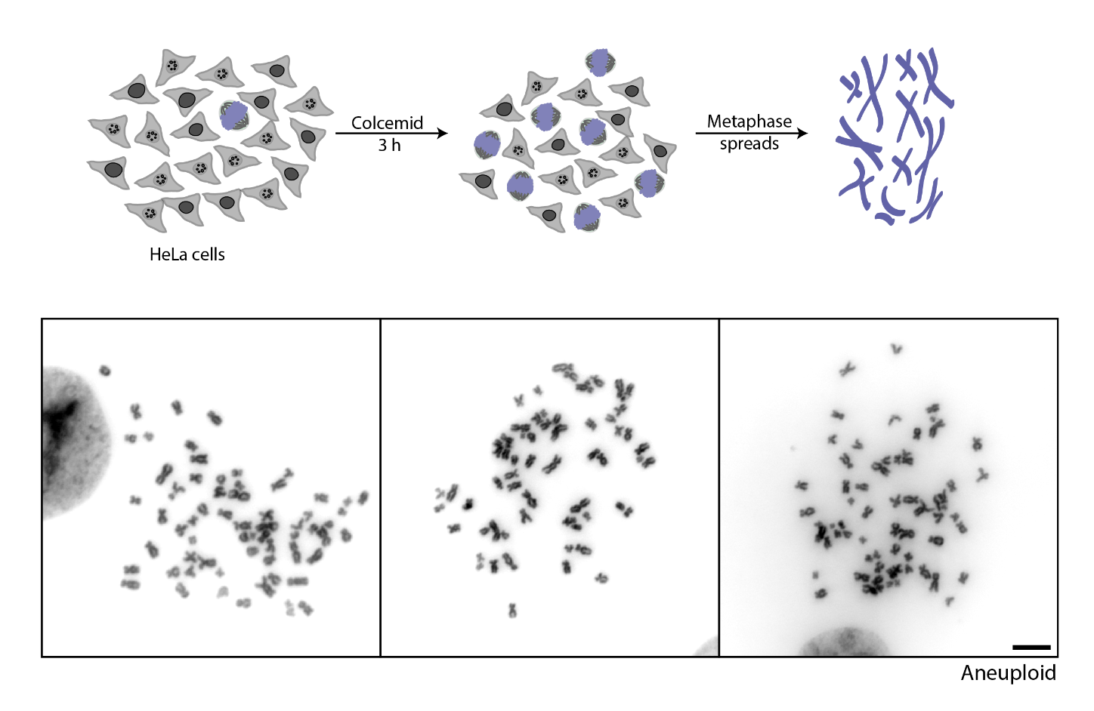

Supplementary figure 4: Metaphase spreads of HeLa K GFP-PCNA cells to determine the ploidy in the cell population (methods, metaphase spreads). Scale bar: 10 µm.

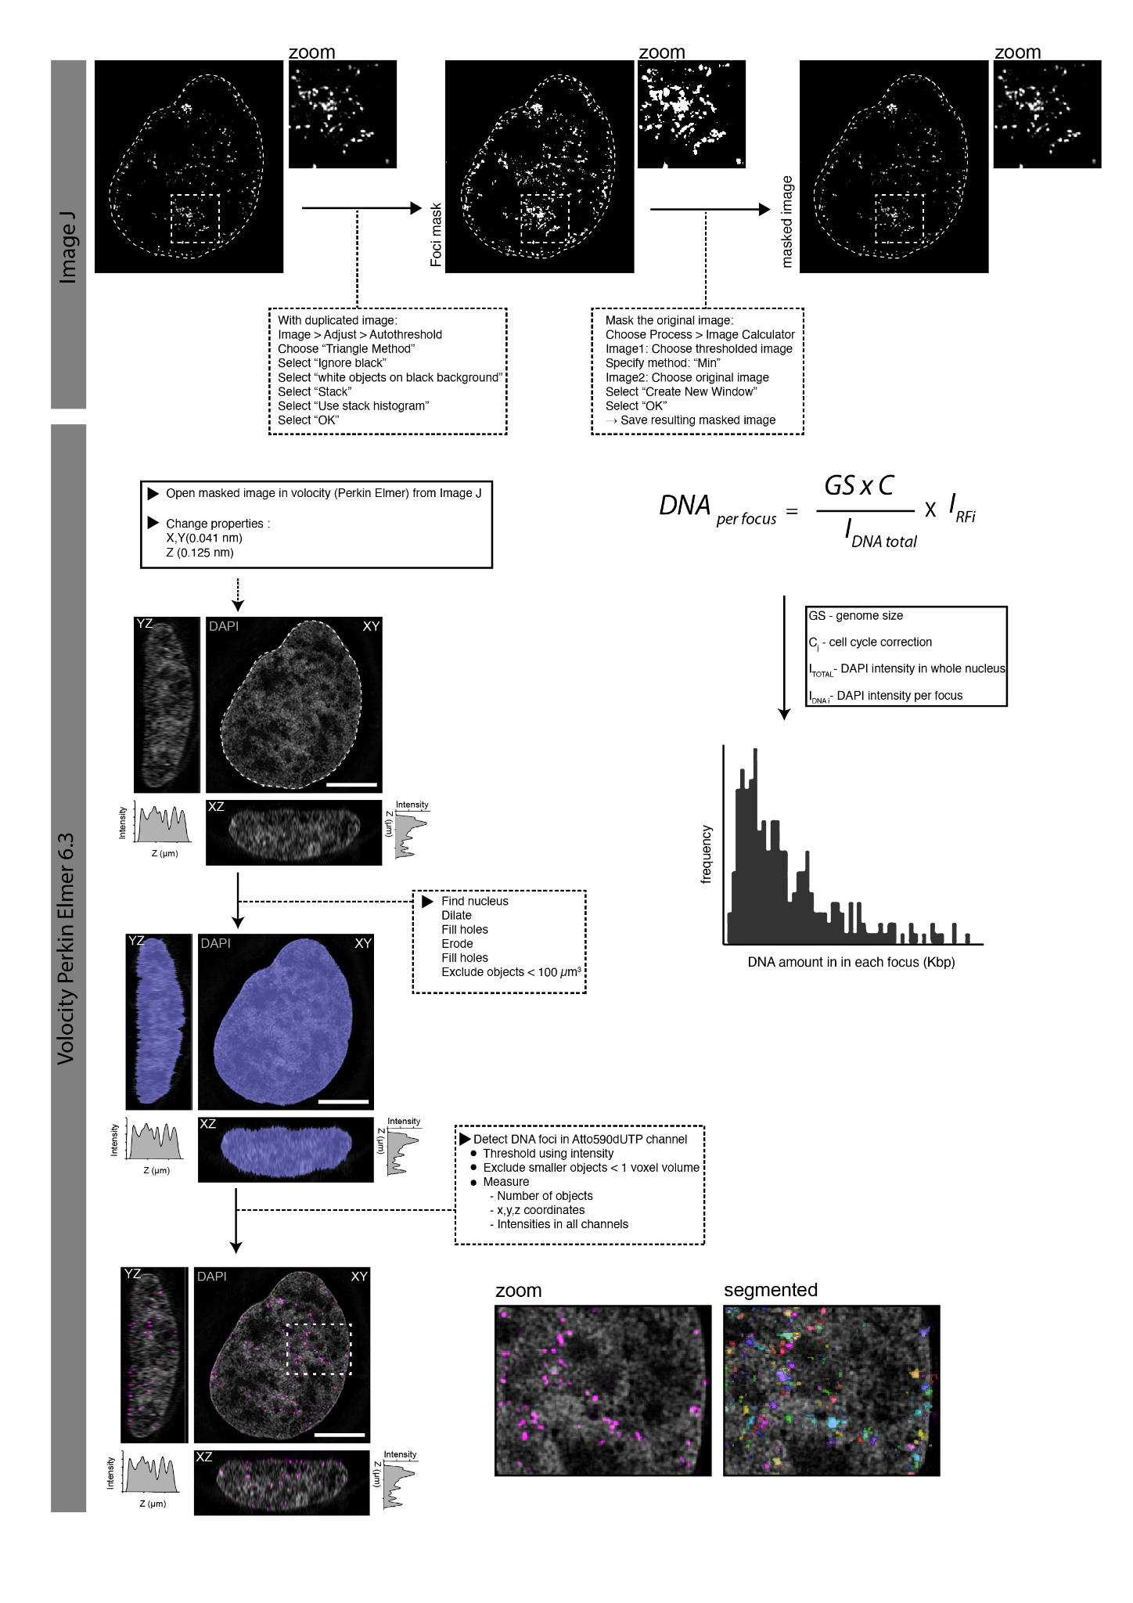
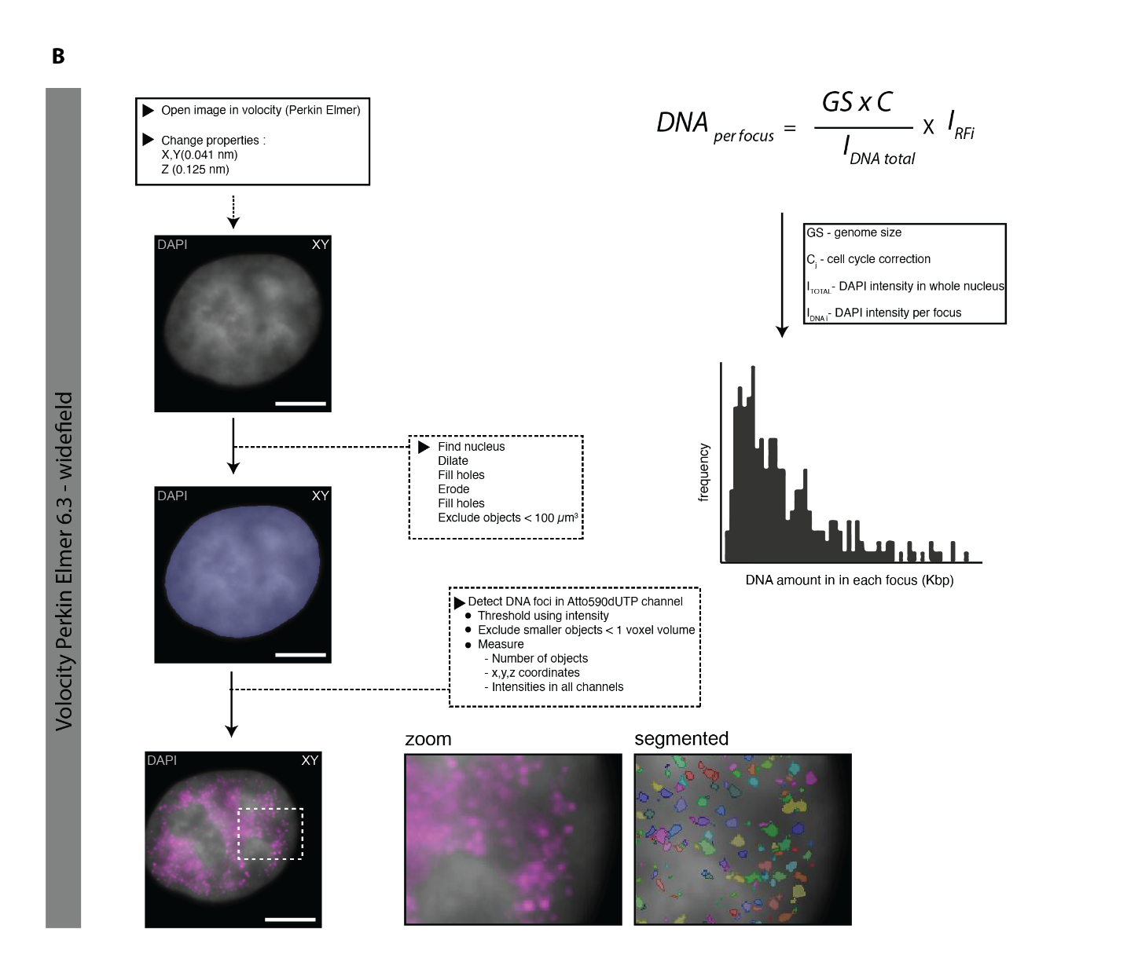

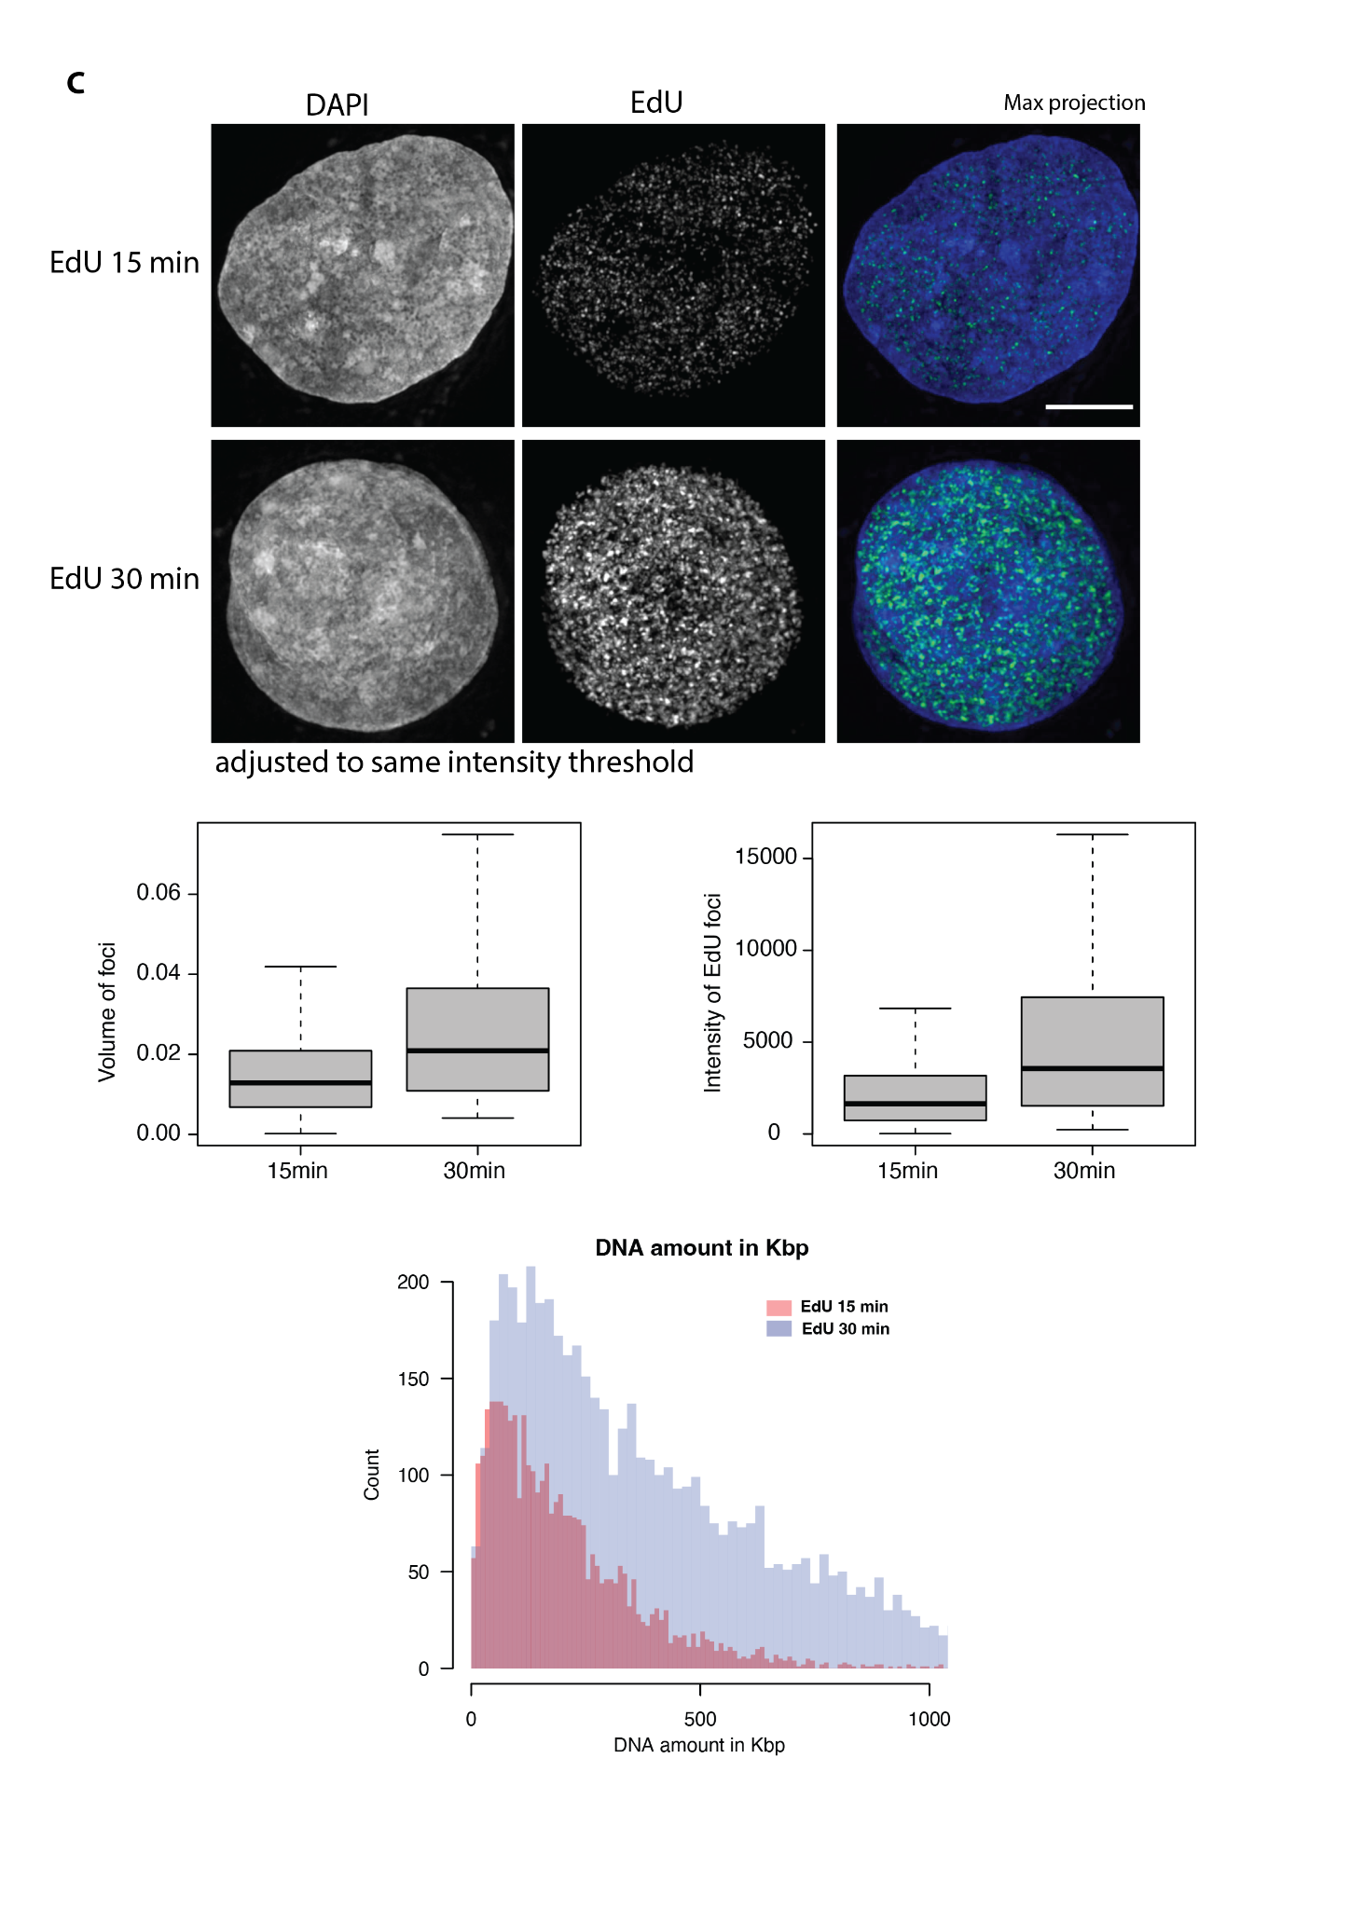Supplementary figure 5: Analysis pipeline to quantify the DNA amount (in Kbp)

(A) Step by step description of analysis pipeline for 3D SIM data (fixed cells) to quantify the DNA amount (in Kbp) within labeled chromatin in HeLa K GFP-PCNA cells (methods, DNA quantification). (B) Step by step description of analysis pipeline for 3D SIM data (fixed cells) to quantify the DNA amount (in Kbp) within labeled chromatin in HeLa K GFP-PCNA cells (methods, DNA quantification). (C) Volume (µm3), intensity of foci, DNA amount (in Kbp) quantification of HeLa K cells pulse labeled with EdU for 15 min and 30 min. Scale bar: 5 µm.

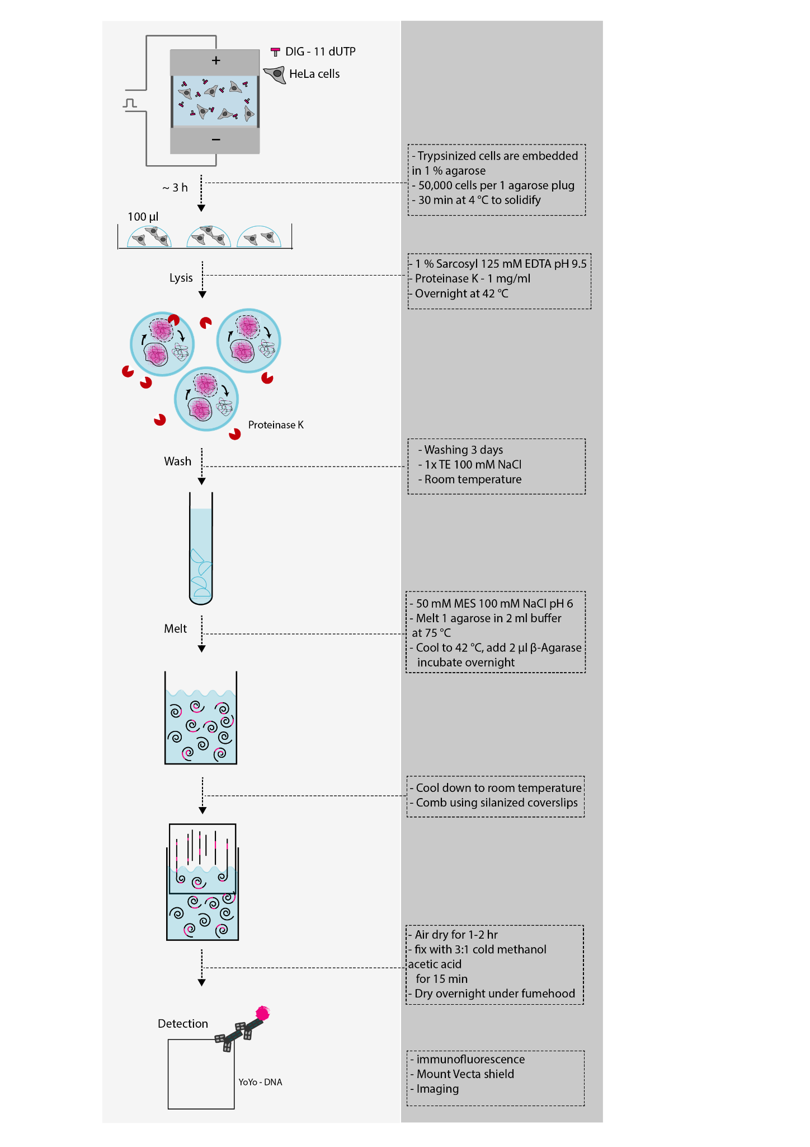

Supplementary figure 6: Step by step protocol for preparation of DNA fibers for single molecule DNA fiber analysis (methods, DNA combing).

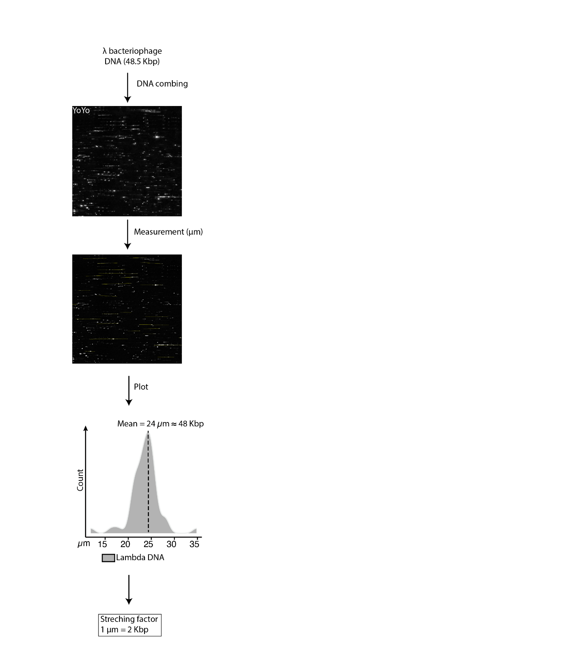

Supplementary figure 7: DNA fiber combing of bacteriophage lambda DNA for calibration of stretching factor (methods, DNA combing).

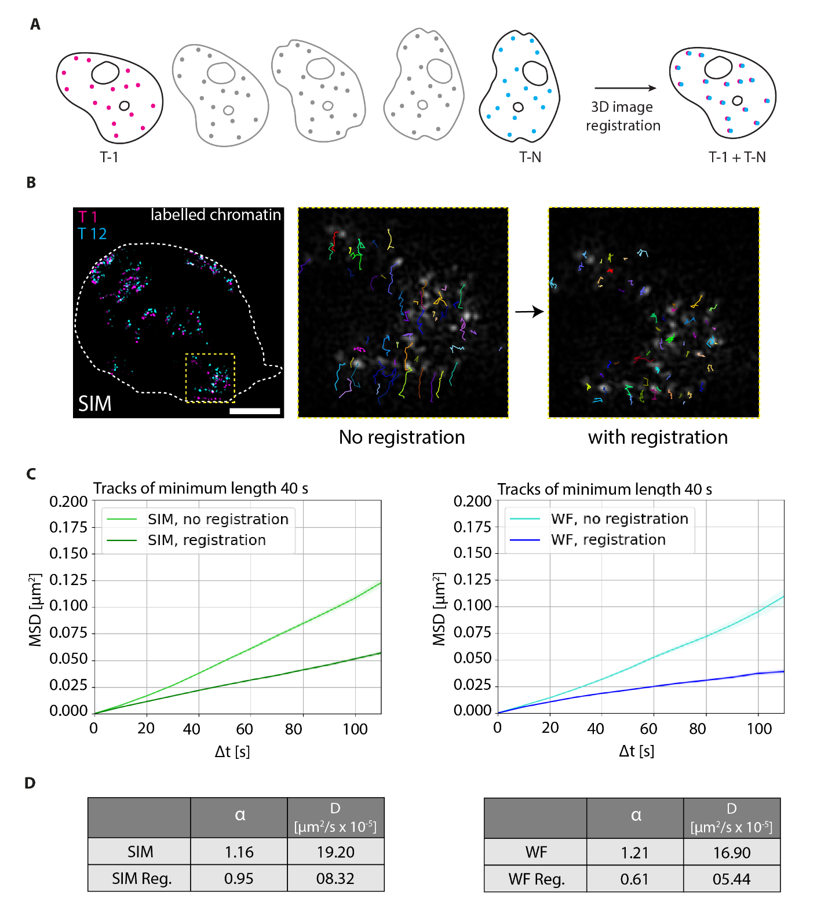

Supplementary figure 8: 3D-registration of live cell datasets.
(A) Illustration of HeLa K GFP-PCNA live cells with labeled chromatin over time. The initial timepoint was used to perform 3D non-rigid registration of cells over time (methods, non-rigid registration). (B) PCNA (green) signal was used to identify the nuclear border (white dotted border). The labeled chromatin of time point 1 (T1, magenta) is overlaid on chromatin in time point 12 (T12, cyan). The chromatin tracks of the zoomed region (yellow insert) are shown with no registration and non-rigid registration. (C) The Mean Squared Displacement curves (MSD, µm²) over time intervals (s) for SIM (without registration, light green), SIM non-rigid registration (with registration, green), WF (without registration, light blue), WF non-rigid registration (with registration,dark blue) were then plotted. (D) The table details the values of the anomalous diffusion coefficient α and the diffusion coefficient D (µm²/s x 10⁻⁵). Scale bar: 5 µm.
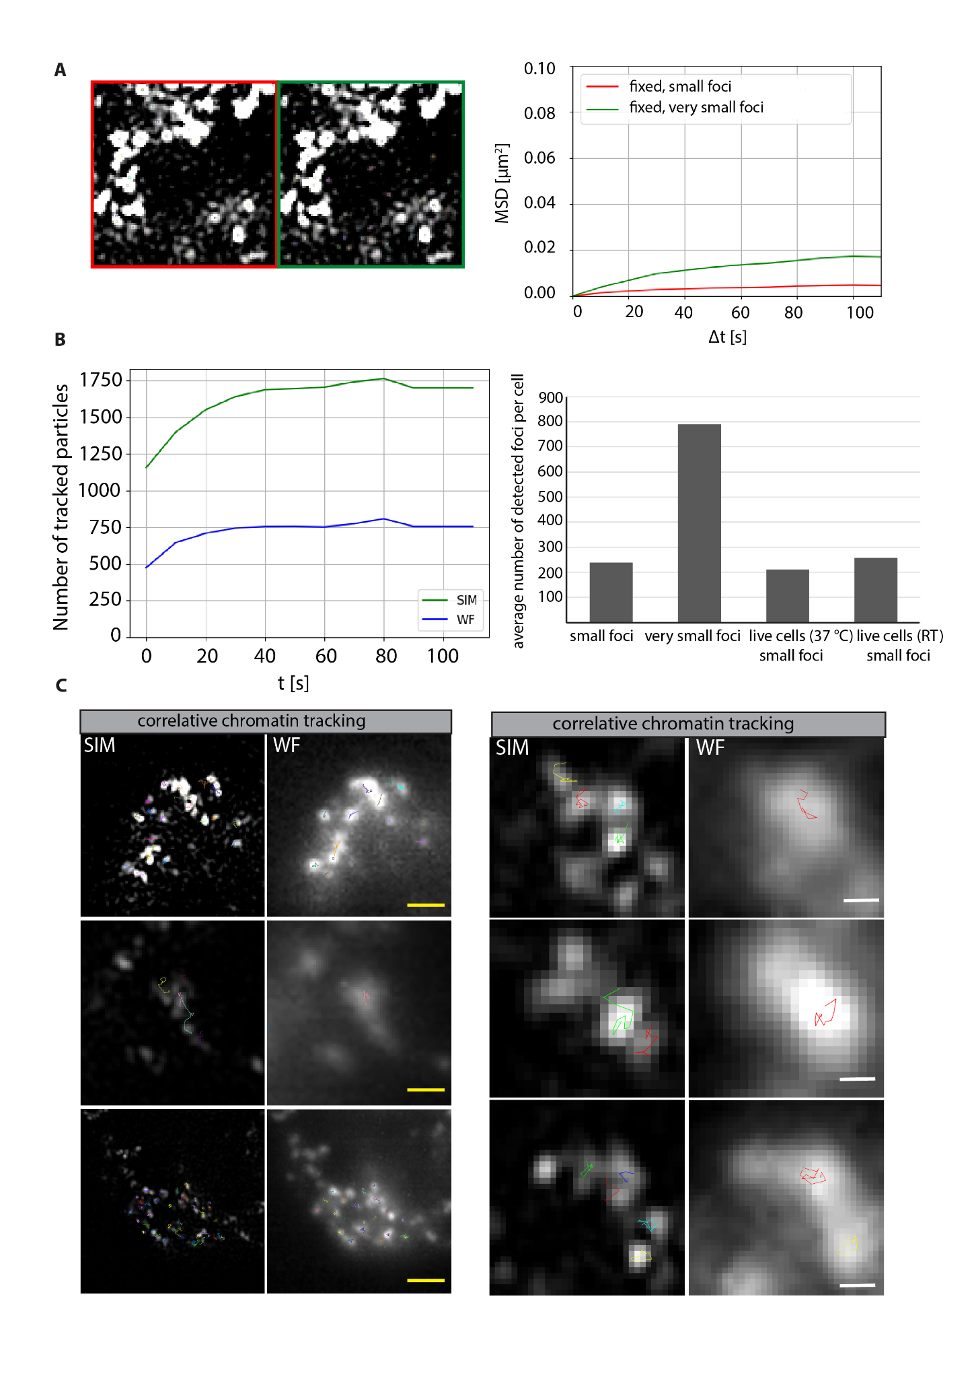

Supplementary figure 9: Optimization of particle detection and comparison of particle detection at multiple resolutions.
(A) Representative image of fixed cell chromatin tracks with different strength of detection. Chromatin tracks of fixed cells with detection of small particles (red) and very small foci corresponding to fine structures (green) were used to obtain the Mean Squared Displacement (MSD, µm²) over time intervals (s) and plotted. Small and very small particles were determined by applying high and low thresholds on the LoG filter response, respectively. The high threshold was selected so that visually relevant foci are detected. (B) Comparison of the number of chromatin particles over time (s) in SIM and WF and average number of particles detected in fixed and live cells. (C) Representative images of particle detection and tracks of chromatin of same cells (regions) in SIM and WF microscopy. Scale bar: 1 µm (yellow) and 500 nm (white).

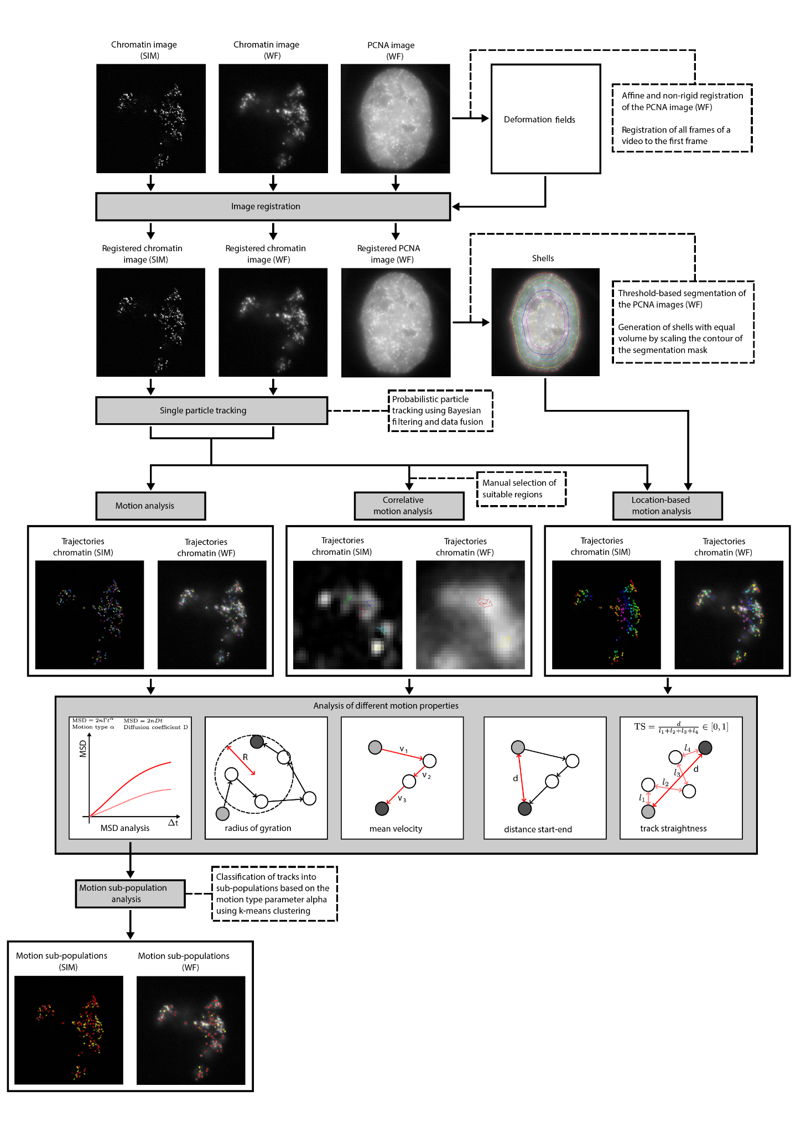

Supplementary figure 10: Step by step pipeline description of chromatin tracking and motion analysis in 3D (x,y,z) for SIM and WF timelapse movies (methods, tracking).

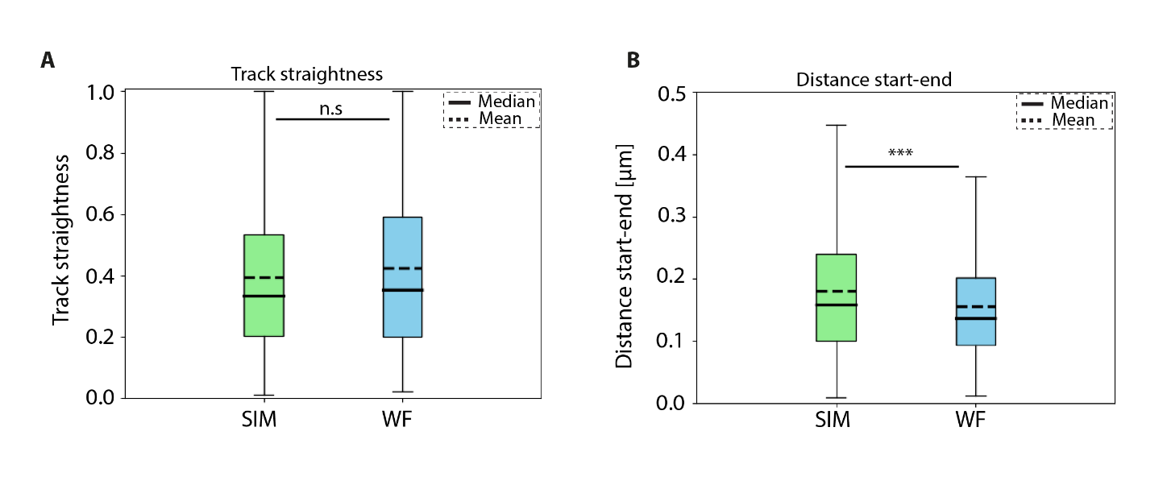

Supplementary figure 11: Comparison of different parameters between SIM and WF chromatin tracks.
(A) Track straightness of labeled chromatin foci for SIM (green) and WF (blue) plotted as a box plot. (B) The distance start-end (µm) of labeled chromatin foci for SIM (green) and WF (blue) plotted as a box plot. The median and mean values of the measurements are indicated. The statistics of the plots are shown in the figure and listed in (Supplementary table 6).

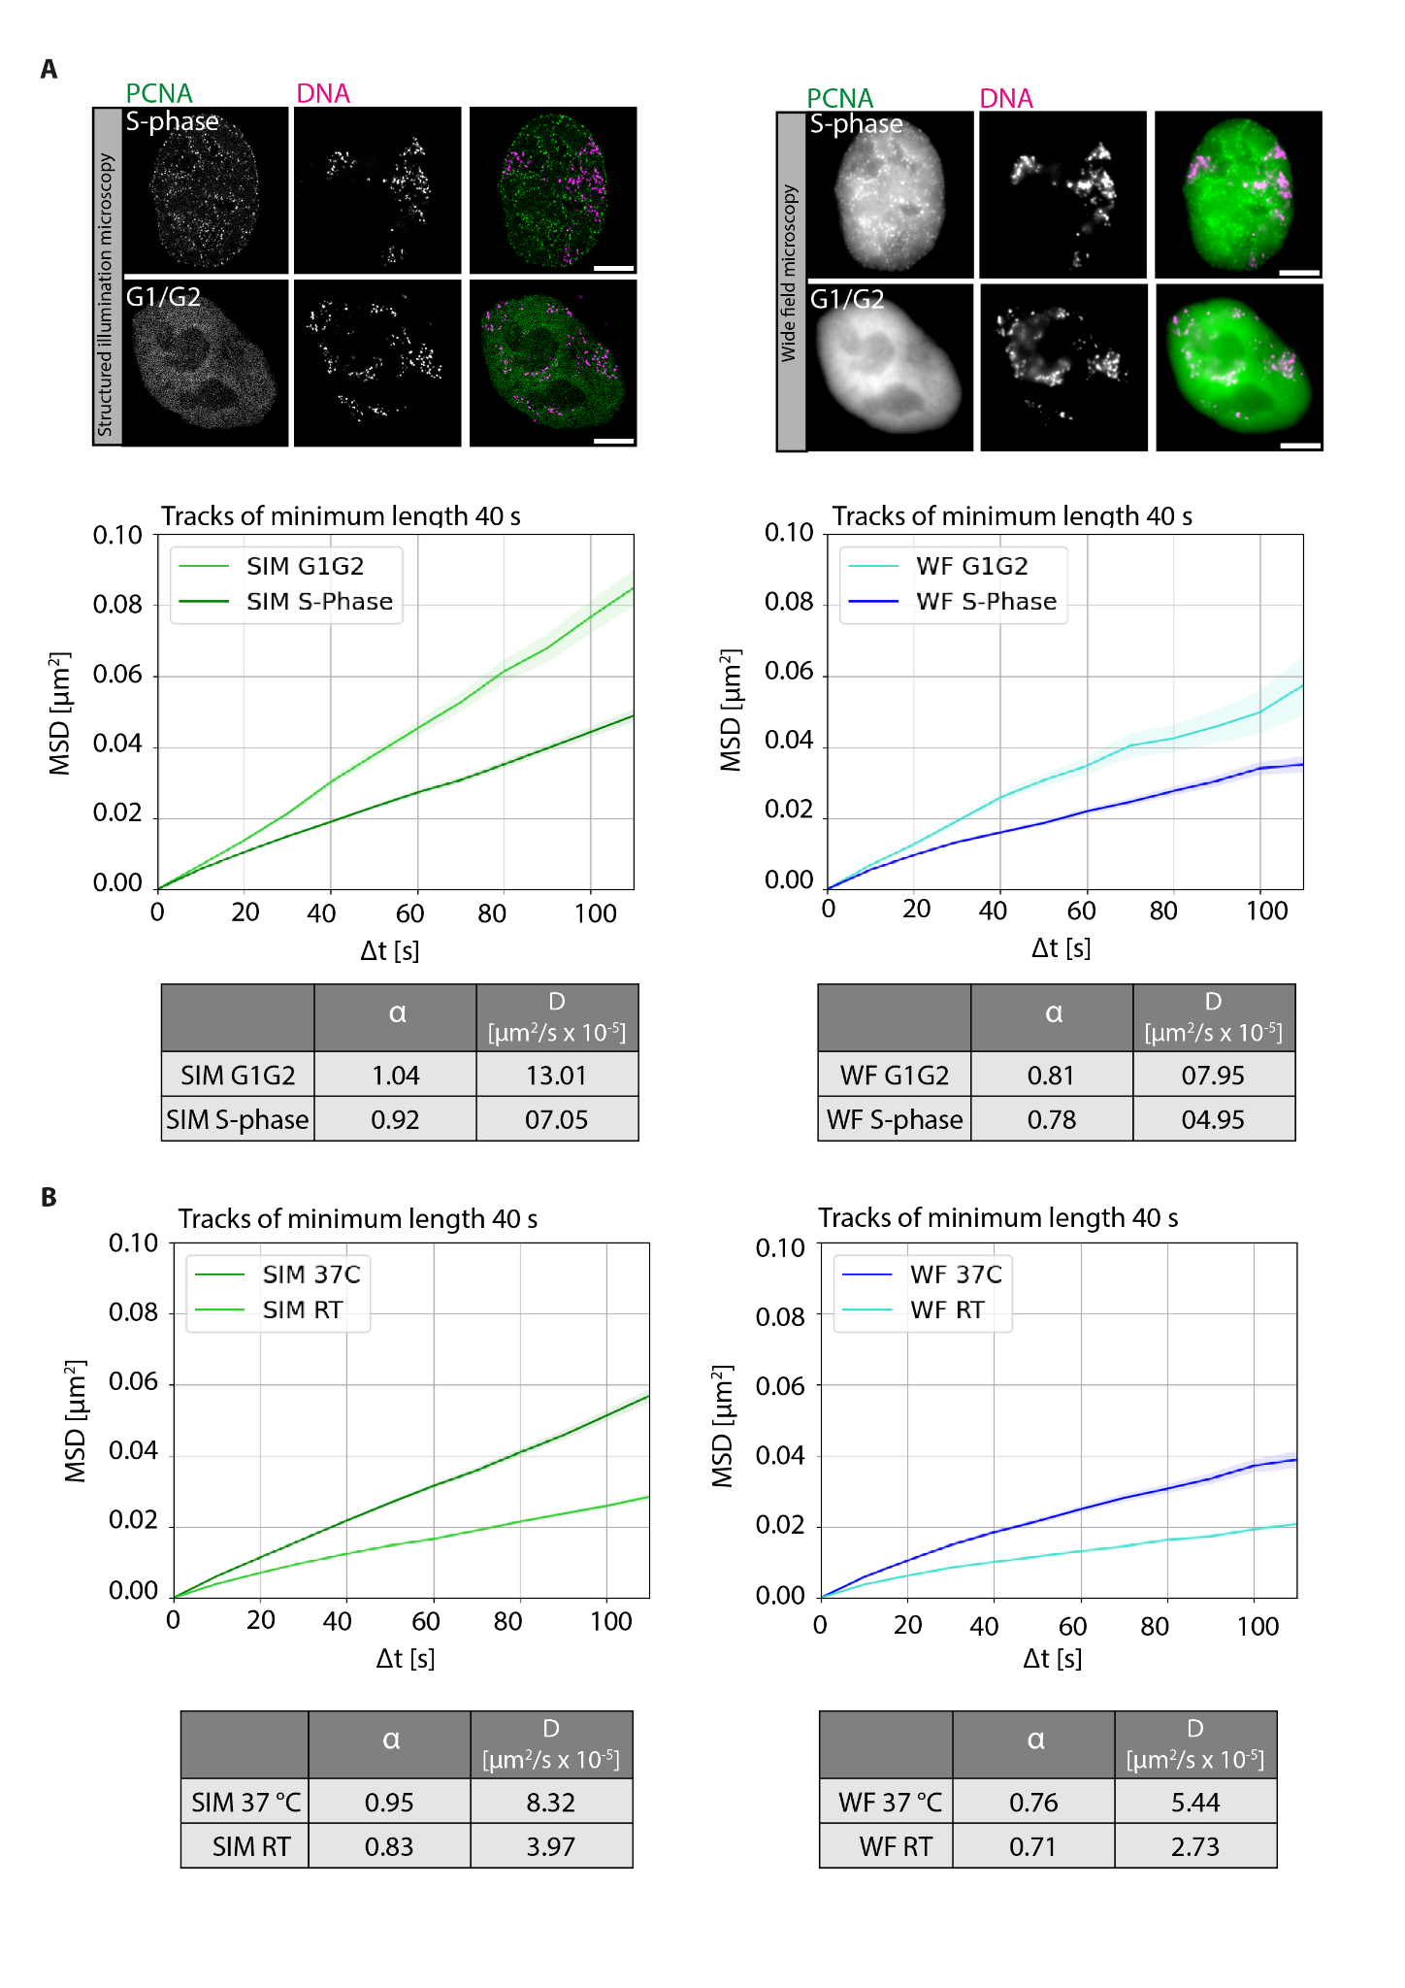

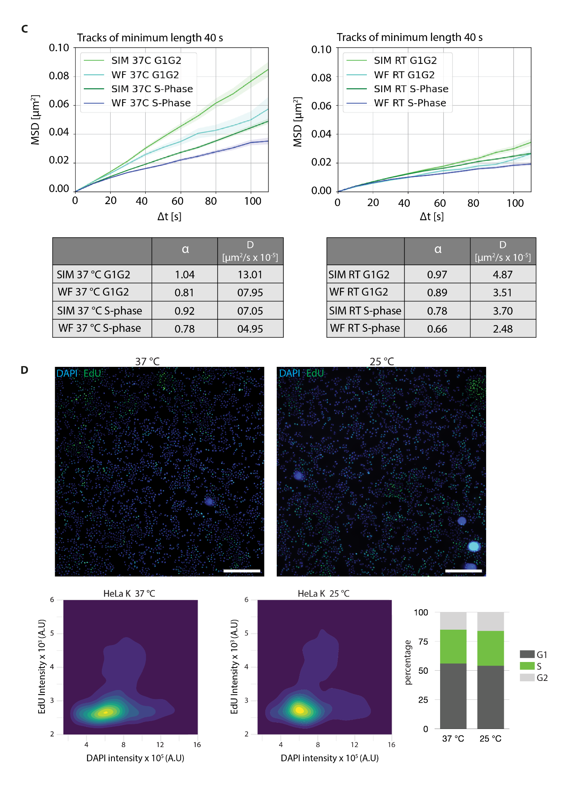Supplementary figure 12: Effect of DNA replication and temperature on chromatin mobility.
(A) HeLa K cells with labeled DNA were used to obtain 3D live cell time lapse movies (frame interval of 10 sec) (Methods, Supplementary table 1, 2). Correlative imaging of two channels GFP-PCNA and labeled chromatin in WF and SIM were obtained (Supplementary table 4). During S-phase, proliferating cell nuclear antigen (PCNA) accumulates within the nucleus at sites of active DNA replication and exhibits a distinct puncta pattern. During G1 and G2, GFP-PCNA is diffusely distributed throughout the nucleus. GFP-PCNA patterns were used to classify cells in different cell cycle stages (Supplementary figure 3). The representative images show GFP-PCNA (green) and labeled DNA (magenta) for both SIM and WF resolutions. The registered time lapse movies were used to detect chromatin foci of both SIM and WF and then analyzed to obtain the Mean Squared Displacement curves (MSD, µm²) over time intervals (s) (Supplementary figure 8). The MSD curves over time intervals (s) were plotted for S-phase and G1/G2 for both SIM and WF. The table details the values of the anomalous diffusion coefficient α and the diffusion coefficient D (µm²/s x 10⁻⁵). Scale bar: 5 µm. (B) During live cell imaging of chromatin labeled HeLa K GFP-PCNA cells, experiments at two different temperatures (37 ℃ and room temperature (RT)) were performed. The MSD curves over time intervals (s) were plotted for imaging at 37 °C and RT for both SIM and WF. The table details the values of the anomalous diffusion coefficient α and the diffusion coefficient D (µm²/s x 10⁻⁵). (C) The MSD curves over time intervals (s) were plotted for S-phase and G1/G2 for RT and 37 ℃ for both SIM and WF. The table details the values of the anomalous diffusion coefficient α and the diffusion coefficient D (µm2/s x 10-5). (D) Representative images of fixed HeLa K cells labeled with EdU (green, 10 µM) for 15 minutes and DAPI (blue). Cell cycle profile analysis of HeLa K cells cultured at 37 ℃ and RT with 5% CO2. The boxplot shows the percentage of cells in G1, S, G2 for HeLa K cells cultured at 37 ℃ and RT. Scale bar: 200 µm.

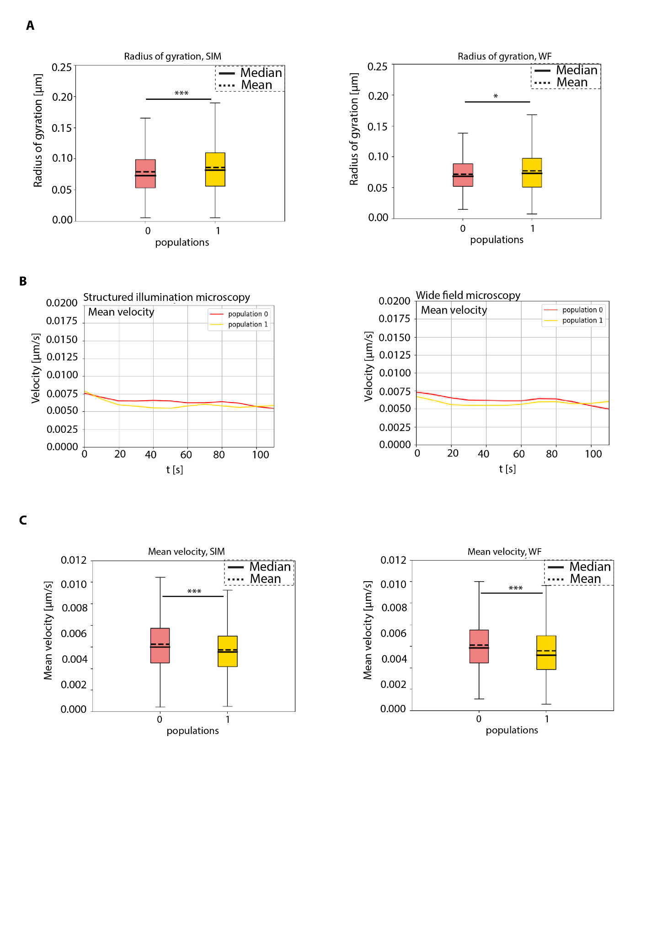

Supplementary figure 13: Comparison of different parameters between SIM and WF chromatin tracks.
(A) The radius of gyration (µm) of labeled chromatin foci for SIM and WF time lapse videos for population 0 (red) and population 1 (yellow) plotted as a box plot (Figure 5). (B) Mean velocity (µm/s) of labeled chromatin foci for SIM and WF for population 0 (red) and population 1 (yellow) plotted as a curve over time (s). (C) The mean velocity (µm/s) of labeled chromatin foci for SIM and WF time lapses for population 0 (red) and population 1 (yellow) plotted as a box plot (Figure 5). The median and mean values of the measurements are indicated in the figure. The statistics of the plots are shown in the figure and listed in (Supplementary table 6).

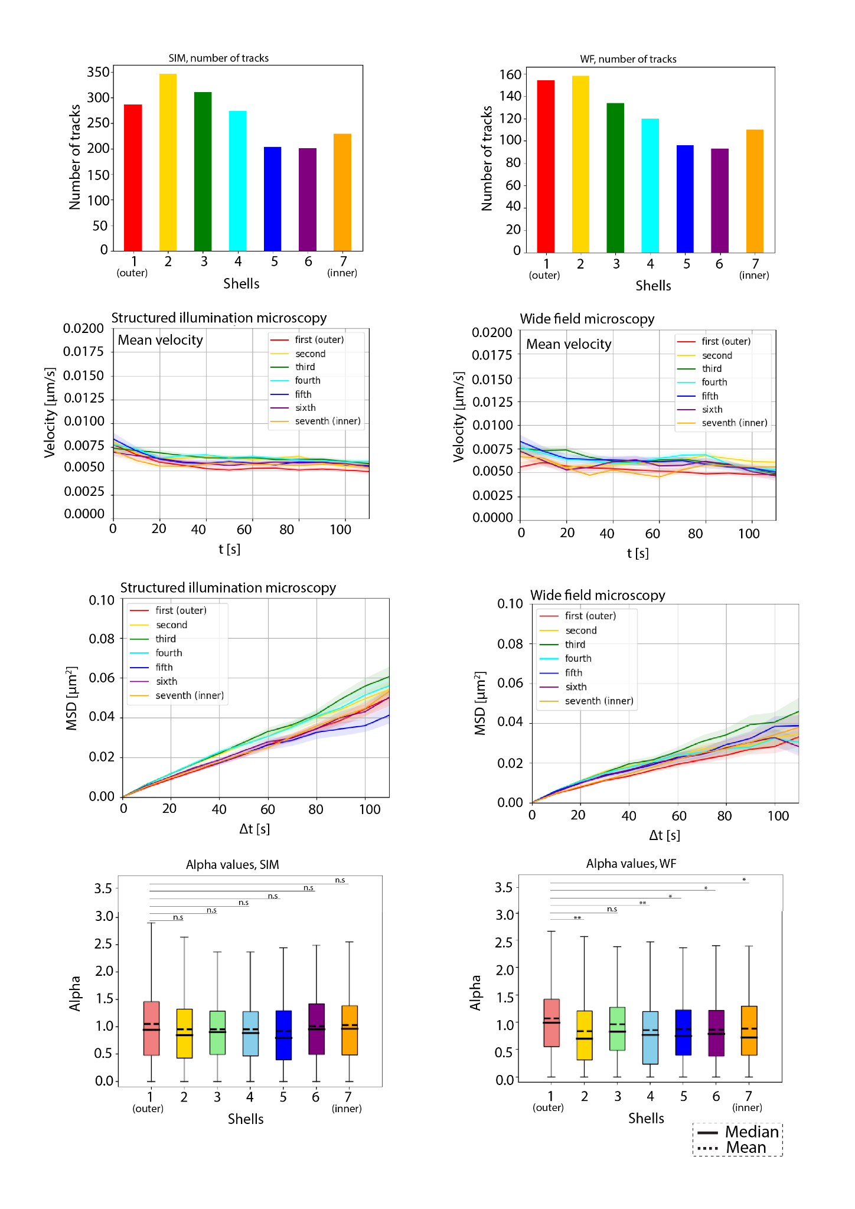
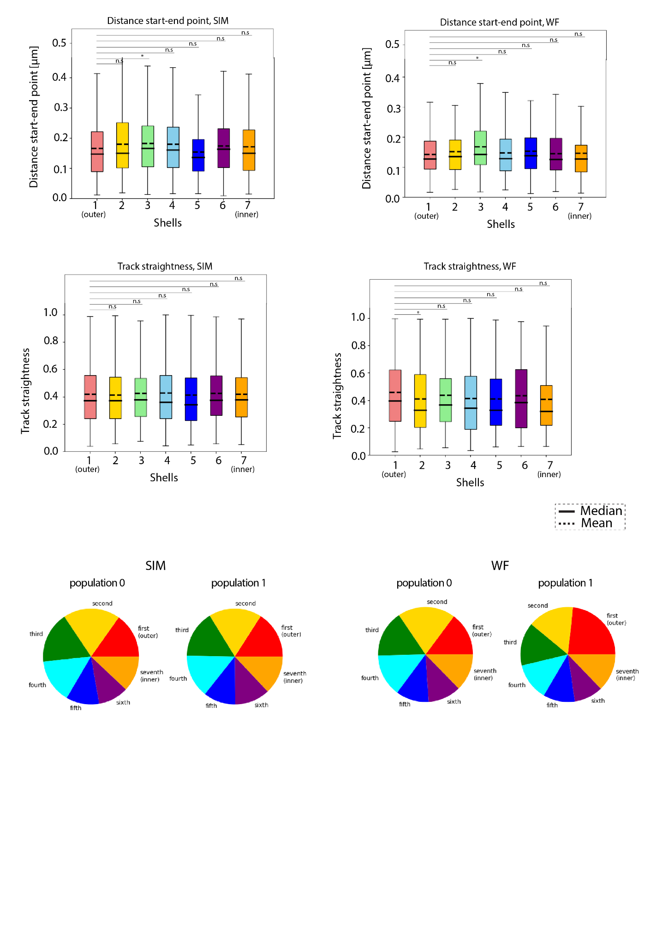
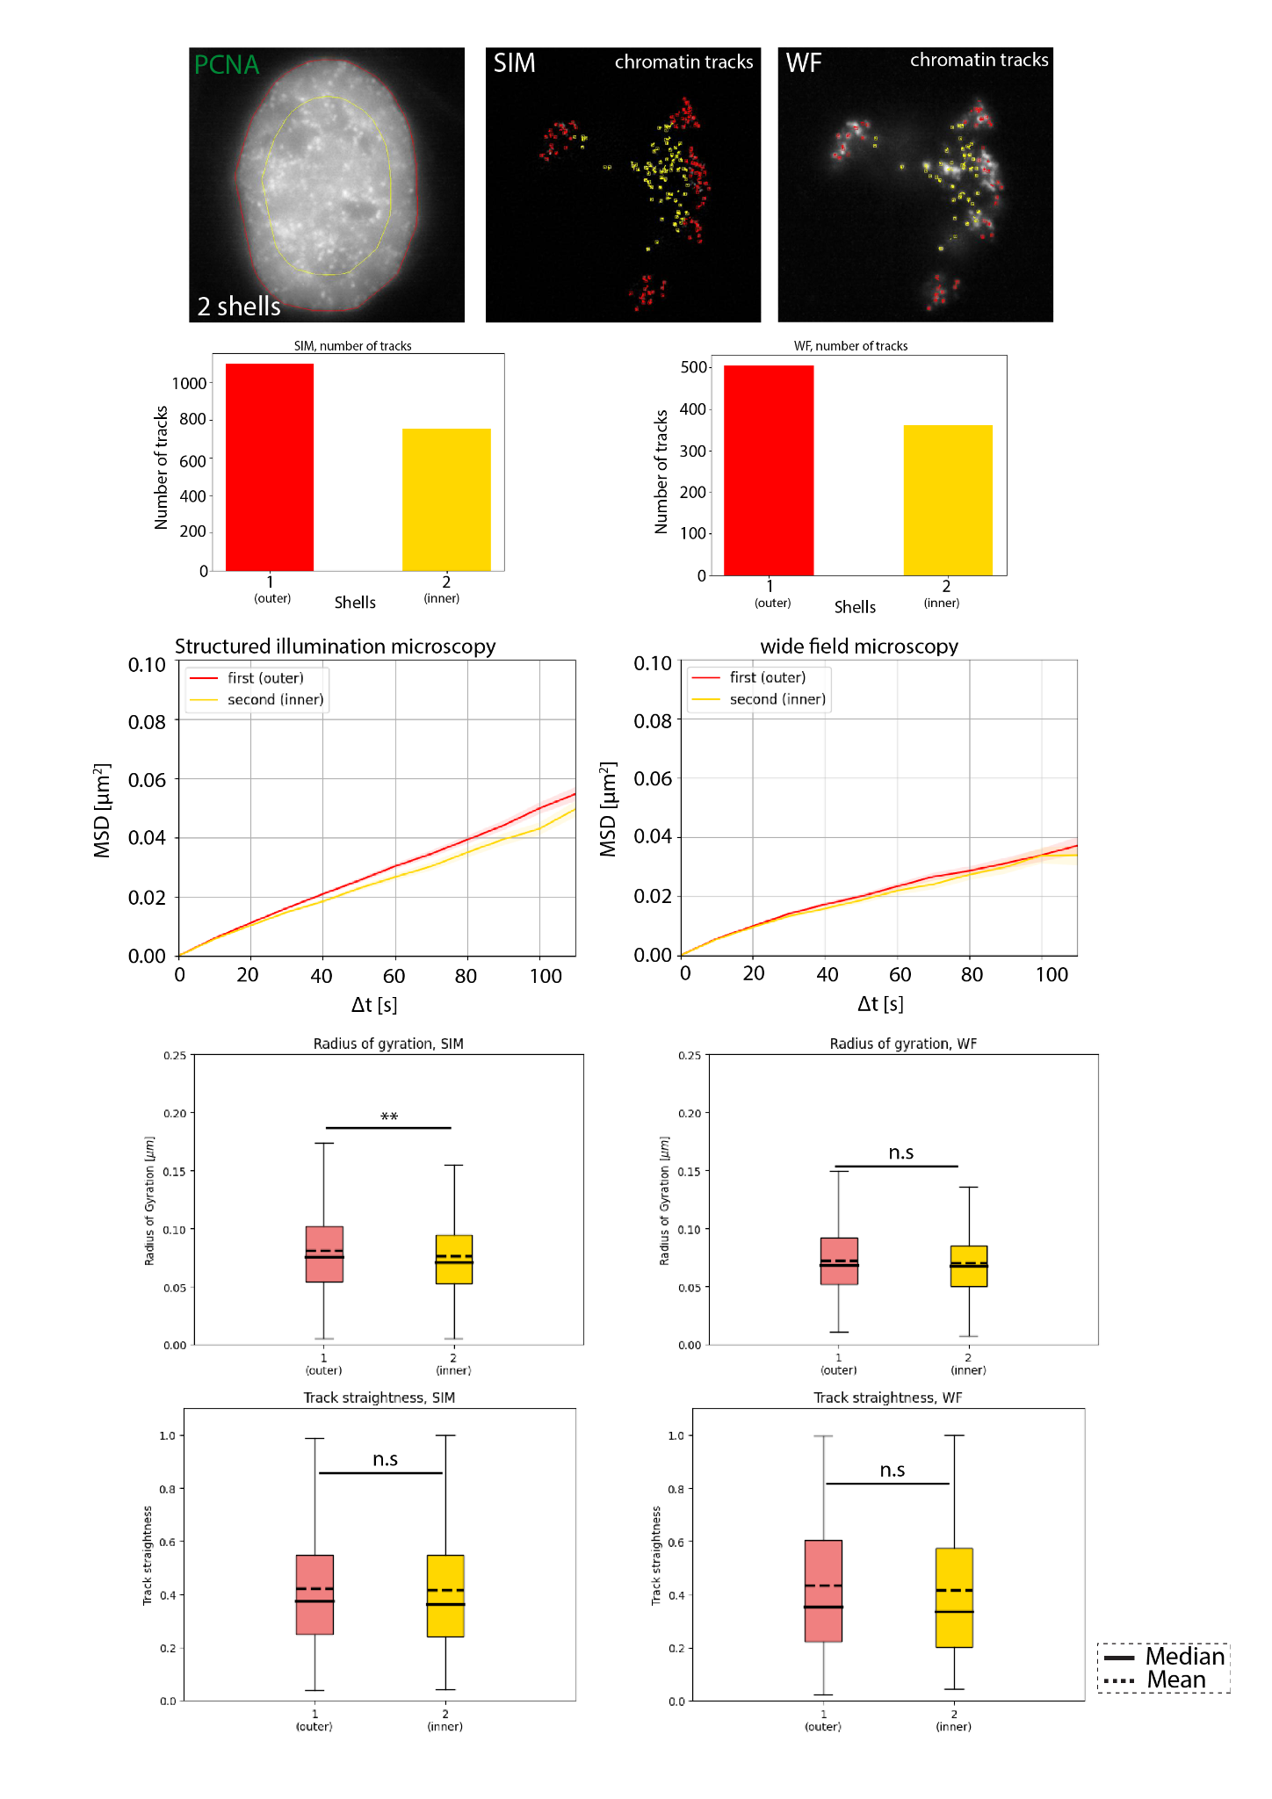

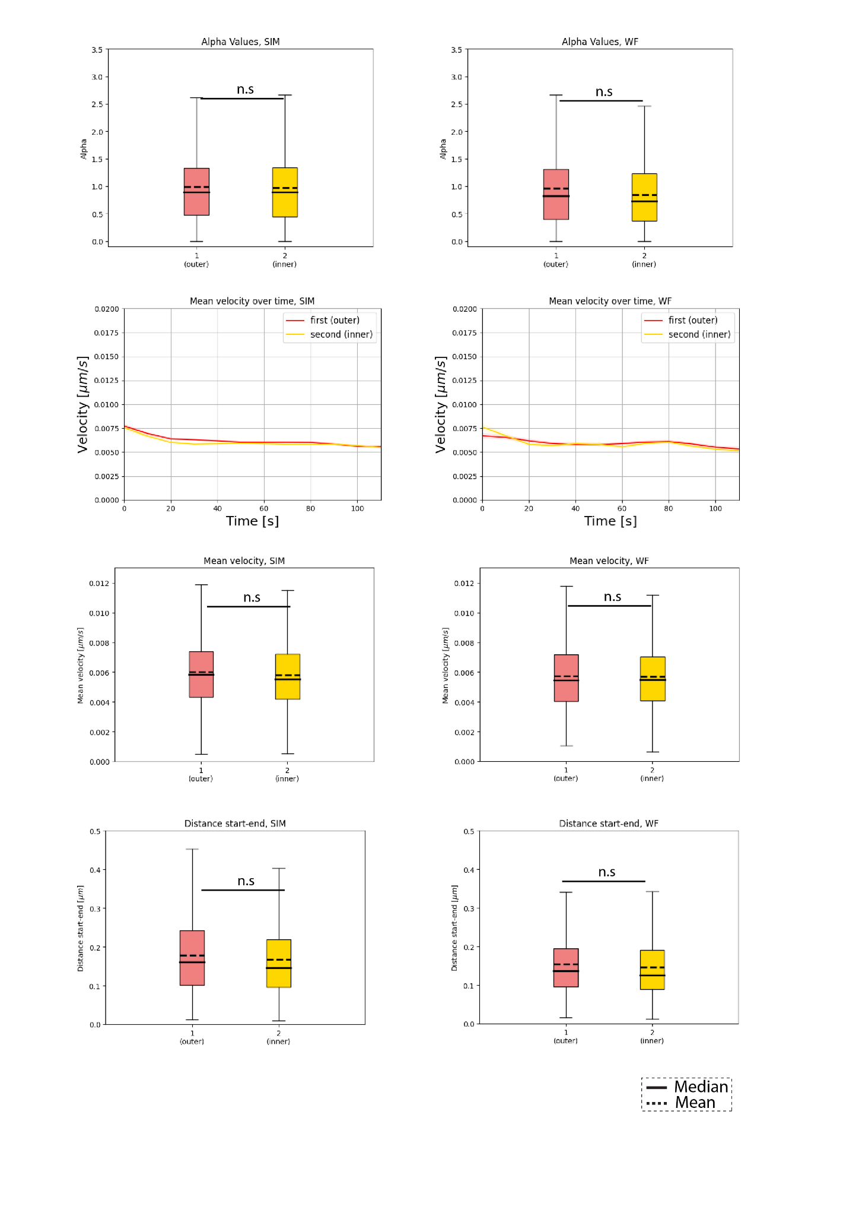
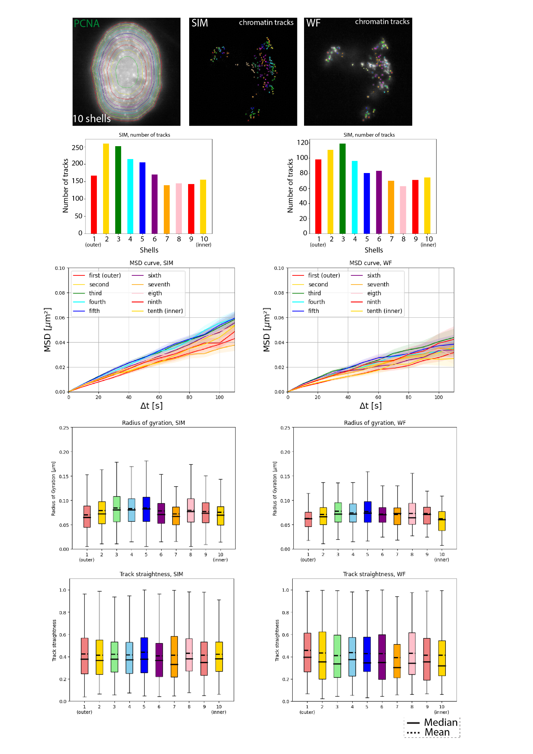
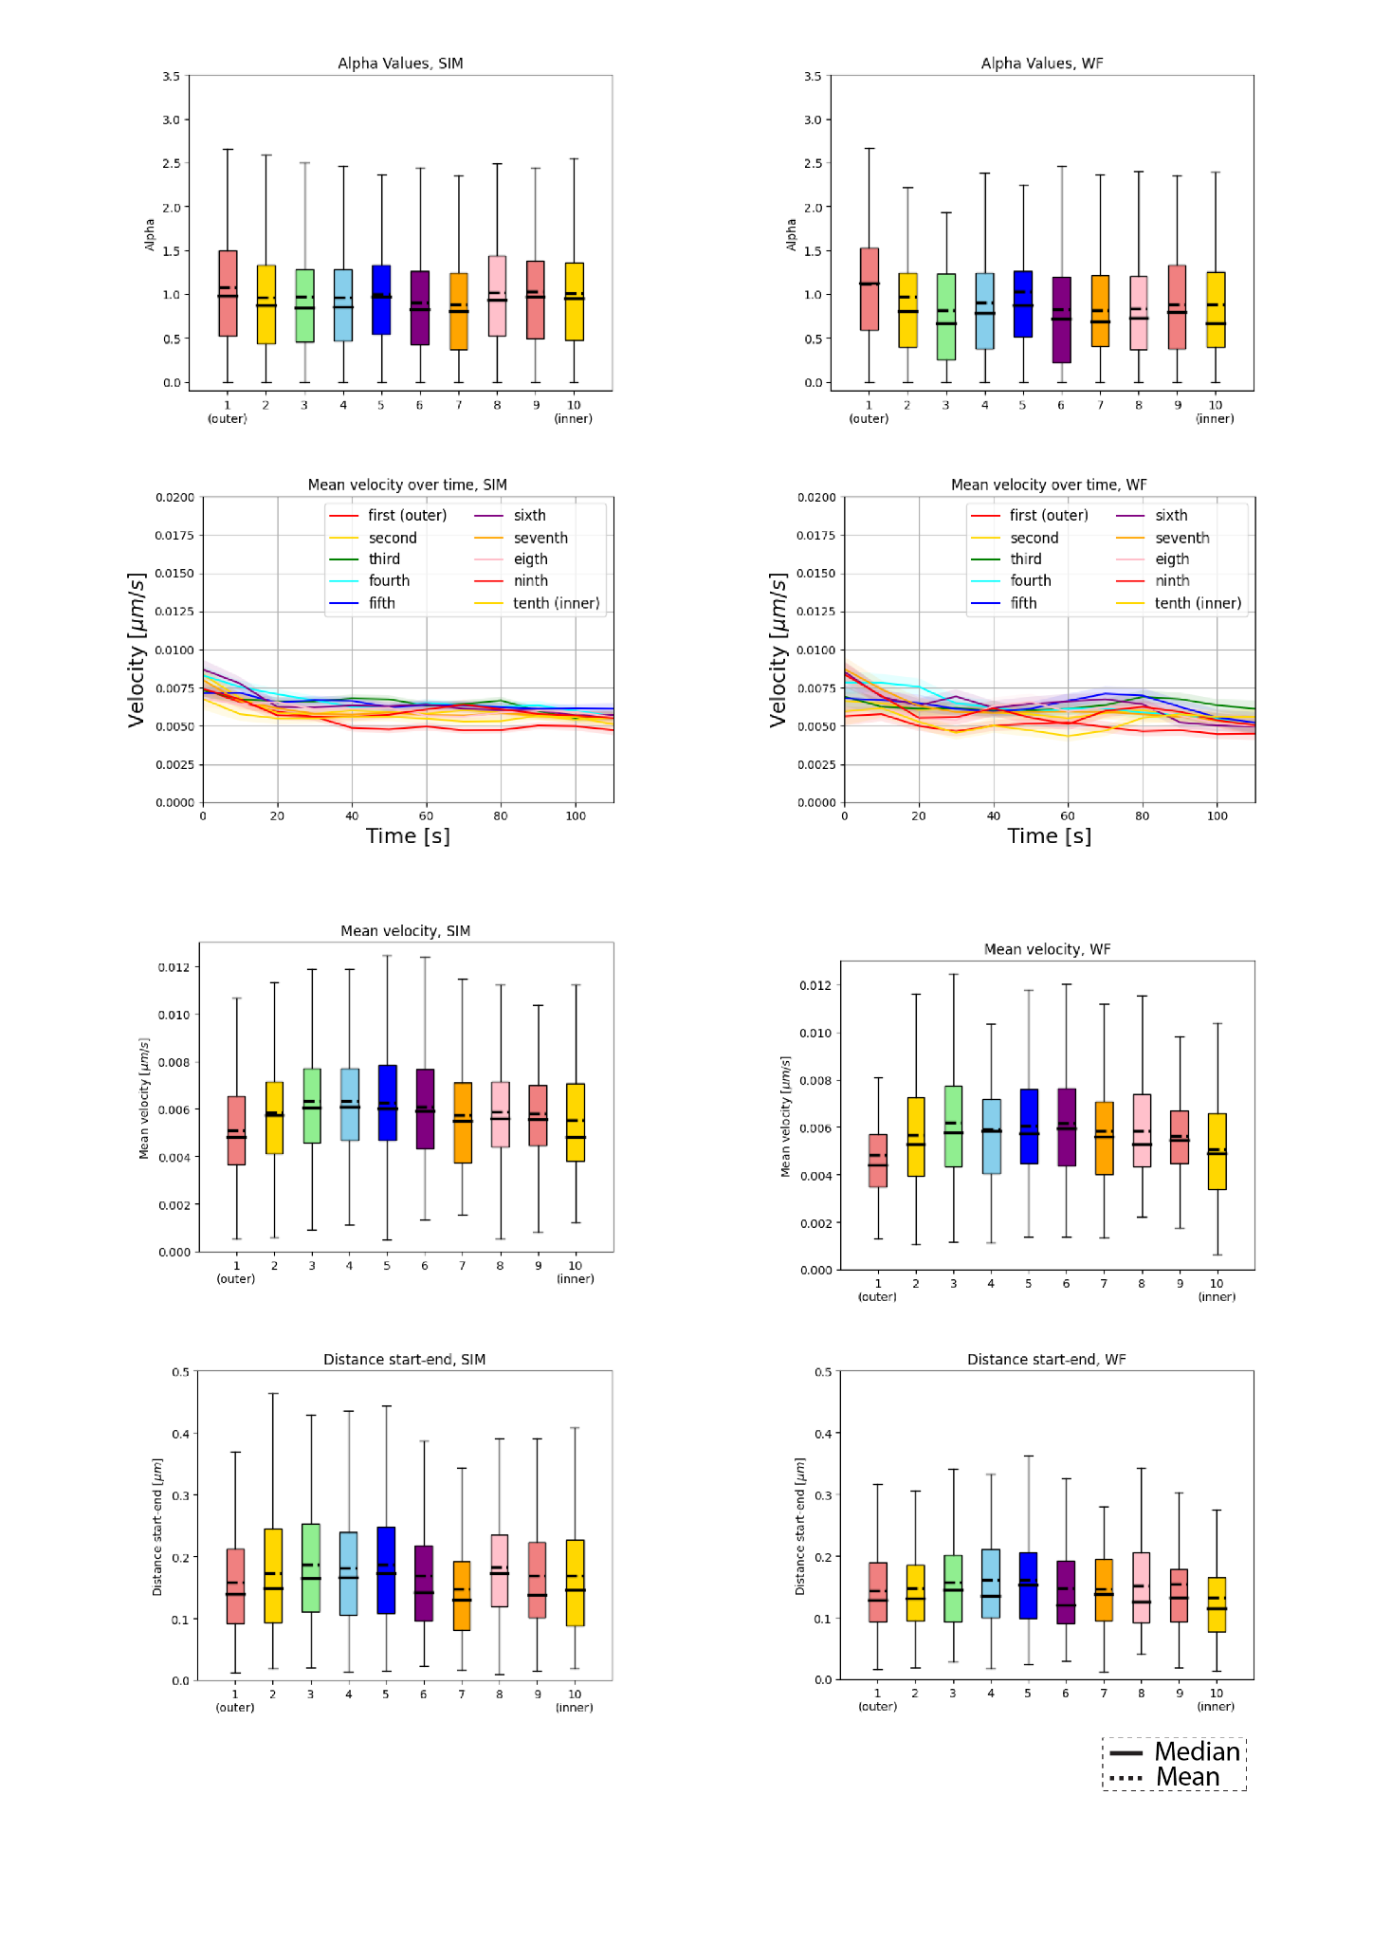

Supplementary figure 14: Location-based analysis of chromatin domains with different shell numbers.
Location-based analysis of chromatin within the nucleus was performed using different numbers of shells (2, 7, 10) of equal volume. Chromatin was subdivided into different shells and color-coded according to the shell color. We computed and plotted different parameters within each shell such as the number of chromatin foci, mean velocity over time, Mean Square Displacement curves (MSD), radius of gyration, alpha values, distance start to end, and track straightness.

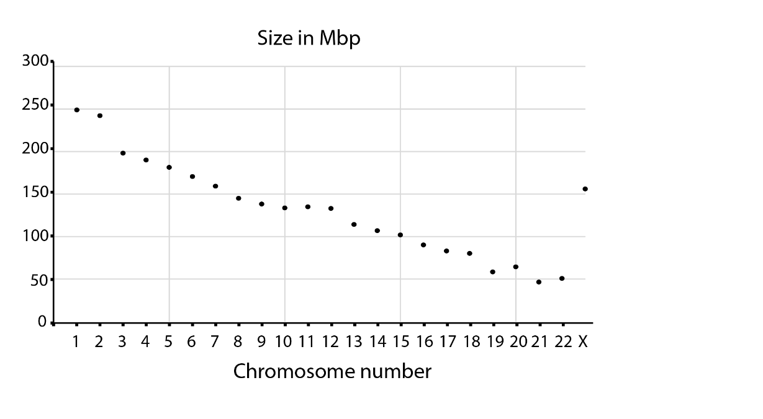

Supplementary figure 15: Human chromosomes sizes.

SUPPLEMENTARY TABLES AND FIGURES

Supplementary table 1: Cell line characteristics
Name | Species | Type | Genome size  (Gbp) | Reference
HeLa K | Homo sapiens | Cervical adenocarcinoma | 9.682±0.002 | (Erfle et al. 2007)
HeLa K GFP-PCNA | Homo sapiens | Cervical adenocarcinoma | 9.682±0.002 | (Chagin et al. 2016)
HeLa K FRTLacZ | Homo sapiens | Cervical adenocarcinoma | 9.682±0.002 | (Chagin et al. 2016)

Supplementary table 2: Nucleotide and chemical characteristics
Name | Application | Detection | Cat # | Company
ATTO590-dUTP | Replication labeling  (Labeling of nascent DNA) | - | NU-821-590 | Jena Biosciences, Germany
Cy3-dUTP | Replication labeling  (Labeling of nascent DNA) | - | ABD-17025 | Biomol GmbH,  Germany
5-ethynyl-2’-  deoxyuridine (EdU) | Labeling of nascent DNA  in pulse (chase) experiments | ClickIT chemistry | 7773.1 | Carl Roth, Germany
5-Bromo-2’-  Deoxyuridine  (BrdU) | Labeling of nascent DNA  in pulse (chase) experiments | Antibody | B5002 | Sigma Aldrich,  Merck, Germany
DIG-11-dUTP | DNA fibers | Antibody | NU-803-DIGXS | Jena Biosciences,  Germany

Supplementary table 3: Primary and secondary antibody characteristics
Reactivity | Host | Clonality | Dilution | Application | Cat / Clone# | Company / References
Anti BrdU* | rabbit | Monoclonal | 1:500 | IF | 600-401-C29 | Rockland, USA
anti digoxigenin | rabbit | Monoclonal | 1:500 | IF | #9H27L19 | Thermo fisher scientific, USA
anti-rabbit  IgG Cy3 | Donkey | Polyclonal | 1:500 | IF (fluorescent  secondary) | JIM-711-165-152 | Jackson immuno research, USA
anti-rabbit  IgG Cy5 | Donkey | Polyclonal | 1:500 | IF (fluorescent  secondary) | 711-175-152 | Jackson immuno research, USA
*DNAse treatment #Clone number

Supplementary table 4: Imaging systems characteristics
Microscope/  Company | Lasers/lamps | Filters (ex. &  em. [nm])* | Objectives/  lenses | Detection  system | Incubation  system | Application
DeltaVision OMX V3 Blaze system (Applied Precision) | 592 nm and 488 nm diode lasers | Ex (464/492 nm)  Em (500/523 nm)  Ex (531/556 nm)  Em (564/611 nm) | 60/1.42 NA PlanApo oil objective | sCMOS cameras (PCO) | 37°C incubation chamber, with 5% C02 and 60% humidity | 3D-SIM and 3D WF live cell time lapse microscopy
Nikon TiE2 inverted with crest spinning disk unit/ Nikon, Japan | SPECTRA X light engine  395/25 nm with 295 mW  440/20 nm with 256 mW  470/24 nm with 196 mW  510/25 nm with 62 mW  540/30 nm with 231 mW  550/15 nm with 260 mW  575/25 nm with 310 mW | LED-DA/FI/TR/Cy5-4X-B  Quadbandpassex:390/18,  475/35,  535/50  em:460/60,  530/43,  580LP | 40x air (0.95 NA) & 250 µm WD*** | Cooled Nikon Qi2 camera and 16.25 megapixel sCMOS sensor. readout noise is: 2.2. electron | Self build - 37°C incubation chamber, with 5% C02 and 60% humidity chamber | high throughput, high content imaging and image analysis
Bio Rad S3 cell sorter | 488 nm with 100 mW/ 561 nm with 100 mW | The filter sets are:  FL1: 525/30 nm  FL2: 587/25 nm  FL3: 615/25 nm  FL4: 655 nm LP | – | Forward scatter (FSC) with PMT  Side scatter (SSC) with PMT  2 fluorescence detectors with PMT  Minimum resolution: 0.5 µm | 4–37°C  Peltier solid-state system | Sorting of cells based on intensity
* ex.: excitation & em.: emission, ** dichroic specification, *** WD: working distance.

Supplementary Table 5: Software

Name | Version | Website | Company/University | Application
Volocity | 6.3 | - | PerkinElmer, USA | Analysis of DNA domain sizes
Fiji | 1.53c | https://imagej.net/software/fiji/ | Wayne Rasband, National Institutes of Health, USA | Image processing and image analysis
RStudio | 1.1.447-1.2.5033 | https://rstudio.com/ | RStudio | Statistical analysis and plotting
FCS express | RUO 7.20.0020 | https://denovosoftware.com | Denovo software by dotmatics | For analysis of flow cytometry data and plots
Adobe Illustrator | 2024 | https://www.adobe.com/ | Adobe, USA | Graphical sketch and figures arrangement

Supplementary Table 6: Statistics
Figure | Sample | n/number of replicates | Total percentage | Percentage of overlap | P value
1B | HeLa K nucleotide overlap  0’ chase  15’ chase  30’ chase  45’ chase  60’ chase  120’ chase | 3 biological  replicates | 100% | 56 %  33 %  10 %  8 %  7 %  10 % | NA
Figure | Sample | Number of cells | Median (Kbp) | Mode (Kbp) | P value
2A | SIM datasets | 30 | 110 | 70 | NA
2A | WF datasets | 30 | 210 | 70 | NA
Figure | Sample | Number of tracks | Alpha (ɑ) | Diffusion coefficient (D, µm²/s x 10⁻⁵) | Gamma (Γ, µm²/s^{ɑ} x 10⁻⁵)
3C | SIM | 2113 | 0.95 | 8.32 | 10.72
3C | WF | 1000 | 0.76 | 5.44 | 18.18
3C | Fixed | 1903 | 0.46 | 0.52 | 09.49
Figure | Sample | Number of tracks | Median (µm) | Mean (µm) | P value
3E | Radius of gyration, SIM | 2113 | 0.0763 | 0.0818 | 0.0000006
3E | Radius of gyration, WF | 1000 | 0.0699 | 0.0739 | 0.0000006
Figure | Sample | Number of tracks | Median (µm³) | Mean (µm³) | P value
3F | Mean particle size, SIM | 2113 | 0.0087 | 0.0127 | 0.0000
3F | Mean particle size, WF | 1000 | 0.0112 | 0.0256 | 0.0000
Figure | Sample | Number of tracks | Median (µm/s) | Mean (µm/s) | P value
3H | Mean velocity, SIM | 2113 | 0.00585 | 0.00604 | 0.098254
3H | Mean velocity, WF | 1000 | 0.00556 | 0.00590 | 0.098254
Figure | Sample | Number of tracks | Alpha (ɑ) | Diffusion coefficient (D, µm²/s x 10⁻⁵) | Gamma (Γ, µm²/s^{ɑ} x 10⁻⁵)
4B, 4C | G1/G2, SIM | 519 | 1.04 | 13.01 | 10.59
4B, 4C | G1/G2, WF | 257 | 0.81 | 07.95 | 20.79
4B, 4C | S-phase, SIM | 1594 | 0.92 | 07.05 | 10.45
4B, 4C | S-Phase, WF | 743 | 0.78 | 04.95 | 14.38
4E, 4F | 37 ℃, SIM | 2113 | 0.95 | 08.32 | 10.72
4E, 4F | 37 ℃, WF | 2568 | 0.76 | 05.44 | 18.18
4E, 4F | RT, SIM | 1000 | 0.83 | 03.97 | 09.54
4E, 4F | RT, WF | 1104 | 0.71 | 02.73 | 11.88
Figure | Sample | Number of tracks | Median (µm) | Mean (µm) | P value
5B | Population 0, SIM | 1172 | 1.8429 | 2.3067 | 0.560174
5B | Population 1, SIM | 678 | 1.9281 | 2.3652 | 0.560174
5B | Population 0, WF | 560 | 1.8756 | 2.3504 | 0.142176
5B | Population 1, WF | 305 | 1.7083 | 2.2399 | 0.142176
Figure | Sample | Number of tracks | Median (µm³) | Mean (µm³) | P value
5C | Particle size, SIM  Population 0  Population 1 | 1308  805 | 0.0087  0.0088 | 0.0128  0.0125 | 0.959039
5C | Particle size, WF  Population 0  Population 1 | 619  381 | 0.0121  0.0107 | 0.0241  0.0282 | 0.328000
Figure | Sample | Number of tracks | Median | Mean | P value
5D | Track straightness, SIM  Population 0  Population 1 | 1308  805 | 0.2874  0.5359 | 0.3310  0.5816 | 0.00000
5D | Track straightness, WF  Population 0  Population 1 | 619  381 | 0.2596  0.5842 | 0.3181  0.6252 | 0.00000
Figure | Sample | Number of tracks | Median (µm) | Mean (µm) | P value
5E | Distance start-end, SIM  Population 0  Population 1 | 1308  805 | 0.1308  0.2227 | 0.1463  0.2339 | 0.000000
5E | Distance start-end, WF  Population 0  Population 1 | 619  381 | 0.1139  0.1934 | 0.1259  0.2047 | 0.000000
Figure | Sample | Sample | Median (µm/s) | Mean (µm/s) | P value (shell 1 to shell n)
6B | Mean velocity, SIM | Shell 1 (outer) | 0.005100 | 0.005370 | NA
6B | Mean velocity, SIM | Shell 2 | 0.005982 | 0.006184 | 0.00003471
6B | Mean velocity, SIM | Shell 3 | 0.006042 | 0.006252 | 0.00000440
6B | Mean velocity, SIM | Shell 4 | 0.006122 | 0.006257 | 0.00000867
6B | Mean velocity, SIM | Shell 5 | 0.005642 | 0.005824 | 0.05842831
6B | Mean velocity, SIM | Shell 6 | 0.005344 | 0.005750 | 0.06446484
6B | Mean velocity, SIM | Shell 7 (inner) | 0.005279 | 0.005687 | 0.18390360
6B | Mean velocity, WF | Shell 1 (outer) | 0.004692 | 0.005072 | NA
6B | Mean velocity, WF | Shell 2 | 0.005620 | 0.006012 | 0.00023403
6B | Mean velocity, WF | Shell 3 | 0.005924 | 0.005985 | 0.00042127
6B | Mean velocity, WF | Shell 4 | 0.005820 | 0.006169 | 0.00012767
6B | Mean velocity, WF | Shell 5 | 0.005649 | 0.005944 | 0.00250355
6B | Mean velocity, WF | Shell 6 | 0.005220 | 0.005655 | 0.02411346
6B | Mean velocity, WF | Shell 7 (inner) | 0.005332 | 0.005265 | 0.31939619
Figure | Sample | Sample | Median (µm) | Mean (µm) | P value (shell 1 to shell n)
6C | Radius of gyration, SIM | Shell 1 (outer) | 0.06907 | 0.07462 | NA
6C | Radius of gyration, SIM | Shell 2 | 0.07400 | 0.08233 | 0.00531
6C | Radius of gyration, SIM | Shell 3 | 0.08140 | 0.08370 | 0.00037
6C | Radius of gyration, SIM | Shell 4 | 0.07905 | 0.08278 | 0.00300
6C | Radius of gyration, SIM | Shell 5 | 0.06826 | 0.07356 | 0.84909
6C | Radius of gyration, SIM | Shell 6 | 0.07356 | 0.07787 | 0.11634
6C | Radius of gyration, SIM | Shell 7 (inner) | 0.07295 | 0.07730 | 0.25357
6C | Radius of gyration, WF | Shell 1 (outer) | 0.06374 | 0.06544 | NA
6C | Radius of gyration, WF | Shell 2 | 0.06950 | 0.07477 | 0.00701
6C | Radius of gyration, WF | Shell 3 | 0.07411 | 0.07686 | 0.00072
6C | Radius of gyration, WF | Shell 4 | 0.07011 | 0.07390 | 0.01274
6C | Radius of gyration, WF | Shell 5 | 0.07324 | 0.07253 | 0.05828
6C | Radius of gyration, WF | Shell 6 | 0.06490 | 0.07055 | 0.27735
6C | Radius of gyration, WF | Shell 7 (inner) | 0.06580 | 0.06756 | 0.90629
Figure | Sample | Percentage of population 0 | Percentage of population 1 | Ratio population0/  population 1 | –
6D/ Supplementary figure 14 | Shell 1 (outer), SIM | 15 % | 16 % | 0.93 | –
6D/ Supplementary figure 14 | Shell 2, SIM | 19 % | 18 % | 1.05 | –
6D/ Supplementary figure 14 | Shell 3, SIM | 17 % | 16 % | 1.06 | –
6D/ Supplementary figure 14 | Shell 4, SIM | 15 % | 15 % | 1 | –
6D/ Supplementary figure 14 | Shell 5, SIM | 11 % | 11 % | 1 | –
6D/ Supplementary figure 14 | Shell 6, SIM | 10 % | 12 % | 0.83 | –
6D/ Supplementary figure 14 | Shell 7 (inner), SIM | 12 % | 13 % | 0.92 | –
6D/ Supplementary figure 14 | Shell 1 (outer), WF | 15 % | 23 % | 0.65 | –
6D/ Supplementary figure 14 | Shell 2, WF | 20 % | 16 % | 1.25 | –
6D/ Supplementary figure 14 | Shell 3, WF | 16 % | 15 % | 1.06 | –
6D/ Supplementary figure 14 | Shell 4, WF | 14 % | 13 % | 1.07 | –
6D/ Supplementary figure 14 | Shell 5, WF | 11 % | 11 % | 1 | –
6D/ Supplementary figure 14 | Shell 6, WF | 11 % | 10 % | 1.1 | –
6D/ Supplementary figure 14 | Shell 7 (inner), WF | 13 % | 23 % | 0.56 | –
Figure | Sample | Number of tracks | Alpha (ɑ) | Diffusion coefficient (D, µm²/s x 10⁻⁵) | Gamma (Γ, µm²/s^{ɑ} x 10⁻⁵)
7B, 7C | SIM | 2113 | 0.95 | 08.32 | 10.72
7B, 7C | WF | 1000 | 0.76 | 05.44 | 18.18
7B, 7C | Territories | 48 | 1.06 | 03.18 | 02.45
Supp Figure | Sample | Cell cycle stage | Mode (DNA intensity) | Cell cycle correction factor (C) | –
3 | HeLa K GFP-PCNA cells asynchronous population propidium iodide stained | G1 | 16480 | 1.00 | –
3 |  | Early S-phase | 17550 | 1.06 | –
3 |  | Mid S-phase | 21050 | 1.27 | –
3 |  | Late S-phase | 28100 | 1.71 | –
3 |  | G2 | 32644 | 1.98 | –
Supp Figure | Sample | Number of tracks | Alpha (ɑ) | Diffusion coefficient (D, µm²/s x 10⁻⁵) | Gamma (Γ, µm²/s^{ɑ} x 10⁻⁵)
8 | SIM, no registration | 2186 | 1.16 | 19.20 | 8.80
8 | SIM, registration | 2113 | 0.95 | 8.32 | 10.72
8 | WF, no registration | 1032 | 1.21 | 16.90 | 6.09
8 | WF, registration | 1000 | 0.76 | 5.44 | 18.18
Supp Figure | Sample | average number of tracks per cell | – | – | –
9B | fixed cell small foci | 237.9 | – | – | –
9B | fixed cell very small foci | 790.0 | – | – | –
9B | live cell small foci (37 °C) | 211.3 | – | – | –
9B | live cell small foci (RT) | 256.8 | – | – | –
Supp Figure | Sample | Number of tracks | Median | Mean | P value
11 - A | Track straightness, SIM | 2213 | 0.3775 | 0.4264 | 0.61907
11 - A | Track straightness, WF | 1000 | 0.3620 | 0.4351 | 0.61907
Supp Figure | Sample | Number of tracks | Median (µm) | Mean (µm) | P value
11 - B | Distance start-end, SIM | 2213 | 0.1580 | 0.1797 | 0.000000
11 - B | Distance start-end, WF | 1000 | 0.1372 | 0.1559 | 0.000000
Supp Figure | Sample | Number of tracks | Alpha (ɑ) | Diffusion coefficient (D, µm²/s x 10⁻⁵) | Gamma (Γ, µm²/s^{ɑ} x 10⁻⁵)
12 | G1/G2, SIM | 519 | 1.04 | 13.01 | 10.59
12 | S-Phase, SIM | 1594 | 0.92 | 07.05 | 10.45
12 | G1/G2, WF | 257 | 0.81 | 07.95 | 20.79
12 | S-Phase, WF | 743 | 0.78 | 04.95 | 14.83
12 | 37 ℃, SIM | 2113 | 0.95 | 8.32 | 10.72
12 | 37 ℃, WF | 1000 | 0.76 | 5.44 | 18.18
12 | RT, SIM | 2568 | 0.83 | 3.97 | 9.54
12 | RT, WF | 1104 | 0.71 | 2.73 | 11.88
Supp Figure | Sample | Number of tracks | Median (µm) | Mean (µm) | P value
13-A | Radius of gyration, SIM  Population 0  Population 1 | 1308  805 | 0.0730  0.0820 | 0.0792  0.0861 | 0.0001165
13-A | Radius of gyration, WF  Population 0  Population 1 | 619  381 | 0.0686  0.0733 | 0.0719  0.0771 | 0.059529
Supp Figure | Sample | Number of tracks | Median (µm/s) | Mean (µm/s) | P value
13-C | Mean velocity, SIM  Population 0  Population 1 | 1308  805 | 0.006013  0.005543 | 0.006242  0.005716 | 0.000002
13-C | Mean velocity, WF  Population 0  Population 1 | 619  381 | 0.005827  0.005169 | 0.006101  0.005561 | 0.000057
Supp Figure | Sample | Number of tracks | – | – | –
14 | Shell 1 (outer), SIM | 286 | – | – | –
14 | Shell 2, SIM | 346 | – | – | –
14 | Shell 3, SIM | 311 | – | – | –
14 | Shell 4, SIM | 273 | – | – | –
14 | Shell 5, SIM | 204 | – | – | –
14 | Shell 6, SIM | 201 | – | – | –
14 | Shell 7 (inner), SIM | 229 | – | – | –
14 | Shell 1 (outer), WF | 154 | – | – | –
14 | Shell 2, WF | 158 | – | – | –
14 | Shell 3, WF | 134 | – | – | –
14 | Shell 4, WF | 120 | – | – | –
14 | Shell 5, WF | 96 | – | – | –
14 | Shell 6, WF | 93 | – | – | –
14 | Shell 7 (inner), WF | 110 | – | – | –
Supp Figure | Sample | Sample | Median | Mean | P value (shell 1 to shell n)
14 | Alpha values, SIM | Shell 1 (outer) | 0.9401 | 1.0485 | NA
14 | Alpha values, SIM | Shell 2 | 0.8447 | 0.9526 | 0.15615
14 | Alpha values, SIM | Shell 3 | 0.9003 | 0.9567 | 0.20455
14 | Alpha values, SIM | Shell 4 | 0.8836 | 0.9552 | 0.28661
14 | Alpha values, SIM | Shell 5 | 0.7950 | 0.9244 | 0.09317
14 | Alpha values, SIM | Shell 6 | 0.9521 | 1.0155 | 0.99791
14 | Alpha values, SIM | Shell 7 (inner) | 0.9590 | 1.0287 | 0.97765
14 | Alpha values, WF | Shell 1 (outer) | 0.9908 | 1.0662 | NA
14 | Alpha values, WF | Shell 2 | 0.6977 | 0.8406 | 0.00150
14 | Alpha values, WF | Shell 3 | 0.8242 | 0.9578 | 0.17688
14 | Alpha values, WF | Shell 4 | 0.7667 | 0.8583 | 0.00269
14 | Alpha values, WF | Shell 5 | 0.7446 | 0.8729 | 0.0194
14 | Alpha values, WF | Shell 6 | 0.7854 | 0.8634 | 0.04262
14 | Alpha values, WF | Shell 7 (inner) | 0.7149 | 0.8829 | 0.027413
Supp Figure | Sample | Sample | Median (µm) | Mean (µm) | P value (shell 1 to shell n)
14 | Distance start-end, SIM | Shell 1 (outer) | 0.1473 | 0.1667 | NA
14 | Distance start-end, SIM | Shell 2 | 0.1501 | 0.1795 | 0.135905
14 | Distance start-end, SIM | Shell 3 | 0.1667 | 0.1826 | 0.024090
14 | Distance start-end, SIM | Shell 4 | 0.1615 | 0.1803 | 0.066405
14 | Distance start-end, SIM | Shell 5 | 0.1369 | 0.1546 | 0.210906
14 | Distance start-end, SIM | Shell 6 | 0.1641 | 0.1748 | 0.167986
14 | Distance start-end, SIM | Shell 7 (inner) | 0.1507 | 0.1723 | 0.453838
14 | Distance start-end, WF | Shell 1 (outer) | 0.1273 | 0.1428 | NA
14 | Distance start-end, WF | Shell 2 | 0.1357 | 0.1512 | 0.559429
14 | Distance start-end, WF | Shell 3 | 0.1416 | 0.1680 | 0.018751
14 | Distance start-end, WF | Shell 4 | 0.1292 | 0.1478 | 0.882723
14 | Distance start-end, WF | Shell 5 | 0.1385 | 0.1533 | 0.479737
14 | Distance start-end, WF | Shell 6 | 0.1257 | 0.1448 | 0.975072
14 | Distance start-end, WF | Shell 7 (inner) | 0.1273 | 0.1456 | 0.500560
Supp Figure | Sample | Sample | Median | Mean | P value (shell 1 to shell n)
14 | Track straightness, SIM | Shell 1 (outer) | 0.3730 | 0.4212 | NA
14 | Track straightness, SIM | Shell 2 | 0.3731 | 0.4140 | 0.672754
14 | Track straightness, SIM | Shell 3 | 0.3783 | 0.4257 | 0.782575
14 | Track straightness, SIM | Shell 4 | 0.3608 | 0.4281 | 0.979520
14 | Track straightness, SIM | Shell 5 | 0.3434 | 0.4126 | 0.398322
14 | Track straightness, SIM | Shell 6 | 0.3741 | 0.4255 | 0.810307
14 | Track straightness, SIM | Shell 7 (inner) | 0.3778 | 0.4197 | 0.8707723
14 | Track straightness, WF | Shell 1 (outer) | 0.3947 | 0.4595 | NA
14 | Track straightness, WF | Shell 2 | 0.3268 | 0.4106 | 0.047195
14 | Track straightness, WF | Shell 3 | 0.3672 | 0.4384 | 0.577206
14 | Track straightness, WF | Shell 4 | 0.3420 | 0.4137 | 0.110704
14 | Track straightness, WF | Shell 5 | 0.3290 | 0.4099 | 0.110695
14 | Track straightness, WF | Shell 6 | 0.3856 | 0.4362 | 0.461081
14 | Track straightness, WF | Shell 7 (inner) | 0.3188 | 0.4069 | 0.086930
Supp Figure | Sample | Number of tracks | – | – | –
14 | Shell 1 (outer), SIM | 1098 | – | – | –
 | Shell 2 (inner), SIM | 752 | – | – | –
 | Shell 1 (outer), WF | 504 | – | – | –
 | Shell 2 (inner), WF | 361 | – | – | –
Supp Figure | Sample | Number of tracks | Median | Mean | P value
14 | Radius of gyration, SIM  Shell 1 (outer)  Shell 2 (inner) | 1098  752 | 0.07614  0.07132 | 0.08111  0.07680 | 0.0086527
14 | Radius of gyration, WF  Shell 1 (outer)  Shell 2 (inner) | 504  361 | 0.06833  0.06752 | 0.07269  0.07030 | 0.1709711
14 | Track straightness, SIM  Shell 1 (outer)  Shell 2 (inner) | 1098  752 | 0.3744  0.3638 | 0.4230  0.4180 | 0.484973
14 | Track straightness, WF  Shell 1 (outer)  Shell 2 (inner) | 504  361 | 0.3531  0.3380 | 0.4336  0.4159 | 0.226971
14 | Alpha values, SIM  Shell 1 (outer)  Shell 2 (inner) | 1098  752 | 0.8909  0.8959 | 0.9900  0.9695 | 0.7855995
14 | Alpha values, WF  Shell 1 (outer)  Shell 2 (inner) | 504  361 | 0.8268  0.7282 | 0.9589  0.8485 | 0.066803
14 | Mean velocity, SIM  Shell 1 (outer)  Shell 2 (inner) | 1098  752 | 0.005836  0.005518 | 0.006016  0.005809 | 0.029837
14 | Mean velocity, WF  Shell 1 (outer)  Shell 2 (inner) | 504  361 | 0.005440  0.005479 | 0.005730  0.005709 | 0.902479
14 | Distance start-end, SIM  Shell 1 (outer)  Shell 2 (inner) | 1098  752 | 0.1605  0.1463 | 0.1783  0.1677 | 0.023000
14 | Distance start-end, WF  Shell 1 (outer)  Shell 2 (inner) | 504  361 | 0.1365  0.1263 | 0.1538  0.1463 | 0.089760
Supp Figure | Sample | Number of tracks | – | – | –
14 | Shell 1 (outer), SIM | 167 | – | – | –
14 | Shell 2, SIM | 259 | – | – | –
14 | Shell 3, SIM | 252 | – | – | –
14 | Shell 4, SIM | 215 | – | – | –
14 | Shell 5, SIM | 205 | – | – | –
14 | Shell 6, SIM | 170 | – | – | –
14 | Shell 7, SIM | 139 | – | – | –
14 | Shell 8, SIM | 145 | – | – | –
14 | Shell 9, SIM | 143 | – | – | –
14 | Shell 10 (inner), SIM | 155 | – | – | –
14 | Shell 1 (outer), WF | 98 | – | – | –
14 | Shell 2, WF | 111 | – | – | –
14 | Shell 3, WF | 119 | – | – | –
14 | Shell 4, WF | 96 | – | – | –
14 | Shell 5, WF | 80 | – | – | –
14 | Shell 6, WF | 83 | – | – | –
14 | Shell 7, WF | 70 | – | – | –
14 | Shell 8, WF | 63 | – | – | –
14 | Shell 9, WF | 71 | – | – | –
14 | Shell 10 (inner), WF | 74 | – | – | –
Supp Figure | Sample | Sample | Median (µm) | Mean (µm) | P value (shell 1 to shell n)
14 | Radius of gyration, SIM | Shell 1 (outer) | 0.06506 | 0.07068 | NA
14 | Radius of gyration, SIM | Shell 2 | 0.07227 | 0.07930 | 0.0216720
14 | Radius of gyration, SIM | Shell 3 | 0.08057 | 0.08493 | 0.0000507
14 | Radius of gyration, SIM | Shell 4 | 0.08073 | 0.08353 | 0.0001354
14 | Radius of gyration, SIM | Shell 5 | 0.08274 | 0.08464 | 0.0000772
14 | Radius of gyration, SIM | Shell 6 | 0.07102 | 0.07819 | 0.0656678
14 | Radius of gyration, SIM | Shell 7 | 0.06727 | 0.07231 | 0.6223969
14 | Radius of gyration, SIM | Shell 8 | 0.07690 | 0.08005 | 0.0065577
14 | Radius of gyration, SIM | Shell 9 | 0.07356 | 0.07749 | 0.0493245
14 | Radius of gyration, SIM | Shell 10 (inner) | 0.07005 | 0.07563 | 0.0187361
14 | Radius of gyration, WF | Shell 1 (outer) | 0.06233 | 0.06298 | NA
14 | Radius of gyration, WF | Shell 2 | 0.06646 | 0.07138 | 0.0577303
14 | Radius of gyration, WF | Shell 3 | 0.07209 | 0.07753 | 0.0007889
14 | Radius of gyration, WF | Shell 4 | 0.07171 | 0.07436 | 0.0022220
14 | Radius of gyration, WF | Shell 5 | 0.07399 | 0.07721 | 0.0023389
14 | Radius of gyration, WF | Shell 6 | 0.07024 | 0.07196 | 0.0184034
14 | Radius of gyration, WF | Shell 7 | 0.07315 | 0.07132 | 0.0686121
14 | Radius of gyration, WF | Shell 8 | 0.06422 | 0.07337 | 0.1207169
14 | Radius of gyration, WF | Shell 9 | 0.07116 | 0.07283 | 0.0543791
14 | Radius of gyration, WF | Shell 10 (inner) | 0.05993 | 0.06243 | 0.7736363
14 | Track straightness, SIM | Shell 1 (outer) | 0.3790 | 0.4264 | NA
14 | Track straightness, SIM | Shell 2 | 0.3650 | 0.4130 | 0.436420
14 | Track straightness, SIM | Shell 3 | 0.3773 | 0.4223 | 0.800939
14 | Track straightness, SIM | Shell 4 | 0.3728 | 0.4158 | 0.704146
14 | Track straightness, SIM | Shell 5 | 0.3782 | 0.4412 | 0.7007078
14 | Track straightness, SIM | Shell 6 | 0.3670 | 0.4089 | 0.406041
14 | Track straightness, SIM | Shell 7 | 0.3300 | 0.4137 | 0.229260
14 | Track straightness, SIM | Shell 8 | 0.3815 | 0.4332 | 0.672914
14 | Track straightness, SIM | Shell 9 | 0.3494 | 0.4134 | 0.420675
14 | Track straightness, SIM | Shell 10 (inner) | 0.3816 | 0.4220 | 0.868215
14 | Track straightness, WF | Shell 1 (outer) | 0.3964 | 0.4582 | NA
14 | Track straightness, WF | Shell 2 | 0.3536 | 0.4360 | 0.290698
14 | Track straightness, WF | Shell 3 | 0.3377 | 0.4124 | 0.086100
14 | Track straightness, WF | Shell 4 | 0.3765 | 0.4369 | 0.420457
14 | Track straightness, WF | Shell 5 | 0.3462 | 0.4277 | 0.416261
14 | Track straightness, WF | Shell 6 | 0.3488 | 0.4287 | 0.241937
14 | Track straightness, WF | Shell 7 | 0.3031 | 0.3933 | 0.059388
14 | Track straightness, WF | Shell 8 | 0.3422 | 0.4315 | 0.450187
14 | Track straightness, WF | Shell 9 | 0.3557 | 0.4132 | 0.167848
14 | Track straightness, WF | Shell 10 (inner) | 0.3181 | 0.4124 | 0.151283
14 | Alpha values, SIM | Shell 1 (outer) | 0.9836 | 1.0834 | NA
14 | Alpha values, SIM | Shell 2 | 0.8700 | 0.9604 | 0.0968973
14 | Alpha values, SIM | Shell 3 | 0.8447 | 0.9735 | 0.0786903
14 | Alpha values, SIM | Shell 4 | 0.8592 | 0.9586 | 0.0685896
14 | Alpha values, SIM | Shell 5 | 0.9716 | 1.0042 | 0.4269511
14 | Alpha values, SIM | Shell 6 | 0.8212 | 0.9010 | 0.0249519
14 | Alpha values, SIM | Shell 7 | 0.8105 | 0.8854 | 0.0154331
14 | Alpha values, SIM | Shell 8 | 0.9295 | 1.0226 | 0.5605983
14 | Alpha values, SIM | Shell 9 | 0.9683 | 1.0291 | 0.6559403
14 | Alpha values, SIM | Shell 10 (inner) | 0.9501 | 1.0153 | 0.4211240
14 | Alpha values, WF | Shell 1 (outer) | 1.1302 | 1.1148 | NA
14 | Alpha values, WF | Shell 2 | 0.8063 | 0.9704 | 0.0274637
14 | Alpha values, WF | Shell 3 | 0.6748 | 0.8127 | 0.0005340
14 | Alpha values, WF | Shell 4 | 0.7830 | 0.9051 | 0.0222278
14 | Alpha values, WF | Shell 5 | 0.8788 | 1.0337 | 0.0689346
14 | Alpha values, WF | Shell 6 | 0.7156 | 0.8222 | 0.0019695
14 | Alpha values, WF | Shell 7 | 0.6909 | 0.8137 | 0.0032087
14 | Alpha values, WF | Shell 8 | 0.7282 | 0.8369 | 0.0144681
14 | Alpha values, WF | Shell 9 | 0.7986 | 0.8872 | 0.0259881
14 | Alpha values, WF | Shell 10 (inner) | 0.6718 | 0.8834 | 0.0119245
14 | Mean velocity, SIM | Shell 1 (outer) | 0.004808 | 0.005092 | NA
14 | Mean velocity, SIM | Shell 2 | 0.005723 | 0.005855 | 0.0024424
14 | Mean velocity, SIM | Shell 3 | 0.006069 | 0.006326 | 0.0000009
14 | Mean velocity, SIM | Shell 4 | 0.006091 | 0.006318 | 0.0000008
14 | Mean velocity, SIM | Shell 5 | 0.006019 | 0.006275 | 0.0000012
14 | Mean velocity, SIM | Shell 6 | 0.005928 | 0.006086 | 0.000319
14 | Mean velocity, SIM | Shell 7 | 0.005476 | 0.005736 | 0.067785
14 | Mean velocity, SIM | Shell 8 | 0.005608 | 0.005874 | 0.007485
14 | Mean velocity, SIM | Shell 9 | 0.005543 | 0.005789 | 0.0044535
14 | Mean velocity, SIM | Shell 10 (inner) | 0.004838 | 0.005529 | 0.2769457
14 | Mean velocity, WF | Shell 1 (outer) | 0.004413 | 0.004804 | NA
14 | Mean velocity, WF | Shell 2 | 0.005269 | 0.005651 | 0.002930
14 | Mean velocity, WF | Shell 3 | 0.005768 | 0.006202 | 0.000011
14 | Mean velocity, WF | Shell 4 | 0.005854 | 0.005911 | 0.000226
14 | Mean velocity, WF | Shell 5 | 0.005719 | 0.006057 | 0.000254
14 | Mean velocity, WF | Shell 6 | 0.005941 | 0.006149 | 0.0000491
14 | Mean velocity, WF | Shell 7 | 0.005598 | 0.005828 | 0.002264
14 | Mean velocity, WF | Shell 8 | 0.005292 | 0.005825 | 0.002496
14 | Mean velocity, WF | Shell 9 | 0.005442 | 0.005638 | 0.0028115
14 | Mean velocity, WF | Shell 10 (inner) | 0.004881 | 0.005071 | 0.376419
14 | Distance start-end, SIM | Shell 1 (outer) | 0.1390 | 0.1584 | NA
14 | Distance start-end, SIM | Shell 2 | 0.1487 | 0.1730 | 0.311918
14 | Distance start-end, SIM | Shell 3 | 0.1649 | 0.1868 | 0.006579
14 | Distance start-end, SIM | Shell 4 | 0.1667 | 0.1818 | 0.017904
14 | Distance start-end, SIM | Shell 5 | 0.1733 | 0.1874 | 0.004527
14 | Distance start-end, SIM | Shell 6 | 0.1419 | 0.1687 | 0.592970
14 | Distance start-end, SIM | Shell 7 | 0.1298 | 0.1478 | 0.249994
14 | Distance start-end, SIM | Shell 8 | 0.1733 | 0.1822 | 0.0141171
14 | Distance start-end, SIM | Shell 9 | 0.1383 | 0.1690 | 0.3011126
14 | Distance start-end, SIM | Shell 10 (inner) | 0.1461 | 0.1697 | 0.4572556
14 | Distance start-end, WF | Shell 1 (outer) | 0.1283 | 0.1436 | NA
14 | Distance start-end, WF | Shell 2 | 0.1308 | 0.1470 | 0.901501
14 | Distance start-end, WF | Shell 3 | 0.1453 | 0.1575 | 0.373059
14 | Distance start-end, WF | Shell 4 | 0.1351 | 0.1610 | 0.292015
14 | Distance start-end, WF | Shell 5 | 0.1536 | 0.1614 | 0.141326
14 | Distance start-end, WF | Shell 6 | 0.1205 | 0.1480 | 0.925145
14 | Distance start-end, WF | Shell 7 | 0.1385 | 0.1469 | 0.907794
14 | Distance start-end, WF | Shell 8 | 0.1257 | 0.1513 | 0.835364
14 | Distance start-end, WF | Shell 9 | 0.1325 | 0.1540 | 0.858436
14 | Distance start-end, WF | Shell 10 (inner) | 0.1146 | 0.1322 | 0.154839
Supp Figure | Sample | Sample | Mbp | – | –
15 | chromosome sizes | 1 | 248.95642 | – | –
15 | chromosome sizes | 2 | 242.19353 | – | –
15 | chromosome sizes | 3 | 198.29556 | – | –
15 | chromosome sizes | 4 | 190.21456 | – | –
15 | chromosome sizes | 5 | 181.53826 | – | –
15 | chromosome sizes | 6 | 170.80598 | – | –
15 | chromosome sizes | 7 | 159.34597 | – | –
15 | chromosome sizes | 8 | 145.13864 | – | –
15 | chromosome sizes | 9 | 138.39472 | – | –
15 | chromosome sizes | 10 | 133.79742 | – | –
15 | chromosome sizes | 11 | 135.08662 | – | –
15 | chromosome sizes | 12 | 133.27531 | – | –
15 | chromosome sizes | 13 | 114.36433 | – | –
15 | chromosome sizes | 14 | 107.04372 | – | –
15 | chromosome sizes | 15 | 101.99119 | – | –
15 | chromosome sizes | 16 | 90.338345 | – | –
15 | chromosome sizes | 17 | 83.257441 | – | –
15 | chromosome sizes | 18 | 80.373285 | – | –
15 | chromosome sizes | 19 | 58.617616 | – | –
15 | chromosome sizes | 20 | 64.444167 | – | –
15 | chromosome sizes | 21 | 46.709983 | – | –
15 | chromosome sizes | 22 | 50.818468 | – | –
15 | chromosome sizes | X | 156.0409 | – | –

Video captions:
Video 1: Simultaneous live cell imaging of GFP-PCNA (green) and labeled DNA (magenta) in Wide-Field (WF) and Structured Illumination Microscopy (SIM). Scale bar: 5 µm.
Video 2: HeLa K GFP-PCNA live cells labeled with Atto590-dUTP (magenta). Chromatin tracking over time of labeled DNA before and after registration. Scale bar: 5 µm.
Video 3: HeLa K GFP-PCNA live cells labeled with Atto590-dUTP (magenta). Chromatin tracking over time of labeled DNA at WF and SIM resolutions. Scale bar: 5 µm.
Video 4: Correlative chromatin tracking of labeled DNA at WF and SIM resolutions. Scale bar: 100 nm.
Video 5: HeLa K GFP-PCNA live cells labeled with Atto590-dUTP (magenta). G1G2 and S-phase cells at WF and SIM resolutions. Correlative chromatin tracking of labeled DNA at different resolutions and cell cycle stages. Scale bar: 5 µm.
Video 6: HeLa K GFP-PCNA live cells labeled with Atto590-dUTP (magenta) showing chromatin tracking at segregated chromosome territories, TAD domains (WF) and chromatin loops (SIM). Scale bar: 5µm.

References
Chagin VO, Casas-Delucchi CS, Reinhart M, et al (2016) 4D Visualization of replication foci in mammalian cells corresponding to individual replicons. Nat Commun 7:11231. https://doi.org/10.1038/ncomms11231
Erfle H, Neumann B, Liebel U, et al (2007) Reverse transfection on cell arrays for high content screening microscopy. Nat Protoc 2:392–399. https://doi.org/10.1038/nprot.2006.483

