Supplementary Material

to

„The impact of land-use on the acoustic behavior of cicadas in the Chocó lowland tropical forest of Ecuador“

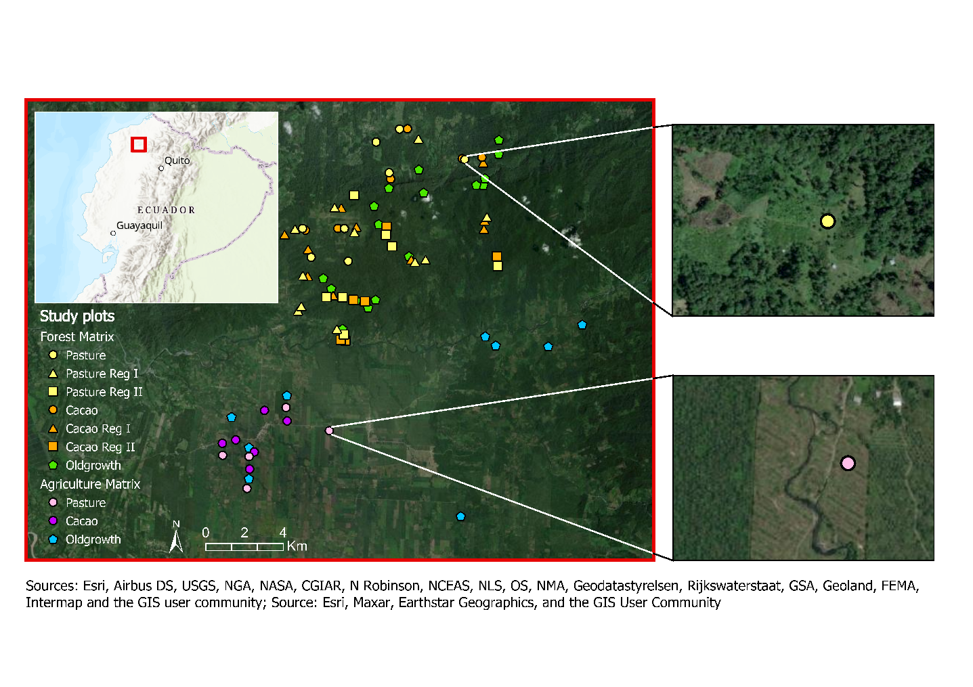
FIGURE S1 Map of study area. Top left: map of Ecuador with the study region marked by the red square. Center: map of study region with the treatment types represented by the different shape of symbols (points = active agriculture, triangles = regeneration plots of the early succession state, squares = regeneration plots of the second state, pentagons = old-growth forest). Furthermore, two satellite pictures are included as examples for the same habitat type (here: active pasture) embedded in the different landscape types, forest matrix (a) and agricultural matrix (b). The map was created in ArcGIS using the ESRI base map (Sources: Esri, Airbus DS, USGS, NGA, NASA, CCIAR, N Robinson, NCEAS, NILS, OS, NMA, Geodatasyreisen, Rijkswaterstaat, GSA, Geoland, FEMA,Intermap and the GIS user community; Esri, Maxar, Earthstar Geographics, and the User Community).
).

a
b

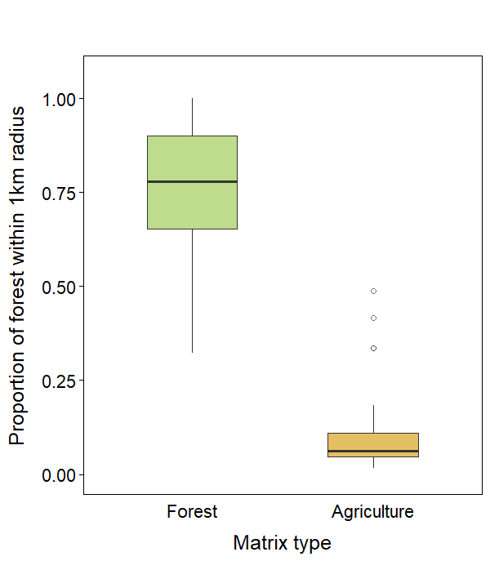
FIGURE S2 Proportion of forest within a 1km radius around study plots situated either within a forest matrix or an agricultural matrix.
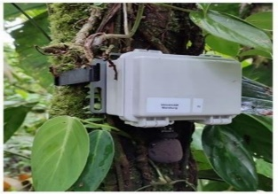
FIGURE S3 Sound recorder used in this study (Source: Müller et al., 2023).

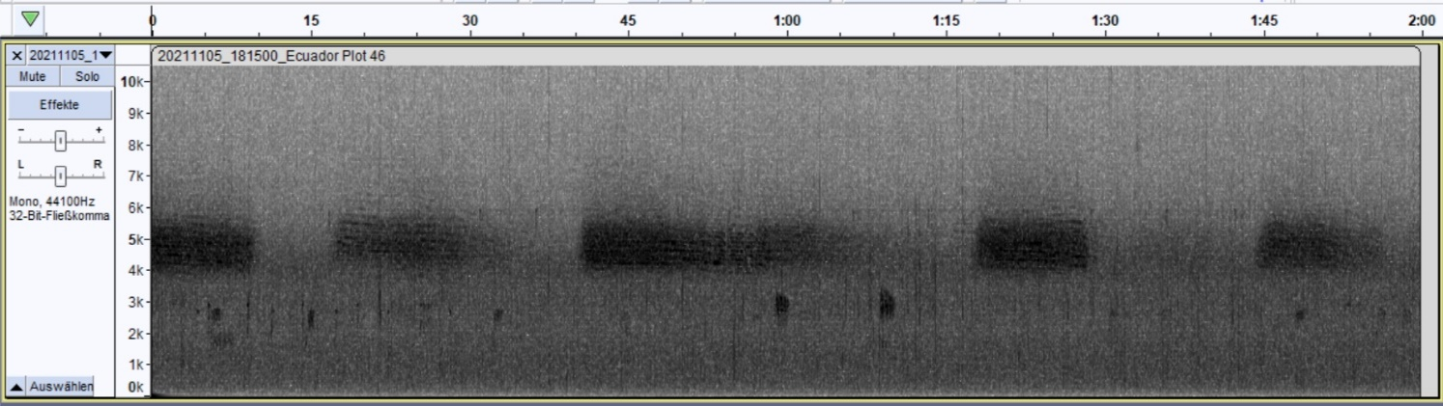
C
C
C
C
C
FIGURE S4 Grey scale spectrogram of a file containing cicada sound. The x-axis (shown at the top of the spectrogram) represents the time (from 0 seconds to two minutes), the y-axis the frequency (from 0 to 10000 Hz). The shades of grey represent the amplitude, with a darker color indicating a higher amplitude and therefore louder acoustic signal. In this spectrogram present cicada sounds are highlighted by the letter “C”.

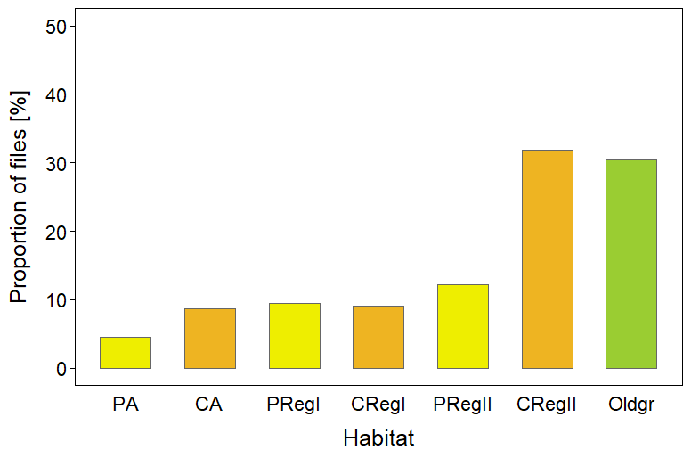
FIGURE S5 Proportions of files containing cicada signals according to the manual classification in different habitat types (active pasture, active cacao, secondary forests of regeneration stage I (1-20 years old) with pasture legacy, secondary forests of regeneration stage I with cacao plantation legacy, secondary forests of regeneration stage II (21-38 years old) with pasture legacy, secondary forests of regeneration stage II with cacao plantation legacy and old-growth forest). The land-use legacy is color coded (yellow: pasture legacy; orange: cacao plantation legacy; green: old-growth forests).

TABLE S1 Generalized additive model (GAM) with presence/absence of cicada sound in the two-minute audio file as binary response variable, the time of the day and plot location as smooth terms and the order of habitat types along a forest recovery gradient (active pasture, active cacao, secondary forests of regeneration stage I with a land-use legacy of pasture, secondary forests of regeneration stage I with cacao plantation legacy, secondary forests of regeneration stage II with pasture legacy, secondary forests of regeneration stage II with cacao plantation legacy and old-growth forest) and the elevation as linear explanatory variables. Significant p-values (p < 0.05) are indicated in bold font.
Predictors | Estimate | Std. Error | z-value | p-value
(Intercept) | ̶ 3.287 | 0.555 | ̶ 5.922 | < 0.001
Ord. Habitat Types - Linear | 1.364 | 0.345 | 3.955 | < 0.001
Elevation | 0.002 | 0.002 | 1.145 | 0.252
Smooth terms | edf | Ref. df | Chi. sq | p-value
Time of the day | 8.646 | 8.958 | 452.200 | < 0.001
Plot location | 22.156 | 26.001 | 135.400 | < 0.001

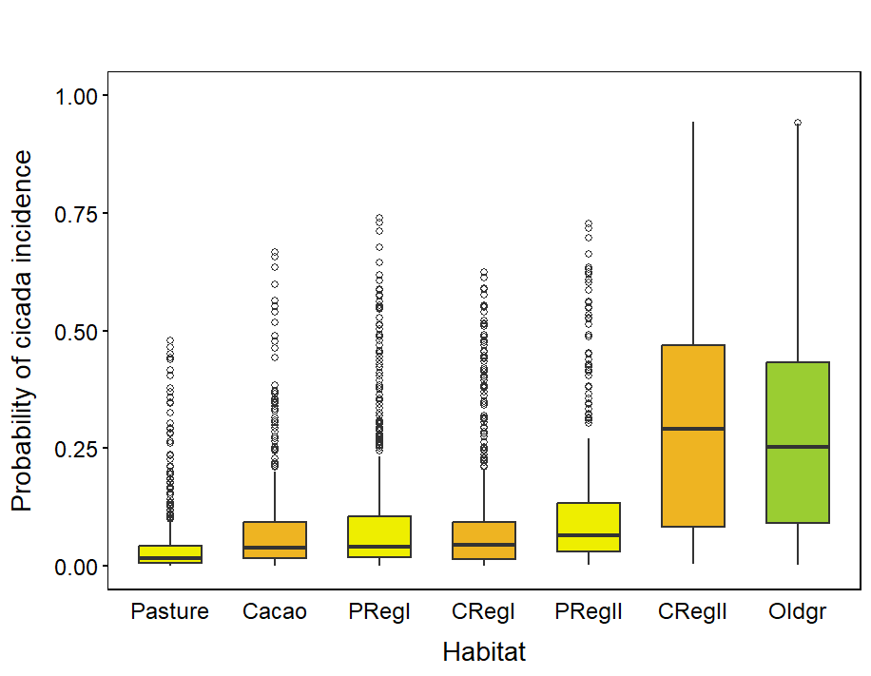
FIGURE S6 Estimated probability of cicada sound incidence in an audio file per habitat type based on the generalized additive model with habitat types as ordered factors (active pasture, active cacao, secondary forests of regeneration stage I (1-20 years old) with pasture legacy, secondary forests of regeneration stage I with cacao plantation legacy, secondary forests of regeneration stage II (21-38 years old) with pasture legacy, secondary forests of regeneration stage II with cacao plantation legacy and old-growth forest). The land-use legacy is color coded (yellow: pasture legacy; orange: cacao plantation legacy; green: old-growth forests).

TABLE S2 Generalized additive model (GAM) with the presence/absence of cicada sound in the two-minute audio files as binary response variable, the time of the day and plot as smooth terms and habitat type and matrix type as linear explanatory variables. Significant p-values (p < 0.05) are indicated in bold font.
Predictors | Estimate | Std. Error | z-value | p-value
(Intercept) | ̶ 4.531 | 0.506 | ̶ 8.960 | < 0.001
Habitat_Oldgrowth | 2.366 | 0.519 | 4.562 | < 0.001
Habitat_Active Pasture | 0.106 | 0.595 | 0.178 | 0.858
Matrix_Forest | 0.873 | 0.414 | 2.108 | 0.035
Smooth terms | edf | Ref. df | Chi. sq | p-value
Time of the day | 8.313 | 8.861 | 309.400 | < 0.001
Plot | 39.291 | 48.000 | 298.600 | < 0.001
Note: For Habitat the comparison is active cacao (C), for Matrix it is agriculture (A).

TABLE S3 Operational Taxonomic Units (OTU) of Cicadidae from light traps placed at 52 of our study plots within the four different habitat types: active agriculture, regeneration 1, regeneration 2 and old-growth forests located in the forest matrix. Numbers are reads summed up across plots (for methods see Müller et al., 2023).
Category | OTU_1807 | OTU_1830 | OTU_1834 | OTU_1882 | OTU_1884 | OTU_2032 | OTU_2061 | OTU_2063 | OTU_2066 | OTU_2067 | OTU_2213 | OTU_2389 | OTU_245 | OTU_2609
Agri | 15 | 0 | 0 | 3 | 0 | 14 | 135 | 241 | 73 | 6 | 1539 | 0 | 0 | 0
Reg1 | 8 | 0 | 85 | 0 | 0 | 0 | 22 | 162 | 7 | 88 | 247 | 3 | 11 | 2
Reg2 | 300 | 6 | 0 | 360 | 2 | 8 | 0 | 8 | 0 | 37 | 4 | 0 | 468 | 0
Old | 277 | 169 | 0 | 391 | 0 | 164 | 0 | 0 | 2 | 2 | 0 | 0 | 76 | 0

Category | OTU_2877 | OTU_3204 | OTU_3207 | OTU_34 | OTU_600 | OTU_626 | OTU_628 | OTU_778 | OTU_832 | OTU_8560 | OTU_901 | OTU_917 | OTU_9383 | OTU_9415
Agri | 0 | 0 | 0 | 0 | 0 | 0 | 0 | 2768 | 0 | 0 | 0 | 2219 | 4 | 0
Reg1 | 0 | 2 | 337 | 0 | 0 | 3 | 187 | 3397 | 9 | 2 | 2 | 0 | 0 | 0
Reg2 | 2 | 0 | 0 | 24 | 109 | 0 | 1141 | 0 | 0 | 0 | 0 | 0 | 0 | 0
Old | 0 | 10 | 0 | 0 | 156 | 18 | 17 | 194 | 0 | 0 | 0 | 5 | 0 | 8
Acoustic index failed to detect cicada sounds in audio data
Background
In a preparatory work to this study, we tested the performance of an acoustic index, developed by Towsey et al. (2014), for automatic cicada sound detection. This index is based on the use of the acoustic indices background noise and entropy of average spectrum ($H\left[s\right]$) and was developed through a decision tree training with a See5 classifier. According to the resulting rule, an audio segment is considered to contain cicada chorus signals if the value of the entropy of average spectrum is below a threshold of 0.6 and the one of background noise above – 24 dB at the same time (Eq. 1).
$if \left(\left(H\left[s\right]<0.6\right) \&\&\left(background noise>-24 dB\right)\right) then cicada chorus ;else none.$ (1)
To analyze the performance of the index, we used audio files recorded in the Ecuadorian Chocó region along a chronosequence of forest recovery. First, we divided each file into one-minute segments, calculated the index for them and then randomly selected 200 segments from both recording years (2021 and 2022) with half of them being classified as cicada and the other half as none by the cicada index. For the analysis we manually classified the audio files, into the categories none and cicada-faint or cicada-loud. We did the subdivision into the two cicada categories to include softer signals that might be captured by the index, but also to be able to distinguish between the two types of cicada sound in the analysis in case of too many errors in the manual classification of the quiet ones.
Comparison of manual classification and cicada index classification
First, we compared the results of the manual classification, with those of the index by plotting the proportion of files being classified as cicada or none by the index for each of the three manual classification categories in form of a stacked bar plot, using the package ggplot2. We then calculated the accuracy following the descriptions by Metz (1978).
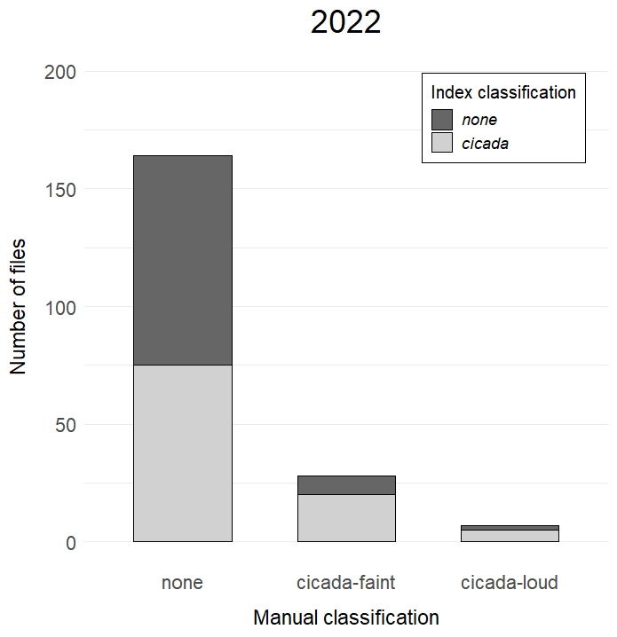
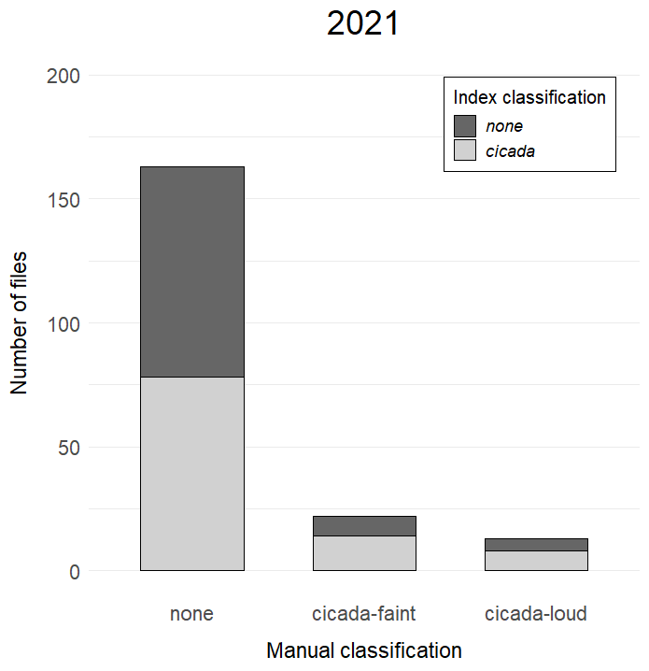
There was no clear concordance between the outcome of the automatic index classification and our manual classification. Out of 163 files we classified as none in the year 2021, the index showed the same result in just 78 cases (47.85%) and detected cicada sounds in the other 85 files. In the category cicada-faint the index detected cicada sounds in 14 of the 22 files and in eight out of 13 files for the category cicada-loud (Figure S7a). A similar trend could be observed for the data of 2022. Out of the 164 files we labeled as none the index classification delivered the same result in 89 files (54.27%) and classified the other 75 files as cicada. In the category cicada-faint the index classified 20 files out of 28 as cicada as well and for the files of the category cicada-loud five out of seven (Figure S7b).
a
b
FIGURE S7 Comparison of the manual classification and the cicada index classification for the two recording years, 2021 (a) and 2022 (b). The plots show the number of files that were manually classified as one of the three categories: none, cicada-faint or cicada-loud. The two different shades of grey in each bar show the ratio of files that were either classified as none (dark grey) or cicada (light grey) by the cicada index within the respective group of the manual classification.
The accuracy of the cicada index that derived from applying it on our data was at 54.04% in the year 2021 and 57.29% in 2022 or when only considering cicada-loud files as files containing cicada signals at 46.97% in 2021 and 47.24% in 2022. To rule out the possibility that the low accuracy was related to mistakes in the manually classification, the subsample of the 200 files from the year 2021 was sent to an orthopteran expert. Except for the category cicada-faint, in which he was even more critical than we were, the expert’s evaluation confirmed our classification results and particularly in the category cicada-loud he agreed in all cases.
Investigating diurnal distribution of files classified as cicada
The second approach to measure the performance of the cicada index was to analyze the diurnal distribution of files identified as cicadas by the index and examine its plausibility. For that, the proportion of files being classified as cicada was calculated separately for each hour of the day across all plots and survey days using the package dplyr (Wickham et al., 2023) and the results were plotted in form of a histogram. The diurnal distribution of files classified as cicada by the index provide strong evidence that the cicada index in this form cannot capture the sound of these animals adequately. According to the index cicadas were mainly active during the night and just to a lesser degree at daytime (Figure S8). This represents almost the reversed temporal pattern of what is known for cicadas from literature, with the prime vocal activity period at day (Gogala & Riede, 1995; Sueur, 2002; Young, 1972, 1981). In the manual classification we could not detect any cicada signals of the category cicada-loud in nighttime recordings either (Table S4).
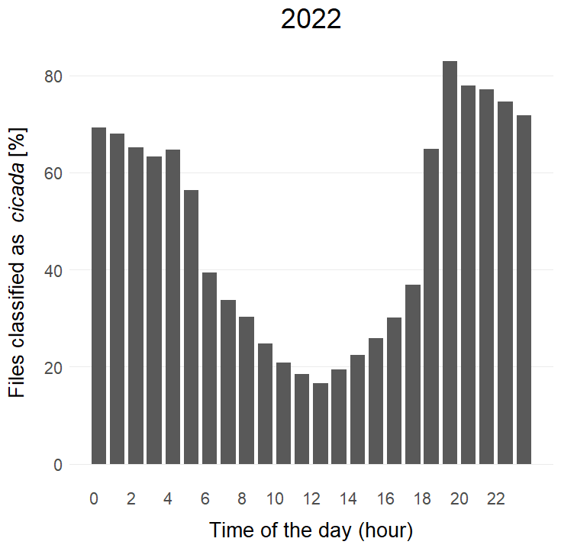
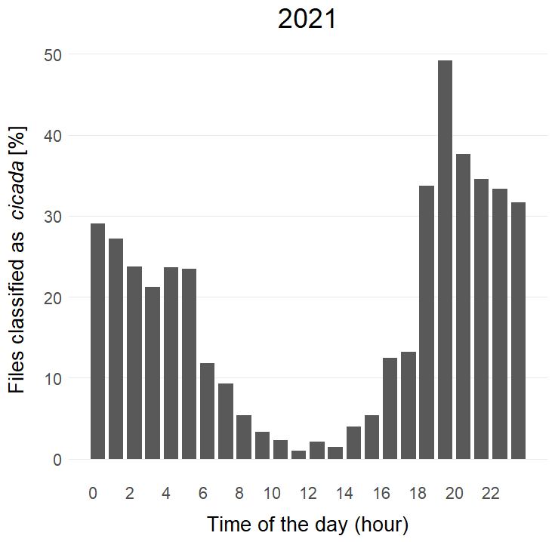
FIGURE S8 Diurnal distribution of cicada-positive files for both recording years. The bar charts show the proportion of files classified as cicada by the cicada index along the time of the day for the year 2021 (a) and 2022 (b).
a
b
TABLE S4 Proportion of files containing cicada signals according to the index and the manual classification in daytime recordings (5 am – 7 pm) (n= 206) and nighttime recordings (7 pm – 5 am) (n= 191). For the analysis of the manual classification only files of the category cicada-loud were considered as these were the files where the expert fully agreed with the classification.
 | Index classification | Manual classification
Daytime recordings | 36.89% | 9.71%
Nighttime recordings | 64.92% | 0.00%

Conclusion
The findings of this analysis demonstrate that the cicada index could not adequately capture and classify cicada sound in the present dataset, which was reflected in an accuracy below 60% and temporal activity patterns reversed to the commonly observed behavior of cicadas. The insufficient performance might be attributed to the simple structure of the cicada index with relying on just two acoustic indices, which could be easily influenced by non-target sources such other vocalizing animals (Oliveira et al., 2021) or geophony background noise (Brown et al., 2019). Further development of this index would therefore be necessary for a successful application in ecological studies. However, it remains questionable whether it is possible to develop a single acoustic index or formula that can detect cicada sounds sufficiently. We suggest that upcoming research should focus on more complex approaches for the automatic detection of cicada sounds using for instance different classifiers, clustering algorithms or deep learning techniques, as they have already shown promising results (Alberti et al., 2023; Brown et al., 2019; Guerrero et al., 2023; Tey et al., 2022). Furthermore, given the significant shortage of reference insect sounds (Gibb et al., 2019) a priority should also be the expansion of insect sound libraries. This could open up the possibility of transferring successful species recognition methods for avian species, such as the algorithm “BirdNET” (Kahl et al., 2021), on cicadas and other singing insects in the future as well, bringing us closer to fully utilize the potential of bioacoustics for global, large-scale insect monitoring.

References to Supplementary Material

Alberti, S., Stasolla, G., Mazzola, S., Casacci, L. Pietro, & Barbero, F. (2023). Bioacoustic IoT sensors as next-generation tools for monitoring: Counting flying insects through buzz. Insects, 14(12), 924. https://doi.org/10.3390/insects14120924
Brown, A., Garg, S., & Montgomery, J. (2019). Automatic rain and cicada chorus filtering of bird acoustic data. Applied Soft Computing, 81, 105501. https://doi.org/10.1016/j.asoc.2019.105501
Gibb, R., Browning, E., Glover‐Kapfer, P., & Jones, K. E. (2019). Emerging opportunities and challenges for passive acoustics in ecological assessment and monitoring. Methods in Ecology and Evolution, 10, 169–185. https://doi.org/10.1111/2041-210X.13101
Gogala, M., & Riede, K. (1995). Time sharing of song activity by cicadas in Temengor Forest Reserve, Hulu Perak, and in Sabah, Malaysia. Malayan Nature Journal, 48, 297–305.
Guerrero, M. J., Bedoya, C. L., López, J. D., Daza, J. M., & Isaza, C. (2023). Acoustic animal identification using unsupervised learning. Methods in Ecology and Evolution, 14, 1500–1514. https://doi.org/10.1111/2041-210X.14103
Kahl, S., Wood, C. M., Eibl, M., & Klinck, H. (2021). BirdNET: A deep learning solution for avian diversity monitoring. Ecological Informatics, 61, 101236. https://doi.org/10.1016/j.ecoinf.2021.101236
Metz, C. E. (1978). Basic principles of ROC analysis. Seminars in Nuclear Medicine, 8(4), 283–298. https://doi.org/10.1016/S0001-2998(78)80014-2
Müller, J., Mitesser, O., Schaefer, H. M., Seibold, S., Busse, A., Kriegel, P., Rabl, D., Gelis, R., Arteaga, A., Freile, J., Leite, G. A., de Melo, T. N., LeBien, J., Campos-Cerqueira, M., Blüthgen, N., Tremlett, C. J., Böttger, D., Feldhaar, H., Grella, N., … Buřivalová, Z. (2023). Soundscapes and deep learning enable tracking biodiversity recovery in tropical forests. Nature Communications, 14, 6191. https://doi.org/10.1038/s41467-023-41693-w
Oliveira, E. G., Ribeiro, M. C., Roe, P., & Sousa-Lima, R. S. (2021). The Caatinga Orchestra: Acoustic indices track temporal changes in a seasonally dry tropical forest. Ecological Indicators, 129, 107897. https://doi.org/10.1016/j.ecolind.2021.107897
Sueur, J. (2002). Cicada acoustic communication: potential sound partitioning in a multispecies community from Mexico (Hemiptera: Cicadomorpha: Cicadidae). Biological Journal of the Linnean Society, 75, 379–394.
Tey, W. T., Connie, T., Choo, K. Y., & Goh, M. K. O. (2022). Cicada species recognition based on acoustic signals. Algorithms, 15(10), 358. https://doi.org/10.3390/a15100358
Towsey, M., Wimmer, J., Williamson, I., & Roe, P. (2014). The use of acoustic indices to determine avian species richness in audio-recordings of the environment. Ecological Informatics, 21, 110–119. https://doi.org/10.1016/j.ecoinf.2013.11.007
Wickham, H., François, R., Henry, L., Müller, K., & Vaughan, D. (2023). dplyr: A grammar of data manipulation. R Package Version 1.1.2. https://CRAN.R-project.org/package=dplyr
Young, A. M. (1972). Cicada ecology in a Costa Rican tropical rain forest. Biotropica, 4(3), 152–159. https://doi.org/10.2307/2989777
Young, A. M. (1981). Temporal selection for communicatory optimazation: The dawn-dusk chorus as an adaptation in tropical cicadas. The American Naturalist, 117, 826–829.

