Supplement S1
Sample coverage affects diversity measures of bird communities along a natural recovery gradient of abandoned agriculture in tropical lowland forests

Mareike Kortmann, Anne Chao, H. Martin Schaefer, Nico Blüthgen, Rudy Gelis, Constance J. Tremlett, Annika Busse, Marcel Püls, Sebastian Seibold, Peter Kriegel, Dominik Rabl, Maria de la Hoz, Çağan H. Şekercioğlu, Matthias Schleuning, Heike Feldhaar, Felicity L. Newell, Sonja Kümmet, Oliver Mitesser, Marcel K. Peters and Jörg Müller

Figure S1.1. Species rarefaction and extrapolation curves for taxonomic, phylogenetic and functional diversity for rare, common and dominant species (Hill number q=0, q=1, q=2). Solid dots squares, triangles and diamonds show observed values, solid lines show rarefied values and dotted lines extrapolated values.

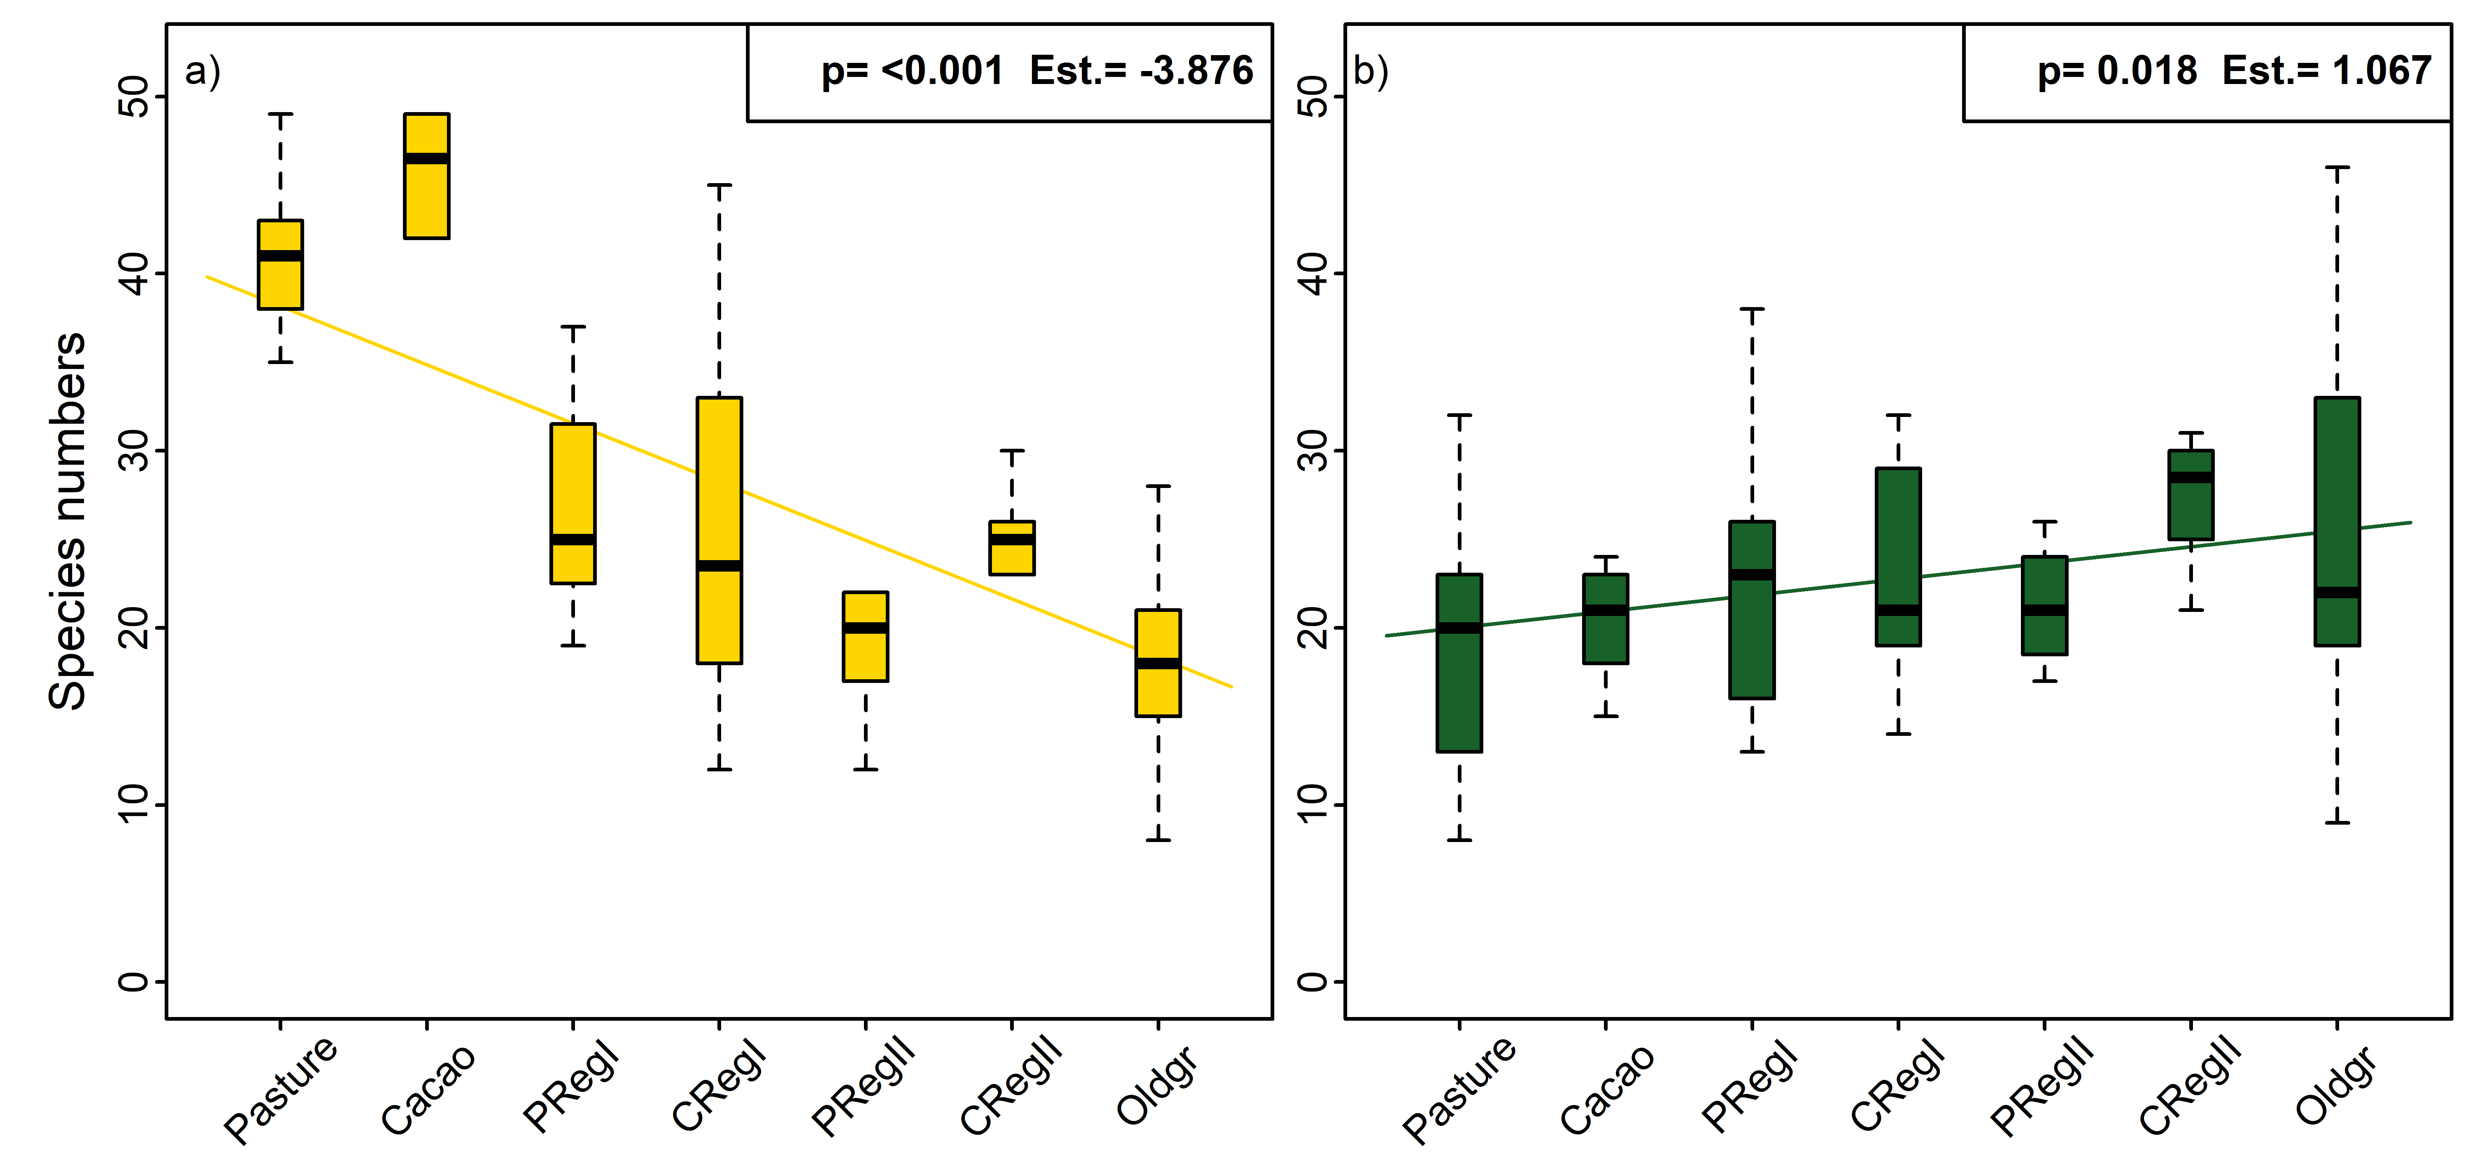
Figure S1.2. Boxplots for species numbers per habitat type and results of linear models with habitat types as ordered factors. a) Numbers of species found in agricultural sites and b) numbers of species found in old-growth sites. The agricultural subset includes species that could occur also in all other sites, but had to be present in at least one of the cacao and pasture sites. The same rule was applied for the old-growth subset. We modelled species numbers of both subsets along the regrowth gradient with linear models.

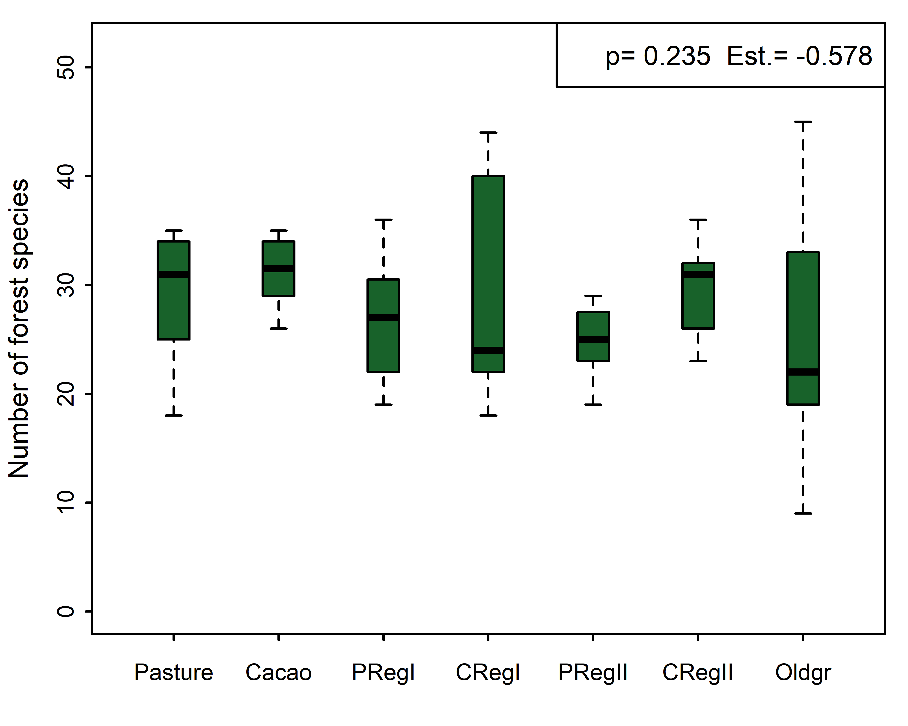
Figure S1.3. Boxplots for species numbers per habitat type and results of linear models with habitat types as ordered factors. Species numbers refer to a subset of species classified as forest species in the AVONET trait data base.
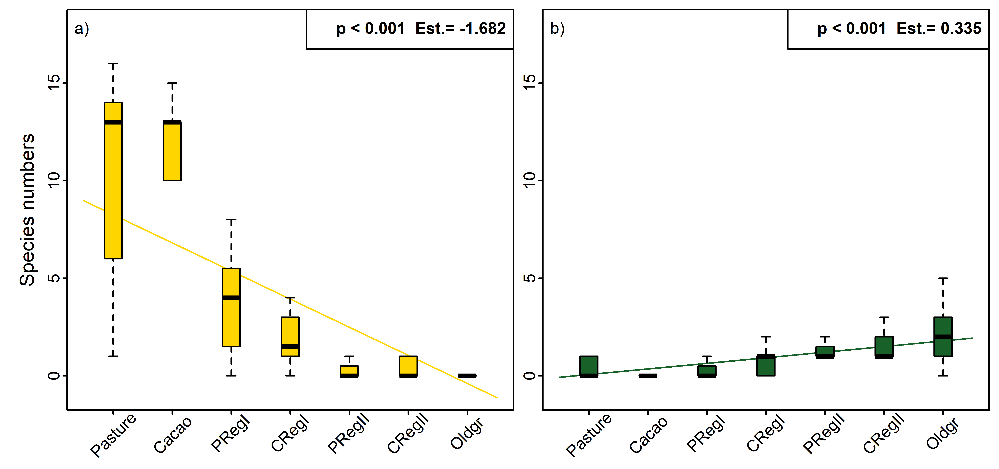
Figure S1.4. Boxplots for species numbers per habitat type and results of linear models with habitat types as ordered factors. a) Numbers of agriculture specialists and b) numbers of old-growth specialists. Specialists were calculated with Multinomial Species Classification Method (CLAM) with the clamtest function from the vegan package in R. We used a significance level of 0.005 and a specialisation threshold of 0.66. In total we classified five species as old-growth specialists and 18 as agriculture specialists. We modelled species numbers of both subsets along the regrowth gradient with linear models.

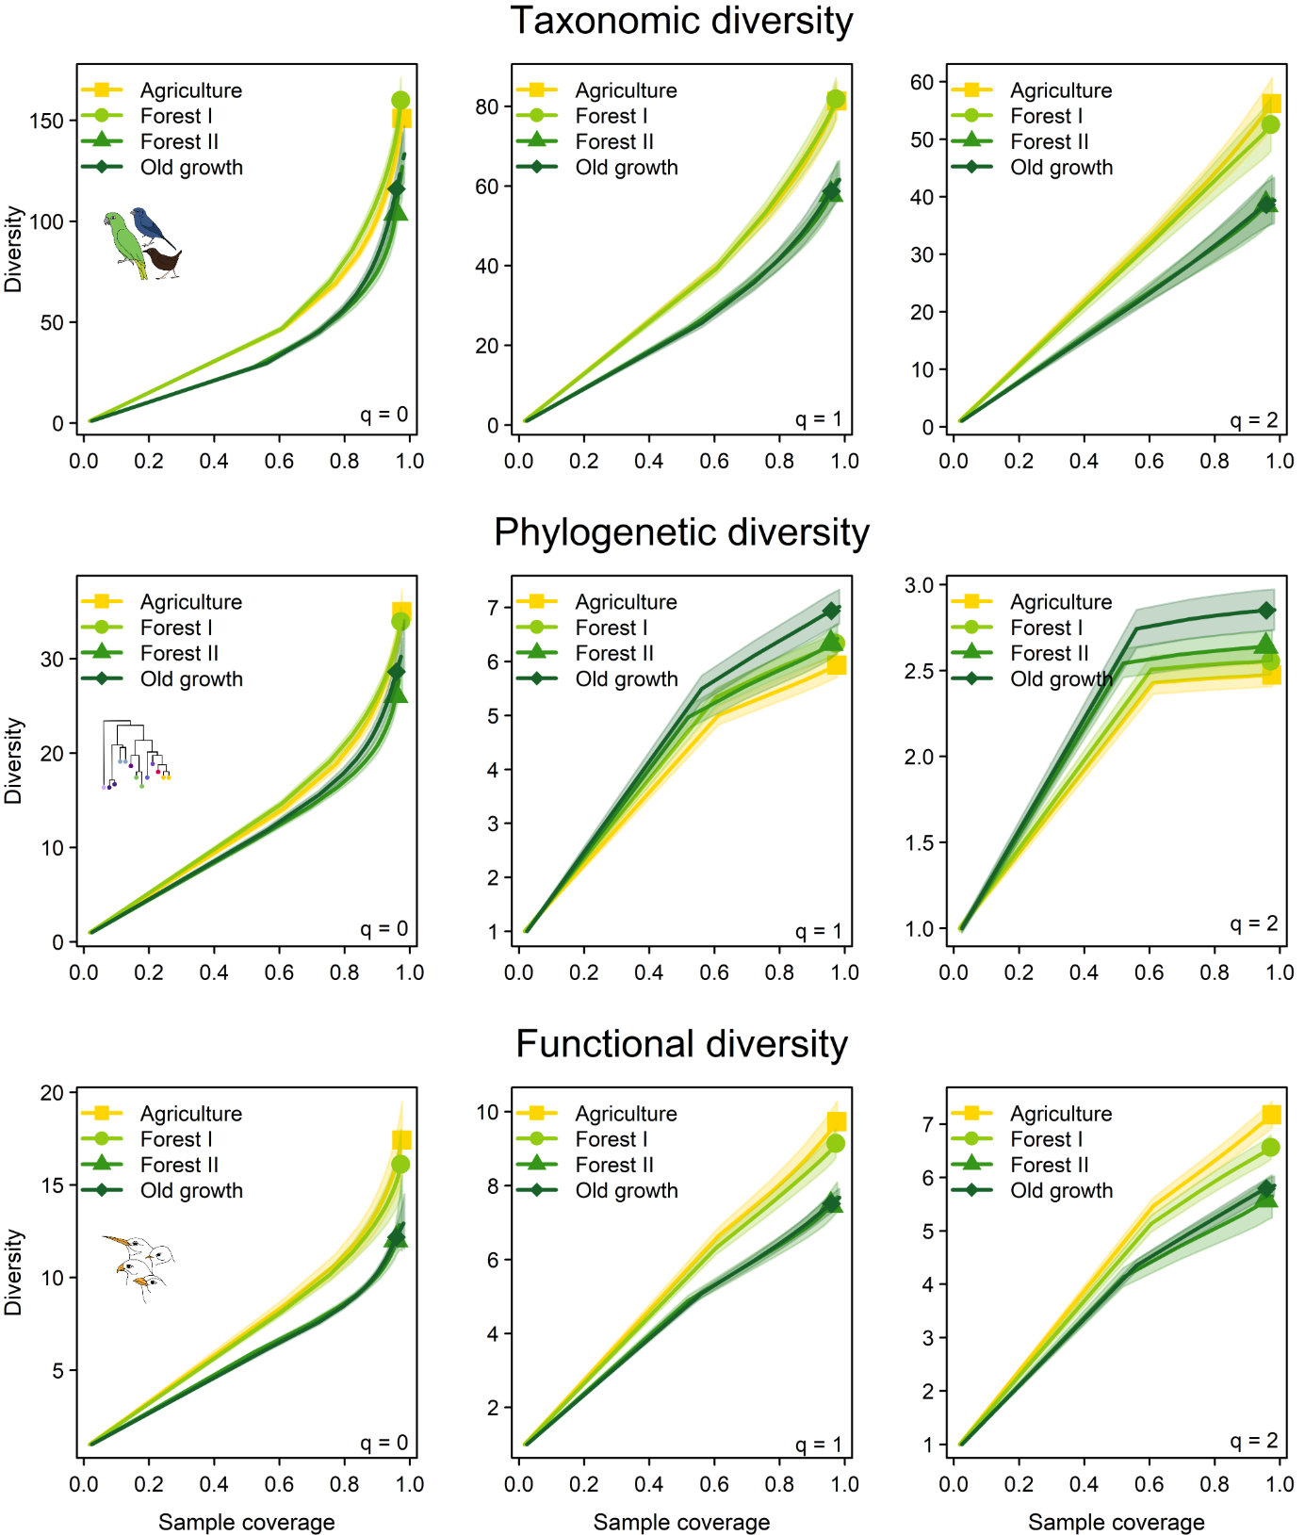
Figure S1.5. Species accumulation curves for taxonomic, phylogenetic and functional diversity with increasing sample coverage for all Hill numbers (q=0, q=1, q=2).

Figure S1.6. Boxplots of different diversity metrics per habitat type (pasture, cacao, secondary forest on former pasture 1-20 years old (PRegI), secondary forest on former cacao 1-20 years old (CRegI), secondary forest on former pasture 21-38 years old (PRegII), secondary forest on former cacao 21-38 years old (CRegII), and old-growth forest (Oldgr)). Lines indicate significant results (p < 0.05) of linear models with habitat types as ordered factors. Left side shows results for observed taxonomic, phylogenetic and functional diversity for the entire data set. Right side shows results for a subset excluding all species that can be heard over a couple of hundred meters to test for possible biases by species that are detected outside of the observed patch.

Table S1.1. Results of the linear models with the different habitat types (pasture, cacao, second-growth after pasture, second-growth after cacao, old-growth) as ordered factors as predictor and observed taxonomic, phylogenetic and functional diversity for q=0, q=1, and q=2 as response variable.
 | Obs. taxonomic q=0 |  |  |  | Obs. taxonomic q=1 |  |  |  |  |  | Obs. taxonomic q=2
Predictors | Estimates |  | Statistic | p | Estimates |  | Statistic |  | p |  | Estimates |  | Statistic |  | P
(Intercept) | 43.14 |  | 16.27 | <0.001 | 33.06 |  | 15.48 |  | <0.001 |  | 25.81 |  | 14.60 |  | <0.001
Regrowth gradient | -2.64 |  | -4.77 | <0.001 | -1.80 |  | -4.03 |  | <0.001 |  | -1.23 |  | -3.34 |  | 0.001
Observations | 66 |  |  |  | 66 |  |  |  |  |  | 66
R² / R² adjusted | 0.262 / 0.251 |  |  |  | 0.202 / 0.190 |  |  |  |  |  | 0.149 / 0.135
 |  | Obs. phylogenetic q=0 |  |  | Obs. phylogenetic q=1 |  |  |  |  | Obs. phylogenetic q=2
Predictors |  | Estimates | Statistic | p | Estimates | Statistic |  | p |  | Estimates |  | Statistic |  | p
(Intercept) |  | 13.35 | 19.10 | <0.001 | 9.07 | 17.71 |  | <0.001 |  | 6.91 |  | 17.18 |  | <0.001
Regrowth gradient |  | -0.44 | -3.01 | 0.004 | -0.22 | -2.04 |  | 0.046 |  | -0.16 |  | -1.86 |  | 0.068
Observations |  | 66 |  |  | 66 |  |  |  |  | 66
R² / R² adjusted |  | 0.124 / 0.110 |  |  | 0.061 / 0.046 |  |  |  |  | 0.051 / 0.036

 | Obs. functional q=0 |  |  | Obs. functional q=1 |  |  | Obs. functional q=2
Predictors | Estimates | Statistic | p | Estimates | Statistic | p | Estimates | Statistic | p
(Intercept) | 11.67 | 19.75 | <0.001 | 10.04 | 19.23 | <0.001 | 9.12 | 18.89 | <0.001
Regrowth gradient | -0.75 | -6.12 | <0.001 | -0.63 | -5.75 | <0.001 | -0.56 | -5.60 | <0.001
Observations | 66 |  |  | 66 |  |  | 66
R² / R² adjusted | 0.369 / 0.359 |  |  | 0.340 / 0.330 |  |  | 0.329 / 0.318

Table S1.2. Results of the linear models with the different habitat types (pasture, cacao, second-growth after pasture, second-growth after cacao, old-growth) as ordered factors as predictor and estimated taxonomic, phylogenetic and functional diversity for q0, q1, and q2 as response variable for a sample coverage of 90%.
 | Est. taxonomic q0 |  |  | Est. taxonomic q1 |  |  | Est. taxonomic q2
Predictors | Estimates | Statistic | p | Estimates | Statistic | p | Estimates | Statistic | p
(Intercept) | 53.87 | 8.55 | <0.001 | 37.39 | 10.14 | <0.001 | 25.41 | 10.65 | <0.001
Regrowth gradient | -1.55 | -1.18 | 0.241 | -0.88 | -1.15 | 0.254 | -0.33 | -0.66 | 0.510
Observations | 66 |  |  | 66 |  |  | 66
R² / R² adjusted | 0.021 / 0.006 |  |  | 0.020 / 0.005 |  |  | 0.007 / 0.000

 | Est. phylogenetic q0 |  |  | Est. phylogenetic q1 |  |  | Est. phylogenetic q2
Predictors | Estimates | Statistic | p | Estimates | Statistic | p | Estimates | Statistic | p
(Intercept) | 16.03 | 13.24 | <0.001 | 9.82 | 15.97 | <0.001 | 6.92 | 15.95 | <0.001
Regrowth gradient | -0.33 | -1.31 | 0.195 | -0.14 | -1.12 | 0.268 | -0.08 | -0.90 | 0.372
Observations | 66 |  |  | 66 |  |  | 66
R² / R² adjusted | 0.026 / 0.011 |  |  | 0.019 / 0.004 |  |  | 0.012 / 0.000

 | Est. functional q0 |  |  | Est. functional q1 |  |  | Est. functional q2
Predictors | Estimates | Statistic | p | Estimates | Statistic | p | Estimates | Statistic | p
(Intercept) | 13.07 | 18.08 | <0.001 | 10.58 | 18.72 | <0.001 | 9.28 | 18.68 | <0.001
Regrowth gradient | -0.79 | -5.22 | <0.001 | -0.60 | -5.13 | <0.001 | -0.53 | -5.14 | <0.001
Observations | 66 |  |  | 66 |  |  | 66
R² / R² adjusted | 0.299 / 0.288 |  |  | 0.291 / 0.280 |  |  | 0.292 / 0.281

Table S1.3. Results of the linear models with the different habitat types (pasture, cacao, second-growth after pasture, second-growth after cacao, old-growth) as ordered factors as predictor and estimated taxonomic, phylogenetic and functional diversity for q0, q1, and q2 as response variable for a sample coverage of 64%.
 | Est. taxonomic q0 |  |  | Est. taxonomic q1 |  |  | Est. taxonomic q2
Predictors | Estimates | Statistic | p | Estimates | Statistic | p | Estimates | Statistic | p
(Intercept) | 26.88 | 10.03 | <0.001 | 22.51 | 10.50 | <0.001 | 18.65 | 10.69 | <0.001
Regrowth gradient | -0.57 | -1.03 | 0.309 | -0.39 | -0.88 | 0.383 | -0.25 | -0.68 | 0.499
Observations | 66 |  |  | 66 |  |  | 66
R² / R² adjusted | 0.016 / 0.001 |  |  | 0.012 / -0.004 |  |  | 0.007 / -0.008

 | Est. phylogenetic q0 |  |  | Est. phylogenetic q1 |  |  | Est. phylogenetic q2
Predictors | Estimates | Statistic | p | Estimates | Statistic | p | Estimates | Statistic | p
(Intercept) | 10.32 | 14.55 | <0.001 | 7.78 | 15.78 | <0.001 | 6.14 | 15.99 | <0.001
Regrowth gradient | -0.21 | -1.40 | 0.165 | -0.12 | -1.17 | 0.247 | -0.07 | -0.91 | 0.368
Observations | 66 |  |  | 66 |  |  | 66
R² / R² adjusted | 0.030 / 0.015 | 0.021 / 0.006 | 0.013 / -0.003

 | Est. functional q0 |  |  | Est. functional q1 |  |  | Est. functional q2
Predictors | Estimates | Statistic | p | Estimates | Statistic | p | Estimates | Statistic | p
(Intercept) | 10.14 | 18.69 | <0.001 | 9.23 | 18.82 | <0.001 | 8.64 | 18.74 | <0.001
Regrowth gradient | -0.58 | -5.10 | <0.001 | -0.54 | -5.26 | <0.001 | -0.52 | -5.38 | <0.001
Observations | 66 |  |  | 66 |  |  | 66
R² / R² adjusted | 0.289 / 0.278 |  |  | 0.302 / 0.291 |  |  | 0.312 / 0.301

Table S1.4. Results of the linear models with the different habitat types (pasture, cacao, second-growth after pasture, second-growth after cacao, old-growth) as ordered factors as predictor and sample coverage as response variable.
 | Sample coverage
Predictors | Estimates | Statistic | p
(Intercept) | 0.80  (0.75 – 0.85) | 31.83 | <0.001
Regrowth gradient | -0.01  (-0.02 – -0.00) | -2.44 | 0.017
Observations | 66
R² / R² adjusted | 0.085 / 0.071

