Supplementary Information

High-Throughput Synthesis of CeO₂ Nanoparticles for Transparent Nanocomposites Repelling Pseudomonas aeruginosa Biofilms
Massih Sarif,^{1, †} Olga Jegel,^{1, †} Athanasios Gazanis,² Jens Hartmann,¹ Sergi Plana-Ruiz,^{1,3} Jan Hilgert,¹ Hajo Frerichs,¹ Melanie Viel,¹ Martin Panthöfer,¹ Ute Kolb,^{1,3} Muhammad Nawaz Tahir,^{4,5} Jörg Schemberg,⁶ Michael Kappl,⁷ Ralf Heermann^{2*} and Wolfgang Tremel¹*
¹ Department Chemie, Johannes Gutenberg-Universität Mainz, Duesbergweg 10-14, D-55128 Mainz, Germany
² Johannes-Gutenberg-Universität Mainz, Institut für Molekulare Physiologie, Mikrobiologie und Biotechnologie, Hanns-Dieter-Hüsch-Weg 17, D-55128 Mainz, Germany
³ Department of Materials and Geoscience, Technical University Darmstadt, Petersenstrasse 23, D-64287 Darmstadt, Germany
⁴ Chemistry Department, King Fahd University of Petroleum and Materials, Dhahran 31261, Kingdom of Saudi Arabia
⁵ Interdisciplinary Research Center for Hydrogen and Energy Storage (IRC-HES), King Fahd University of Petroleum and & Minerals, Dhahran 31261, Saudi Arabia
⁶ Institut für Bioprozess- und Analysenmesstechnik e.V., Rosenhof, D-37308 Heilbad Heiligenstadt, Germany
⁷ Max-Planck-Institute for Polymer Research, Ackermannweg 10, D-55128 Mainz, Germany
† these authors contributed equally to this work

Table S1. General information concerning the Rietveld refinement.
General information | Description
Diffractometer  Detector | Stoe Stadi P  Dectris Mythen 1k
Wavelength (Å) | 0.7093 (MoKα₁)
Temperature (K)  Program | 298  TOPAS Academic 6.0
Number of parameters  Space group (cerianite) | 17  Fm-3m
Wyckoff positions | Ce: 4a, O: 9c

Table S2. Information concerning the Rietveld refinement.
Sample | R_{wp} | Cell parameter (Å) | Crystallite size (nm)
MF RT | 4.36 | 5.418(1) | 5.86(7)
MF 185 °C | 4.21 | 5.423(1) | 5.83(5)
MF 500 °C | 4.44 | 5.4141(2) | 16.2(1)
MF 800 °C | 8.70 | 5.41678(2) | 71.5(4)
Batch RT | 4.58 | 5.412(1) | 3.15(2)
Batch 185 °C | 4.28 | 5.417(2) | 3.78(3)

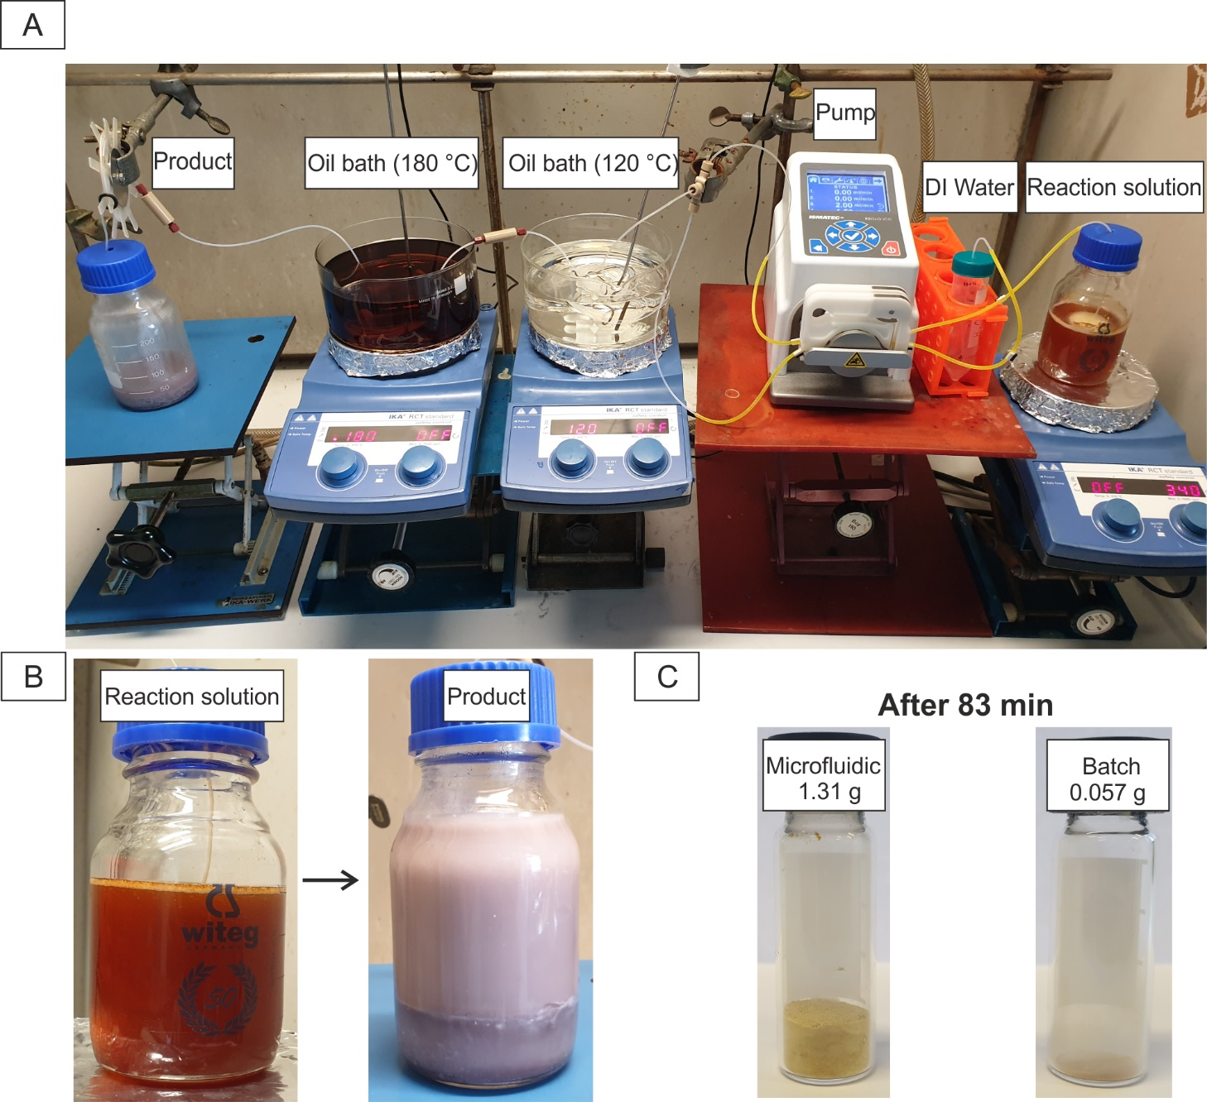
Figure S1. (A) Setup for the segmented flow, (B) comparison of the reaction solution and the product. (C) CeO₂ NPs after 83 minutes in the segmented flow and in the batch process.

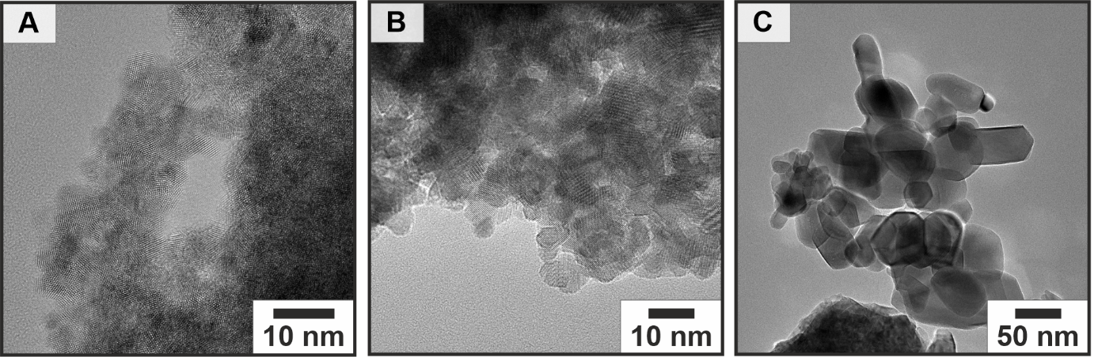
Figure S2. HRTEM images of CeO₂ NPs obtained under segmented flow conditions and annealed for 5 h at (A) 185 °C, (B) 500 °C and (C) 800 °C.

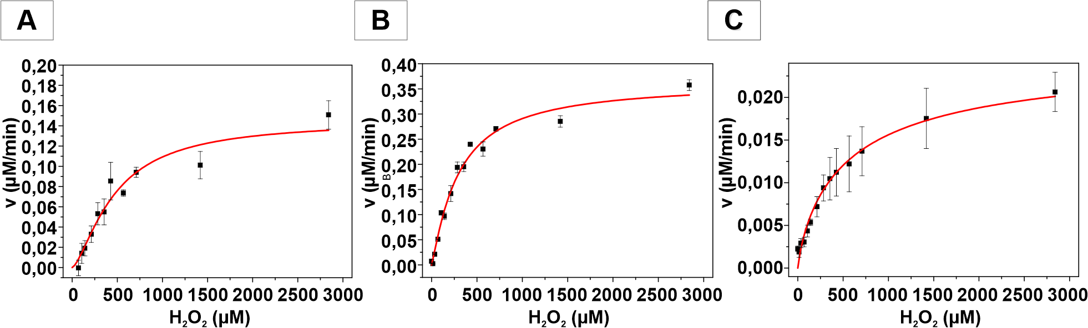
Figure S3. Michaelis-Menten kinetics for H₂O₂, with the corresponding Hill fit (red line) for the CeO₂ NPs obtained from the segmented flow (A) annealed at 185 °C, (B) 500 °C and (C) 800 °C.

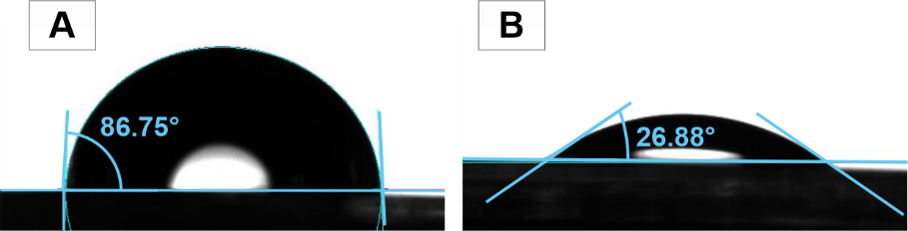

Figure S4. Contact angle measurements of polycarbonate with water (A) before and (B) after oxygen plasma treatment.

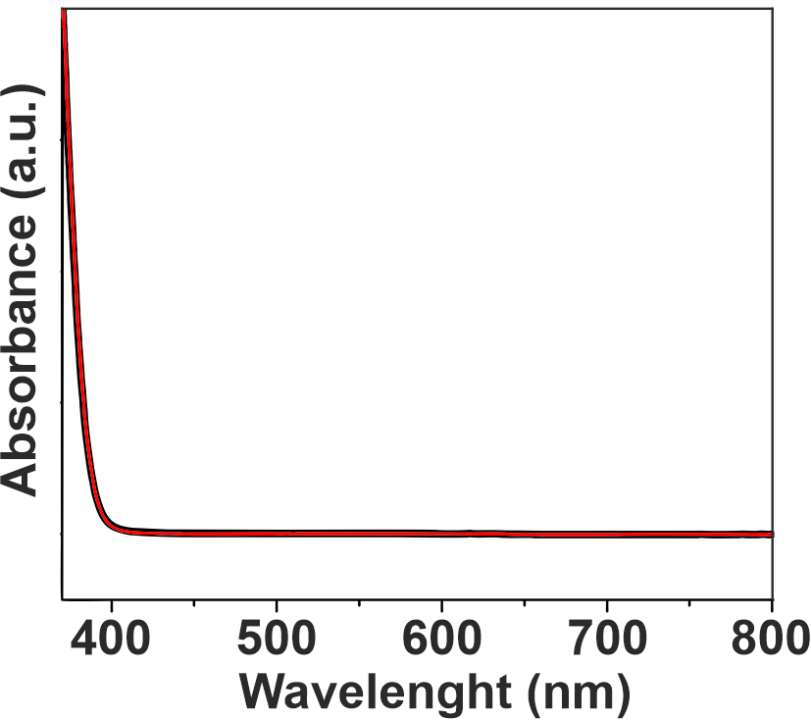
Figure S5. UV-VIS absorption spectra of polycarbonate before (black) and after coating (red) with CeO₂ NPs.

