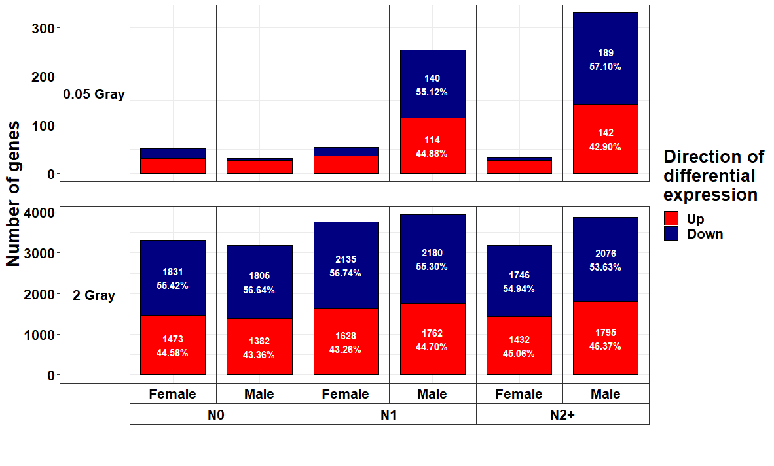
Additional File 11a: Bar charts showing the number and proportion of up- and downregulated genes stratified by dose, donor group, and sex. Differentially expressed genes were computed comparing irradiated to sham-irradiated fibroblasts after exposure to 0.05 and 2 Gray (false discovery rate adjusted p < 0.05), considering age at sampling. N0 = fibroblasts of cancer-free controls, N1 = fibroblasts of childhood-cancer survivors, N2+ = fibroblasts of childhood-cancer survivors with at least one second primary neoplasm; * p-value < 0.05, ** p-value < 0.01, *** p-value < 0.001.
Additional File 11b. Upper Half: Volcano plots showing differential expression after 0.05 Gray stratified by donor group and sex, considering age at sampling. Lower Half: Heat map showing top five ranking genes with regard to p-value per group considering age at sampling. N0 = fibroblasts of cancer-free controls, N1 = fibroblasts of childhood-cancer survivors, N2+ = fibroblasts of childhood-cancer survivors with at least one second primary neoplasm; * p-value < 0.05, ** p-value < 0.01, *** p-value < 0.001. N.S. = not significant (p-value > 0.05).
Additional File 11c. Upper Half: Volcano plots showing differential expression after 2 Gray stratified by donor group and sex, considering age at sampling. Lower Half: Heat map showing top five ranking genes with regard to p-value per group considering age at sampling. N0 = fibroblasts of cancer-free controls, N1 = fibroblasts of childhood-cancer survivors, N2+ = fibroblasts of childhood-cancer survivors with at least one second primary neoplasm; * p-value < 0.05, ** p-value < 0.01, *** p-value < 0.001. N.S. = not significant (p-value > 0.05).

Additional File 11d: Overview of affected (false discovery rate adjusted p-value < 0.05) and (in-) activated pathways (|z| ≥ 2), predicted upstream effectors, downstream biofunctions and diseases, and observed molecule networks after irradiation with a low (0.05 Gray) or a high dose (2 Gray) ordered by p-value, stratified by sex and considering age at sampling. For molecule networks, the network score instead of a p-value and no z-score was calculated by Ingenuity Pathway Analysis. N0 = fibroblasts of cancer-free controls, N1 = fibroblasts of childhood-cancer survivors, N2+ = fibroblasts of childhood-cancer survivors with at least one second primary neoplasm; *p-value < 0.05, ** p-value < 0.01, ***p-value < 0.001.

Additional File 11e: Heat map showing all pathways from Ingenuity Pathway Analysis that were significantly enriched in one of the three donor groups (false discovery rate adjusted p-value < 0.05) using results from the differential gene expression data stratified by sex and considering age at sampling after exposure to 2 Gray. N0 = fibroblasts of cancer-free controls, N1 = fibroblasts of childhood-cancer survivors, N2+ = fibroblasts of childhood-cancer survivors with at least one second primary neoplasm; *p-value < 0.05, ** p-value < 0.01, ***p-value < 0.001.

