Additional File 3a: Constructed and purchased primer sequences for the qRT-PCR.
RNA PCNA F | GCTCTTCCCTTACGCAAGTCT
RNA PCNA R | TAGCTGGTTTCGGCTTCAGG

RNA FANCD2F | TGCATGTATGTTTGAAGTATGGGC
RNA FANCD2R | GGAATGGAAATGGGCATAGAAG

RNA IL1B F | TTCGAGGCACAAGGCACAA
RNA IL1B R | TGGCTGCTTCAGACACTTGAG

CCNE2 F (4) | CACCCGGGTTACCAATGACA
CCNE2 R (4) | GGATGCACTTTTTGCCCTTCTTA

Hs_IL6_1_SG QuantiTect Primer Assay CATALOG No. - QT00083720
Hs_DDB2_1_SG QuantiTect Primer Assay CATALOG No. - QT00062986
Hs_MSH6_1_SG QuantiTect Primer Assay CATALOG No. - QT00054663
Hs_EGR1_1_SG QuantiTect Primer Assay CATALOG No. - QT00218505

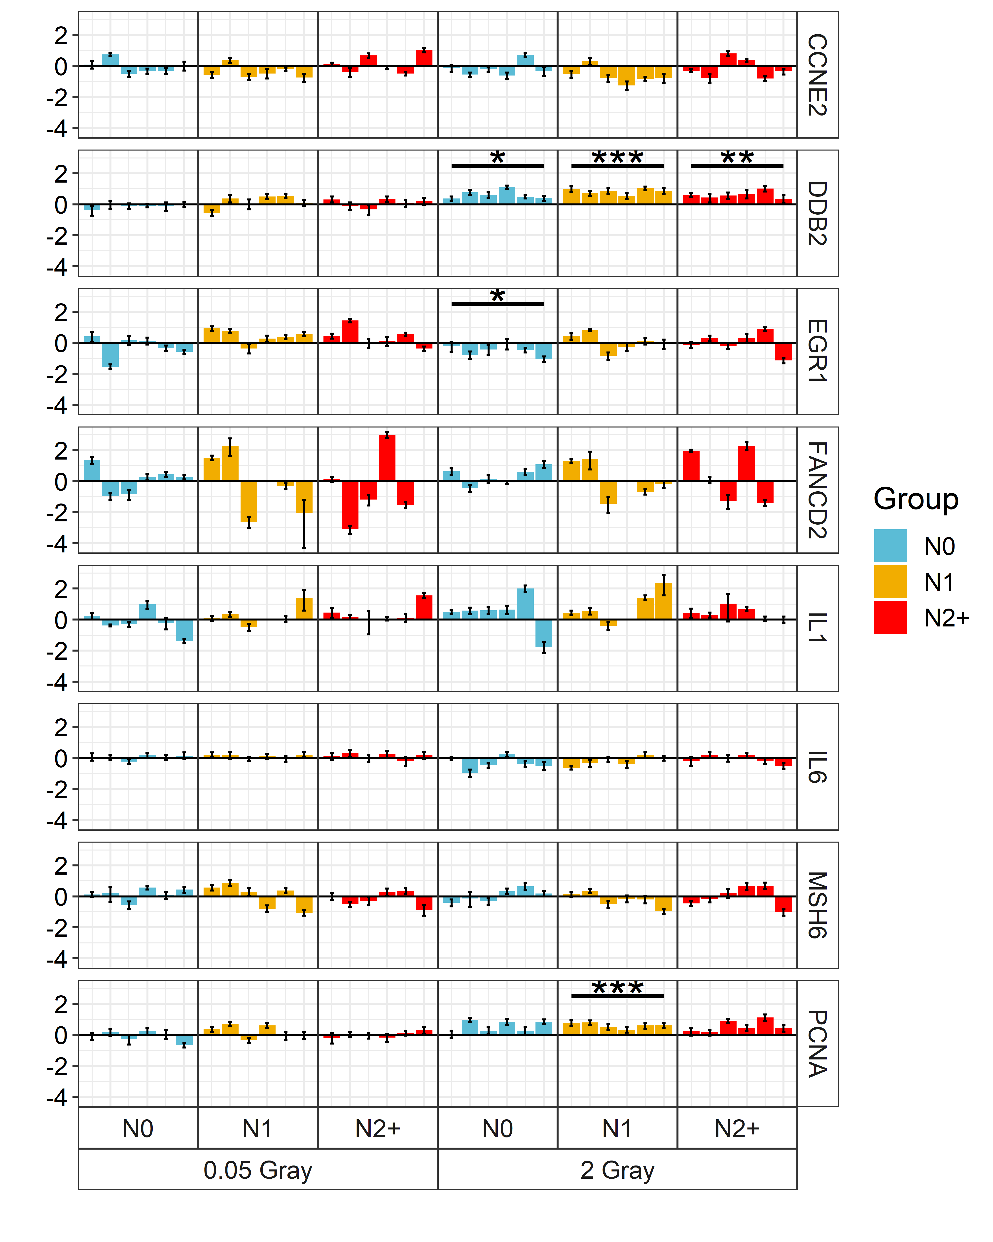
Additional File 3b: Log₁₀ relative expression measured in quantitative reverse transcriptase polymerase chain reaction (qRT-PCR) for selected genes compared to TATA-Box Binding Protein (TBP), stratified by group (each n= 6, three replicates per individuals) and radiation dose. Asterisks imply the p-value thresholds of two-sided t-tests after adjustment for false discovery rate (* p-value < 0.05, ** p-value < 0.01, *** p-value < 0.001). N0 = fibroblasts of cancer-free controls, N1 = fibroblasts of childhood-cancer survivors, N2+ = fibroblasts of childhood-cancer survivors with at least one second primary neoplasm.
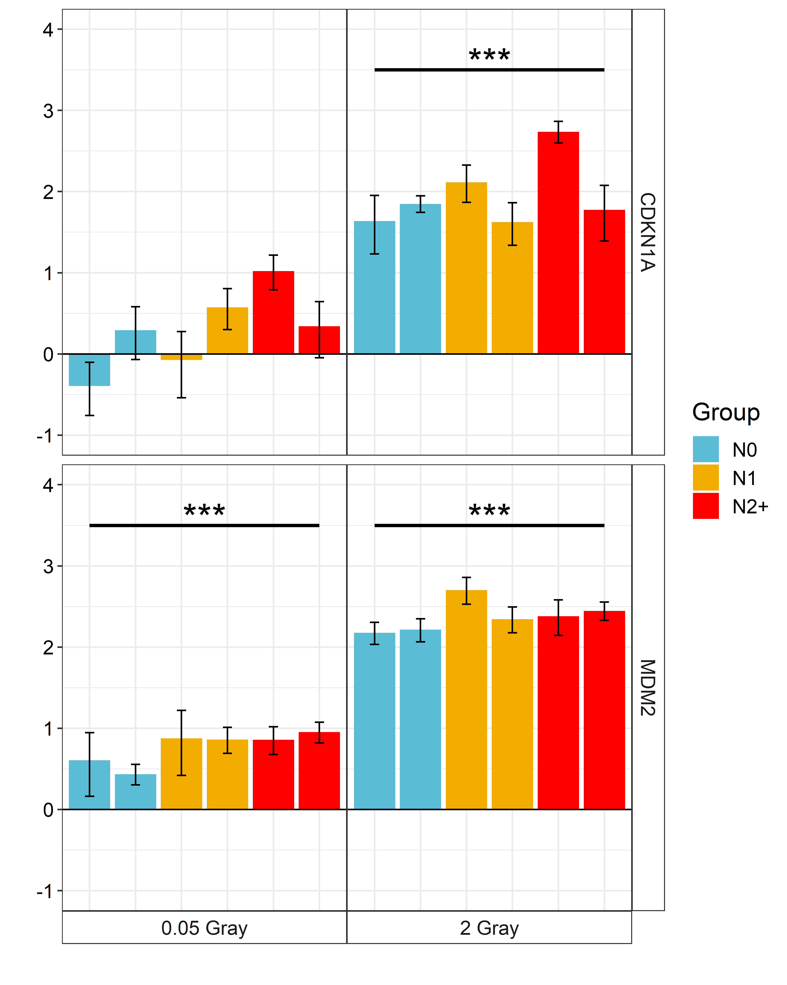
Additional File 3c: Log₁₀-relative expression measured in quantitative reverse transcriptase polymerase chain reaction (qRT-PCR) for mouse double minute 2 (MDM2) and Cyclin Dependent Kinase Inhibitor 1A (CDKN1A) compared to TATA-Box Binding Protein (TBP). Data adapted from Brackmann et al. 2020, coloured by group (each n = 2, three replicates per individuals) and stratified by radiation dose. Asterisks imply the p-value thresholds of two-sided t-tests (* p-value < 0.05, ** p-value < 0.01, *** p-value < 0.001). N0 = fibroblasts of cancer-free controls, N1 = fibroblasts of childhood-cancer survivors, N2+ = fibroblasts of childhood-cancer survivors with at least one second primary neoplasm.

