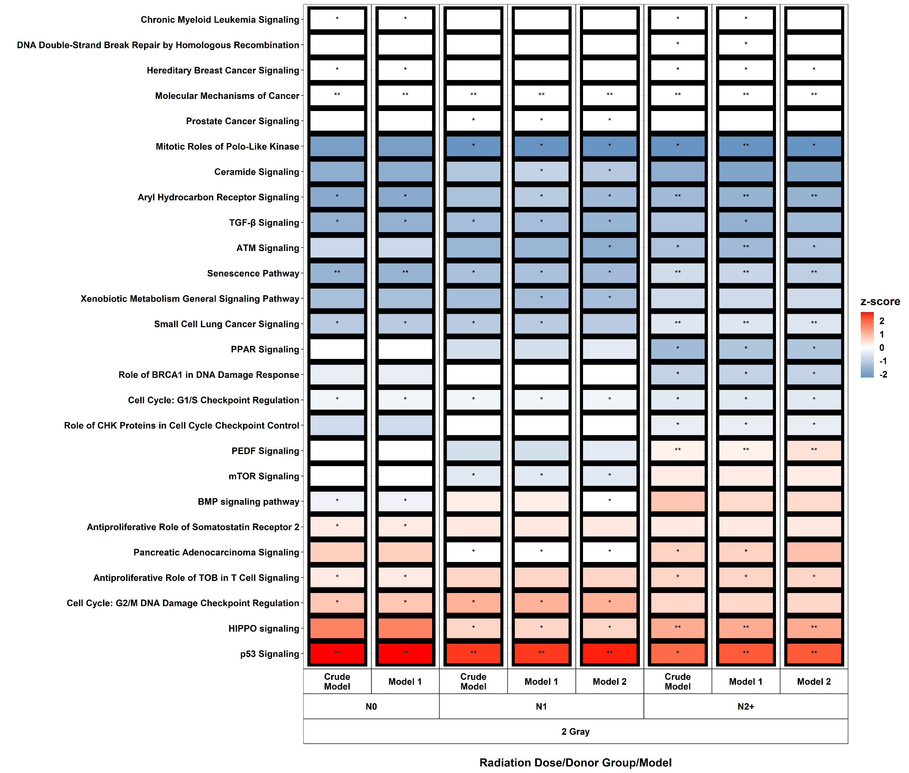
AdditionalFile 6: Heat map showing all pathways that were significantly enriched in one of the three donor groups (false discovery rate adjusted p-value < 0.05) in the differential gene expression data after exposure to 2 Gray. Model 1 considers age at sampling and sex, model 2 additionally considers age at and year of diagnosis of the first neoplasm, and tumor type. N0 = fibroblasts of cancer-free controls, N1 = fibroblasts of childhood-cancer survivors, N2+ = fibroblasts of childhood-cancer survivors with at least one second primary neoplasm, * p-value < 0.05, ** p-value < 0.01, *** p-value < 0.001.

