**SUPPLEMENTARY MATERIAL**

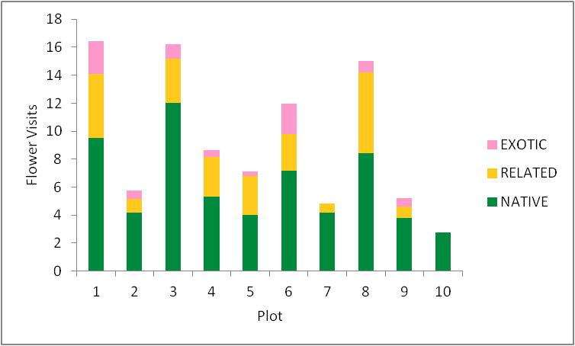

**FIGURE S1** Comparison of the average number of flower visitors observed on the studied plant species per study plot, summarized for the target plant groups NATIVE (green), RELATED (yellow) and EXOTIC (pink). Plot 1: Botanical Garden; Plot 2: Lichtwiese; Plot 3 and 4: Old Cemetery; Plot 5: Georg Büchner School; Plot 6: Riedstraße; Plot 7: Birkenweg; Plot 8: Elisabethenstraße; Plot 9 and 10: Industrial area Im Tiefen See.

**FIGURE S2** Comparison of the mean feeding damage (%) observed for the studied plant species per study plot, summarized for the target plant groups NATIVE (green), CONVERTED (yellow) and EXOTIC (pink). Plot 1: Botanical Garden; Plot 2: Lichtwiese; Plot 3 and 4: Old Cemetery; Plot 5: Georg Büchner School; Plot 6: Riedstraße; Plot 7: Birkenweg; Plot 8: Elisabethenstraße; Plot 9 and 10: Industrial area Im Tiefen See.

**TABLE S1** Overview of plant species that have not flowered in the named plots

|  |  |
| --- | --- |
|  |  |
| **Plant species** | **Plot no.** |
| *Thermopsis chinensis* | 1 -10 |
| *Campanula portenschlagiana* 'Birch' | 7 |
| *Centaurea dealbata* | 7 |
| *Salvia pratensis* | 10 |
| *Lotus corniculatus* | 6 |
| *Lotus corniculatus* | 8 |
| *Lotus corniculatus* | 9 |
| *Lotus corniculatus* | 10 |
| *Asclepias tuberosa* | 7 |
| *Kniphofia uvaria* 'Grandiflora' | 7 |
| *Agastache  x cultorum* 'Blue Boa®' | 7 |
| *Helenium x cultorum* 'Rubinzwerg' | 7 |
| *Helenium x cultorum* 'Rubinzwerg' | 8 |
| *Helenium x cultorum* 'Rubinzwerg' | 9 |
| *Ceratostigma plumbaginoides* | 2 |
| *Ceratostigma plumbaginoides* | 10 |
|  |  |