Design and synthesis of peptides as stabilizers of histone deacetylase 4
Annika Lill^{[a]}, Markus Schweipert^{[b]}, Thomas Nehls^{[c]}, Eva Wurster^{[b]}, Frederik Lermyte^{[c]}, Franz-Josef Meyer-Almes*^{[b]}, Katja Schmitz*^{[a]}

[a] Annika Lill, Prof. Dr. Katja Schmitz)
Biological Chemistry
Clemens-Schöpf-Institute for Organic Chemistry and Biochemistry, Technical University of Darmstadt
Peter-Grünberg-Straße 8, 64287 Darmstadt, Germany
E-mail: katja.schmitz@tu-darmstadt.de
[b] Markus Schweipert, Eva Wurster, Prof. Dr. Franz-Josef Meyer-Almes
Physical Biochemistry
Chemical engineering and biotechnology. University of Applied Sciences Darmstadt
Stefanstraße 7, 64295 Darmstadt, Germany
E-mail: franz-josef.meyer-almes@h-da.de
[c] Thomas Nehls, Prof. Dr. Frederik Lermyte,
Conformation-Sensitive Mass Spectrometry Laboratory
Clemens-Schöpf-Institute for Organic Chemistry and Biochemistry, Technical University of Darmstadt
Peter-Grünberg-Straße 4, 64287 Darmstadt, Germany

Table of Contents
S1 Supporting tables and figures 3
S2 Fluorescent probe displacement to test for competitive binding 9
S3 Rigid docking 10
S4 Mutagenesis, recombinant production and purification of cHDAC4 wildtype and variants 11
S5 Photocrosslink between cBpa-SM1-E and cHDAC4 WT 12
S6 Ion-mobility mass spectrometry (IM-MS) 17
S7 Peptide synthesis, purification and analysis 18
S7.1 Synthesis of linear peptides 18
S7.2 Peptide purification and characterization 18
S7.3 Linear Peptides 19
S7.3.1 SM1 19
S7.3.2 TAMRA-SM1 21
S7.3.3 SP1 22
S7.3.4 W-SM1 23
S7.3.5 WW-SM1 24
S7.3.6 WWW-SM1 25
S7.3.7 SM1-W 26
S7.3.8 F-SM1 27
S7.3.10 FFF-SM1 29
S7.3.13 AA-SM1 32
S7.3.14 AAA-SM1 33
S7.3.15 SM1-A 34
S7.4 Cyclic Peptides 35
S7.4.1 cSM1-E 35
S7.4.2 cSM1-D 36
S7.4.3 cSM1-Q 37
S7.4.4 cSM1-N 38
S7.4.5 cW-SM1-D 39
S7.4.6 cW-SM1-Q 40
S7.4.7 cW-SM1-N 41
S7.4.8 cA-SM1-E 42
S7.4.9 cV-SM1-E 43
S7.4.10 cPhg-SM1-E 44
S7.4.11 cF-SM1-E 45
S7.4.12 cW-SM1-E 46
S7.4.13 cNal-SM1-E 47
S7.4.14 cBip-SM1-E 48
S7.4.15 cBpa-SM1-E 49
References 50

S1 Supporting tables and figures
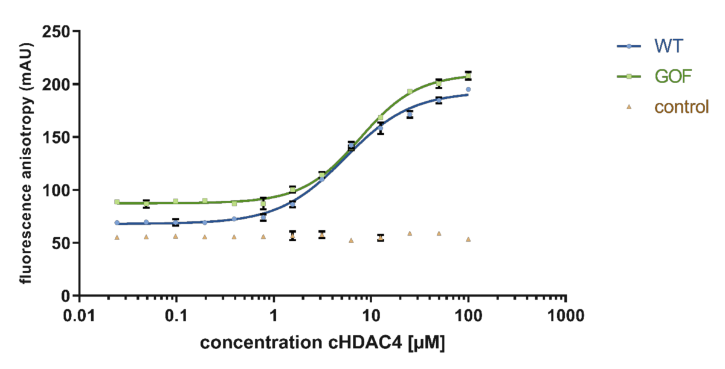
Figure S1 Fluorescence anisotropy measurements of TAMRA-SM1 with cHDAC4 (catalytic domain of HDAC4) WT and GOF. As a control, free TAMRA was used. Data was fitted in GraphPad Prism with the Agonist vs. Response variable Hillslope equation (lines). Error bars represent the standard deviation of technical triplicates.
Table S1. Inhibition and stabilisation data of SM1 peptides with additional N-terminal amino acids towards cHDAC4 WT and GOF. Mean and standard deviation of the thermal stabilization data come from technical quadruplicates
 | K_{i}/µM |  | ΔT_{M}/°C
 | WT | GOF | WT | GOF
WW-SM1 | 7.7 ± 1.8 | 1.6 ± 0.2 | 4.32 ± 0.08 | 1.05 ± 0.07
WWW-SM1 | 19.8 ± 6.1 | 1.8 ± 0.3 | 3.92 ± 0.20 | 0.98 ± 0.13
FF-SM1 | 8.8 ± 1.4 | 2.5 ± 0.3 | 4.00 ± 0.12 | 1.16 ± 0.20
FFF-SM1 | 8.3 ± 1.4 | 2.3 ± 0.3 | 3.38 ± 0.08 | 1.05 ± 0.13
AA-SM1 | 10.9 ± 1.8 | 3.8 ± 0.9 | 3.52 ± 0.09 | 0.98 ± 0.07
AAA-SM1 | 9.3 ± 0.9 | 2.6 ± 0.5 | 3.96 ± 0.09 | 1.22 ± 0.16

Table S2 Melting points of cHDAC4 WT and alanine variants. Mean and standard deviation of the melting points come from technical quadruplicates. The mutants F871A and L943A were not stable and could therefore not be investigated.
cHDAC4 variant | T_{M} /°C
WT | 54.22 ± 0.18
D757A | 53.29 ± 0.06
S758A | 54.26 ± 0.06
D759A | 53.78 ± 0.08
P809A | 50.03 ± 0.08
F812A | 62.36 ± 0.09
P872A | 37.76 ± 0.12

Table S3 Collision-Cross-Section (CCS) top values (in Å²) and difference to the apo form in % for the different cHDAC4 WT or GOF + peptide complexes. CCS top was determined from drift time of peak maxima.
 |  | z=10 |  | z=11 |  | z=12 |  | z=13
 |  | WT | GOF | WT | GOF | WT | GOF | WT | GOF
APO | CCS Top (Å²) | 4069,6 | 4069,6 | 3819,9 | 3819,9 | 3611,3 | 3640,8 | 3493,2 | 3493,2
SM1 | CCS Top (Å²) | 4116,7 | 4140,3 | 3872,7 | 3925,9 | 3670,1 | 3729,2 |  | 3557,8
 | diff to apo in % | 1,2 | 1,7 | 1,4 | 2,8 | 1,6 | 2,4 |  | 1,9
W-SM1 | CCS Top (Å²) | 4163,8 | 4163,8 | 3952,3 | 3925,8 | 3729,2 | 3729,2 | 3557,8 | 3557,8
 | diff to apo in % | 2,3 | 2,3 | 3,5 | 2,8 | 3,3 | 2,4 | 1,8 | 1,8
cSM1-D | CCS Top (Å²) | 4163,8 | 4163,8 | 3925,9 | 3925,9 | 3699,8 | 3729,2 | 3525,4 | 3557,8
 | diff to apo in % | 2,3 | 2,3 | 2,8 | 2,8 | 2,4 | 3,3 | 0,9 | 1,8
cA-SM1-E | CCS Top (Å²) | 4163,8 | 4163,8 | 3899,4 | 3925,8 | 3699,7 | 3729,2 | 3557,8 | 3557,8
 | diff to apo in % | 2,3 | 2,3 | 2,1 | 2,8 | 2,4 | 3,3 | 1,8 | 1,8
cV-SM1-E | CCS Top (Å²) | 4163,8 | 4163,8 | 3952,3 | 3925,8 | 3729,2 | 3729,1 | 3557,8 | 3557,8
 | diff to apo in % | 2,3 | 2,3 | 3,5 | 2,8 | 3,3 | 2,4 | 1,8 | 1,8
cF-SM1-E | CCS Top (Å²) | 4163,7 | 4187,3 | 3925,8 | 3952,3 | 3729,1 | 3729,1 | 3557,8 | 3557,7
 | diff to apo in % | 2,3 | 2,9 | 2,8 | 3,5 | 3,3 | 2,4 | 1,8 | 1,8
cW-SM1-E | CCS Top (Å²) | 4140,2 | 4187,3 | 3899,3 | 3952,2 | 3670,0 | 3729,1 | 3492,8 | 3557,7
 | diff to apo in % | 1,7 | 2,9 | 2,1 | 3,5 | 1,6 | 2,4 | 0,0 | 1,8
cNal-SM1-E | CCS Top (Å²) | 4163,7 | 4187,3 | 3925,8 | 3952,2 | 3729,1 | 3729,1 | 3557,7 | 3557,7
 | diff to apo in % | 2,3 | 2,9 | 2,8 | 3,5 | 3,3 | 2,4 | 1,8 | 1,8
cBpa-SM1-E | CCS Top (Å²) | 4211,0 | 4211,0 | 3978,6 | 3952,2 | 3729,1 | 3758,5 | 3590,1 | 3590,1
 | diff to apo in % | 3,5 | 3,5 | 4,2 | 3,5 | 3,3 | 3,2 | 2,8 | 2,8

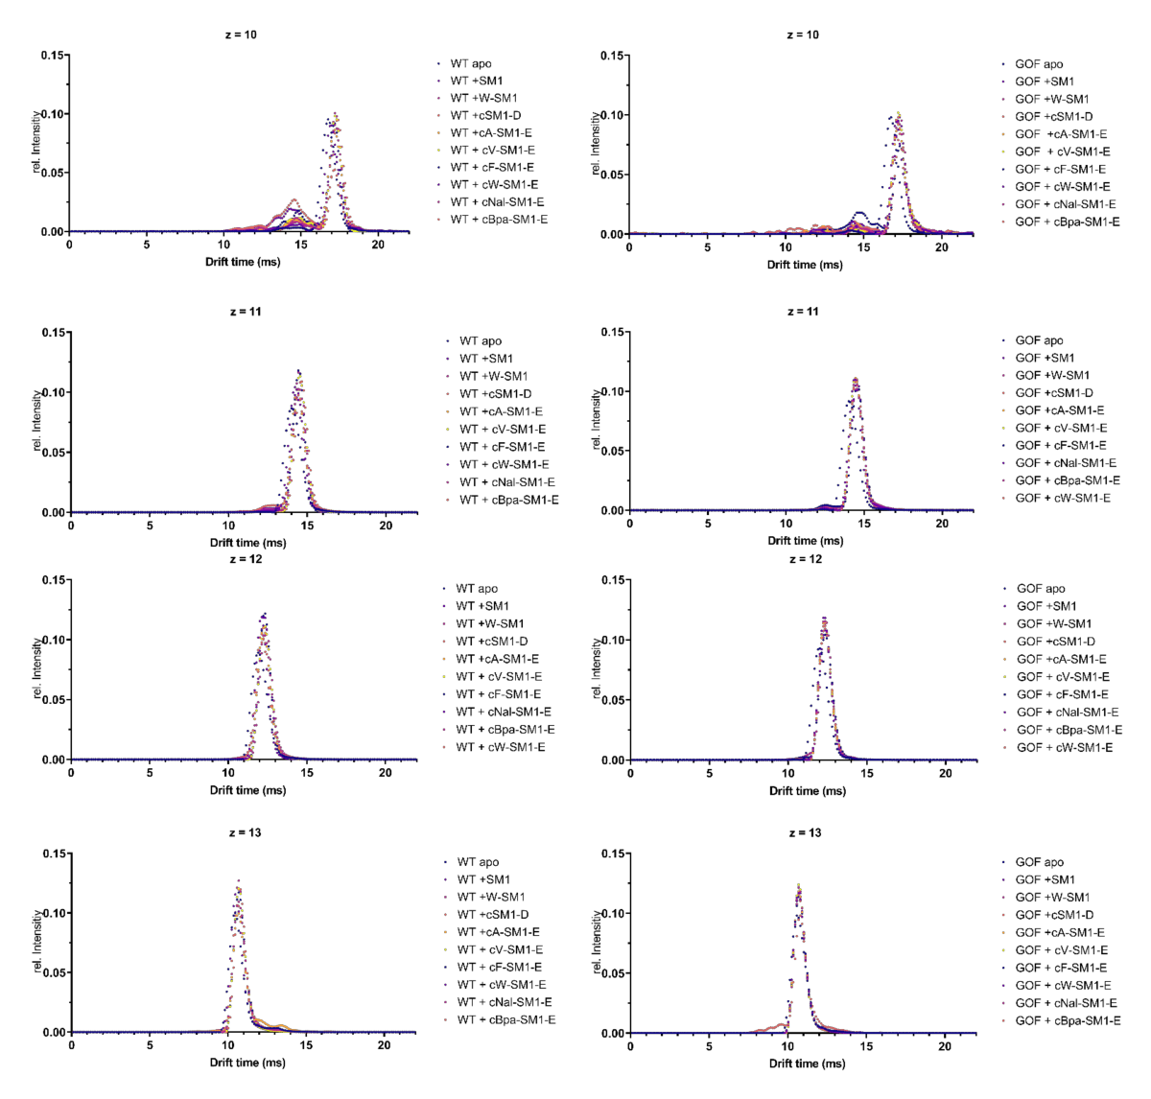
Figure S2. Ion mobility chromatograms for the complexes of cHDAC4 WT (left column) and cHDAC4 GOF (right column) with different peptides. The additional peak at shorter drift times that is best visible at z=10 arises from dimers of the proteins and does not represent another conformation of the protein (Figure S4).
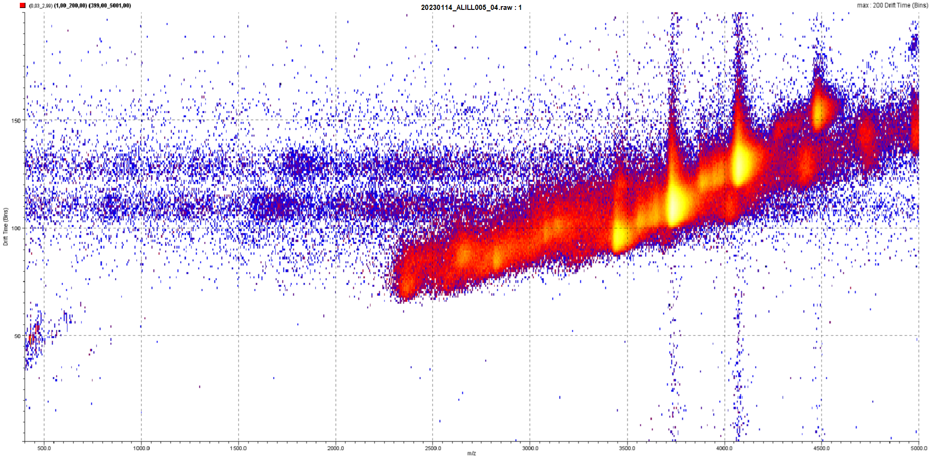
Figure S3 2D mobilogram (heat map) for cHDAC4 WT with drift time (bins) as ordinate and mass-to-charge ratio as abscissa. The intensity is shown as heat indicator, ranging from blue for low intensity over red to yellow and white for the highest intensities. Mobilograms were recorded on a Synapt G2-S with nanoESI, a wave velocity of 800 m/s, a wave height of 40 V, and nitrogen as drift gas.

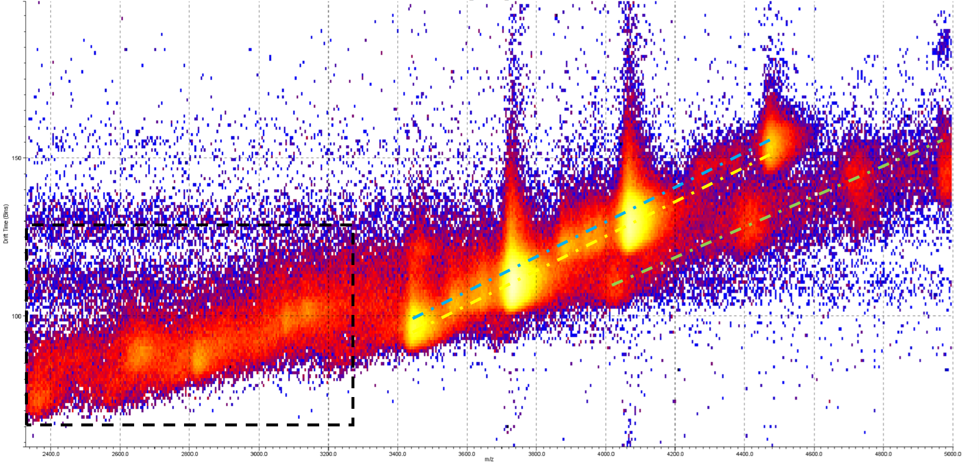
Figure S4 Magnification of the relevant area of Figure S3. The dash-dotted line in cyan highlights the signals corresponding to monomers, the yellow dotted line shows the signals of dimers, and the green dotted line indicates contaminants. The black dotted frame shows other chemical noise, recognizable by the absence of the typical repetition of different charge states from proteins.
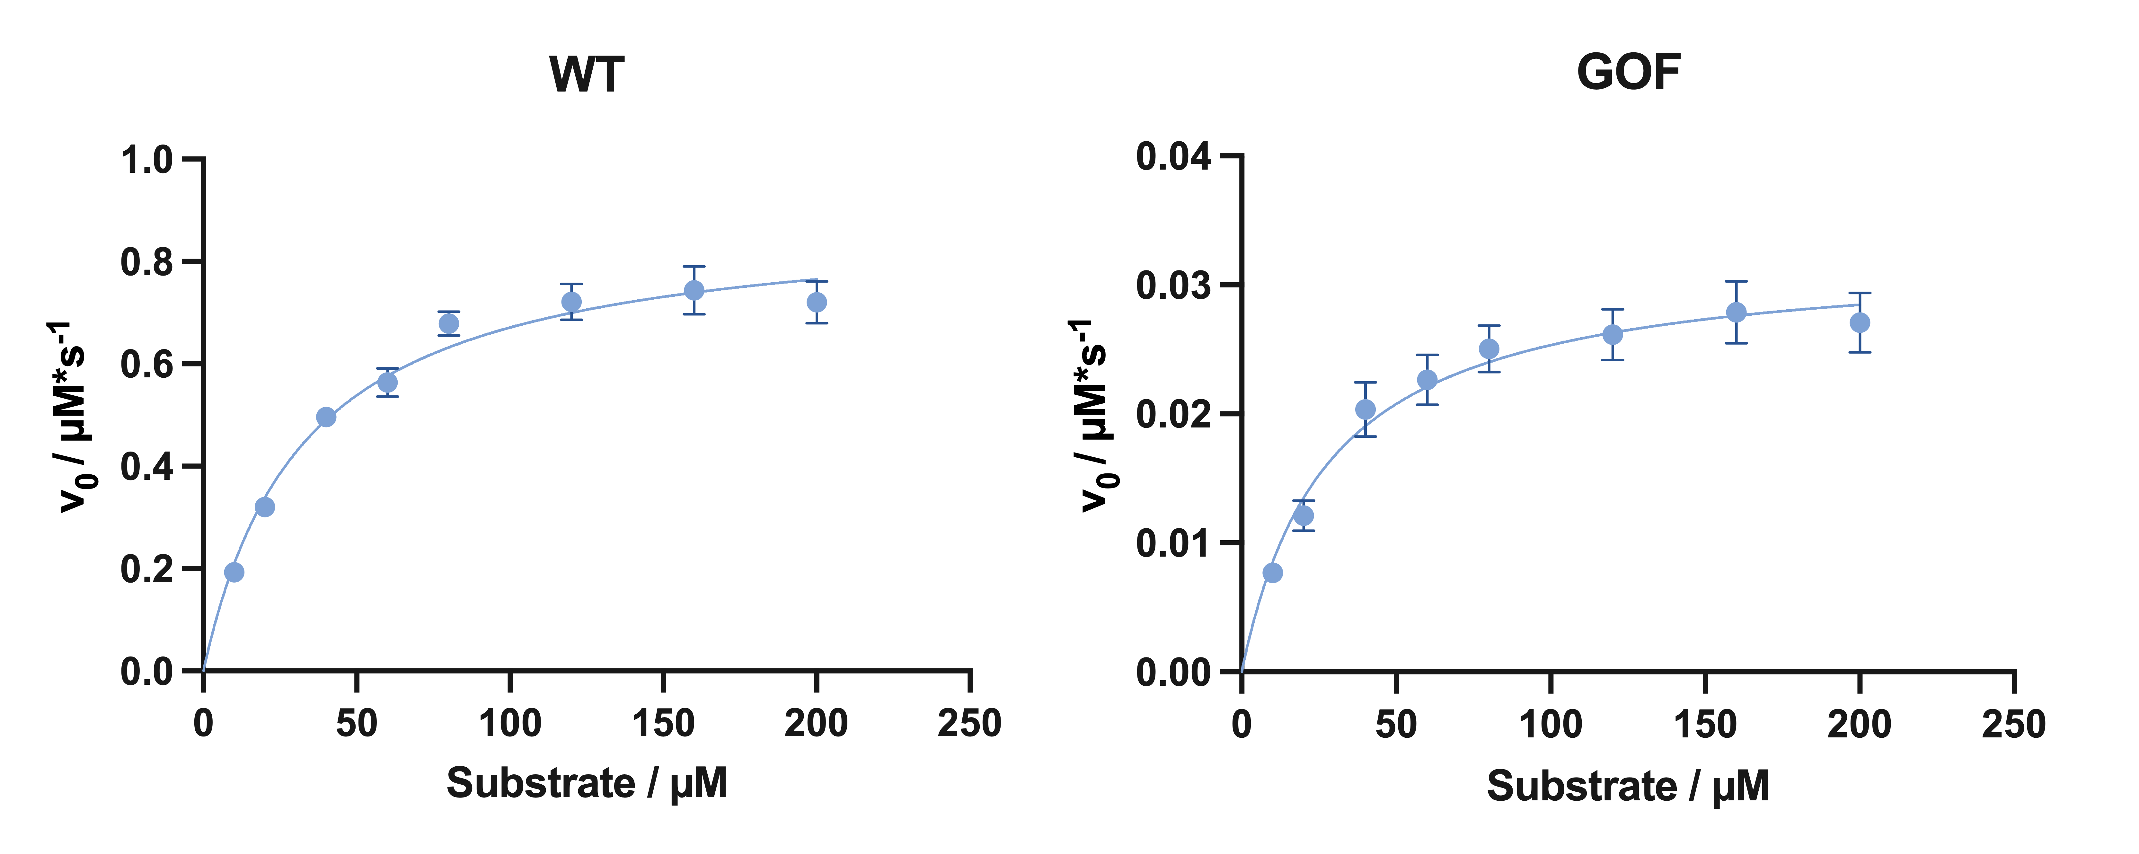
Figure S5 Michaelis-Menten plots for cHDAC4 WT and GOF variant. The Michaelis constant is required to transform IC₅₀ values in K_{i} values. For the WT and GOF K_{m} values of (32 ± 4) µM and (29 ± 3) µM, respectively, where determined. The method is described in Schweipert et al. 2021.¹

S2 Fluorescent probe displacement to test for competitive binding
For the displacement assays 1 µM of the respective protein was incubated with 200 nM of a fluorescent tracer² for 1 h at 30 °C and 450 rpm in reaction tubes (Sarstedt, Nümbrecht, Germany). A sample containing 200 nM of the fluorescent tracer without any protein was prepared in the same manner. After incubation, the samples were transferred into a black 96-well half-area microtiter plate (Greiner, Kremsmünster, Austria). Fluorescence polarization was measured to confirm the formation of protein-tracer complexes. Subsequently, displacement was initiated by the addition of 50 µM of the respective peptide to the protein-tracer complex. The ligand SATFMK (K_{I} = 0.012 µM towards cHDAC4 WT ³), also at a concentration of 50 µM, served as a control for tracer displacement. All measurements were performed in triplicates using a microplate reader (Spark, Tecan, Männedorf, Switzerland) at λ_{Em} = 530 (λ_{Ex} = 400).

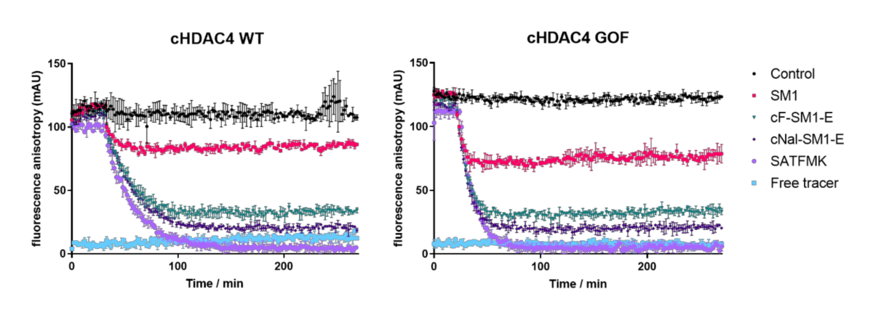
Figure S6 Behaviour of selected peptides and SATFMK towards a cHDAC4-fluorescent probe complex. As control the cHDAC4-probe complex was measured over time to ensure the stability of the complex. Error bars represent the standard deviation of technical triplicates.

S3 Rigid docking
The crystal structure of HDAC4 in complex with SP1-peptide (PDB-ID 5ZOO) was obtained from the Protein Data Bank (https://www.rcsb.org/).⁴ The protein structure was prepared and protonated using MOE 2022.02 and partial charges were added using the AMBER 14 force field in the same program. The linear peptide ligand SP1 was extracted from the structure of the protein-peptide complex and cyclic peptides were modeled in the protein builder of MOE based on the SP1 structure. The resulting structures of the cyclic peptides were energy minimized using AMBER 14 force field resulting in similar structures to linear horseshoe shaped SP1. For rigid docking ZDOCK 3.0.2 was used.⁵ PDB-files of the apo-protein and the peptides were uploaded and calculations were carried out on the ZDOCK server (https://zdock.umassmed.edu/).

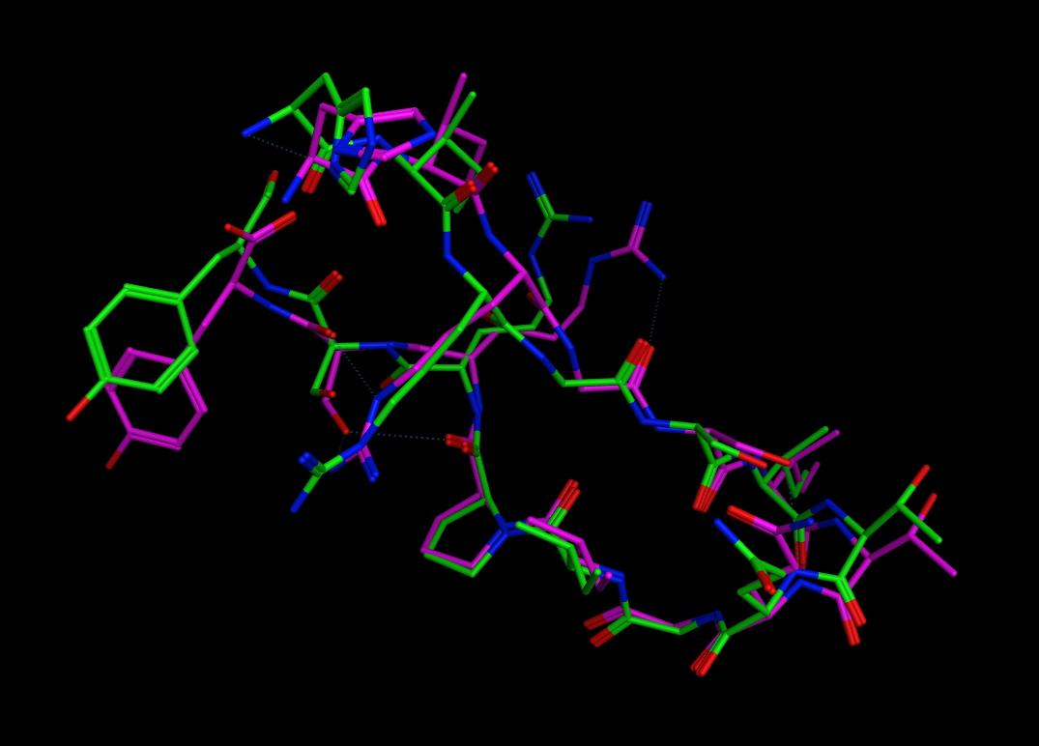
Figure S7 Validation of docking procedure: Binding poses of crystallized (green) and redocked (magenta) SP1 bound to the crystal structure of HDAC4 (PDB-ID: 5ZOO). RMSD = 0.95 Å).

S4 Mutagenesis, recombinant production and purification of cHDAC4 wildtype and variants
Starting cultures for both cHDAC4 variants were prepared in Lennox LB media (20 g/L) with 100 µg/mL ampicillin and incubated over night at 37 °C and 180 rpm. The next day, both starting cultures were washed twice with fresh Lennox LB media (20 g/L) with centrifugations steps in between (2000 g and 4 °C, 10 min) to remove accumulated beta-lactamase. Subsequently the washed starting cultures were used to inoculate two production flasks containing auto induction media (3.08 g/L KH₂PO₄, 3.10 g/L Na₂HPO₄, 0.44 g/L MgSO₄, 4.6 g glycerol and 20 g/L Lennox LB media) supplemented with, 0.45 g/L glucose, 1.2 g/L lactose and 100 µg/mL ampicillin for both cHDAC4 variants and incubated over night at 30 °C and 225 rpm. The next day, cells were harvested (2000 g, 4 °C, 10 min) and the cell pellets were washed twice with PBS buffer with centrifugations steps in between (2000 g and 4 °C, 10 min). Afterwards the pellets were resuspended in IMAC buffer (150 mM KCl, 50 mM TRIS-HCl, pH 8.0) supplemented with 3 µg/mL DNase I (AppliChem, Darmstadt, Germany) and 5 mM dithiothreitol and incubated on ice fore 30 min. Cell lysis was performed on ice via ultra sound for 10 min in intervals of 1 s with 2 s cooling phase (Digital Sonifier C25, Branson, Danbury, United States) at 25 % amplitude. Cell debris were separated from lysate by centrifugation (18000 g and 4 °C, 30 min). Subsequently the lysate was filtrated with a 0.45 µm filter (Filtropur, Sarstedt, Nümbrecht, Germany) diluted with IMAC buffer to 100 mL and supplemented with 5 mM imidazole. An IMAC column (5 mL cOmplete His-Tag Purification Resin, Roche, Basel, Switzerland) was equilibrated with 5 column volumes (CV) of IMAC buffer containing 5 mM imidazole and the lysate was loaded onto the column. The column was washed with 10 CV of column equilibration buffer. The protein was eluted with 15 CV of IMAC buffer containing 75 mM imidazole via step elution. Protein containing fractions were pooled and diluted to 50 mL with IMAC buffer. 5 mM dithiothreitol and 6 µg/mL SUMO protease were added and the reaction mixture was transferred into a dialysis tube (Membra-Cel dialysis tube, MWCO 3.5 kDa, Serva, Heidelberg, Germany). The His6-SUMO tag was cleaved during dialysis against 2 L IMAC buffer supplemented with 5 mM dithiothreitol at 4 °C over night. The next day, the protein was filtered with a 0.2 µm filter (Filtropur, Sarstedt, Nümbrecht, Germany). To remove the His6-SUMO tag by HIC, the protein sample was diluted with an equal volume of 2x HIC A buffer A (2 M (NH₄)₂SO₄, 50 mM TRIS-HCl, pH 8.0). After equilibration of the HIC column (5 mL Toyopearl Butyl-650M, Tosoh Bioscience, Tokyo, Japan) with 5 CV of ddH₂O, 5 CV of HIC B buffer B (50 mM TRIS-HCl, pH 8.0) and 10 CV of HIC A Buffer A (1 M (NH₄)₂SO₄, 50 mM TRIS-HCl, pH 8.0) the protein was loaded onto the column. The column was washed with 5 CV of HIC A buffer and the protein was eluted with 15 CV of HIC buffer B via step elution. Protein containing fractions were concentrated via ultrafiltration (Vivaspin 2, MWCO 3.5 kDa, Sartorius, Göttingen, Germany) at 8000 g and 4 °C and 5 mM dithiothreitol was added. For the final purification step, size exclusion chromatography (SEC, HiLoad Superdex 16/600 75 pg, Cytiva, Marlborough, United States) was utilized. After equilibration of the SEC column with SEC buffer (150 mM KCl, 50 mM TRIS-HCl, 1 mM TCEP, 5 % glycerol pH 8.0) the protein was loaded onto the column and and eluted with SEC buffer. The protein containing fractions were concentrated via ultrafiltration (Vivaspin 2, MWCO 3.5 kDa, Sartorius, Göttingen, Germany) at 8000 g, flash frozen in liquid nitrogen and stored at -80 °C.
All centrifugation steps were performed in a 6–16K centrifuge (Sigma, Osterode am Harz, Germany). All chromatography steps were performed with an ÄKTA pure chromatography device (GE Healthcare Life Sciences, Chicago, United States) using flow rates of 5 mL/min, except for SEC which was performed at 1 mL/min. All columns were regenerated as recommended by the respective manufacturer.

S5 Photocrosslink between cBpa-SM1-E and cHDAC4 WT
17 µL of a 19.64 mg/mL cHDAC4 WT (7.5 nmol) solution in 50 mM Tris; 150 mM KCl, 5% glycerol and 1 mM TCEP was added to 0.1 mg of lyophilised cBpa-SM1-E (77 nmol). The peptide was carefully dissolved, mixed with the protein solution and incubated at room temperature for one hour and then irradiated at 365 nm with an LED for another hour. In preparation for the trypsin digest, the solution was diluted to 100 µL and transferred to a microdialysis chamber (Carl Roth, Karlsruhe, DE) with a molecular weight cut-off of 3.5 kDa and dialysed at 4 °C in 200 mL of 50 mM ammonium bicarbonate buffer pH 7.8 for 5 cycles of 1 hour and an additional cycle overnight. The solution was then transferred to a microcentrifuge tube and 10 µL of a 10 mM DTT solution in ammonium bicarbonate buffer was added and incubated for 20 min at 95 °C. After cooling to room temperature, 35 µL of 100 mM iodoacetamide solution in ammonium bicarbonate buffer was added and incubated for 30 min. 8 µL of 50 µg/mL sequencing grade trypsin (Promega, Madison, USA) solution in ammonium bicarbonate buffer was added and the digest was carried out over night at 37 °C. The reaction was stopped with 3 µL of TFA. As controls, a tryptic digest of cHDAC4 WT was prepared in the same way without the peptide, and the peptide itself was digested by trypsin, too. MALDI-TOF MS spectra were measured at the mass spectrometry core facility of the Chemistry Department at the Technical University of Darmstadt. MALDI-TOF mass spectra were processed using mMass.⁶

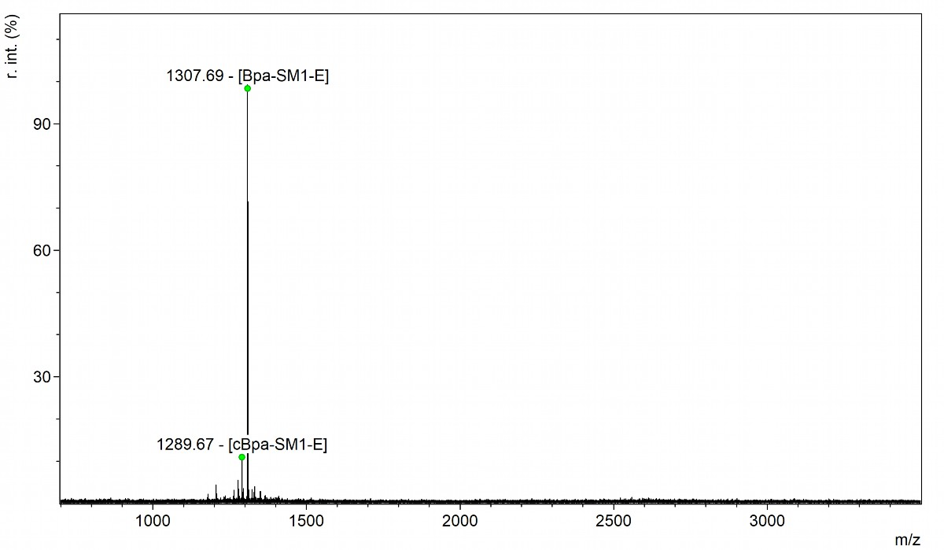
Figure S9 MALDI-TOF MS spectrum of cBpa-SM1-E after UV-irradiation and digestion with trypsin. The cyclic peptide ([M+H]⁺ of 1289) was mostly cleaved by trypsin between the Arg-Glu bond yielding the linear peptide Bpa-SM1-E with an [M+H]⁺ of 1307.

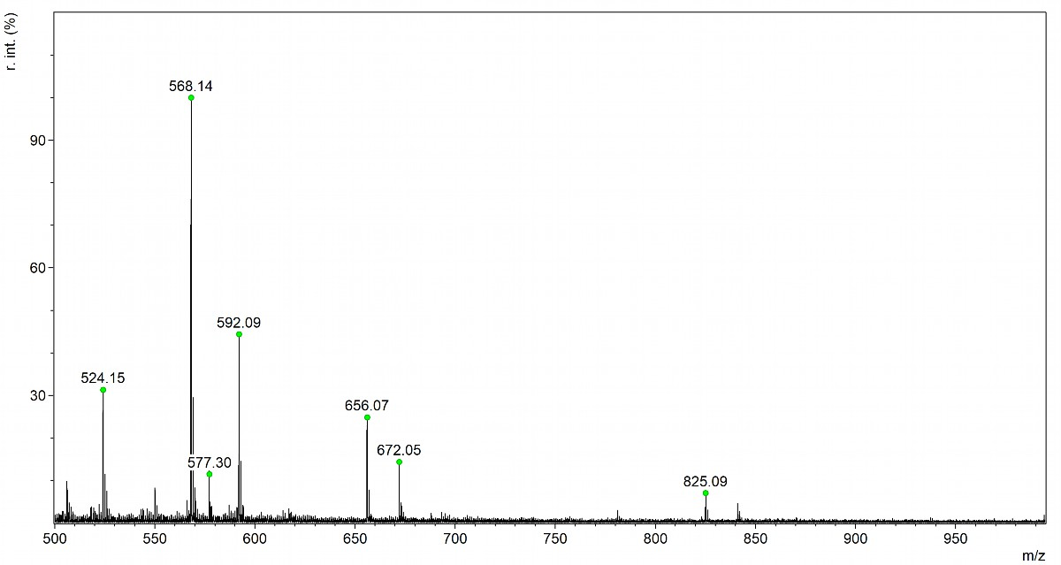
Figure S10 MALDI-TOF MS spectra of α-cyano-4-hydroxycinnamic acid that was used for the peptide and protein digested MALDI-TOF MS spectra. Peaks that are similar to fragments of digested cHDAC4 WT are marked by green dots.
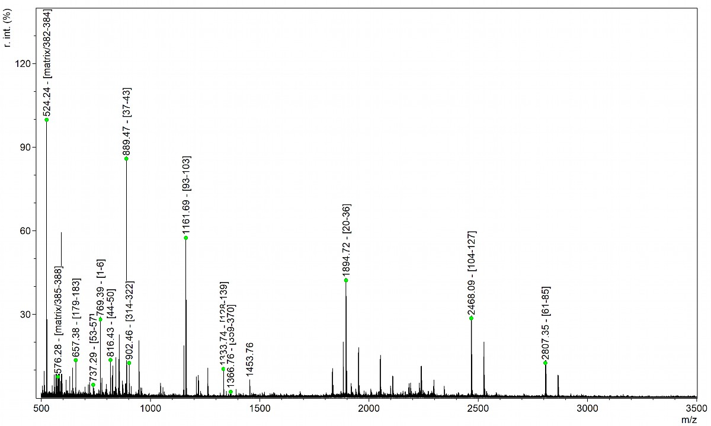
Figure S11 MALDI-TOF MS spectra of cHDAC4 WT after digestion with trypsin. Peaks of identified cHDAC4 WT fragments were labeled accordingly.

Table S4 Summary of the digest of cHDAC4 WT with trypsin. Theoretical [M+H]⁺ masses of fragments were calculated with mMass⁶ in the range of 0 to 3000 Da. The fragments cover 35 % of the total cHDAC4 WT sequence (when the possible matrix peaks are included). The fragment 307-315 was not included in sequence coverage calculation, since it is more likely that the peak belongs to fragment 37-43.
Start-End | Sequence (cysteine modification) | calculated [M+H]⁺ | found [M+H]⁺ | Mass difference (Da)/ comment
61-85 | ATLEELQTVHSEAHTLLYGTNPLNR | 2807.43 | 2807.34 | -0.09
104-127 | LPCGGVGVDSDTIWNEVHSAGAAR (1x Carbamidomethyl) | 2468.16 | 2468.08 | -0.08
20-36 | HQCTCGSSSSHPEHAGR (2x Carbamidomethyl) | 1894.77 | 1894.72 | -0.05
359-370 | VLQQRPNANAVR | 1365.77 | 1366.76 | 0.98
128-139 | LAVGCVVELVFK (1x Carbamidomethyl) | 1333.75 | 1333.74 | -0.02
93-103 | LLGSLASVFV R | 1161.7 | 1161.69 | -0.01
314-322 | QLMGLAGGR | 902.49 | 902.46 | -0.03
37-43 | IQSIWSR | 889.49 | 889.47 | -0.02
307-315 | CFGYLTK (1x Carbamidomethyl) | 888.43 | 889.47 | 1.04  (more likely fragment 37-43)
44-50 | LQETGLR | 816.46 | 816.43 | -0.03
1-6 | MHTKPR | 769.41 | 769.39 | -0.02
53-57 | CECIR (2x Carbamidomethyl) | 737.31 | 737.28 | -0.02
179-183 | LLQQR | 657.4 | 657.38 | -0.02
385-388 | CLQR (1x Carbamidomethyl) | 576.29 | 577.25 | 0.95 (also possible matrix)
382-384 | YWR | 524.26 | 524.24 | -0.02 (also possible matrix)
396-412 | SLIEAQTCENEEAETVT (1x Carbamidomethyl) | 1923.85
7-19 | FTTGLVYRTLMLK | 1501.8
375-381 | VMEIHSK | 843.44
140-146 | VATGELK | 717.41
389-395 | TTSTAGR | 693.35
184-188 | LSVSK | 533.33
371-374 | SMEK | 494.23
88-91 | LDSK | 462.26
86-87 | QK | 275.17
58-59 | GR | 232.14
51-52 | GK | 204.13
60-60/ 92-92 | K | 147.11

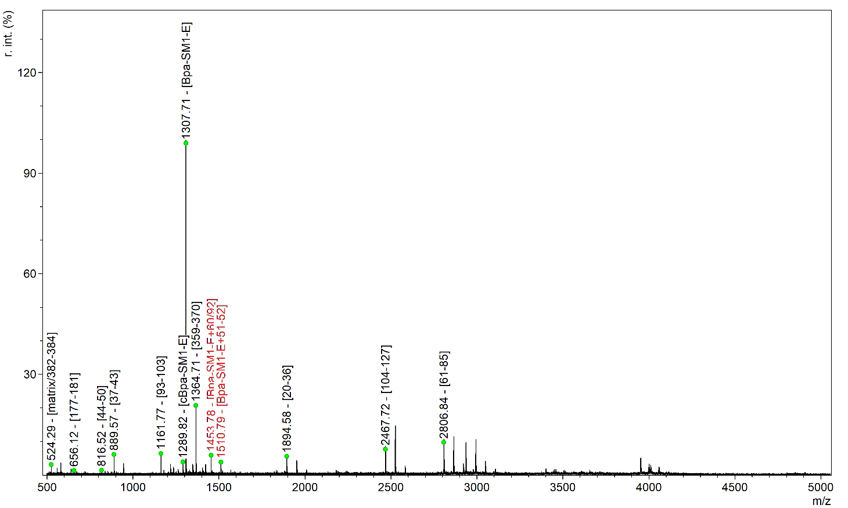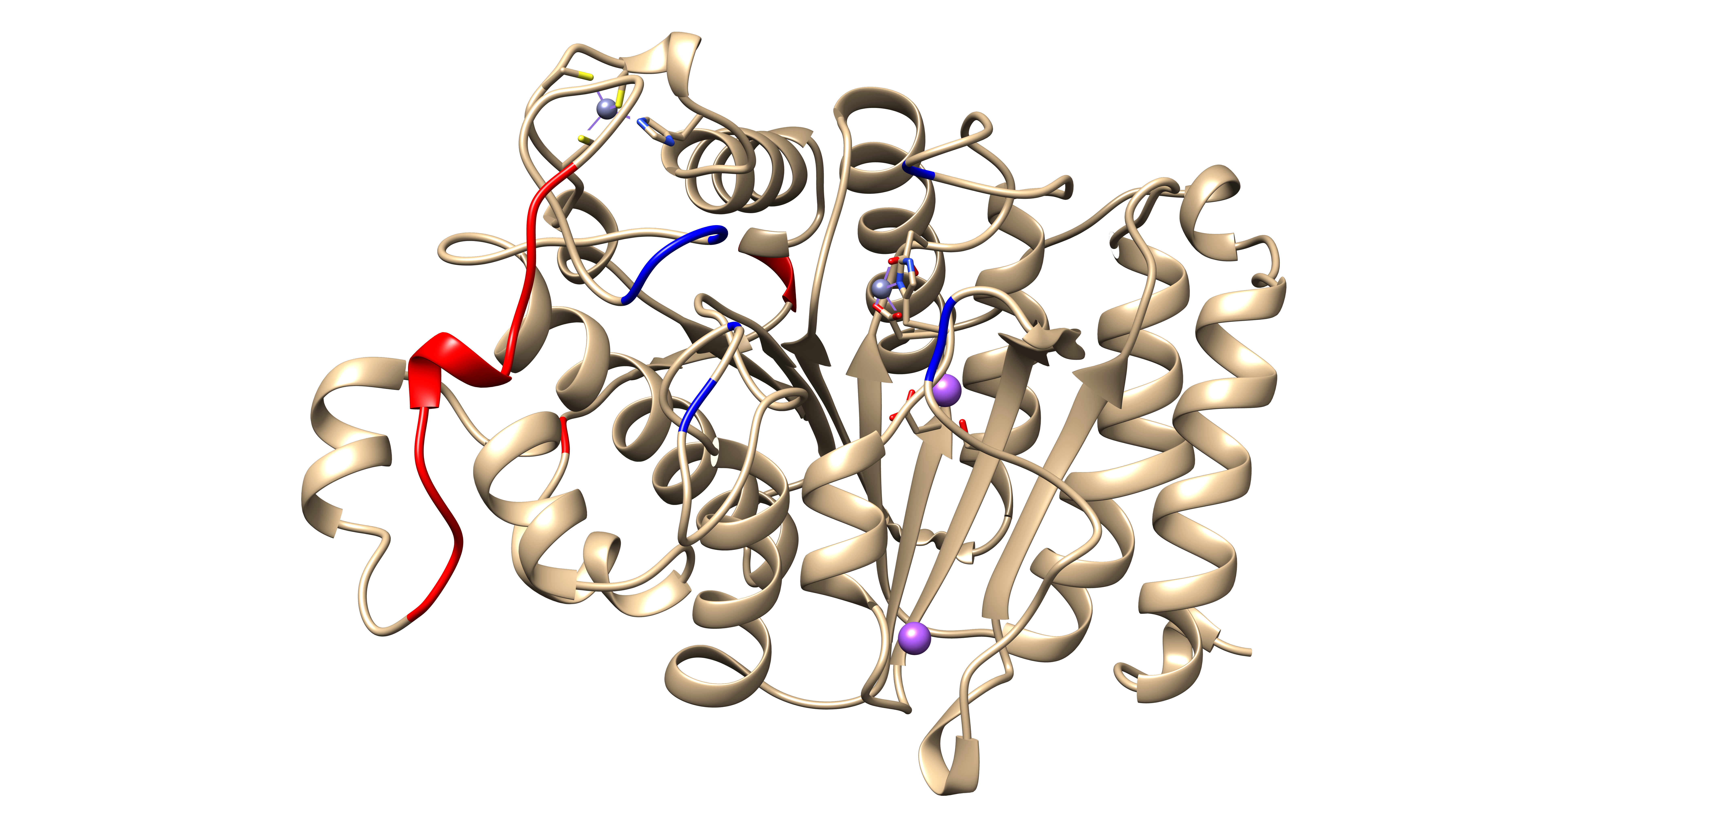
Figure S12 Left: MALDI-TOF MS spectra of cHDAC4 WT after incubation with a 10fold excess of cBpa-SM1-E and uv-irradiation and trypsin digest. Peaks that could be assigned to cHDAC4 WT fragments or fragments crosslinked with the linear peptide are labelled. Further details about the peaks are provided in Table S5. Right: Position of amino acids that were chosen as alanine variants based on the rigid docking (blue) and amino acids/fragments, for which possible photocrosslinked peaks could be identified in the MALDI-TOF MS spectra (red) on the crystal structure of cHDAC4 WT (PDB: 4CBY). USCF Chimera⁷ was used to remove the ligand and colour of the amino acids.
It was anticipated that if a photocrosslink occurred, it would involve the amino acid S758/D759 (S113/D114) or an amino acid that was spatially adjacent based on the rigid docking and cHDAC4 variant experiment. These two amino acids are present in fragment 104-127, which was identified in the spectra with and without the photocrosslink; however, the corresponding crosslinked product was not found.
Three peaks were identified, that are similar to the theoretical masses of photocrosslinked products. A peak with a difference of 0.66 Da was observed between the theoretical mass and the found mass of the crosslinked product of 93-103+Bpa-SM1-E. We assume that this is a false positive crosslink product, which is actually the fragment 104-127 that has a similar mass. The not-crosslinked fragment 93-103 was also found after photocrosslinking. Since the same mass peak was also seen in the MALDI-TOF MS spectra of the cHDAC4 WT digest without photocrosslinking, the mass for the photocrosslink of the single-amino-acid-fragment 60 or 92 with the peptide was also considered a false positive. We assume, that the photocrosslinked product of 51-52 with the peptide resulted from nonspecific peptide binding on the surface of the protein, due to the high excess of the peptide, as the fragment is spatially separated from the peptide binding site, determined through the cHDAC4 variants and rigid docking.

Table S5 Summary of the MALDI-TOF MS spectra of cHDAC4 WT after crosslinking with cBpa-SM1-E and digestion with trypsin. Theoretical [M+H]⁺ masses of fragments were calculated with mMass in the range of 0 to 3000 Da, theoretical [M+H]⁺ masses of fragments with the crosslinked peptide were calculated by adding the monoisotopic mass of the linear Bpa-SM1-E (Figure S7) to the theoretical masses. The fragments cover 29 % of the total cHDAC4 WT sequence (when the possible matrix peaks are included).
Start-End | Sequence | calculated [M+H]+ | found  [M+H]⁺ | Mass difference (Da)/ comment | cal. [M+H]⁺ Fragment + digested peptide | [M+H]⁺ found | Mass difference (Da)/ comment
61-85 | ATLEELQTVHSE AHTLLYGTNPLNR | 2807.43 | 2806.82 | -0.61 | 4114.1
104-127 | LPCGGVGVDSDTIWNEVHSAGAAR (1x Carbamidomethyl) | 2468.16 | 2467.71 | -0.45 | 3774.83
20-36 | HQC TCGSSSSHPE HAGR (2x Carbamidomethyl) | 1894.77 | 1894.58 | -0.19 | 3201.44
359-370 | VLQQRPNANAVR | 1365.77 | 1364.71 | -1.06 | 2672.44
93-103 | LLGSLASVFV R | 1161.7 | 1161.76 | 0.06 | 2468.37 | 2467.71 | -0.66 (most likely fragment 104-127)
314-322 | QLMGLAGGR | 902.49 | 902.58 | 0.09 | 2209.16
37-43 | IQSIWSR | 889.49 | 889.58 | 0.09 | 2196.16
307-315 | CFGYLTK (1x Carbamidomethyl) | 888.43 | 889.58 | 1.15  (more likely fragment 37-43) | 2195.1
44-50 | LQETGLR | 816.46 | 816.52 | 0.06 | 2123.13
179-183 | LLQQR | 657.4 | 656.12 | -1.28 (possible matrix peak) | 1964.07
382-384 | YWR | 524.26 | 524.29 | 0.03 (possible matrix peak) | 1830.93
51-52 | GK | 204.13 |  |  | 1510.8 | 1510.79 | 0.01
60-60/ 92-92 | K | 147.11 |  |  | 1453.78 | 1453.79 | 0.01 (also present w/o peptide)

S6 Ion-mobility mass spectrometry (IM-MS)
For measurements, the water (LC-MS) was purchased from Fisher Scientific (Hampton, New Hampshire, USA). The acetonitrile (LC-MS) and formic acid (p.a.) were purchased from Merck (Darmstadt, Germany). For the 200 mM ammonium acetate solution a 7.5 M ammonium acetate stock solution (Merck, Darmstadt, Germany) was diluted with water. Tris(2-carboxyethyl)phosphine hydrochloride (TCEP) and Dimethyl sulfoxide (DMSO) were purchased from Carl Roth (Karlsruhe, Germany). Holomyoglobin (horse), cytochrome C (horse), and ubiquitin (bovine) for CCS calibration were purchased from Merck (Darmstadt, Germany). Stock solutions of 410 µM of HDAC4 WT and 533 µM HDAC4 GoF were prepared in storage buffer (150 mM KCl, 50 mM TRIS-HCl, 5 % glycerol, and 1 mM TCEP) . The ligands were dissolved with DMSO to yield a stock solution of 1 mM. The Synapt G2-S was calibrated with sodium iodide solution from Waters (Milford, Massachusetts, USA). For Ion Mobility MS measurement, the protein samples were re-buffered with 500 µL Amicon Ultra Filter with a 10 K cut-off (Merck, Darmstadt, Germany) at 14,000 x g for 20 minutes with 200 mM ammonium acetate and 0.5 mM TCEP one time, followed by re-buffering four times with 200 mM ammonium acetate. The protein solution was then diluted with 200 mM ammonium acetate to the final concentration of 10 µM. The ligands in DMSO were diluted with 200 mM ammonium acetate to a final concentration of 10 µM. The apo-HDAC4 WT contained 1.0 vol% DMSO as a negative control. The samples were measured with direct-infusion nanoESI on a Synapt G2-S with travelling wave technology from Waters.⁸ For that, 10 µL protein-solution was loaded in a self-pulled nanoESI capillary. A Micropipette Puller Model P-97 from Sutter Instrument (Novato, California, USA) was used to make the capillaries. The Capillary Voltage was between 1.0 and 1.7 kV, Sampling Cone 20 V, Source Offset 20 V, Source Temperature 30 °C, Cone Gas Flow 50 L/h, and Purge Gas Flow 300 L/h for the nanoESI-source. For mass recalibration, we performed an internal calibration using the masses of the analytes with a 1st order regression. For the IM-MS measurements, we used helium at 180 mL/min as the cooling gas and nitrogen at 90 mL/min as the drift gas for the IMS cell. A travelling wave velocity of 800 m/s and a wave height of 40 V were used in the IM cell for all measurements. The wave velocity and height in the transfer cell were held at 150 m/s and 4 V, respectively. The DC bias voltage of the trap was 30 V. The quadrupole with the RF generator of 800 kHz was set to RF only, and the TOF was in resolution mode. The mass range was from 400 to 5000 m/z. Before the measurements, the MS was mass calibrated with sodium iodide to 5000 m/z. For CCS calibration, we measured horse holo-myoglobin, horse cytochrome c, and bovine ubiquitin with the same settings and a concentration of 10 µM for each standard.

S7 Peptide synthesis, purification and analysis

S7.1 Synthesis of linear peptides
If not stated otherwise, 1 mL of solvent was used for 100 mg of resin. The resin was swollen in a fritted syringe in dichloromethane (DCM) for 30 min, washed twice with dimethylformamide (DMF), and shaken for 10 min in DMF. The Fmoc-protecting groups were removed by incubation with 20 % piperidine in DMF for 10 min and again for 20 min with fresh 20 % piperidine in DMF solution. The resin was washed three times with DMF, twice with DCM, and twice with DMF. The first amino acid was always coupled manually overnight using 3 eq. of Fmoc-protected amino acid, 3 eq. 2-(1H-Benzotriazol-1-yl)-1,1,3,3-tetramethyluronium-hexafluorophosphat (HBTU), and 6 eq. N,N-Diisopropylethylamine (DIEA) dissolved in DMF to yield an approximately 0.4 M amino acid solution, which was then activated for 5 min on an orbital shaker prior to addition to the resin. After coupling, the resin was washed and Fmoc deprotection was carried out as described above. The following amino acids were coupled as described above but this time twice for one hour each. 5(6)-carboxytetramethylrhodamine (TAMRA) was coupled like an amino acid. Prior to cleavage of the peptide from the solid support, the Fmoc-group on the N-terminus was removed as described above and the resin was washed three times with DCM and three times with methanol and dried under reduced pressure. The dried resin was treated for three hours with a cleavage solution containing 95 % TFA, 2.5 % TIS, 2.5 % water, which cleaved all remaining protecting groups simultaneously. The cleavage solution was collected, and the tenfold volume of ice-cold Methyl tert-butyl ether (MTBE) was added to precipitate the peptide. The mixture was cooled for a few minutes on ice and centrifuged. The supernatant was discarded, and the precipitate was dissolved in 50% acetonitrile in water and lyophilized.

S7.2 Peptide purification and characterization
Peptides were purified by reverse-phase HPLC on a Jasco (Tokyo, Japan) system with two pumps PU-2089plus and a UV-2075plus detector. A 250x20 mm YMC-Triart Prep C18-S column (YMC, Kyoto, Japan) was used. The crude peptide was dissolved in eluent A (95 % water, 5 % acetonitrile, supplemented with 0.1 % TFA). If necessary, small amounts of eluent B (5 % water, 95 % acetonitrile, with 0.1 % TFA) were added. Before injection, the column was equilibrated with 20 mL of eluent A or a mixture of A and B corresponding to that in which the peptide was dissolved. The peptide was injected into the column through a 2-mL injection loop. A flow rate of 10 mL/min was applied, and the column was washed for 10 min with the eluent mixture used for equilibration, then the concentration of eluent B was increased in a linear gradient over 25 min to 100 % eluent B. The column was washed for 10 min with eluent B. Absorption was monitored at 550 nm for the TAMRA-labeled peptides, 280 nm for peptides with an aromatic side chains, or 220 nm. Chromatogram traces recorded at 220 nm are shown below. Fractions were collected based on the absorption and lyophilized.
MALDI-TOF MS spectra of the purified peptide fractions were measured with α-cyano-4-hydroxycinnamic acid as matrix in a range from 700 to 3500 Da at the mass spectrometry core facility of the Chemistry Department at the Technical University of Darmstadt. Fractions containing the desired peptide were pooled.
Purity of the peptides was determined through analytical HPLC on a Shimadzu (Kyoto, Japan) system with two LC20AD pumps and an SPD-M20A photodiode array detector. An analytical 150x4.6 mm YMC-Triart C18 column (YMC) was employed. All purified peptides were dissolved in eluent A and injected onto the column. A flow rate of 1 mL/min was applied. After injection, the column was washed for 4.5 min with 100 % eluent A, followed by a linear gradient from 0 to 100% eluent B over 7.5 min and another washing step with 100 % eluent B over 4.5 min. Then the concentration of eluent B was decreased from 100% to 0% over 1.5 min and the column was washed again for 4.5 min with eluent A. Purity was calculated by the are under the peak of the analytic HPLC-chromatogram.
In the analytic HPLC chromatograms shown below the peptide peak is always labelled with retention time (min)/Area%. In the MALDI-TOF MS spectra, both the monoisotopic [M+H]⁺ and the monoisotopic [M+Na]⁺ (if present) peak are labelled.

S7.3 Linear Peptides

S7.3.1 SM1
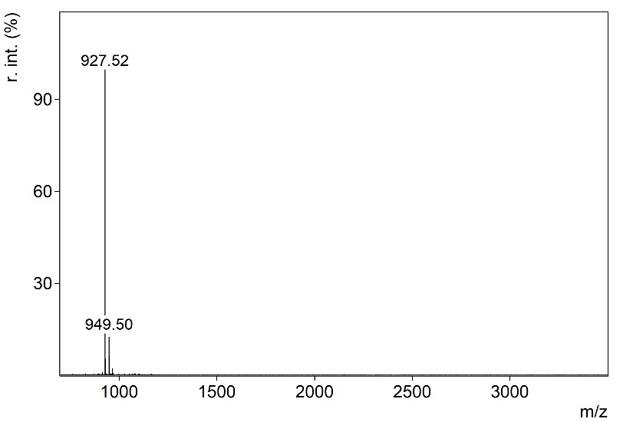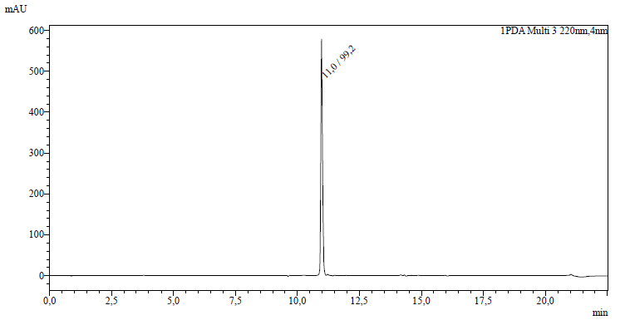
H-GSITQGIPR-NH₂

S7.3.2 TAMRA-SM1
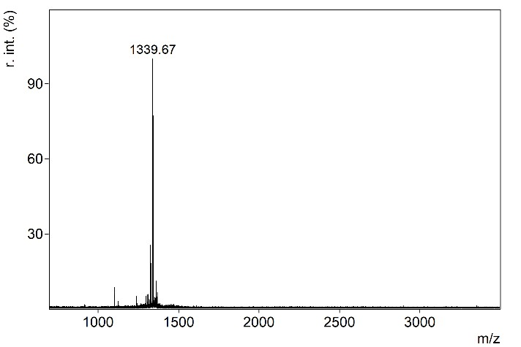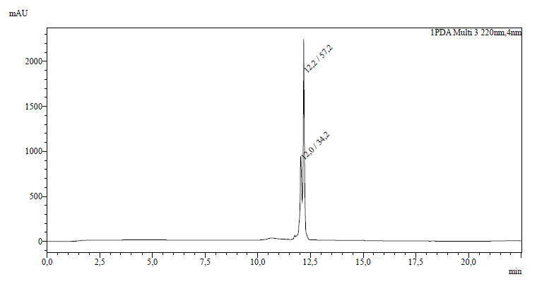
TAMRA-GSITQGIPR-NH₂
(5(6)-Carboxytetramethylrhodamine was used here only the 6-TAMRA peptide is shown)

S7.3.3 SP1
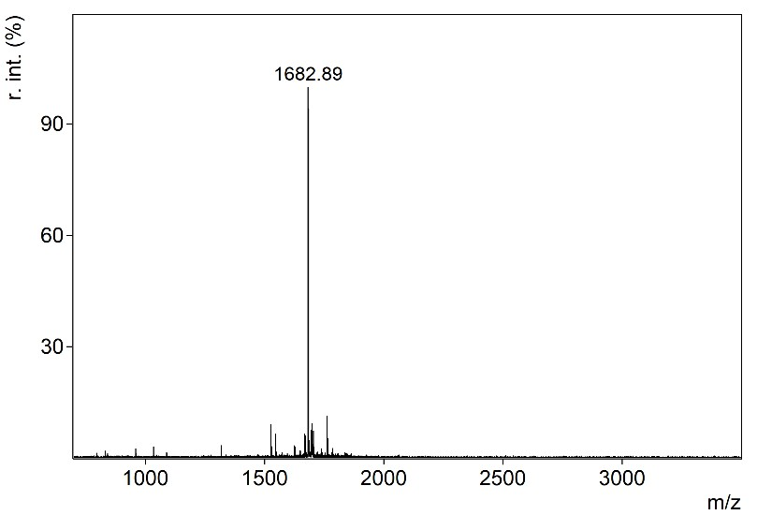
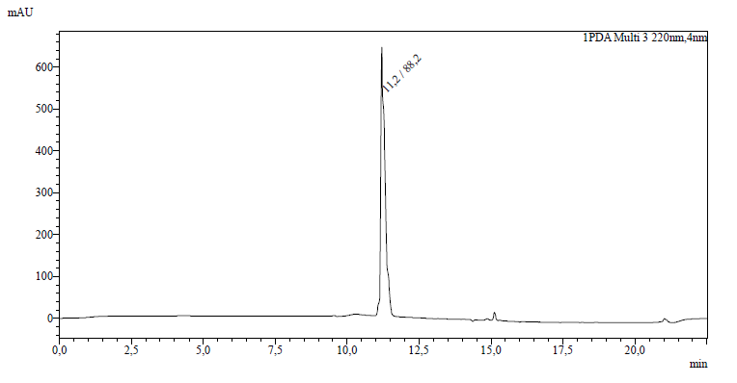
H-HIRGSITQGIPRSYV-NH₂

S7.3.4 W-SM1
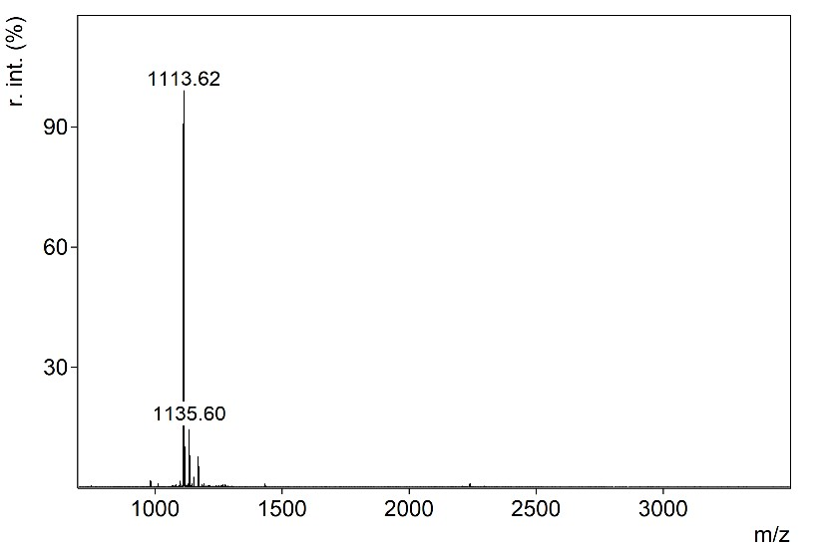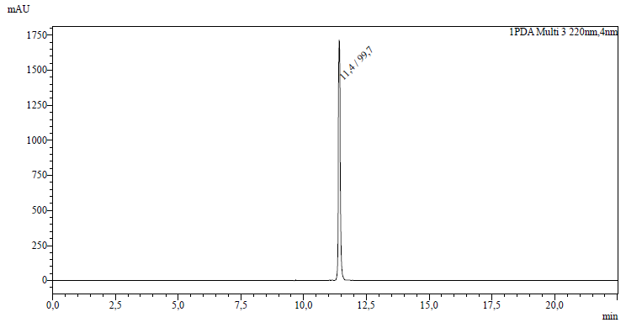
H-WGSITQGIPR-NH₂

S7.3.5 WW-SM1
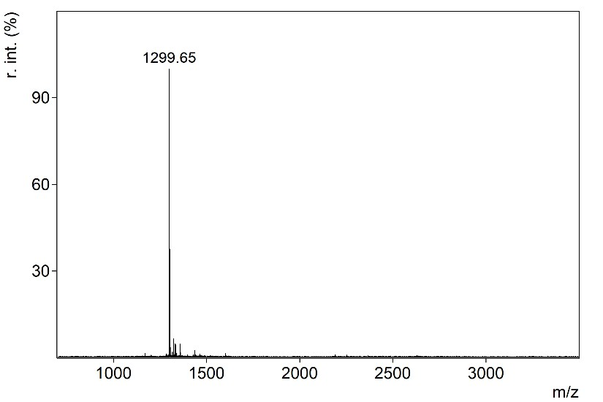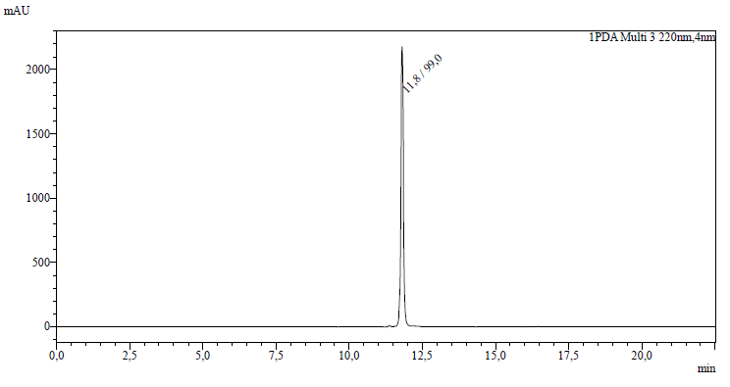
H-WWGSITQGIPR-NH₂

S7.3.6 WWW-SM1
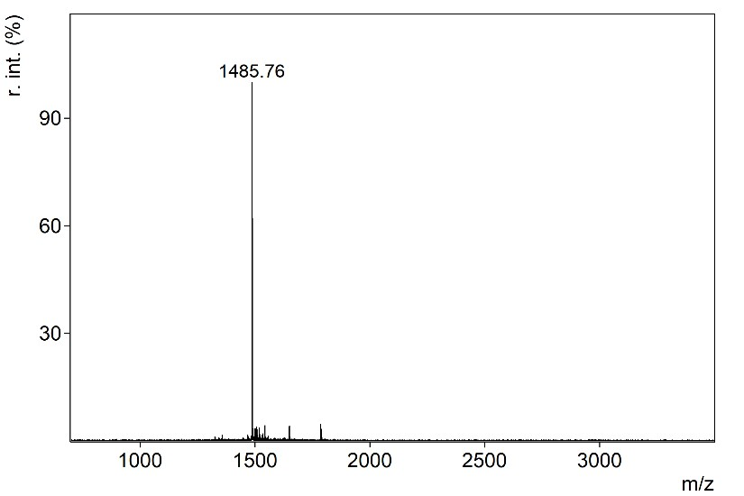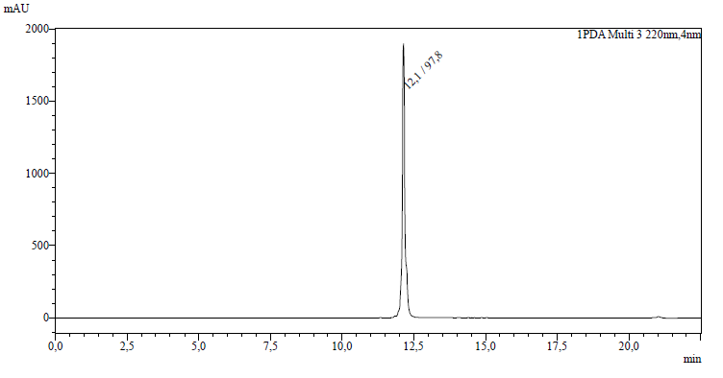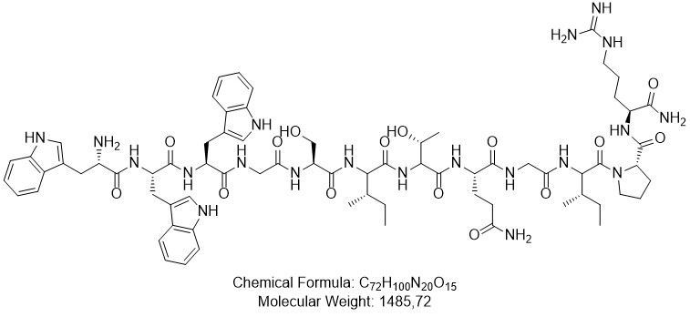

H-WWWGSITQGIPR-NH₂

S7.3.7 SM1-W
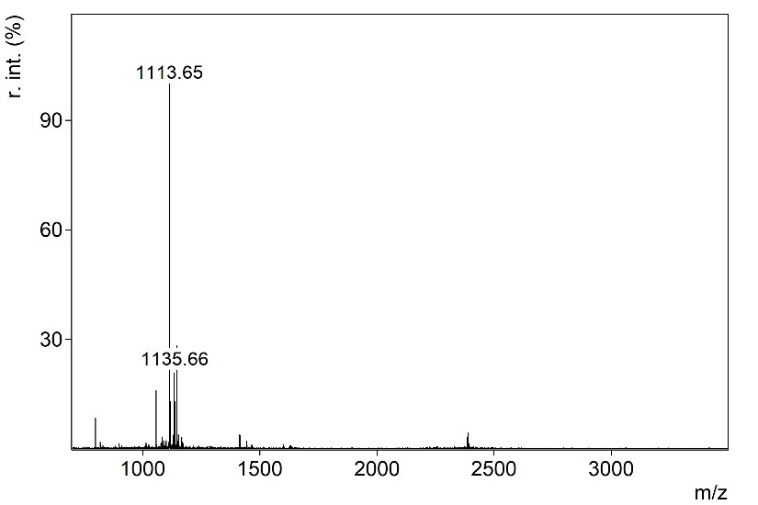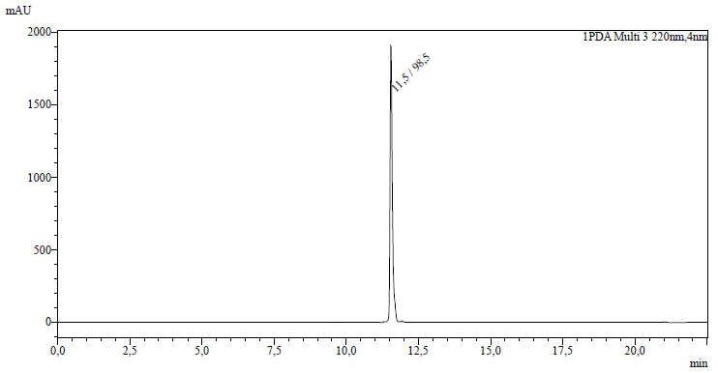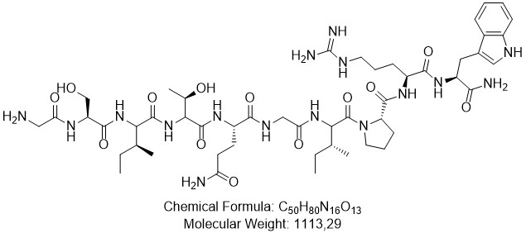

H-GSITQGIPRW-NH₂

S7.3.8 F-SM1
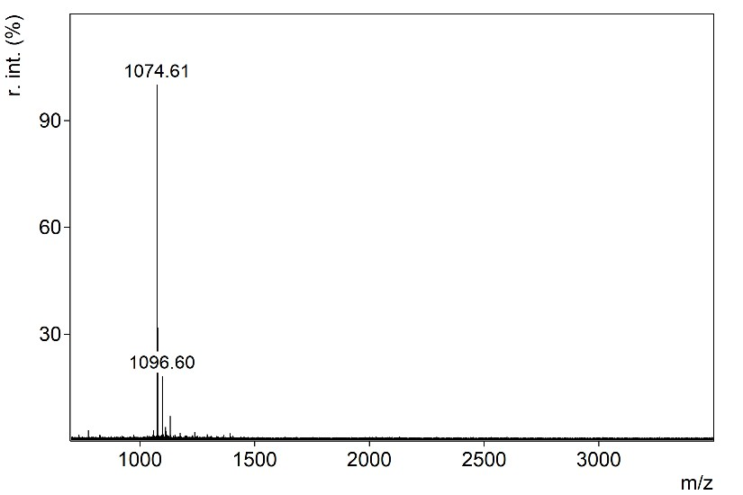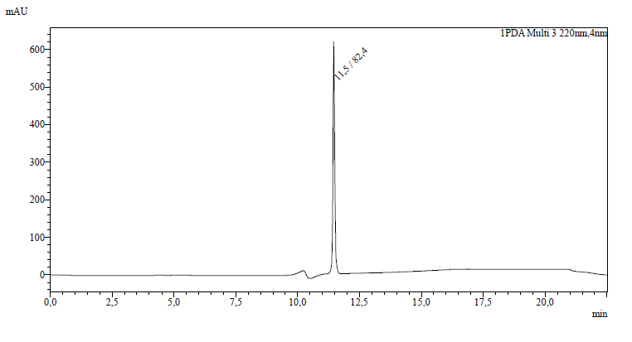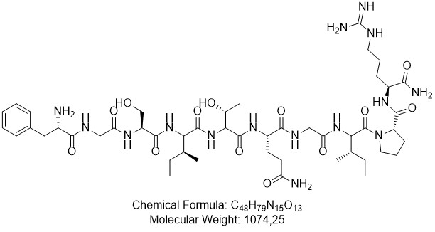

H-FGSITQGIPR-NH₂
S7.3.9 FF-SM1
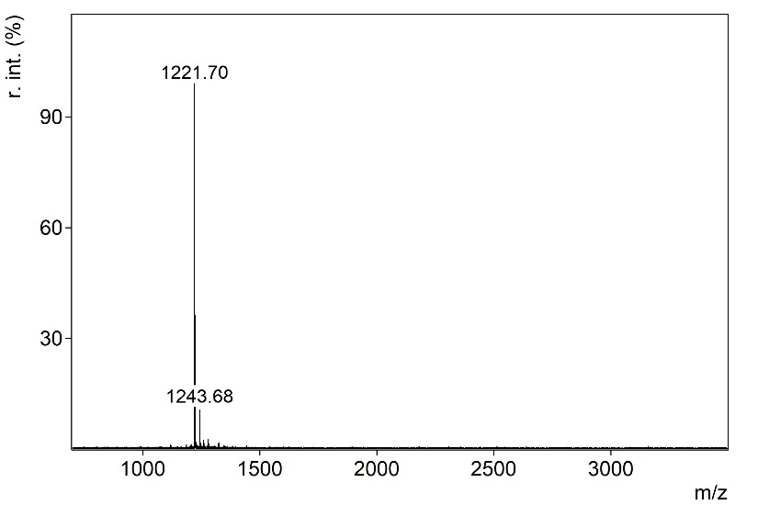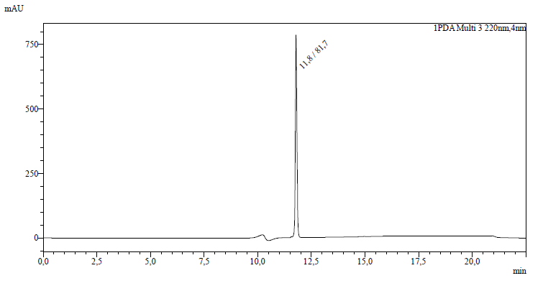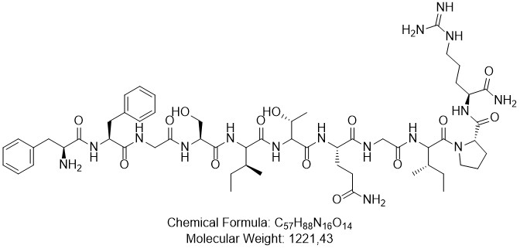

H-FFGSITQGIPR-NH₂

S7.3.10 FFF-SM1
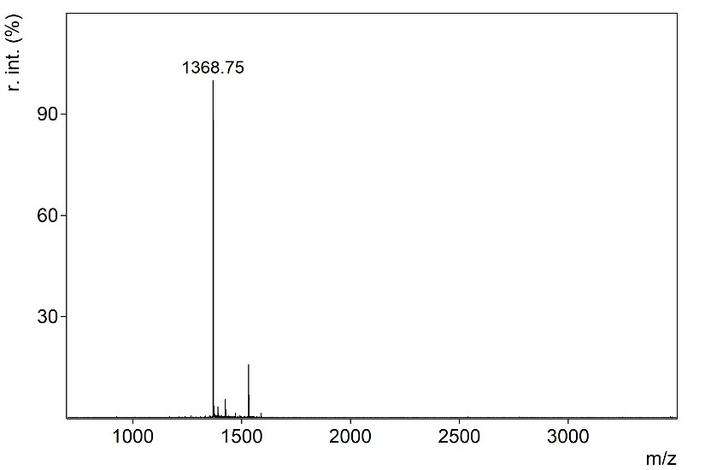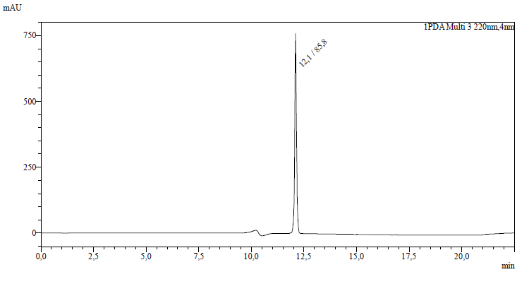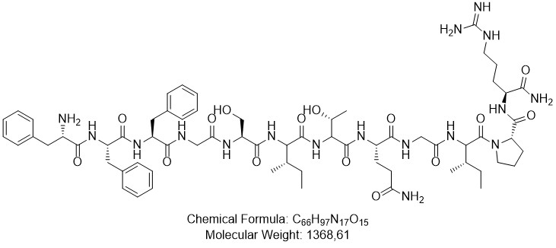

H-FFFGSITQGIPR-NH₂
S7.3.11 SM1-F
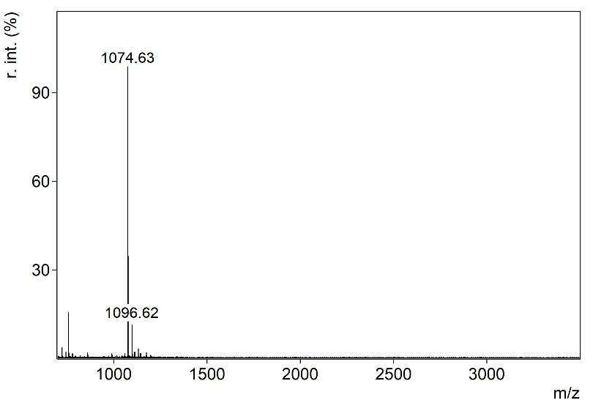
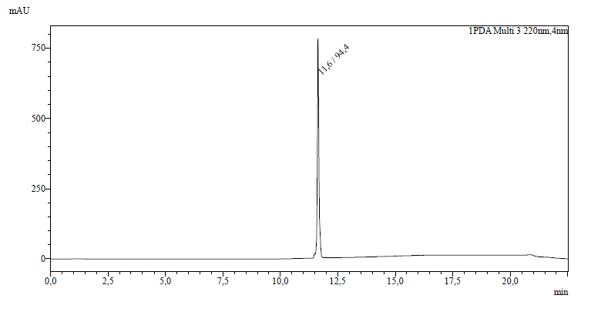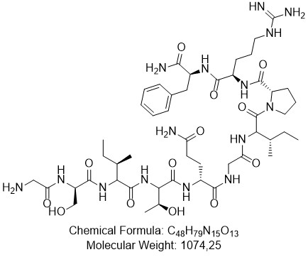
H-GSITQGIPRF-NH₂
S7.3.12 A-SM1
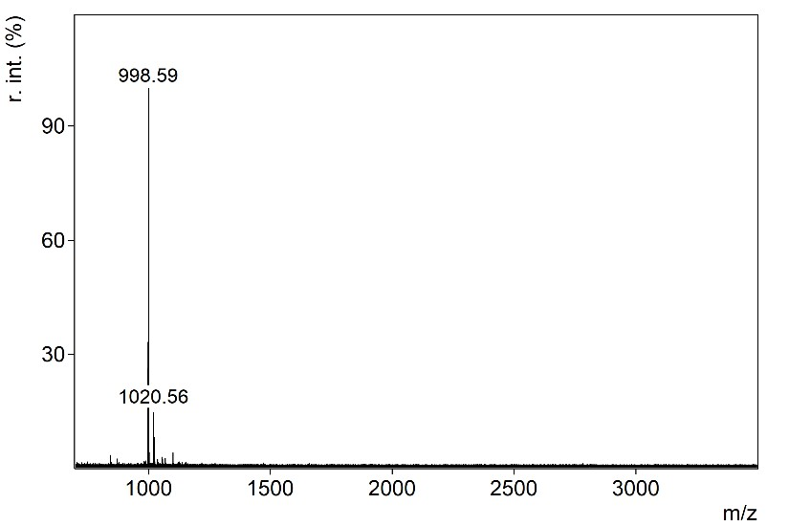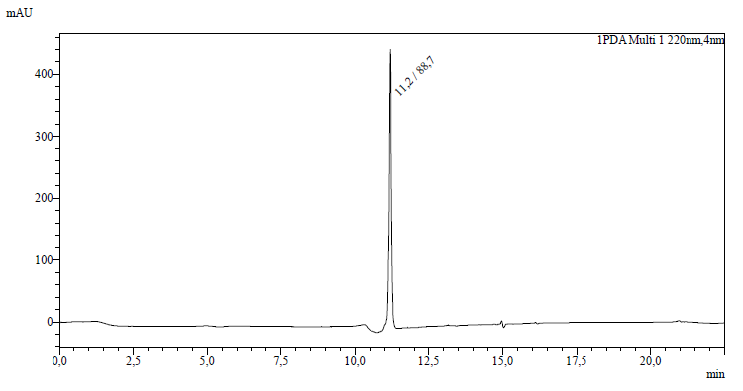
H-AGSITQGIPR-NH₂

S7.3.13 AA-SM1
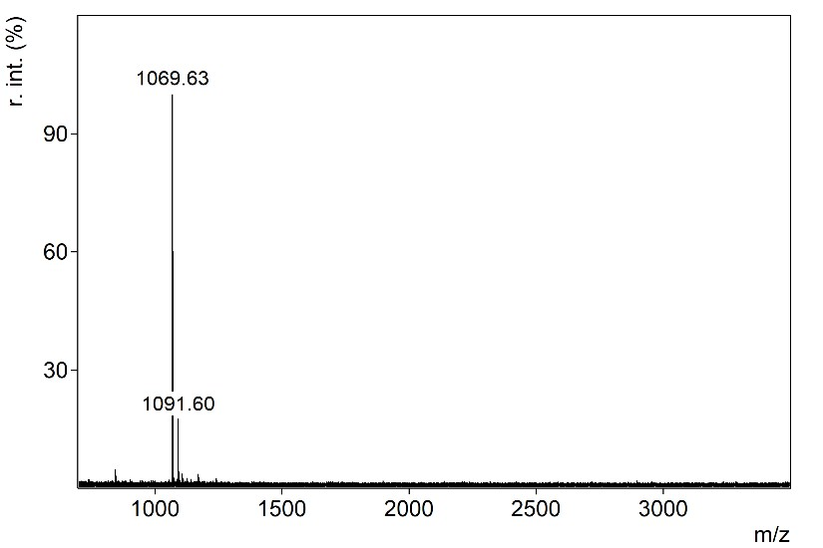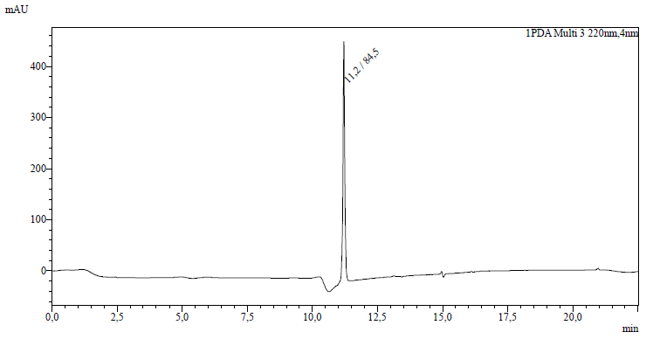
H-AAGSITQGIPR-NH₂

S7.3.14 AAA-SM1
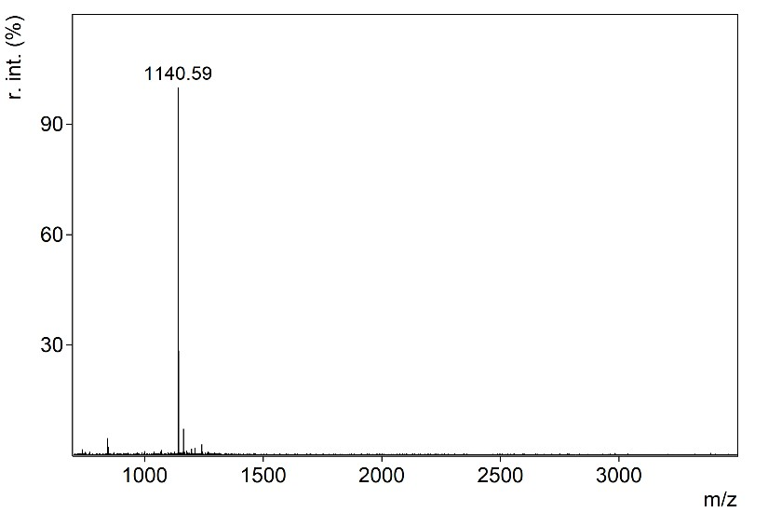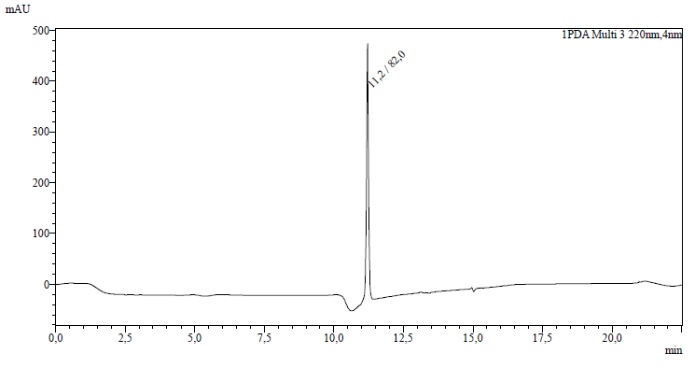
H-AAAGSITQGIPR-NH₂

S7.3.15 SM1-A
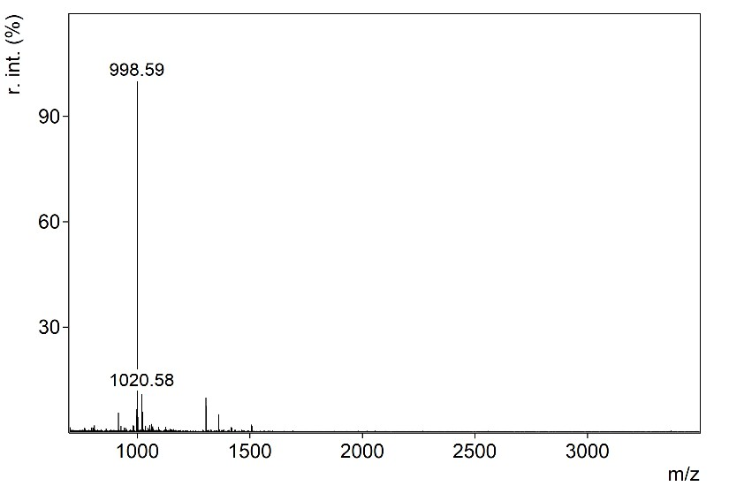
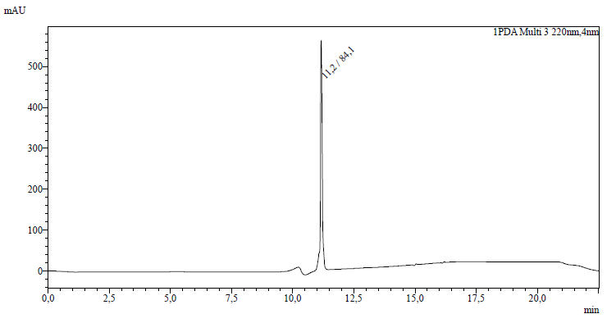
H-GSITQGIPRA-NH₂

S7.4 Cyclic Peptides

S7.4.1 cSM1-E
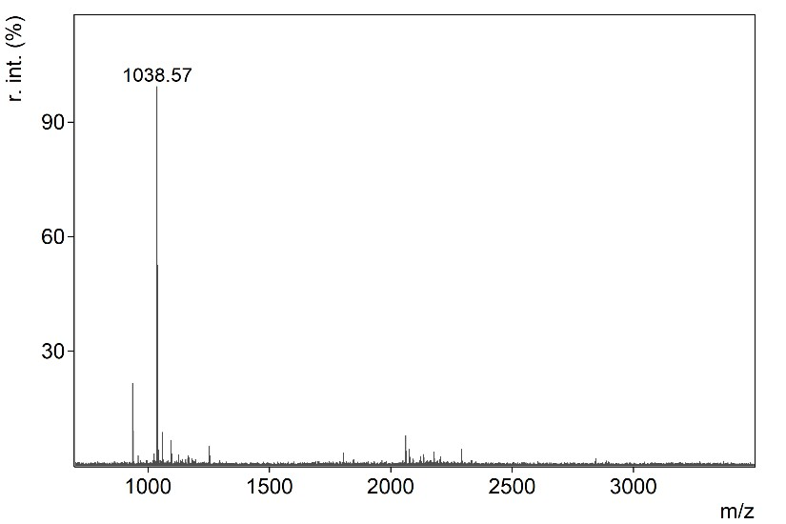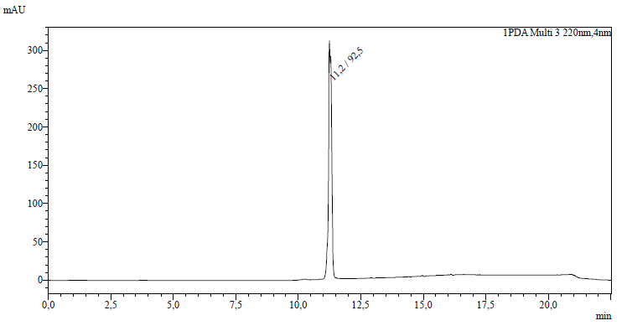
[GSITQGIPRE]-NH₂

S7.4.2 cSM1-D
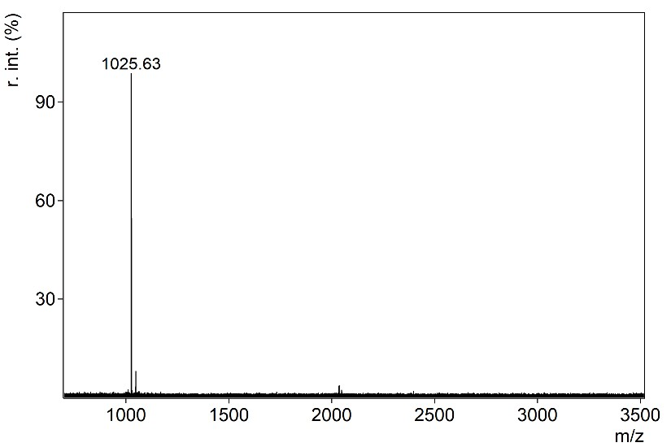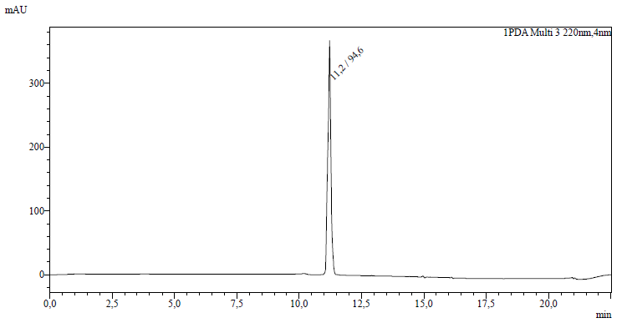
[GSITQGIPRD]-NH₂

S7.4.3 cSM1-Q
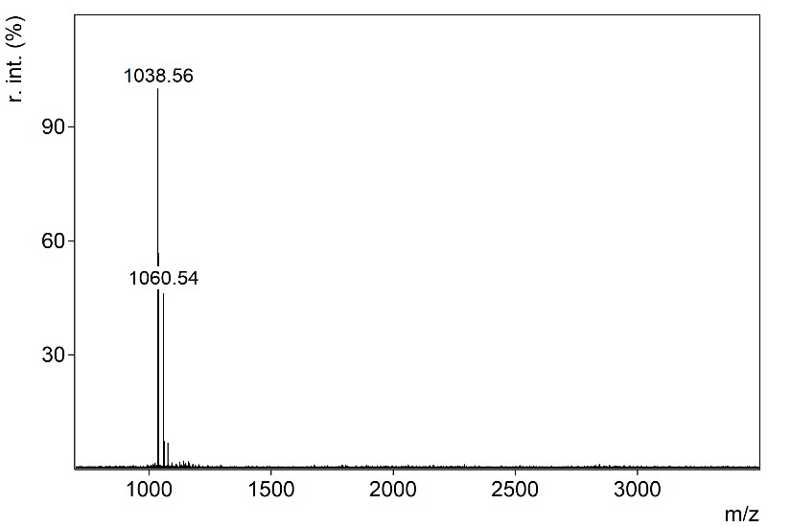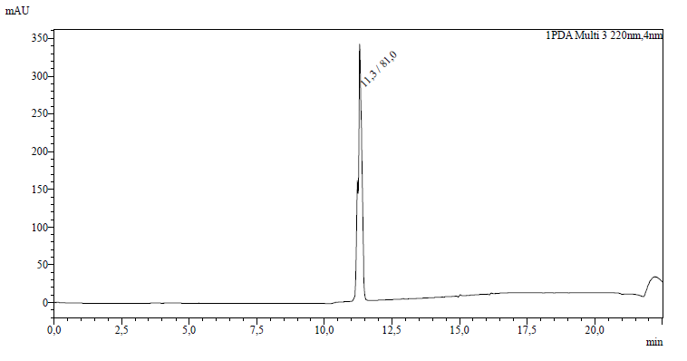
[GSITQGIPRQ]

S7.4.4 cSM1-N
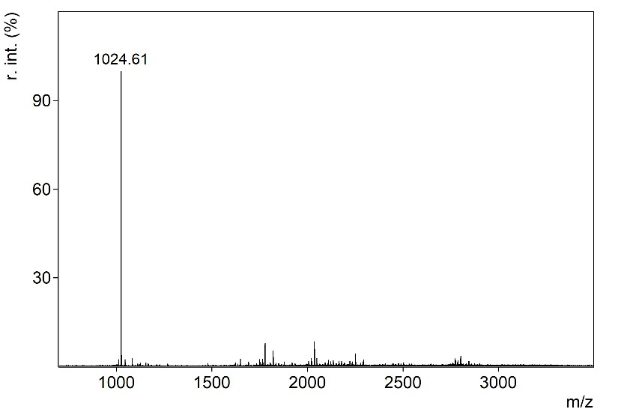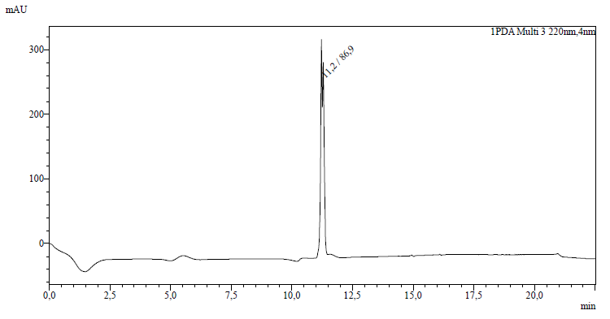
[GSITQGIPRN]

S7.4.5 cW-SM1-D
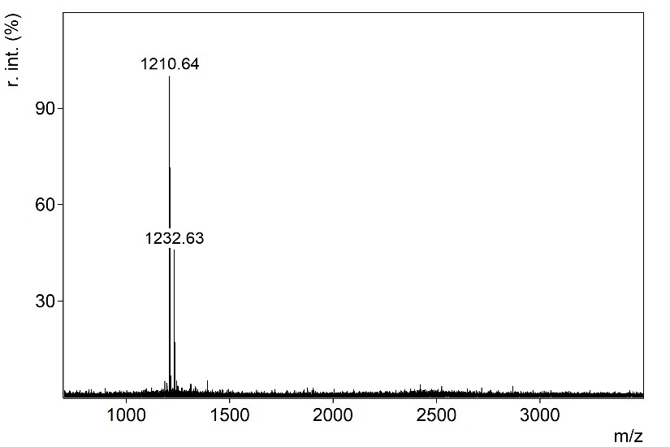 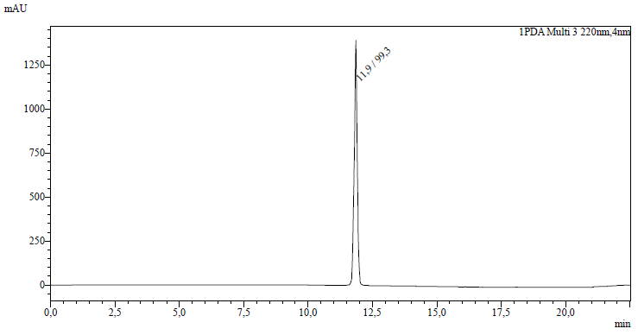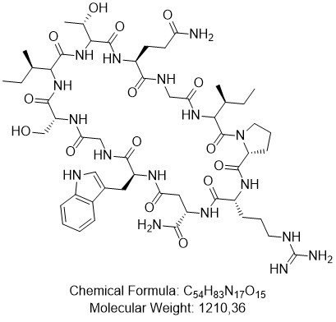[WGSITQGIPRD]-NH₂

S7.4.6 cW-SM1-Q
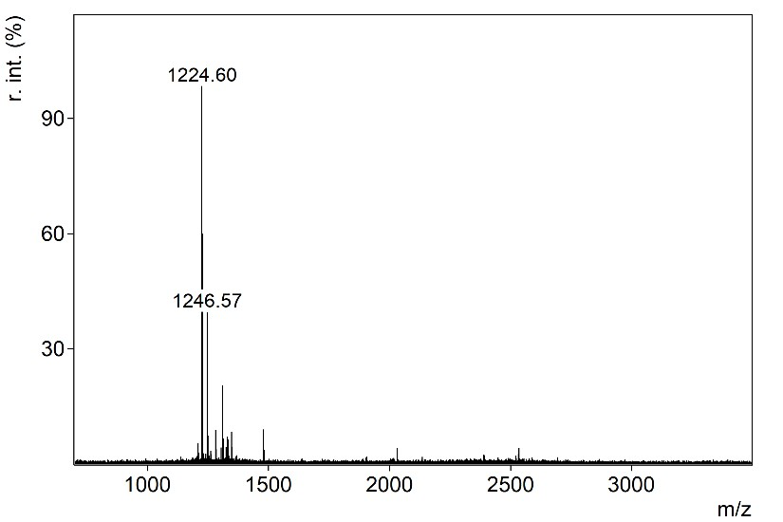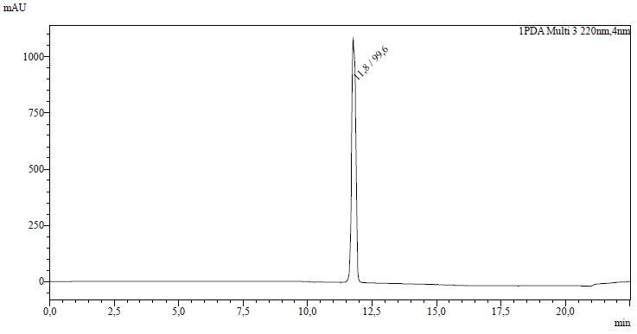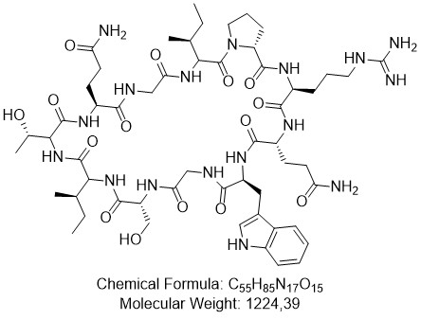

[WGSITQGIPRQ]

S7.4.7 cW-SM1-N
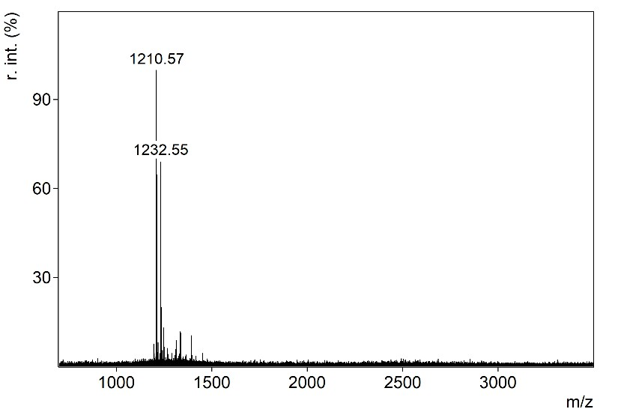 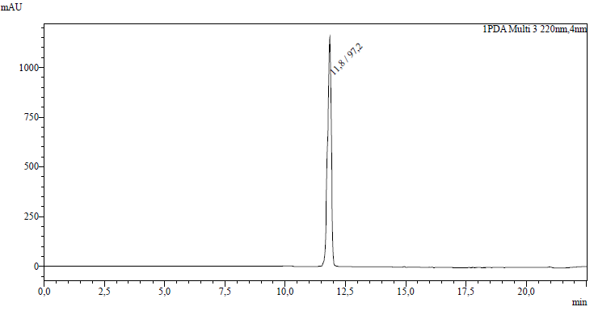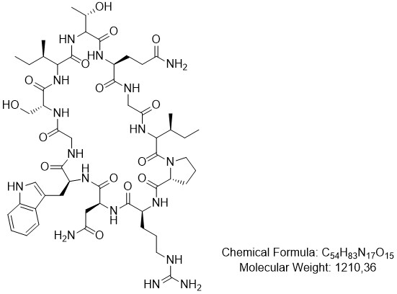[WGSITQGIPRN]

S7.4.8 cA-SM1-E
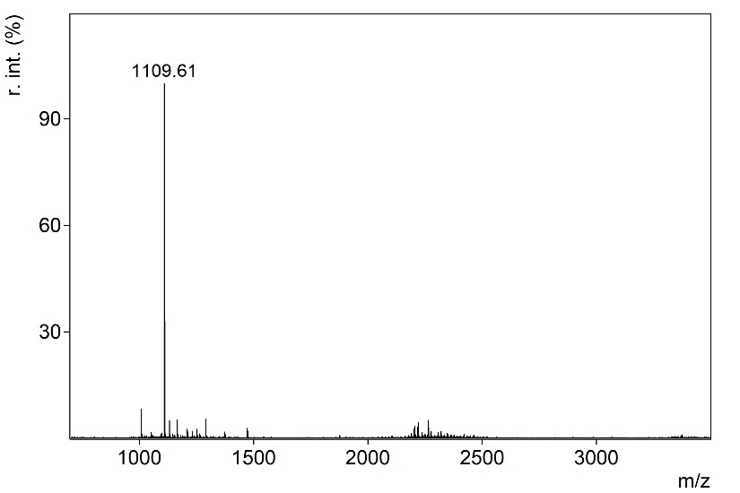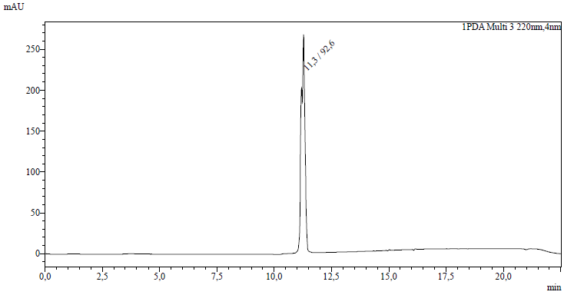
[AGSITQGIPRE]-NH₂

S7.4.9 cV-SM1-E
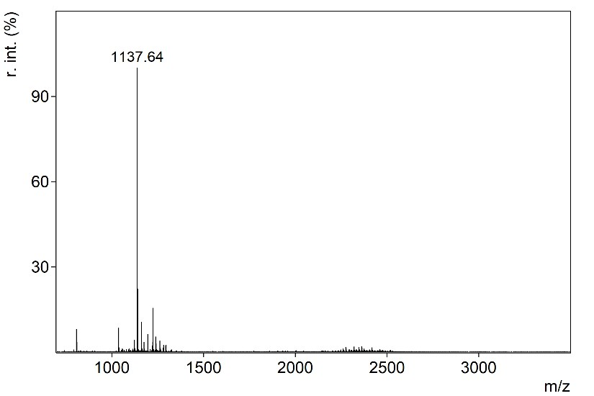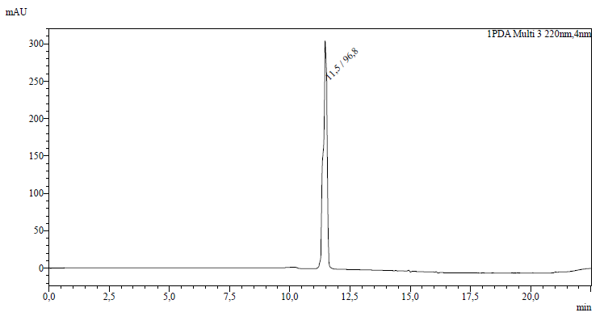
[VGSITQGIPRE]-NH₂

S7.4.10 cPhg-SM1-E
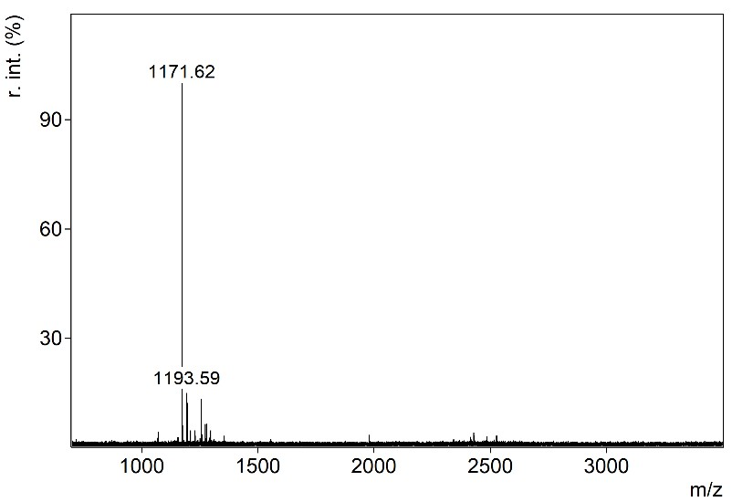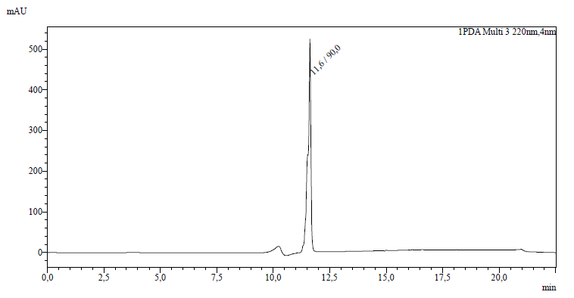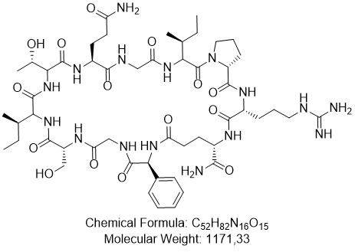

[Phg-GSITQGIPRE]-NH₂

S7.4.11 cF-SM1-E
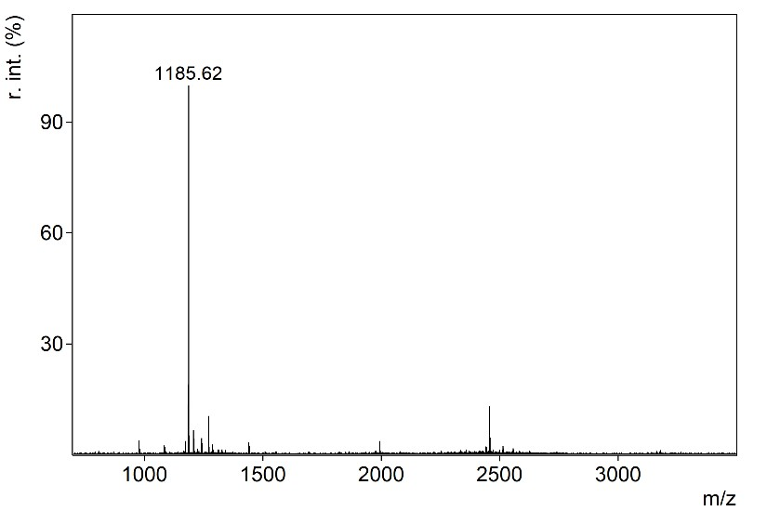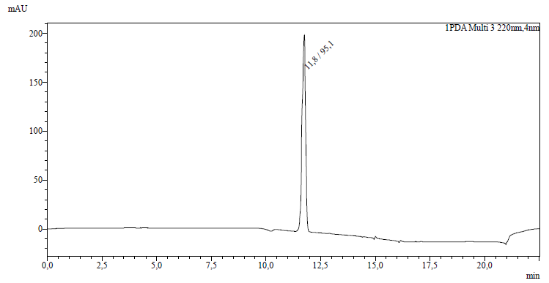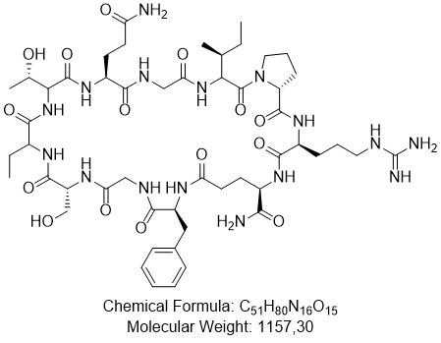
[FGSITQGIPRE]-NH₂

S7.4.12 cW-SM1-E
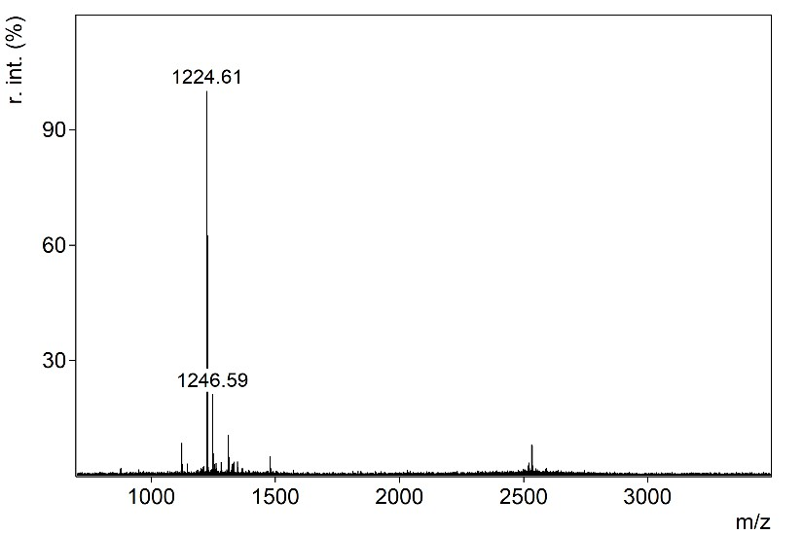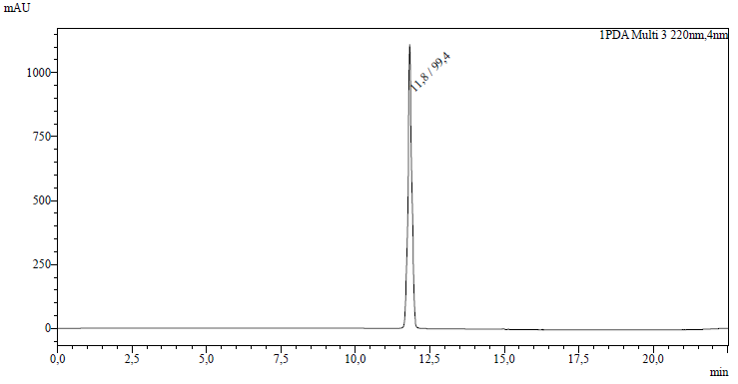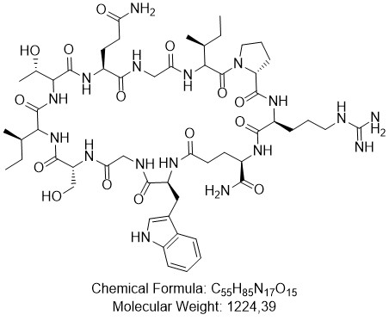

[WGSITQGIPRE]-NH₂

S7.4.13 cNal-SM1-E
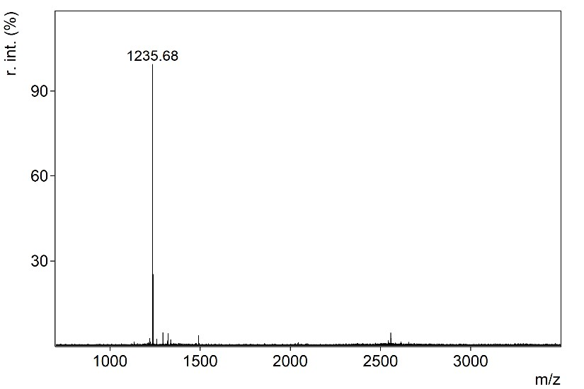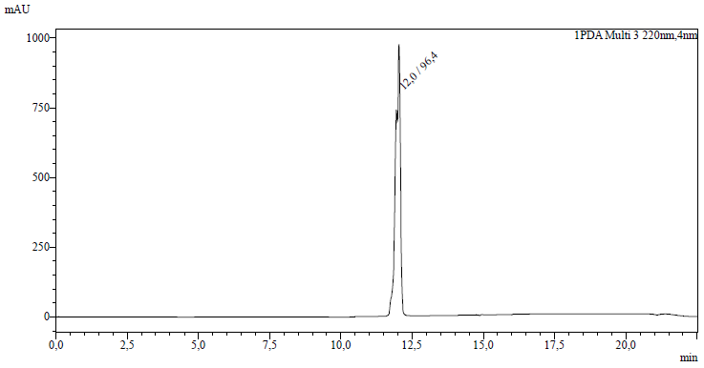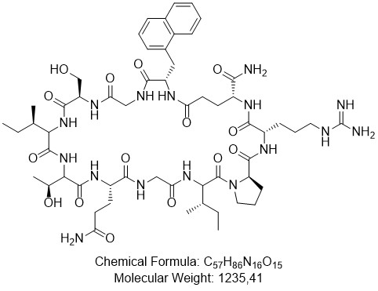

[Nal-GSITQGIPRE]-NH₂

S7.4.14 cBip-SM1-E
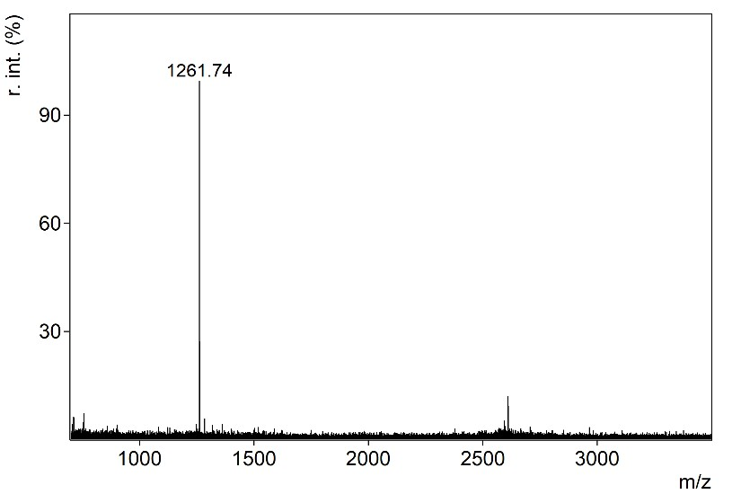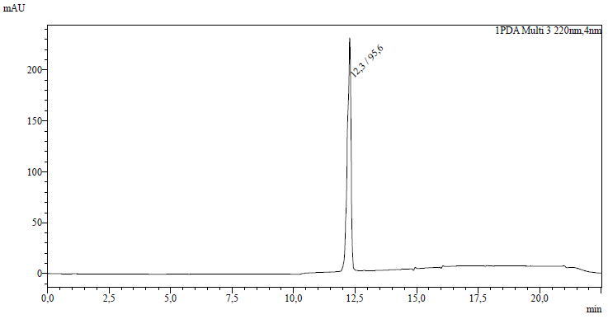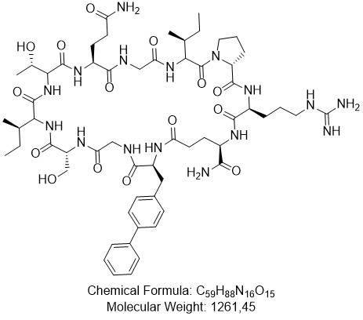

[Bip-GSITQGIPRE]-NH₂

S7.4.15 cBpa-SM1-E
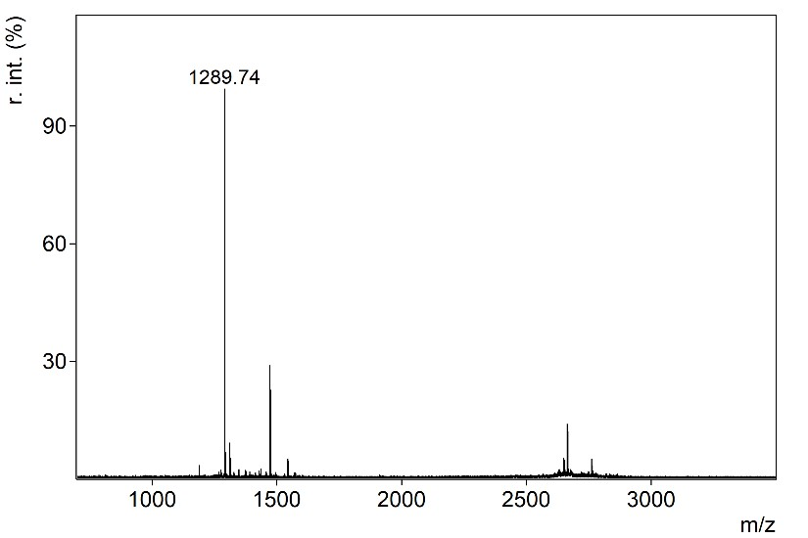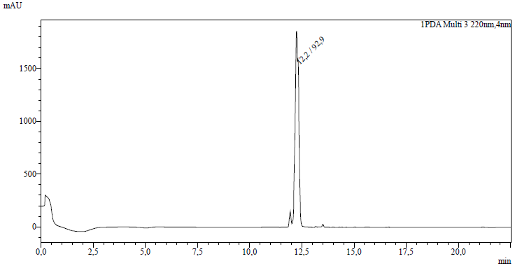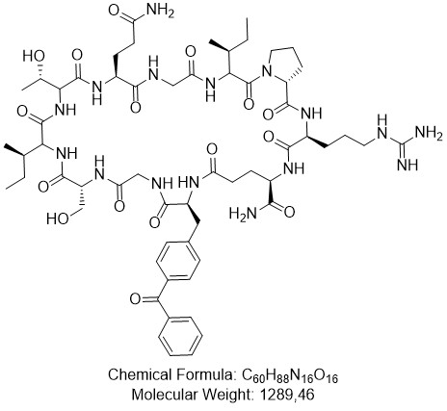
[Bpa-GSITQGIPRE]-NH₂

References
[1] Schweipert M, Jänsch N, Upadhyay N, et al. Mechanistic Insights into Binding of Ligands with Thiazolidinedione Warhead to Human Histone Deacetylase 4. Pharmaceuticals. 2021; 14(10): 1032, DOI: 10.3390/ph14101032.
[2] Schweipert M, Jänsch N, Sugiarto WO, Meyer-Almes F-J. Kinetically selective and potent inhibitors of HDAC8. Biol Chem. 2019; 400(6): 733-43, DOI: 10.1515/hsz-2018-0363.
[3] Meyners C, Mertens M, Wessig P, Meyer-Almes F-J. A Fluorescence-Lifetime-Based Binding Assay for Class IIa Histone Deacetylases. Chemistry. 2017; 23(13): 3107-16, DOI: 10.1002/chem.201605140.
[4] Berman HM, Westbrook J, Feng Z, et al. The Protein Data Bank. Nucleic Acids Res. 2000; 28(1): 235-42, DOI: 10.1093/nar/28.1.235.
[5] Pierce BG, Wiehe K, Hwang H, Kim B-H, Vreven T, Weng Z. ZDOCK server: interactive docking prediction of protein-protein complexes and symmetric multimers. Bioinformatics. 2014; 30(12): 1771-3, DOI: 10.1093/bioinformatics/btu097.
[6] Strohalm M, Hassman M, Kosata B, Kodícek M. mMass data miner: an open source alternative for mass spectrometric data analysis. Rapid Commun Mass Spectrom. 2008; 22(6): 905-8, DOI: 10.1002/rcm.3444.
[7] Pettersen EF, Goddard TD, Huang CC, et al. UCSF Chimera--a visualization system for exploratory research and analysis. J Comput Chem. 2004; 25(13): 1605-12, DOI: 10.1002/jcc.20084.
[8] Pringle SD, Giles K, Wildgoose JL, et al. An investigation of the mobility separation of some peptide and protein ions using a new hybrid quadrupole/travelling wave IMS/oa-ToF instrument. International Journal of Mass Spectrometry. 2007; 261(1): 1-12, DOI: 10.1016/j.ijms.2006.07.021.

