***Supplementary material for***

**Near-surface plastic deformation in polycrystalline SrTiO3 via room temperature cyclic Brinell indentation**

Chukwudalu Okafor1,4*, Kuan Ding1a, Oliver Preuß1, Neamul Khansur2, Wolfgang Rheinheimer3, Xufei Fang1,4

1Department of Materials and Earth Sciences, Technical University of Darmstadt, Peter-Grünberg Str. 2, 64287 Darmstadt, Germany.

2Department of Materials Science and Engineering, Friedrich-Alexander-Universität Erlangen-Nürnberg (FAU), 91058 Erlangen, Germany.

3Institute of Manufacturing Technologies of Ceramic Components and Composites, University of Stuttgart, 70569 Stuttgart, Germany.

4Institute for Applied Materials, Karlsruhe Institute of Technology, Kaiserstrasse 12, 76131, Karlsruhe, Germany

aMax Planck Institute for Sustainable Materials, Max-Planck-Straße 1, 40237 Düsseldorf, Germany

*Corresponding Author:

Chukwudalu Okafor, Email: chukwudalu.okafor2@kit.edu

**This file contains:**

**Sec 1.** Schematic illustration of the sequential grinding and polishing of single crystal STO with (001) surface. Brinell indentations were performed 200 µm away from the edge of the sample as shown in **Fig. S1A** to avoid cracking due to stress concentration at the edges. The second row of indents was made to accommodate possible misalignment of the sample during the sequential grinding and polishing step. From the <010> direction, the sample was ground and subsequently polished until half of the Brinell indent impression was revealed **Fig. S1B**.

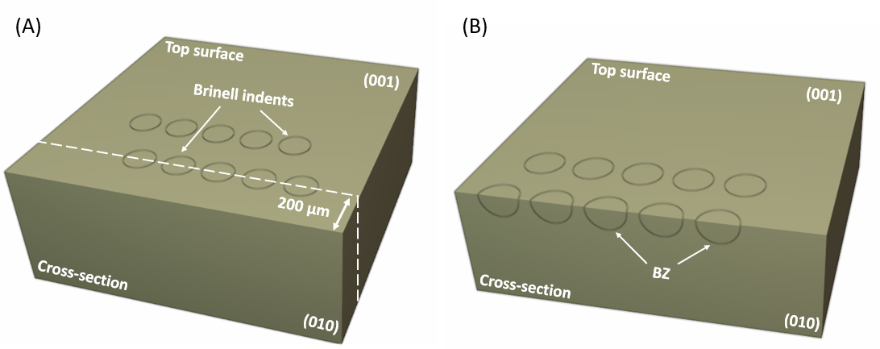

***Fig. S1:*** *Schematic illustration of the sequential grinding and polishing steps which reveals the cross-section of 5 representative Brinell indents. (A) Before grinding and polishing with the target final surface indicated with the dashed white line. (B) Cross-section revealed after grinding and polishing. ‘BZ’ represents the illustration of the Brinell zone. Dislocation etch-pits were made visible by chemical etching as shown in the main text (****Figure 3****).*

**Sec 2**: A depth profile of the three polycrystalline STO samples after cyclic Brinell indentation is presented in **Fig S2**. Material sink-in is observed and correlates to the grain sizes in agreement to the Hall-Petch relationship.

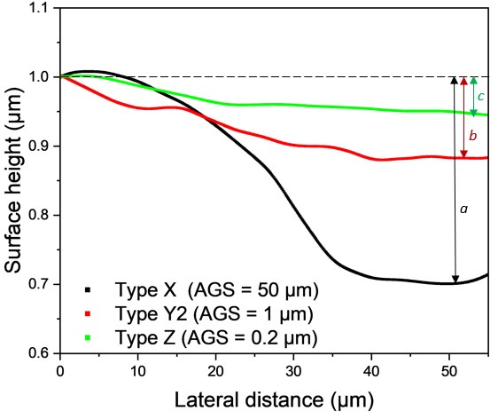

***Fig. S2****: Surface topography of three polycrystalline STO samples after 10x Brinell indentation. The depth of the indentation impression for Types X, Y2 and Z are a ~ 330 nm, b ~110 nm, and c ~65 nm respectively. Dashed black line represents the surface position before cyclic Brinell indentation.*

**Sec. 3.** Slip traces after 1x and 10x indentation (positions A2, A3, B2, and B3) and the corresponding EBSD map. The optical microscope images show a similar trend with the single crystal results as in **Figure 1** (main text)**.** An overall increase in deformability was observed between 1x and 10x indentations evident from the overall high density of the slip traces within the contact circle (white dashed circle) (**Fig. S2**).

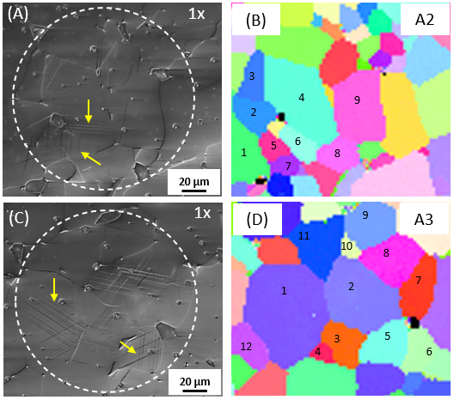

|  |
| --- |
|  |
|  |

***Fig. S3****: Slip traces after 1x (A), (C) and 10x (E), (G) and corresponding EBSD mapping depicting the color code of individual grains in (B), (D), (F), (G) respectively. Slip traces are highlighted with yellow arrows.*

|  |  |  |  |
| --- | --- | --- | --- |
| Grains (A1) | Orientation (Euler Angles)  (°) | Orientation {h k l} | Pseudo-Schmid Factor (msp) |
| 1 | (31.0, 88.8, 3.8) | (2,1,28) | 0.489 |
| 2 | (260.4, 43.1, 120.0) | (9,5,11) | 0.48 |
| 3 | (202.0, 115.6, 235.3) | (7,6,10) | 0.452 |
| 4 | (36.2, 93.8, 16.2) | (4,1,13) | 0.354 |
| 5 | (330.9, 101.8, 191.8) | (1,1,15) | 0.333 |
| 6 | (338.6, 115.6, 17.3) | (5,3,10) | 0.156 |
| 7 | (139.4, 158.1, 273.1) | (10,1,25) | 0.264 |
| 8 | (0.7, 121.4, 5.3) | (6,1,10) | 0.072 |
| 9 | (325.9, 39.5, 219.8) | (7,6,11) | 0.261 |

***Table S1:*** *Euler angles, orientation {h k l}, and pseudo-Schmid factor of grains (A1) as in* ***Figure 7B.***

|  |  |  |  |
| --- | --- | --- | --- |
| Grains (B1) | Orientation (Euler Angles)  (°) | Orientation {h k l} | Pseudo-Schmid Factor (msp) |
| 1 | (1.7, 79.2, 233.8) | (3,1,4) | 0.500 |
| 2 | (218.1, 38.8, 113.0) | (9,4,12) | 0.264 |
| 3 | (106.3, 87.1, 335.4) | (7,1,15) | 0.213 |
| 4 | (148.5, 113.3, 111.2) | (6,5,13) | 0.468 |
| 5 | (48.0, 94.1, 11.8) | (3,1,14) | 0.423 |
| 6 | (275.2, 54.1, 103.6) | (3,1,4) | 0.495 |
| 7 | (192.4, 139.0, 238.8) | (8,5,11) | 0.346 |
| 8 | (340.1, 44.5, 235.0) | (7,5,9) | 0.466 |

***Table S2:*** *Euler angles, orientation {h k l}, and pseudo-Schmid factor of grains (B1) as in* ***Figure 7D.***

**Sec. 4.** We further imprinted dislocations into a much larger plastic zone size on polycrystalline SrTiO3 adopting the cyclic Brinell scratching method established on single crystals [1]. The length of the plastic zone is 2 mm for demonstration purpose, and can be longer depending on the sample dimension (**Fig. S4**).

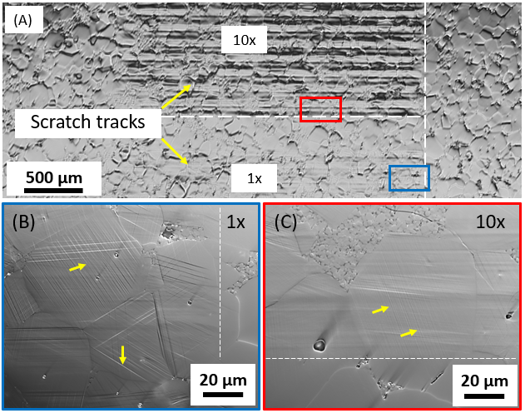

***Fig. S4****: Optical microscope image of the overlapping scratch tracks on type X polycrystalline SrTiO3*. *(A) Overview after 1x (bottom) and 10x (top) with the scratch tracks highlighted with yellow arrows. (B) Zoom into 1x region just at the edge of scratch track, white dashed line differentiates the scratched region from the pristine region. (C) Zoom into 10x region same as in (B) after cyclic Brinell scratching. Some of the slip traces in* ***Figs. S4B and C*** *are highlighted with yellow arrows.*

**References**

[1] X. Fang, O. Preuß, P. Breckner, J. Zhang, W. Lu, Engineering dislocation-rich plastic zones in ceramics via room-temperature scratching, Journal of the American Ceramic Society 106(8) (2023) 4540-4545.