Supporting Information

**The effects of soil microbial disturbance and plants on arsenic concentrations and speciation in soil water and soils**

Hang Guan ([0000-0002-0126-5954](https://orcid.org/0000-0002-0126-5954))†, Veronica Caggìa‡, Andrea Gómez-Chamorro ([0000-0003-1022-2689](https://orcid.org/0000-0003-1022-2689) )¶, Daniela Fischer†, Miquel Coll-Crespí†, Xiaowen Liu†¤, Teresa Chávez-Capilla ([0000-0002-8666-5518](https://orcid.org/0000-0002-8666-5518) )†, Klaus Schlaeppi ([0000-0003-3620-0875](https://orcid.org/0000-0003-3620-0875)) ‡§, Alban Ramette (0000-0002-3437-4639)¶, Adrien Mestrot ([0000-0002-4387-3886](https://orcid.org/0000-0002-4387-3886)) † andMoritz Bigalke ([0000-0002-6793-6159](https://orcid.org/0000-0002-6793-6159)) †

†Institute of Geography, University of Bern, Hallerstrasse 12, CH-3012 Bern, Switzerland

‡Institute of Plant Sciences, University of Bern, Altenbergrain 21, CH-3013 Bern, Switzerland

¶Institute for Infectious Diseases, University of Bern, Friedbühlstrasse 51, CH-3001 Bern, Switzerland

¤Center of Deep Sea Research, Institute of Oceanology, Center for Ocean Mega-Science, Chinese Academy of Sciences, CN-266071 Qingdao, China

§Department of Environmental Sciences, University of Basel, CH-4056 Basel, Switzerland

*Institute of Applied Geoscience, Technical University Darmstadt, Schnittspahnstrasse 9, D-64287 Darmstadt, Germany

Content includes 18 pages with seven tables and 11 figures

Contents

1 Materials and Methods (detailed information) 4

1.1 Soil Incubation 4

1.2 Preparation of Microbial Extracts 4

1.3 Soil spiking with As 4

1.4 Chemical Characterizations of Soils 5

1.5 Greenhosue Conditions 5

1.6 Maize Biomass Estimation Model 6

1.7 Soil Solution Sampling 6

1.8 HPLC Operating Parameters 7

1.9 Arsenic speciation by HPLC-ICP-MS 7

2 Results 8

2.1 Three-way Interaction Effects on Soil Solution and Soils 8

2.2 Time-series Plots 11

**List of Tables**

Table S1. Characterizations of native soil (NS) and disturbed soil (DS). 5

Table S2. The operating parameters for HPLC 7

Table S3. The p values of univariate ANOVA statistical analysis on totAs and As species in soil solution 9

Table S4. The estimated marginal means (emmeans) of totAs and As species concentrations in soil solution 10

Table S5. The p values of MANOVA statistical analysis on As species in soil solution and in soils 10

Table S6. The p values of univariate ANOVA statistical analysis on totAs and As species in soils 11

Table S7. The estimated marginal means (emmeans) of the concentrations of total As (totAs) and various As species in soils 11

**List of Figures**

Figure S1. (a) Preparation of microbial extracts in a concrete mixer and (b) sieving of their supernatants 4

Figure S2. Maize biomass estimation model 6

Figure S3. An example of a soil solution sampler in a 7 L pot 7

Figure S 4: Example chromatogram for As speciation in soil water 8

Figure S5. The totAs concentration in soil solution 12

Figure S6. The inAs concentration in soil solution 13

Figure S7. The orgAs concentration in soil solution 14

Figure S8. The concentration of the individual organic As species in soil solution 15

Figure S9. The concentration of the individual organic As species (a) MMA**V**; (b) DMA**V**; and (c) TMAO in soils 16

Figure S10. The concentration of DOC in soil solution 17

Figure S11. The positive correlations of DOC concentration with (a) totAs concentration and (b) orgAs concentration in the soil solution of As0 group 18

Figure S12. The soil pH 19

# 1 Materials and Methods (detailed information)

## Soil Incubation

After sampling soils from the field, the maximum water holding capacity (WHC) of the soil was measured following the standard of ISO DIS 11268-2. And ISO 11465 was applied to the quantification of soil water content on the same day of soil sampling. During soil incubation time, the water content in soils was hold at 50% of WHC. The soils were incubated for two months in the greenhouse building Nr. 24 in Ostermundigen, Switzerland, until reaching the equilibrium of As concentrations between soil and soil solution phases (data not shown) and simulate aging (Song et al., 2006).

## 1.2 Preparation of Microbial Extracts

**a**

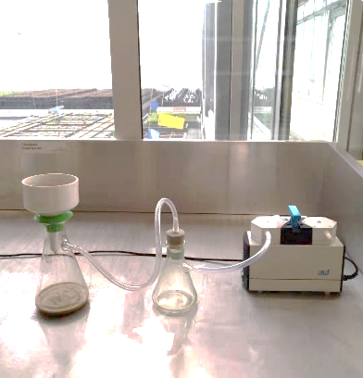

**b**

Figure S1. (a) Preparation of microbial extracts in a concrete mixer and (b) sieving of their supernatants

## 1.3 Soil spiking with As

The soils were sampled, sieved to 1cm and air dried at room temperature. Before and after spiking with As solutions, the soils were fully homogenized through a splitting and combining of the soil samples by diagonal flipping using plastic sheeting, spatula and shovel. Arsenic solutions were added stepwise 4 times to each box and thoroughly mixed with the soils.

Our homogenized method was as follows: we had 25.6kg * 26 boxes soils to be spiked with three different levels of As solutions. A box of 25.6 kg soils was first divided diagonally into four parts with a plastic sheet. Each part was again diagonally divided into four small parts, then each of the four small soil parts was mixed with the each of the small parts from another box (with the same As content). These two combined parts were combined and mixed with other combined parts, randomly distributed among several boxes. In the boxes, these soils were homogenized mixed again with a shovel. During the soil incubation period, for each As-level group, three soil water samplers were randomly placed in the boxes to collect weekly soil water, determining the As levels in soil water, to determine, when As concentrations in soil water stabilized.

## 1.4 Chemical Characterizations of Soils

Table S1. Characterizations of native soil (NS) and disturbed soil (DS).

|  | **pH** | **Clay** | **Silt** | **Sand** | **Corg** | **N** | **S** |
| --- | --- | --- | --- | --- | --- | --- | --- |
|  |  | [%] | [%] | [%] | [g kg-1] | [g kg-1] | [g kg-1] |
| **Native Soil (NS)** | 7.03 ± 0.06 | 17.27 ± 0.76 | 66.04 ± 1.04 | 16.69 ± 0.30 | 21.92 ± 0.12 | 2.70 ± 0.07 | 0.37 ± 0.03 |
| **Disturbed Soil (DS)** | 7.14 ± 0.07 | 17.96 ± 0.80 | 70.95 ± 2.48 | 11.09 ± 3.21 | 22.79 ± 0.08 | 2.76 ± 0.09 | 0.42 ± 0.07 |
|  | **CEC** | **Na** | **Mg** | **Al** | **K** | **Mn** | **Fe** |
|  | [mmolc kg-1] | [g kg-1] | [g kg-1] | [mg kg-1] | [g kg-1] | [g kg-1] | [g kg-1] |
| **Native Soil (NS)** | 268.41 ± 3.40 | 0.33 ± 0.01 | 2.21 ± 0.02 | 11.25 ± 7.30 | 2.40 ± 0.06 | 0.03 ± 0.00 | 21.71 ± 0.20 |
| **Disturbed Soil (DS)** | 282.83 ± 1.12 | 0.32 ± 0.05 | 2.23 ± 0.03 | 10.72 ± 0.54 | 2.64 ± 0.04 g | 0.21 ± 0.00 | 22.21 ± 1.43 |

± standard deviations

## 1.5 Greenhosue Conditions

The maize plants were cultivated in the greenhouse with 14 h of light each day and a temperature of 18 - 26°C during the day and 16 - 24°C at night. The greenhouse cabin is heated in case of temperatures below 18°C during the day and below 16°C at night. The cooling system automatically turns on if the temperature exceeds 26°C. The ventilation system turns on once temperature is over 22°C in the daytime or over 20°C at night. The humidity ranged from 30% to 60%.

## 1.6 Maize Biomass Estimation Model

Maize biomass needs to be known to control soil WHC, but maize cannot be harvested during growth. By developing a model that correlates maize fresh biomass with green pixel areas (Figure S2), we can estimate their fresh biomass over time. We grew 72 maize plants and recorded their images biweekly for four months using a conventional camera and harvested them to determine their actual weight. In our experiment, we applied this estimation model for growing maize plants and controlling WHC at 50% in soils.

Figure S2. Maize biomass estimation model

## 1.7 Soil Solution Sampling

From the side of a pot, a hole was established 2 cm above the water level of the saucer with a wood stick. To avoid space between soils and the soil solution sampler, a soil-water slurry was made to fill the hole. The soil solution sampler was then installed for 10 cm in a pot (Figure S3). The sampler was well fixed in the hole by sealing with a hot melt glue gun. The sampler is composed of three parts: the front tip is a porous part with a bulb diameter of 2.8 mm and a porous tubing of 10 cm with an average pore diameter of 0.15 μm; the middle is an extension tube of 12 cm (made of PE/PVC tubing); and the end is a joint with a female luer lock used to connect the syringe. The sampler was then connected with a 30 mL syringe and extended by a yellow wood stick to suck up soil solution. The pressure of the syringe allowed soil solution to be sampled overnight.

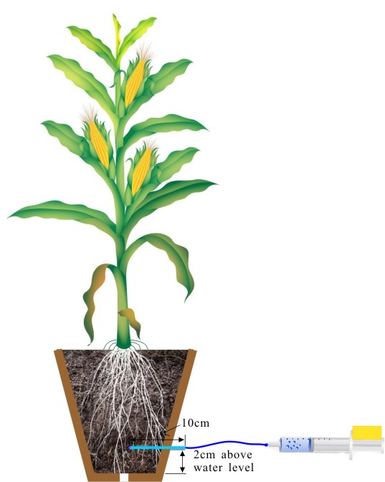

Figure S3. An example of a soil solution sampler in a 7 L pot

## 1.8 HPLC Operating Parameters

Table S2 gives information about the details of HPLC operating parameters. The column recovery for the column was 90.60 ± 14.67 % based on the calculations of 28 soil samples.

Table S2. The operating parameters for HPLC

| HPLC conditions | |
| --- | --- |
| Injection volume | 5 μl |
| Column temperature | 20 °C |
| Mobile phase | 50 mM ammonium carbonate (NH4)2CO3 (pH 8.9) in 3% methanol |
| Flow rate | 1 mL min-1 |
| Calibration standards | DMAV (0 - 150 ppb) |
| Quality controls | DMAV (0.4, 4, and 8 ppb) |

## 1.9 Arsenic speciation by HPLC-ICP-MS

Beside the targeted As species AsV, DMAV, MMAV and TMAO, two unknown species were derected in the chromatogram (figure S4).

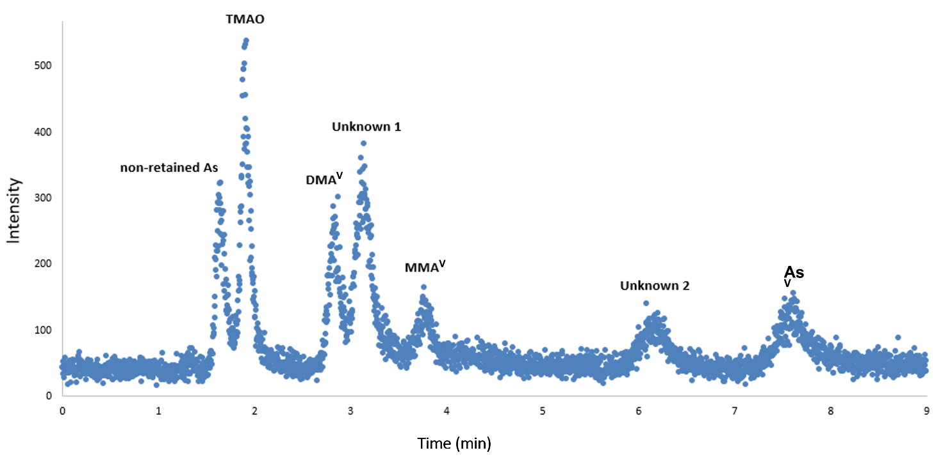

Figure S 4: Example chromatogram for As speciation in soil water

# 2 Results

## 2.1 Three-way Interaction Effects on Soil Solution and Soils

The univariate analysis of variance (ANOVA) results showed that the interaction effects were significant among the three variables of microbial disturbance, plants, and As treatment (p < 0.05), but not with the temporal effect (Table S3). It was also significant between microbial disturbance and As treatment (F4, 397 = 21.428, *p* < 0.001) as well as between plants and As treatment (F2, 397 = 61.668, *p* < 0.001), as shown in Figure S4.

The multivariate analysis of variance (MANOVA) statistical results showed that the three-way and two-way interactions among the microbial disturbance, plants, and As treatment significantly affected As species in soil solution (*p* < 0.001; Table S5). In contrast, MANOVA analysis in soils showed insignificant three-way interactions (F4, 294 = 0.854, p = 0.647), which was also true for the ANOVA statistical results (Table S6). The three-way interactions were insignificant for inAs, orgAs, orgAs%, and individual organic As species (MMAV, DMAV and TMAO). The microbial disturbance made no difference in As speciation in soils. All the three soils had similar levels of inAs, but not of orgAs. Due to the few proportion of orgAs in soils, the difference of orgAs played a negligible role in the statistical result.

Table S3. The p values of univariate ANOVA statistical analysis on totAs and As species in soil solution

| **Independent variables** | **totAs** | **inAs** | **orgAs** | **orgAs%** | **MMAV** | **DMAV** | **TMAO** |
| --- | --- | --- | --- | --- | --- | --- | --- |
| microbial disturbance | *** | 0.020* | *** | *** | *** | *** | *** |
| plants | 0.047* | *** | 0.007** | 0.364 | 0.231 | 0.010** | 0.007** |
| As treatments | *** | *** | *** | *** | *** | *** | *** |
| time | *** | *** | *** | *** | *** | *** | *** |
| microbial disturbance × plants × As treatments | *** | 0.099 | 0.002** | *** | 0.202 | 0.055 | *** |
| microbial disturbance × plants | *** | 0.439 | 0.301 | 0.223 | *** | 0.385 | 0.483 |
| microbial disturbance × As treatments | *** | *** | *** | *** | 0.117 | *** | *** |
| plants × As treatments | *** | *** | *** | 0.003** | 0.006** | *** | 0.032* |

× interaction terms

***: *p* < 0.001; **: significant at α = 0.01; *: significant at α = 0.05

Table S4. The estimated marginal means (emmeans) of totAs and As species concentrations in soil solution

|  |  |  |  |  |  |  |  |
| --- | --- | --- | --- | --- | --- | --- | --- |
| **Treatments** | **totAs**  **µg/kg** | **inAs**  **µg/kg** | **orgAs**  **µg/kg** | **orgAs %**  **%** | **MMAV**  **µg/kg** | **DMAV**  **µg/kg** | **TMAO**  **µg/kg** |
| As0-NS-NP | 2.82 ± 0.20 | 1.73 ± 0.11 | 1.64 ± 0.19 | 47.7 ± 4.31 | 1.06 ± 0.04 | 1.07 ± 0.10 | 1.09 ± 0.14 |
| As0-RS-NP | 5.59 ± 0.36 | 1.75 ± 0.11 | 2.62 ± 0.29 | 68.3 ± 5.90 | 1.07 ± 0.04 | 1.19 ± 0.11 | 1.36 ± 0.17 |
| As0-DS-NP | 7.76 ± 0.55 | 1.89 ± 0.13 | 3.43 ± 0.39 | 71.9 ± 6.50 | 1.15 ± 0.04 | 1.32 ± 0.13 | 1.78 ± 0.24 |
| As100-NS-NP | 217 ± 26.4 | 132 ± 10.2 | 2.88 ± 0.38 | 2.44 ± 0.26 | 1.08 ± 0.05 | 1.37 ± 0.15 | 1.93 ± 0.30 |
| As100-RS-NP | 239. ± 16.0 | 181 ± 11.6 | 6.57 ± 0.72 | 3.98 ± 0.35 | 1.09 ± 0.04 | 1.81 ± 0.17 | 3.83 ± 0.49 |
| As100-DS-NP | 255 ± 16.2 | 190 ± 11.9 | 10.1 ± 1.10 | 5.51 ± 0.48 | 1.39 ± 0.05 | 2.99 ± 0.27 | 5.42 ± 0.68 |
| As200-NS-NP | 872 ± 82.1 | 682 ± 59.9 | 2.76 ± 0.42 | 1.32 ± 0.16 | 1.11 ± 0.06 | 1.62 ± 0.21 | 1.57 ± 0.28 |
| As200-RS-NP | 962 ± 67.7 | 689 ± 48.0 | 8.47 ± 1.02 | 2.19 ± 0.21 | 1.11 ± 0.04 | 1.81 ± 0.18 | 4.77 ± 0.67 |
| As200-DS-NP | 941 ± 62.9 | 665 ± 45.5 | 4.66 ± 0.55 | 1.58 ± 0.15 | 1.28 ± 0.05 | 1.50 ± 0.15 | 2.32 ± 0.32 |
| As0-NS-P | 5.71 ± 0.49 | 1.76 ± 0.13 | 2.09 ± 0.27 | 59.8 ± 6.18 | 1.07 ± 0.05 | 1.20 ± 0.13 | 1.12 ± 0.17 |
| As0-RS-P | 7.02 ± 0.40 | 1.86 ± 0.11 | 2.87 ± 0.30 | 68.1 ± 5.70 | 1.17 ± 0.04 | 1.23 ± 0.11 | 1.37 ± 0.17 |
| As0-DS-P | 8.00 ± 0.48 | 1.97 ± 0.12 | 3.15 ± 0.32 | 68.4 ± 5.50 | 1.12 ± 0.04 | 1.34 ± 0.11 | 1.45 ± 0.17 |
| As100-NS-P | 133 ± 13.0 | 126 ± 9.50 | 2.25 ± 0.29 | 2.13 ± 0.22 | 1.10 ± 0.05 | 1.19 ± 0.13 | 1.34 ± 0.20 |
| As100-RS-P | 162 ± 8.30 | 152 ± 8.00 | 5.94 ± 0.56 | 5.09 ± 0.35 | 1.14 ± 0.03 | 1.55 ± 0.11 | 3.65 ± 0.37 |
| As100-DS-P | 221 ± 12.8 | 162 ± 9.00 | 5.38 ± 0.51 | 3.63 ± 0.27 | 1.17 ± 0.04 | 1.81 ± 0.15 | 3.20 ± 0.35 |
| As200-NS-P | 733 ± 77.9 | 467 ± 39.8 | 3.34 ± 0.49 | 1.57 ± 0.18 | 1.18 ± 0.06 | 1.40 ± 0.17 | 2.31 ± 0.39 |
| As200-RS-P | 791 ± 42.4 | 579 ± 30.5 | 6.76 ± 0.62 | 2.09 ± 0.15 | 1.23 ± 0.04 | 2.18 ± 0.17 | 3.44 ± 0.36 |
| As200-DS-P | 690 ± 38.0 | 476 ± 26.0 | 5.72 ± 0.54 | 2.05 ± 0.15 | 1.28 ± 0.04 | 1.80 ± 0.14 | 2.89 ± 0.32 |

± standard errors; NP: No-plant pots and P: Plant pots

Table S5. The p values of MANOVA statistical analysis on As species in soil solution and in soils

| **Independent variables** | **As species in soil solution** | **As species in soil** |
| --- | --- | --- |
| microbial disturbance | *** | 0.337 |
| plants | *** | 0.022* |
| As treatments | *** | *** |
| time | *** | *** |
| microbial disturbance × plants × As treatments | *** | 0.647 |
| microbial disturbance × plants | 0.008** | 0.941 |
| microbial disturbance × As treatments | *** | 0.236 |
| plants × As treatments | *** | 0.126 |

× interaction terms

***: *p* < 0.001; **: significant at α = 0.01; *: significant at *α* = 0.05

Table S6. The p values of univariate ANOVA statistical analysis on totAs and As species in soils

| **Independent variables** | **inAs** | **orgAs** | **orgAs%** | **MMAV** | **DMAV** | **TMAO** |
| --- | --- | --- | --- | --- | --- | --- |
| microbial disturbance | 0.459 | 0.639 | 0.996 | 0.021* | 0.737 | 0.419 |
| plants | 0.610 | 0.046* | 0.016* | 0.208 | 0.075 | 0.003** |
| As treatments | *** | *** | *** | *** | *** | *** |
| time | *** | *** | 0.607 | *** | *** | *** |
| microbial disturbance × plants × As treatments | 0.727 | 0.676 | 0.981 | 0.225 | 0.940 | 0.219 |
| microbial disturbance × plants | 0.447 | 0.710 | 0.977 | 0.565 | 0.752 | 0.374 |
| microbial disturbance × As treatments | 0.478 | 0.620 | 0.242 | 0.021* | 0.764 | 0.482 |
| plants × As treatments | 0.186 | 0.835 | 0.008** | 0.681 | 0.670 | 0.525 |

*×* interaction terms

***: *p* < 0.001; **: significant at α = 0.01; *: significant at α = 0.05

Table S7. The estimated marginal means (emmeans) of the concentrations of total As (totAs) and various As species in soils

|  |  |  |  |  |  |  |
| --- | --- | --- | --- | --- | --- | --- |
| **Treatments** | **inAs**  **µg/kg** | **orgAs**  **µg/kg** | **orgAs %**  **%** | **MMAV**  **µg/kg** | **DMAV**  **µg/kg** | **TMAO**  **µg/kg** |
| As0-NS-NP | 727 ± 109.7 | 37.6 ± 13.48 | 5.84 ± 0.55 | 3.56 ± 1.80 | 31.2 ± 8.52 | 1.83 ± 0.68 |
| As0-RS-NP | 778 ± 124.5 | 38.3 ± 14.29 | 5.62 ± 0.56 | 3.16 ± 1.70 | 27.4 ± 7.93 | 2.49 ± 0.98 |
| As0-DS-NP | 987 ± 148.8 | 44.7 ± 13.48 | 5.14 ± 0.48 | 6.88 ± 3.49 | 33.6 ± 9.16 | 1.26 ± 0.47 |
| As100-NS-NP | 44421 ± 6700 | 69.0 ± 13.48 | 1.15 ± 0.11 | 6.51 ± 3.29 | 49.3 ± 13.45 | 2.46 ± 0.92 |
| As100-RS-NP | 43391 ± 6545 | 88.7 ± 13.48 | 1.19 ± 0.11 | 13.41 ± 6.79 | 40.1 ± 10.94 | 4.68 ± 1.74 |
| As100-DS-NP | 41443 ± 6251 | 115.2 ± 13.48 | 1.26 ± 0.12 | 20.40 ± 10.33 | 42.8 ± 11.68 | 8.17 ± 3.04 |
| As200-NS-NP | 107111 ± 16157 | 93.9 ± 13.48 | 1.09 ± 0.11 | 7.73 ± 3.91 | 64.4 ± 17.57 | 3.27 ± 1.22 |
| As200-RS-NP | 102585 ± 15474 | 145.7 ± 13.48 | 1.14 ± 0.11 | 23.86 ± 12.08 | 88.3 ± 24.10 | 2.50 ± 0.93 |
| As200-DS-NP | 108431 ± 16356 | 169.8 ± 13.48 | 1.15 ± 0.11 | 14.13 ± 7.15 | 103.9 ± 28.37 | 6.70 ± 2.49 |
| As0-NS-P | 895 ± 76.5 | 38.4 ± 7.64 | 4.59 ± 0.24 | 3.63 ± 1.04 | 24.2 ± 3.74 | 1.49 ± 0.31 |
| As0-RS-P | 1154 ± 109 | 39.9 ± 8.43 | 4.23 ± 0.25 | 5.69 ± 1.80 | 26.6 ± 4.54 | 1.31 ± 0.31 |
| As0-DS-P | 1007 ± 95 | 37.8 ± 8.43 | 4.02 ± 0.24 | 4.01 ± 1.27 | 24.0 ± 4.10 | 1.32 ± 0.31 |
| As100-NS-P | 41774 ± 3451 | 66.5 ± 7.38 | 1.15 ± 0.06 | 9.14 ± 2.53 | 40.6 ± 6.07 | 2.20 ± 0.45 |
| As100-RS-P | 44979 ± 3992 | 74.7 ± 7.93 | 1.16 ± 0.06 | 7.38 ± 2.20 | 43.3 ± 6.96 | 2.94 ± 0.64 |
| As100-DS-P | 45206 ± 4092 | 73.3 ± 8.09 | 1.16 ± 0.07 | 8.41 ± 2.56 | 43.5 ± 7.13 | 2.39 ± 0.53 |
| As200-NS-P | 104216 ± 8610 | 85.3 ± 7.38 | 1.08 ± 0.06 | 4.90 ± 1.36 | 57.1 ± 8.53 | 2.16 ± 0.44 |
| As200-RS-P | 107456 ± 10139 | 139.3 ± 8.43 | 1.14 ± 0.07 | 25.73 ± 8.15 | 74.7 ± 12.76 | 2.11 ± 0.49 |
| As200-DS-P | 92074 ± 8171 | 130.6 ± 7.93 | 1.18 ± 0.07 | 20.94 ± 6.24 | 72.2 ± 11.59 | 2.1 ± 0.47 |

± standard errors; NP: No-plant pots and P: Plant pots

## 2.2 Time-series Plots

According to ANOVA results on Table S5, significant difference was observed for MMA**V**, DMA**V**, and TMAO concentrations in soil solution for all four variables (microbial disturbance, plants, As treatment, and time) (*p* < 0.05) (Figure S7). The concentrations of MMA**V**, DMA**V**, and TMAO in soils were affected by the time effect (*p* < 0.001), which explained the large variations in the boxplot (Figure S8).

Figure S5. The totAs concentration in soil solution of (a) No-plant_As0 group; (b) Plant_As0 group; (c) No-plant_As100 group; (d) Plant_As100 group; (e) No-plant _As200 group; and (f) Plant_As200 group

Figure S6. The inAs concentration in soil solution of (a) No-plant_As0 group; (b) Plant_As0 group; (c) No-plant_As100 group; (d) Plant_As100 group; (e) No-plant_As200 group; and (f) Plant_As200 group

Figure S7. The orgAs concentration in soil solution of (a) No-plant_As0 group; (b) Plant_As0 group; (c) No-plant_As100 group; (d) Plant_As100 group; (e) No-plant_As200 group; and (f) Plant_As200 group

Figure S8. The concentration of the individual organic As species (a) MMA**V**; (b) DMA**V**; and (c) TMAO in soil solution

Figure S9. The concentration of the individual organic As species (a) MMA**V**; (b) DMA**V**; and (c) TMAO in soils

Figure S10. The concentration of DOC in soil solution of (a) No-plant_As0 group; (b) Plant_As0 group; (c) No-plant_As100 group; (d) Plant_As100 group; (e) No-plant_As200 group; and (f) Plant_As200 group

Missing data were due to insufficient quantity of samples.

Figure S11. The positive correlations of DOC concentration with (a) totAs concentration and (b) orgAs concentration in the soil solution of As0 group

Figure S12. The soil pH in (a) No-plant_As0 group; (b) Plant_As0 group; (c) No-plant_As100 group; (d) Plant_As100 group; (e) No-plant_As200 group; and (f) Plant_As200 group. Each sampling point contains 2-6 soil solution samples with standard deviation calculated based on the ion concentration, which was too small to be visible. Missing data were due to insufficient quantity of samples.

**References**

Song J, Zhao F-J, McGrath SP, Luo Y-M. Influence of soil properties and aging on arsenic phytotoxicity. Environmental toxicology and chemistry 2006;25(6):1663–70.