*For submission to The Holocene*

**Historical trend of polycyclic aromatic hydrocarbons in a sediment core from Osaka Bay during the Meghalayan**

Kai Nils Nitzsche‡, Naoto F. Ishikawa, Toshihiro Yoshimura, Hiroto Kajita, Hodaka Kawahata, Nanako O. Ogawa, Hisami Suga and Naohiko Ohkouchi

Email contact: nitzsche@geo.tu-darmstadt.de

Ein Bild, das Text, Karte, Diagramm, Schrift enthält.

Figure S1. Kawachi Lake during the 3rd and 4th centuries CE The location of Naniwa no Horie canal and the port Naniwa-tsu (constructed in the 5th century AD), of Naniwa Palace and the present Yodo River and Yamato River are also shown. The figure is reproduced from Nitzsche et al. (2022) and was modified after Kajiyama and Itihara (1986), Kajiyama and Itihara (1972) and Kusaka (2012).

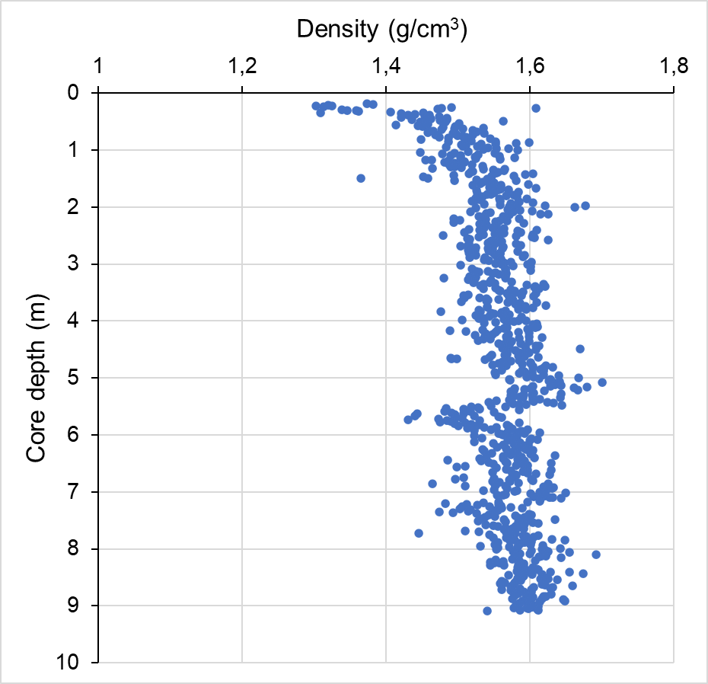

Figure S2. Depth profile of the wet density determined by gamma ray transmission. Note that the pattern is relatively constant.



Figure S3. Historical trend of individual polycyclic aromatic hydrocarbons (PAH).

Ein Bild, das Text, Reihe, Screenshot, Diagramm enthält.

Figure S4. Historical trend of the ratios of Ant/(Ant+Phe) and of BaA/(BaA+Chr).

Ein Bild, das Text, Screenshot, Diagramm, Reihe enthält.

Figure S5. Historical trend of perylene.

**References**

Kajiyama H and Ichihara M (1986) *Osaka Heiya No Oitachi (Life History of the Osaka Plain)*. Tokyo: Aoki Shoten (In Japanese).

Kajiyama H and Itihara M (1972) The developmental history of the Osaka Plain with references to the radio-carbon dates. *The Geological Society of Japan* 7: 101–112.

Kusaka M (2012) *History from the Topography*. Tokyo: Kodansha (In Japanese).

Nitzsche KN, Yoshimura T, Ishikawa NF, et al. (2022) Metal contamination in a sediment core from Osaka Bay during the last 400 years. *Progress in Earth and Planetary Science* 9: 58.