Supporting information

Combination of hydrophobicity and codon usage bias determines sorting of model K⁺ channel protein to either mitochondria or endoplasmic reticulum.

Anja J. Engel¹, Steffen Paech², Markus Langhans², James L. Van Etten³, Anna Moroni⁴, Gerhard Thiel¹, Oliver Rauh¹.

Figure S1

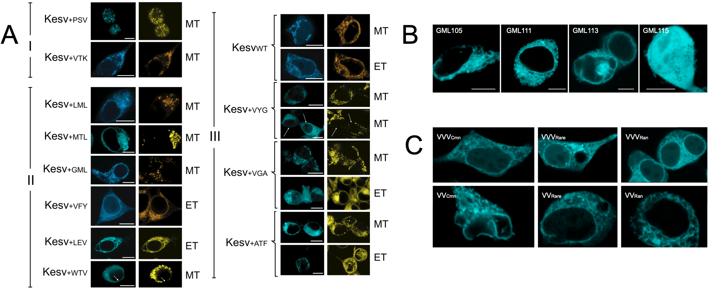
Figure 1: Sorting destiny of Kesv with insertion of AA triplet in ct-TMD. (A) Exemplary fluorescent images of HEK293 cells transfected with Kesv₊₃ in which the constructs are positively sorted according to classification of Fig. 2A to the mitochondria (type I), to the ER (type II) or to either of the two destinations (type III). Images in left panels show fluorescence (cyan) from GFP tagged Kesv₊₃ constructs given on the left of images. The same cells were stained (yellow) with either ER-TrackerTM Red (ET) or MitoTrackerTM Red (MT) as indicated on the right of images. In the case of Kesv_{+WTV} and Kesv_{+VYG} arrows indicate the presence of staining of the perinuclear ring in the GFP channel and the absence of staining in the MitoTrackerTM Red channel. All scale bares 10 µm. (B). Exemplary fluorescent images (cyan) of HEK293 cells transfected with GFP tagged Kesv₊₃ constructs containing the AA triplets given in individual panels. Scale bars 10 µm. (C) Exemplary fluorescent images (cyan) from HEK293 cells transfected with GFP tagged Kesv_{+GML} in which GML triplet was inserted in positions indicated in images. All scale bars 10 µm.

Figure S2

Figure S2: Effect of randomization of CUB values on the Pearson correlation coefficient for Kesv₊₃ sorting to the ER as function of the product of hydrophobicity and codon usage bias (HyP x CUB). To address the question if a Pearson correlation coefficient r(pearson) of 0.5459 for sorting of Kesv₊₃ constructs with randomly chosen codons to the ER as function of HyP x CUB is a coincidence, the CUB values of all 11 constructs from Fig. 1 were randomized before multiplication with the HyP values. The absolute frequency distribution of the calculated correlation coefficients of all possible combinations (11! = 39,916,800) is shown as histogram with a bin width of 0.01. The distribution shows a mean value of 0.0466 with a standard deviation of 0.2349. A correlation coefficient greater than the one of the original data set (r = 0.5459) is found for only 1.36% of all possible combinations (red area).

Figure S3
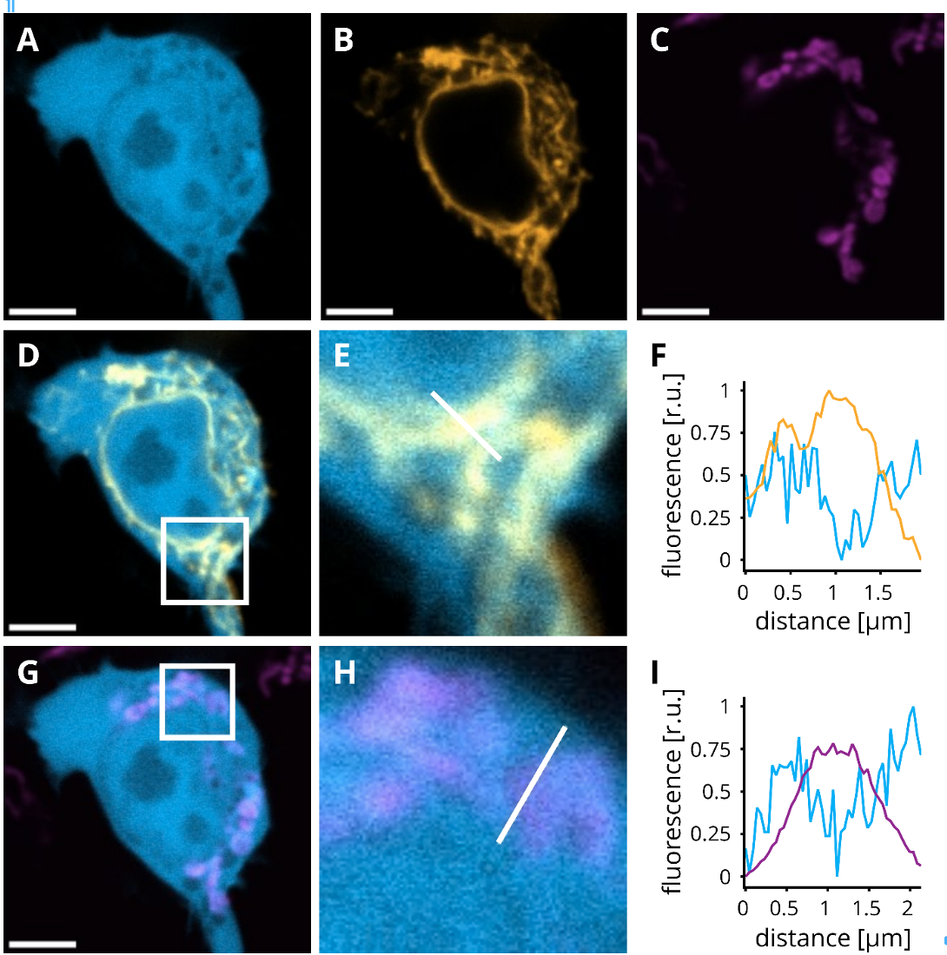

Figure S3: Fluorescent images of HEK293 cell transfected with Kesv_{+QQQ} in position 113. Fluorescent images of an exemplary HEK293 cell transfected A: Kesv_{+QQQ}::eGFP; B: ER marker HDEL::mCherry, C: MitoTrackerTM DeepRed; Overlay images of A and B in D and A and C in G. Image in E and H are blow ups from white frames in D and G respectively. F and I: Line Plots with normalized fluorescence intensity along lines in E and H respectively show coincidence of a minimum in GFP signal with a maximum of yellow ER marker (E) or turquoise mitochondria dye (H). Scale bars: 5 µm.

Table S1: Prediction of ct-TMD fold and length for Kesv wt and insertion mutants Kesv₊₃. Start and end of ct-TMD with corresponding number of amino acids (AA) forming the ct-TMD2 as well as the proposed fold, was obtained from structural prediction algorithm DeepTMHMM [Hallgren et al. 2022]. Fold of ct-TMD as well as its length was also obtained from structural predictions by AlphaFold [Jumper et al. 2021]. The length of the respective TMDs in Å was measured as distance in the predicted structure between first and last alpha C-atom in this domain with ChimeraX [Pettersen et al. 2021].

Prediction from DeepTMHMM Prediction from AlphaFold
Protein | AA for start of ct-TMD | AA for end of ct-TMD | Length of ct-TMD in AA | Predicted domain fold | Length of ct-TMD in Å | Predicted domain fold
Kesv _{wt} | 101 | 118 | 17 | 𝛼-helix | 25.701 | 𝛼-helix
Kesv_{+ATF} | 101 | 118 | 17 | 𝛼-helix | 26.157 | 𝛼-helix
Kesv_{+GML} | 101 | 121 | 20 | 𝛼-helix | 29.853 | 𝛼-helix
Kesv_{+LEV} | 101 | 118 | 17 | 𝛼-helix | 25.891 | 𝛼-helix
Kesv_{+LML} | 101 | 118 | 17 | 𝛼-helix | 25.982 | 𝛼-helix
Kesv_{+LVA} | 101 | 118 | 17 | 𝛼-helix | 26.116 | 𝛼-helix
Kesv_{+LVA} | 101 | 118 | 17 | 𝛼-helix | 26.115 | 𝛼-helix
Kesv_{+MTL} | 101 | 118 | 17 | 𝛼-helix | 26.082 | 𝛼-helix
Kesv_{+PSV} | 101 | 118 | 17 | 𝛼-helix | 26.824 | 𝛼-helix
Kesv_{+SKA} | 101 | 121 | 20 | 𝛼-helix | 29.633 | 𝛼-helix
Kesv_{+VFY} | 101 | 118 | 17 | 𝛼-helix | 26.053 | 𝛼-helix
Kesv_{+VGA} | 101 | 118 | 17 | 𝛼-helix | 25.993 | 𝛼-helix
Kesv_{+VTK} | 101 | 118 | 17 | 𝛼-helix | 26.122 | 𝛼-helix
Kesv_{+VYG} | 101 | 118 | 17 | 𝛼-helix | 25.807 | 𝛼-helix
Kesv_{+WTF} | 101 | 118 | 17 | 𝛼-helix | 26.013 | 𝛼-helix
Kesv_{+WTV} | 101 | 118 | 17 | 𝛼-helix | 25.998 | 𝛼-helix
Kesv_{+AAA} | 101 | 118 | 17 | 𝛼-helix | 26.073 | 𝛼-helix
Kesv_{+EEE} | 101 | 118 | 17 | 𝛼-helix | 26.017 | 𝛼-helix
Kesv_{+III} | 101 | 118 | 17 | 𝛼-helix | 26.047 | 𝛼-helix
Kesv_{+LLL} | 101 | 118 | 17 | 𝛼-helix | 25.723 | 𝛼-helix
Kesv_{+QQQ} | 101 | 118 | 17 | 𝛼-helix | 26.085 | 𝛼-helix
Kesv_{+RRR} | 101 | 118 | 17 | 𝛼-helix | 26.146 | 𝛼-helix
Kesv_{+SSS} | 101 | 121 | 20 | 𝛼-helix | 29.841 | 𝛼-helix
Kesv_{+TTT} | 101 | 121 | 20 | 𝛼-helix | 29.700 | 𝛼-helix
Kesv_{+WWW} | 101 | 118 | 17 | 𝛼-helix | 25.896 | 𝛼-helix
Kesv_{+VVV} | 101 | 118 | 17 | 𝛼-helix | 26.14 | 𝛼-helix
Kesv_{+VV} | 101 | 120 | 19 | 𝛼-helix | 27.104 | 𝛼-helix
Kesv_{+V} | 101 | 116 | 15 | 𝛼-helix | 22.192 | 𝛼-helix
Kesv_{+KVT} | 101 | 121 | 20 | 𝛼-helix | 29.663 | 𝛼-helix
Kesv_{+VKT} | 101 | 121 | 20 | 𝛼-helix | 29.630 | 𝛼-helix
Kesv_{+EKE} | 101 | 118 | 17 | 𝛼-helix | 25.984 | 𝛼-helix
Kesv_{+KEE} | 101 | 118 | 17 | 𝛼-helix | 26.058 | 𝛼-helix
Kesv_{+EEK} | 101 | 118 | 17 | 𝛼-helix | 26.000 | 𝛼-helix
Referees
Hallgren, J., Tsirigos, K.D., Pedersen, M.D., et al. (2022). DeepTMHMM predicts alpha and beta transmembrane proteins using deep neural networks. bioRxiv, DOI: 10.1101/2022.04.08.487609.
Pettersen, E.F., Goddard, T.D., Huang, C.C., Meng, E.C., Couch, G.S., Croll, T.I., Morris, J.H., Ferrin, T.E. (2021). UCSF ChimeraX: Structure visualization for researchers, educators, and developers. Protein Sci. 30(1), 70-82.
Table S2. List of codons for insertion of one to three amino acids in ct-TMD of Kesv. Synonymous codons for amino acids (in one letter code) were chosen according to the following criteria:
- Codons which are most common in mammalian cells (Cmn)
- Codons which are the least common (Rar)
- Random choice of codons (Rand)

Amino acids Codon
ATF_{Rare} GCG ACG TTT
ATF_{Ran} GCG ACC TTC
ATF_{Cmn} GCC ACC TTC

GML_{Rare} GGT ATG TTA
GML_{Ran} GGG ATG TTG
GML_{Cmn} GGC ATG CTG

LEV_{Rare} TTA GAA GTA
LEV_{Ran} TTG GAG GTG
LEV_{Cmn} CTG GAG GTG

LML_{Rare} TTA ATG TTA
LML_{Ran} TTG ATG TTG
LML_{Cmn} CTG ATG CTG

LVA_{Rare} TTA GTA GCG
LVA_{Ran} TTG GTG GCG
LVA_{Cmn} CTG GTG GCC

MTL_{Rare} ATG ACG TTA
MTL_{Ran} ATG ACC TTG
MTL_{Cmn} ATG ACC CTG

PSV_{Rare} CCG TCG GTA
PSV_{Ran} CCC TCT GTG
PSV_{Cmn} CCC AGC GTG

SKA_{Rare} TCA AAA GCG
SKA_{Ran} TCC AAG GCG
SKA_{Cmn} ACG AAG GCC

VFY_{Rare} GTA TTT TAT
VFY_{Ran} GTG TTC TAC
VFY_{Cmn} GTG TTC TAC

VGA_{Rare} GTA GGT GCG
VGA_{Ran} GTG GGC GCG
VGA_{Cmn} GTG GGC GCC

VTK_{Rare} GTA ACG AAA
VTK_{Ran} GTG ACC AAG
VTK_{Cmn} GTG ACC AAG

VYG_{Rare} GTA TAT GGT
VYG_{Ran} GTG TAC GGC
VYG_{Cmn} GTG TAC GGC

WTF_{Rare} TGG ACG TTT
WTF_{Ran} TGG ACT TTC
WTF_{Cmn} TGG ACC TTC

WTV_{Rare} TGG ACG GTA
WTV_{Ran} TGG ACC GTG
WTV_{Cmn} TGG ACC GTG

AAA_{Rare} GCG GCG GCG
AAA_{Cmn} GCC GCC GCC

EEE_{Rare} GAA GAA GAA
EEE_{Cmn} GAG GAG GAG

III_{Rare} ATA ATA ATA
III_{Cmn} ATC ATC ATC

LLL_{Rare} CTA CTA CTA
LLL_{Cmn} CTG CTG CTG

QQQ_{Rare} CAA CAA CAA
QQQ_{Cmn} CAG CAG CAG

RRR_{Rare} CGA CGA CGA
RRR_{Cmn} CGG CGG CGG

SSS_{Rare} TCG TCG TCG
SSS_{Cmn} AGC AGC AGC

TTT_{Rare} ACG ACG ACG
TTT_{Ran} ACC ACC ACC
TTT_{Cmn} ACC ACC ACC

VVV_{Rare} GTA GTA GTA
VVV_{Ran} GTG GTG GTG
VVV_{Cmn} GTG GTG GTG

WWW TGG TGG TGG

V_{Rare} GTA
V_{Ran} GTC
V_{Cmn} GTG

VV_{Rare} GTA GTA
VV_{Ran} GTA GTG
VV_{Cmn} GTG GTG

KVT_{Cmn} AAG GTG ACC
VKT_{Cmn} GTG AAG ACC

EKE_{Cmn} GAG AAG GAG

KEE_{Cmn} AAG GAG GAG

EEK_{Cmn} GAG GAG AAG

