Supplementary Material

The catalytic domain of free or ligand bound histone deacetylase 4 occurs in solution predominantly in closed conformation

Markus Schweipert¹, Thomas Nehls², Anton Frühauf¹, Cecilé Debarnot¹, Adarsh Kumar³, Stefan Knapp³, Frederik Lermyte², Franz-Josef Meyer-Almes^{1*}
¹Department of Chemical Engineering and Biotechnology, University of Applied Sciences, 64295 Darmstadt, Germany
²Department of Chemistry, Clemens-Schöpf-Institute of Chemistry and Biochemistry, Technical University of Darmstadt, 64287 Darmstadt, Germany
³ Institut für Pharmazeutische Chemie, Goethe-University Frankfurt, Biozentrum, Max-von-Laue-Str. 9, 60438, Frankfurt Am Main, Germany

*Corresponding author: franz-josef.meyer-almes@h-da.de,
Keywords:
HDAC4, CONFORMATIONS, CONFORMATION SENSITIVE MASS SPECTROMETRY, NMR, LIGAND BINDING

Table of contents

Fig. S1: Overlap of the re-evaluated structure from this study (magenta) and 2VQJ (cyan). 4
Fig. S2: Crystal packing analysis.. 5
Tab. S3: GBVI/WSA dG scores of HDAC4-ligand complex structures. 5
Fig. S4: Redocking of the co-crystallized hydroxamic acid inhibitor in complex with HDAC4 (PDB-ID: 4CBY). 5
Fig. S5: Melting curves of HDAC4 wild type and Cys669Ala/His674Ala variant.. 6
Fig. S6: Thermal stabilization of HDAC4 and Cys669Ala/His674Ala variant by SATFMK and the TFG ligand.. 6
Fig. S7: Thermal stabilization of HDAC4 by the TFG ligand in NMR buffer system.. 7
Fig. S8: Full spectra of 19F-NMR measurements. 8
Tab. S9: Composition of M9 minimal media. 8
Tab. S10: Primer for HDAC4 variants. 8
Tab. S11: Charge states and literature CCS-values used for the calibrants for helium-nitrogen regression (IM-MS) based on data from Bush lab.(1) 8
Fig. S12: Helium-nitrogen regression plot for IM-MS. 11
Fig. S13: Mass spectra of HDAC4 WT and Cys669Ala/His675Ala.. 12
Fig. S14: 2D mobilogram with drift time as ordinate and mass-to-charge ratio as abscissa for HDAC4 WT.. 13
Fig. S15: Mobilograms of HDAC4 WT with all measured ligands, its apo form and Cys669Ala/His675Ala variant.. 14
Fig. S16: 1D-MS data of charge states comparing (A) wild type and (B) double mutant variant. 15
Fig. S17: Change in microenvironment of a modeled tfmPhe746 between the proposed open (A) and closed (B) conformation of HDAC4 with distances between the CF3 moiety of tmfPhe and neighboring atoms of side chains. 16
Fig. S18: (A) 2D mobilogram with drift time as ordinate and mass-to-charge ratio as abscissa for HDAC4 WT showing only low degree of dimerization (B) Corresponding 1D mass spectra. Charges Peaks are labeled with corresponding charges. 17

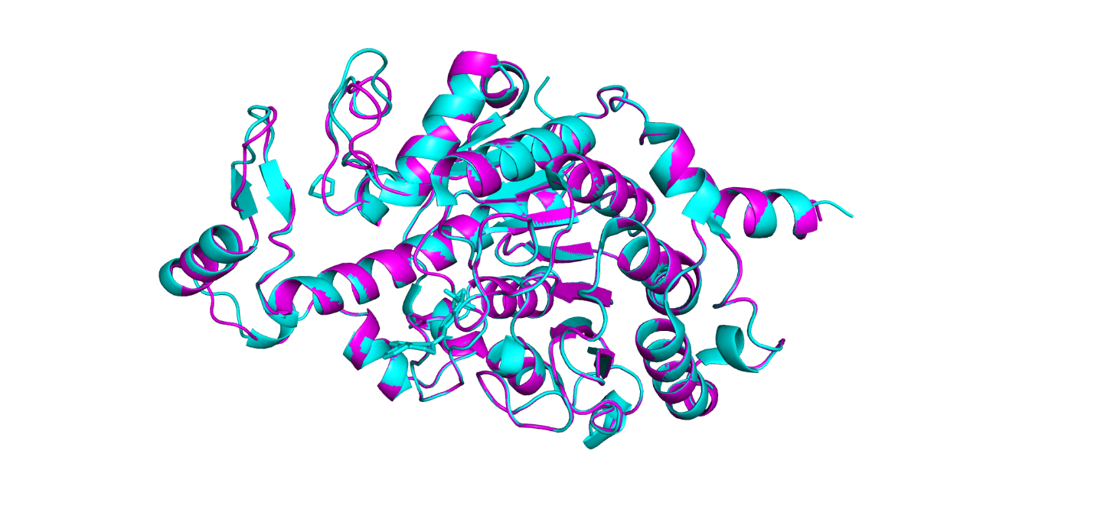
Fig. S1: Overlap of the re-evaluated structure from this study (magenta) and 2VQJ (cyan).

Fig. S2: Crystal packing analysis. An overall comparison of our re-evaluated structure (magenta) with 5ZOP (grey; closed conformation) A) The positions of loop1 and loop2 are highlighted for our structure (red) and 5ZOP (blue). (B and C) The shows symmetry molecule (blue) occupying same region as the loops in closed conformation. Red dotted line represents the disordered region of loop2 in 5ZOP. D) Zoomed-in view of loop1 region. The overlap of open loop2 with closed loop1 is shown by an arrow suggesting loop2 could also push the loop1 open and occupy its position.

Tab. S3: GBVI/WSA dG scores of HDAC4-ligand complex structures.
Protein-ligand complex | Score (GBVI/WSA dG)
HDAC4c (PDB-ID: 4CBY) + co-crystallized hydroxamate ligand | -12.0
HDAC4c (PDB-ID: 4CBY) + docked TFG ligand | -14.6
HDAC4o (PDB-ID: 2VQJ) + co-crystallized TFG ligand | -13.2
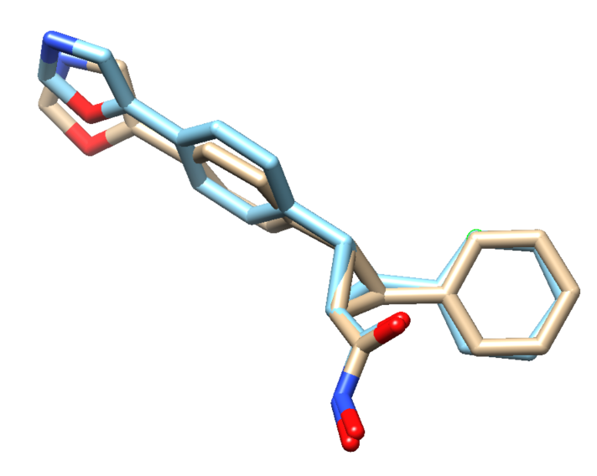

Fig. S4: Redocking of the co-crystallized hydroxamic acid inhibitor in complex with HDAC4 (PDB-ID: 4CBY).

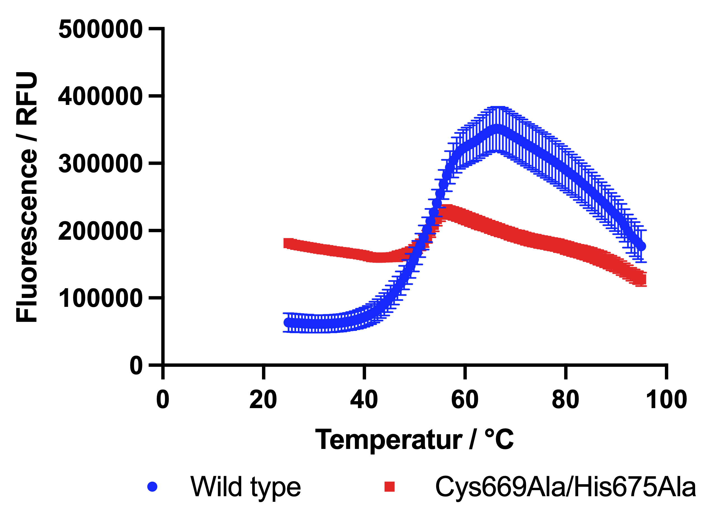

Fig. S5: Melting curves of HDAC4 wild type and Cys669Ala/His674Ala variant. Error bars are displayed as standard deviation (n=4).

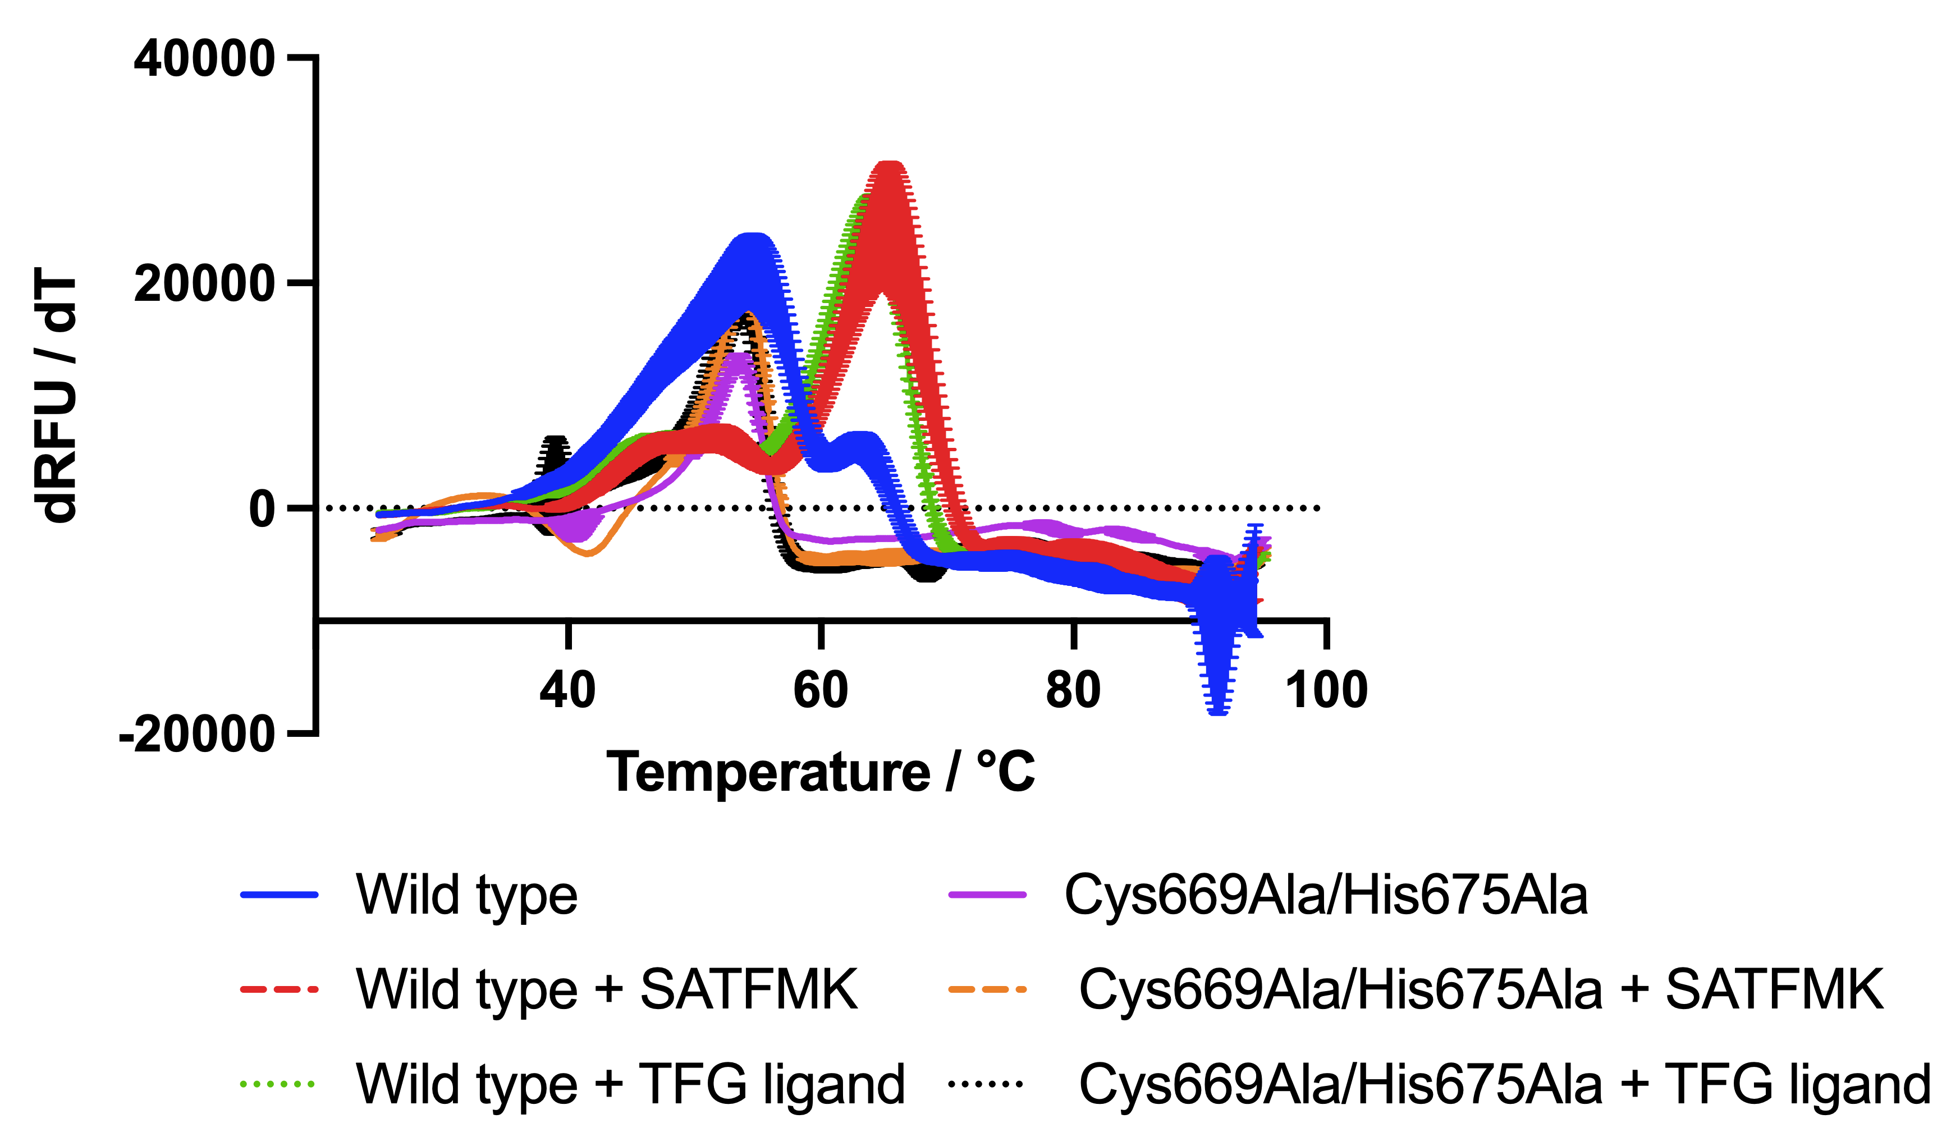

Fig. S6: Thermal stabilization of HDAC4 and Cys669Ala/His674Ala variant by SATFMK and the TFG ligand. Error bars are displayed as standard deviation (n=4).

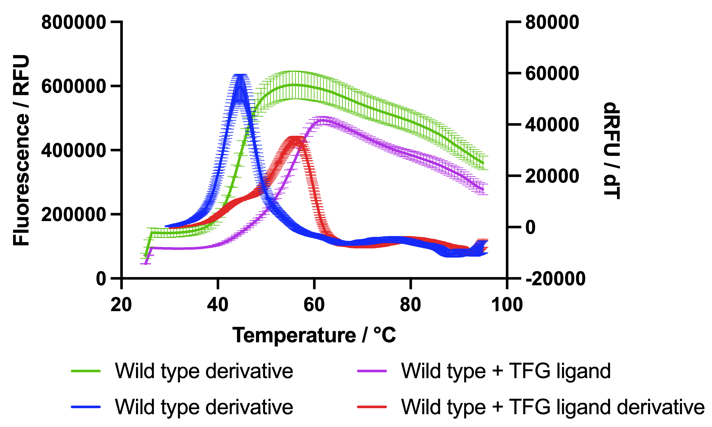

Fig. S7: Thermal stabilization of HDAC4 by the TFG ligand in NMR buffer system. Error bars are displayed as standard deviation (n=4).

Fig. S8: Full spectra of 19F-NMR measurements. (A) Spectrum of unlabelled protein, (B) free amino acid (tfmPhe), (C) labelled protein and (D) labelled protein in presence of the TFG ligand. Spectra were calibrated relative to the artefact at -75.25 ppm

Tab. S9: Composition of M9 minimal media. Based on the protocol of Arie Geerlof, Helmholtz Center Munich
Ingredient | Concentration
Na₂HPO₄* | 33.7 mM
KH₂PO₄* | 22.0 mM
NaCl* | 8.55 mM
¹⁵NH₄Cl* | 9.35 mM
MgSO₄* | 1 mM
CaCl₂* | 0.3 mM
Glucose* | 0.4 %
Biothin⁺ | 1 µg/L
Thiamin⁺ | 1 µg/L
FeCl₃⁺ | 31 µM
ZnCl₂⁺ | 6.2 µM
CuCl₂⁺ | 0.76 µM
CoCl₂⁺ | 0.42 µM
H₃BO₃⁺ | 1.62 µM
MnCl₂⁺ | 0.081 µM
*sterilized via autoclave
⁺sterilized with 0.22 µM filter

Tab. S10: Primer for HDAC4 variants.
Mutation | Sequence
Phe764_tagCodon | For: ctggcaagtgttTAGgttcgtctgccg  Rev: cggcagacgaacCTAaacacttgccag
Cys669Ala/His675Ala | For: catcagtgcaccGCTggtagcagtagcagcGCTccggaacatgcaggt  Rev: acctgcatgttccggAGCgctgctactgctaccAGCggtgcactgatg

Tab. S11: Charge states and literature CCS-values used for the calibrants for helium-nitrogen regression (IM-MS) based on data from Bush lab.(1)
Protein (native) | Number of  Subunits |  | m (kDa) | z | Ω(He) (Å²) | Ω(N2) (Å²) | Organism | Source
cytochrome c | 1 |  | 12 | 6 | 1240 | 1490 | equine heart | Fluka 30396
cytochrome c | 1 |  | 12 | 7 | 1280 | 1590 | equine heart | Fluka 30396
b-lactoglobulin | 1 |  | 18 | 7 | 1660 | 1950 | bovine milk | Sigma L7880
b-lactoglobulin | 1 |  | 18 | 8 | 1690 | 2030 | bovine milk | Sigma L7880
b-lactoglobulin | 2 |  | 37 | 11 | 2850 | 3230 | bovine milk | Sigma L7880
b-lactoglobulin | 2 |  | 37 | 12 | 2900 | 3310 | bovine milk | Sigma L7880
b-lactoglobulin | 2 |  | 37 | 13 | 2960 | 3430 | bovine milk | Sigma L7880
transthyretin | 4 |  | 56 | 14 | 3410 | 3840 | human plasma | Sigma P1742
transthyretin | 4 |  | 56 | 15 | 3400 | 3850 | human plasma | Sigma P1742
transthyretin | 4 |  | 56 | 16 | 3380 | 3880 | human plasma | Sigma P1742
avidin | 4 |  | 64 | 15 | 3640 | 4150 | egg white | Sigma A9275
avidin | 4 |  | 64 | 16 | 3640 | 4150 | egg white | Sigma A9275
avidin | 4 |  | 64 | 17 | 3640 | 4160 | egg white | Sigma A9275
serum albumin | 1 |  | 66 | 14 | 4090 | 4490 | bovine | Sigma P7656
serum albumin | 1 |  | 66 | 15 | 4100 | 4490 | bovine | Sigma P7656
serum albumin | 1 |  | 66 | 16 | 4060 | 4470 | bovine | Sigma P7656
serum albumin | 1 |  | 66 | 17 | 4040 | 4490 | bovine | Sigma P7656
concanavalin A | 4 |  | 103 | 20 | 5550 | 6080 | canavalia ensiformis | Sigma C2010
concanavalin A | 4 |  | 103 | 21 | 5550 | 6090 | canavalia ensiformis | Sigma C2010
concanavalin A | 4 |  | 103 | 22 | 5480 | 6050 | canavalia ensiformis | Sigma C2010
serum amyloid P | 5 |  | 125 | 22 | 7030 | 7630 | human serum | CalBioChem 565190
serum amyloid P | 5 |  | 125 | 23 | 6970 | 7600 | human serum | CalBioChem 565190
serum amyloid P | 5 |  | 125 | 24 | 6930 | 7460 | human serum | CalBioChem 565190
serum amyloid P | 5 |  | 125 | 25 | 6860 | 7310 | human serum | CalBioChem 565190
serum amyloid P | 5 |  | 125 | 26 | 6830 | 7280 | human serum | CalBioChem 565190
alcohol dehydogenase | 4 |  | 143 | 23 | 6940 | 7420 | saccharomyces cerevisiae | Sigma A7011
alcohol dehydogenase | 4 |  | 143 | 24 | 6940 | 7450 | saccharomyces cerevisiae | Sigma A7011
alcohol dehydogenase | 4 |  | 143 | 25 | 6830 | 7440 | saccharomyces cerevisiae | Sigma A7011
alcohol dehydogenase | 4 |  | 143 | 26 | 6720 | 7500 | saccharomyces cerevisiae | Sigma A7011
pyruvate kinase | 4 |  | 237 | 31 | 10300 | 11100 | rabbit heart | Sigma P9136
pyruvate kinase | 4 |  | 237 | 32 | 10300 | 11100 | rabbit heart | Sigma P9136
pyruvate kinase | 4 |  | 237 | 33 | 10200 | 11000 | rabbit heart | Sigma P9136
pyruvate kinase | 4 |  | 237 | 34 | 10200 | 11000 | rabbit heart | Sigma P9136
pyruvate kinase | 4 |  | 237 | 35 | 10000 | 11000 | rabbit heart | Sigma P9136
serum amyloid P | 10 |  | 250 | 31 | 10400 | 11100 | human serum | CalBioChem 565190
serum amyloid P | 10 |  | 250 | 32 | 10500 | 11200 | human serum | CalBioChem 565190
serum amyloid P | 10 |  | 250 | 33 | 10600 | 11200 | human serum | CalBioChem 565190
serum amyloid P | 10 |  | 250 | 34 | 10500 | 11100 | human serum | CalBioChem 565190
glutamate dehydrogenase | 6 |  | 336 | 38 | 12800 | 13400 | bovine liver | Sigma G7882
glutamate dehydrogenase | 6 |  | 336 | 39 | 12800 | 13400 | bovine liver | Sigma G7882
glutamate dehydrogenase | 6 |  | 336 | 40 | 12800 | 13400 | bovine liver | Sigma G7882
glutamate dehydrogenase | 6 |  | 336 | 41 | 12800 | 13500 | bovine liver | Sigma G7882
GroEL | 14 |  | 801 | 67 | 20900 | 22000 | escherichia coli | Sigma C7688
GroEL | 14 |  | 801 | 68 | 20900 | 21900 | escherichia coli | Sigma C7688
GroEL | 14 |  | 801 | 69 | 20700 | 21900 | escherichia coli | Sigma C7688
GroEL | 14 |  | 801 | 70 | 20700 | 21800 | escherichia coli | Sigma C7688
GroEL | 14 |  | 801 | 71 | 20600 | 21900 | escherichia coli | Sigma C7688

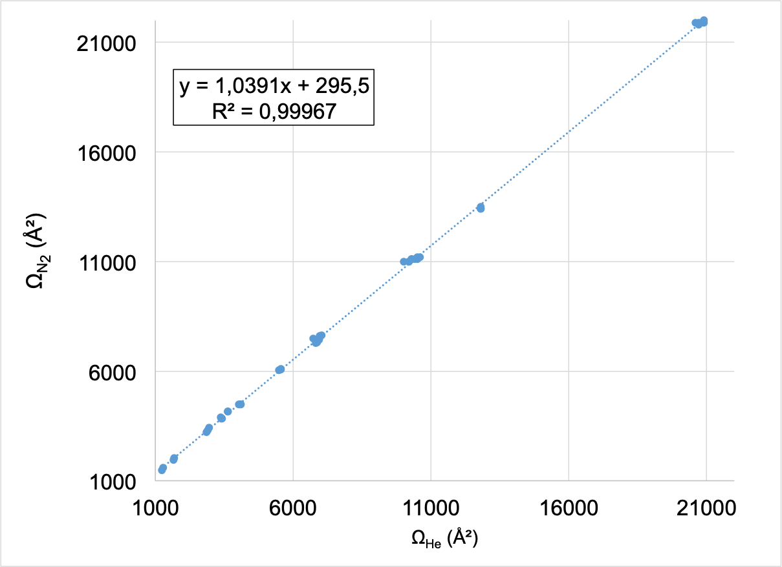

Fig. S12: Helium-nitrogen regression plot for IM-MS.

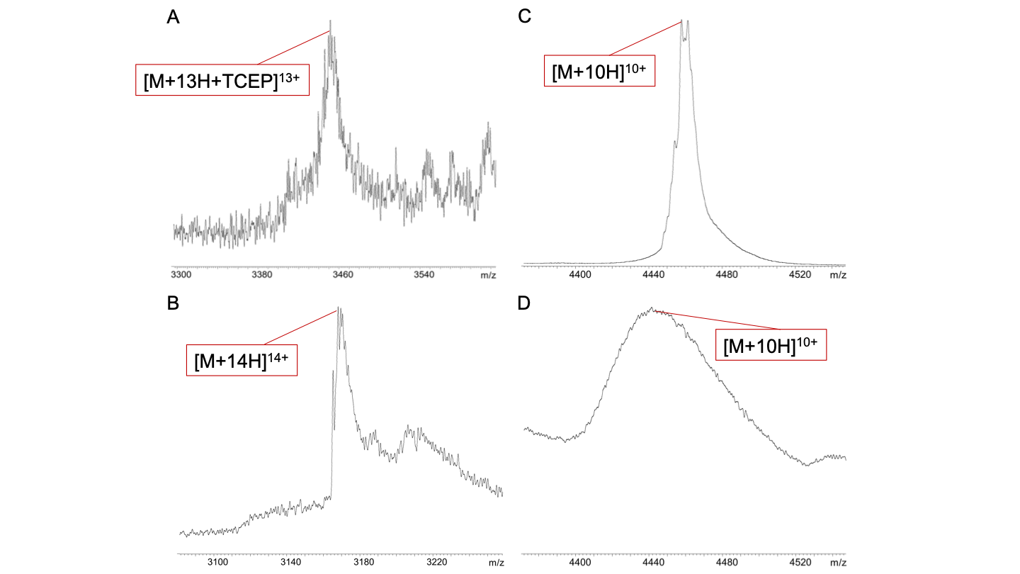

Fig. S13: Mass spectra of HDAC4 WT and Cys669Ala/His675Ala. A: Mass spectra of HDAC4 WT with z = 13+, with 2x zinc atoms and bound TCEP (mass error 33.8 ppm). B: Mass spectra of Cys669Ala/His675Ala with z = 14+ and no zinc atom (mass error < 0.1 ppm). C: Mass spectra of HDAC4 WT with z = 10+ and with 2x zinc atoms (mass error 14.3 ppm). D: Mass spectra of Cys669Ala/His675Ala with z = 10+ and with one zinc atom (mass error 0.2 ppm).

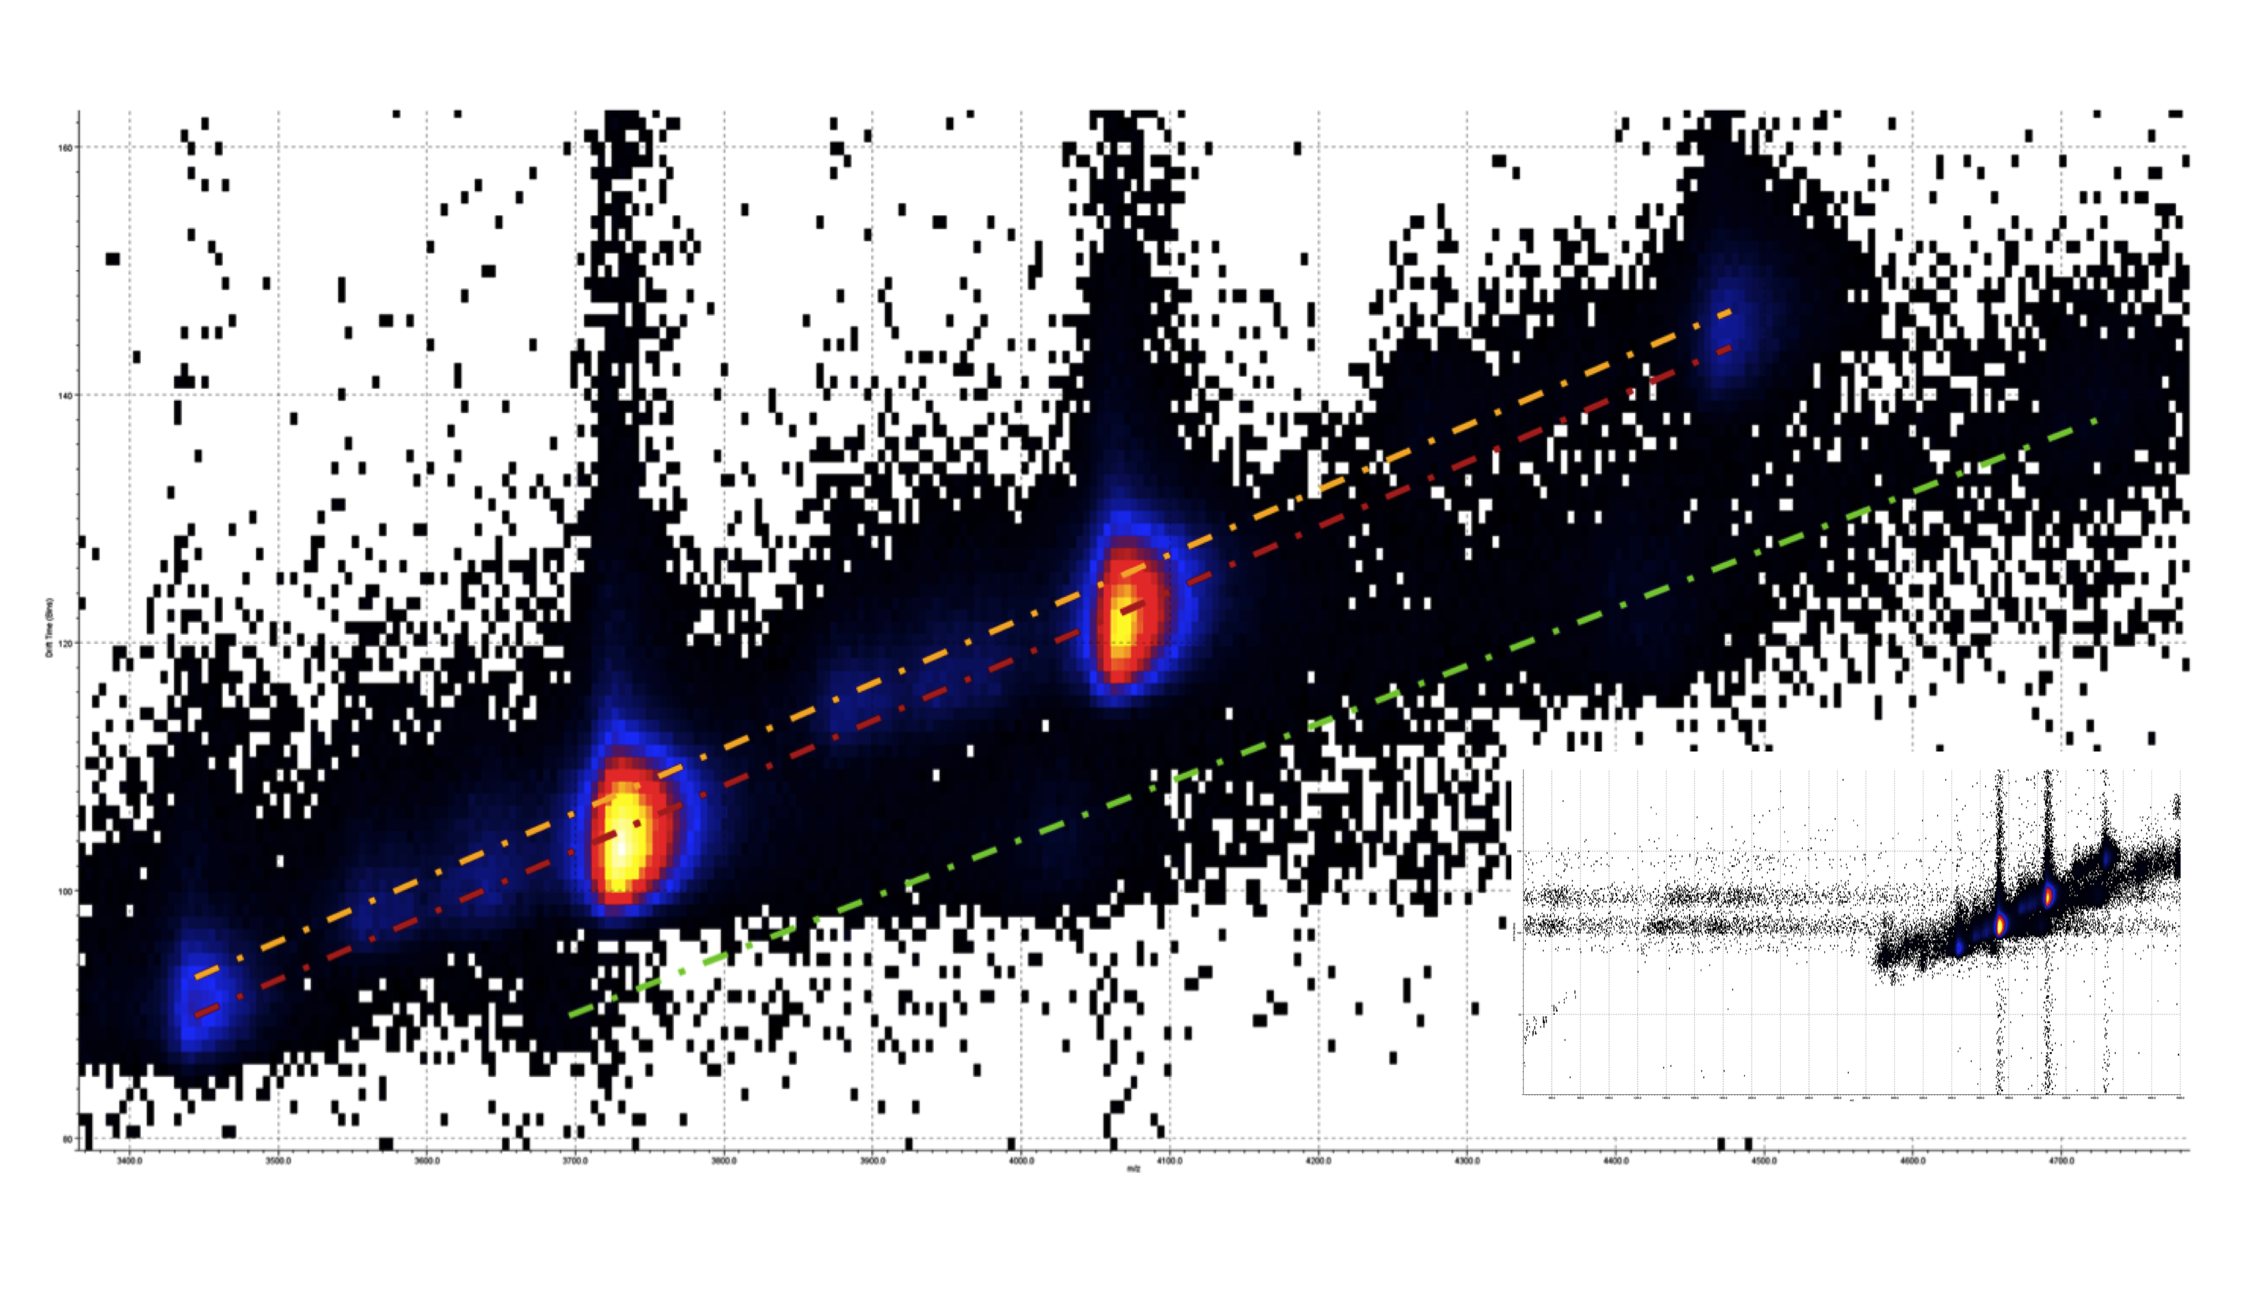

Fig. S14: 2D mobilogram with drift time as ordinate and mass-to-charge ratio as abscissa for HDAC4 WT. Magnification of inlay to the relevant area. The red dotted line shows the signals from monomers, the yellow dotted line shows the signals of dimers, and the green dotted line indicates noise signals. The noise signals were obtained by extracting the mobilograms of the m/z value for the different charge states of the monomer. The intensity is show as heat indicator, red indicates high signal intensity. This measurement was performed on a Synapt XS with nanoESI, a wave velocity of 900 m/s, a wave height of 40 V, and nitrogen as drift gas.

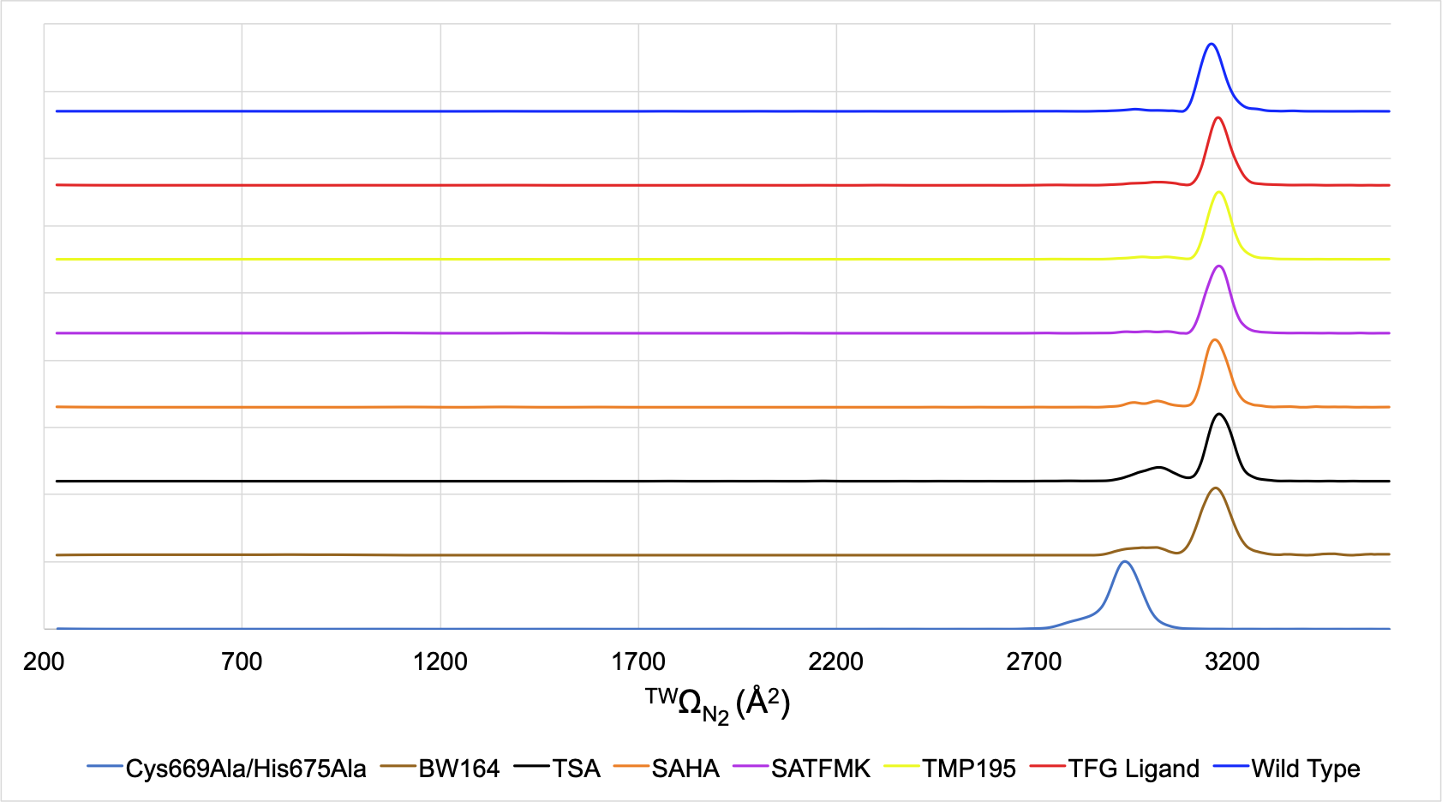

Fig. S15: Mobilograms of HDAC4 WT with all measured ligands, its apo form and Cys669Ala/His675Ala variant. All wild type measurements contained two zinc atoms and the Cys669Ala/His675Ala variant one zinc atom. All mobilograms are for z = 10+ with a wave velocity of 900 m/s, a wave height of 40 V, and nitrogen as drift gas, measured on a Synapt XS with nanoESI.

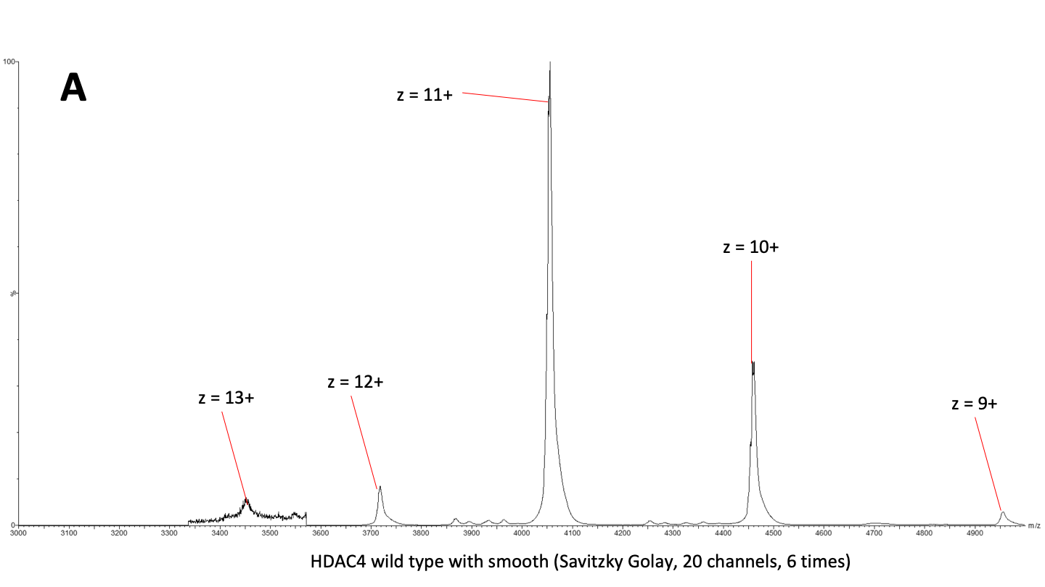
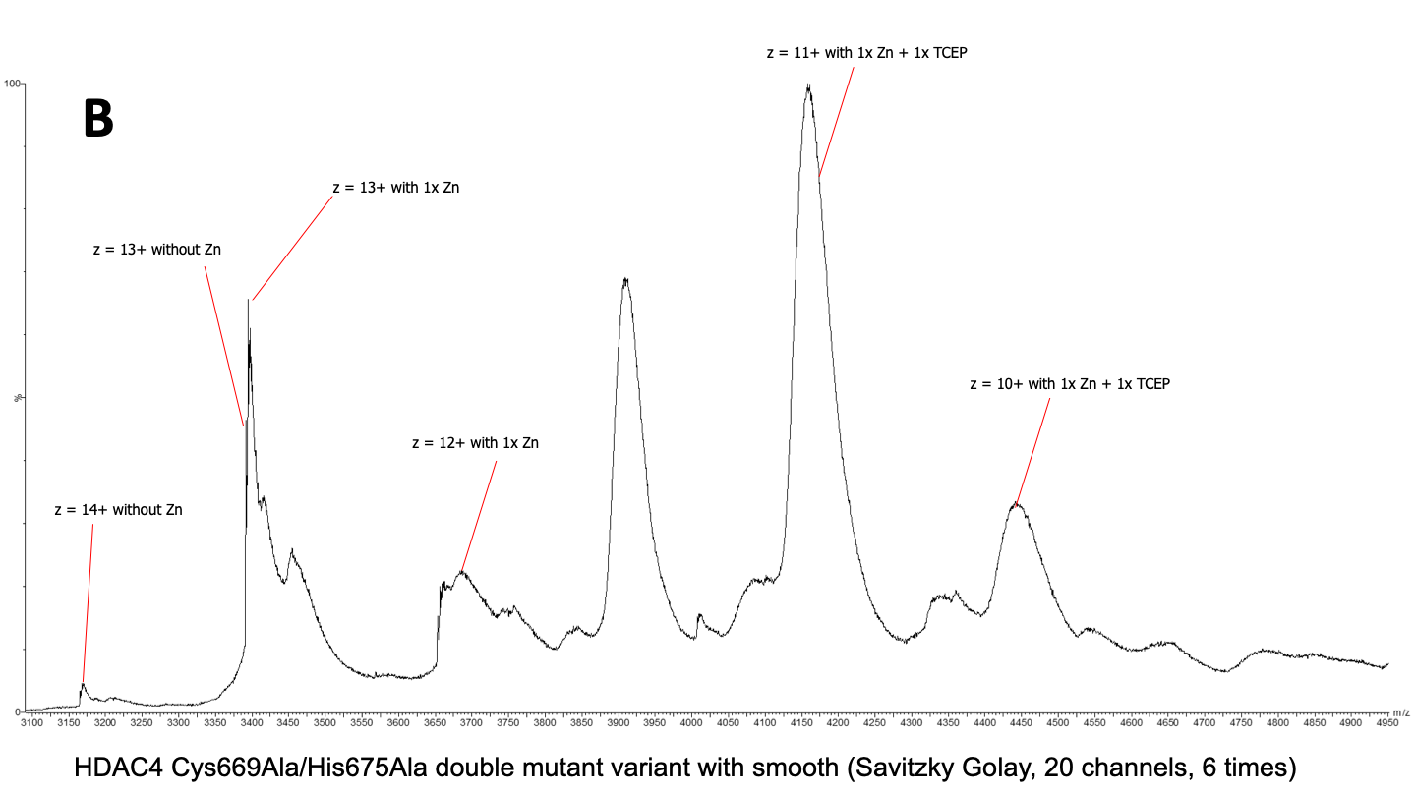

Fig. S16: 1D-MS data of charge states comparing (A) wild type and (B) double mutant variant. Note, more clusters were observed because the IM-MS the condition was set so soft as possible

Fig. S17: Change in microenvironment of a modeled tfmPhe746 between the proposed open (A) and closed (B) conformation of HDAC4 with distances between the CF3 moiety of tmfPhe and neighboring atoms of side chains.

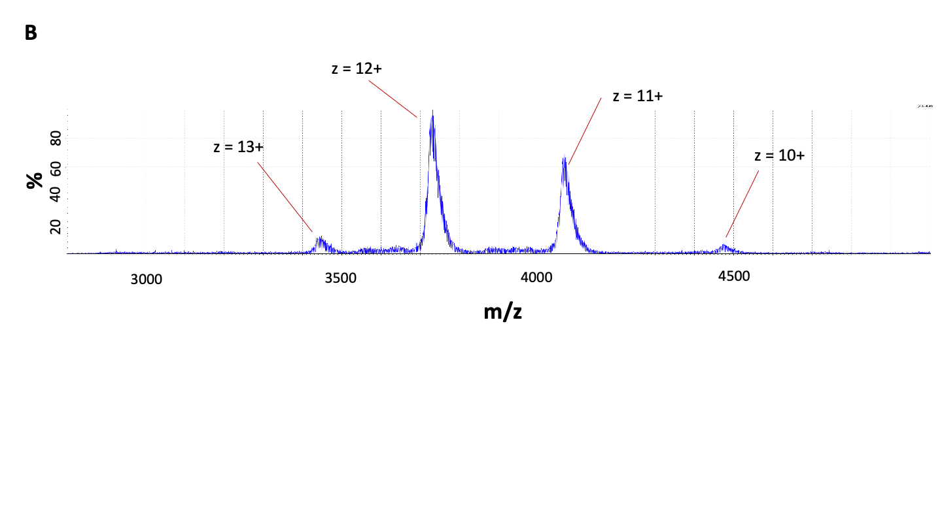
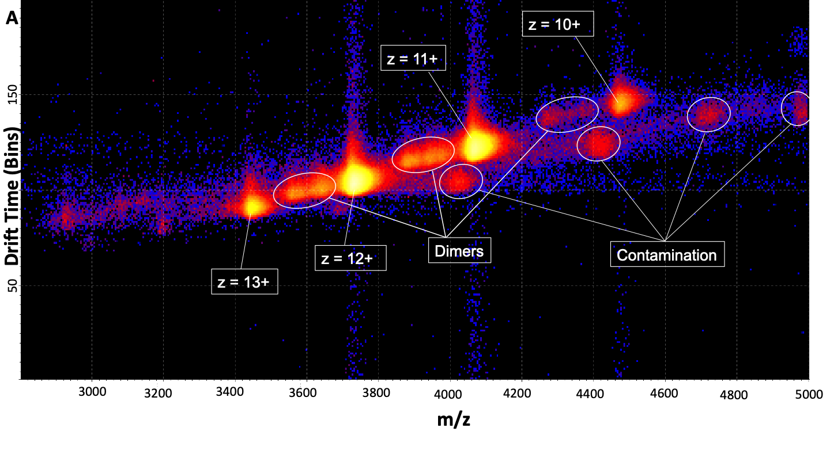

Fig. S18: (A) 2D mobilogram with drift time as ordinate and mass-to-charge ratio as abscissa for HDAC4 WT showing only low degree of dimerization (B) Corresponding 1D mass spectra. Charges Peaks are labeled with corresponding charges.

Acknowledgments:

Funding:
This research was supported by the LOEWE priority program TRABITA, State of Hesse, Germany (to FJMA, FL, SK, MS and TN). The Synapt XS instrument was funded through the German Research Foundation (DFG), grant number 461372424.

References:

1. Bush MF, Hall Z, Giles K, Hoyes J, Robinson CV, Ruotolo BT (2010) Collision Cross Sections of Proteins and Their Complexes: A Calibration Framework and Database for Gas-Phase Structural Biology. Analytical Chemistry 82:9557-9565.

