Supporting Information for
Forest structure and heterogeneity increase diversity and alter composition of host-parasitoid networks
Nolan J. Rappa, Michael Staab, Laura-Sophia Ruppert, Julian Frey, Marco A. R. Mello, Alexandra-Maria Klein

Contents
Supplementary methods 1-4
Figure S1 Map of study area and plots 5
Figure S2 Host and parasitoid species accumulation curves 6
Figure S3 Host-parasitoid interaction accumulation curve 7
Figure S4 Parasitoid biodiversity metrics and host abundance 8
Figure S5 Parasitoid and host ordinations 9
Table S1 Spearman coefficients of environmental variables 10
Table S2 Parasitoid species collected 11-12
Table S3 Results of Procrustes comparisons 13
Table S4 Biodiversity metric model coefficients 14
Table S5 Results of fitting environmental variables to host species NMDS 15
Table S6 Results of fitting environmental variables to parasitoid species NMDS 16
Table S7 Parasitoid species interactions 17-20
Table S8 Bipartite network indices model coefficients of all networks 21
Table S9 Bipartite network indices model coefficients excluding <10 cell networks 22
Table S10 Metanetwork interaction model coefficients 23
Table S11 Results of Moran’s I calculations 24
Table S12 Spearman coefficients of metanetwork and bipartite network indices 25
Table S13 Results of additional analyses excluding M. acasta 26
Table S14 Results of additional analysis of parasitism rate 27
References cited in supporting information 28-30

Supplementary methods
a) Remotely sensed environmental variables
The stand structural complexity index (SSCI) is derived from the points on a terrestrially laser scanned vertical scanline of the whole plot. Points on this line are then connected to a polygon which creates a ration of area to perimeter. The SSCI gains especially high values if vegetation or large objects are recorded close to the scanner. Therefore, open stands with many strata occupied by vegetation, and structures such as deadwood and hanging branches gain the highest values (Ehbrecht et al. 2019). The effective number of layers (ENL) is the number of 1 m forest strata occupied by vegetation measured by filled voxels. A high value of the ENL indicates many forest strata occupied by vegetation, a more evenly layered and diverse stand. The ENL reaches high scores if the forest is high with an even distribution of plant material along the vertical axis. Extreme values of ENL are reached in high forests where crown space is densely occupied (Ehbrecht et al. 2016). While the ENL is representing the layering as well as the stand height, the SSCI is capturing the structural heterogeneity and overall shape complexity.

b) Insect collection, identification, and categorisation
Trap nests were constructed by filling ~150 20 cm long reed (Phragmites australis Cav.) internodes into an 11 cm diameter PVC plastic tubes. This results in ~150 ± 11 SD cavities exposed per side. Cavity diameters ranged between 1 ± 0.3 to 10 ± 1.1 mm in diameter, to attract nesting females of as many species as possible (Krombein 1967). After filling tubes until no more internodes could fit inside, cavity entrances were wire brushed to improve suitability for bee and wasp nest building. Traps were secured in pairs to each of two wooden poles of ~2 m height approximately halfway between plot centres and the NW and SE corners, with each trap oriented to expose reed cavities in the NW and SE directions, to standardise sampling of communities. Traps were collected following ~7 months of exposure time (March-October 2020) to allow ample time for nest building. Following retrieval from plots, traps were immediately stored in a cool and dry basement room to prevent early emergence of nested individuals. Traps were gradually inspected, with nests found and transferred to a 4 ºC cooling chamber.
During refrigeration, nests were opened with razor blades so that identifications could be made (when possible), and the abundance of hosts and parasitoids quantified. Families and genera, (and often species) can be identified by their nest structure, resources provisioned and materials used (Gathmann and Tscharntke, 1999). Refrigeration duration to simulate winter diapause varied between taxa, as several require longer durations to complete development, but was at minimum 8 weeks. Duration of refrigeration has little influence on hatching of individuals, provided that a minimum time (~6 weeks) is met and an extended time (e.g. 32 weeks) is not exceeded. After rewarming, adults hatched, were collected, and then prepared according to entomological standards so that species could be identified (Table S2).
Following morphological identification, host and parasitoid species were categorised according to forest specialisation (forest and non-forest specialists) and host-specificity (general and specific) respectively. Categorisation was done by cross-referencing the relevant literature and habitat description for host species, and examining the range of hosts for parasitoids in our data.
When a host species’ habitat description exclusively included terms such as “forest”, “forest margins”, “woodland”, “open forest” or “forest clearing”, it was considered a forest specialist. When the habitat description of a species included other habitat types, or the previously mentioned forest types in combination with terms such as “heathland”, “sand dunes” or “meadows”, that species was considered a non-forest specialist. For example, Hylaeus difformis is a species of cavity-nesting mask bee. According to Westrich et al., (2018), this species’ preferred habitat is described as “open forest areas, forest edges and forest clearings”, and it was therefore classified as a forest specialist (Table S7). When a parasitoid species utilised hosts from species within only one genus, it was considered host-specific. When a parasitoid utilised hosts species from multiple genera, but > 95% of host species were within one genus, it was considered host-specific. When a parasitoid utilised hosts from multiple genera, with no clear preference for one genus it was considered host-general (Table S7).
c) Bipartite network description
Bipartite networks represent a one-way interaction between two sets of nodes, in this case parasitoids in the higher and their hosts in the lower trophic levels (Fig 4). Networks can be constructed according to temporal or (as in the case of our data) spatial scales. Numerous indices can be calculated at network level to allow the comparison between networks (Dormann et al. 2009, Almende et al. 2021), and to test if network properties are related to the environment where the interactions were observed. In our data, connectance and linkage density were chosen to measure network strength while link diversity and specialisation (H2’) were chosen to measure diversity and network specialisation.
Connectance is defined as the linkage density divided by the number of species in the network, and infers the interactivity of species. Linkage density is defined as the marginal totals-weighted diversity of interactions per species. Together they inform about the number and frequency of interactions, and can be used to infer the potential stability of host populations and thus of the entire network (Brown 2022).
Link diversity is the Shannon entropy for all interactions in a given network. Specialisation (H2’) is a measure of discrimination, or how distinct interactions or groups of interactions become in a given network. High values of link diversity indicate potentially high specialisation in networks. High values of specialisation indicate unique and distinct sets of interactions, comprised of species that have a restricted range of hosts.
d) Metanetwork core description
The core of the metanetwork was identified by examining the degree values of interactions to infer centrality. Interactions with degree values within three standard deviations of the maximum value were considered most central and thus forming the metanetwork core. The host-parasitoid interaction pairs forming the metanetwork core and their corresponding degree values were: Trypoxylon figulus-Trichrysis cyanea (117), Ancistrocerus trifasciatus-Chrysis solida (107), T. figulus-Melittobia acasta (100), T. figulus-Nematopodius debilis (87), Deuteragenia subintermedia-M. acasta (79), Passaloecus insignis-Omalus aeneus (76), P. insignis-Omalus puncticollis (73), Symmorphus gracilis-Chrysis corusca (73), Trypoxylon clavicerum-N. debilis (64).

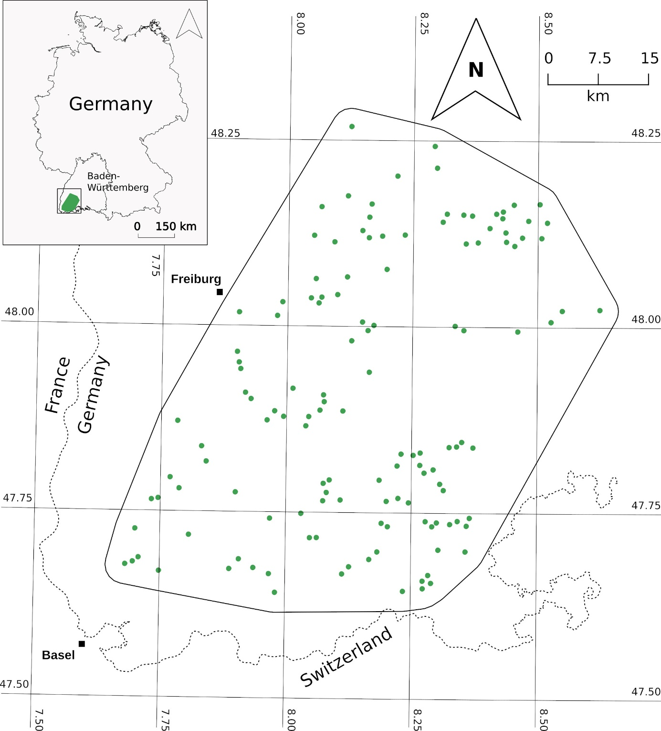
Figure. S1. Map of the 134 ConFoBi research plots sampled in the southern Black Forest, Baden-Württemberg, Germany. Green points correspond to plot geolocations (latitude and longitude of plot centres). Figure credit: Julian Frey.

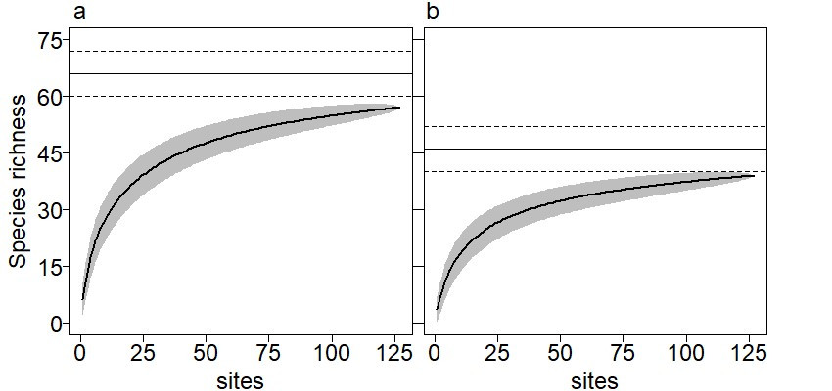
Figure S2. Species accumulation curves of: a) cavity-nesting bees and wasps and b) their associated parasitoids, collected using 4 trap-nests on each of 127 plots. Plots missing remotely sensed variables (7) were excluded prior to analyses. Observed cumulative species richness is represented in each figure by solid lines, with 95% CI of accumulation curves shown as grey polygons. Total species richness (extrapolated) based on jackknife1 estimators is represented by horizontal lines (solid) with 95% CI (dashed lines). In total, 57 species (86% of expected total richness) of cavity-nesting Hymenoptera and 39 species (85 % of expected total richness) of parasitoids were collected.

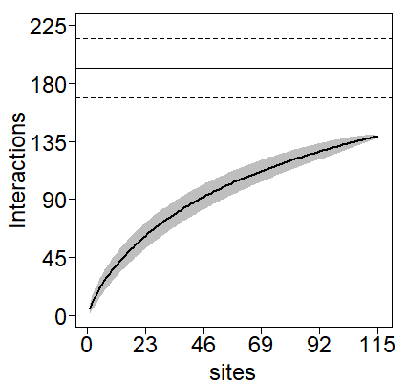
Figure S3. Host-parasitoid interaction accumulation curve, displaying cumulative parasitism events (one species parasitising another) per each of 115 sampled plots where parasitism was observed. Observed cumulative interactions is represented by solid lines, with 95% CI accumulation curves shown in grey. Total interactions possible (extrapolated) based on jackknife1 estimators is represented by horizontal lines (solid) with 95% CI (dashed lines). In total, 139 interactions (72% of expected total interactions) were observed.
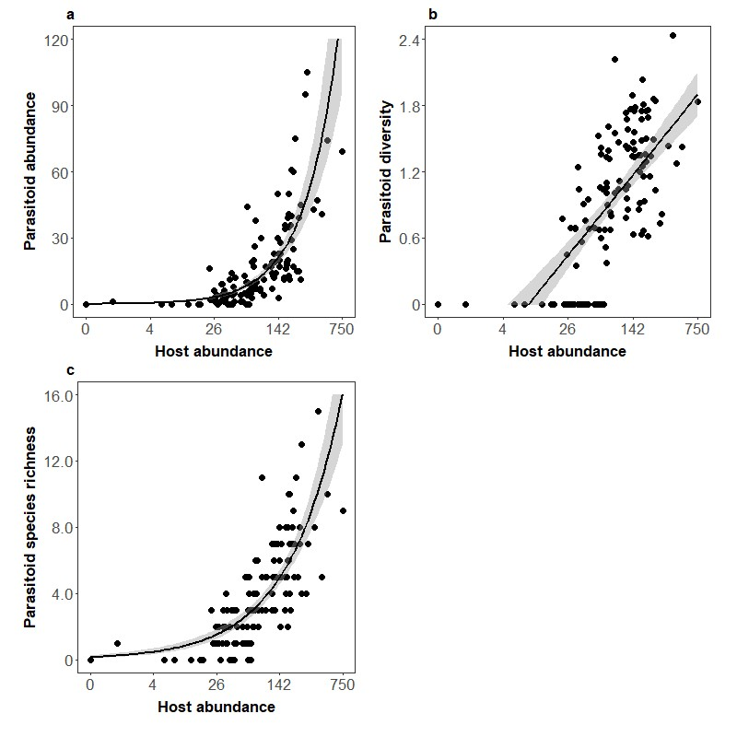
Figure S4. Abundance (parasitised brood cells) (a), diversity (b) and species richness (c) of parasitoids of cavity-nesting bees and wasps and host abundance. Host abundance was log-transformed (log(x+1, 10)) prior to plotting in each figure. Trend lines are depicted for negative binomial generalised linear models (a and c) and a linear model (b), with 95 % confidence intervals coloured in grey.

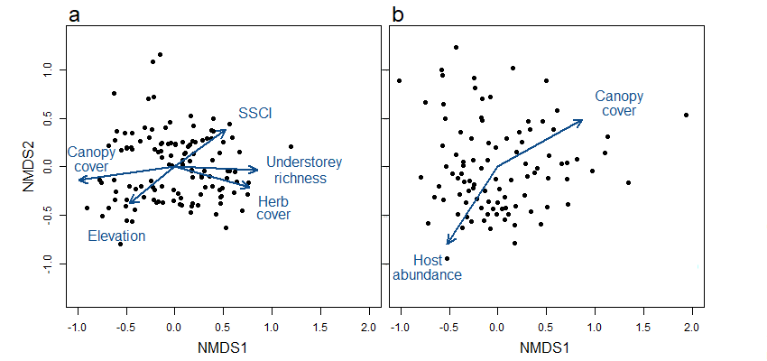
Figure S5. NMDS (‘metaMDS’, permutations=1,000) of a) cavity nesting bees and wasps and b) their parasitoid species matrices using Bray-Curtis dissimilarities on 3 axes at 0.191 and 0.164 stress respectively. Forest variables were correlated with the scores of each NMDS using the ‘envfit’ function (permutations=1,000, p<0.05). Plots where only one or no individuals were collected were omitted prior to ordination, resulting in 122 plots used for cavity-nesting Hymenoptera and 97 for their parasitoids respectively.

Table S1. Spearman correlation coefficients (ρ) for all pairwise comparisons of environmental variables. Abbreviations are as follows: DBH, diameter at breast height; ENL, effective number of layers or 1-meter forest strata; SSCI, stand structural complexity index.
 | Canopy cover (%) | Deadwood DBH (lying) | Deadwood DBH (standing) | Deciduous tree share (%) | ENL | Elevation | Forest cover | Herb cover (%) | SSCI | Understorey species richness
Canopy cover (%) | 1 | -0.38 | 0.05 | 0.25 | -0.11 | -0.34 | <-0.01 | -0.24 | 0.03 | -0.11
Deadwood DBH (lying) |  | 1 | <0.01 | 0.25 | 0.05 | 0.09 | 0.15 | 0.12 | 0.05 | 0.12
Deadwood DBH (standing) |  |  | 1 | -0.10 | -0.07 | 0.09 | 0.10 | -0.12 | -0.01 | 0.03
Deciduous tree share (%) |  |  |  | 1 | -0.32 | -0.28 | 0.08 | -0.29 | 0.29 | 0.03
ENL |  |  |  |  | 1 | 0.02 | 0.04 | 0.41 | -0.19 | 0.12
Elevation |  |  |  |  |  | 1 | 0.13 | 0.21 | -0.02 | -0.18
Forest cover |  |  |  |  |  |  | 1 | -0.16 | <-0.01 | -0.22
Herb cover (%) |  |  |  |  |  |  |  | 1 | -0.19 | 0.20
SSCI |  |  |  |  |  |  |  |  | 1 | 0.05
Understorey species richness |  |  |  |  |  |  |  |  |  | 1

Table S2. Parasitoid (including klepto-parasitic) species collected between March-October of 2020 using trap nests, deployed on 134 plots. The total number of nests, genera and host species parasitised are listed for each parasitoid species. The total abundance (number of parasitised brood cells) is listed for each species. The relevant literature used for identification is listed for each species.
Species | Nests parasitised | Genera parasitised | Host species parasitised | Abundance | Identification  literature
Anthrax  anthrax | 6 | 3 | 4 | 7 | (Oosterbroek 2006, Schaefer 2018)
Ammobia  signata | 38 | 5 | 7 | 84
Coelioxys  alata | 2 | 1 | 1 | 4 | (Amiet et al. 2004, Westrich 2018)
inermis | 4 | 1 | 1 | 7
Chrysis angustula | 29 | 2 | 5 | 45 | (Paukkunen et al. 2015, Wiesbauer et al. 2020)
corusca | 32 | 2 | 6 | 58
fulgida | 30 | 2 | 5 | 41
ignita | 43 | 2 | 5 | 62
impressa | 10 | 2 | 4 | 13
leptomandibularis | 1 | 1 | 1 | 1
ruddii | 2 | 1 | 1 | 2
schencki | 1 | 1 | 1 | 1
solida | 78 | 2 | 4 | 118
terminata | 2 | 1 | 1 | 4
vanlithi | 7 | 2 | 4 | 12
Coelopencyrtus  arenarius | 8 | 1 | 2 | 23 | (Westrich 2018)
Ephialtes  manifestator | 18 | 7 | 9 | 25 | (Fitton et al. 1988, Horstmann, 1989, Broad et al. 2018, Riedel et al. 2021)
Gasteruption  assectator | 23 | 1 | 3 | 33 | (Bogusch, 2021)
boreale | 14 | 1 | 3 | 15
jaculator | 21 | 1 | 2 | 21
nigritarse | 13 | 1 | 2 | 23
undulatum | 4 | 1 | 2 | 5
Lochetica  westoni | 3 | 1 | 1 | 6 | (Fitton et al. 1988, Horstmann, 1989, Broad et al. 2018, Riedel et al. 2021)
Melittobia  acasta | 320 | 14 | 24 | 815 | (Gathmann and Tscharntke, 1999)
Nematopodius  debilis | 144 | 2 | 6 | 189 | (Fitton et al. 1988, Horstmann, 1989, Broad et al. 2018, Riedel et al. 2021)
formosus | 8 | 1 | 3 | 11
Omalus  aeneus | 61 | 1 | 3 | 73 | (Paukkunen et al. 2015, Wiesbauer et al. 2020)
puncticollis | 37 | 1 | 3 | 51
Perithous  divinator | 8 | 1 | 2 | 11 | (Fitton et al. 1988, Horstmann, 1989, Broad et al. 2018, Riedel et al. 2021)
scurra | 1 | 1 | 1 | 1
Picardiella  melanoleuca | 1 | 1 | 1 | 1
Poemenia  brachyura | 7 | 2 | 3 | 26
collaris | 11 | 2 | 3 | 14
notata | 13 | 1 | 1 | 16
Pseudomalus  auratus | 13 | 1 | 1 | 15 | (Paukkunen et al. 2015, Wiesbauer et al. 2020)
pusillus | 5 | 1 | 2 | 5
triangulifer | 3 | 1 | 1 | 4
violaceus | 2 | 1 | 1 | 2
Trichrysis  cyanea | 313 | 3 | 10 | 371

Table S3. Results of Procrustes comparison of 3 to 2 axes ordinations for both host and parasitoid species composition. Procrustes sum of squares is represented as m². Significant p-values (listed in bold) indicate correlation between ordinations.
 | m² | p-value
Host composition | <0.001 | 0.001
Parasitoid composition | <0.001 | 0.001

Table S4. Regression coefficients of models of parasitoid abundance (negative binomial), parasitism rate (binomial), parasitoid species richness (negative binomial) and parasitoid diversity (normal) sampled on 127 plots. Each model included all environmental variables listed in Table 1, with log-transformed host abundance at plot-level included as a covariate. Significant coefficients are displayed in bold. Conditional and marginal R² values are listed in parentheses for models of diversity and parasitism rate, while McFadden’s pseudo R² is listed for models of abundance and parasitoid species richness.
 | Parasitism rate  (R²c=0.17, R²m=0.91) | Parasitoid abundance  (R²=0.14) | Parasitoid diversity  (R²c=0.52, R²m=0.47) | Parasitoid richness  (R²=0.20)
 | Est. z-value  ±SE p-value | Est. z-value  ±SE p-value | Est. t-value  ±SE p-value | Est. z-value  ±SE p-value
Canopy cover | - 0.031 - 0.301  0.102 0.763 | - 0.061 - 0.767  0.079 0.443 | - 0.048 - 0.898  0.053 0.371 | - 0.056 - 0.991  0.057 0.322
Deadwood DBH sum (lying) | - 0.075 - 0.735  0.102 0.462 | - 0.056 - 0.717  0.079 0.473 | - 0.046 - 0.906  0.051 0.367 | - 0.039 - 0.631  0.062 0.528
Deadwood DBH sum (standing) | 0.266 2.998  0.089 < 0.001 | 0.232 3.368  0.069 < 0.001 | 0.042 0.945  0.045 0.347 | 0.026 0.478  0.055 0.633
Deciduous tree share (%) | 0.065 0.636  0.103 0.525 | 0.035 0.427  0.082 0.669 | - 0.018 - 0.325  0.054 0.745 | 0.006 0.103  0.061 0.918
ENL | -0.004 - 0.042  0.091 0.966 | -0.015 - 0.209  0.072 0.835 | 0.044 0.903  0.048 0.368 | 0.039 0.697  0.055 0.486
Elevation | -0.038 - 0.311  0.119 0.756 | -0.060 - 0.647  0.093 0.518 | - 0.093 - 1.566  0.059 0.120 | - 0.050 - 0.682  0.071 0.495
Forest cover (%) | -0.107 - 1.317  0.081 0.188 | -0.082 - 1.300  0.064 0.194 | - 0.045 -1.005  0.045 0.317 | - 0.064 - 1.449  0.044 0.147
Herb cover (%) | -0.034 - 0.346  0.098 0.729 | -0.027 - 0.345  0.077 0.730 | 0.009 0.182  0.051 0.856 | - 0.036 - 0.632  0.057 0.527
Host abundance | 0.089 0.649  0.137 0.517 | 1.029 - 9.832  0.105 < 0.001 | 0.376 6.640  0.057 < 0.001 | 0.671 8.680  0.077 < 0.001
SSCI | 0.145 1.646  0.088 0.099 | 0.139 2.036  0.069 0.042 | 0.105 2.284  0.046 0.024 | 0.031 0.617  0.050 0.537
Understorey species richness | -0.067 - 0.815  0.083 0.415 | -0.078 - 1.181  0.066 0.237 | - 0.069 - 1.503  0.046 0.135 | - 0.061 - 1.252  0.049 0.211

Table S5. Summary results from permutation tests fitting environmental variables to host species NMDS (“metaMDS, 1,000 permutations) using “envfit” function with 1,000 permutations. Significant correlations (p<0.05) are displayed in bold.
Forest variable | NMDS1 | NMDS2 | r² | p
Canopy cover | -0.990 | -0.135 | 0.157 | <0.001
Deadwood DBH (lying) | 0.999 | -0.009 | 0.012 | 0.474
Deadwood DBH (standing) | 0.879 | -0.476 | 0.005 | 0.776
Deciduous tree share (%) | 0.183 | 0.983 | 0.013 | 0.471
ENL | 0.824 | -0.566 | 0.001 | 0.914
Elevation | -0.759 | -0.650 | 0.064 | 0.021
Forest cover (%) | -0.934 | -0.356 | 0.031 | 0.145
Herb cover (%) | 0.967 | -0.255 | 0.065 | 0.015
SSCI | 0.803 | 0.595 | 0.071 | 0.001
Understorey species richness | 0.999 | -0.047 | 0.063 | 0.019

Forest variable | NMDS1 | NMDS2 | r² | p
Canopy cover | 0.872 | 0.489 | 0.080 | 0.026
Deadwood DBH (lying) | -0.899 | -0.437 | 0.041 | 0.129
Deadwood DBH (standing) | -0.584 | -0.812 | 0.047 | 0.091
Deciduous tree share (%) | 0.077 | -0.997 | 0.003 | 0.893
ENL | 0.025 | 0.999 | 0.021 | 0.375
Elevation | -0.806 | 0.592 | 0.007 | 0.716
Forest cover (%) | -0.051 | 0.999 | 0.020 | 0.389
Herb cover (%) | -0.422 | -0.907 | 0.014 | 0.519
Host abundance | -0.547 | -0.837 | 0.094 | 0.015
SSCI | -0.579 | -0.815 | 0.024 | 0.307
Understorey species richness | 0.400 | -0.916 | 0.007 | 0.728
Table S6. Summary results from permutation tests fitting environmental variables to parasitoid species NMDS (“metaMDS, 1,000 permutations) using “envfit” function with 1, 000 permutations. Significant correlations (p<0.05) are displayed in bold.

Table S7. Parasitoid interactions (parasitoids, corresponding hosts and number of parasitised brood cells) from 115 plots where parasitism was sampled. Corresponding bipartite network numbers for parasitoids and their hosts are listed in parentheses. Corresponding habitat specialisation of hosts and specificity (restriction in host acceptance) of parasitoids are included for each interaction.
Parasitoid | Parasitoid specificity | Host | Host habitat specialisation | Cells parasitised
Anthrax anthrax (1) | General | Megachile  lapponica (19)  versicolor (21)  Symmorphus  crassicornis (9)  Trypoxylon  clavicerum (32) | Forest  Forest | 4  1  1
Ammobia signata (2) | General | Ancistrocerus  trifasciatus (5)  Deuteragenia  subintermedia (14)  Symmorphus  allobrogus (7)  bifasciatus (13)  gracilis (10)  Passaloecus  corniger (25)  Trypoxylon  figulus (34) | Forest  Forest  Forest  Forest  Forest  Forest  Non-forest | 39  5  11  4  1  4  20
Coelioxys alata (3) | Specific | Megachile  ligniseca (20) | Forest | 4
Coelioxys inermis (4) | Specific | Megachile  lapponica  versicolor | Forest  Forest | 5  2
Coelopencyrtus arenarius (5) | Specific | Hylaeus  confusus (17)  difformis (18) | Forest  Forest | 2  21
Chrysis angustula (6) | General | Ancistrocerus  trifasciatus (5)  Symmorphus  allobrogus (7)  bifasciatus (8)  crassicornis (9)  gracilis (10) | Forest  Forest  Forest  Forest  Forest | 13  6  16  8  1
Chrysis corusca (7) | Specific | Ancistrocerus  trifasciatus (5)  Symmorphus  allobrogus (7)  bifasciatus (8)  crassicornis (9)  gracilis (10)  murarius (11) | Forest  Forest  Forest  Forest  Forest  Non-forest | 2  5  2  3  44  2
Chrysis fulgida (8) | Specific | Ancistrocerus  trifasciatus (5)  Symmorphus  allobrogus (7)  bifasciatus (8)  crassicornis (9)  murarius (11) | Forest  Forest  Forest  Forest  Non-forest | 1  4  18  9  7
Chrysis ignita (9) | General | Ancistrocerus  trifasciatus (5)  Symmorphus  allobrogus (7)  bifasciatus (8)  crassicornis (9)  murarius (11) | Forest  Forest  Forest  Forest  Non-forest | 28  6  7  15  1
Chrysis impressa (10) | Specific | Ancistrocerus  claripennis (2)  trifasciatus (5)  Symmorphus  allobrogus (7)  bifasciatus (8) | Forest  Forest  Forest  Forest | 7  4  1  1
Chrysis leptomandibularis (11) | Specific | Ancistrocerus  trifasciatus (5) | Forest | 1
Chrysis ruddii (12) | Specific | Ancistrocerus  scoticus (4) | Forest | 2
Chrysis schencki (13) | Specific | Ancistrocerus  trifasciatus (5) | Forest | 1
Chrysis solida (14) | Specific | Ancistrocerus  claripennis (14)  Ancistrocerus  trifasciatus (5)  Symmorphus  bifasciatus (8)  crassicornis (9) | Forest  Forest  Forest  Forest | 2  114  1  1
Chrysis terminata (15) | Specific | Ancistrocerus  nigricornis (3) | Non-forest | 4
Chrysis vanlithi (16) | Specific | Ancistrocerus  nigricornis (3)  scoticus (4)  trifasciatus (5)  Symmorphus  bifasciatus (8) | Non-forest  Forest  Forest  Forest | 1  1  8  2
Ephialtes manifestator (24) | General | Ancistrocerus  trifasciatus (5)  Symmorphus  bifasciatus (8)  crassicornis (9)  gracilis (10)  Deuteragenia  subintermedia (14)  Megachile  versicolor (21)  Passaloecus  insignis (27)  Pemphredon  lugens (28)  Trypoxylon  figulus (34) | Forest  Forest  Forest  Forest  Forest  Forest  Forest  Forest  Non-forest | 2  1  1  3  1  1  3  9  2
Gasteruption assectator (35) | Specific | Hylaeus  communis (16)  confusus (17)  difformis (18) | Non-forest  Forest  Forest | 9  6  16
Gasteruption boreale (36) | Specific | Hylaeus  communis (16)  confusus (17)  difformis (18) | Non-forest  Forest  Forest | 9  1  7
Gasteruption jaculator (37) | Specific | Hylaeus  communis (16)  difformis (18) | Non-forest  Forest | 1  20
Gasteruption nigritarse (38) | Specific | Hylaeus  communis (16)  difformis (18) | Non-forest  Forest | 8  15
Gasteruption undulatum (39) | Specific | Hylaeus  confusus (17)  difformis (18) | Forest  Forest | 3  2
Lochetica westoni (25) | Specific | Passaloecus  insignis (27) | Forest | 6
Melittobia acasta (34) | General | Ampulex  fasciata (1)  Ancistrocerus  claripennis (2)  trifasciatus (5)  Auplopus  carbonarius (12)  Deuteragenia  bifasciata (13)  subintermedia (14)  variegata (15)  Discoelius  zonalis (6)  Hylaeus  communis (16)  Megachile  lapponica (19)  versicolor (21)  Nitela  borealis  spinolae  Osmia  leaiana (22)  Passaloecus  corniger (25)  insignis (27)  Pemphredon  lugens (28)  Rhopalum  clavipes (30)  Symmorphus  allobrogus (7)  gracilis (10)  Trypoxylon  clavicerum (32)  figulus (34)  kolazyi (35)  kostylevi (36) | Forest  Forest  Forest  Forest  Forest  Forest  Forest  Forest  Non-forest  Forest  Forest  Forest  Forest  Non-forest  Forest  Forest  Forest  Forest  Forest  Forest  Forest  Non-forest  Non-forest  Non-forest | 3  18  25  13  14  62  5  3  2  7  4  9  1  8  2  23  2  50  5  13  13  459  1  9
Nematopodius debilis (26) | Specific | Deuteragenia  subintermedia (14)  Trypoxylon  beaumonti (31)  clavicerum (32)  figulus (34)  kolazyi (35)  kostylevi (36) | Forest  Non-forest  Forest  Non-forest  Non-forest  Non-forest | 2  2  90  83  4  2
Nematopodius formosus (27) | Specific | Trypoxylon  beaumonti (31)  deceptorium (33)  figulus (34) | Non-forest  Non-forest  Non-forest | 1  1  7
Omalus aeneus (17) | Specific | Passaloecus  corniger (25)  insignis (27) | Forest  Forest | 5  66
Omalus puncticollis (18) | Specific | Passaloecus  corniger (25)  eremita (26)  insignis (27) | Non-forest  Forest  Forest | 6  3  42
Perithous divinator (30) | Specific | Pemphredon  lugens (28)  lugubris (29) | Forest  Forest | 9  2
Perithous scurra (33) | Specific | Symmorphus  murarius (11) | Non-forest | 1
Picardiella melanoleuca (31) | Specific | Auplopus  carbonarius (12) | Forest | 1
Poemenia brachyura (28) | Specific | Passaloecus  corniger (25)  insignis (27)  Pemphredon  lugens (28) | Forest  Forest  Forest | 4  21  1
Poemenia collaris (29) | Specific | Symmorphus  gracilis (10)  Passaloecus  corniger (25)  insignis (27) | Forest  Forest  Forest | 1  4  8
Poemenia notata (32) | Specific | Passaloecus  corniger (25) | Forest | 16
Pseudomalus auratus (19) | Specific | Pemphredon  lugens (28) | Forest | 15
Pseudomalus pusillus (20) | Specific | Passaloecus  corniger (25)  insignis (27) | Forest  Forest | 2  3
Pseudomalus triangulifer (21) | Specific | Passaloecus  insignis (27) | Forest | 4
Pseudomalus violaceus (22) | Specific | Passaloecus  insignis (27) | Forest | 2
Trichrysis cyanea (23) | Specific | Auplopus  carbonarius (12)  Deuteragenia  bifasciata (13)  subintermedia (14)  variegata (15)  Trypoxylon  beaumonti (31)  clavicerum (32)  figulus (34)  kolazyi (35)  kostylevi (36)  minus (37) | Forest  Forest  Forest  Forest  Non-forest  Forest  Non-forest  Non-forest  Non-forest  Forest | 3  6  14  2  5  15  306  2  1  2

Table S8. Regression coefficients of models using bipartite network indices as response variables, excluding networks with single links for which no indices could be calculated, resulting in values from 90 networks being analysed. Models included all environmental variables listed in Table 1 as fixed-effects and log-transformed host abundance at plot-level as a covariate. Weighted connectance (linear), link density (linear) linkage diversity (linear) and network specialisation (linear) were analysed. Number of interactions (parasitised brood cells) among modelled networks ranged from 3-105 (23 ± 20). Conditional and marginal R² values are listed in parentheses for each model.
 | Connectance  (weighted)  (R²c=0.50, R²m=0.43) | Linkage density  (R²c=0.28, R²m=0.18) | Link diversity  (R²c=0.41, R²m=0.32) | Specialisation  (H2’)  (R²c=0.14, R²m=0.02)
 | Est. t-value  ±SE p-value | Est. t-value  ±SE p-value | Est. t-value  ±SE p-value | Est. t-value  ±SE p-value
Canopy cover | - 0.003 - 0.346  0.007 0.731 | - 0.093 - 2.467  0.038 0.016 | - 0.112 - 2.093  0.053 0.039 | 0.066 1.951  0.034 0.054
Deadwood DBH sum (lying) | 0.004 0.629  0.007 0.531 | 0.039 1.084  0.036 0.281 | - 0.008 - 0.162  0.050 0.872 | 0.021 0.662  0.032 0.510
Deadwood DBH sum (standing) | 0.015 2.116  0.007 0.038 | 0.030 0.835  0.036 0.406 | - 0.006 - 0.114  0.051 0.909 | - 0.074 - 2.277  0.033 0.026
Deciduous tree share (%) | - 0.002 - 0.179  0.009 0.858 | 0.008 0.177  0.044 0.860 | - 0.007 - 0.116  0.062 0.908 | 0.058 - 1.474  0.039 0.144
ENL | - 0.007 - 0.946  0.007 0.347 | - 0.055 - 1.470  0.038 0.157 | 0.031 0.602  0.053 0.549 | 0.005 0.146  0.034 0.885
Elevation | - 0.002 0.203  0.009 0.839 | - 0.005 - 0.095  0.048 0.925 | - 0.077 - 1.144  0.068 0.256 | - 0.009 - 0.217  0.043 0.828
Forest cover (%) | 0.006 0.875  0.007 0.384 | 0.012 0.351  0.034 0.727 | 0.007 0.140  0.048 0.889 | - 0.006 - 0.211  0.031 0.834
Herb cover (%) | 0.017 2.297  0.008 0.024 | 0.016 0.416  0.038 0.679 | - 0.050 0.906  0.054 0.358 | - 0.031 - 0.896  0.034 0.373
Host abundance | - 0.053 - 6.724  0.008 < 0.001 | 0.105 2.653  0.039 0.009 | 0.259 4.647  0.056 < 0.001 | 0.019 0.543  0.035 0.589
SSCI | 0.002 0.296  0.007 0.768 | 0.013 0.336  0.038 0.738 | 0.053 0.997  0.053 0.322 | - 0.015 - 0.457  0.034 0.649
Understorey species richness | 0.007 1.051  0.007 0.297 | - 0.034 - 0.992  0.034 0.324 | - 0.075 - 1.557  0.048 0.123 | - 0.001 - 0.032  0.030 0.974

Table S9. Regression coefficients of models using bipartite network indices as response variables, and all environmental variables listed in Table 1 as fixed-effects and log-transformed host abundance at plot-level as a covariate. Weighted connectance (linear), link density (linear) linkage diversity (linear) and network specialisation (linear) were analysed. Bipartite networks which were too small (singleton and doubleton), as well as networks with fewer than ten parasitised brood cells were excluded prior to analyses, resulting in values from 68 networks being analysed. Number of interactions (parasitised brood cells) among modelled networks ranged from 10-105 (27 ± 19). Conditional and marginal R² values are listed in parentheses for each model.
 | Connectance (weighted)  (R²c=0.36, R²m=0.19) | Linkage density  (R²c=0.22, R²m=0.06) | Link diversity  (R²c=0.23, R²m=0.07) | Specialisation (H2’)  (R²c=0.12, R²m=-0.05)
 | Est. t-value  ±SE p-value | Est. t-value  ±SE p-value | Est. t-value  ±SE p-value | Est. t-value  ±SE p-value
Canopy cover | 0.003 0.419  0.008 0.677 | - 0.099 - 2.215  0.045 0.031 | - 0.134 - 2.168  0.062 0.034 | 0.030 0.919  0.031 0.362
Deadwood DBH sum (lying) | 0.004 0.495  0.008 0.622 | 0.047 1.040  0.045 0.303 | - 0.007 - 0.115  0.062 0.906 | - 0.014 - 0.409  0.032 0.684
Deadwood DBH sum (standing) | 0.011 1.432  0.008 0.157 | 0.018 -0.396  0.046 0.693 | - 0.025 - 0.391  0.063 0.697 | - 0.027 - 0.818  0.035 0.417
Deciduous tree share (%) | - 0.008 - 0.895  0.009 0.374 | 0.034 0.628  0.054 0.533 | 0.054 0.725  0.074 0.471 | 0.001 0.037  0.039 0.970
ENL | - 0.013 - 1.743  0.008 0.086 | - 0.059 - 1.339  0.044 0.186 | 0.068 1.125  0.061 0.265 | 0.031 0.939  0.032 0.352
Elevation | - 0.002 - 0.237  0.009 0.813 | 0.028 0.519  0.054 0.606 | - 0.037 - 0.489  0.075 0.627 | 0.003 - 0.077  0.040 0.939
Forest cover (%) | 0.006 0.870  0.007 0.388 | - 0.018 - 0.448  0.041 0.656 | - 0.017 - 0.302  0.057 0.764 | <-0.001 - 0.003  0.030 0.998
Herb cover (%) | 0.007 0.866  0.008 0.390 | 0.031 0.684  0.045 0.497 | - 0.002 0.024  0.061 0.981 | -0.004 - 0.112  0.032 0.911
Host abundance | - 0.026 - 3.407  0.008 0.001 | 0.039 0.908  0.044 0.368 | 0.105 1.745  0.059 0.087 | - 0.039 - 1.228  0.032 0.224
SSCI | < 0.001 0.107  0.008 0.916 | - 0.002 - 0.060  0.044 0.953 | 0.059 0.981  0.061 0.331 | - 0.019 - 0.605  0.033 0.547
Understorey species richness | 0.004 0.546  0.007 0.587 | - 0.017 - 0.444  0.039 0.659 | - 0.043 - 0.788  0.054 0.434 | - 0.004 - 0.135  0.029 0.893

Table S10. Regression coefficients of models using indices calculated for each interaction (host parasitised by parasitoid species) throughout metanetwork as response variables. Interaction degree (negative binomial) and interaction closeness (normal) were each modelled with site included as a random term and an offset using the number of observed interactions per site. Indices were calculated for interactions for each site where they were observed. Singleton interactions (those occurring alone at site level) were excluded prior to analyses, resulting in indices calculated from parasitoids collected on 90 plots being modelled. Each model included all environmental variables listed in Table 1, with log-transformed host abundance at plot-level included as a covariate. Conditional and marginal R² values are listed in parentheses for each model.
 | Interaction  Degree  (R²c=0.08, R²m=0.08) | Interaction  Closeness  (R²c=0.99, R²m=0.54)
 | Est. z-value  ±SE p-value | Est. t-value  ±SE p-value
Canopy cover | 0.078 1.910  0.041 0.056 | 0.048 2.188  0.022 0.032
Deadwood DBH sum (lying) | - 0.047 - 1.390  0.034 0.164 | <-0.001 - 0.015  0.016 0.988
Deadwood DBH sum (standing) | - 0.022 0.630  0.036 0.529 | - 0.007 - 0.410  0.016 0.682
Deciduous tree share (%) | - 0.056 -1.271  0.044 0.204 | - 0.010 - 0.463  0.022 0.645
ENL | 0.013 0.356  0.036 0.722 | - 0.008 - 0.455  0.017 0.650
Elevation | -0.026 - 0.573  0.046 0.567 | 0.010 0.465  0.022 0.643
Forest cover (%) | 0.042 1.218  0.035 0.223 | 0.009 0.526  0.017 0.601
Herb cover (%) | - 0.012 - 0.322  0.036 0.747 | 0.026 1.430  0.018 0.157
Host abundance | - 0.184 - 4.856  0.038 < 0.001 | - 0.139 - 7.338  0.019 < 0.001
SSCI | 0.002 0.061  0.036 0.952 | 0.009 - 0.467  0.019 0.642
Understorey species richness | 0.053 1.549  0.034 0.121 | 0.028 1.684  0.017 0.096

Table S11. Results of Moran’s I calculations for assessing potential spatial autocorrelation in model residuals. Moran’s I calculations were performed using residuals of bipartite models including and excluding small networks (fewer than 10 parasitised brood cells) separately. Calculations were performed using simulated residuals for mixed-models of interaction degree and closeness. Note: All models’ residuals were tested for spatial-autocorrelation using the “DHARMa” package (Hartig 2022).
Model | Observed Moran’s I | Expected Moran’s I | Standard deviation | P value
Parasitoid abundance | -0.005 | -0.008 | 0.005 | 0.233
Parasitoid diversity | -0.016 | -0.008 | 0.005 | 0.959
Parasitoid richness | -0.009 | -0.008 | 0.005 | 0.609
Parasitism rate | -0.004 | -0.008 | 0.005 | 0.187
Bipartite connectance (weighted) | -0.006 | -0.011 | 0.007 | 0.239
Bipartite linkage density | -0.011 | -0.011 | 0.007 | 0.482
Bipartite link diversity | -0.009 | -0.011 | 0.007 | 0.357
Bipartite specialisation (H2’) | -0.007 | -0.011 | 0.007 | 0.288
Bipartite connectance (weighted) excluding small networks | -0.008 | -0.015 | 0.010 | 0.245
Bipartite linkage density excluding excluding small networks | -0.009 | -0.015 | 0.010 | 0.262
Bipartite link diversity excluding excluding small networks | -0.007 | -0.015 | 0.010 | 0.198
Bipartite specialisation (H2’) excluding excluding small networks | -0.013 | -0.015 | 0.009 | 0.438
Metanetwork degree | -0.008 | -0.011 | 0.007 | 0.309
Metanetwork closeness | -0.007 | -0.011 | 0.007 | 0.256

Table S12. Spearman correlation coefficients (ρ) for all pairwise comparisons of bipartite (rows) and mean metanetwork interaction (columns) indices. Mean values of Spearman’s correlation coefficients for interaction degree (0.062 ± 0.039) and interaction closeness (0.066 ± 0.024) showed no correlation to bipartite network indices.
 | Interaction degree | Interaction closeness
Connectance (weighted) | 0.006 | -0.028
Link density | -0.087 | -0.066
Link diversity (Shannon) | -0.109 | -0.092
Specialisation (H2) | -0.047 | -0.079

Table S13. Regression coefficients of models of parasitoid abundance (negative binomial), parasitism rate (binomial), parasitoid species richness (negative binomial) and parasitoid diversity (normal) sampled on 127 plots, following removal of the most common parasitoid species M. Acasta from the dataset. Each model included all environmental variables listed in Table 1, with log-transformed host abundance at plot-level included as a covariate. Significant coefficients are displayed in bold. Conditional and marginal R² values are listed in parentheses for the models of diversity and parasitism rate, while McFadden’s pseudo R² is listed for models of abundance and parasitoid species richness.
 | Parasitism rate  (R²c=0.17, R²m=0.91) | Parasitoid abundance  (R²=0.14) | Parasitoid diversity  (R²c=0.50, R²m=0.45) | Parasitoid richness  (R²=0.20)
 | Est. z-value  ±SE p-value | Est. z-value  ±SE p-value | Est. t-value  ±SE p-value | Est. z-value  ±SE p-value
Canopy cover | - 0.014 - 0.129  0.111 0.897 | -0.065 - 0.738  0.089 0.460 | - 0.045 - 0.795  0.057 0.428 | - 0.060 - 1.017  0.059 0.309
Deadwood DBH sum (lying) | - 0.058 - 0.521  0.111 0.602 | -0.054 - 0.614  0.088 0.539 | - 0.059 - 1.092  0.054 0.277 | - 0.053 - 0.804  0.066 0.422
Deadwood DBH sum (standing) | 0.312 3.235  0.097 0.001 | 0.275 3.595  0.076 < 0.001 | 0.029 0.621  0.048 0.536 | 0.024 0.419  0.058 0.676
Deciduous tree share (%) | 0.081 0.725  0.111 0.468 | 0.066 0.734  0.090 0.463 | - 0.003 - 0.047  0.058 0.963 | 0.012 - 0.181  0.064 0.856
ENL | -0.020 - 0.203  0.099 0.839 | 0.002 0.025  0.080 0.979 | 0.050 0.967  0.052 0.336 | 0.042 0.716  0.058 0.474
Elevation | -0.059 - 0.449  0.130 0.653 | -0.083 - 0.810  0.103 0.418 | - 0.097 - 1.532  0.063 0.128 | - 0.055 - 0.739  0.074 0.460
Forest cover (%) | -0.123 - 1.384  0.089 0.166 | -0.095 - 1.331  0.071 0.183 | - 0.049 - 1.010  0.048 0.315 | - 0.075 - 1.617  0.046 0.106
Herb cover (%) | -0.106 - 0.994  0.107 0.320 | -0.075 - 0.868  0.086 0.385 | 0.019 0.349  0.055 0.728 | - 0.039 - 0.666  0.059 0.505
Host abundance | 0.029 - 0.200  0.148 0.841 | 0.958 8.362  0.115 < 0.001 | 0.322 5.337  0.060 < 0.001 | 0.646 8.013  0.081 < 0.001
SSCI | 0.095 0.986  0.096 0.324 | 0.103 1.341  0.077 0.179 | 0.084 1.709  0.049 0.090 | 0.026 0.491  0.052 0.623
Understorey species richness | -0.053 - 0.590  0.090 0.555 | -0.071 - 0.961  0.074 0.337 | - 0.072 - 1.456  0.049 0.148 | - 0.071 - 1.380  0.051 0.168

Table S14. Regression coefficients of models of parasitism rate (binomial), sampled on 127 plots. Each model included all environmental variables listed in Table 1, with log-transformed host and nest abundances at plot-level included as covariates. Significant coefficients are displayed in bold. Conditional and marginal R² values are listed in parentheses.
Parasitism rate
(R²c=0.20, R²m=0.91)
Est. z-value
±SE p-value
Canopy cover | - 0.013 - 0.118  0.111 0.906
Deadwood DBH sum (lying) | - 0.062 - 0.562  0.111 0.574
Deadwood DBH sum (standing) | 0.312 3.232  0.096 0.001
Deciduous tree share (%) | 0.096 0.851  0.113 0.395
ENL | -0.032 - 0.317  0.101 0.751
Elevation | -0.044 - 0.336  0.131 0.737
Forest cover (%) | -0.133 - 1.480  0.089 0.139
Herb cover (%) | -0.115 - 1.069  0.107 0.285
Host abundance | -0.288 - 0.637  0.453 0.524
Nest abundance | 0.306 - 0.741  0.413 0.459
SSCI | 0.091 0.953  0.096 0.340
Understorey species richness | -0.048 - 0.532  0.091 0.594

References cited in supporting information
Almende, B.V., Thieurmel, B., Robert, T., 2021. _visNetwork: Network visualization using ‘vis.js’ Library_. R package version 2.1.0, https://CRAN.R-project.org/package=visNetwork.
Amiet, F., Herrmann, M., Müller, A., Neumeyer, R., 2004. Fauna Helvetica 9: Apidae IV, Anthidium, Chelostoma, Coelioxys, Dioxys, Heriades, Lithurgus, Megachile, Osmia, Stelis. Schweizerische Entomologische Gesellschaft (SEG), Neuchâtel, Switzerland.
Bogusch, P., 2021. The genus Gasteruption Latreille, 1796 (Hymenoptera: Gasteruptiidae) in the Czech Republic and Slovakia: distribution, checklist, ecology, and conservation status. Zootaxa 4935, 001-063.
Broad, G.R., Shaw, M.R., Fitton, M.G., 2018. Ichneumonid wasps (Hymenoptera: Ichneumonidae): their classification and biology. Royal Entomological Society, London, United Kingdom.
Brown, M.J.F., 2022. Complex networks of parasitoids and pollinators: moving towards a healthy balance. Philos. Trans. Royal Soc. 377, 20210161. https://doi.org/10.1098/rstb.2021.0161.
Csardi, G., Nepusz, T., 2006. The igraph package for complex network research. InterJournal, Complex Systems 1695. https://igraph.org.
Dormann, C.F., Fründ, J., Blüthgen, N., Gruber, B., 2009. Indices, graphs and null models: analyzing bipartite ecological networks. Open J. Ecol. 2(1), 7-24. https://doi.org/10.2174/1874213000902010007.
Ehbrecht, M., Schall, P., Ammer, C., Fischer, M., Seidel, D., 2019. Effects of structural heterogeneity on the diurnal temperature range in temperate forest ecosystems. For. Ecol. Manag. 432, 860-867. https://doi.org/10.1016/j.foreco.2018.10.008.
Ehbrecht, M., Schall, P., Juchheim, J., Ammer, C., Seidel, D., 2016. Effective number of layers: a new measure for quantifying three-dimensional stand structure based on sampling with terrestrial LiDAR. For. Ecol. Manag. 380, 212-223. https://doi.org/10.1016/j.foreco.2016.09.003.
Fitton, M.G., Shaw, M.R., Gauld, I.D., 1988. Handbooks for the identification of British insects. Pimpline Ichneumon-flies: Hymenoptera, Ichneumonidae (Pimplinae) Vol. 7. Royal Entomological society, London, United Kingdom.
Gathmann, A., Tscharntke, T., 1999. Biomonitoring using trap-nesting bees and wasps: community structure, interactions and identification keys. Naturschutz und Landschaftspflege Baden-Württemberg 73, 277-305. Appendix: Abb. 9; Appendix: Abb. 10.
Hartig, F., 2022. _DHARMa: Residual diagnostics for hierarchical (Multi-level/Mixed) regression models_. R Package version 0.4.5. https://CRAN.R-project.org/package=DHARMa.
Horstmann, K., 1989. Die westpaläarktischen Arten einiger Gattungen der Cryptini. In: Mitt. Münchner Ent. Ges. 79, 65-89. Munich, Germany.
Krombein, K.V., 1967. Trap-nesting wasps and bees: life histories, nests, and associates. Smithsonian press. Washington, D.C., U.S.A.
Oosterbroek, P., 2006. The European families of the Diptera. KNNV Publishing, Zeist, Netherlands.
Paukkunen, J., Berg, A., Soon, V., Ødegaard, F., Rosa, P., 2015. An illustrated key to the cuckoo wasps (Hymenoptera, Chrysididae) of the Nordic and Baltic countries, with a description of a new species. ZooKeys 548, 1-116. https://doi.org/10.3897/zookeys.548.6164.
Riedel, M., Humala, A.E., Schwarz, M., Schnee, H., Schmidt, S., 2021. Checklist of the Ichneumonidea of Germany (Insecta, Hymenoptera). Biodivers. Data J. 9, e64267. https://doi.org/10.3897/BDJ.9.e64267.
Schaefer, M., 2018. Brohmer Fauna von Deutschland. Quelle & Meyer Verlag GmbH & Co., Wiebelsheim, Germany.
Westrich, P., 2018. Die Wildbienen Deutschlands. Eugen Ulmer KG, Stuttgart, Germany.
Wiesbauer, H., Rosa, P., Zettel, H., 2020. Die Goldwespen Mitteleuropas. Eugen Ulmer KG, Stuttgart, Germany.

