Supplementary A
Additional Data to the experimental part: Summary of the total temperature curves used for the post treatment and the set-up for the measurement of the high-Q resonators.

Figure S1: Combined debinding and sintering curves with variation of the maximum temperature.

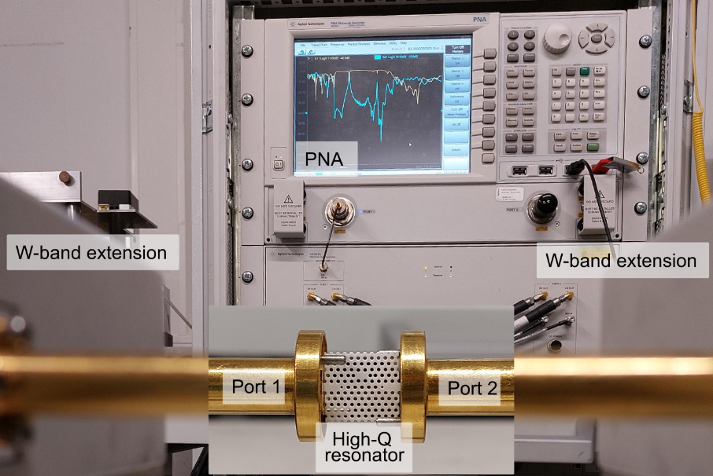
Figure S2: Set-up for the characterization of the dielectric properties of the high-Q resonator.

Supplementary B
Examples of light microscope investigation of Al₂O₃ high-Q resonators sintered at different temperatures ranging from 1250 °C – 1650 °C with the same magnification in all pictures. This shows the application of the knowledge about the shrinkage factors during the temperature treatment to create similar sized structures.
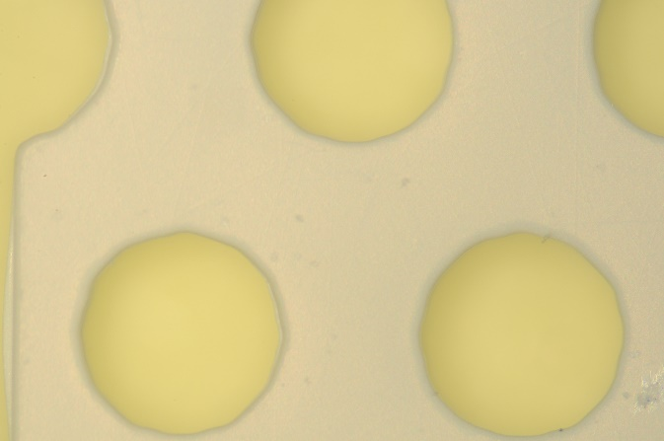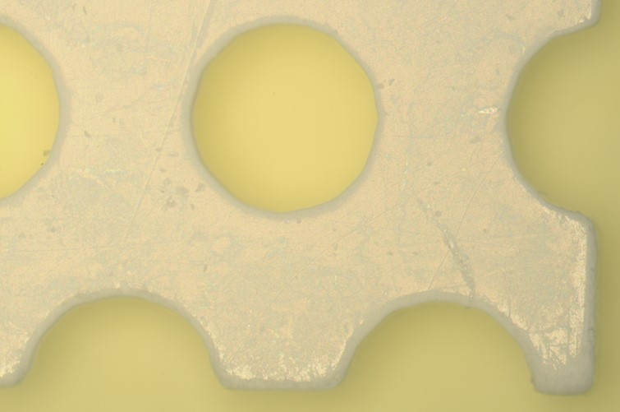
Figure S3: Sample sintered at 1250 °C.

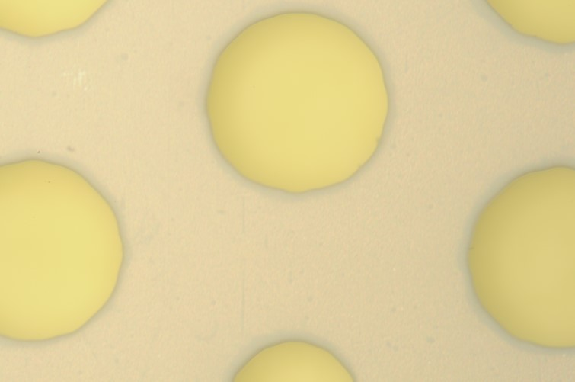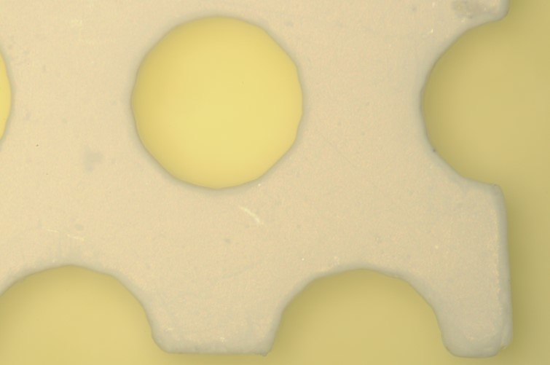
Figure S4: Sample sintered at 1350 °C.

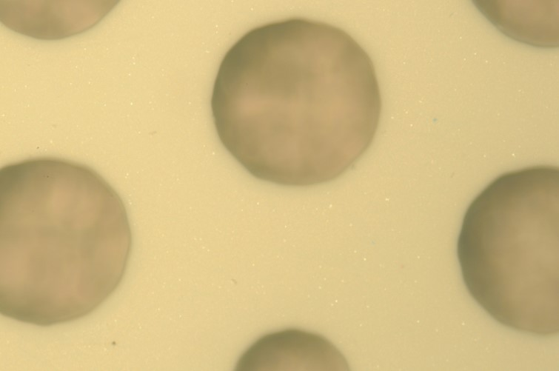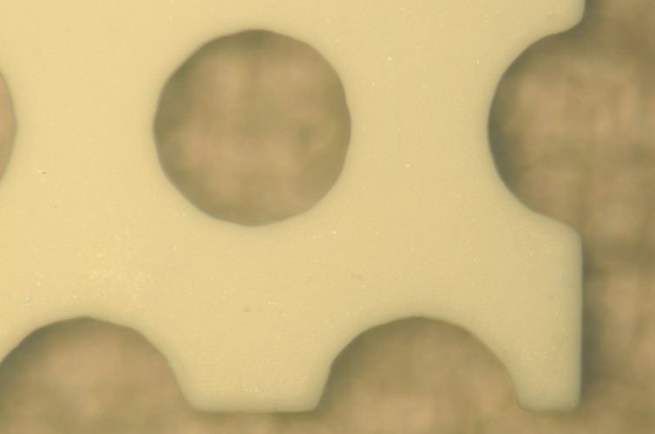
Figure S5: Sample sintered at 1450 °C.

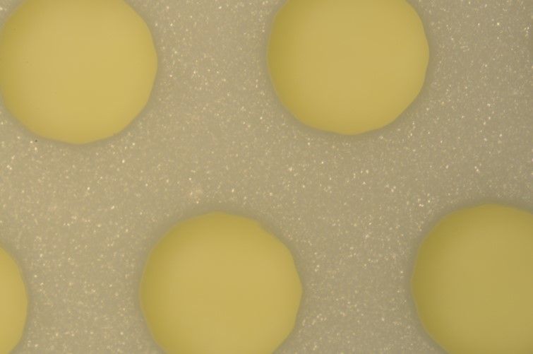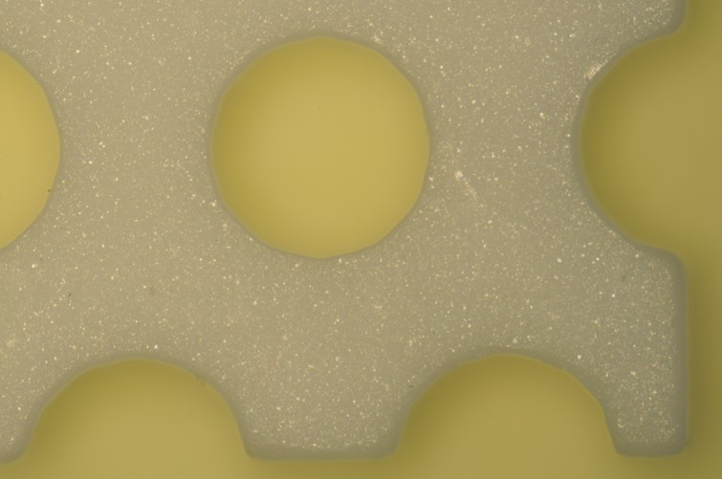
Figure S6: Sample sintered at 1550 °C.

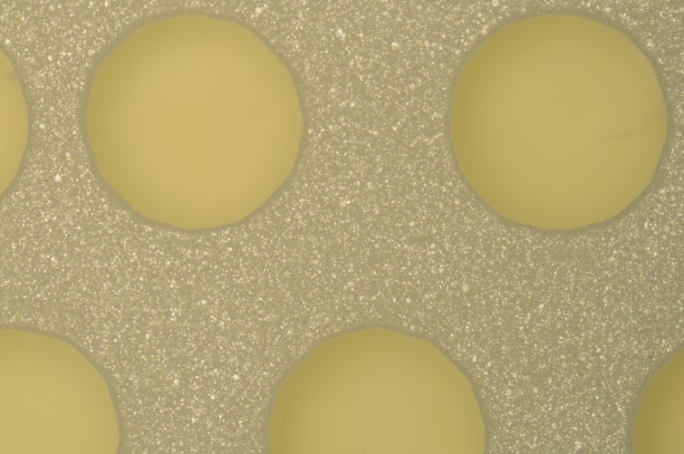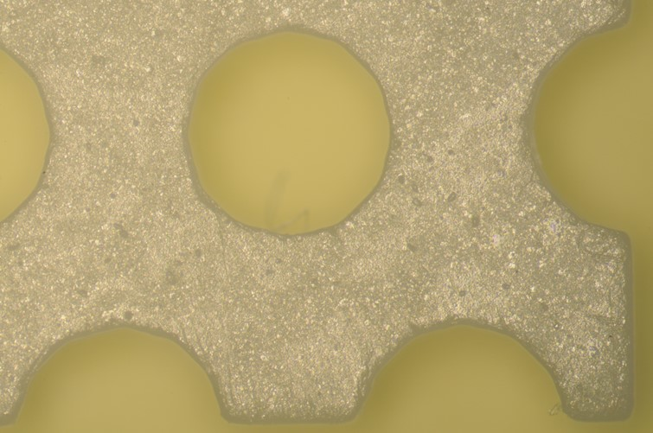
Figure S7: Sample sintered at 1650 °C.

Supplementary C
Absolute values of the dimensions of the samples based on the investigation with the light microscope.

Table S1: Absolute values of the measured and calculated dimensions.
Parameter | Design | 1250 °C | 1350 °C | 1450 °C | 1550 °C | 1650 °C
p [µm] | 1160 | 1155 | 1153 | 1159 | 1161 | 1160
h_{r} [µm] | 345 | 348 | 344 | 342 | 345 | 343
l_{x} [µm] | 12025 | 12020 | 11940 | 11990 | 12080 | 12030
l_{y} [µm] | 12760 | 12707 | 12658 | 12711 | 12820 | 12775
h_{s1} [µm] | 290 | 289 | 289 | 294 | 285 | 289
h_{s2} [µm] | 133 | 132 | 131 | 134 | 135 | 135
t [µm] | 789 | 780 | 785 | 790 | 802 | 800

Supplementary D
Measurement of the $\left|S_{21}\right|$ parameter in dependency of the frequency for each high-Q resonator. The resonance frequency is marked in red. This shows the shift of the resonance frequency in dependency of the material properties.
Figure S8: Measurement of the $\left|S_{21}\right|$ parameter of a high-Q resonator sintered at 1250 °C in dependency of the frequency.

Figure S9: Measurement of the $\left|S_{21}\right|$ parameter of a high-Q resonator sintered at 1350 °C in dependency of the frequency.

Figure S10: Measurement of the $\left|S_{21}\right|$ parameter of a high-Q resonator sintered at 1450 °C in dependency of the frequency.

Figure S11: Measurement of the $\left|S_{21}\right|$ parameter of a high-Q resonator sintered at 1550 °C in dependency of the frequency.

Figure S12: Measurement of the $\left|S_{21}\right|$ parameter of a high-Q resonator sintered at 1650 °C in dependency of the frequency.

