Supplementary

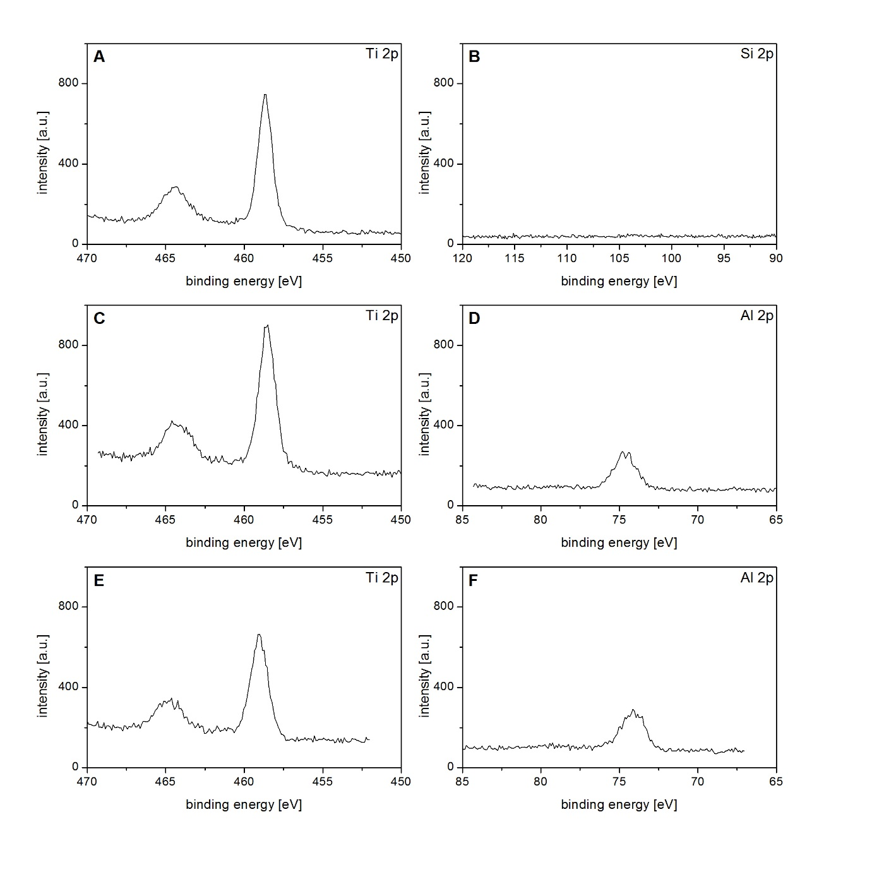 Figure S1. XP spectra obtained during the process of nanocavity formation on planar Si(100)-wafers: A and B show the Ti 2p and Si 2p regions of an Si-wafer + 80x TiO₂, C and D the Ti 2p and Al 2p regions of an Si-wafer + 80x TiO₂ + calixarene + 5x Al₂O₃, and E and F

