Methodology for the Identification of Carbonyl Absorption Maxima of Carbon Surface Oxides in DRIFT spectra

**Supplementary Information**

Felix Herolda, Oliver Leubnera, Katharina Jeschoneka, Christian Hessb, Alfons Drochnera, Wei Qic and Bastian J. M. Etzolda,*

aTechnical University of Darmstadt, Department of Chemistry, Ernst-Berl-Institut für Technische und Makromolekulare Chemie, 64287 Darmstadt, Germany

bTechnical University of Darmstadt, Department of Chemistry, Eduard-Zintl-Institut für Anorganische und Physikalische Chemie, 64287 Darmstadt, Germany

cShenyang National Laboratory for Materials Science, Institute of Metal Research, Chinese Academy of Sciences, Shenyang 110016, People’s Republic of China

\**Corresponding Author*: B. J. M. Etzold, Email: bastian.etzold@tu-darmstadt.de

EXPERIMENTAL

Analytics

Temperature programmed desorption was conducted in a STA 409PC Luxx thermogravimetry device (NETZSCH GmbH) coupled to an online mass spectrometer (Omnistar, Pfeiffer Vacuum GmbH). Under a stream of 30 cm3 min-1 (STP) He, 50 mg of a carbon sample were initially heated with a rate of 5 °C min-1 to 100 °C, allowing the sample to dry for 2 h. Subsequently, the sample was heated from 100 °C to 1000 °C with a rate of 5 °C min-1. The mass spectrometer was calibrated utilizing (gravimetrically) premixed gas mixtures (Westfalen AG, 2 vol-% CO in He, 2 vol-% CO2 in He, 5 vol-% O2 in He and 2 % N2 in He). H2O was calibrated by feeding a defined amount of O2 (prior calibrated by a defined gas mixture) and H2 to a total oxidation catalyst (Pt/Al2O3, Shimadzu Corp.) at 350 °C. The analytical error, determined by the combined thermogravimetric/TPD analysis of a known amount of CaC2O4*H2O was found to be around 5 %.

Deconvolution of the TPD profiles was carried out building on work of Pereira, Figueiredo and co-workers by utilizing Gaussian functions and a least squares fit procedure.[1–3] In case of the CO2 emission profile, the temperature maximum of carboxylic acids was positioned at 310 ± 25 °C, that of anhydrides at 450 ± 25°C and that of lactones at 650 ± 25 °C. In a similar manner, deconvolution of the CO emission profiles was carried out assuming the position of the desorption maxima of an unspecified low temperature CO evolution at 250 ± 25 °C, of primary alcohols at 410 ± 25 °C[4], of phenols at 510 ± 25 °C[4], of carbonyl groups (aldehydes, ketones) and ethers at 675 ± 25 °C and of quinones at 825 ± 25 °C. The half width at half maximum (HWHM) was fixed for all contributions to a range of 75 ± 25 °C

Potentiometric titrations were conducted using an automatic titrator Mettler Toledo T50. About 25 mg of the sample were suspended in 60 mL of a 0.1 M aqueous solution of KNO3 and adjusted to an initial value of pH 3 with 0.1 M HCl (Merck). The actual titration was carried out with 0.1 M KOH (Merck), dosing 60 μL every 1200 s while bubbling N2 through the suspension in order to avoid carbonate formation. Prior each titration, the pH electrode was calibrated using appropriate analytical standards purchased by Carl Roth. The measurement error, found in the deviation of ion-exchange capacity determined by consecutive titrations of a given sample, was found be in the range of 5-10 % For the calculation of the ion exchange capacity, the corresponding blank capacity is subtracted from the observed sample capacity. Proton sorption isotherms and the corresponding acidity constant distributions were derived from potentiometric titration curves according to a procedure proposed by Bandosz and co-workers.[5] Boehm titration was carried out following a procedure proposed by Ackermann *et al*.[6]In short, 50 mg of a carbon sample are dispersed for 48 h under inert atmosphere in 40 mL of 0.01 N NaHCO3, Na2CO3 and NaOH. After carbon removal by filtration, 10 mL aliquots of the base solutions are mixed with 15 mL of 0.01 N HCl each, and are subsequently titrated with a 0.01 N Na2CO3 solution using an automatic potentiometric titrator (Mettler Toledo T50). All results of Boehm titration are corrected by a corresponding blank measurement. Diffuse reflectance infrared fourier transform spectroscopy (DRIFTS) was performed employing a Bruker VERTEX 70 spectrometer with a resolution of 1 cm-1 using a N2 flushed Praying-Mantis diffuse reflection accessory (Harrick Scientific) in combination with a liquid-nitrogen-cooled mercury cadmium telluride detector. Samples were not processed or diluted, as reference served optical grade KBr (Sigma Aldrich). The pictured spectra were averaged from 300 scans, using an aperture of 3.5 mm. The reproducibility concerning the position of the observed absorption maxima was determined to be within a range of 1 cm‑1.[4] X‑ray photoelectron spectroscopy was performed on a SSX 100 ESCA spectrometer (Surface Science Laboratories) using monochromatic Al Kα irradiation (1486.6 eV) operating at 100 W and a pressure of 10-8 mbar. Quantification of detected species was performed using the CasaXPS software, employing sensitivity factors of 1 for carbon species and 2,5 for oxygen species.The energy axis was calibrated by fixing the C1s contribution of sp2 carbon (“graphite”) at 284.6 eV. For deconvolution, linear combinations of Gaussian and Lorentzian functions were utilized (“pseudo-Voigt”-profiles) and Shirley background subtraction was performed prior fitting. Deconvolution of the C1s regions was performed assuming the contribution of non-functionalized sp2-carbon at 284.6 ± 0.1 eV, carbon bound to oxygen by a single bond at 286.1 ± 0.1 eV, carbon bound to oxygen by a double bond at 287.5 ± 0.1 eV, carboxylic acid derivates at 288.7 ± 0.1 eV and the π→π* transition satellite at 290.5 ± 0.1 eV.[7,8] The full width at half maximum (FWHM) was restricted to values between 1.4 and 1.6 eV. Shape factors (ratio of Lorentzian/Gaussian functions) were kept equal for all functions during the fit, and were usually close to 0.5. The O1s contribution was fitted assuming the contribution of oxygen bound to carbon by a double bond at 531.3 ± 0.2 eV, oxygen of carboxylic acids at 532.3 ± 0.2 eV, oxygen bound to carbon by single bond(s) at 533.5 ± 0.2 eV and adsorbed water at 535.2 ± 0.2 eV.[8,9] FWHM values were restricted between 1.4 and 1.8 eV. Shape factors were kept equal for all functions during the fit, and were usually located close to 0.5. Elemental analysis (C, H, N) was conducted in a Vario EL III (Elementar Analysesysteme GmbH) device using O2 as oxidant, He as carrier gas and a gas chromatograph with thermal conductivity detector for the detection and quantification of the reaction products. Each sample was analysed twice, whereas the deviation in carbon content was usually found to be below 1 %.

Table S1. Elemental analysis (C, H, N) of the oxidized polymer derived carbons.

|  |  |  |  |  |
| --- | --- | --- | --- | --- |
| Sample | C [wt-%] | H [wt-%] | N [wt-%] | Oǂ [wt-%] |
| **O-PDC-\*** | 62.4 | 2.1 | 1.1 | 34.3 |
| -He510°C | 80.0 | 2.2 | 1.3 | 16.5 |
| -He510°C-KOH | 75.5 | 2.2 | 1.1 | 21.2 |
| -KOH-RT-6h | 66.0 | 2.5 | 1.0 | 30.4 |
| -KOH-RT-24h | 65.9 | 2.4 | 1.0 | 30.7 |
| -KOH-60°C-24h | 66.6 | 2.3 | 0.9 | 30.3 |
| -KOH-120°C-24h | 69.6 | 2.5 | 0.7 | 27.3 |
| -KOH-He315°C | 73.6 | 2.0 | 0.9 | 23.6 |

*Obtained by hydrothermal oxidation at 180 °C with 1.5 M HNO3 for 1 h. All other samples are produced by processing oxidized polymer-derived carbon. ǂOxygen content is assumed to be residual mass unaccounted for by C, H and N.

Table S2. Literature data on decomposition products and temperature ranges for individual oxygen surface groups on carbon during temperature programmed desorption.

|  |  |  |  |
| --- | --- | --- | --- |
| Functional Group | Decomposition product(s) | Desorption Temperature | Reference |
| Carboxylic acids | CO2 | 327 °C  200 – 250 °C  340 °C  310 °C  252 °C  275 °C | [10]  [11]  [7]  [12]  [13]  [14] |
| Lactones | CO2 | 627 °C  350 - 400 °C  127 °C - 627 °C  650 °C  625 °C  252 – 620 °C  650 °C | [15]  [11]  [16]  [7]  [12]  [13]  [14] |
| Anhydrides | CO+CO2 | 627 °C  627 °C  350 - 450°C  470 °C  440 °C  315-620°C  435-460 °C | [10]  [15]  [11]  [7]  [12]  [13]  [14] |
| Ethers | CO | 680 °C  700 °C  > 670 °C  620 - 800 °C  735 °C | [17]  [7]  [13]  [14] |
| Alcohols | CO | 410 - 510 °C  700 °C  > 670 °C  620 - 800 °C  735 °C | [4]  [7]  [12]  [13]  [14] |
| Ketones | CO | 800 – 900 °C  680 °C  280 °C  800-1000 °C  920 °C | [11]  [4]  [7]  [13]  [14] |
| Aldehydes | CO | 800 - 900 °C  680 °C  280 °C  310 °C  800-1000°C | [11]  [4]  [7]  [12]  [13] |
| Quinones | CO | 800 - 900 °C  680 °C  700 °C  > 670 °C  800 - 1000 °C  920 °C | [11]  [17]  [7]  [12]  [13]  [14] |

Table S3. Composition of surface oxygen species derived from deconvolution of O1s XP spectra.

|  |  |  |  |  |
| --- | --- | --- | --- | --- |
| Sample | O*  [at-%] | C=**O**+  [at-%] | C**OO**H#  [at-%] | C-**O**-ǂ  [at-%] |
| **O-PDC-** | 17.9 | 5.4 | 6.2 | 5.8 |
| -He510°C | 12.8 | 4.6 | 3.2 | 5.0 |
| -He510°C-KOH | 19.3 | 3.9 | 6.4 | 8.2 |
| -KOH-RT-6h | 22.2 | 4.8 | 6.9 | 9.6 |
| -KOH-RT-24h | 21.4 | 6.2 | 8.1 | 7.1 |
| -KOH-60°C-24h | 20.0 | 4.1 | 6.3 | 8.8 |
| -KOH-120°C-24h | 22.8 | 1.9 | 6.1 | 10.8 |
| -KOH-He315°C | 18.8 | 6.4 | 3.6 | 7.8 |

*XPS oxygen content. As also N was present (~1 at-%), the sum of C and O surface concentration does not equal one. +Corresponding to carbonyl oxygen species in carboxylic anhydrides, lactones, ketones, aldehydes and quinones. #Oxygen in carboxylic acids. ǂIndicating single-bond oxygen species occurring in alcohols, ethers, anhydrides and lactones.

Table S4. Composition of surface carbon species derived from deconvolution of C1s XP spectra.

|  |  |  |  |  |  |
| --- | --- | --- | --- | --- | --- |
| Sample | C*  [at-%] | **C**-C  [at-%] | **C**-O+  [at-%] | **C**=O#  [at-%] | O-**C**=Oǂ  [at-%] |
| **O-PDC-** | 82.1 | 61.8 | 9.2 | 3.1 | 8.1 |
| -He510°C | 86.0 | 74.2 | 4.8 | 3.3 | 3.8 |
| -He510°C-KOH | 80.0 | 59.1 | 10.5 | 3.0 | 7.4 |
| -KOH-RT-6h | 76.5 | 53.3 | 10.3 | 3.7 | 9.3 |
| -KOH-RT-24h | 77.6 | 58.3 | 7.9 | 2.7 | 8.8 |
| -KOH-60°C-24h | 73.1 | 57.9 | 9.4 | 2.8 | 8.9 |
| -KOH-120°C-24h | 76.3 | 53.8 | 10.7 | 2.9 | 9.0 |
| -KOH-He315°C | 80.1 | 56.3 | 11.3 | 4.0 | 8.4 |

*XPS carbon content. As also N was present (~1 at-%), the sum of C and O surface concentration does not equal one +Corresponding to carbon in alcohols, ethers, carbon bound to lactone bridge-O. #Indicating carbonyl species such as aldehydes, ketones, and quinones. ǂCarbonyl carbon in carboxylic acid derivatives such as carboxylic acids, anhydrides and lactones.

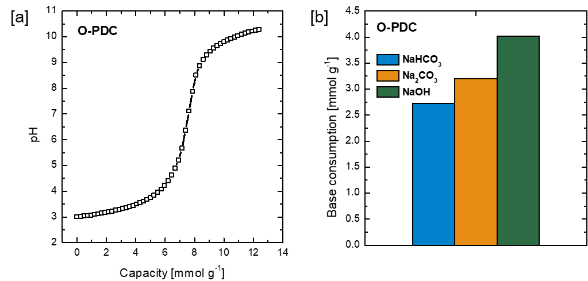

Figure S1: [a] Potentiometric titration of O-PDC and [b] Boehm titration of O-PDC.

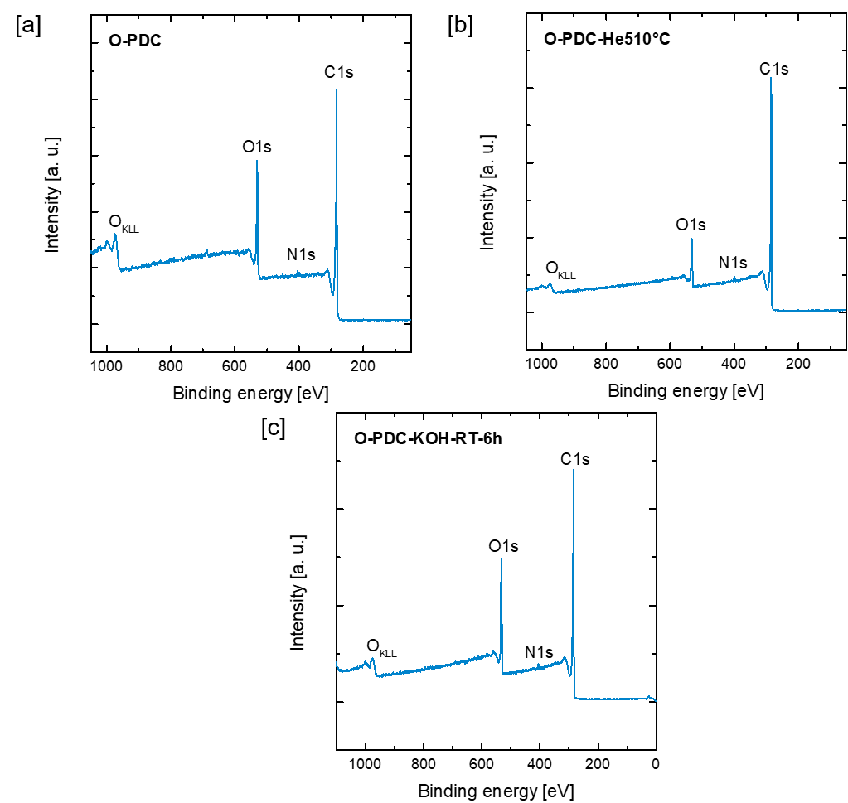

Figure S2: XPS survey scans of [a] O-PDC, [b] O-PDC-He510°C and [c] O-PDC-KOH-RT-6h. Note that a negligible fluorine contribution can be observed at 688 eV in the survey scan of O-PDC. This contamination originates most likely from abrasion processes caused by the magnetic stirrer bar that is used in the PTFE lined autoclave employed for hydrothermal HNO3 oxidation. The F1s contribution is not present in any of the other samples.

*Lactones*

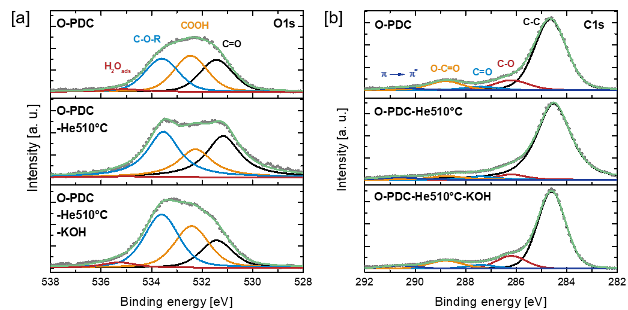

Figure S3: Deconvolution of [a] XPS O1s and [b] C1s spectra of O-PDC, O-PDC-He510°C and O-PDC-He510°C-KOH

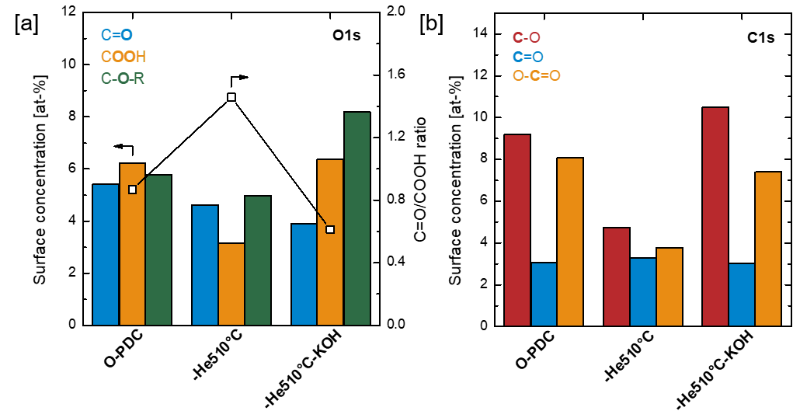

Figure S4: Composition of O and C species derived from deconvolution of [a] XPS C1s spectra and [b] XPS O1s spectra of O-PDC, O-PDC-He510°C and O-PDC-He510°C-KOH.

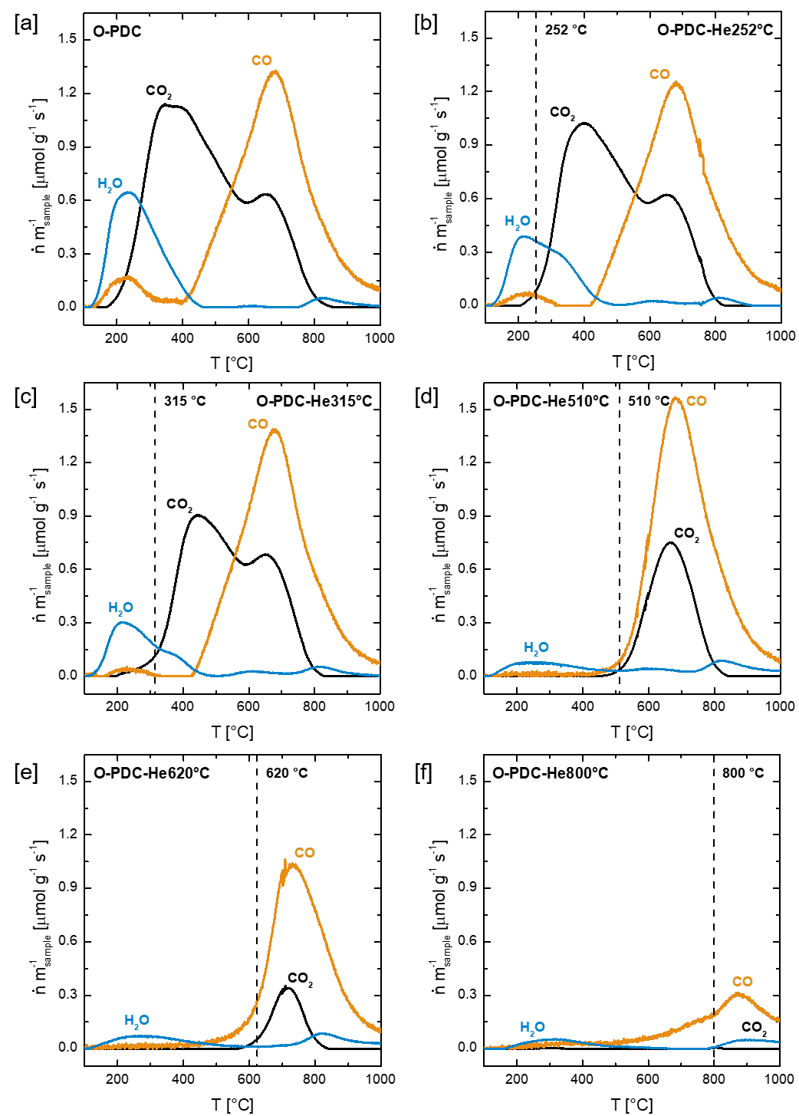

Figure S5: Temperature programmed desorption experiments subsequent to annealing in inert atmosphere at various temperatures. [a] Pristine O-PDC. O-PDC annealed at [b] 252 °C, [c] 315 °C [d] 510 °C [e] 620 °C [f] 800 °C. Note that this particular series of experiments was conducted with a different batch of O-PDC than the experiments shown in the main paper.

The thermal desorption approach was tested by annealing O-PDC in inert atmosphere at various temperatures between 252 °C and 800 °C, whereas the chosen temperatures for the desorption of individual surface oxides where inspired by Düngen et al. (Figures S6).[13] TPD analysis of the annealed carbon shows, that annealing at 315 °C reduces the formerly three contributions of the TPD CO2 evolution profile to two, centered at 445 °C and 650 °C, suggesting thereby the loss of carboxylic acid groups (Figure S6c). Annealing to 510 °C reduces the CO2 emission profile further, with one single desorption peak left centered at 665 °C, indicating the additional loss of carboxylic anhydrides (Figure 6d). At this annealing temperature, also the CO evolution profile is affected as the decomposition of thermally labile CO emitting surface groups starts around 400 °C (e. g. anhydrides). Annealing at 620 °C leads to a further loss of CO emitting surface oxides and lactones, whereas some high temperature stable lactones remain, as indicated by a small TPD CO2 emission peak centered at 715 °C (Figure 6e). Thermal treatment at 800 °C causes the loss of all CO2 emitting groups and a majority of groups that develop CO upon thermal decomposition (Figure 6f).

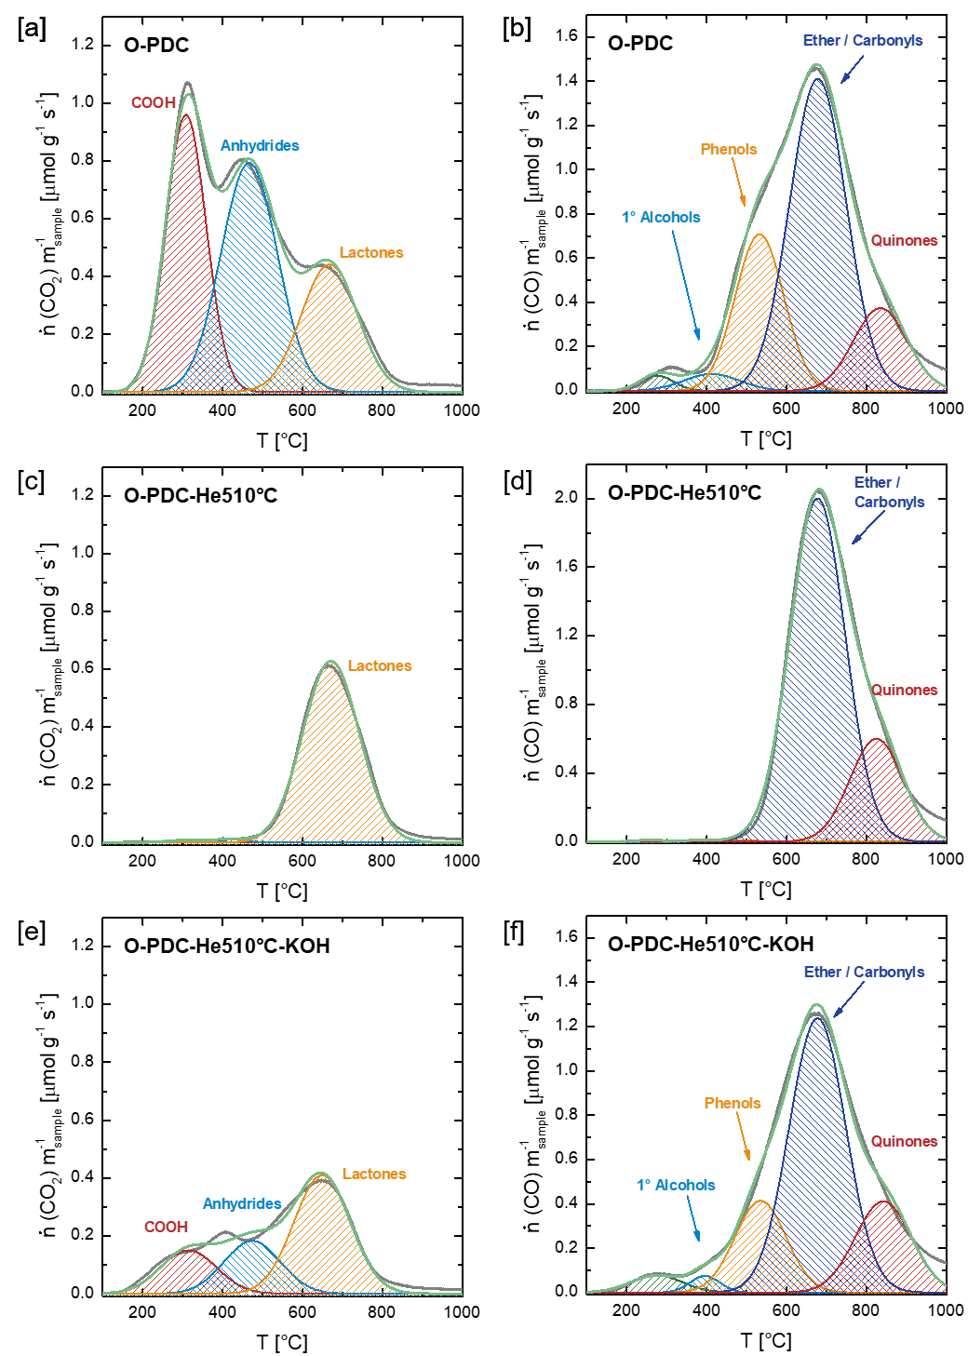

Figure S6: Fitting of TPD emission profiles. [a] CO2 emission profile of O-PDC, [b] CO emission profile of O-PDC, [c] CO2 emission profile of O-PDC-He510°C [d] CO emission profile of O-PDC-He510°C, [e] CO2 emission profile of O-PDC-He510-KOH and [f] CO emission profile of O-PDC-He510°C-KOH.

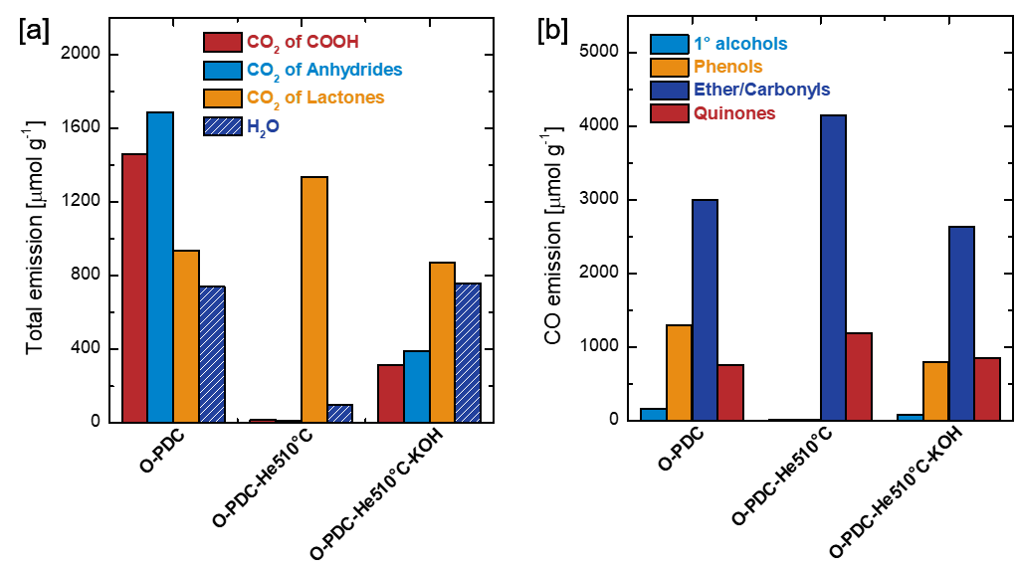

Figure S7: [a] Total emission of H2O and CO2 assigned to the thermal decomposition of carboxylic acids, anhydrides and lactones of O-PDC, O-PDC-He510°C and O-PDC-He510°C-KOH. [b] Total emission of CO assigned to the thermal decomposition of primary alcohols, phenols and carbonyls/ethers and quinones of O-PDC, O-PDC-He510°C and O-PDC-He510°C-KOH.

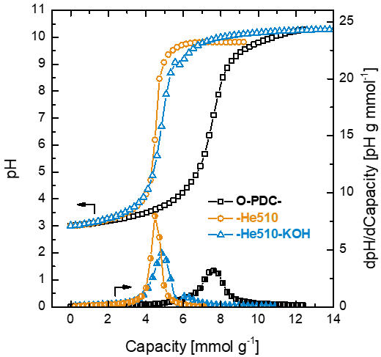

Figure S8: Potentiometric titration curves and 1st derivatives of the titration curves of about 25 mg of O-PDC, O-PDC-He510 and O-PDC-He510-KOH in 0.1 M KNO3 aqueous solution with 0.1 M KOH.

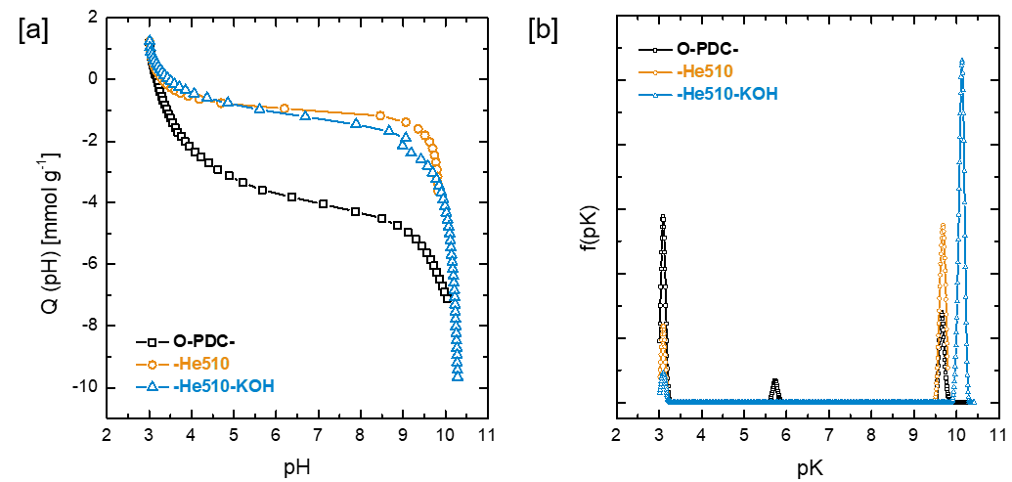

Figure S9: [a] Proton adsorption isotherms derived from the potentiometric titration curves of O-PDC, O-PDC-He510 and O-PDC-He510-KOH. [b] Distribution of acidity constants for O-PDC, O-PDC-He510 and O-PDC-He510-KOH.

D:\01.Oberflächenoxide\Paper - Surface Oxides - Assignment Carbonyl Band\Manuskript\Differenzplot.emf

Figure S10: TPD difference plot. The CO and CO2 profile of O-PDC-He510°C are subtracted from the corresponding TPD-profiles of O-PDC-He510°C-KOH.

*Carboxylic acids*

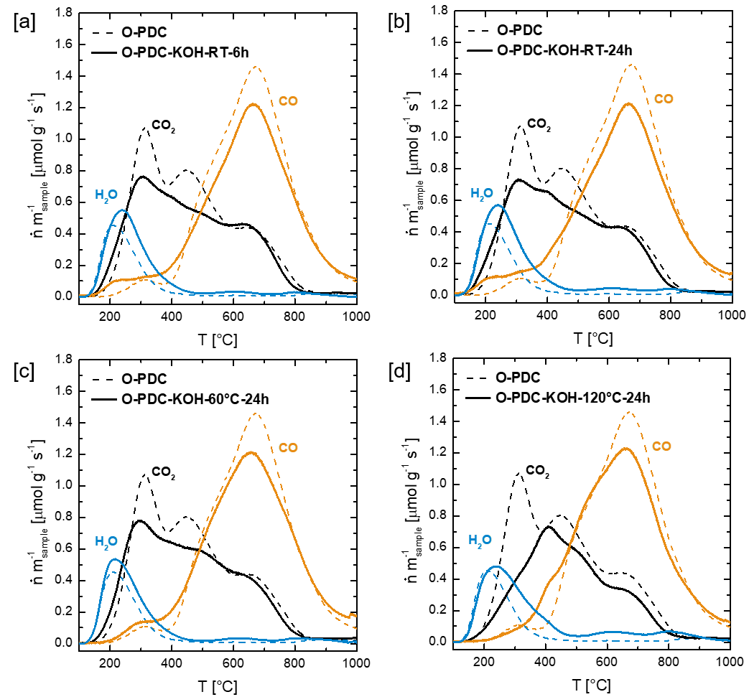

Figure S11: Temperature programmed desorption of oxidized polymer-derived carbons treated with KOH at different conditions. [a] Comparison of O-PDC with O-PDC-KOH-RT-6h. [b] Comparison of O-PDC with O-PDC-KOH-RT-24h. [c] Comparison of O-PDC with O-PDC-KOH-60°C-24h. [d] Comparison of O-PDC with O-PDC-KOH-120°C-24h.

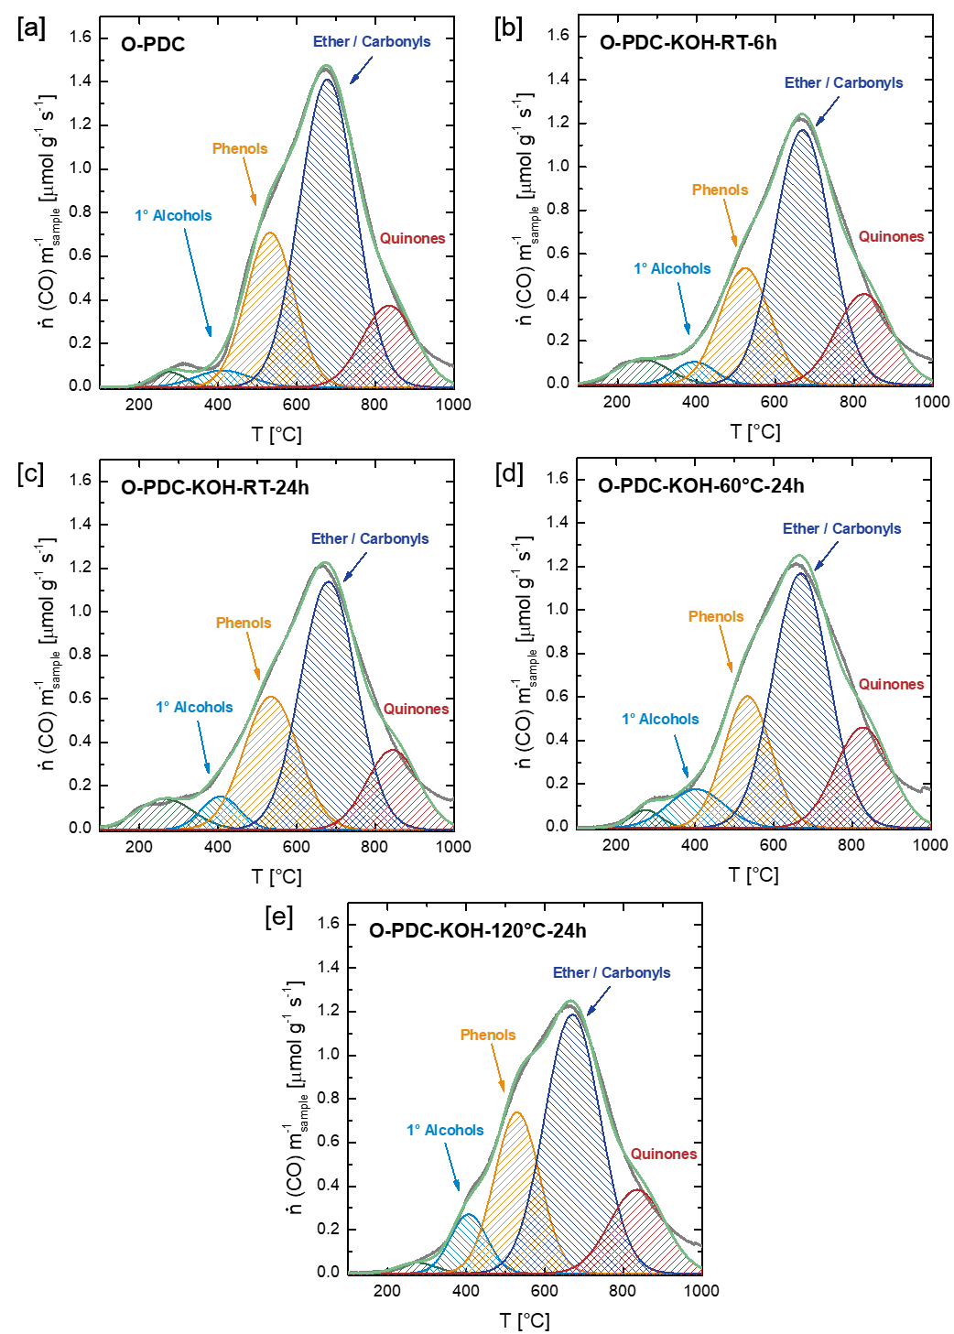

Figure S12: Fitting of TPD emission profiles. [a] CO emission profile of O-PDC, [b] CO emission profile of O-PDC-KOH-RT-6h, [c] CO emission profile of O-PDC-KOH-RT-24h [d] CO emission profile of O-PDC-KOH-60°C-24h and [e] CO emission profile of O-PDC-KOH-120°C-24h.

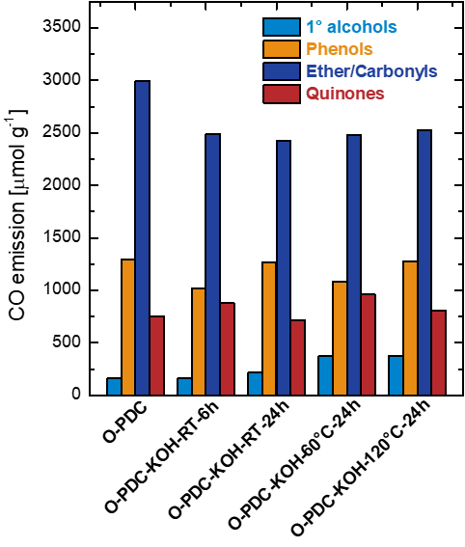

Figure S13: Total emission of CO assigned to the thermal decomposition of primary alcohols, phenols and carbonyls/ethers and quinones of O-PDC, O-PDC-KOH-RT-6h, O-PDC-KOH-RT-24h, O-PDC-KOH-60°C-24h and O-PDC-KOH-120°C-24h.

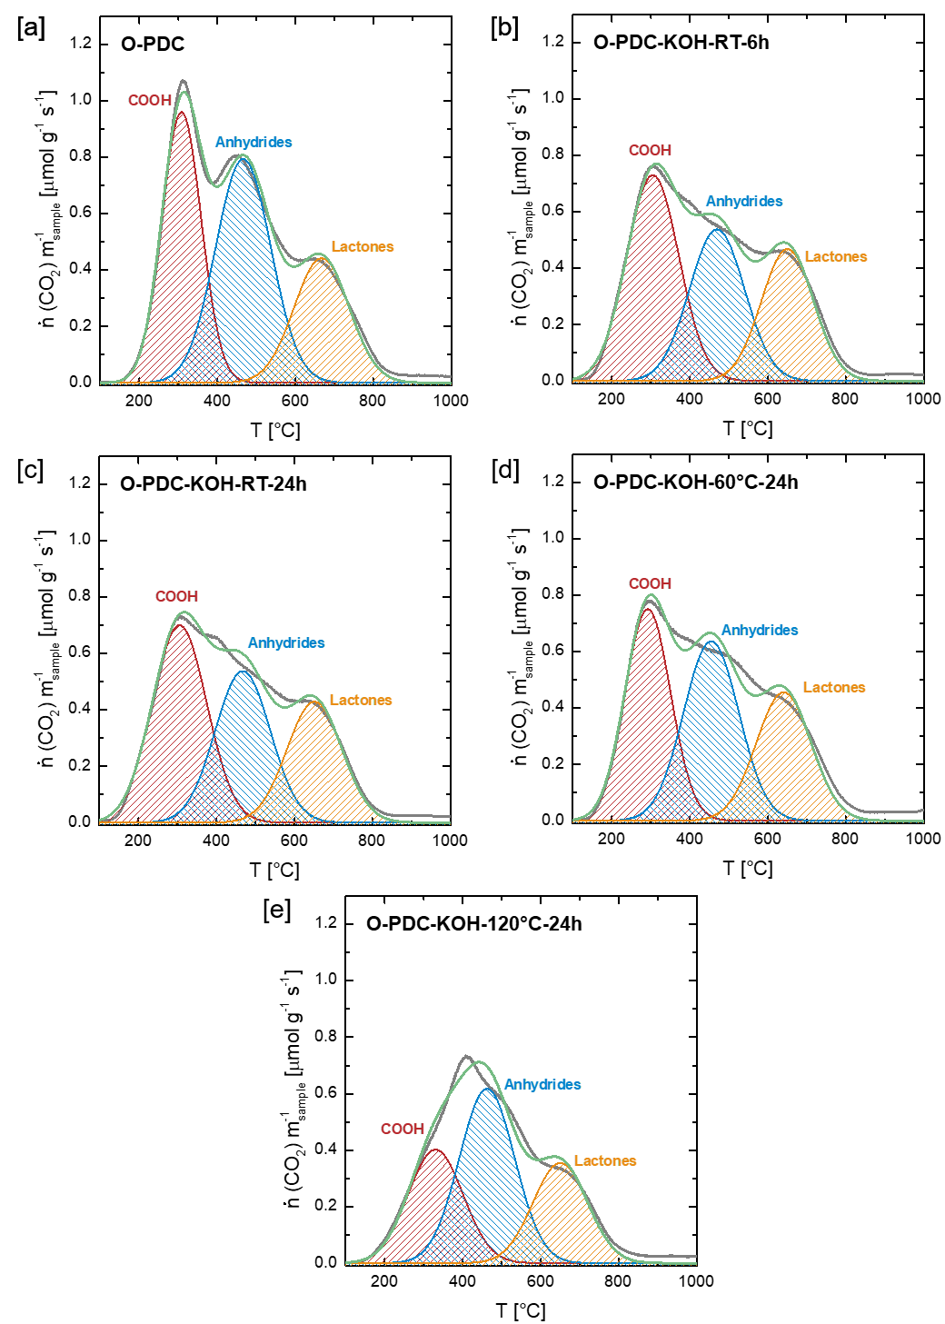

Figure S14: Fitting of TPD emission profiles. [a] CO2 emission profile of O-PDC, [b] CO2 emission profile of O-PDC-KOH-RT-6h, [c] CO2 emission profile of O-PDC-KOH-RT-24h [d] CO2 emission profile of O-PDC-KOH-60°C-24h and [e] CO2 emission profile of O-PDC-KOH-120°C-24h.

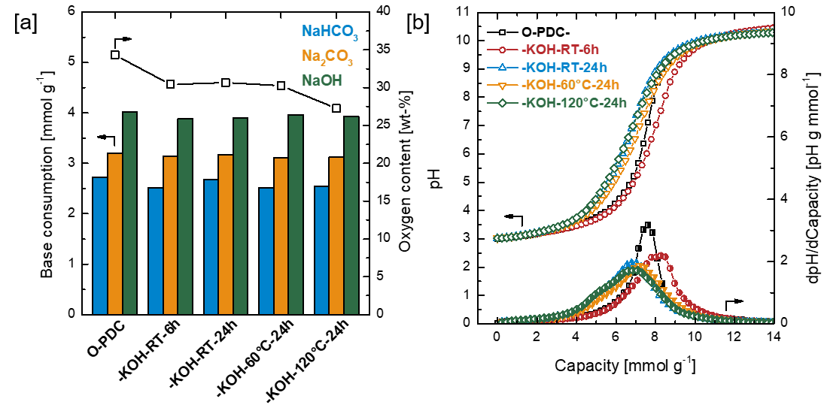

Figure S15: [a] Boehm titration and oxygen content (obtained by elemental analysis (mass unaccounted for by C, H, N) as well as [b] potentiometric titration results of O-PDC, O-PDC-KOH-RT-6h, O-PDC-KOH-RT-24h, O-PDC-KOH-60°C-24h and O-PDC-KOH-120°C-24h.

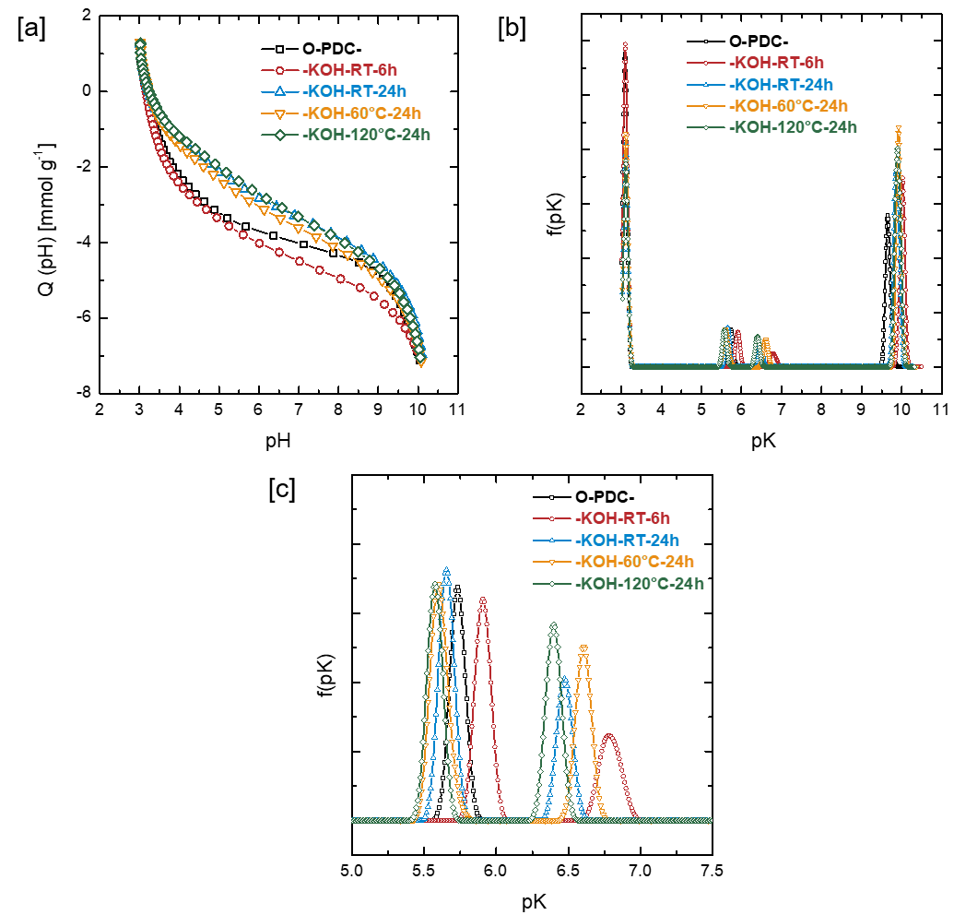

Figure S16: [a] Proton adsorption isotherms derived from the potentiometric titration curves of O-PDC, O-PDC-KOH-RT-6h, O-PDC-KOH-RT-24h, O-PDC-KOH-60°C-24h and O-PDC-KOH-120°C-24h. [b] Distribution of acidity constants for O-PDC, O-PDC-KOH-RT-6h, O-PDC-KOH-RT-24h, O-PDC-KOH-60°C-24h and O-PDC-KOH-120°C-24h. [c] Detail of [b].

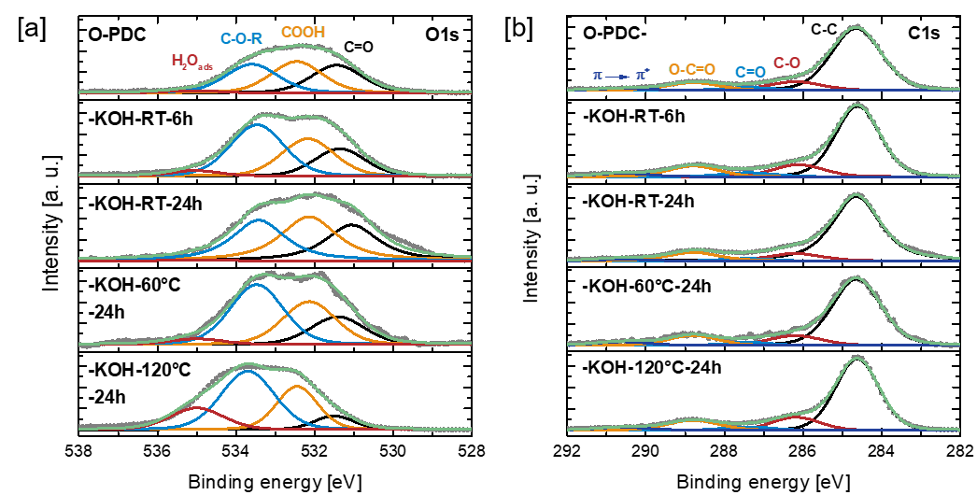

Figure S17: Deconvolution of XPS [a] O1s and [b] C1s spectra of O-PDC, O-PDC-KOH-RT-6h, O-PDC-KOH-RT-24h, O-PDC-KOH-60°C-24h and O-PDC-KOH-120°C-24h.

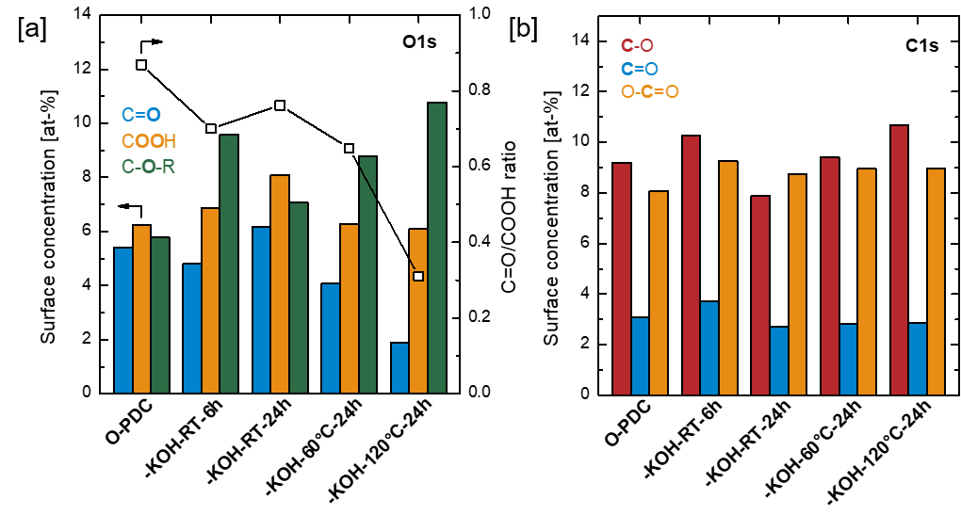

Figure S18: Composition of O and C species derived from deconvolution of [a] XPS C1s spectra and [b] XPS O1s spectra of O-PDC, O-PDC-KOH-RT-6h, O-PDC-KOH-RT-24h, O-PDC-KOH-60°C-24h and O-PDC-KOH-120°C-24h.

*Carboxylic Anhydrides*

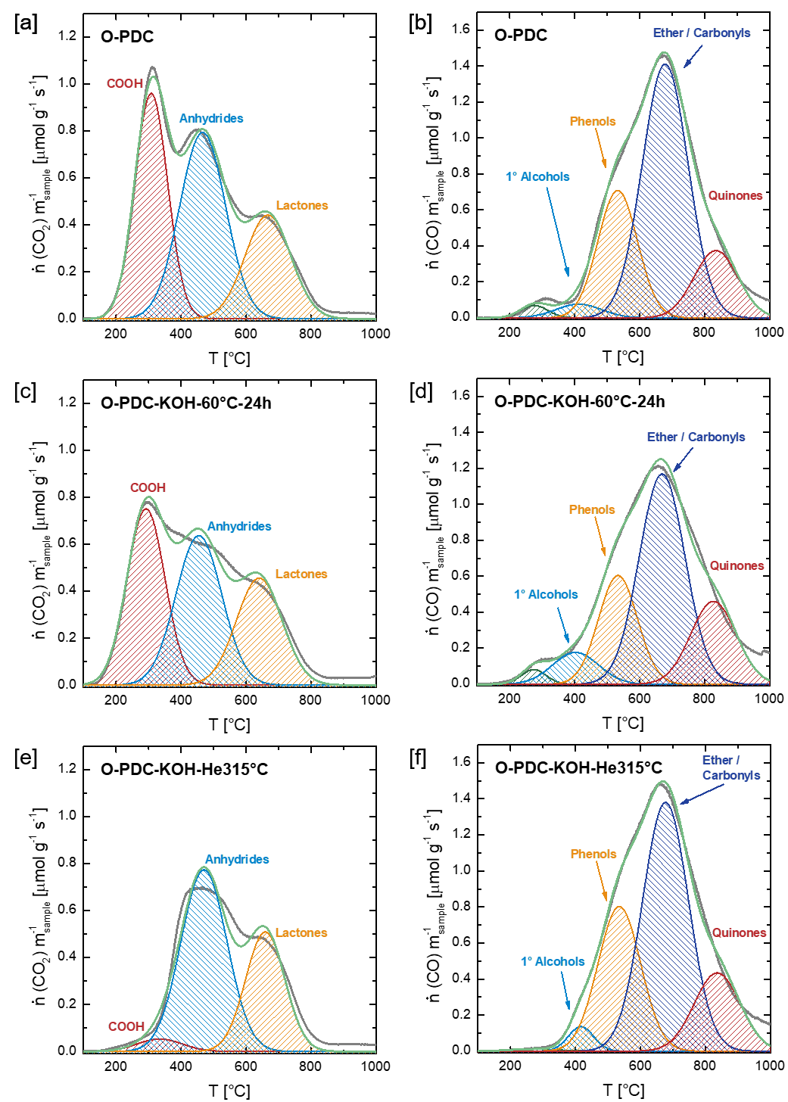

Figure S19: Fitting of TPD emission profiles. [a] CO2 emission profile of O-PDC, [b] CO emission profile of O-PDC, [c] CO2 emission profile of O-PDC-KOH [d] CO emission profile of O-PDC-KOH, [e] CO2 emission profile of O-PDC-KOH-He315°C and [f] CO emission profile of O-PDC-KOH-He315°C.

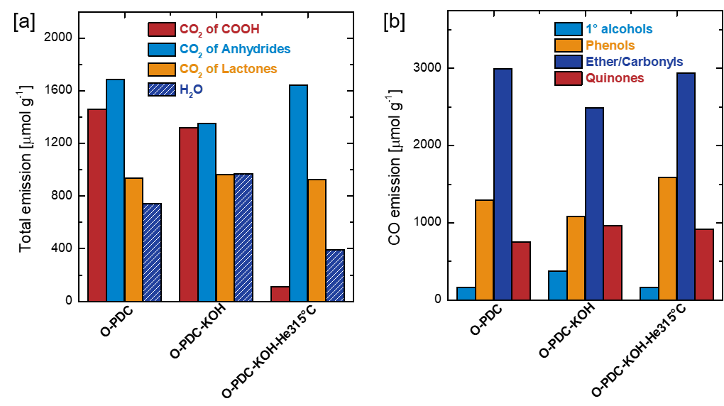

Figure S20: [a] Total emission of H2O and CO2 assigned to the thermal decomposition of carboxylic acids, anhydrides and lactones of O-PDC, O-PDC-He510°C and O-PDC-He510°C-KOH. [b] Total emission of CO assigned to the thermal decomposition of primary alcohols, phenols and carbonyls/ethers and quinones of O-PDC, O-PDC-He510°C and O-PDC-He510°C-KOH.

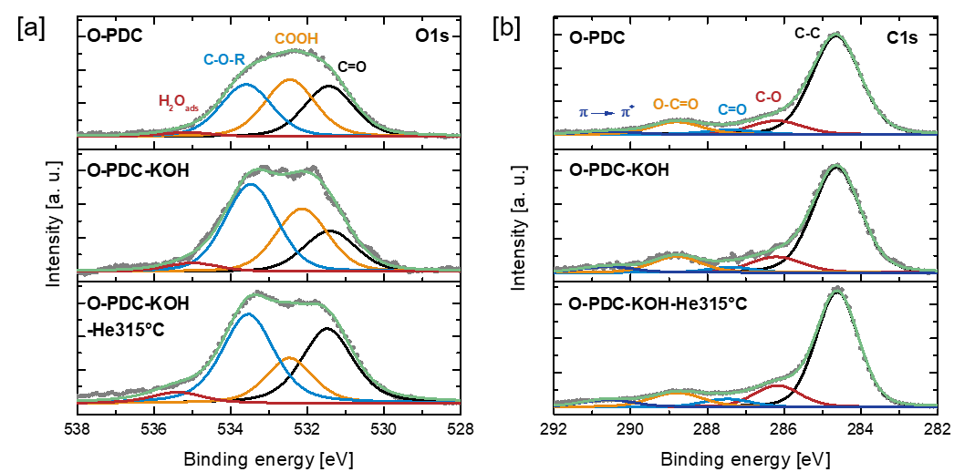

Figure S21: Deconvolution of XPS [a] O1s and [b] C1s spectra of O-PDC, O-PDC-KOH and O-PDC-KOH-He315°C.

D:\01.Oberflächenoxide\Paper - Surface Oxides - Assignment Carbonyl Band\Manuskript\C1s-Übersicht-Anhydride.emf

Figure S22: Composition of C species derived from deconvolution of XPS C1s spectra of O-PDC, O-PDC-KOH and O-PDC-KOH-He315°C.

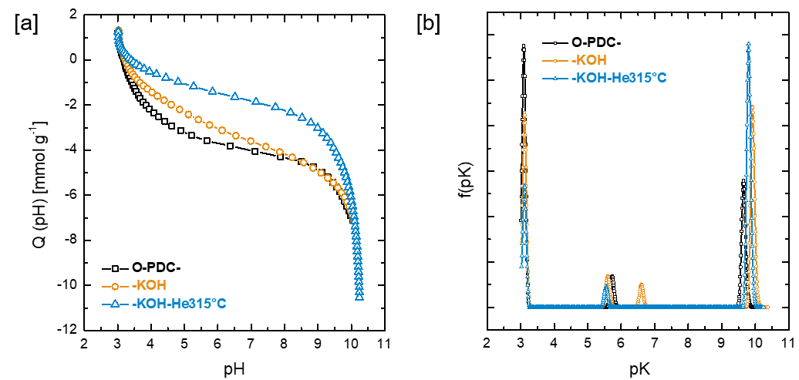

Figure S23: [a] Proton adsorption isotherms derived from the potentiometric titration curves of O-PDC, O-PDC-KOH and O-PDC-KOH-He315°C. [b] Distribution of acidity constants for O-PDC, O-PDC-KOH and O-PDC-KOH-He315°C.

D:\01.Oberflächenoxide\Paper - Surface Oxides - Assignment Carbonyl Band\Manuskript\Boehm-Anhydrid.emf

Figure S24: Boehm titration results and oxygen content (obtained by elemental analysis (mass unaccounted for by C, H, N) of O-PDC, O-PDC-KOH and O-PDC-KOH-He315°C.

D:\01.Oberflächenoxide\Paper - Surface Oxides - Assignment Carbonyl Band\Manuskript\O-PDC Baselinekorrektur.emf

Figure S25: Baseline correction of the DRIFT spectrum of O-PDC. The correction was executed by utilizing a polynomial function, assuming that absorption of functional groups at wavenumbers above 1925 cm-1 is negligible. In light of the given sample composition (C, H, O, N), in the spectral region between 1900 and 2200 cm-1 only the absorption of some exotic structures like C≡C triple bonds, cumulated double bonds and nitriles (N < 1 wt-%) is expected.

REFERENCES

[1] H.F. Gorgulho, J.P. Mesquita, F. Gonçalves, M.F.R. Pereira, J.L. Figueiredo, Characterization of the surface chemistry of carbon materials by potentiometric titrations and temperature-programmed desorption, Carbon 46 (2008) 1544–1555.

[2] J. Figueiredo, M. Pereira, M. Freitas, J. Órfão, Modification of the surface chemistry of activated carbons, Carbon 37 (1999) 1379–1389.

[3] J.L. Figueiredo, M.F.R. Pereira, M.M.A. Freitas, J.J.M. Órfão, Characterization of Active Sites on Carbon Catalysts, Ind. Eng. Chem. Res. 46 (2007) 4110–4115.

[4] F. Herold, O. Leubner, P. Pfeifer, D. Zakgeym, A. Drochner, W. Qi, B.J.M. Etzold, Synthesis strategies towards amorphous porous carbons with selective oxygen functionalization for the application as reference material, Carbon 171 (2021) 658–670.

[5] T.J. Bandosz, J. Jagiello, C. Contescu, J.A. Schwarz, Characterization of the surfaces of activated carbons in terms of their acidity constant distributions, Carbon 31 (1993) 1193–1202.

[6] J. Ackermann, A. Krueger, Highly sensitive and reproducible quantification of oxygenated surface groups on carbon nanomaterials, Carbon 163 (2020) 56–62.

[7] S. Kundu, Y. Wang, W. Xia, M. Muhler, Thermal Stability and Reducibility of Oxygen-Containing Functional Groups on Multiwalled Carbon Nanotube Surfaces, J. Phys. Chem. C 112 (2008) 16869–16878.

[8] J. Lahaye, G. Nanse, P. Fioux, A. Bagreev, A. Broshnik, V. Strelko, Chemical transformation during the carbonisation in air and the pyrolysis under argon of a vinylpyridine–divinylbenzene copolymer by X-ray photoelectron spectroscopy, Appl. Surf. Sci. 147 (1999) 153–174.

[9] F. Li, P. Yan, F. Herold, A. Drochner, H. Wang, T. Cao, W. Liu, X. Dai, B. Zhang, B.J. Etzold, W. Qi, Oxygen assisted butanol conversion on bifunctional carbon nanotube catalysts, Carbon 170 (2020) 580–588.

[10] Y. Otake, R.G. Jenkins, Characterization of oxygen-containing surface complexes created on a microporous carbon by air and nitric acid treatment, Carbon 31 (1993) 109–121.

[11] U. Zielke, K.J. Hüttinger, W.P. Hoffman, Surface-oxidized carbon fibers, Carbon 34 (1996) 983–998.

[12] S. Kundu, W. Xia, W. Busser, M. Becker, D.A. Schmidt, M. Havenith, M. Muhler, The formation of nitrogen-containing functional groups on carbon nanotube surfaces, Physical chemistry chemical physics 12 (2010) 4351–4359.

[13] P. Düngen, R. Schlögl, S. Heumann, Non-linear thermogravimetric mass spectrometry of carbon materials providing direct speciation separation of oxygen functional groups, Carbon 130 (2018) 614–622.

[14] K. Friedel Ortega, R. Arrigo, B. Frank, R. Schlögl, A. Trunschke, Acid–Base Properties of N-Doped Carbon Nanotubes, Chem. Mater. 28 (2016) 6826–6839.

[15] Q.-L. Zhuang, T. Kyotani, A. Tomita, DRIFT and TK/TPD Analyses of Surface Oxygen Complexes Formed during Carbon Gasification, Energy Fuels 8 (1994) 714–718.

[16] B. Marchon, J. Carrazza, H. Heinemann, G.A. Somorjai, TPD and XPS studies of O2, CO2, and H2O adsorption on clean polycrystalline graphite, Carbon 26 (1988) 507–514.

[17] Q.-L. Zhuang, T. Kyotani, A. Tomita, The change of TPD pattern of O2-gasified carbon upon air exposure, Carbon 32 (1994) 539–540.