Supporting Information
Easy Made Setup for High-Temperature (up to 1100°C) Electrochemical Impedance Spectroscopy
Mariusz Radtke ^{1, *} and Christian Hess ^{2,}
^{1, 2} Eduard-Zintl-Institute, Technical University of Darmstadt, Germany, Alarich-Weiss-Str. 8 64287, Darmstadt, Germany; mariusz.radtke@tu-darmstadt.de
* Correspondence: mariusz.radtke@tu-darmstadt.de

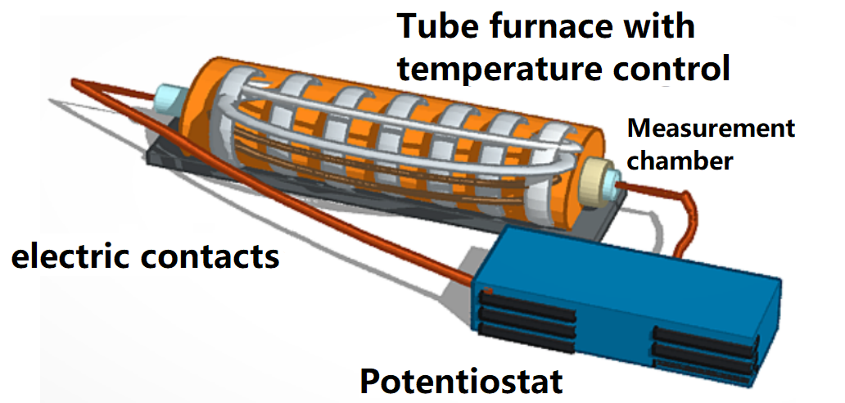
Figure S1. Schematic of the tube furnace, the gas inlets are not shown and are introduced through same inlets as electric contracts by a capillary into the measurement chamber (tube). The measurement cell from the main text is placed inside the Furnace.
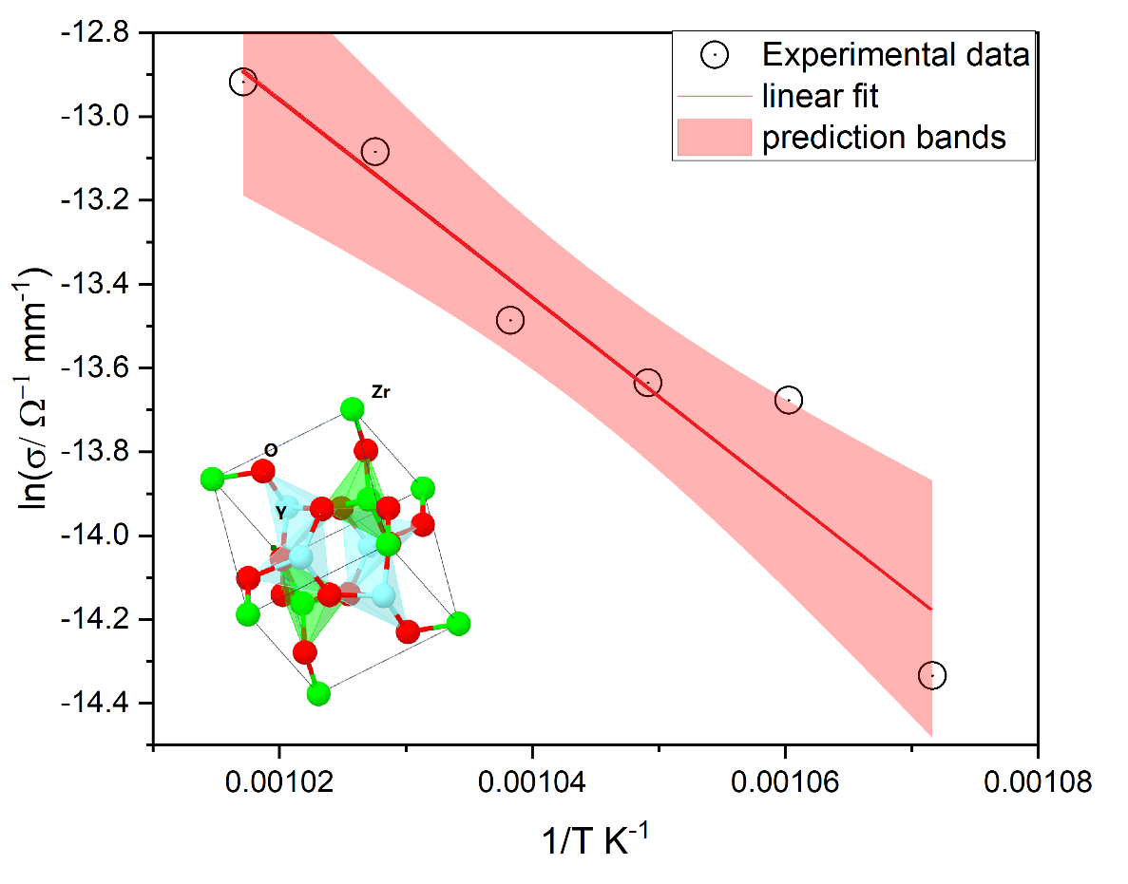
Figure S2. Arrhenius plot of the commercial 8YSZ with the schematic crystallographic structure of Yttria Stabilized Zirconia and prediction bands.
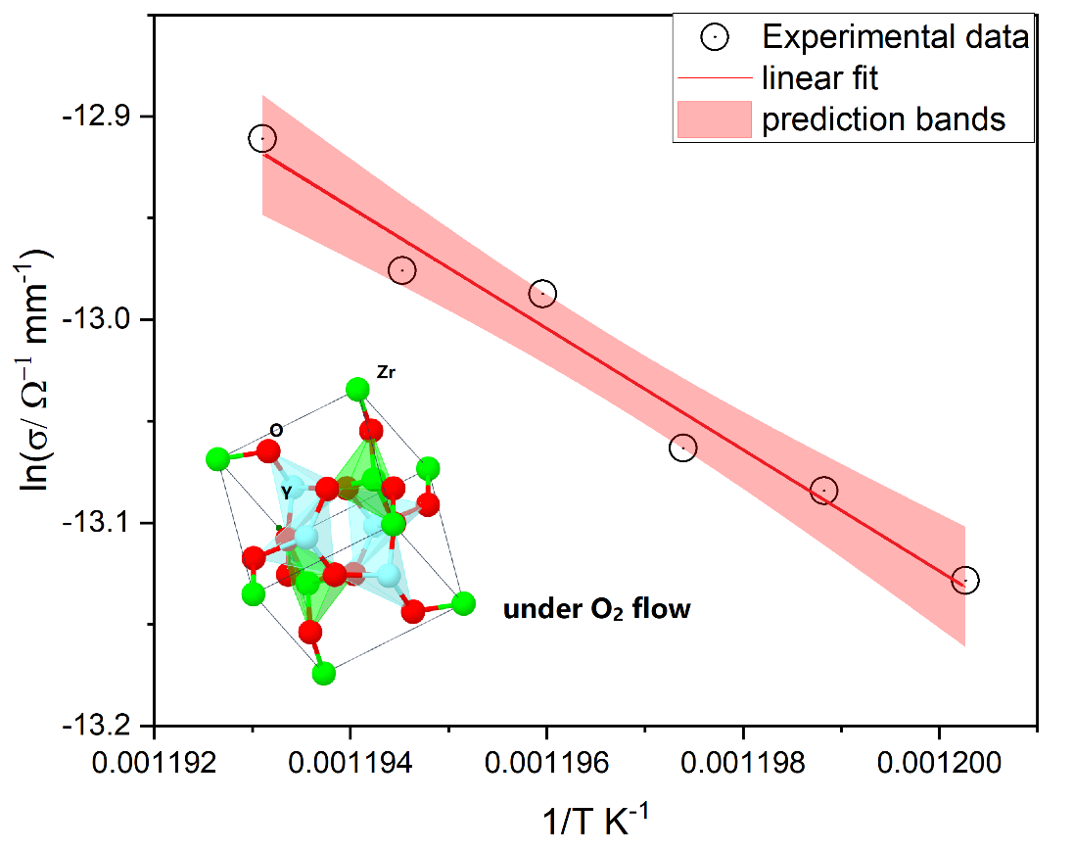
Figure S3. Arrhenius plot of the commercial 8YSZ with the schematic crystallographic structure of Yttria Stabilized Zirconia and prediction bands under 20 sccm oxygen flow.

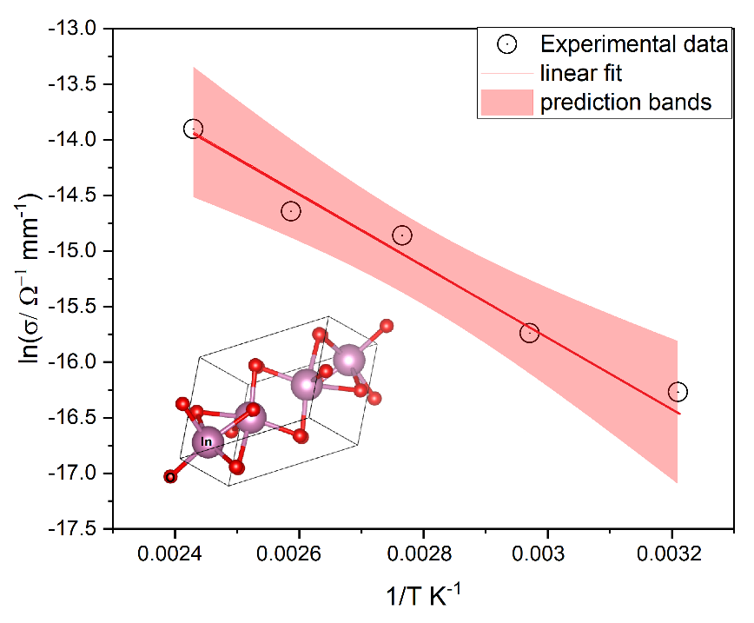
Figure S4. Arrhenius plot for the commercial In₂O₃ used in this study for the estimation of the activation energy of oxygen vacancies.
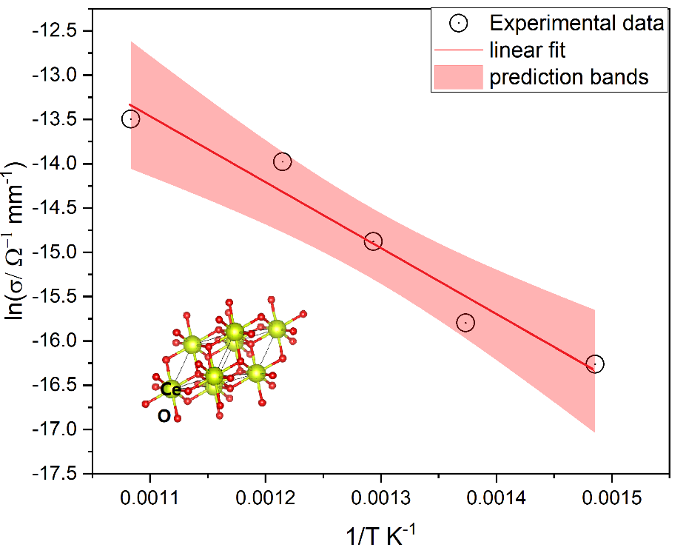
Figure S5. Arrhenius plot for the commercial CeO₂ used for the estimation of oxygen vacancies.

