Effect of resting time on rheological properties of glass beads suspensions: Depletion and bridging force among particles
Yanliang Ji^{a, *}, Simon Becker^{b}, Zichen Lu ^{c, *}, Alexander Mezhov^{d}
Regine von Klitzing^{b}, Schmidt Wolfram^{d}, Dietmar Stephan ^{a, *}

a. Department of Civil Engineering, Technische Universität Berlin, 13355 Berlin, Germany.
b. Soft Matter at Interfaces, Department of Physics, Technische Universität Darmstadt, 64289 Darmstadt, Germany.
c. Key Laboratory of Advanced Civil Engineering Materials, Ministry of Education, Tongji University, 201804 Shanghai, China.
d. Division of Technology of Construction Materials, Bundesanstalt für Materialforschung und prüfung (BAM), 12205 Berlin, Germany.

Correspondence to:
Yanliang Ji, E-Mail: ji@tu-berlin.de
Zichen Lu, E-Mail: luzc@tongji.edu.cn
Dietmar Stephan, E-mail: stephan@tu-berlin.de

1 Dynamic light scattering (DLS) measurement
The relative hydrodynamic radius was measured by Dynamic light scattering (DLS). For comparison, the sample of PCE in CaCl₂ solution (ionic strength is 180 mM) with or without additional mixing (30 s) was measured at 0 min, 60 min, and 120 min. The results are shown in Fig. SI 1.
Fig. SI 1 Relative hydrodynamic radius of PCE in CaCl₂ solution with or without additional mixing
It can be observed that the sample can get bigger spontaneously and the 30 s additional mixing can make the PCE coils get even bigger. The PCE in ionic solution has Brownian motion, by which the -COO⁻ will be linked by the cation (Ca²⁺) and then get a bigger size. The possible reason for the even bigger PCE with mixing is that, despite the Brownian motion, the additional mixing enhanced the chance of PCE molecules entanglement or bonding with another PCE, and as a result, a larger hydrodynamic radius of PCE can be measured. In addition, the radius of PCE radius in solutions measured at 0 min by DLS is summarized in Table. SI 1. It can be seen that the radius of the PCE in solution at 0 min is dependent on the ionic strength. Higher ionic strength will generally lead to a smaller radius detected by DLS.

Table. SI 1 Hydrodynamic radius of PCE in different solution at 0 min measured by DLS
Sample | PCE (0.2%) in DI water | PCE (0.1%) in APs | PCE (0.2%) in APs | PCE (0.4%) in in APs
Radius at 0 min  (nm) | 48.30 | 34.43 | 21.31 | 21.57
Sample | PCE (0.2%) in KCl(0 mM) | PCE (0.2%) in KCl(3 mM) | PCE (0.2%) in KCl(60 mM) | PCE (0.2%) in KCl(180 mM)
Radius at 0 min  (nm) | 101.14 | 90.77 | 76.04 | 92.48
Sample | PCE (0.2%) in CaCl₂(0 mM) | PCE (0.2%) in CaCl₂ (3 mM) | PCE (0.2%) in CaCl₂ (60 mM) | PCE (0.2%) in CaCl₂(180 mM)
Radius at 0 min  (nm) | 102.53 | 105.38 | 53.26 | 51.36

2 Atomic force microscopy (AFM)

The interparticle force between two glass beads were measured using colloidal probe atomic force microscopy. The adhesion force between two such glass beads in salt solutions containing KCl @ pH 11 with and without PCE is depicted in Fig SI 2
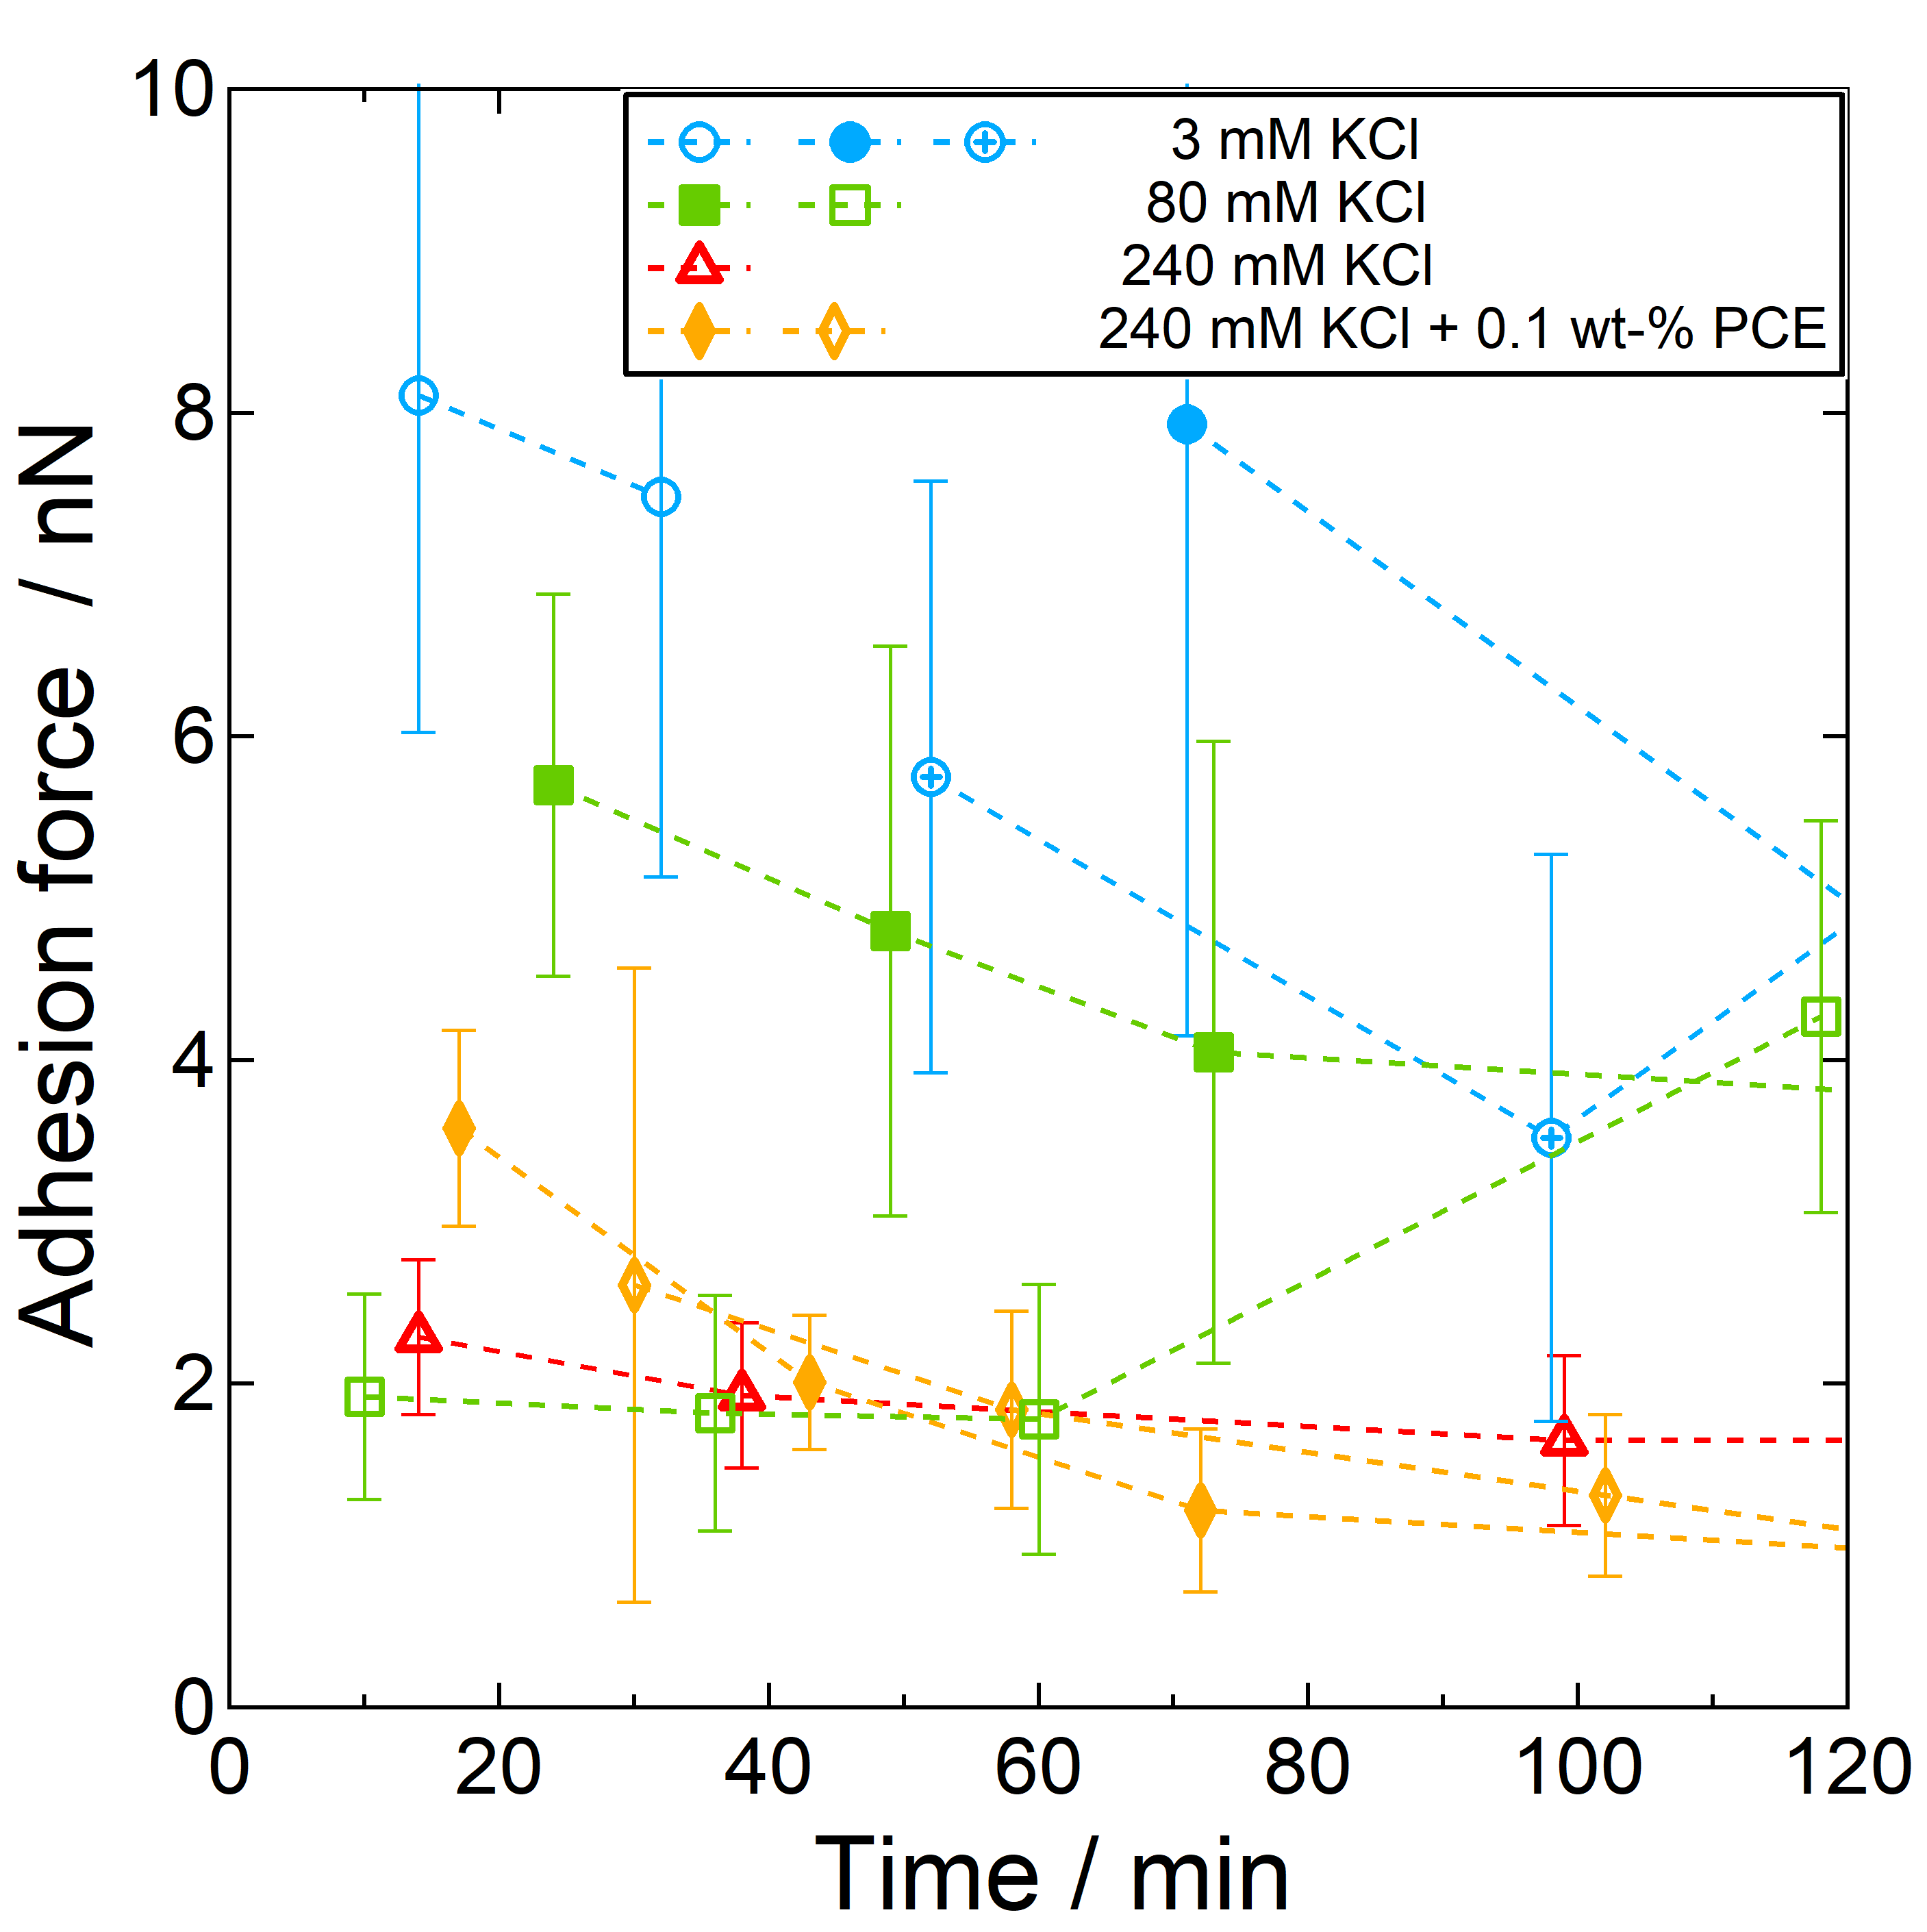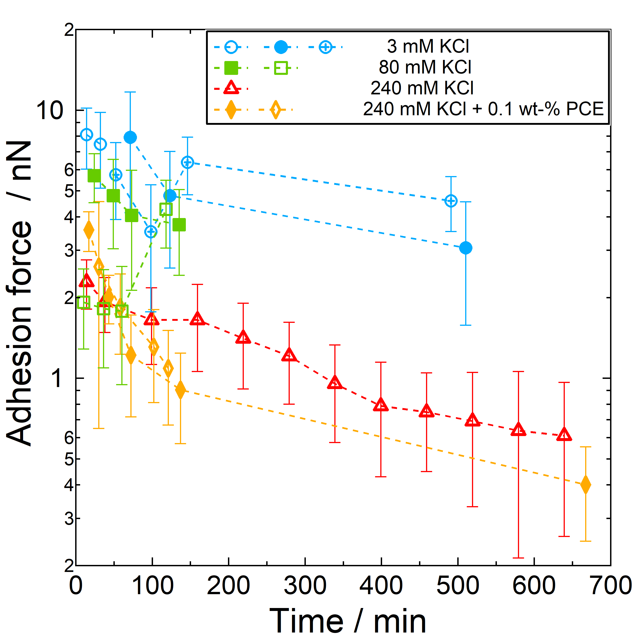
Fig. SI 2 Adhesion force between two glass beads vs. resting time for different glass bead pairs and different concentration of KCl. For 240mM a comparison with and without PCE is given. Left: linear scale zoom to 0-120 min. Right: Log scale (full time range).
The adhesion force decreases with time for the lowest and the highest salt concentration, i.e. 3mM and 240mM KCl. For 80mM for the second GB the adhesion force increases again after 60 minutes. It is worth noting, that for this concentration the difference in adhesion force between the two pairs of GB is highest. The decrease in the adhesion force with time is also present in at high ion concentration (240 mM) and PCE (0.1 wt-% - weight of PCE / weight of solution). For up to 150 minutes the decay of adhesion force seems to be faster than without PCE.

3 Macro aggregates at different times
The purpose of this experiment is to check if the amount of macro aggregates consisting of glass beads will increase or decrease as a function of time. The materials we use in this study are relatively inert glass beads. Even though a low liquid-to-glass ratio is used, sedimentation will occur to some degree. Therefore, besides the impacts from the PCE size change mainly discussed in this paper, there is also a possible reason that the PCE or ions increase the sedimentation and then more macro aggregates are formed with cannot be destroyed by the additional mixing, then higher yield stress is found. To evaluate macro aggregates amount, optical microscopy and image analysis are applied.

3.1 Experiment
An optical microscope (Stemi SV 11, Zeiss Microscope, Germany) was used in this study to monitor the agglomerates in the GB suspension. The GB suspension at a resting time of 0 mins, 60 mins, and 120 mins was poured on glass made sheet (20 mm×20mm) to form a thin layer. And then, they will be covered by a plastic film to prevent evaporation and dust on the sample surface. After that, the sample will be observed on a microscope under 0.6 X and 1.2 X magnification. As an example, a typical measurement of GB suspension on glass made a sheet with the optical microscope and image analysis process is shown in Fig. SI 3.
Fig. SI 3 A typical measurement of GB suspension on glass made a sheet with the optical microscope(a) and image analysis process(b) (in the image the white part is well-distributed glass beads, and the dark part is considered as agglomerates)
To objectively evaluate the amount of agglomerates, three glass sheets with samples and a total of 12 images were used to determine the value of the area-to-image ratio (AOI) by using the software of Image-Pro Plus 6.0 (Media Cybernetics, Inc., USA). A typical measurement is shown in Fig. SI 3b. Fixed processing, enhancement, and calculation procedure are used. The average value of AOI from 12 images is taken to characterise agglomeration.

3.2 Results and analysis

Fig. SI 4 The area of agglomerates to image ratio of GB suspension made by artificial solution (a), KCl solution(b) and CaCl₂ solution(c) as a function of resting time, from 0 min to 120 mins
The calculated results for the area-to-image ratio of GB suspension made by artificial pore solution (Fig. SI 4a), KCl solution (Fig. SI 4b), and CaCl2 solution (Fig. SI 4c) as a function of resting time are given. Despite the significant standard deviation, the area-to-image ratio of GB suspension in all cases decreases as a function of resting time. This result indicates that the agglomerates amount is reduced gradually in the sample. At a resting time of 0, there is no regularity in the area-to-image ratio of GB suspension, and the decreasing extent of agglomerates amount after 120 mins is various, which at least suggests that the increase of PCE dosage and ion strength did not contribute to the formation of macro agglomerates in the system.

