Supporting Information

Magnetism and site-selective substitution in arc melted perovskite titanates ATiO_{3–δ} (A = Ca, Sr, Ba)

Songhak Yoon^{a,}*, Wenjie Xie^{b}, Xingxing Xiao^{b}, Stefano Checchia^{c}, Mauro Coduri^{d}, Peter Schuetzenduebe^{e}, Marc Widenmeyer^{b}, Stefan G. Ebbinghaus^{f}, Benjamin Balkeª, Anke Weidenkaff^{a,b}, Gisela Schütz^{e}, Kwanghyo Son^{e,g}*

ª Fraunhofer Research Institution for Materials Recycling and Resource Strategies IWKS, Aschaffenburger Straße 121, 63457 Hanau, Germany
^{b} Department of Materials and Earth Sciences, Materials and Resources, Technical University of Darmstadt, Alarich-Weiss-Straße 2, 64287 Darmstadt, Germany
^{c} European Synchrotron Radiation Facility, 71 avenue des Martyrs, 38042 Grenoble, France
^{d} Chemistry Department, University of Pavia, via Taramelli 16, 27100 Pavia, Italy
^{e} Department of Modern Magnetic Systems, Max Planck Institute for Intelligent Systems, Heisenbergstraße 3, 70569 Stuttgart, Germany
^{f} Institute of Chemistry, Martin Luther University, Halle-Wittenberg, Kurt-Mothes-Straße 2, 06120 Halle, Germany
^{g} Department of Physics Education, Kongju National University, Gonjudaehak-ro 56, 32588 Gongju, South Korea

Supporting information S1. Songhak Yoon et al.

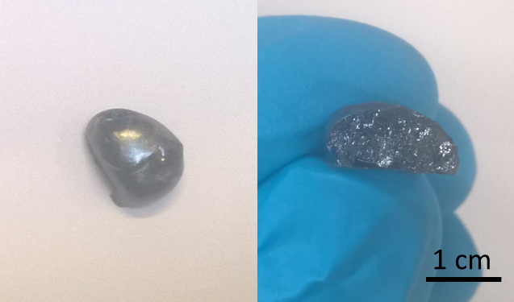

Supporting information Fig. S1. Examplarily shown STO_arc sample after arc-melting (left) and cross-section (right).

Supporting information S2. Songhak Yoon et al.
Supporting information Figure S2. Reflection width of the main diffraction peaks before (black) and after (red) arc-melting (λ = 0.35439 Å).

Table S1. The estimated full width at half maximum (FWHM) value.

Sample | FWHM₍₁₂₁₎ (°) | Sample | FWHM₍₀₁₁₎ (°) | Sample | FWHM₍₀₁₁₎ (°)
CTO | 0.0136 | STO | 0.0143 | BTO | 0.0177
CTO_arc | 0.0047 | STO_arc | 0.0073 | BTO_arc | 0.0092

Supporting information S3. Songhak Yoon et al.

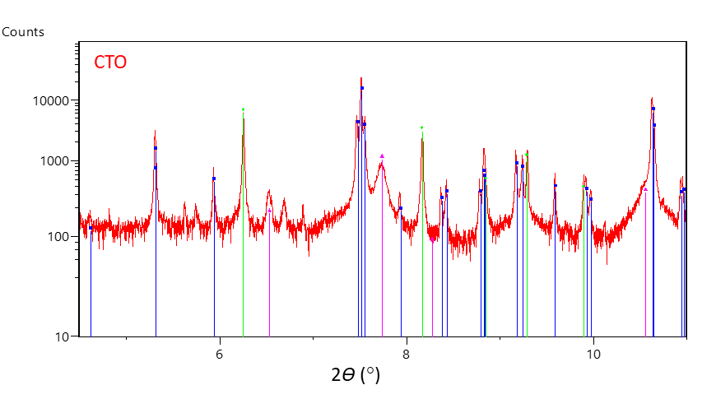
Supporting information Figure S3. (a) Intensity is plotted on a logarithmic scale. The main reflections of CTO were indexed as CaTiO₃ (blue-colored lines, JCPDS-PDF No. 98-018-3209). The secondary phases were identified to be TiO₂ (green-colored lines, JCPDS-PDF No. 98-004-4882) and Ca(OH)₂ (magenta-colored lines, JCPDS-PDF No. 98-007-3467).

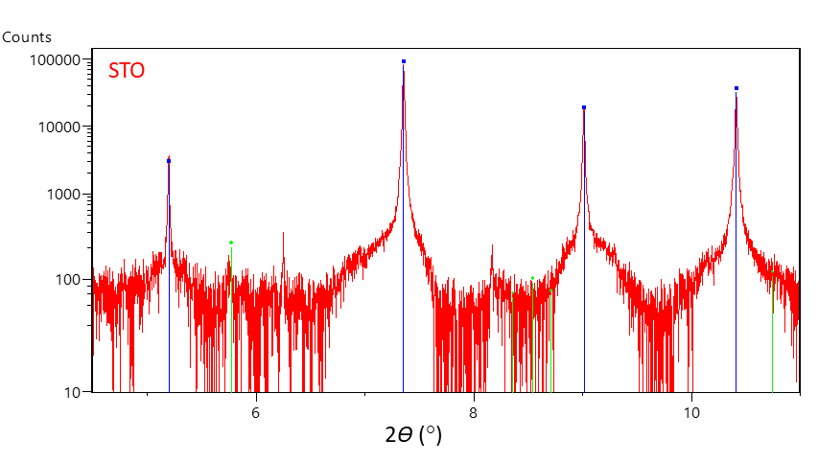

Supporting information Figure S3. (b) Intensity is plotted on a logarithmic scale. The main reflections of STO were all indexed as SrTiO₃ (blue-colored lines, JCPDS-PDF No. 98-007-6186). The secondary phase was identified to be TiO₂ (green-colored lines, JCPDS-PDF No. 98-016-8140).

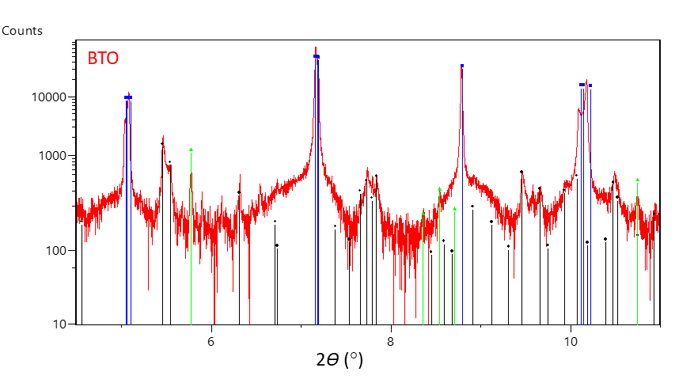

Supporting information Figure S3. (c) Intensity is plotted on a logarithmic scale. The main reflections of BTO were all indexed as BaTiO₃ (blue-colored lines, JCPDS-PDF No. 98-006-6482). The secondary phases were identified to be TiO₂ (green-colored lines, JCPDS-PDF No. 98-004-4882) and BaCO₃ (black-colored lines, JCPDS-PDF No. 98-015-8378).

Supporting information S4. Songhak Yoon et al.

Supporting information Figure S4. Powder X-ray diffraction pattern (λ = 0.35439 Å) and Rietveld refinement plots of (a) CTO_arc, (b) STO_arc, and (c) BTO_arc obtained at room temperature.
Supporting information S5. Songhak Yoon et al.

Table S2. Crystallographic and structural refinement data determined by Rietveld refinements of the synchrotron powder diffraction patterns of arc-melted perovskite titanates.

Chemical Formula | (a) CTO_arc | (b) STO_arc | (c) BTO_arc
Crystal system | orthorhombic | cubic | tetragonal
Space group | Pnma | Pm$\overline{3}$m | P4mm
Z | 4 | 1 | 1
Lattice parameter a (Å) | 5.3813(1) | 3.9068(1) | 3.9980(1)
Lattice parameter b (Å) | 7.6425(1) | – | –
Lattice parameter c (Å) | 5.4441(1) | – | 4.0238(1)
V(Å³) | 223.897(1) | 59.628(1) | 64.315(1)
R_{p} (%) | 8.25 | 7.38 | 9.77
R_{wp} (%) | 10.7 | 9.69 | 13.7
R_{exp} (%) | 4.43 | 4.07 | 3.65
χ² | 5.78 | 5.67 | 14.0
Wavelength (Å) | 0.354388 | 0.354388 | 0.354388
2θ range (deg) | 3–32 | 3–32 | 3–32
2θ step width (deg) | 0.002 | 0.002 | 0.002

R_{p}, R_{wp}, R_{exp}, and χ² are the reliability factors and goodness-of-fit, respectively.

Supporting information S6. Songhak Yoon et al.

Table S3. Atomic structural parameters determined by Rietveld refinements of the synchrotron powder diffraction patterns of arc-melted perovskite titanates. Numbers in parentheses are standard deviations.

(a) CTO_arc
Atom | x | y | z | B_{iso} (Å²)
Ca | 0.9931(2) | 0.0369(1) | 1/4 | 0.39(1)
Ti | 1/2 | 0 | 0 | 0.05(1)
O(1) | 0.0719(4) | 0.4825(4) | 1/4 | 0.36(4)
O(2) | 0.7109(3) | 0.2890(3) | 0.0384(2) | 0.26(3)

(b) STO_arc
Atom | x | y | z | B_{iso} (Å²)
Sr | 0 | 0 | 0 | 0.08(1)
Ti | 1/2 | 1/2 | 1/2 | 0.04(2)
O | 0 | 1/2 | 1/2 | 0.21(4)

(b) BTO_arc
Atom | x | y | z | B_{iso} (Å²)
Ba | 0 | 0 | -0.0095 | 0.26(1)
Ti | 1/2 | 1/2 | 0.4968 | 0.20(2)
O(1) | 1/2 | 1/2 | 0.0144 | 0.19(5) ^{[a]}
O(2) | 1/2 | 0 | 0.4934 | 0.19(5) ^{[a]}
An anisotropic strain model was applied. Thermal factors (B_{iso}) for O(1) and O(2) are constrained during the refinements otherwise a negative thermal factor was obtained after refinements.^{[a]}

Supporting information S7. Songhak Yoon et al.

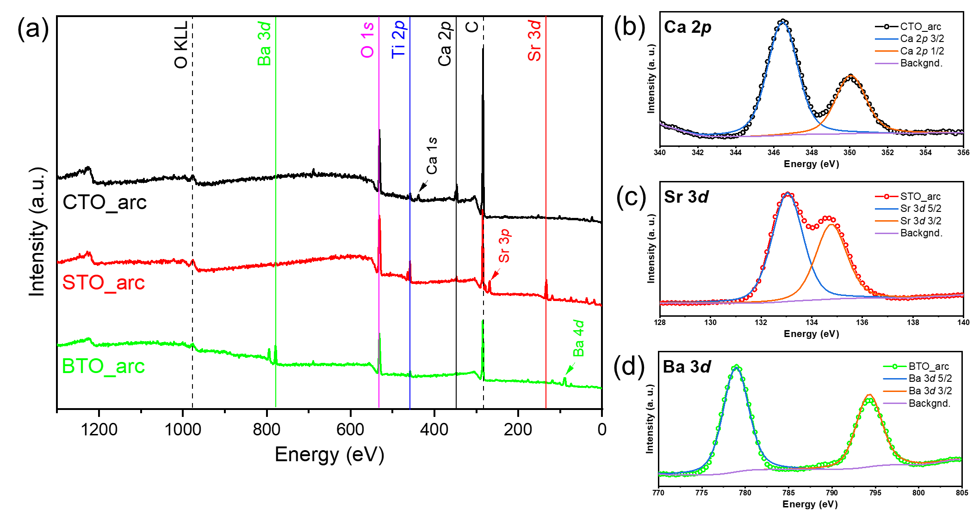

Supporting information Figure S5. X-ray photoelectron spectroscopy (XPS) data for CTO_arc, STO_arc, and BTO_arc. (a) Survey spectra, (b) Ca 2p of CTO_arc, (c) Sr 3d of STO_arc, and (d) Ba 3d of BTO_arc.

Supporting information S8. Songhak Yoon et al.

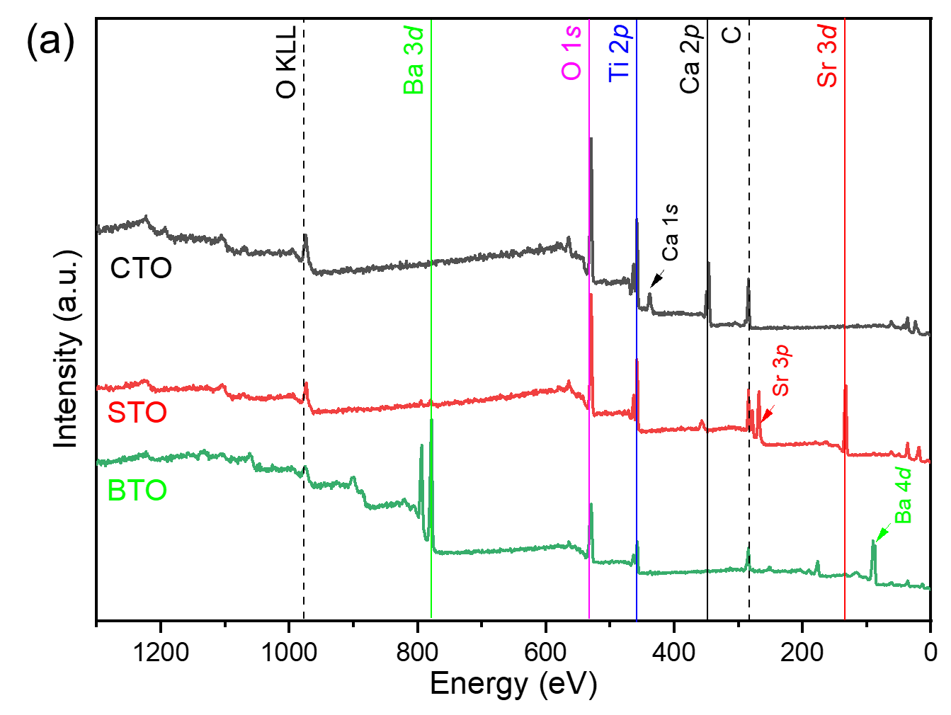

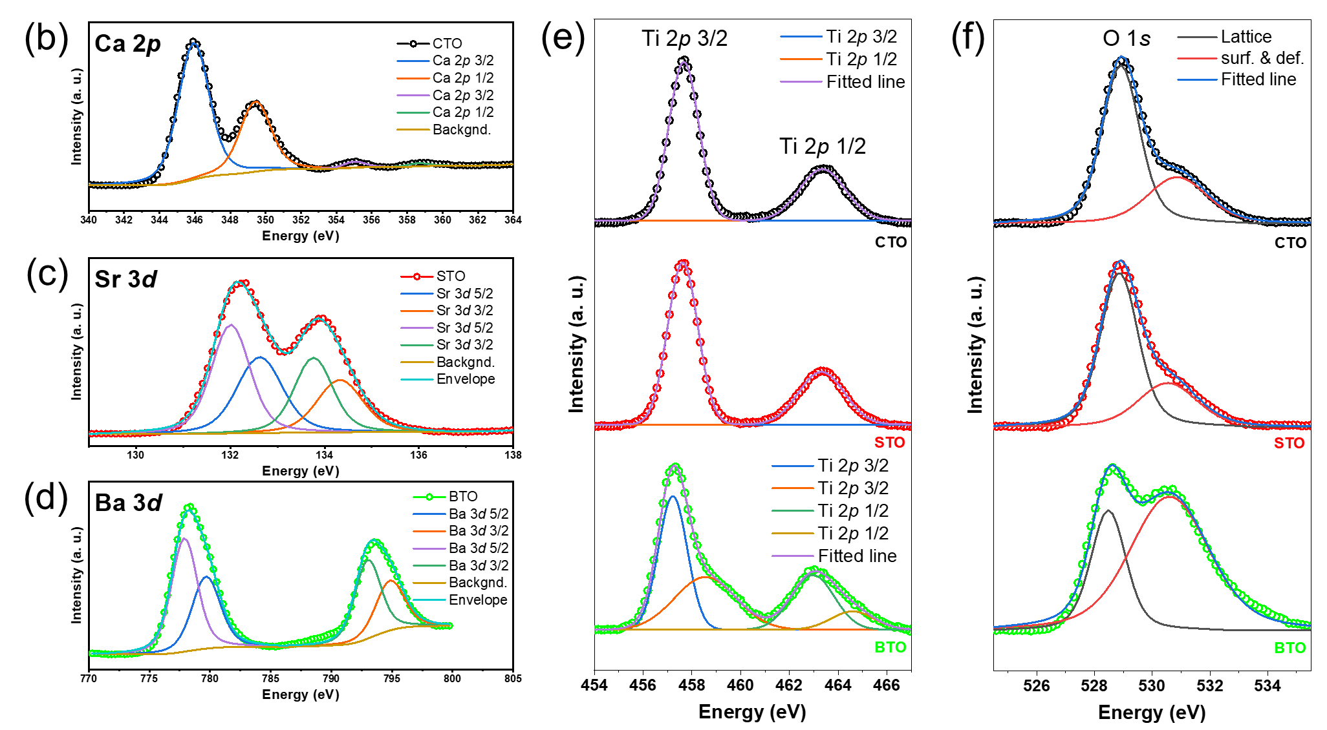

Supporting information Figure S6. XPS spectra of pristine CTO, STO, and BTO. (a) Survey spectra, (b) Ca 2p of CTO, (c) Sr 3d of STO, and (d) Ba 3d of BTO. (e) Ti 2p (f) O 1s.
Supporting information S9. Songhak Yoon et al.

Supporting information Figure S7. Magnetic susceptibility curves for pristine CTO, STO, and BTO in comparison to arc-melted samples in Fig. 4 a) full range of 3 K –350 K, b) enlarged low-temperature region of a).

Supporting information S10. Songhak Yoon et al.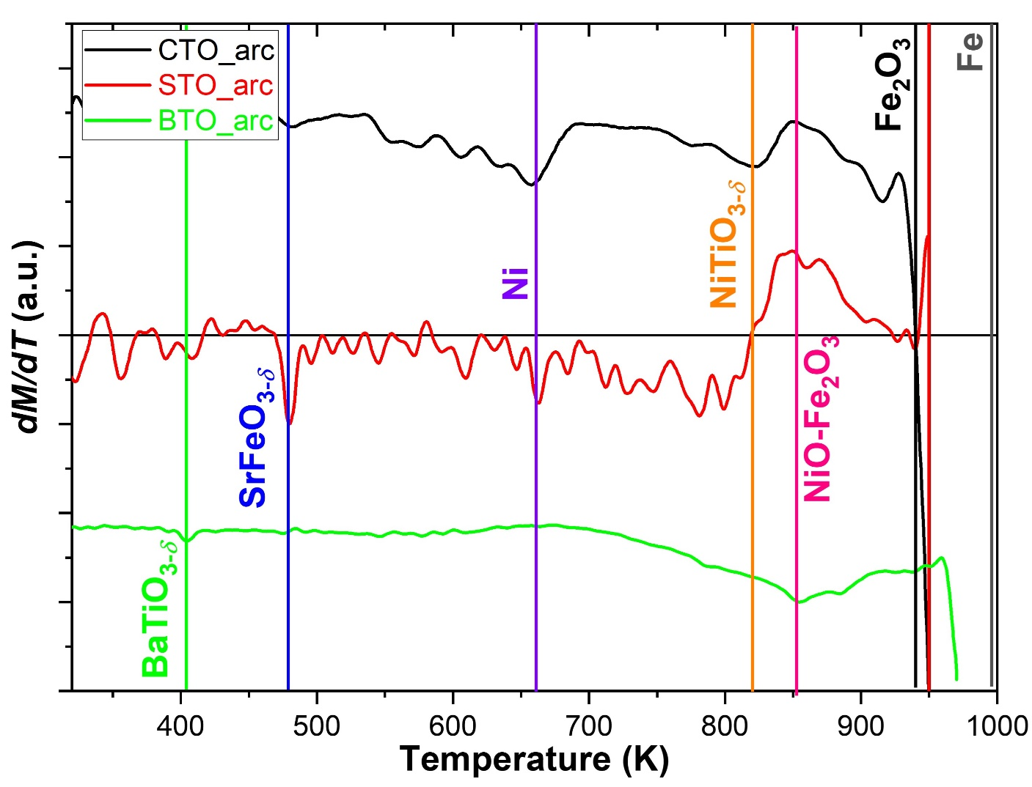
Supporting information Figure S8. Derivative magnetization of arc-melted samples, CTO_arc (black), STO_arc (red), and BTO_arc (green). The critical temperatures, i.e., Curie or Néel temperatures, are given with corresponding compounds. The respective values are listed in Table S11.

Supporting information S11. Songhak Yoon et al.

Table S4. Summary of critical temperatures of representative perovskites and further magnetic materials.

Materials | Critical Temperature (K) | Critical Temperature (K)  (From experimental results) | Ref.
NiTiO₃ | 820 | 820 (CTO_arc)  819 (STO_arc) | ^{⁠1}
CaFeO₃ | T_{N}: 120 | – | ^{⁠2}
SrFeO₃ | T_{N}: 473 | 479 (STO_arc) | ^{⁠3}
BaFeO₃ | T_{N}: 250 | – | ^{⁠4}
(Ca,Sr) TiO₃ | – | –
BaTiO₃ | 396 | 400 (BTO_arc) | ^{⁠5}
Fe | 1043 | –
Ni | 627 | 656 (CTO_arc)  661 (STO_arc)
Fe₂O₃ | 948 | 950 (CTO_arc)  949 (STO_arc)  946 (BTO_arc)
NiO-Fe₂O₃ | 858 | 848 (CTO_arc)  850 (STO_arc)  853 (BTO_arc)

Supporting information S12. Songhak Yoon et al.

Supporting information Figure S9. M-H curves at various temperatures for pristine CTO, STO, and BTO samples with paramagnetic correction.

Supporting information S13. Songhak Yoon et al.

Supporting information Figure S10. M-H curves at (a) RT and (b) 3 K of CTO_arc, STO_arc, and BTO_arc without paramagnetic correction.

Supporting information S14. Songhak Yoon et al.

Supporting information Figure S11. Normalized experimental and simulated X-ray absorption spectra (XAS) at the L₂ e_{g} peak for the CTO_arc, STO_arc, and BTO_arc. Lines are expremental spectra and dots are simulation results; green for Ti⁴⁺, black for Ti³⁺ with charge transfer, and red for Ti³⁺ without charge transfer, respectively.^{⁠6}

Supporting information S15. Songhak Yoon et al.

Supporting information Figure S12. Sum rules for the Ti L-edges XAS and X-ray magnetic circular dichroism (XMCD) spectra of the CTO_arc, STO_arc, and BTO_arc. The blue lines are the integrated area of the spectra.

From XMCD in total electron yield, we obtained spin magnetic moments using sum rules. The orbital magnetic moment is quenched due to random direction in bulk samples. The equation of $m_{spin}=-{(3p-2q)∙n_{h}}/r$ is used for the sum rule, where n_{h} is the number of holes in d shells (n_{h} = 9 for Ti).^{⁠7} The p and q are the integrated areas of the XMCD signal at the L₃ edge and L_{2,3} edges, respectively. The r is the integrated area of the corrected XAS by the subtraction of a baseline at L_{2,3} edges. The obtained spin magnetic moment values by XMCD sum rule analysis were 0.016 µ_{B}/Ti, 0.021 µ_{B}/Ti, and 0.027 µ_{B}/Ti for CTO_arc, STO_arc, and BTO_arc, respectively. The obtained magnetic moment values are negligible compared to the contribution of transition metal impurities.

Supporting information S16. Songhak Yoon et al.

The elements like Fe, Co, and Ni were quantitatively analyzed by ICP-OES (inductively coupled plasma-optical emission spectrometry, Spectro Ciros CCD ICP-OES) in solutions. The oxygen and hydrogen contents were determined by the hot-gas extraction method using an ELTRA ONH 2000 analyzer. Each sample was measured three times and the obtained oxygen and hydrogen amounts were averaged.

Table S5. Elemental analysis of 3d impurities by ICP-OES (parts per million in weight) and oxygen deficiency (δ) estimated by the oxygen contents obtained by the hot-gas extraction technique.

Sample | Fe | Co | Ni | δ
CTO | 90 | 80 | 100 | 0.03 ± 0.03
CTO_arc | 70 | 80 | 100 | 0.06 ± 0.03
STO | 60 | 80 | 100 | 0.03 ± 0.03
STO_arc | 60 | 70 | 100 | 0.11 ± 0.03
BTO | 90 | 100 | 100 | 0.17 ± 0.03
BTO_arc | 100 | 80 | 100 | 0.25 ± 0.03

References
1. Bahadur N, Pasricha R, Govind, Chand S, Kotnala RK. Effect of Ni doping on the microstructure and high Curie temperature ferromagnetism in sol–gel derived titania powders. Mater Chem Phys. 2012;133:471–9.
2. Kanamaru F, Miyamoto H, Mimura Y, Koizumi M, Shimada M, et al. Synthesis of a new perovskite CaFeO₃. Mater Res Bull. 1970;5:257–61.
3. Tsujimoto Y, Tassel C, Hayashi N, Watanabe T, Kageyama H, et al. Infinite-layer iron oxide with a square-planar coordination. Nature. 2007;450:1062–5.
4. Takeda Y, Shimada M, Kanamaru F, Koizumi M, Yamamoto N. Magnetic properties and Mössbauer effect in 12-layer hexagonal BaFeO₃. Mater Res Bull. 1974;9:537–43.
5. Sakayori K, Matsui Y, Abe H, Nakamura E, Kenmoku M, et al. Curie temperature of BaTiO₃. Jap J Appl Phys. 1995;34:5443–5.
6. Salluzzo M, Gariglio S, Stornaiuolo D, Sessi V, Rusponi S, et al. Origin of interface magnetism in BiMnO₃/SrTiO₃ and LaAlO₃/SrTiO₃ heterostructures. Phys Rev Lett. 2013;111:87204.
7. Garcia-Barriocanal J, Cezar JC, Bruno FY, Thakur P, Brookes NB, et al. Spin and orbital Ti magnetism at LaMnO₃/SrTiO₃ interfaces. Nat Commun. 2010;1:82.

