Supplementary Information (SI)
Dislocation-tuned electrical conductivity in solid electrolytes (9YSZ): A micro-mechanical approach
Qaisar Khushi Muhammad,^{1,}* Marcela Valderrama,¹ Mengkun Yue,^{2,†} Alexander Karl Opitz,³ Stefanie Taibl,³ Matthäus Siebenhofer,³ Enrico Bruder,⁴ Jürgen Fleig,³ Xufei Fang,¹ and Till Frömling^{1,*}

¹Division of Nonmetallic-Inorganic Materials, Department of Materials and Earth Sciences, Technical University of Darmstadt, Alarich-Weiss-Str. 2, Darmstadt 64287, Germany
²AML, Department of Engineering Mechanics, Tsinghua University, Beijing 100084, PR China
†Center for Flexible Electronics Technology, Tsinghua University, Beijing 100084, PR China
³Christian-Doppler-Laboratory for Ferroic Materials, Institute of Chemical Technologies and Analytics, Vienna University of Technology, Vienna A-1060, Austria
⁴Division of Physical Metallurgy, Department of Materials and Earth Sciences, Technical University of Darmstadt, Alarich-Weiss-Str. 2, Darmstadt 64287, Germany

*Corresponding authors
muhammad@ceramics.tu-darmstadt.de
Froemling@ceramics.tu-darmstadt.de

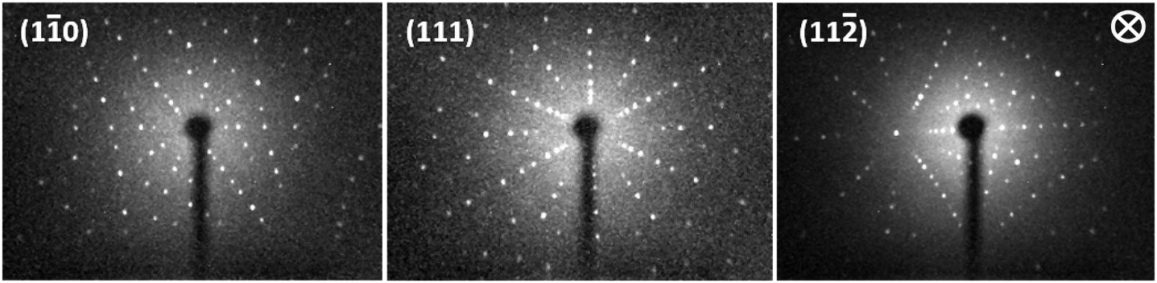
Figure S1: Laue back-reflection patterns of final sample orientations. The incident direction of X-rays was always perpendicular to the plane of the specimen (symbol ⊗). Indentation experiments were performed on YSZ (111) planes.

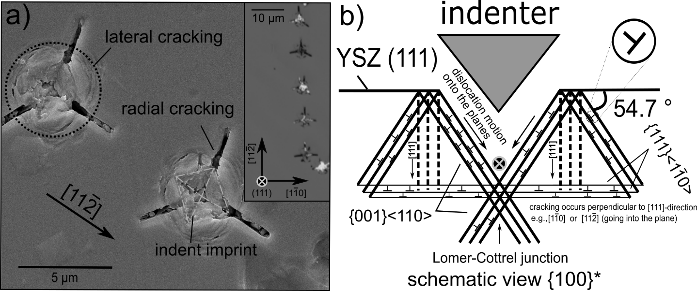
Figure S2: (a) FESEM image of 0.1 N Vickers indents marked on (111) plane of 9YSZ, here with a center-to-center spacing of 10 µm (also for the inset). Both lateral and radial cracking and three-fold symmetry in [11$\overline{2}$] direction was observed when indented at room temperature. (b) Cross-sectional schematic/{100} view, representing the slip traces inside the YSZ specimen when indented at (111) planes.¹ Activated slip systems are labelled. The dislocations gliding on respective planes converging at {111} planes forming the Lomer-Cottrel junction (symbolized with ⊗).

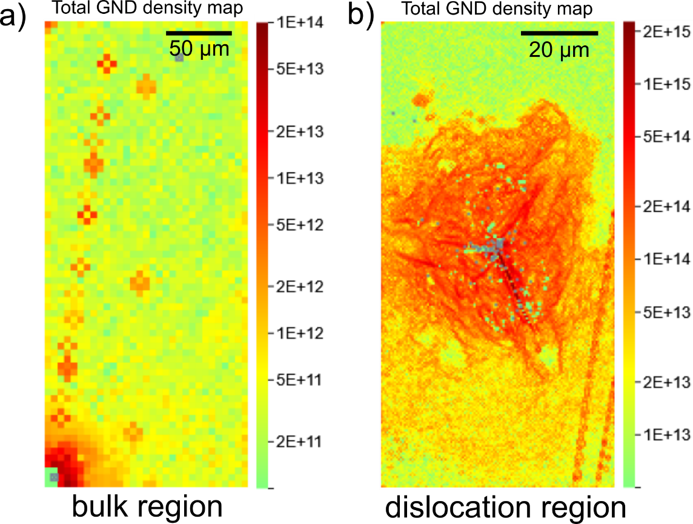
Figure S3: Electron backscatter diffraction (EBSD) maps of bulk and indentation-induced dislocation areas, depicting each region's geometrically necessary dislocation (GND) densities. The data is reported for the specimens indented with Berkovich pyramid-shaped indenter at 600 °C substrate temperature.

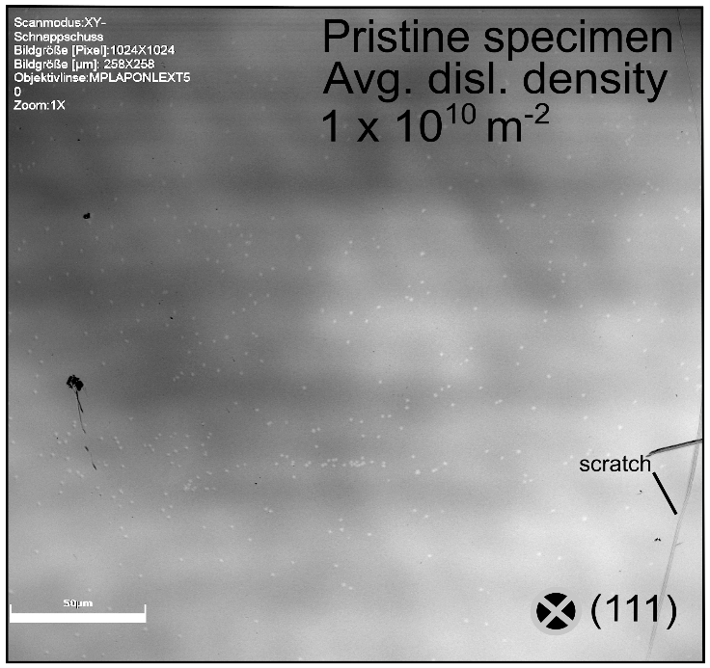
Figure S4: Dislocation density evaluation for pristine specimens. Chemical etching was employed to reveal the pre-existing dislocations in the form of etch-pits (bright spots in the image). Statistics were recorded in different regions onto the same specimen to evaluate the pristine average dislocation density.

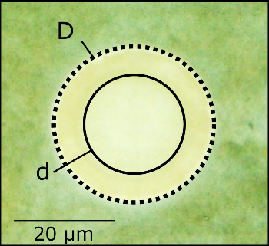
Figure S5: The optical-light micrograph of La_{0.6}Sr_{0.4}CoO_{3-δ} (LSC) microcontact portrays the intemperate chemical etching process. "D" shows the initial diameter of the microcontact, and "d" depicts the final achieved diameter. Resistivity data presented in Fig. 4d was evaluated considering "d".

References
1. Morscher GN, Pirouz P, Heuer AH. Temperature dependence of hardness in yttria‐stabilized zirconia single crystals. J Am Ceram Soc. 1991;74(3):491-500.

