**Supplemental materials**

**Temperature-dependence of poling-induced texture and piezoelectric properties in Mg-doped NBT-6BT**

## Laura Cangini, Andreas Wohninsland, Daniel Bremecker, Lovro Fulanović, Changhao Zhao, and Jürgen Rödel

## Division of Nonmetallic-Inorganic Materials, Department of Materials and Earth Sciences, Technical University of Darmstadt, 64287 Darmstadt, Germany

Corresponding author: [cangini@ceramics.tu-darmstadt.de](mailto:cangini@ceramics.tu-darmstadt.de)

**Fig. S1.** Examples for weighted refined diffraction patterns of poled NBT-6BT and NBT-6BT-0.5Mg collected at 30 °C. The insets show an enlarged part of the diffraction patterns with the 111pc and 200pc sets of reflections.

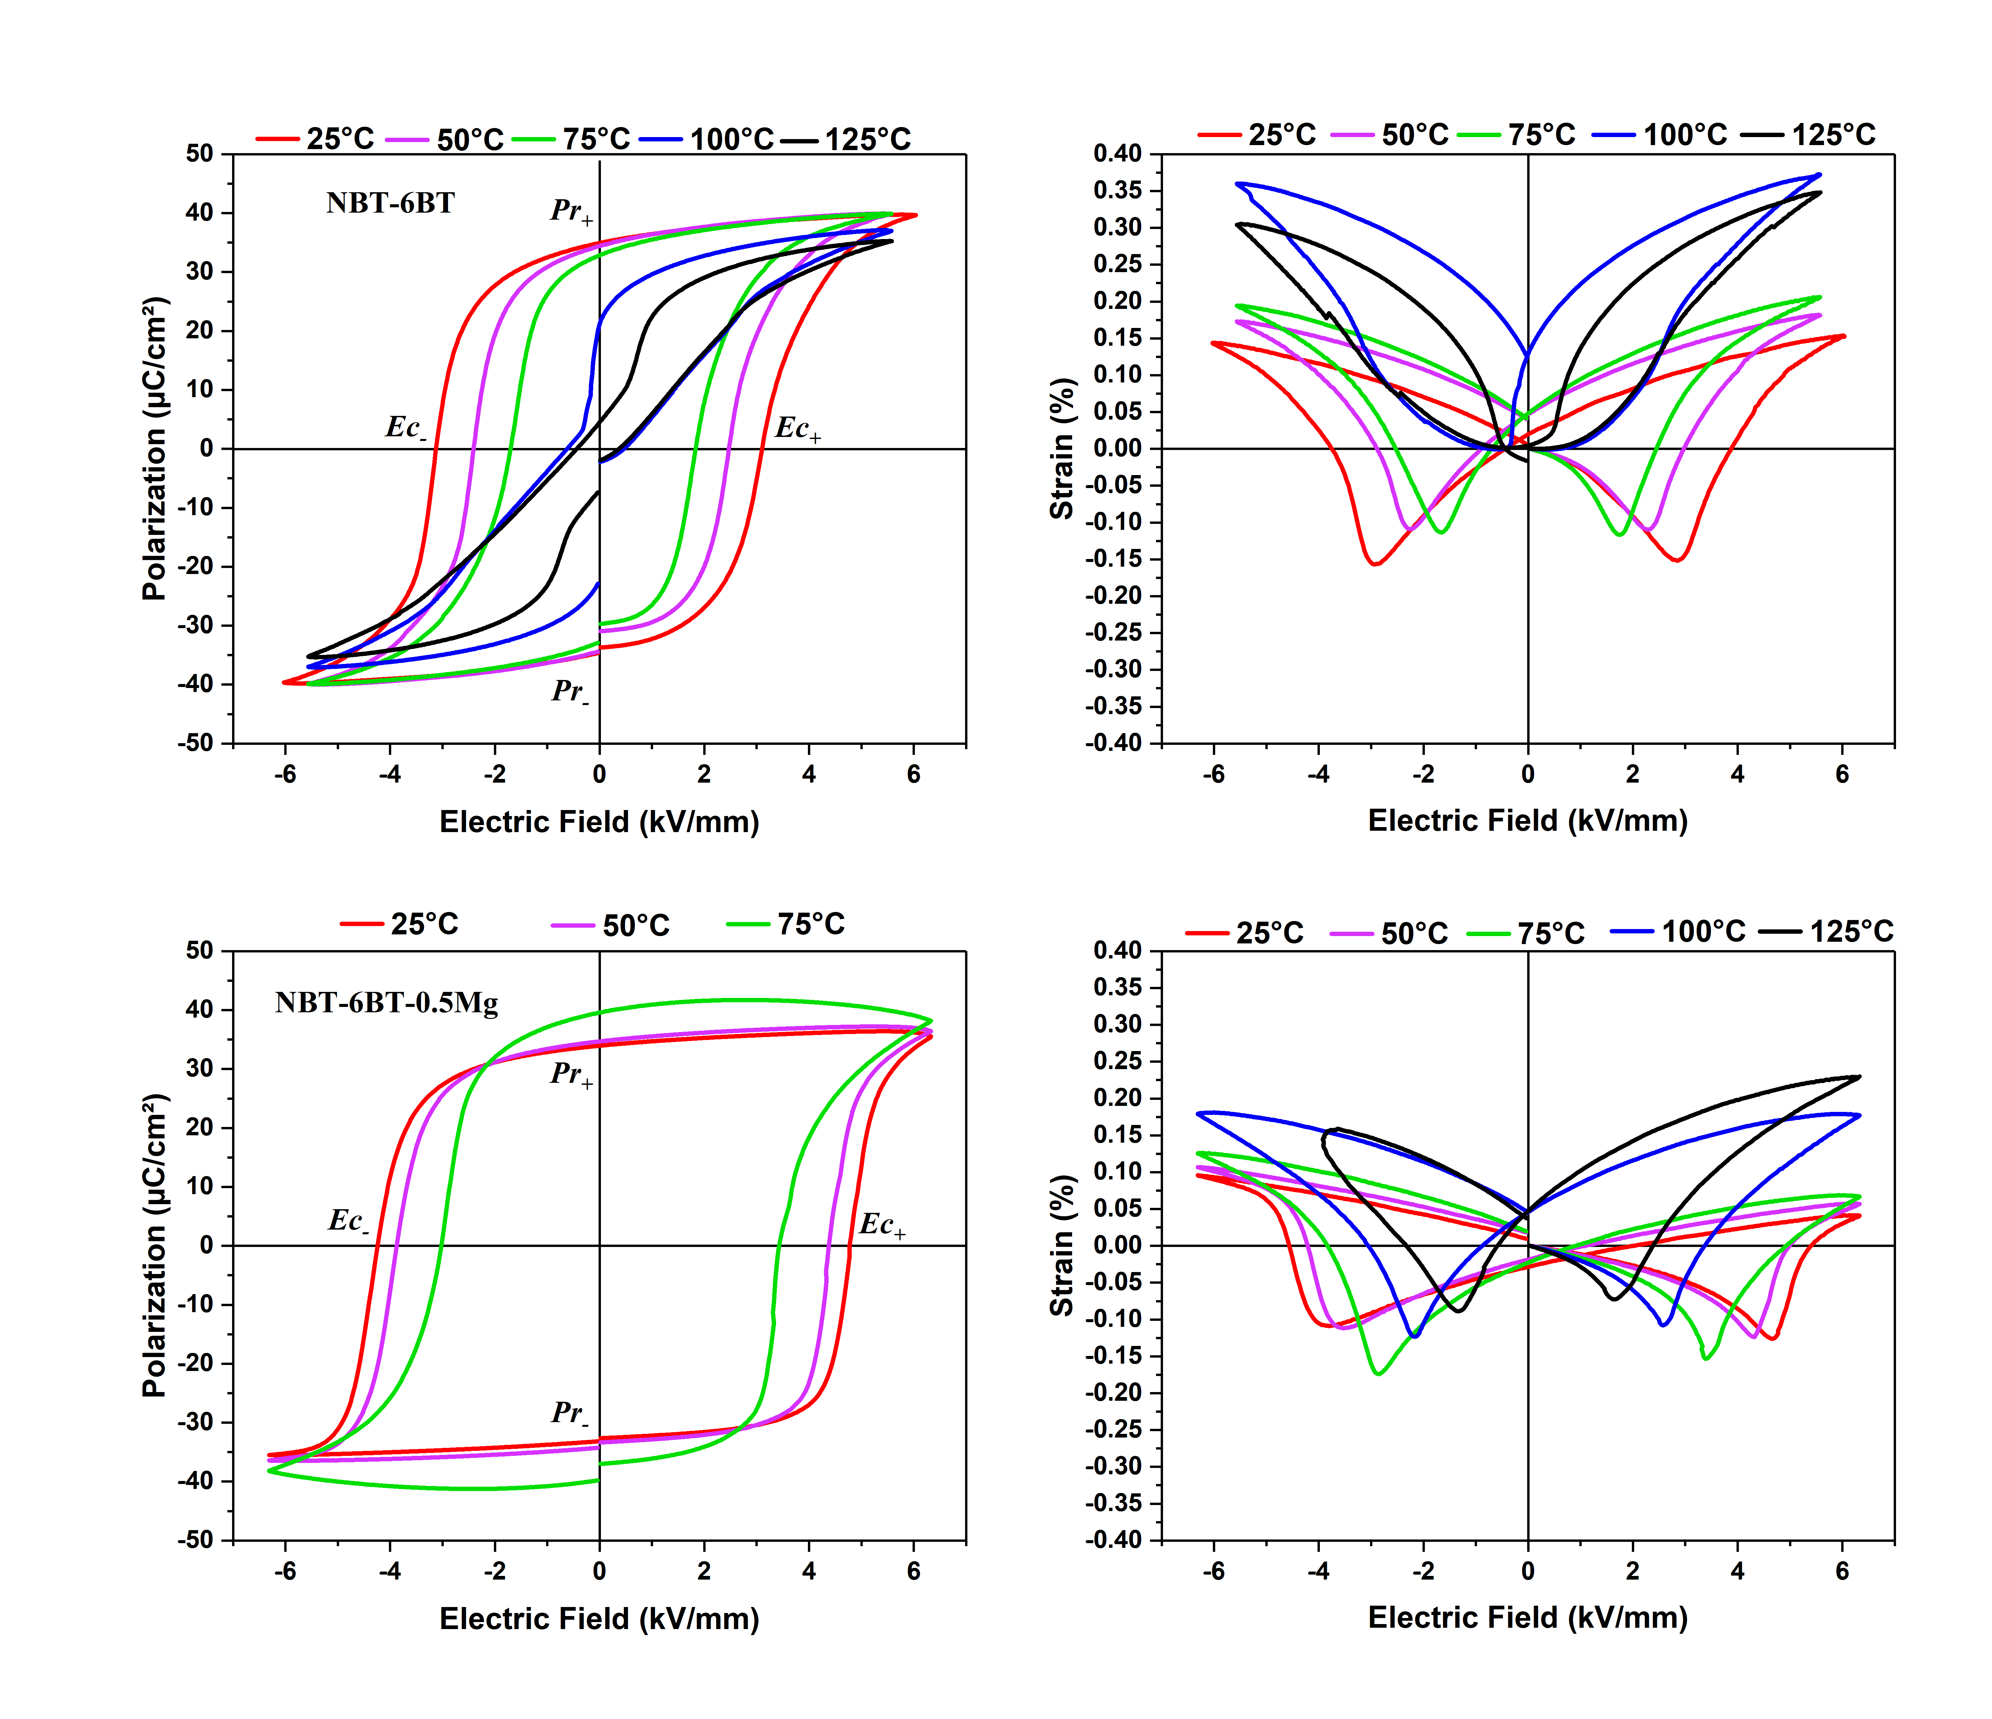

**Fig. S2.** Polarization and strain hysteresis loops of poled NBT-6BT (top) and NBT-6BT-0.5Mg (bottom) in temperature at 1Hz. Due to conductivity of NBT-6BT-0.5Mg, the polarization loops could only be recorded at maximum temperature of 75 °C.

**Fig. S3.** Mechanical quality factor ($Q_{R}^{31}$) of NBT-6BT (red) and NBT-6BT-0.5Mg (blue) samples as a function of vibration velocity at room temperature.

**Fig. S4.** (a) Piezoelectric coefficient (d31) and (b) coupling coefficient (k31) of NBT-6BT-0.5Mg as function of vibration velocity in temperature.

**Table S1.** Temperature-dependent structural parameters of NBT-6BT extracted from Rietveld refinements. The errors established with the refinement software are smaller than the last given digit in the table. Rhombohedral and tetragonal distortions are given as 90-αrhom and ctet/atet -1, respectively.



**Table S2.** Temperature-dependent structural parameters of NBT-6BT-0.5Mg extracted from Rietveld refinements. The errors established with the refinement software are smaller than the last given digit in the table. Rhombohedral and tetragonal distortions are given as 90-αrhom and ctet/atet -1, respectively.

