**Supplementary Material**

**Table S1.** Correlation matrix of biodiversity and plot characteristics used in the analyses. Pearson’s *r* (upper right part of table) and P-values (lower left part), with significant (P ≤ 0.05) correlations indicated in bold. AG = aboveground, BG = belowground, C = carbon.



**Table S2.** Component loadings and eigenvalues of principal components (PC) selected from PCA reduction analysis on environmental variables.

|  |  |  |
| --- | --- | --- |
|  | PC1 | PC2 |
| Elevation | 0.63 | -0.08 |
| Slope | -0.05 | 0.86 |
| Northness | 0.19 | 0.46 |
| pH_H2O | -0.42 | -0.19 |
| Mean annual temperature | -0.62 | 0.12 |
|  |  |  |
| Standard deviation | 1.48 | 1.04 |
| Proportion of variance | 0.44 | 0.22 |
| Cumulative proportion | 0.44 | 0.65 |

**Table S3.** Effect size measures (standardized regression coefficients with lower and upper 95% confidence intervals) of the relationships between carbon stocks and biodiversity across (i.e. multidiversity) and within trophic groups. Values in brackets for overall and belowground multidiversity are results for models that excluded bacteria from the multidiversity indices.

|  |  |  |  |
| --- | --- | --- | --- |
| **Taxon** | **Stand. coeff.** | **lower CI** | **upper CI** |
| **~aboveground carbon** |  |  |  |
| Multidiversity total | 0.39 (0.37) | 0 (-0.03) | 0.79 (0.77) |
| Multidiversity AG | 0.21 | -0.22 | 0.63 |
| Multidiversity BG | 0.48 (0.52) | 0.10 (0.15) | 0.86 (0.89) |
| Arthropod predators | -0.37 | -0.77 | 0.03 |
| Arthropod herbivores | 0.41 | 0.02 | 0.81 |
| Macrofaunal decomposers | 0.2 | -0.22 | 0.63 |
| Pathogenic fungi | 0.34 | -0.07 | 0.74 |
| Saprotrophic fungi | 0.56 | 0.2 | 0.92 |
| Mycorrhizal fungi | 0.44 | 0.05 | 0.82 |
| Bacteria (overall) | 0.07 | -0.36 | 0.5 |
| Acidobacteria | 0.05 | -0.38 | 0.48 |
| Actinobacteria | 0.16 | -0.27 | 0.59 |
| Alphaproteobacteria | 0.01 | -0.42 | 0.44 |
| Bacteroidetes | 0.02 | -0.41 | 0.45 |
| Betaproteobacteria | 0.21 | -0.22 | 0.63 |
| Cloroflexi | -0.26 | -0.67 | 0.16 |
| Deltaproteobacteria | 0.1 | -0.33 | 0.53 |
| Gammaproteobacteria | 0.07 | -0.36 | 0.5 |
| **~forest-floor carbon** |  |  |  |
| Multidiversity total | 0.86 (0.81) | -0.07 (-0.13) | 1.79 (1.75) |
| Multidiversity AG | 0.48 | -1.1 | 1.47 |
| Multidiversity BG | 1.01 (1.01) | 0.11 (0.10) | 1.92 (1.91) |
| Arthropod predators | -0.3 | -1.3 | 0.69 |
| Arthropod herbivores | 1.35 | 0.53 | 2.17 |
| Macrofaunal decomposers | 0.17 | -0.83 | 1.18 |
| Pathogenic fungi | 0.66 | -0.3 | 1.62 |
| Saprotrophic fungi | 1.2 | 0.35 | 2.06 |
| Mycorrhizal fungi | 0.75 | -0.2 | 1.7 |
| Bacteria | 0.65 | -0.32 | 1.61 |
| Acidobacteria | 0.56 | -0.42 | 1.53 |
| Actinobacteria | 0.5 | -0.48 | 1.48 |
| Alphaproteobacteria | 0.38 | -0.61 | 1.37 |
| Bacteroidetes | 0.37 | -0.62 | 1.37 |
| Betaproteobacteria | 0.48 | -0.5 | 1.46 |
| Cloroflexi | 0.25 | -0.75 | 1.25 |
| Deltaproteobacteria | 0.67 | -0.29 | 1.63 |
| Gammaproteobacteria | 0.68 | -0.29 | 1.64 |
| **~belowground carbon** |  |  |  |
| Multidiversity total | 1.71 (1.72) | 0.95 (0.96) | 2.47 (2.48) |
| Multidiversity AG | 1.6 | 0.8 | 2.41 |
| Multidiversity BG | 1.41 (1.47) | 0.54 (0.63) | 2.28 (2.32) |
| Arthropod predators | -0.93 | -1.91 | 0.05 |
| Arthropod herbivores | 1.23 | 0.32 | 2.15 |
| Macrofaunal decomposers | 1.69 | 0.92 | 2.46 |
| Pathogenic fungi | 0.79 | -0.21 | 1.8 |
| Saprotrophic fungi | 1.6 | 0.8 | 2.41 |
| Mycorrhizal fungi | 1.47 | 0.62 | 2.32 |
| Bacteria | 0.53 | -0.51 | 1.56 |
| Acidobacteria | 0.3 | -0.75 | 1.35 |
| Actinobacteria | 0.03 | -1.03 | 1.09 |
| Alphaproteobacteria | 0.57 | -0.46 | 1.61 |
| Bacteroidetes | 0.26 | -0.8 | 1.31 |
| Betaproteobacteria | -0.07 | -1.13 | 0.99 |
| Cloroflexi | -0.14 | -1.2 | 0.92 |
| Deltaproteobacteria | 1.07 | 0.11 | 2.03 |
| Gammaproteobacteria | 0.93 | -0.05 | 1.91 |
| **~total carbon** |  |  |  |
| Multidiversity total | 1.65 (1.62) | 0.79 (0.75) | 2.51 (2.49) |
| Multidiversity AG | 1.31 | 0.34 | 2.27 |
| Multidiversity BG | 1.59 (1.68) | 0.71 (0.84) | 2.47 (2.53) |
| Arthropod predators | -1.01 | -2.04 | 0.02 |
| Arthropod herbivores | 1.4 | 0.46 | 2.34 |
| Macrofaunal decomposers | 1.32 | 0.36 | 2.28 |
| Pathogenic fungi | 1.03 | 0 | 2.05 |
| Saprotrophic fungi | 1.74 | 0.91 | 2.57 |
| Mycorrhizal fungi | 1.57 | 0.69 | 2.46 |
| Bacteria | 0.46 | -0.64 | 1.56 |
| Acidobacteria | 0.3 | -0.81 | 1.41 |
| Actinobacteria | 0.26 | -0.85 | 1.37 |
| Alphaproteobacteria | 0.41 | -0.69 | 1.51 |
| Bacteroidetes | 0.17 | -0.95 | 1.28 |
| Betaproteobacteria | 0.22 | -0.9 | 1.33 |
| Cloroflexi | -0.4 | -1.5 | 0.71 |
| Deltaproteobacteria | 0.86 | -0.19 | 1.91 |
| Gammaproteobacteria | 0.78 | -0.29 | 1.84 |

**Table S4.** Path model results for effects of tree species richness, stand age, woody plant diversity and *total* carbon stocks on *overall* multidiversity. Fitting carbon–multidiversity relationships as a covariance rather than a direct path resulted in inferior model fit (AICc = 342.2; Chi-square = 14.8; P = 0.005; DF = 4).

|  |  |  |  |  |
| --- | --- | --- | --- | --- |
| **Model** |  |  |  |  |
| AICc initial model | 547.7 |  |  |  |
| AICc minimal model | 331.2 |  |  |  |
| Number of observations | 25 |  |  |  |
| Chi-square | 3.8 |  |  |  |
| P (Chi-square) | 0.437 |  |  |  |
| P (Bollen-Stine Bootstrap) | 0.498 |  |  |  |
| Degrees of freedom | 4 |  |  |  |
| RMSEA | 0 |  |  |  |
| 95% CI (RMSEA) | 0 - 0.294 |  |  |  |
| P (RMSEA) | 0.47 |  |  |  |
|  |  |  |  |  |
| **Regressions** |  |  |  |  |
| Respone ~ Predictor | Stand. Est. | SE | z | P (bootstr.) |
| **Multidiversity ~** |  |  |  |  |
| Total carbon | 0.58 | 0.17 | 3.3 | 0.001 |
| Woody plant diversity | 0.41 | 0.15 | 2.7 | 0.006 |
| **Total carbon ~** |  |  |  |  |
| Stand age | 0.45 | 0.19 | 2.3 | 0.021 |
| Tree species richness | 0.45 | 0.18 | 2.5 | 0.012 |
|  |  |  |  |  |
| **Variances** |  |  |  |  |
| Variable | Stand. Est. | SE | z | P (bootstr.) |
| Stand age | 1.00 | 0.21 | 4.5 | < 0.001 |
| Tree species richness | 1.00 | 0.19 | 4.7 | < 0.001 |
| Woody plant diversity | 1.00 | 0.28 | 3.4 | 0.001 |
| Total carbon | 0.37 | 0.08 | 4.5 | < 0.001 |
| Multidiversity | 0.43 | 0.09 | 4.9 | < 0.001 |
|  |  |  |  |  |
| **Covariances** |  |  |  |  |
| Variables | Stand. Est. | SE | z | P (bootstr.) |
| **Tree species richness ~~** |  |  |  |  |
| Woody plant diversity | 0.31 | 0.16 | 2.2 | 0.029 |
| Stand age | 0.55 | 0.13 | 3.3 | 0.001 |
|  |  |  |  |  |
| **R²** |  |  |  |  |
| Variable | Stand. Est. |  |  |  |
| Total carbon | 0.63 |  |  |  |
| Multidiversity | 0.57 |  |  |  |

AICc = second-order Akaike Information Criterion; RMSEA = Root Mean Square Error of Approximation; CI = Confidence Interval

**Table S5.** Path model results for effects of tree species richness, stand age, woody plant diversity and *aboveground* carbon stocks on *overall* multidiversity. Fitting carbon–multidiversity relationships as a covariance rather than a direct path resulted in the same model output (AICc = 266.3; Chi-square = 1.2; P = 0.747; DF = 3).

|  |  |  |  |  |
| --- | --- | --- | --- | --- |
| **Model** |  |  |  |  |
| AICc initial model | 553.2 |  |  |  |
| AICc minimal model | 266.3 |  |  |  |
| Number of observations | 25 |  |  |  |
| Chi-square | 1.2 |  |  |  |
| P (Chi-square) | 0.747 |  |  |  |
| P (Bollen-Stine Bootstrap) | 0.762 |  |  |  |
| Degrees of freedom | 3 |  |  |  |
| RMSEA | 0 |  |  |  |
| 95% CI (RMSEA) | 0-0.235 |  |  |  |
| P (RMSEA) | 0.764 |  |  |  |
|  |  |  |  |  |
| **Regressions** |  |  |  |  |
| Respone ~ Predictor | Stand. Est. | SE | z | P (bootstr.) |
| **Multidiversity ~** |  |  |  |  |
| Stand age | 0.54 | 0.14 | 3.6 | < 0.001 |
| Woody plant diversity | 0.41 | 0.15 | 2.8 | 0.006 |
| **Aboveground carbon ~** |  |  |  |  |
| Stand age | 0.70 | 0.20 | 3.6 | < 0.001 |
|  |  |  |  |  |
| **Variances** |  |  |  |  |
| Variable | Stand. Est. | SE | z | P (bootstr.) |
| Stand age | 1.00 | 0.21 | 4.5 | < 0.001 |
| Woody plant diversity | 1.00 | 0.26 | 3.8 | < 0.001 |
| Aboveground carbon | 0.51 | 0.15 | 3.2 | 0.003 |
| Multidiversity | 0.54 | 0.10 | 4.7 | < 0.001 |
|  |  |  |  |  |
| **R²** |  |  |  |  |
| Variable | Stand. Est. |  |  |  |
| Aboveground carbon | 0.49 |  |  |  |
| Multidiversity | 0.46 |  |  |  |

AICc = second-order Akaike Information Criterion; RMSEA = Root Mean Square Error of Approximation; CI = Confidence Interval

**Table S6.** Path model results for effects of tree species richness, stand age, woody plant diversity and *belowground* carbon stocks on *overall* multidiversity. Fitting carbon–multidiversity relationships as a covariance rather than a direct path resulted in inferior model fit (AICc = 342.3; Chi-square = 8.1; P = 0.087; DF = 4).

|  |  |  |  |  |
| --- | --- | --- | --- | --- |
| **Model** |  |  |  |  |
| AICc initial model | 545.3 |  |  |  |
| AICc minimal model | 337.7 |  |  |  |
| Number of observations | 25 |  |  |  |
| Chi-square | 3.5 |  |  |  |
| P (Chi-square) | 0.476 |  |  |  |
| P (Bollen-Stine Bootstrap) | 0.410 |  |  |  |
| Degrees of freedom | 4 |  |  |  |
| RMSEA | 0 |  |  |  |
| 95% CI (RMSEA) | 0 - 0.285 |  |  |  |
| P (RMSEA) | 0.509 |  |  |  |
|  |  |  |  |  |
| **Regressions** |  |  |  |  |
| Respone ~ Predictor | Stand. Est. | SE | z | P (bootstr.) |
| **Multidiversity ~** |  |  |  |  |
| Belowground carbon | 0.54 | 0.12 | 4.2 | < 0.001 |
| Stand age | 0.25 | 0.12 | 2.0 | 0.050 |
| Woody plant diversity | 0.40 | 0.15 | 2.6 | 0.008 |
| **Belowground carbon ~** |  |  |  |  |
| Tree species richness | 0.58 | 0.18 | 3.3 | 0.001 |
|  |  |  |  |  |
| **Variances** |  |  |  |  |
| Variable | Stand. Est. | SE | z | P (bootstr.) |
| Stand age | 1.00 | 0.21 | 4.7 | < 0.001 |
| Tree species richness | 1.00 | 0.18 | 5.0 | < 0.001 |
| Woody plant diversity | 1.00 | 0.28 | 3.5 | 0.001 |
| Belowground carbon | 0.67 | 0.17 | 3.8 | < 0.001 |
| Multidiversity | 0.33 | 0.07 | 4.1 | < 0.001 |
|  |  |  |  |  |
| **Covariances** |  |  |  |  |
| Variables | Stand. Est. | SE | z | P (bootstr.) |
| **Tree species richness ~~** |  |  |  |  |
| Woody plant diversity | 0.31 | 0.14 | 2.1 | 0.033 |
| Stand age | 0.55 | 0.16 | 3.3 | 0.001 |
|  |  |  |  |  |
| **R²** |  |  |  |  |
| Variable | Stand. Est. |  |  |  |
| Belowground carbon | 0.33 |  |  |  |
| Multidiversity | 0.67 |  |  |  |

AICc = second-order Akaike Information Criterion; RMSEA = Root Mean Square Error of Approximation; CI = Confidence Interval

**Table S7.** Path model results for effects of tree species richness, stand age, woody plant diversity and *total* carbon stocks on *aboveground* multidiversity. Fitting carbon–multidiversity relationships as a covariance rather than a direct path resulted in inferior model fit (AICc = 267.9; Chi-square = 7.9; P = 0.019; DF = 2).

|  |  |  |  |  |
| --- | --- | --- | --- | --- |
| **Model** |  |  |  |  |
| AICc initial model | 558.7 |  |  |  |
| AICc minimal model | 261.4 |  |  |  |
| Number of observations | 25 |  |  |  |
| Chi-square | 1.4 |  |  |  |
| P (Chi-square) | 0.486 |  |  |  |
| P (Bollen-Stine Bootstrap) | 0.610 |  |  |  |
| Degrees of freedom | 2 |  |  |  |
| RMSEA | 0 |  |  |  |
| 95% CI (RMSEA) | 0 - 0.360 |  |  |  |
| P (RMSEA) | 0.508 |  |  |  |
|  |  |  |  |  |
| **Regressions** |  |  |  |  |
| Respone ~ Predictor | Stand. Est. | SE | z | P (bootstr.) |
| **Multidiversity Aboveground ~** |  |  |  |  |
| Total carbon | 0.50 | 0.18 | 2.7 | 0.006 |
| **Total carbon ~** |  |  |  |  |
| Stand age | 0.45 | 0.20 | 2.3 | 0.024 |
| Tree species richness | 0.45 | 0.20 | 2.3 | 0.023 |
|  |  |  |  |  |
| **Variances** |  |  |  |  |
| Variable | Stand. Est. | SE | z | P (bootstr.) |
| Stand age | 1.00 | 0.21 | 4.5 | < 0.001 |
| Tree species richness | 1.00 | 0.21 | 4.6 | < 0.001 |
| Total carbon | 0.36 | 0.08 | 4.4 | < 0.001 |
| Multidiversity AG | 0.75 | 0.15 | 4.9 | < 0.001 |
|  |  |  |  |  |
| **Covariances** |  |  |  |  |
| Variables | Stand. Est. | SE | z | P (bootstr.) |
| **Tree species richness ~~** |  |  |  |  |
| Stand age | 0.56 | 0.17 | 3.3 | 0.001 |
|  |  |  |  |  |
| **R²** |  |  |  |  |
| Variable | Stand. Est. |  |  |  |
| Total carbon | 0.64 |  |  |  |
| Multidiversity AG | 0.25 |  |  |  |

AICc = second-order Akaike Information Criterion; RMSEA = Root Mean Square Error of Approximation; CI = Confidence Interval

**Table S8.** Path model results for effects of tree species richness, stand age, woody plant diversity and *total* carbon stocks on *belowground* multidiversity. Fitting carbon–multidiversity relationships as a covariance rather than a direct path resulted in inferior model fit (AICc = 343.9; Chi-square = 15.1; P = 0.005; DF = 4).

|  |  |  |  |  |
| --- | --- | --- | --- | --- |
| **Model** |  |  |  |  |
| AICc initial model | 549.1 |  |  |  |
| AICc minimal model | 333.4 |  |  |  |
| Number of observations | 25 |  |  |  |
| Chi-square | 4.6 |  |  |  |
| P (Chi-square) | 0.331 |  |  |  |
| P (Bollen-Stine Bootstrap) | 0.408 |  |  |  |
| Degrees of freedom | 4 |  |  |  |
| RMSEA | 0.08 |  |  |  |
| 95% CI (RMSEA) | 0 - 0.320 |  |  |  |
| P (RMSEA) | 0.364 |  |  |  |
|  |  |  |  |  |
| **Regressions** |  |  |  |  |
| Respone ~ Predictor | Stand. Est. | SE | z | P (bootstr.) |
| **Multidiversity Belowground ~** |  |  |  |  |
| Total carbon | 0.56 | 0.15 | 3.8 | 0.009 |
| Woody plant diversity | 0.40 | 0.15 | 2.6 | < 0.001 |
| **Total carbon ~** |  |  |  |  |
| Stand age | 0.45 | 0.20 | 2.2 | 0.025 |
| Tree species richness | 0.45 | 0.19 | 2.4 | 0.015 |
|  |  |  |  |  |
| **Variances** |  |  |  |  |
| Variable | Stand. Est. | SE | z | P (bootstr.) |
| Stand age | 1.00 | 0.21 | 4.6 | < 0.001 |
| Tree species richness | 1.00 | 0.20 | 4.5 | < 0.001 |
| Woody plant diversity | 1.00 | 0.27 | 3.5 | < 0.001 |
| Total carbon | 0.37 | 0.08 | 4.3 | < 0.001 |
| Multidiversity Belowground | 0.47 | 0.10 | 4.8 | < 0.001 |
|  |  |  |  |  |
| **Covariances** |  |  |  |  |
| Variables | Stand. Est. | SE | z | P (bootstr.) |
| **Tree species richness ~~** |  |  |  |  |
| Woody plant diversity | 0.31 | 0.14 | 2.1 | 0.037 |
| Stand age | 0.55 | 0.15 | 3.3 | 0.001 |
|  |  |  |  |  |
| **R²** |  |  |  |  |
| Variable | Stand. Est. |  |  |  |
| Total carbon | 0.63 |  |  |  |
| Multidiversity Belowground | 0.53 |  |  |  |

AICc = second-order Akaike Information Criterion; RMSEA = Root Mean Square Error of Approximation; CI = Confidence Interval

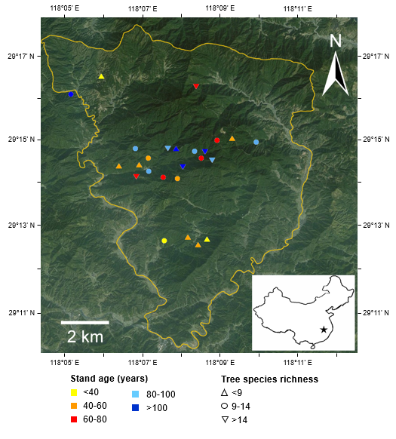

**Figure S1.** Map of the Gutianshan National Nature Reserve and the location of the 25 study plots included in the analyses. Map lines delineate study areas and do not necessarily depict accepted national boundaries.

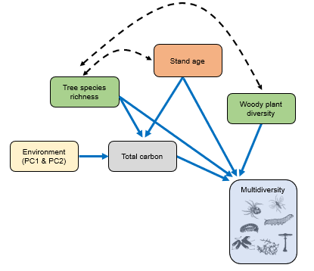

**Figure S2.** Initial model structure of the path models based on theoretical expectations and correlations among predictors: tree species richness (green; trees ≥ 10 cm dbh), stand age (orange), woody plant diversity (green; all trees and shrubs ≥ 1m height), environmental conditions (yellow), and total carbon stocks (grey). Blue arrows show expected causal relationships. Black dashed lines are covariances.

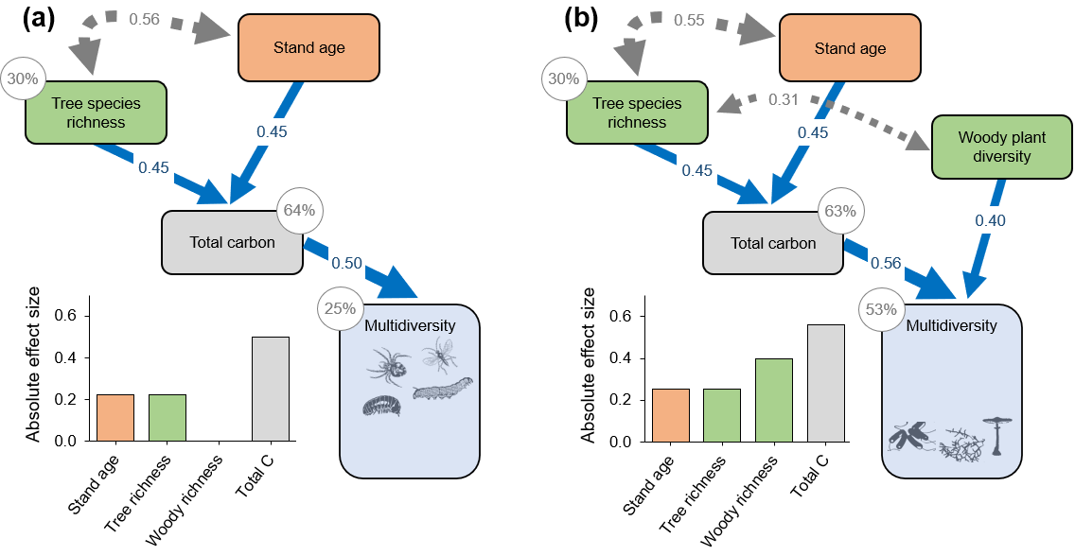

**Figure S3.** Path models showing the direct and indirect effects of tree species richness (green), stand age (orange), woody plant diversity (green; all trees and shrubs ≥ 1m height), and carbon stocks (grey) on multidiversity averaged across a) aboveground trophic groups (χ2 = 1.4, DF = 2, *P* = 0.610), and b) belowground trophic groups (χ2 = 4.6, DF = 4, P = 0.408) in 25 secondary forest plots selected to represent gradients of tree species richness and stand age. Arrows show significant relationships (*P* ≤ 0.05 based on 1000 bootstrap draws) and are scaled by their standardized effects (plotted on top of the arrows). Percentage values are explained variance of dependent variables. Blue arrows show expected causal relationships, grey dashed lines are covariances. Full model results are shown in Supplementary Tables S6-S7. Inset diagrams show the summed effects of the predictor variables based on the standardized path coefficients (absolute effect sizes calculated by summing up the product of standardized path coefficients for each pathway connecting a given predictor with multidiversity).