Supplementary Material

for

Dislocation toughening in single-crystal KNbO₃

Oliver Preuß¹*, Enrico Bruder², Wenjun Lu³, Fangping Zhuo¹, Christian Minnert², Jiawen Zhang³, Jürgen Rödel¹, Xufei Fang¹*

¹Division Nonmetallic-Inorganic Materials, Department of Materials and Earth Sciences, Technical University of Darmstadt, Alarich-Weiss Str. 2, 64287 Darmstadt, Germany
²Division Physical Metallurgy, Department of Materials and Earth Sciences, Technical University of Darmstadt, Alarich-Weiss Str. 2, 64287 Darmstadt, Germany
³Department of Mechanical and Energy Engineering, Southern University of Science and Technology, 1088 Xueyuan Avenue, Shenzhen 518055, P.R. China

*Corresponding authors:
Oliver Preuß: preuss@ceramics.tu-darmstadt.de
Dr. Xufei Fang: fang@ceramics.tu-darmstadt.de

Figure S1 demonstrates the depth profiles of the Brinell zones. The depth is in all cases 400 – 500 nm over a diameter of 150 µm, which means the imprint is almost completely flat. Therefore, the effect of the slope on the Vickers indentation is negligible.
Figure S1. Depth profiles of Brinell zones with different cycle count measured by confocal LASER microscopy.
To confirm the Burgers vector, we have performed further characterization using the g·b analysis. In Table 1, the first row presents the possible directions of the Burgers vectors b, while the first column shows the imaging condition via different g vectors. Then, the Burgers vector b of linear dislocations was determined by investigating the line contrast with the invisibility criterion of vector g·b=0 based on the TEM images provided in Fig. S2.
One linear dislocation marked by a red dashed line does not reveal contrast or very weak contrast under g₂=$1\overline{1}0$. Hence, the Burgers vector b yields ±a [$110$] or ±a [$001$]. Nevertheless, the linear dislocation provides strong contrast under g₁=$020$ and g₃ =$\overline{2}00$, which means g·b≠0. This dependence of the dislocation contrast on g demonstrates that the dislocation has b=±a [$110$], which is consistent with literature [1, 2].
Table 1. Dislocation invisibility table from ABF-STEM images
 |  | Burgers vector b
 |  | $$0 1 0$$ | $$1 0 0$$ | $$1 \overline{1} 0$$ | $$1 1 0$$ | $$1 0 1$$ | $$1 0 \overline{1}$$ | $$0 1 \overline{1}$$ | $$0 0 1$$ | $$0 1 1$$
g | $$0 2 0$$ | 0 | 0 | -2 | 2 | 0 | 0 | 2 | 0 | 2
 | $$1 \overline{1} 0$$ | -1 | 1 | 2 | 0 | 1 | 1 | -1 | 0 | -1
 | $$\overline{2} 0 0$$ | 0 | -2 | -2 | -2 | -2 | -2 | 0 | 0 | 0
 |  | Calculation results of g·b

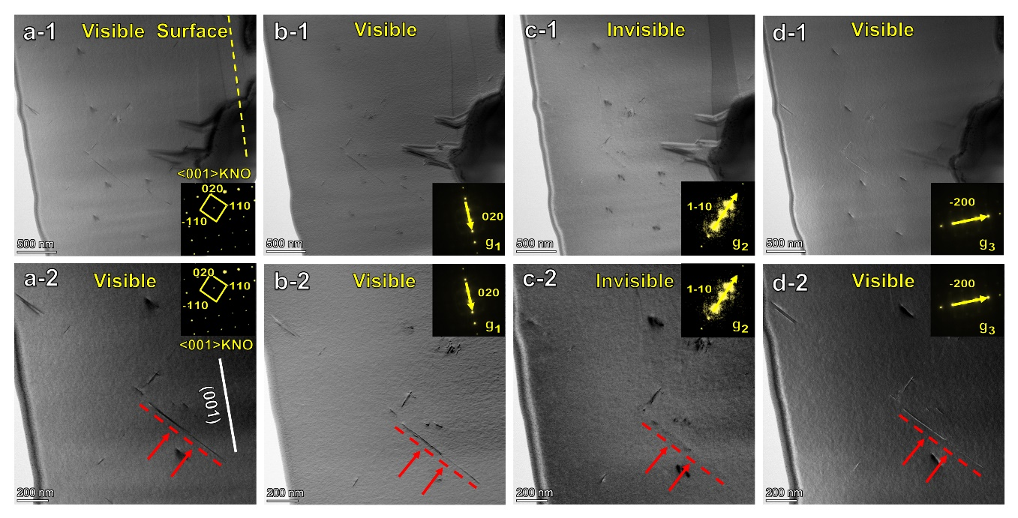
Figure S2. ABF-STEM images featuring a linear dislocation along (a) the [001] zone axis with (b) g1=020; (c) g2=1-10; (d) g3=-200.

To emphasize the correlation between dislocation density and fracture toughness values measured using the ICL method, the toughness values are plotted into the dislocation density figure (Figure S3).
Figure S3. Dislocation density and fracture toughness as a function of number of cycles.

References:
[1] P. Hirel, A.F. Mark, M. Castillo-Rodriguez, W. Sigle, M. Mrovec, C. Elsässer, Theoretical and experimental study of the core structure and mobility of dislocations and their influence on the ferroelectric polarization in perovskite KNbO₃, Physical Review B 92(21) (2015) 214101.
[2] M. Höfling, M. Trapp, L. Porz, H. Uršič, E. Bruder, H.-J. Kleebe, J. Rödel, J. Koruza, Large plastic deformability of bulk ferroelectric KNbO₃ single crystals, J. Eur. Ceram. Soc. 41(7) (2021) 4098–4107.

