Supplementary Materials for:
Engineering dislocation-rich plastic zones in ceramics via room-temperature scratching
Xufei Fang¹*, Oliver Preuß¹, Patrick Breckner¹, Jiawen Zhang², Wenjun Lu²
¹ Department of Materials and Earth Sciences, Technical University of Darmstadt, 64287 Darmstadt, Germany
² Department of Mechanical and Energy Engineering, Southern University of Science and Technology, 1088 Xueyuan Avenue, Shenzhen 518055, P.R. China
*Corresponding author: fang@ceramics.tu-darmstadt.de (Dr. Xufei Fang)

This file contains:
Sec.1. Dark-field optical images demonstrating no visible crack formation underneath the scratching tracks in (A1) and (A2) (Fig. S1)
Fig. S1 Dark-field image demonstrating crack-free regions underneath the scratched surface: (A1) C-DIC mode showing the scratched region, (A2) same location as in (A1) with Dark-field imaging mode showing no visible cracks induced. In contrast, we also visualize the cracked regions in Dark-field imaging mode: (B1) C-DIC mode showing one indented region with induced cracks in the plastic zone, (B2) Dark-field imaging mode for the same region in (B1) highlighting the cracks by the white contrasts.

Sec. 2. Effect of changing scratch track direction with respect to the <100> direction (Fig. S2)
Fig. S2 Due to the fixed slip system in SrTiO₃ at room temperature, the slip traces display a different surface distribution with respect to the scratch directions, as in the case of a pre-set angle of (a) 15° and (b) 45° between the scratch direction (indicated by the yellow arrows) and the [100] direction.

Sec. 3. Brief demonstration of cyclic loading and overlapping the scratch tracks for enlarging the plastic zone (Fig. S3, Fig. S4)
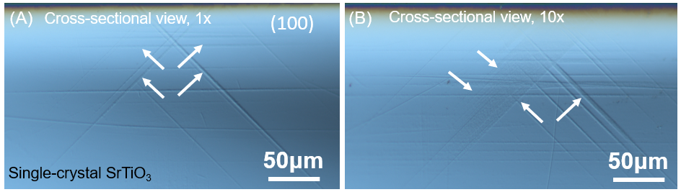
Fig. S3 Cross-sectional images demonstrating the increase of the dislocation densities as well as the plastic zone size after cyclic loading (1 cycle vs. 10 cycles). No visible cracks were found underneath the surface. The sample was deformed on the SrTiO₃ (001) surface.

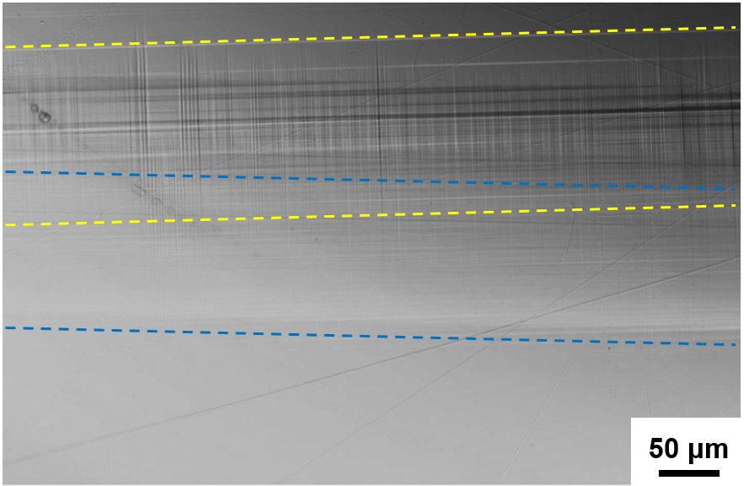
Fig. S4 Demonstration of increasing the plastic zone size on the SrTiO₃ (001) sample surface by overlapping the scratch tracks (one track indicated by yellow dashed lines, and one by blue dashed lines). The width of the plastic zone is almost doubled as compared to a single scratch track. No visible crack is induced in the overlapped region.

