Supplement. Hoenle P.O., Staab, M., Donoso, D.A., Argoti, A.A., and Blüthgen, N. Stratification and recovery time jointly shape ant functional re-assembly in a Neotropical forest

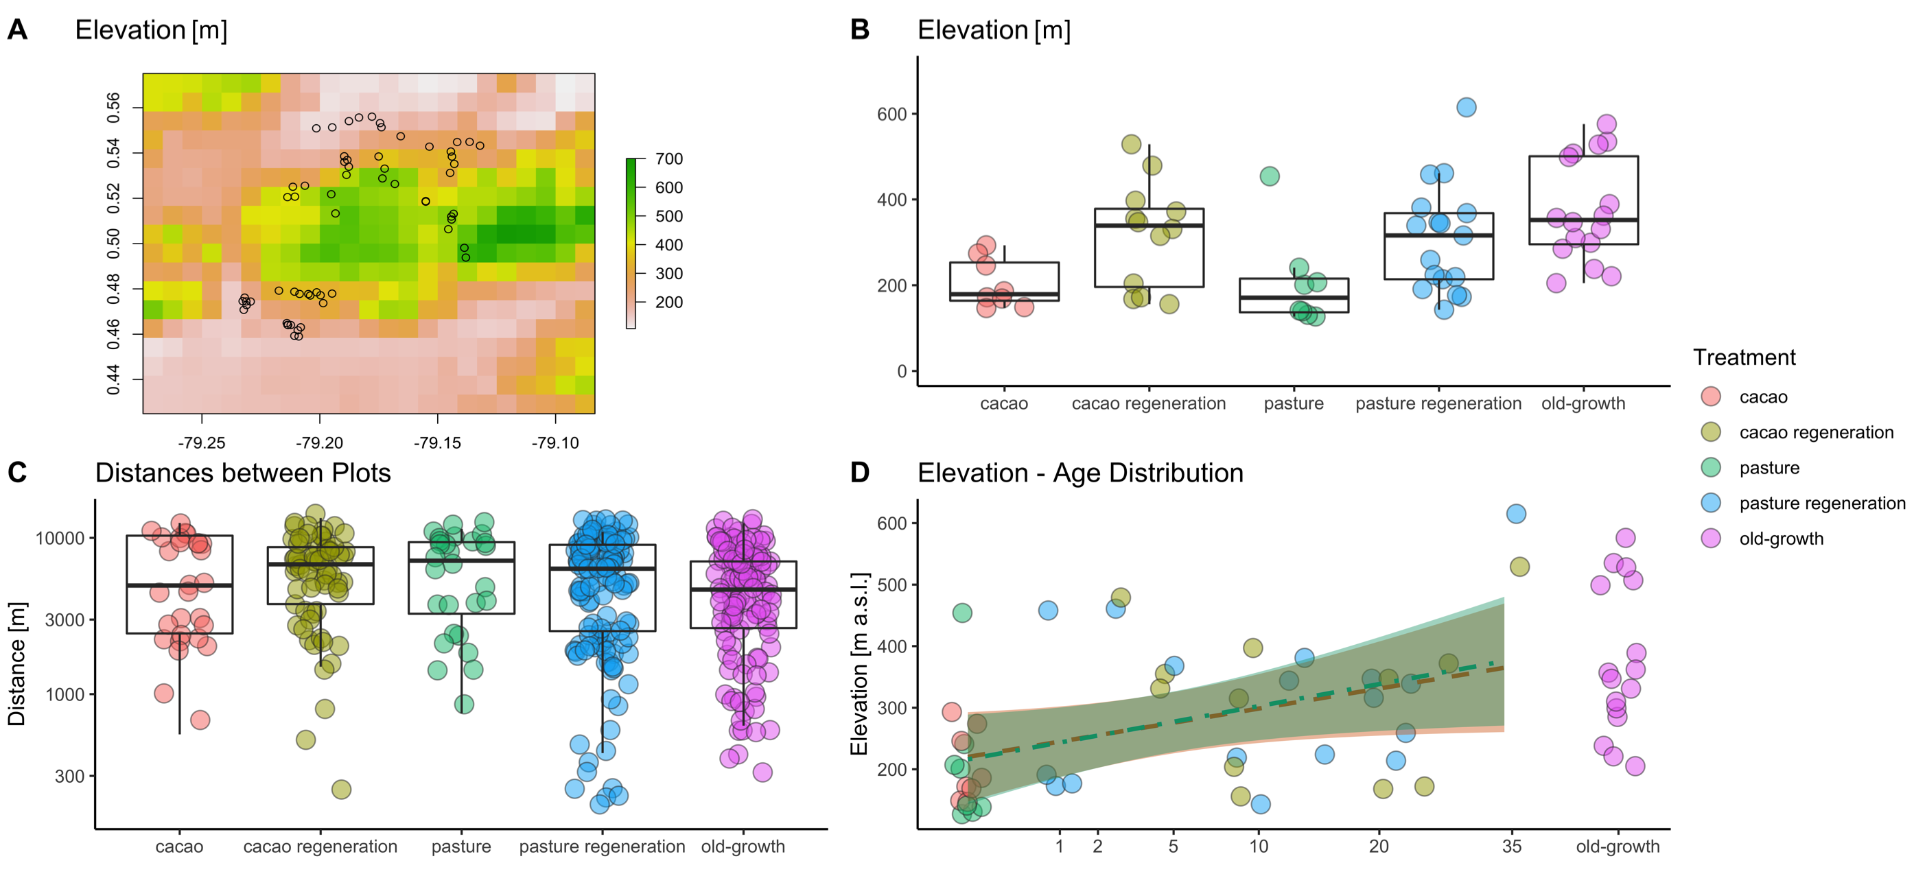
Figure S1. A: Map of all plots superimposed on an elevation heatmap of the study area, made with the r-package ‘raster‘ (Hijman 2011: http://raster.r-forge.r-project.org/) B: Elevational distribution of each plot category. C: Distances among each plot within each category. The y-axis is log-transformed. Mean ± SD distance is 5,799 ± 3,373 m. The shortest inter-category distance is 170 m, the longest is 13,403 m. D: Relationship between elevation and recovery time. The two variables are significantly correlated (linear model; F = 4.80, R² = 0.18, p = 0.003), and there is no difference between cacao and pasture land-use legacy (same model, p = 0.95).

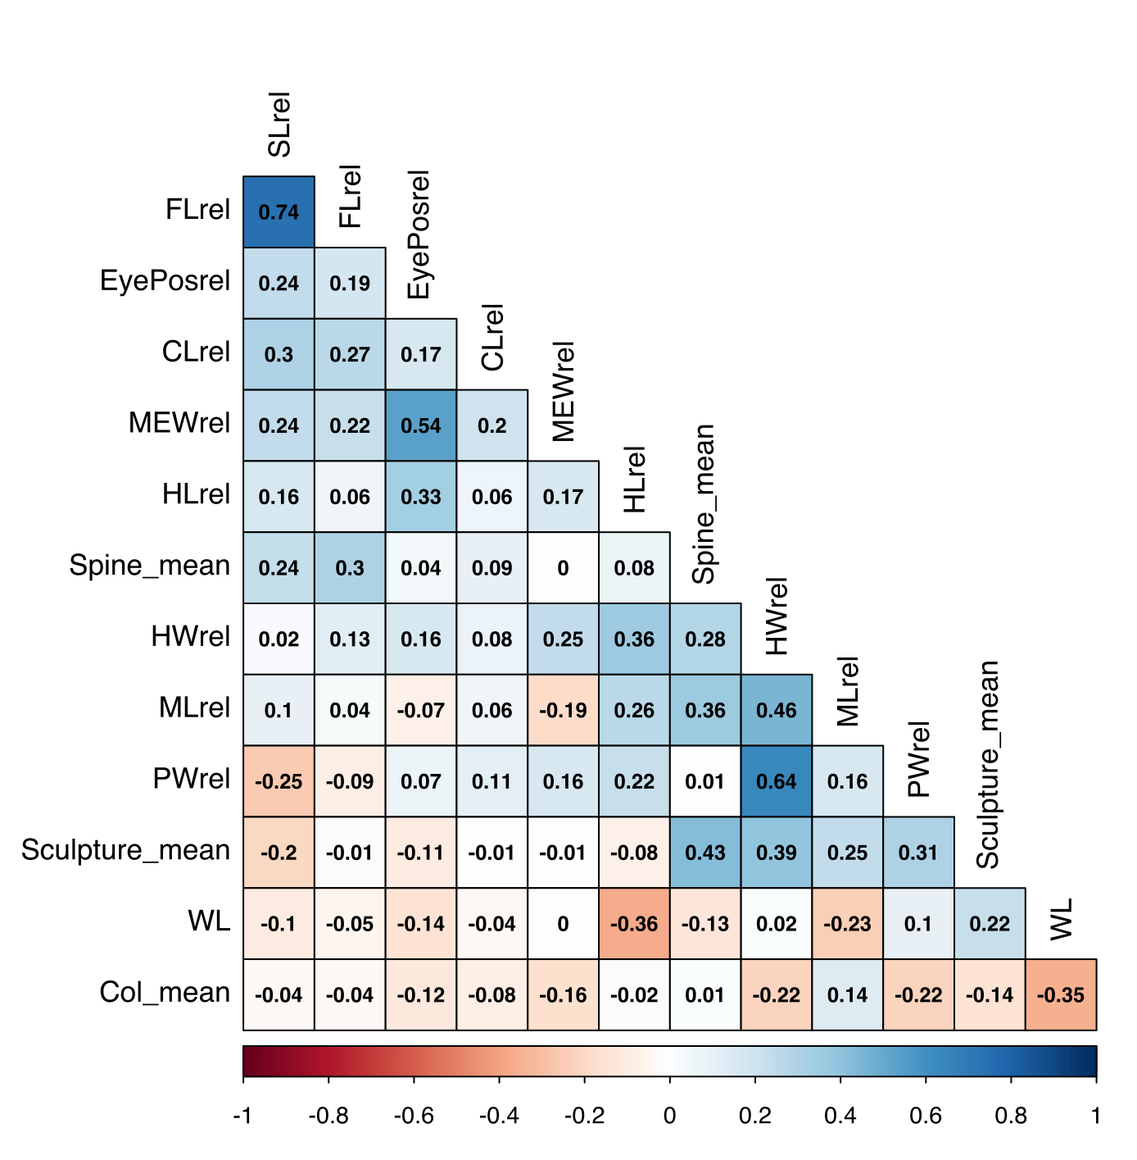
Figure S2 Correlation plot of all measured ant traits. Blue indicates a positive, red a negative pairwise correlation (Spearman correlation). Color intensity scales with strength of correlation. FL= Femur length; EyePosrel; relative Eye position; CLrel = relative Clypeus length; MEWrel = relative Maximum Eye width; HLrel= relative head length; Spine_mean = number of spines; HWrel = relative head width; MLrel = relative mandible length; PWrel = relative pronotum width; Sculpture_mean: Sculpture; WL = Weber’s Length; Col_mean: Color lightness.

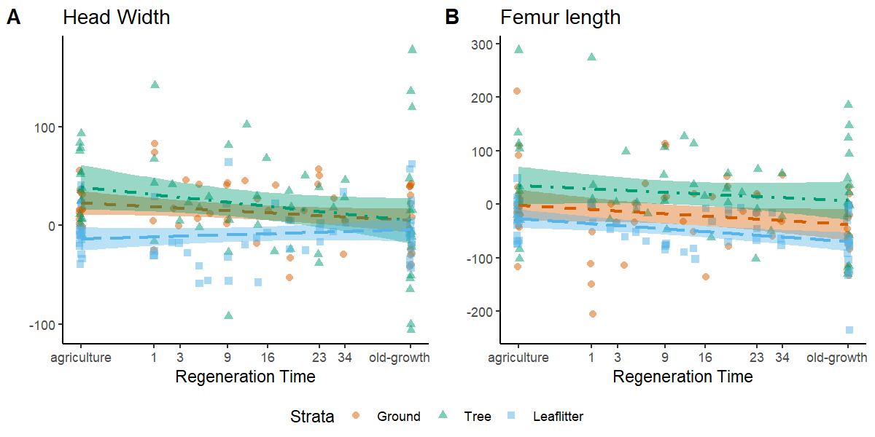
Figure S3. Community weighted means of head width amd along the recovery sequence. The prediction and 95% confidence intervals of each stratum taken from a linear model are plotted.. Colors indicate strata (green = tree trunk; red = ground; blue = leaf litter). Head width has a trajectory consistent with the stratification hypothesis, while Femur length is neither shaped through recovery nor stratification. For the full statistical models see Table S3.

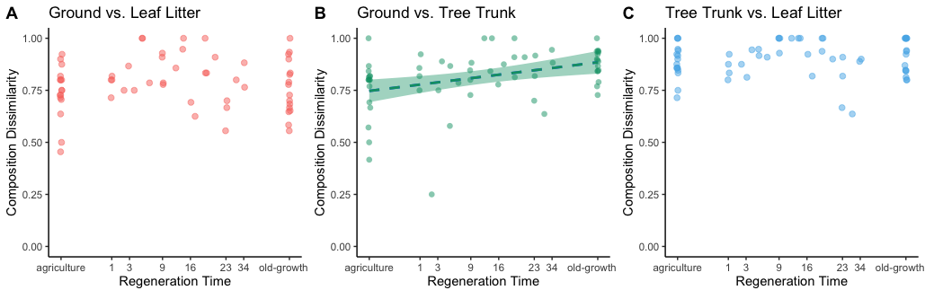
Figure S4: Pairwise comparison of species overlap (as Bray-Curtis Dissimilarity) along recovery time in A) ground vs. leaf litter communities, B) ground vs. tree trunk communities and C) tree trunk vs. leaf litter communities. Only B) was statistically significant (at p<0.05) and was plotted with a regression line and 95% CI from a linear model. For the full models see Supplement Table S2.

Table S1: Species list of the ants collected during this study. In total, 284 species were collected. They are sorted alphabetically within subfamilies. Further given are the sum of occurences for each stratum and the number of individuals measured for the trait analysis. Non-native species are marked with an asterix (*).
Species | n measured | Leaf litter | Ground | Tree
Amblyoponinae
Prionopelta amabilis | 4 | 5 | 0 | 0
Prionopelta modesta | 4 | 8 | 5 | 0
Dolichoderinae
Azteca sp. A | 2 | 0 | 0 | 2
Azteca sp. B | 0 | 0 | 0 | 1
Azteca sp. C | 2 | 0 | 0 | 2
Azteca sp. D | 0 | 0 | 0 | 1
Azteca sp. E | 2 | 0 | 0 | 1
Azteca sp. F | 2 | 0 | 0 | 1
Azteca sp. G | 0 | 0 | 0 | 1
Azteca sp. H | 0 | 0 | 0 | 1
Azteca sp. I | 2 | 0 | 0 | 4
Azteca sp. J | 0 | 0 | 0 | 1
Azteca sp. K | 0 | 0 | 1 | 1
Azteca sp. L | 1 | 0 | 0 | 1
Azteca sp. O | 0 | 0 | 0 | 1
Azteca sp. P | 1 | 0 | 0 | 2
Azteca sp. Q | 0 | 0 | 0 | 1
Dolichoderus baenae | 2 | 0 | 1 | 5
Dolichoderus cf. bispinosus | 2 | 0 | 0 | 3
Dolichoderus cf. validus | 2 | 0 | 1 | 2
Dolichoderus lamellosus | 2 | 0 | 0 | 1
Dolichoderus laurae | 0 | 0 | 0 | 1
Linepithema piliferum | 3 | 2 | 7 | 6
Linepithema tsachila | 3 | 0 | 1 | 3
Tapinoma ramulorum inrectum | 6 | 0 | 0 | 4
Tapinoma sp. A | 0 | 0 | 0 | 1
Tapinoma sp. C | 4 | 0 | 1 | 3
Dorylinae
Eciton burchellii | 2 | 0 | 1 | 2
Eciton lucanoides | 3 | 0 | 1 | 0
Neivamyrmex sp. A | 1 | 0 | 1 | 0
Ectatomminae
Ectatomma goninion | 0 | 1 | 3 | 0
Ectatomma ruidum | 4 | 7 | 34 | 24
Ectatomma tuberculatum | 3 | 0 | 0 | 13
Gnamptogenys annulata | 2 | 0 | 1 | 2
Gnamptogenys banksi | 0 | 0 | 1 | 0
Gnamptogenys cf. brunnea | 4 | 0 | 2 | 3
Gnamptogenys cf. enodis | 0 | 0 | 1 | 0
Gnamptogenys concinna | 1 | 0 | 0 | 1
Gnamptogenys continua | 1 | 1 | 0 | 0
Gnamptogenys extra | 2 | 1 | 1 | 1
Gnamptogenys haenschi | 2 | 1 | 1 | 0
Gnamptogenys horni | 3 | 0 | 5 | 0
Gnamptogenys minuta | 1 | 1 | 1 | 0
Gnamptogenys nr. banski | 2 | 0 | 1 | 0
Gnamptogenys porcata | 4 | 0 | 1 | 20
Gnamptogenys regularis | 1 | 0 | 0 | 1
Gnamptogenys sulcata | 4 | 0 | 0 | 4
Gnamptogenys tornata | 2 | 2 | 1 | 1
Typhlomyrmex pusillus | 2 | 1 | 1 | 0
Typhlomyrmex rogenhoferi | 0 | 0 | 0 | 1
Typhlomyrmex sp. A | 0 | 0 | 1 | 0
Formicinae
Acropyga cf. guianensis | 4 | 2 | 0 | 2
Acropyga fuhrmanni | 2 | 0 | 1 | 2
Brachymyrmex cavernicola | 2 | 0 | 4 | 0
Brachymyrmex cf. australis | 7 | 8 | 4 | 10
Brachymyrmex cf. termitophilus | 2 | 0 | 1 | 2
Brachymyrmex pictus | 6 | 4 | 2 | 7
Brachymyrmex sp. A | 4 | 1 | 5 | 8
Brachymyrmex sp. B | 1 | 0 | 0 | 2
Camponotus cf. brettesi | 0 | 0 | 0 | 1
Camponotus cf. senex | 2 | 0 | 0 | 2
Camponotus novogranadensis | 5 | 0 | 1 | 7
Camponotus sericeiventris | 4 | 0 | 0 | 5
Camponotus sp. A | 0 | 0 | 0 | 1
Camponotus sp. B | 0 | 0 | 0 | 1
Myrmelachista sp. B | 0 | 0 | 0 | 1
Nylanderia cf. guatemalensis | 5 | 5 | 6 | 9
Nylanderia sp. A | 1 | 0 | 0 | 1
Nylanderia sp. B | 3 | 0 | 1 | 1
Nylanderia sp. C | 2 | 3 | 0 | 0
Nylanderia sp. D | 2 | 3 | 2 | 0
Nylanderia sp. F | 2 | 0 | 0 | 1
Nylanderia sp. G | 0 | 0 | 0 | 1
Nylanderia steinheili complex | 3 | 9 | 13 | 20
Heteroponerinae
Acanthoponera minor | 2 | 0 | 0 | 3
Acanthoponera PH1 | 0 | 0 | 0 | 1
Myrmicinae
Acromyrmex cf. octospinosus | 3 | 0 | 4 | 4
Acromyrmex cf. volcanus | 2 | 0 | 0 | 4
Adelomyrmex sp. A | 2 | 1 | 1 | 0
Apterostigma carinatum | 3 | 0 | 2 | 14
Apterostigma chocoense | 2 | 1 | 1 | 0
Apterostigma sp. A | 3 | 1 | 1 | 0
Atta cephalotes | 0 | 3 | 0 | 0
*Cardiocondyla emeryi | 0 | 0 | 1 | 0
*Cardiocondyla minutior | 1 | 1 | 1 | 0
Carebara brevipilosa | 2 | 0 | 1 | 0
Cephalotes cf. peruviensis | 0 | 0 | 0 | 1
Cephalotes cf. umbraculatus | 0 | 0 | 0 | 1
Crematogaster arcuata | 2 | 0 | 1 | 2
Crematogaster brasiliensis | 2 | 0 | 0 | 3
Crematogaster carinata | 4 | 0 | 0 | 9
Crematogaster cf. flavomicrops | 3 | 0 | 3 | 7
Crematogaster crinosa complex | 4 | 0 | 2 | 9
Crematogaster curvispinosa | 4 | 1 | 1 | 9
Crematogaster limata | 4 | 0 | 3 | 12
Crematogaster longispina | 4 | 2 | 6 | 11
Crematogaster nigropilosa | 4 | 0 | 3 | 13
Crematogaster raptor | 2 | 0 | 0 | 1
Crematogaster sotobosque | 4 | 2 | 5 | 1
Crematogaster sp. A | 0 | 0 | 0 | 1
Crematogaster tenuicula | 2 | 0 | 4 | 3
Cyphomyrmex castagnei | 4 | 1 | 5 | 3
Cyphomyrmex cf. bicarinatus | 4 | 3 | 8 | 0
Cyphomyrmex cf. cornutus sp. A | 4 | 1 | 9 | 21
Cyphomyrmex cf. cornutus sp. B | 2 | 1 | 2 | 0
Cyphomyrmex cf. cornutus sp. C | 0 | 0 | 0 | 1
Cyphomyrmex costatus | 4 | 0 | 5 | 0
Cyphomyrmex longiscapus | 2 | 0 | 0 | 4
Cyphomyrmex nr. rimosus sp. A | 4 | 2 | 10 | 6
Cyphomyrmex nr. rimosus sp. B | 3 | 0 | 5 | 3
Cyphomyrmex nr. salvini sp. B | 4 | 1 | 7 | 4
Cyphomyrmex nr. salvini sp. C | 4 | 6 | 4 | 0
Eurhopalothrix xibalba | 0 | 0 | 1 | 0
Hylomyrma montana | 2 | 2 | 0 | 0
Lachnomyrmex cf. haskinsi | 1 | 0 | 1 | 0
Lenomyrmex foveolatus | 4 | 2 | 2 | 2
Megalomyrmex bidentatus | 1 | 0 | 0 | 2
Megalomyrmex incisus | 2 | 1 | 0 | 0
Megalomyrmex leoninus group sp. A | 2 | 0 | 0 | 3
Megalomyrmex leoninus group sp. B | 0 | 0 | 1 | 0
Megalomyrmex leoninus group sp. C | 12 | 0 | 9 | 7
Megalomyrmex modestus group sp. A | 4 | 0 | 1 | 6
Megalomyrmex sp. A | 1 | 1 | 0 | 0
*Monomorium floricola | 4 | 5 | 1 | 1
Mycecopurus tardus | 1 | 0 | 1 | 0
Mycetomoellerius isthmicus | 3 | 2 | 11 | 0
Mycetomoellerius sp. A | 1 | 0 | 1 | 0
Mycetomoellerius sp. B | 1 | 0 | 1 | 0
Nesomyrmex asper | 0 | 0 | 0 | 1
Octostruma cf. amrishi | 4 | 17 | 9 | 0
Octostruma cf. gymnogon | 0 | 0 | 1 | 0
Octostruma cf. onorei | 0 | 1 | 0 | 0
Octostruma stenoscapa | 2 | 3 | 2 | 0
Paratrachymyrmex bugnioni | 1 | 0 | 0 | 1
Paratrachymyrmex cornetzi | 2 | 1 | 3 | 0
Pheidole cf. anastasii | 2 | 1 | 0 | 3
Pheidole cf. boliviana | 1 | 0 | 0 | 1
Pheidole cf. cataphracta | 1 | 0 | 0 | 1
Pheidole cf. excubitor | 2 | 0 | 2 | 0
Pheidole cf. flavens | 3 | 2 | 2 | 26
Pheidole cf. harrisonfordi | 4 | 28 | 11 | 1
Pheidole cf. hazenae | 1 | 0 | 0 | 1
Pheidole cf. jaculifera | 4 | 1 | 9 | 0
Pheidole cf. simonsi | 2 | 0 | 1 | 2
Pheidole cf. tennantae | 2 | 1 | 0 | 1
Pheidole cf. unicornis | 0 | 0 | 1 | 0
Pheidole cf. verricula | 0 | 0 | 1 | 0
Pheidole colobopsis | 5 | 1 | 4 | 0
Pheidole dilligens group sp. A | 2 | 0 | 2 | 1
Pheidole dilligens group sp. B | 1 | 0 | 1 | 0
Pheidole ectatommoides | 2 | 0 | 2 | 0
Pheidole fallax group sp. A | 1 | 0 | 0 | 1
Pheidole fallax group sp. C | 2 | 0 | 1 | 0
Pheidole fallax group sp. D | 1 | 0 | 0 | 3
Pheidole fallax group sp. E | 3 | 1 | 3 | 0
Pheidole fallax group sp. F | 4 | 0 | 5 | 1
Pheidole fallax group sp. G | 4 | 0 | 7 | 2
Pheidole fallax group sp. I | 2 | 0 | 2 | 0
Pheidole fallax group sp. K | 2 | 0 | 1 | 1
Pheidole flavens group sp. A | 1 | 1 | 0 | 0
Pheidole flavens group sp. D | 2 | 0 | 0 | 4
Pheidole flavens group sp. E | 1 | 0 | 0 | 1
Pheidole flavens group sp. G | 3 | 0 | 0 | 4
Pheidole flavens group sp. H | 2 | 2 | 2 | 0
Pheidole flavens group sp. L | 3 | 2 | 3 | 0
Pheidole flavens group sp. M | 2 | 1 | 1 | 0
Pheidole flavens group sp. N | 2 | 2 | 1 | 0
Pheidole flavens group sp. O | 0 | 0 | 0 | 1
Pheidole flavens group sp. P | 2 | 1 | 2 | 0
Pheidole flavens group sp. Q | 1 | 0 | 0 | 1
Pheidole flavens group sp. R | 3 | 0 | 0 | 3
Pheidole flavens group sp. S | 1 | 0 | 0 | 1
Pheidole flavens group sp. T | 2 | 1 | 0 | 0
Pheidole flavens group sp. U | 1 | 0 | 0 | 1
Pheidole flavens group sp. V | 2 | 0 | 0 | 3
Pheidole flavens group sp. W | 1 | 0 | 1 | 0
Pheidole flavens group sp. Z | 1 | 0 | 0 | 1
Pheidole gauthieri | 2 | 0 | 1 | 2
Pheidole guyasana | 3 | 2 | 7 | 0
Pheidole nitella | 3 | 8 | 16 | 6
Pheidole nr. ajax | 2 | 0 | 0 | 1
Pheidole nr. exquisita | 2 | 1 | 1 | 0
Pheidole nr. onyx | 6 | 2 | 4 | 5
Pheidole nr. specularis | 4 | 3 | 3 | 1
Pheidole perpusilla | 2 | 0 | 0 | 3
Pheidole perpusilla group sp. A | 2 | 0 | 0 | 3
Pheidole perpusilla group sp. B | 1 | 0 | 0 | 1
Pheidole rhinomontana | 3 | 2 | 4 | 2
Pheidole rugiceps | 4 | 5 | 9 | 0
Pheidole sensitiva | 2 | 0 | 1 | 0
Pheidole tristis group sp. A | 1 | 0 | 0 | 1
Pheidole tristis group sp. B | 1 | 0 | 1 | 0
Pheidole ulothrix | 4 | 0 | 1 | 9
Pheidole vorax | 2 | 0 | 0 | 1
Pheidole zeteki | 4 | 6 | 3 | 1
Rogeria cf. belti | 4 | 19 | 13 | 1
Rogeria cf. leptonana | 0 | 0 | 1 | 0
Rogeria gibba | 2 | 2 | 5 | 1
Rogeria inermis | 2 | 0 | 1 | 2
Rogeria scandens | 0 | 0 | 0 | 1
Rogeria sp. A | 2 | 0 | 0 | 1
Sericomyrmex cf. amabilis | 8 | 5 | 11 | 0
Solenopsis bicolor | 6 | 3 | 1 | 4
Solenopsis cf. brevicornis | 5 | 21 | 4 | 5
Solenopsis cf. stricta | 2 | 1 | 4 | 0
Solenopsis cf. zeteki | 4 | 0 | 5 | 5
Solenopsis geminata | 4 | 3 | 9 | 3
Solenopsis modesta group | 11 | 26 | 10 | 10
Solenopsis sp. A | 7 | 8 | 5 | 0
Solenopsis sp. B | 4 | 3 | 4 | 0
Solenopsis sp. C | 2 | 2 | 0 | 0
Solenopsis sp. D | 2 | 1 | 2 | 0
Solenopsis sp. E | 2 | 1 | 2 | 0
Solenopsis sp. F | 3 | 3 | 2 | 2
Solenopsis subterranea | 2 | 4 | 0 | 0
Stenamma schmidti | 4 | 4 | 8 | 1
Strumigenys biolleyi | 3 | 3 | 0 | 2
Strumigenys cascanteae | 1 | 0 | 0 | 1
Strumigenys denticulata | 6 | 11 | 1 | 0
Strumigenys eggersi | 3 | 7 | 2 | 0
Strumigenys fridericimuelleri | 2 | 1 | 0 | 1
Strumigenys gundlachi | 4 | 11 | 1 | 1
Strumigenys gundlachi group sp. A | 1 | 0 | 0 | 1
Strumigenys lalassa | 2 | 2 | 0 | 1
Strumigenys longispina | 3 | 0 | 6 | 0
Strumigenys louisianae | 4 | 5 | 11 | 1
Strumigenys myllorhapha | 2 | 2 | 1 | 0
Strumigenys nigrescens | 1 | 0 | 0 | 1
Strumigenys oconitrilloae | 1 | 0 | 0 | 1
Strumigenys schulzi | 1 | 0 | 0 | 1
Strumigenys sp. A (=S. ayersthey) | 0 | 0 | 1 | 0
Strumigenys spathula | 1 | 0 | 1 | 0
Strumigenys trinidadensis | 2 | 0 | 0 | 2
Tranopelta gilva | 4 | 7 | 1 | 12
Wasmannia auropunctata | 7 | 36 | 35 | 40
Wasmannia sigmoidea | 3 | 7 | 3 | 2
Paraponerinae
Paraponera clavata | 1 | 0 | 0 | 5
Ponerinae
Anochetus diegensis | 2 | 1 | 1 | 0
Anochetus mayri | 2 | 0 | 3 | 0
Anochetus simoni | 3 | 3 | 4 | 1
Hypoponera cf. distinguenda | 5 | 6 | 6 | 1
Hypoponera cf. parva | 3 | 2 | 5 | 1
Hypoponera sp. A | 4 | 10 | 13 | 2
Hypoponera sp. B | 3 | 6 | 10 | 1
Hypoponera sp. D | 1 | 1 | 0 | 0
Hypoponera sp. E | 2 | 4 | 1 | 0
Hypoponera sp. F | 2 | 2 | 1 | 1
Hypoponera sp. G | 2 | 2 | 2 | 0
Hypoponera sp. I | 2 | 0 | 0 | 4
Hypoponera sp. J | 0 | 1 | 0 | 0
Hypoponera sp. K | 5 | 22 | 15 | 1
Hypoponera sp. L | 4 | 3 | 4 | 12
Hypoponera sp. N | 0 | 1 | 0 | 0
Leptogenys cf. punctaticeps | 1 | 0 | 0 | 1
Leptogenys sp. B | 2 | 0 | 1 | 1
Leptogenys sp. C | 2 | 0 | 1 | 1
Odontomachus bauri | 5 | 4 | 17 | 16
Odontomachus chelifer | 3 | 0 | 4 | 1
Odontomachus hastatus | 3 | 0 | 0 | 5
Odontomachus meinerti | 2 | 0 | 1 | 1
Odontomachus sp. A | 1 | 0 | 0 | 2
Pachycondyla harpax | 4 | 6 | 22 | 8
Pachycondyla impressa | 2 | 0 | 0 | 1
Platythyrea angusta | 1 | 0 | 1 | 0
Platythyrea prizo | 2 | 0 | 0 | 2
Pseudoponera cf. succedanea | 2 | 1 | 2 | 3
Pseudoponera stigma | 3 | 1 | 0 | 3
Rasopone (=Mayaponera) arhuaca | 2 | 2 | 2 | 0
Neoponera apicalis | 3 | 0 | 0 | 9
Neoponera bugabensis | 0 | 0 | 0 | 1
Neoponera carinulata | 4 | 0 | 0 | 12
Neoponera laevigata | 2 | 0 | 0 | 1
Neoponera striatinodis | 2 | 0 | 0 | 2
Neoponera villosa | 2 | 0 | 1 | 6
Proceratiinae
Discothyrea sexarticulata | 0 | 1 | 0 | 0
Proceratium convexiceps | 0 | 0 | 1 | 0
Pseudomyrmecinae
Pseudomyrmex boopis | 3 | 0 | 5 | 8
Pseudomyrmex gracilis group sp. A | 2 | 0 | 0 | 3
Pseudomyrmex oki | 1 | 0 | 1 | 2
Pseudomyrmex pallidus group sp. A | 2 | 0 | 0 | 1
Pseudomyrmex pallidus group sp. B | 1 | 0 | 0 | 1
Pseudomyrmex spiculus | 1 | 0 | 0 | 1
Pseudomyrmex subater | 0 | 0 | 0 | 1

Table S2 Statistical results for analysis on species richness from Figure 3A and species composition from Figure 2 and Figure S4. The table shows results from PERMANOVA, envfit vectors and linear mixed effects models (LME). The anova in parentheses indicates an Anova test (Type III analysis of variance) on the model for significance. When testing for legacy effects we used a dataset without old-growth forests (see methods). Significant p-values are highlighted in bold.
Composition Dissimilarity: HS vs. T
- LME | Estimates | SE | p
Intercept | 0.7768 | 0.0484 | <0.0001
Elevation [m] | -0.0001 | 0.0002 | 0.5655
Richness | 0.0035 | 0.0039 | 0.3746
Recovery Time | 0.0027 | 0.0001 | 0.0029
- Legacy (Anova) |  |  | 0.4498
- Legacy*Recovery Time (Anova) |  |  | 0.7088
- Marginal R² / Conditional R² | 0.1771/ 0.2681
Composition Dissimilarity: HS vs. W
- LME | Estimates | SE | p
Intercept | 0.8057 | 0.0360 | <0.0001
Elevation [m] | 0.0003 | 0.0001 | 0.0163
Richness | -0.0020 | 0.0031 | 0.5360
Recovery Time | -0.0007 | 0.0008 | 0.3892
- Legacy (Anova) |  |  | 0.3241
- Legacy*Recovery Time (Anova) |  |  | 0.4325
- Marginal R² / Conditional R² | 0.0938/ 0.0938
Composition Dissimilarity: T vs. W
- LME | Estimates | SE | p
Intercept | 0.9092 | 0.0266 | <0.0001
Elevation [m] | <0.0001 | 0.0001 | 0.7870
Richness | 0.0012 | 0.0020 | 0.5710
Recovery Time | 0.0002 | 0.0005 | 0.7230
- Legacy (Anova) |  |  | 0.3241
- Legacy*Recovery Time (Anova) |  |  | 0.4325
- Marginal R² / Conditional R² | 0.0190/ 0.0727
Species Richness
- LME | Estimates | SE | p
Intercept | 6.5560 | 1.6816 | 0.0307
Elevation [m] | 0.0080 | 0.0027 | 0.0042
Recovery Time | 0.0461 | 0.0301 | 0.1278
- Marginal R² / Conditional R² | 0.2286/ 0.3879
- Stratum*Recovery Time (Anova) |  |  | 0.9747
- Legacy (Anova) |  |  | 0.4004
- Legacy*Recovery Time (Anova) |  |  | 0.1777
- Stratum (Anova) |  |  | 0.0256
- contrast estimate (Holm-adj.)
Ground - Tree | -1.0656 | 0.6823 | 0.1210
Ground - Leaf litter | 2.7705 | 0.6823 | 0.0002
Tree - Leaf litter | 3.8361 | 0.6823 | <0.0001
Species Composition Tree Trunk
- PERMANOVA | R2 | F | p
Elevation [m] | 0.0312 | 1.974 | 0.0002
Recovery Time | 0.0364 | 2.301 | <0.0001
Species Composition Leaf litter
- PERMANOVA | R2 | F | p
Elevation [m] | 0.0207 | 1.3158 | 0.0954
Recovery Time | 0.0428 | 2.7236 | <0.0001
Species Composition Ground
- PERMANOVA | R2 | F | p
Elevation [m] | 0.0292 | 1.9066 | 0.0032
Recovery Time | 0.0495 | 3.2307 | <0.001

Table S3 Model results for functional diversity, as SES Rao Q. The table shows linear mixed effects model (LME) results and subsequent post-hoc tests The anova in parentheses indicates an Anova test (type III analysis of variance) on the model for significance. If ‘Stratum’ was significant in the anova, we applied a contrast as post-hoc procedure to test specifically between the strata. If recovery time or an interaction was significant in the LME, we tested the recovery trajectory of each subset separately (‘Recovery subset models’). When testing for legacy effects we used a dataset without old-growth forests (see methods). Significant p-values are highlighted in bold.
Functional Diversity: Stratification Hypothesis
- LME | Estimates | SE | p
Intercept | 0.3306 | 0.2343 | 0.1860
Elevation [m] | -3.365e-05 | 4.544e-04 | 0.9410
Recovery Time | -0.0050 | 0.0050 | 0.3160
Richness | -0.0183 | 0.0124 | 0.1420
- Marginal R² / Conditional R² | 0.3881 / 0.4490
- Legacy (Anova) |  |  | 0.3378
- Legacy*Recovery Time (Anova) |  |  | 0.2517
- Stratum (Anova) |  |  | <0.0001
- contrast estimate (Holm-adj.)
Ground - Tree | -0.4460 | 0.1136 | 0.0001
Ground - Leaf litter | 0.8549 | 0.1183 | <0.0001
Tree - Leaf litter | 1.3009 | 0.1231 | <0.0001

Table S4 Model results for the trait community weighted mean trajectories which are shown in Figure 4. For each trait, we indicated if its trajectory was consistent with the stratification or interaction hypothesis. The anova in parentheses indicates an Anova test (Type III analysis of variance) on the model for significance. If ‘Stratum’ was significant in the anova, we applied a contrast as post-hoc procedure to test specifically between the strata. If recovery time or an interaction was significant in the LME, we tested the recovery trajectory of each subset separately (‘Recovery subset models’). When testing for legacy effects we used a dataset without old-growth forests (see methods). Significant p-values are highlighted in bold.

Head Width CWM: Stratification Hypothesis
- LME | Estimates | SE | p
Intercept | 28.6321 | 13.9148 | 0.0603
Elevation [m] | -0.0043 | 0.0273 | 0.8763
Recovery Time | -0.3512 | 0.3028 | 0.2477
Richness | -0.1502 | 0.7494 | 0.8414
- Marginal R² / Conditional R² | 0.1362/ 0.2074
- Legacy (Anova) |  |  | 0.1197
- Legacy*Recovery Time (Anova) |  |  | 0.1625
- Stratum (Anova) |  |  | 0.0001
-Stratum*Recovery Time (Anova) |  |  | 0.0526
- contrast estimate (Holm-adj.)
Ground - Tree | -7.9736 | 6.9097 | 0.2508
Ground - Leaf litter | 23.4133 | 7.1953 | 0.0029
Tree - Leaf litter | 31.3869 | 7.4905 | 0.0002

Sculpture CWM: Recovery Hypothesis
- LME | Estimates | SE | p
Intercept | 2.2848 | 0.0868 | <0.0001
Elevation [m] | -0.0004 | 0.0002 | 0.0757
Recovery Time | -0.0049 | 0.0022 | 0.0238
Richness | -0.0077 | 0.0051 | 0.1313
- Marginal R² / Conditional R² | 0.1410/ 0.1791
- Legacy (Anova) |  |  | 0.8631
- Legacy*Recovery Time (Anova) |  |  | 0.9489
- Stratum (Anova) |  |  | 0.0007
- Stratum*Recovery Time (Anova) |  |  | 0.0990
- Recovery subset models
Tree Recovery Time | <0.0001 | 0.0022 | 0.9973
Leaf litter Recovery Time | -0.0025 | 0.0026 | 0.3517
Ground Recovery Time | -0.0038 | 0.0022 | 0.0811
- contrast estimate (Holm-adj.)
Ground - Tree | 0.0168 | 0.0491 | 0.7300
Ground - Leaf litter | 0.1937 | 0.0491 | 0.0007
Tree - Leaf litter | 0.1769 | 0.0491 | 0.0025
Eye Position CWM: Recovery Hypothesis
- LME | Estimates | SE | p
Intercept | 12.5731 | 7.2302 | 0.0841
Elevation [m] | 0.0151 | 0.0170 | 0.3793
Recovery Time | -0.5956 | 0.1786 | 0.0011
Richness | -0.3387 | 0.4210 | 0.4222
- Marginal R² / Conditional R² | 0.3020/ 0.3752
- Legacy (Anova) |  |  | 0.4466
- Legacy*Recovery Time (Anova) |  |  | 0.7341
- Stratum (Anova) |  |  | 0.0002
- Stratum*Recovery Time (Anova) |  |  | 0.6021
- contrast estimate (Holm-adj.)
Ground - Tree | -22.7456 | 3.8967 | <0.0001
Ground - Leaf litter | 6.2510 | 4.0981 | 0.1297
Tree - Leaf litter | 28.9966 | 4.3043 | <0.0001
- Recovery subset models
Ground Recovery Time | -0.5316 | 0.1679 | 0.0025
Leaf litter Recovery Time | -0.4398 | 0.1461 | 0.0040
Tree Recovery Time | -0.5397 | 0.2527 | 0.0370

Color CWM: Interaction Hypothesis
- LME | Estimates | SE | p
Intercept | 47.6032 | 3.4072 | <0.0001
Elevation [m] | 0.0016 | 0.0077 | 0.8333
Recovery Time | 0.2261 | 0.0791 | 0.0050
Richness | 0.4892 | 0.1906 | 0.0112
- Marginal R² / Conditional R² | 0.2863/ 0.3963
-Stratum (Anova) |  |  | <0.0001
- Stratum*Recovery Time (Anova) |  |  | <0.0001
- Legacy (Anova) |  |  | 0.0550
- Legacy*Recovery Time (Anova) |  |  | 0.0744
- contrast estimate (Holm-adj.)
Ground - Tree | 2.1554 | 1.6951 | 0.2060
Ground - Leaf litter | -9.4887 | 1.7740 | <0.0001
Tree - Leaf litter | -11.6442 | 1.8551 | <0.0001
- Recovery subset models
Ground Recovery Time | 0.2267 | 0.0871 | 0.0118
Leaf litter Recovery Time | -0.2422 | 0.0920 | 0.0109
Tree Recovery Time | 0.2722 | 0.0762 | 0.0007
Pronotum Width CWM: Interaction Hypothesis
- LME | Estimates | SE | p
Intercept | 36.0498 | 10.3645 | 0.0012
Elevation [m] | 0.0091 | 0.0262 | 0.7304
Recovery Time | -0.63841 | 0.2478 | 0.0111
Richness | -1.0910 | 0.5599 | 0.0534
- Marginal R² / Conditional R² | 0.1859/ 0.4189
- Legacy (Anova) |  |  | 0.1362
- Legacy*Recovery Time (Anova) |  |  | 0.3068
- Stratum (Anova) |  |  | <0.0001
- Stratum*Recovery Time (Anova) |  |  | 0.0016
- contrast estimate (Holm-adj.)
Ground - Tree | -9.7953 | 4.7780 | 0.0433
Ground - Leaf litter | 11.6867 | 5.0238 | 0.0433
Tree - Leaf litter | 21.4820 | 5.2755 | 0.0013
- Recovery subset models
Ground Recovery Time | -0.3791 | 0.2108 | 0.0774
Leaf litter Recovery Time | -0.0503 | 0.1593 | 0.7531
Tree Recovery Time | -1.1354 | 0.3717 | 0.0034
Scape Length CWM: Interaction Hypothesis
- LME | Estimates | SE | p
Intercept | -0.6435 | 0.1608 | 0.0002
Elevation [m] | 0.0006 | 0.0035 | 0.9867
Recovery Time | 0.9251 | 0.3949 | 0.0203
Richness | 1.951 | 0.9511 | 0.0433
- Marginal R² / Conditional R² | 0.2332/ 0.2332
- Stratum*Recovery Time (Anova) |  |  | <0.0001
- Stratum (Anova) |  |  | 0.0792
- Legacy (Anova) |  |  | 0.4491
- Legacy*Recovery Time (Anova) |  |  | 0.6334
- Recovery subset models
Ground Recovery Time | 0.8860 | 0.3744 | 0.0214
Leaf litter Recovery Time | -0.5900 | 0.3286 | 0.0779
Tree Recovery Time | 1.4972 | 0.5679 | 0.0108
Clypeus Length CWM: Interaction Hypothesis
- LME | Estimates | SE | p
Intercept | 44.2905 | 8.4672 | <0.0001
Elevation [m] | -0.0087 | 0.0182 | 0.6337
Recovery Time | -0.8019 | 0.2069 | 0.0002
Richness | -1.1781 | 0.5002 | 0.0205
- Marginal R² / Conditional R² | 0.2799/ 0.2987
- Legacy (Anova) |  |  | 0.4223
- Legacy *Recovery Time (Anova) |  |  | 0.4712
- Stratum (Anova) |  |  | <0.0001
- Stratum*Recovery Time (Anova) |  |  | 0.0214
- contrast estimate (Holm-adj.)
Ground - Tree | -22.6480 | 4.81238 | <0.0001
Ground - Leaf litter | 9.9380 | 5.03184 | 0.0505
Tree - Leaf litter | 32.586 | 5.2578 | <0.0001
- Recovery subset models
Ground Recovery Time | -0.698 | 0.1714 | 0.0001
Leaf litter Recovery Time | -0.2732 | 0.1471 | 0.0686
Tree Recovery Time | -0.7623 | 0.3043 | 0.0152
Head Length CWM: Interaction Hypothesis
- LME | Estimates | SE | p
Intercept | -13.0733 | 11.1391 | 0.2424
Elevation [m] | 0.0086 | 0.0263 | 0.7444
Recovery Time | 0.4439 | 0.2751 | 0.1086
Richness | 0.2089 | 0.6478 | 0.7475
- Marginal R² / Conditional R² | 0.0659/ 0.1689
- Legacy (Anova) |  |  | 0.6153
- Legacy*Recovery Time (Anova) |  |  | 0.8816
- Stratum (Anova) |  |  | 0.0504
- Stratum*Recovery Time (Anova) |  |  | 0.0230
- Recovery subset models
Ground Recovery Time | 0.2773299 | 0.3493535 | 0.4306
Leaf litter Recovery Time | -0.2819231 | 0.2113474 | 0.1875
Tree Recovery Time | 0.75100227 | 0.31975011 | 0.0223
Weber’s Length CWM: Interaction Hypothesis
- LME | Estimates | SE | p
Intercept | 1278.6596 | 119.5524 | 0.0017
Elevation [m] | 0.0279 | 0.1794 | 0.8769
Recovery Time | -1.9746 | 1.9847 | 0.3212
Richness | -0.9566 | 4.9423 | 0.8468
- Marginal R² / Conditional R² | 0.5067/ 0.6169
- Legacy (Anova) |  |  | 0.4688
- Legacy*Recovery Time (Anova) |  |  | 0.1015
- Stratum (Anova) |  |  | <0.0001
- Stratum*Recovery Time (Anova) |  |  | 0.0078
- contrast estimate (Holm-adj.)
Ground - Tree | -162.9934 | 45.1853 | 0.0005
Ground - Leaf litter | 485.6714 | 46.9930 | <0.0001
Tree - Leaf litter | 648.6648 | 48.8640 | <0.0001
- Recovery subset models
Ground Recovery Time | -2.5107 | 1.7920 | 0.1667
Leaf litter Recovery Time | 3.9682 | 1.7579 | 0.0279
Tree Recovery Time | 6.7283 | 2.7224 | 0.0165
Mandible Length CWM: Interaction Hypothesis
- LME | Estimates | SE | p
Intercept | -4.9406 | 10.7036 | 0.6457
Elevation [m] | -0.0114 | 0.0240 | 0.6371
Recovery Time | 0.3502 | 0.2644 | 0.1871
Richness | 0.3615 | 0.6309 | 0.5684
- Marginal R² / Conditional R² | 0.1203/ 0.1526
- Legacy (Anova) |  |  | 0.0391
- contrast estimate (Holm-adj.)
cacao - pasture | 9.98 | 5.44 | 0.0744
- Legacy*Recovery Time (Anova) |  |  | 0.1656
- Stratum (Anova) |  |  | 0.0007
- Stratum*Recovery Time (Anova) |  |  | 0.0238
- contrast estimate (Holm-adj.)
Ground - Tree | 12.6941 | 6.0236 | 0.0744
Ground - Leaf litter | -5.9885 | 6.3192 | 0.3451
Tree - Leaf litter | -18.6826 | 6.6227 | 0.0167
- Recovery subset models
Ground Recovery Time | 0.4283 | 0.1772 | 0.0189
Leaf litter Recovery Time | -0.1192 | 0.2082 | 0.5693
Tree Recovery Time | 0.9527 | 0.4272 | 0.0297
Maximum Eye Width CWM: Interaction Hypothesis
- LME | Estimates | SE | p
Intercept | 33.7688 | 8.7952 | 0.0002
Elevation [m] | 0.0124 | 0.0202 | 0.5435
Recovery Time | -0.8937 | 0.2177 | <0.0001
Richness | -0.6791 | 0.5158 | 0.1897
- Marginal R² / Conditional R² | 0.4629/ 0.4994
- Legacy (Anova) |  |  | 0.1073
- Legacy*Recovery Time (Anova) |  |  | 0.5820
- Stratum (Anova) |  |  | <0.0001
- Stratum*Recovery Time (Anova) |  |  | 0.0024
- contrast estimate (Holm-adj.)
Ground - Tree | -25.4758 | 4.8628 | <0.0001
Ground - Leaf litter | 21.4291 | 5.1101 | 0.0001
Tree - Leaf litter | 46.9049 | 5.3635 | <0.0001
- Recovery subset models
Ground Recovery Time | -0.8681 | 0.1821 | <0.0001
Leaf litter Recovery Time | -0.6701 | 0.1588 | <0.0001
Tree Recovery Time | -1.2897 | 0.3160 | 0.0001
Spines CWM
- LME | Estimates | SE | p
Intercept | 1.3140 | 0.2365 | <0.0001
Elevation [m] | -0.0004 | 0.0005 | 0.4095
Recovery Time | -0.0060 | 0.0059 | 0.3060
Richness | 0.01441 | 0.0140 | 0.3036
- Marginal R² / Conditional R² | 0.0396/ 0.0427
- Legacy (Anova) |  |  | 0.2315
- Legacy*Recovery Time (Anova) |  |  | 0.4655
- Stratum (Anova) |  |  | 0.6004
- Stratum*Recovery Time (Anova) |  |  | 0.9315
- Stratum (Anova) |  |  | 0.1921
Femur Length CWM
- LME | Estimates | SE | p
Intercept | -4.2872 | 21.4078 | 0.8415
Elevation [m] | -0.0209 | 0.0468 | 0.6557
Recovery Time | -0.8496 | 0.5325 | 0.1124
Richness | 1.6126 | 1.2648 | 0.2041
- Marginal R² / Conditional R² | 0.1847/ 0.1847
- Legacy (Anova) |  |  | 0.5596
-Legacy*Recovery Time (Anova) |  |  | 0.8826
- Stratum (Anova) |  |  | 0.1136
- Stratum*Recovery Time (Anova) |  |  | 0.9055
Head Width CWM: Stratification Hypothesis
- LME | Estimates | SE | p
Intercept | 28.6321 | 13.9148 | 0.0603
Elevation [m] | -0.0042 | 0.0273 | 0.8764
Recovery Time | -0.3512 | 0.3028 | 0.2477
Richness | -0.1502 | 0.7494 | 0.8414
- Marginal R² / Conditional R² | 0.1362/ 0.2074
- Legacy (Anova) |  |  | 0.1197
- Legacy*Recovery Time (Anova) |  |  | 0.1625
- Stratum (Anova) |  |  | 0.0001
-Stratum*Recovery Time (Anova) |  |  | 0.0526
- contrast estimate (Holm-adj.)
Ground - Tree | -7.9736 | 6.9097 | 0.2508
Ground - Leaf litter | 23.4133 | 7.1953 | 0.0029
Tree - Leaf litter | 31.3869 | 7.4905 | 0.0002

Table S5 Model results for the phylogenetic diversity trajectory from Figure 3D, which was consistent with the stratification hypothesis. The Anova in brackets indicates an Anova test on the model (type III analysis of variance). Because ‘Stratum’ was significant in the anova, we applied a contrast as post-hoc procedure to test specifically between the strata. When testing for legacy effects we used a dataset without old-growth forests (see methods). Significant p-values are highlighted in bold.
Phylogenetic Diversity: Stratification Hypothesis
- LME | Estimates | SE | p
Intercept | 0.0564 | 0.2747 | 0.8839
Elevation [m] | 0.0002 | 0.0006 | 0.7366
Recovery Time | 0.0102 | 0.0063 | 0.1065
Richness | -0.0031 | 0.0157 | 0.0407
- Marginal R² / Conditional R² | 0.0830/ 0.1111
- Legacy (Anova) |  |  | 0.5192
- Legacy*Recovery Time (Anova) |  |  | 0.6267
- Stratum (Anova) |  |  | 0.0437
- contrast estimate (Holm-adj.)
Ground - Tree | -0.3936 | 0.1409 | 0.0162
Ground - Leaf litter | 0.1053 | 0.1525 | 0.4908
Tree - Leaf litter | 0.4990 | 0.1586 | 0.0062

