Effect of Macrocyclization and TAMRA-Labeling on Chemokine Binding Peptides
Julia Wack^{1*,} Kevin Brahm^{1*}, Philipp Babel^{2*}, James A.R. Dalton^{3,4}, Katja Schmitz^{1°}
¹ Biological Chemistry, Clemens-Schöpf-Institute for Organic Chemistry and Biochemistry, Technical University of Darmstadt, Darmstadt, Germany
² Computational Biology and Simulation, Technical University of Darmstadt, Darmstadt, Germany
³ Laboratory of Molecular Neuropharmacology and Bioinformatics, Unitat de Bioestadística, Institut de Neurociències, Universitat Autònoma de Barcelona, 08193 Bellaterra, Spain
⁴ Ronin Institute, Montclair, New Jersey, 07043, USA
° Contributed equally
* Correspondence: katja.schmitz@tu-darmstadt.de; Tel.: +49-6151-16-21015

Supporting Information

- Content

Method S1 – Expression and Purification of CXCL8
Fig S1 - Conformational and protein-protein interaction potential energy (P.E.) changes of CXCR1:CXCL8 complex during MD simulation.
Method S2 – Absorption measurements
Fig S2 – Absorption changes due to interaction of Tmr-Linloops peptides with CXCL8
Fig S3 - Distance of center of mass (com) of TAMRA label and com of each individual amino acid of the linear IL8Rp-Loops peptides.
Fig S4 - Evaluation of RMSD for all peptides.

Method S1 - Expression and Purification of CXCL8
E. coli BL21 DE3 RIL was transformed with a pET-22b vector, which incorporates the codon- optimized sequence for human CXCL8 (72 aa form). The protein expression was conducted according to an optimized protocol by Wiese and Schmitz.¹⁶ In brief, 400 mL of LB-medium containing 60 µg mL⁻¹ of ampicillin were inoculated with 20 mL of an overnight culture of transformed E. coli in LB/ampicillin medium and incubated at 200 rpm and 37 °C until a final OD₆₀₀ of 0.8 to 1.0 was reached. Expression was induced by adding IPTG to a final concentration of 0.1 mM and carried out for 3 h at 160 rpm and 30 °C. The cell suspension was centrifuged at 4 °C and 5000 x g for 45 min and the supernatant was discarded. After resuspending the pellet in 10 mL of lysis buffer (1 mM EDTA, 0,2 mg mL⁻¹ lysozyme, 0,1 mg mL⁻¹ DNase I, ¼ protease inhibitor tablet (cOmpleteTM Mini, Roche), 40 mM Na₂HPO₄, 90 mM NaCl, pH 7.4) it was incubated on ice for 1.5 h with mixing by inversion at regular intervals. 50 µL of Triton X-100 were added and the suspension was sonified three times for 30 s at 30 % intensity (Sonopuls, Bandelin Electronics). 100 µL of 0.1 mg mL⁻¹ DNase I were added and the lysate was incubated for 30 min at room temperature. The lysate was heated for 10 min in a 70 °C water bath to precipitate undesired E. coli proteins and centrifuged at 4 °C and 5000 x g for 45 min. The pellet was discarded and the supernatant was filtered for further purification.
CXCL8 was purified from the lysate supernatant in two steps by HPLC. First, the protein was purified by cation exchange chromatography on an ÄKTA purifier 10 system (GE Healthcare) with a 5 mL HiTrap SP FF column in a gradient of 0-30 % buffer B (Na₂HPO₄ 40 mM, NaCl 1.5 M, pH 7.4) at a flow rate of 3.5 mL min⁻¹. Protein was detected by absorption at 280 nm and fractions were collected automatically and desalted in a centricon (Vivaspin20, Satorius) against water. Then the protein was purified by C8 reversed-phase HPLC on a Shimadzu LC20-AD system equipped with two pumps, SPD-M20A photodiode array detector and 250 x 10 mm C8 RP column (Machery & Nagel). The protein sample was injected through a 2 mL injection loop to the column. Concentration of eluent B was increased steadily from 0 % to 80 % over 5 CV at a flow rate of 2 mL min⁻¹. Absorption was monitored at 280 nm and fractions were collected and lyophilized manually.
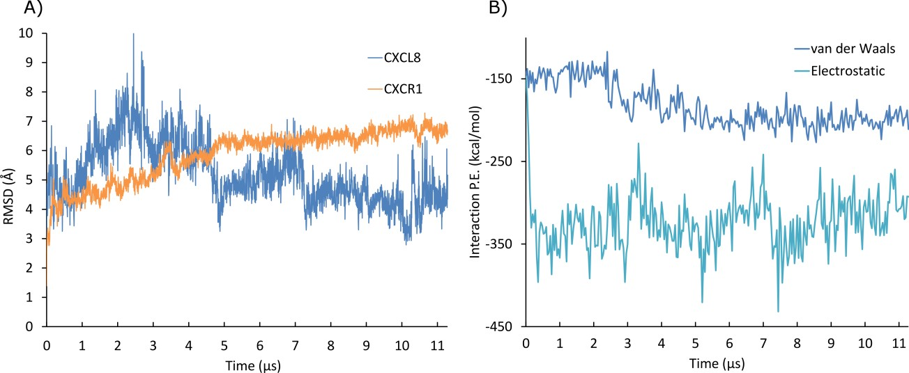
Figure S1. Conformational and protein-protein interaction potential energy (P.E.) changes of CXCR1:CXCL8 complex during MD simulation. A) Root mean square deviation (RMSD) of Cα atoms of CXCR1 and bound CXCL8 compared to initial model. B) Estimated P.E. between CXCR1 and bound CXCL8 according to van-der-Waals and electrostatic interactions.

Method S2 – Absorption measurement
Absorption spectra were measured on a Tecan Infinite M1000 microtiter plate reader (Tecan, Switzerland) in a 384 well black wall, transparent flat-bottom microtiter plate (Corning) in 40 µL total volume. To analyze absorption depending on CXCL8 concentration, a concentration series of 14 consecutive 1:2 dilutions CXCL8 was prepared by transferring 190 μL of CXCL8 stock solution (0,67 mg/mL) from one microfuge tube to another containing 190 μL ls-PBS. 30 µL of each solution was pipetted into six adjacent wells and 10 µL of a stock solution of Tmr-linLoopsE were added to the first three wells of each concentration and 10 µL of a stock solution of Tmr-linLoopsQ were added to the next three. As control, 10 µL of peptide was added to 30 µL of ls-PBS in triplicate and 40 µL of ls-PBS was used as blank, Absorption spectra were recorded from 300 – 700 nm for the wells containing the highest CXCL8 concentration and for the wells containing only peptide in buffer.

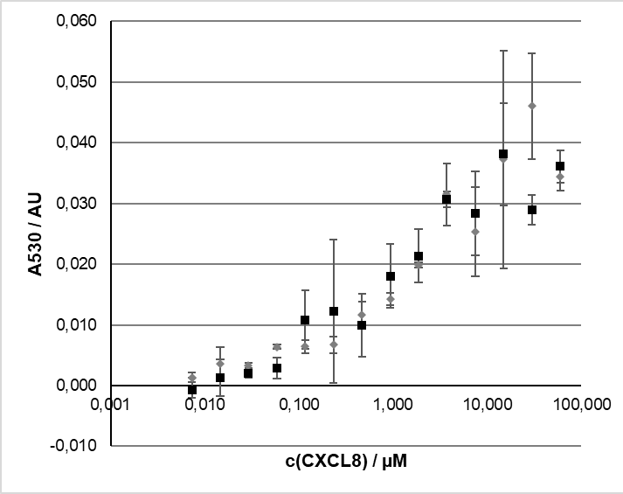 | 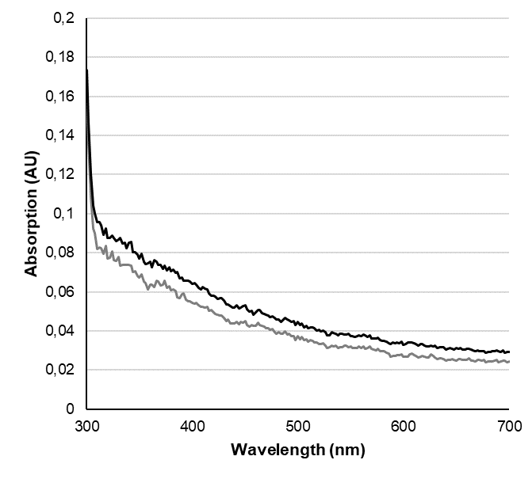
(a) | (b)
Figure S2: Absorption changes due to interaction of TMR-Linloops peptides with CXCL8: (a) Absorption at 530 nm measured for 350 nM of TMR-LinloopsE (gray diamonds) and TMR-LinloopsQ (black squares) in CXCL8 at different concentrations. For background correction, the average value of the blank (buffer C) was subtracted. (b) absorption spectra of 350 nM TMR-LinloopsE (gray line) and TMR-LinloopsQ (black line) in 60 µM CXCL8. Spectra were background-corrected by subtracting the absorption spectrum measured for 40 µL of buffer C.

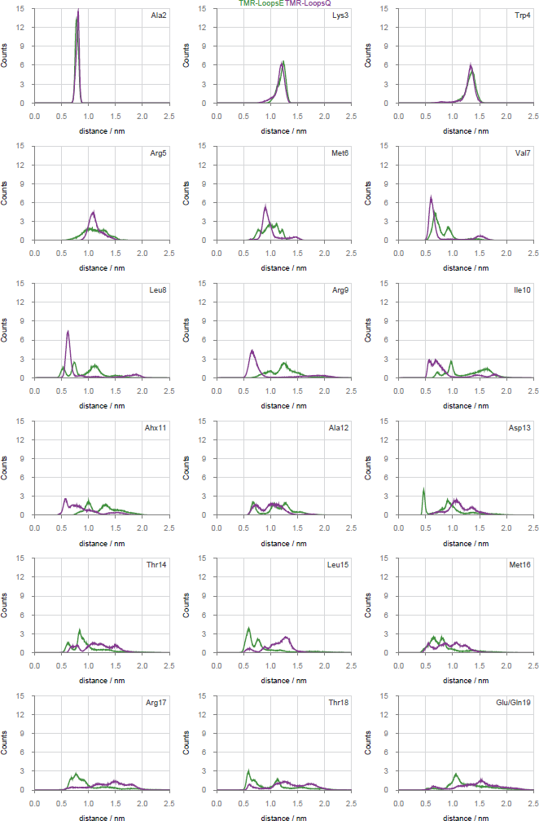

Figure S3: Distance of center of mass (com) of TAMRA label and com of each individual amino acid of the linear IL8Rp-Loops peptides. Green, IL8RP-LoopsE; purple, IL8RP-LoopsQ. Ahx, aminohexanoic acid.

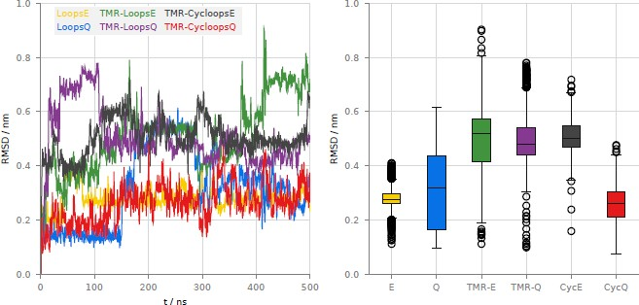
(a) (b)

Figure S4: Evaluation of RMSD for all peptides. (a): RMSD plotted over time. (b): Box plot. Whiskers indicate the 1.5 interquartile range. E, Q: unlabeled peptides; TMR-E/Q: TAMRA-labeled peptides; CycE/Q: TAMRA labeled cyclic peptides.

