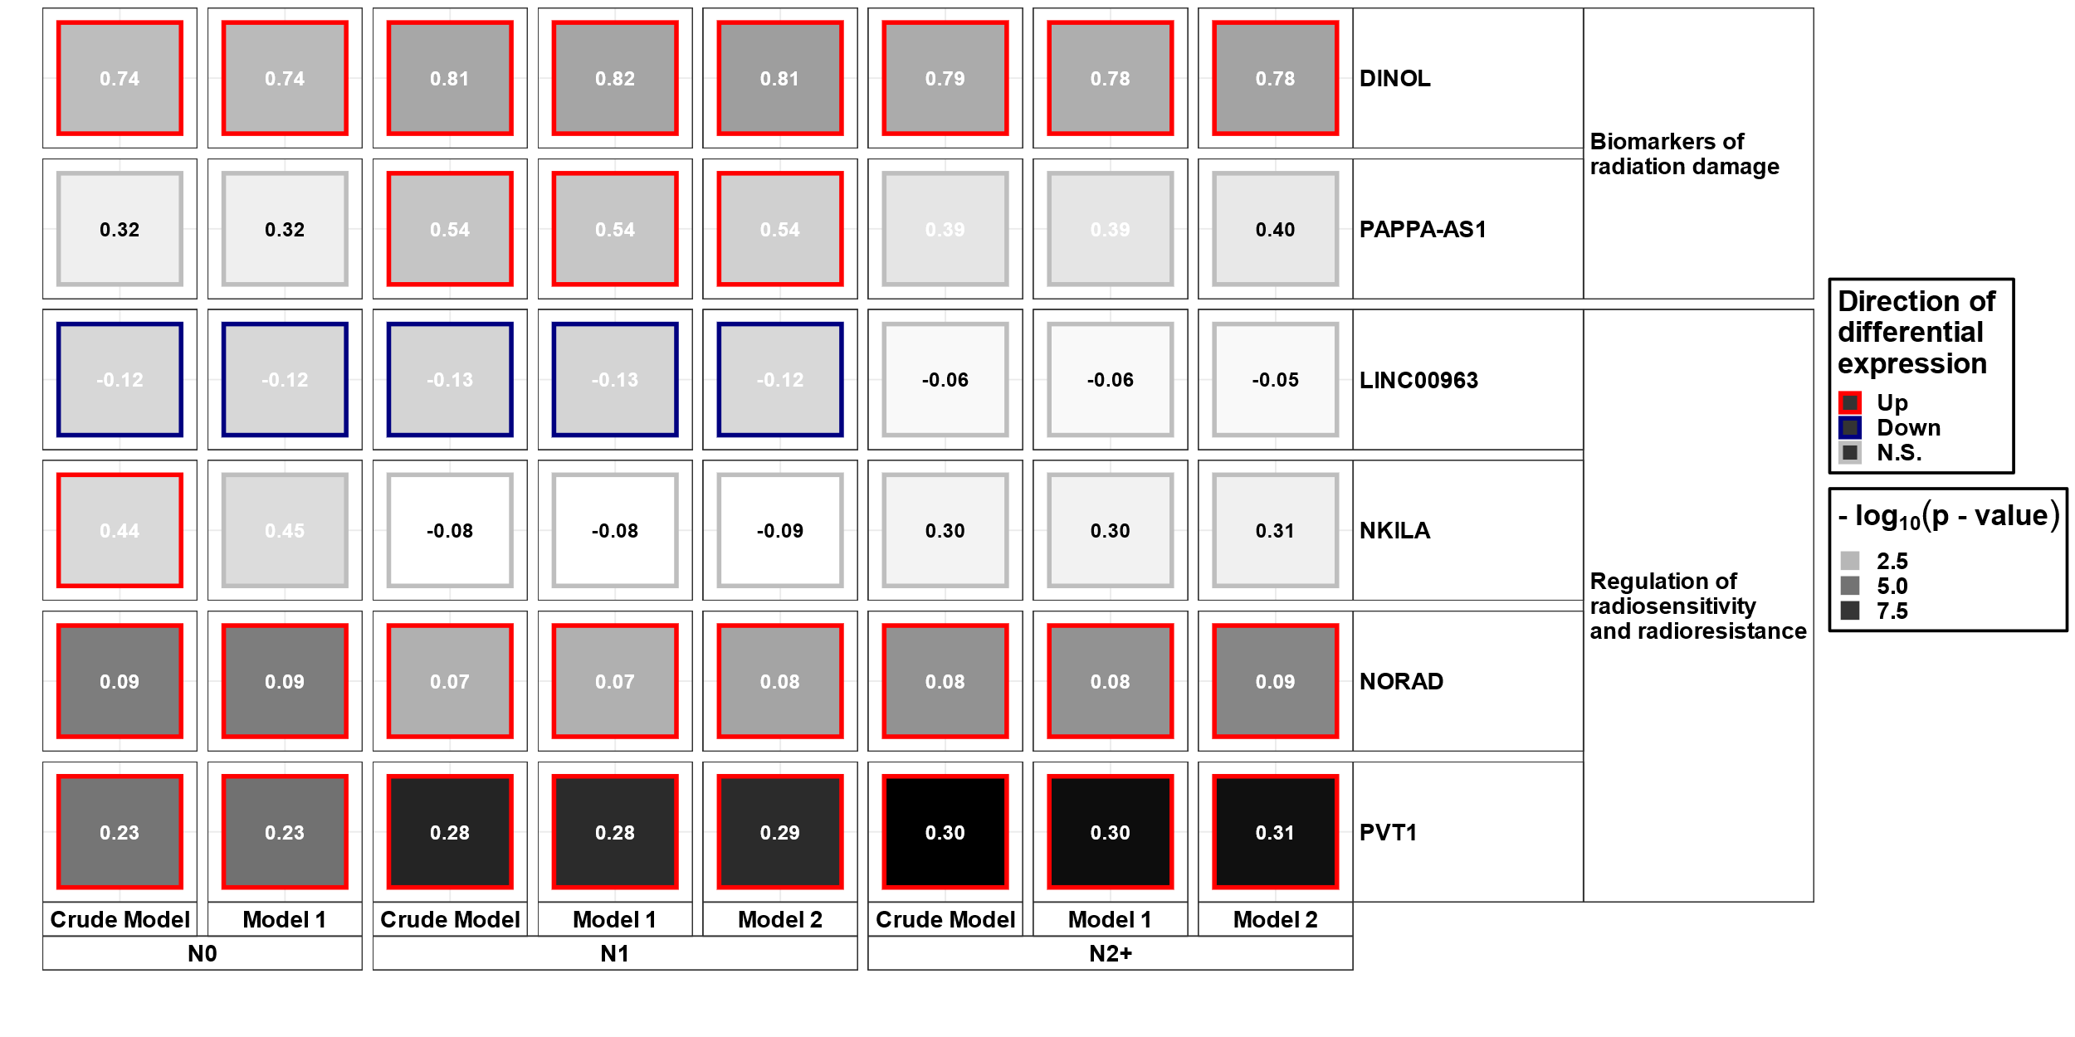
Supplementary Figure S6: Visualisation of differential expression data of lncRNAs potentially involved in the radiation response according to the literature. Differentially expressed lncRNAs in irradiated compared to sham-irradiated fibroblasts from donors with a first primary neoplasm only (N1), donors with at least one second primary neoplasm (N2+), and cancer-free controls (N0) 4h after exposure to 2 Gray (false discovery rate adjusted p-value < 0.05). The data are presented for the crude model, model 1 (considering age at sampling and sex), and model 2 [considering age at sampling, sex, age at and year of diagnosis of the first neoplasm, and tumor type (not applicable for N0 data)]. In total 6225 lncRNAs were detected in the samples. Shown is the heat map of differentially expressed lncRNAs that were also present in the literature review.

