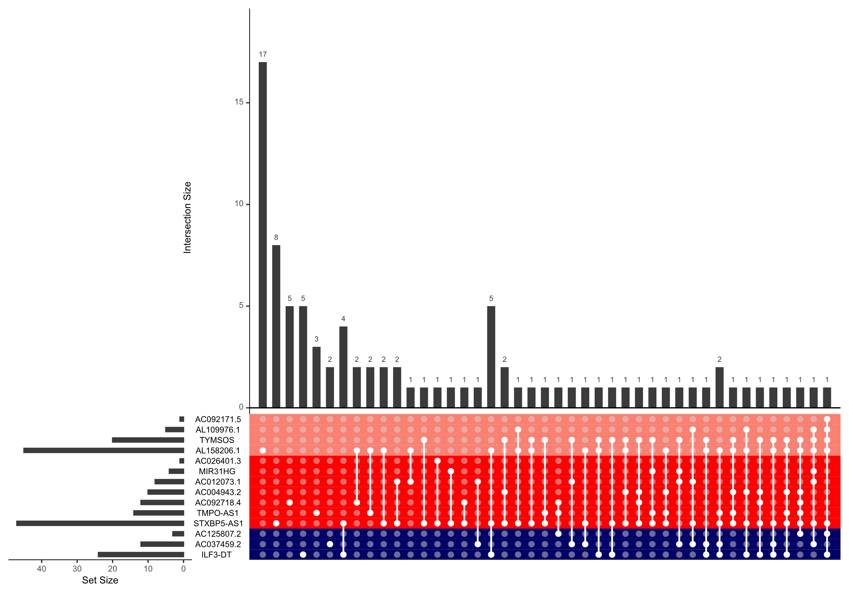
Supplementary Figure S5: Visualization of the intersecting miRNAs from the miRNA target analysis per lncRNA of interest.

