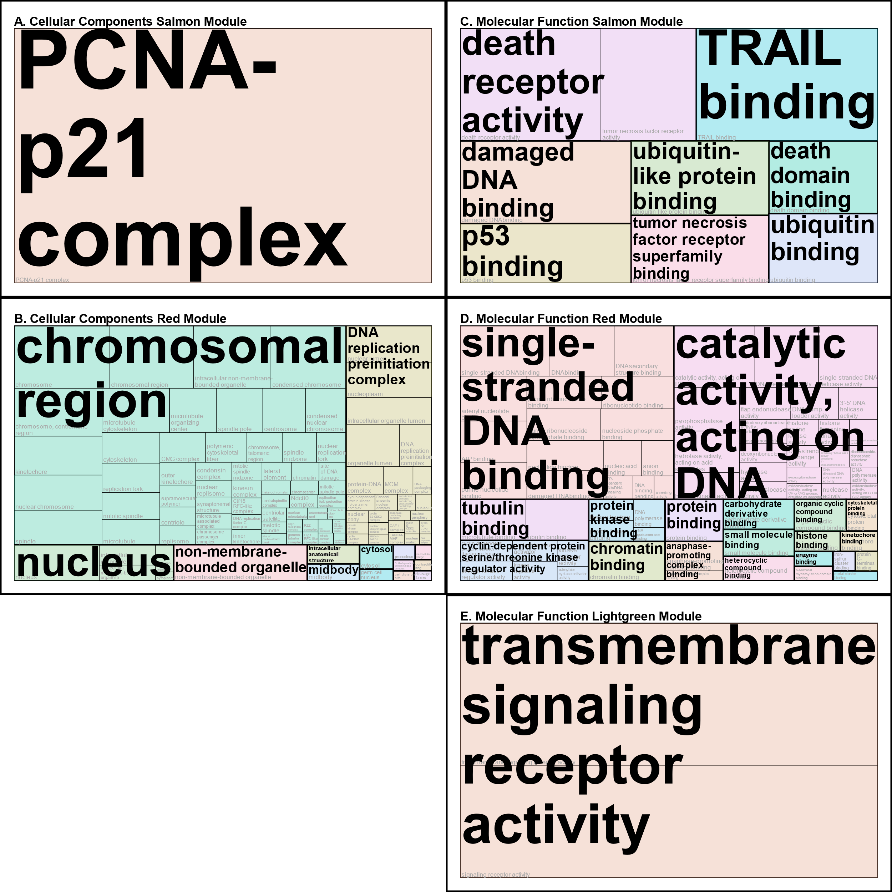

Supplementary Figure S4: Tree maps visualizing cellular components and molecular functions of the gene ontology over-representation analysis.

