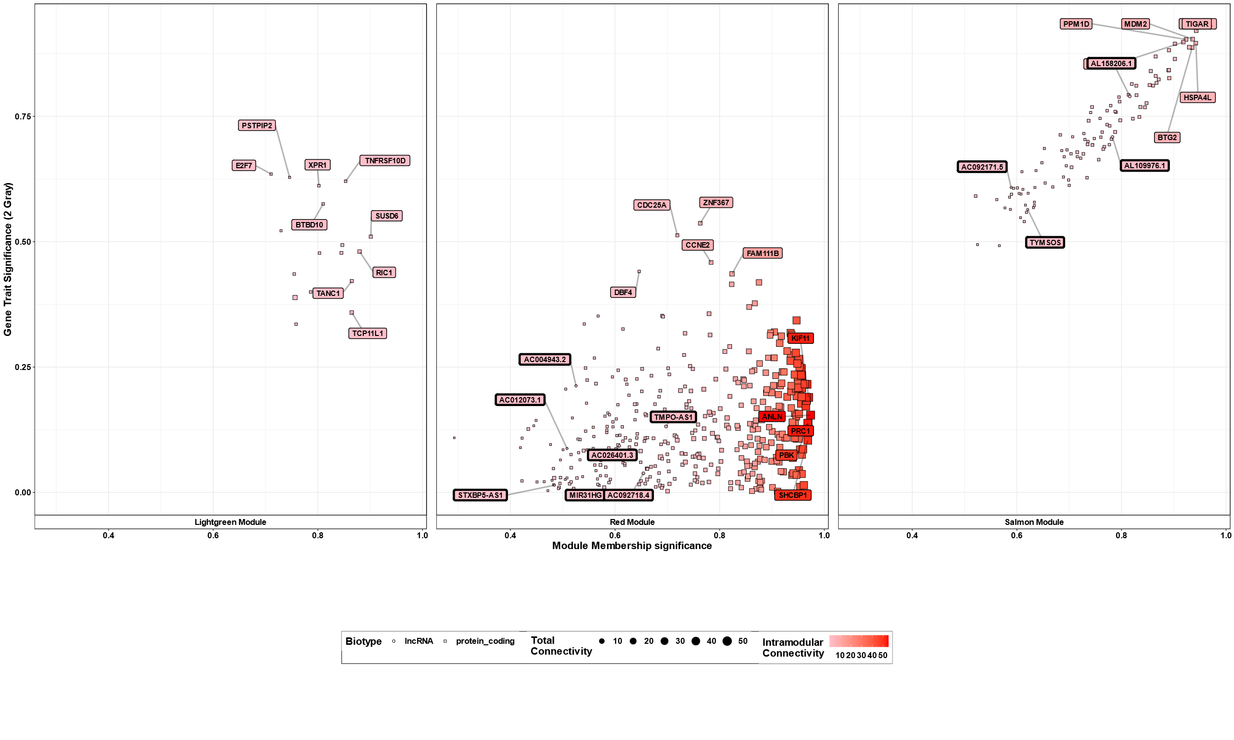
Supplementary Figure S3: Further Network Analysis - Visualization of the network analysis data.

