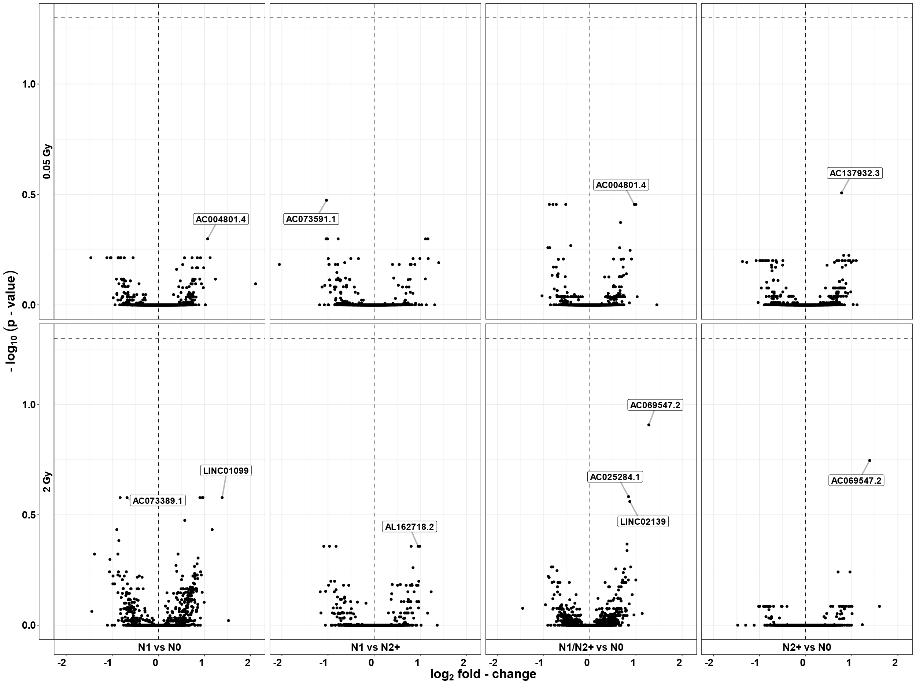

Supplementary Figure S1: Results of the differential lncRNA expression analyses including interaction terms for radiation dose*donor group. N0=fibroblasts of cancer-free controls, N1=fibroblasts of childhood-cancer survivors, N2+=fibroblasts of childhood-cancer survivors with at least one second primary neoplasm

