Hole doped high entropy ferrites: Structure and charge compensation mechanisms in (Gd_{0.2}La_{0.2}Nd_{0.2}Sm_{0.2}Y_{0.2})_{1-x}Ca_{x}FeO₃

Luis Eiseltª, Robert Kruk^{b}, Horst Hahn^{a,b,*}, Abhishek Sarkar^{a,b,*}
ªKIT-TUD-Joint Research Laboratory Nanomaterials, Technical University of Darmstadt, Otto-Berndt-Str. 3, 64287 Darmstadt, Germany
^{b}Institute of Nanotechnology, Karlsruhe Institute of Technology, Hermann-von-Helmholtz-Platz 1, 76344 Eggenstein-Leopoldshafen, Germany
*Corresponding author: abhishek.sarkar@kit.edu, horst.hahn@kit.edu

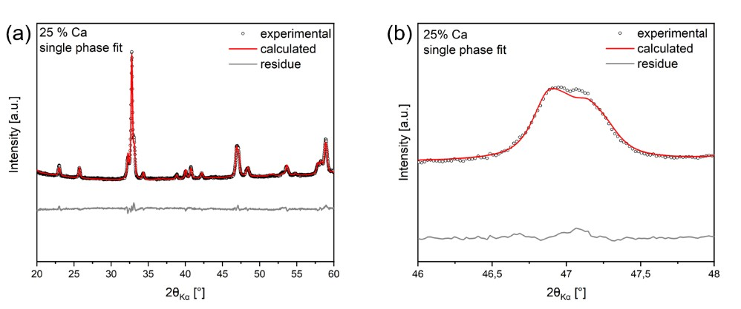
Figure SI1. (a) Single phase orthorhombic fit of 25 % Ca doped (Gd_{0.2}La_{0.2}Nd_{0.2}Sm_{0.2}Y_{0.2})_{1-x}Ca_{x}FeO₃. (b) Exemplary representation of the slight misfit between experimental and calculated pattern for the single phase refinement.
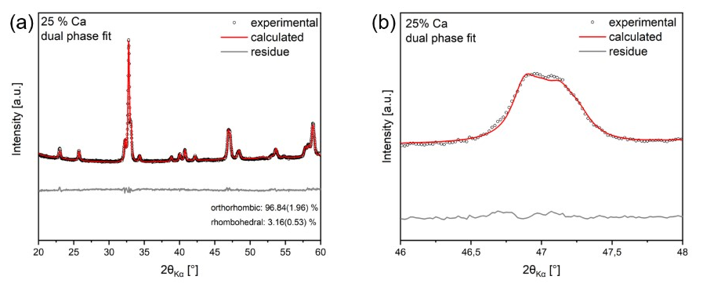
Figure SI2. (a) Dual phase fit (Pbnm + R-3c) of 25 % Ca doped (Gd_{0.2}La_{0.2}Nd_{0.2}Sm_{0.2}Y_{0.2})_{1-x}Ca_{x}FeO₃. (b) Exemplary representation of the improved fit between experimental and calculated pattern for the dual phase refinement process.
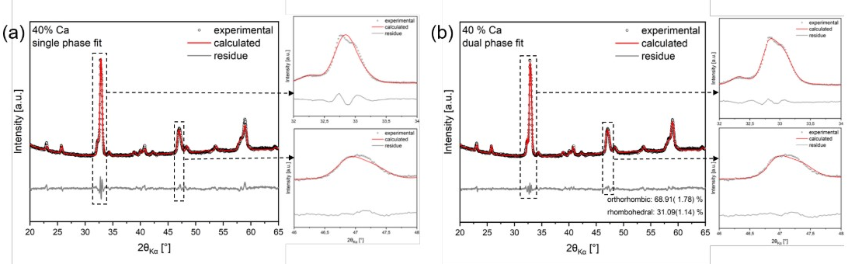
Figure SI3. (a) Single phase (Pbnm) Rietveld fit and (b) dual phase (Pbnm + R-3c) Rietveld fit of 40 % Ca doped (Gd_{0.2}La_{0.2}Nd_{0.2}Sm_{0.2}Y_{0.2})_{1-x}Ca_{x}FeO₃.

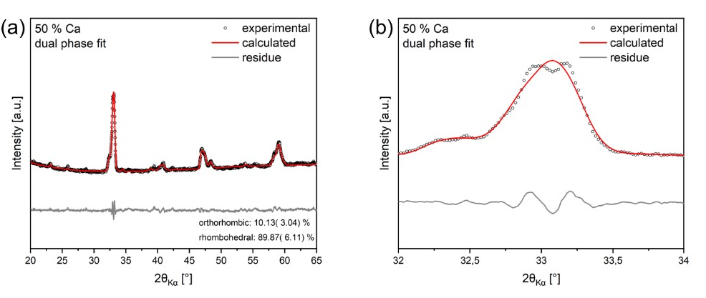
Figure SI4. (a) Dual phase (Pbnm + R-3c) Rietveld fit of the 50 % Ca doped sample. (b) Zoom-in image of the critical region, i.e., around the highest intensity peak.

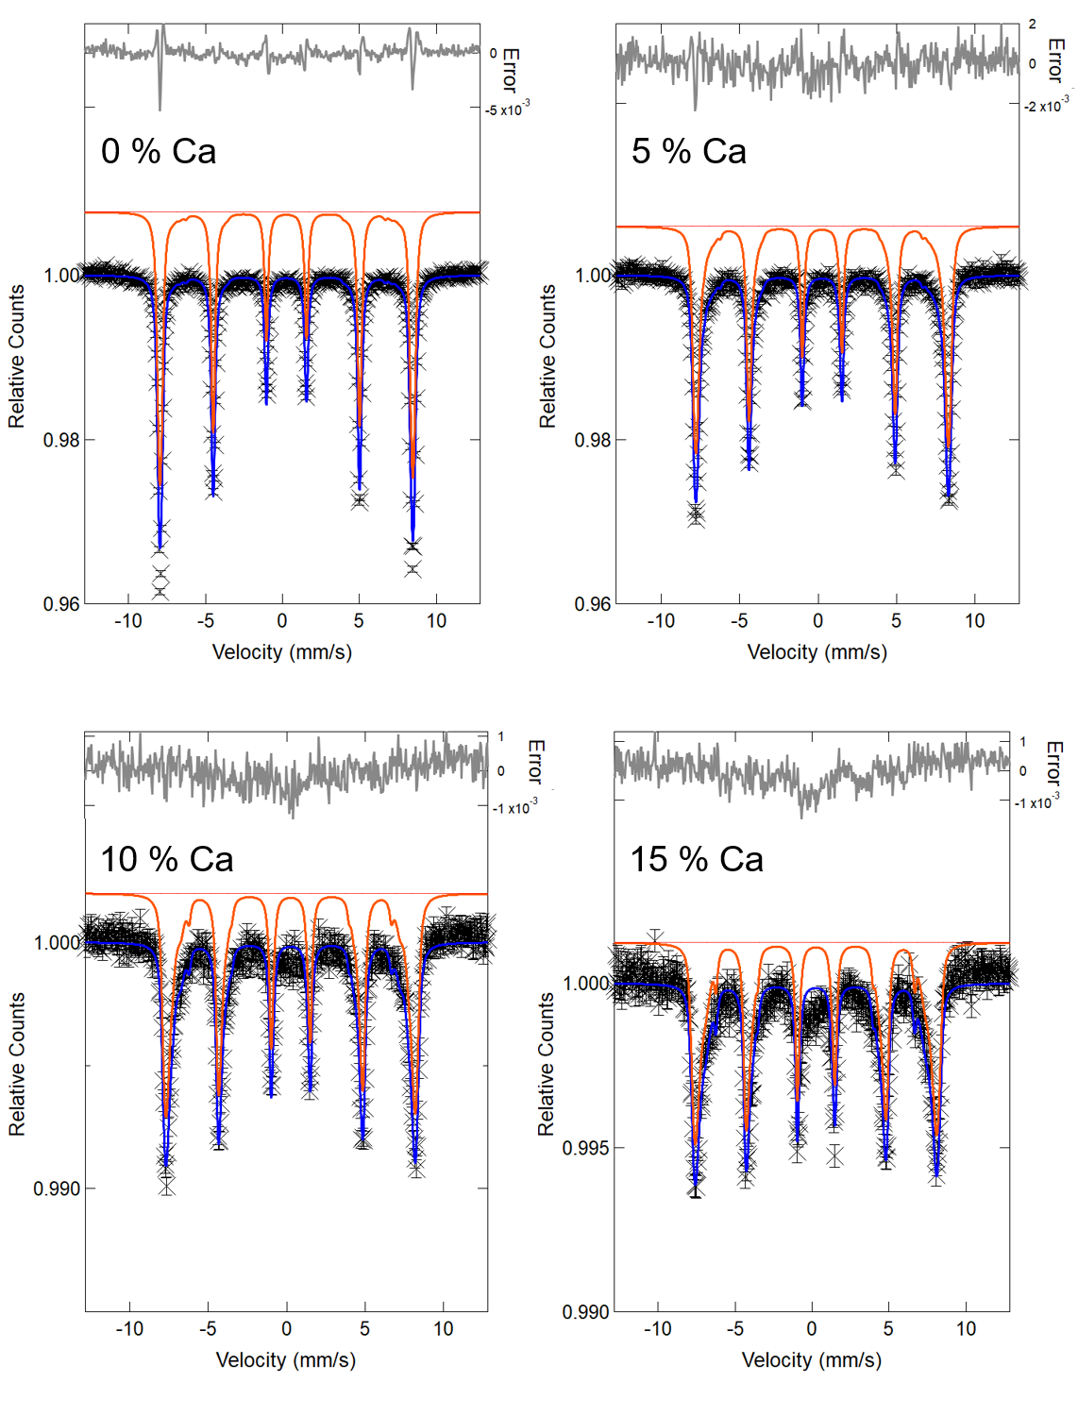
Figure SI5. Mössbauer spectra of 0 %, 5 %, 10 % and 15 % Ca doped systems fitted with the sextet distributions. The respective probabilities of hyperfine distributions are given in Figure 6a (main text).
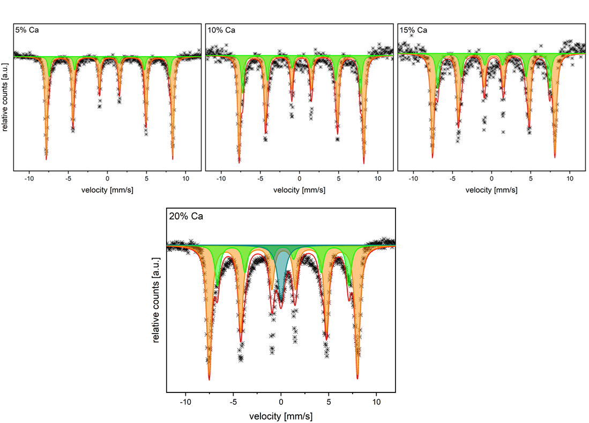
Figure SI6. Mössbauer spectra fitted with two magnetic sextets of 5 %, 10 %, 15 %, 20 % Ca doped systems. Additional singlet is required to fit the 20 % Ca doped system.

Table SI1. Values for the refined lattice parameters, atomic positions and fractions of each phase along with the goodness of fit (GoF).
