Supporting Information

Supplementary data 1: DNA extraction protocol for QIAGEN DNeasy Blood & Tissue Kit

Kit: QIAGEN DNeasy Blood & Tissue Kit (250) (product no. 69506)
BEFORE STARTING: Preheat the incubator to 55–56 °C. Before using some of the buffers provided in the kit for the first time, add the appropriate amount of ethanol (96–100%) as indicated on the bottle to get a working solution. Per sample prepare one column, two collection-tubes, and one final tube. Prepare glass with distilled water for used pestles. Prepare 100% ethanol.
- Place about 50 mg of sample in a 1.5-ml tube. Add 180 µl Buffer ATL. Grind sample using a sterile plastic pestle (clean pestle for each sample).
- Add 20 µl proteinase K, vortex briefly and spin down. Incubate at 56 °C on the shaker for 1–3 h.
- For each sample, mix 200 µl buffer AL with 200 µl 100% ethanol.
- Vortex samples for 15 s and spin down. Add 400 µl AL/ethanol mixture to each sample and vortex briefly.
- Centrifuge for 2 min at 10000 g. Transfer the clear lysate into a DNeasy Mini spin column.
- Centrifuge for 1 min at 6000 g. Discard flow-through and transfer the column to a new collection tube.
- Add 500 µl buffer AW1 and centrifuge for 1 min at 6000 g. Discard flow-through and transfer the column to a new collection tube.
- Add 500 µl buffer AW2 and centrifuge for 3.5 min at maximum g. Discard flow-through.
- Place the column in a new 1.5-ml micro-centrifuge tube and pipette 50-200 µl buffer AE directly onto the membrane.
- Incubate the columns at room temperature for 2 min.
- Centrifuge at 10000 g for 1 min.
- Store the DNA extractions at –20 °C.

Table S1 PCR protocol for COI amplification with insect DNA
 | Temperature (°C) | Time | Cycle number
Initial denaturation | 95 | 3 min
Denaturation | 95 | 30 s | 40
Annealing | 55 | 30 s
Extension | 72 | 50 s
Final extension | 72 | 5 min

Table S2 List of primers used for PCR amplification of a 658 bp, 313 bp and 157 bp COI amplicon
Primer name | Sequence 5' - 3' | Reference
ZBJ-ArtF1c¹ | AGA TAT TGG AAC WTT ATA TTT TAT TTT TGG | Zeale et al., 2011
ZBJ-ArtR2c¹ | WAC TAA TCA ATT WCC AAA TCC TCC | Zeale et al., 2011
dgLCO-1490³ | GGT CAA CAA ATC ATA AAG AYA TYG G | Meyer, 2003
dgHCO-2198^{2,3} | TAA ACT TCA GGG TGA CCA AAR AAY CA | Meyer, 2003
mICOIintF² | GGW ACW GGW TGA ACW GTW TAY CCY CC | Leray et al., 2013
¹157 bp amplicon
²313 bp amplicon
³658 bp amplicon

Table S3 ANOVA results for the relationship between maximum fragment size (response variable) and concentration, extraction date, and temperature for specimens kept in either propylene glycol, ethylene glycol, or Renner solution
Preservative | Variable | F | d.f. | P
Propylene glycol | Concentration | 93.709 | 1,211 | <0.001
 | Extraction date | 0.601 | 1,211 | 0.44
 | Temperature | 13.349 | 1,211 | 0.003
 | Concentration*temperature | 34.956 | 1,211 | <0.001
Ethylene glycol | Concentration | 118.501 | 1,211 | <0.001
 | Extraction date | 8.877 | 1,211 | 0.003
 | Temperature | 66.777 | 1,211 | <0.001
 | Concentration*temperature | 85.749 | 1,211 | <0.001
Renner solution | Concentration | 0.008 | 1,211 | 0.93
 | Extraction date | 0.525 | 1,211 | 0.47
 | Temperature | 12.027 | 1,211 | <0.001
 | Concentration*temperature | 0.012 | 1,211 | 0.91

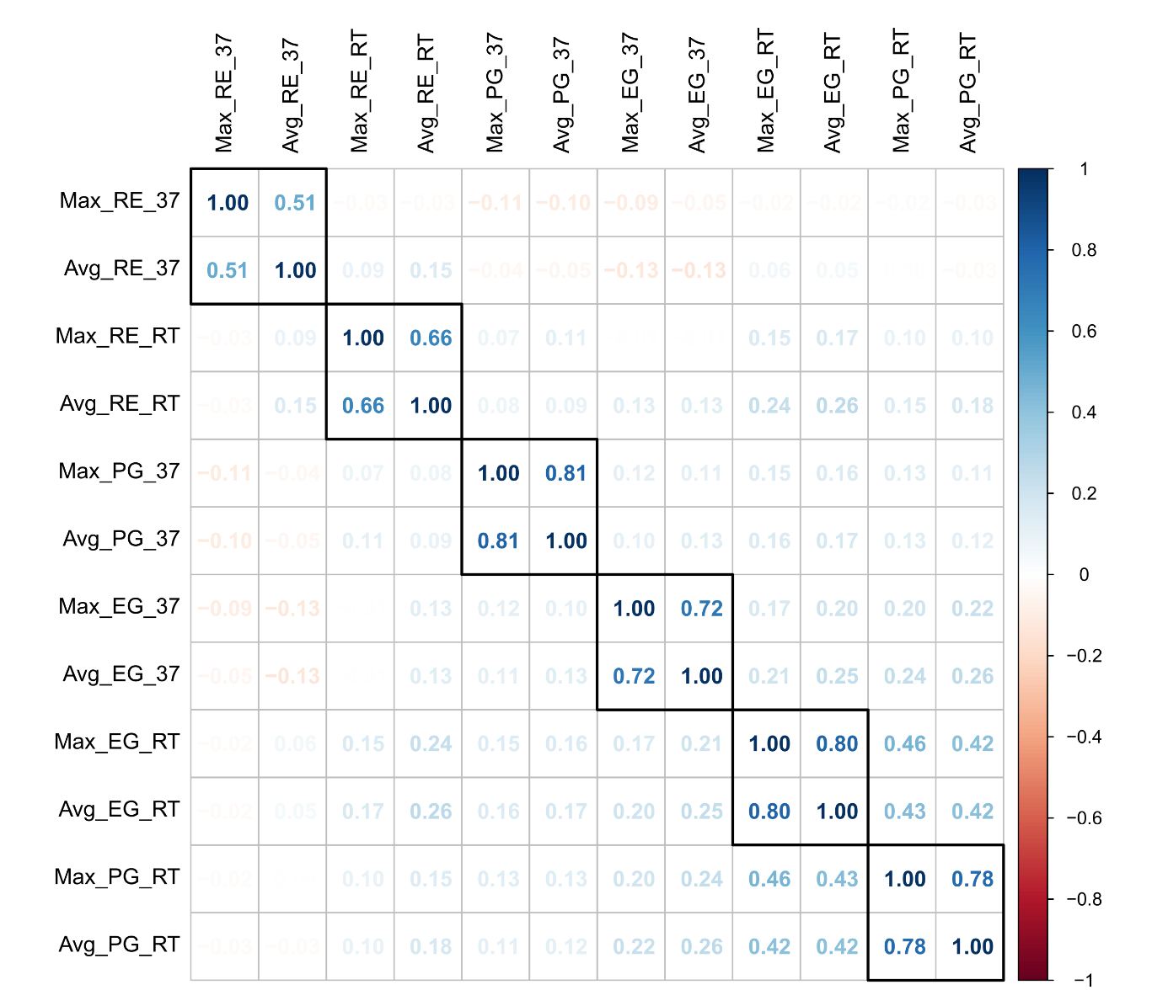
Figure S1 Kendall correlation graph for the maximum (Max) and average (Avg) fragment size of propylene glycol (PG), ethylene glycol (EG), and Renner solution (RE) at room temperature (RT) and 37 °C (37). For all preservatives at both temperatures average and maximum fragment size are strongly correlated.

Figure S2 Average fragment size of samples kept in 100, 75, 50, and 25% concentration of propylene glycol, ethylene glycol, or Renner solution on nine extraction dates on every third day with a total experiment time of 27 days and the negative control (NC). The average fragment size of the positive control is indicated by the dashed line. Fragment lengths ≥50000 bp are condensed in the Fragment Analyser system output. The y-axis is transformed logarithmical for better visualisation.
