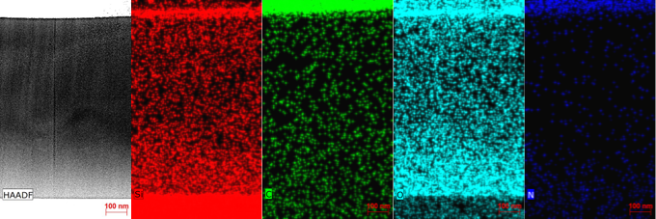
Figure S 1. EDS Profile of C17_1100_3h. No sharp distinction between the SiOC film and the SiO₂ layer is visible.

