Multi-trophic communities re-establish with canopy cover and microclimate in a subtropical forest biodiversity experiment

Felix Fornoff et al.

Supplementary material
Supplementary Table 1:
Cavity-nesting insect communities were assessed in all plots of the ‘full data’. Microclimate data on temperature and relative humidity were only available for a subset of these plots.
 | Tree SR | 1 | 2 | 4 | 8 | 16
Full data | Site A | 8 | 8 | 8 | 8 | 8
 | Site B | 16 | 8 | 8 | 8 | 8
Subset data | Site A | 8 | 8 | 4 | 2 | 2
 | Site B | 16 | 7 | 4 | 2 | 2

Supplementary Table 2:
Species list and occurrences of host and natural enemy species, at site A & B in 2014/2015 (A & B) and at the CSPs (natural forest plots) in 2011/2012. Species are ordered by decreasing occurrence, hosts additionally by their respective functional group (Bee, Herb.-hunt: herbivore-hunting wasp, Spid.-hunt: spider-hunting wasp).
Fun. group | Host species | A | B | CSP |  | Natural enemy species | A | B | CSP
Bee | Megachile spissula | 470 | 216 |  |  | Amobia sp. 1 | 131 | 184 | 125
Bee | Heriades sauteri | 301 | 300 |  |  | Chrysis smaragdula | 83 | 174 | 117
Bee | Osmia taurus | 60 | 48 | 275 |  | Ichneumonidae sp. 3 | 111 | 150
Bee | Megachile sculpturalis | 152 | 101 | 87 |  | Melittobia sp. 1 | 84 | 174
Bee | Hoplitis carinotarsa | 133 | 114 | 29 |  | Lycogaster violaceipennis | 67 | 17 | 93
Bee | Megachile disjunctiformis | 191 | 63 |  |  | Apanteles sp. 1 | 2 | 2 | 88
Bee | Megachile abluta | 72 | 27 | 33 |  | Primeuchroeus kansitakuanus | 9 | 37
Bee | Megachile rixator | 52 | 22 |  |  | Tachinidae sp. 3 |  |  | 40
Bee | Megachile monticola | 23 |  | 17 |  | Ichneumonidae sp. 1 | 6 | 4 | 29
Bee | Trachusa staabi | 14 |  | 11 |  | Coelioxys brevicaudata | 16 | 16 | 4
Bee | Hylaeus sp. 1 | 5 |  |  |  | Euaspis basalis | 32 | 4 | 3
Herb.-hunt. | Anterhynchium flavomarginatum curvimaculatum | 859 | 555 | 1079 |  | Braconidae sp. 1 | 17 | 14 | 4
Herb.-hunt. | Anterhynchium flavomarginatum flavomarginatum |  |  | 328 |  | Coelioxys sp. 4 | 30 | 4
Herb.-hunt. | Orancistrocerus drewseni | 156 | 31 | 13 |  | Anthrax aygula | 19 | 14
Herb.-hunt. | Hoplammophila aemulans |  |  | 199 |  | Melittobia sp. 2 | 11 | 22
Herb.-hunt. | Epsilon fujianensis | 94 | 14 | 24 |  | Trichrysis cyanea | 6 | 23
Herb.-hunt. | Polemistus sp. 1 | 114 |  |  |  | Euaspis sp. 1 | 17 | 10
Herb.-hunt. | Allorhynchium chinense | 47 | 63 | 1 |  | Lycogaster nigralva |  | 4 | 23
Herb.-hunt. | Isodontia nigella | 29 | 73 |  |  | Coelioxys fenestrata | 18 | 2
Herb.-hunt. | Stenodynerus chinensis chinensis | 11 | 90 |  |  | Ichneumonidae sp. 7 | 7 | 1 | 10
Herb.-hunt. | Subancistrocerus kankauensis | 8 | 76 |  |  | Sarcophagidae sp. 4 | 4 | 14
Herb.-hunt. | Pareumenes quadrispinosus transitorus | 9 | 36 |  |  | Irenangulus sp. 1 |  |  | 15
Herb.-hunt. | Euodynerus quadrifasciatus | 8 | 30 |  |  | Leucospis japonica | 7 | 4 | 3
Herb.-hunt. | Eumenes quadratus urainus | 5 | 17 |  |  | Coelioxys ducalis |  |  | 12
Herb.-hunt. | Discoelius wangi | 10 | 11 | 1 |  | Ichneumonidae sp. 8 | 5 | 5 | 1
Herb.-hunt. | Ancistrocerus trifasciatus shibuyai |  |  | 14 |  | Melittobia clavicornis | 8 | 2
Herb.-hunt. | Eumenes quadratus quadratus |  | 11 | 2 |  | Eurytoma sp. 3 | 4 |  | 5
Herb.-hunt. | Ancistrocerus sp. 1 | 8 | 1 |  |  | Diptera sp. 2 |  |  | 8
Herb.-hunt. | Rhopalum sp. 1 | 8 | 1 |  |  | Eurytoma sp. 1 | 2 | 6
Herb.-hunt. | Pararrhynchium ornatum ornatum |  | 3 |  |  | Sarcophagidae sp. 2 | 4 | 4
Herb.-hunt. | Ancistrocerus nigricornis |  |  | 2 |  | Strepsiptera sp. 1 | 5 | 3
Herb.-hunt. | Anterhynchium sp. 1 |  |  | 1 |  | Zonitis japonica |  | 1 | 7
Herb.-hunt. | Okinawepipona kogimai |  | 1 |  |  | Ichneumonidae sp. 11 |  |  | 7
Spid.-hunt. | Auplopus carbonarius | 209 | 248 |  |  | Drosophilidae sp. 1 |  |  | 6
Spid.-hunt. | Deuteragenia ossarium | 16 | 9 | 213 |  | Chrysis angolensis |  | 5
Spid.-hunt. | Auplopus sp. 4 |  |  | 75 |  | Dermestidae sp. 1 | 1 | 4
Spid.-hunt. | Deuteragenia sp. 2 | 32 | 35 | 8 |  | Tachinidae sp. 4 |  |  | 5
Spid.-hunt. | Sceliphron deforme deforme | 4 | 48 |  |  | Tachinidae sp. 6 |  |  | 4
Spid.-hunt. | Pompilidae sp. 1 | 2 | 49 |  |  | Ichneumonidae sp. 4 |  |  | 4
Spid.-hunt. | Pison sp. 1 | 30 | 10 |  |  | Ichneumonidae sp. 6 | 4
Spid.-hunt. | Trypoxylon sp. 1 |  | 29 |  |  | Sarcophagidae sp. 1 | 1 | 3
Spid.-hunt. | Chalybion japonicum |  | 9 | 5 |  | Diptera sp. 1 |  |  | 3
Spid.-hunt. | Deuteragenia sp. 1 |  |  | 11 |  | Apanteles sp. 2 |  |  | 3
Spid.-hunt. | Auplopus sp. 2 |  |  | 8 |  | Perilampidae |  | 3
Spid.-hunt. | Nitela sp. 2 |  | 7 |  |  | Tachinidae sp. 5 |  |  | 3
Spid.-hunt. | Trypoxylon sp. 2 |  | 7 |  |  | Braconidae sp. 2 | 1 | 1
Spid.-hunt. | Trypoxylon malaisei | 5 |  |  |  | Ichneumonidae sp. 2 |  | 2
Spid.-hunt. | Auplopus sp. 3 |  |  | 4 |  | Tachinidae sp. 1 | 1 | 1
Spid.-hunt. | Auplopus sp. 5 |  |  | 4 |  | Braconidae sp. 3 |  | 2
Spid.-hunt. | Nitela sp. 1 | 4 |  |  |  | Comastichus zopheros | 1 | 1
 |  |  |  |  |  | Copidosoma nacoleiae |  | 2
 |  |  |  |  |  | Phoridae sp. 1 |  |  | 2
 |  |  |  |  |  | Sarcophagidae sp. 3 |  | 2
 |  |  |  |  |  | Sarcophagidae sp. 5 |  | 2
 |  |  |  |  |  | Tachinidae sp. 2 | 2
 |  |  |  |  |  | Macrosiagon nasutum |  | 1
 |  |  |  |  |  | Braconidae sp. 2 |  | 1
 |  |  |  |  |  | Chrysis lamellata |  | 1
 |  |  |  |  |  | Coelioxys sp. 3 | 1
 |  |  |  |  |  | Eurytoma sp. 2 |  | 1
 |  |  |  |  |  | Ichneumonidae sp. 10 | 1
 |  |  |  |  |  | Ichneumonidae sp. 9 | 1
 |  |  |  |  |  | Coelioxys sp. 5 |  | 1
 |  |  |  |  |  | Leucospis sp. 2 | 1
 |  |  |  |  |  | Mutillidae sp. 1 |  |  | 1
 |  |  |  |  |  | Omalus pseudoimbecillus | 1
 |  |  |  |  |  | Pseudomalus joannis | 1
 |  |  |  |  |  | Taeniogonalos fasciata |  |  | 1

Supplementary Table 3:
Statistical results table of SEMs testing all direct and indirect correlations of all response variables and among response and predictor variables. – no correlations were identified; ~ correlation was expected, not directional and not tested; SE: standard error; Df: degrees of freedom. The effect of covariate ‘site’ was tested on each response; significant effects of the experimental young forest ‘site A’ in comparison to ‘site B’ are shown. A statistical alternative model for herbivore-hunting wasps replaces the path between canopy and wasp abundance with a path between basal area and wasp abundance (ΔAICc = 1, Estimate = 0.3293, SE = 0.0772, DF = 86, P-value < 0.0001, R²_{abundance} = 0.288). A statistical alternative model for the model including climate data replaces the negative correlation between canopy cover and temperature with a negative correlation between basal area and temperature (ΔAICc = 1, Estimate = -0.2685, SE = 0.0532, DF = 52, P-value < 0.0001, R²_{temperature} = 0.403)
Response | Predictor | Estimate | SE | Df | P-value
Host and natural enemies (full data)
Enemy species richness | Enemy abundance | 0.0283 | 0.0035 | 86 | 0.0000
Enemy abundance | Host abundance | 0.0074 | 0.0019 | 85 | 0.0001
Enemy abundance | Site | -0.3456 | 0.1465 | 85 | 0.0183
Host species richness | -
Host abundance | Canopy cover | 0.5662 | 0.1846 | 85 | 0.0022
Host abundance | Site | 0.3163 | 0.1287 | 85 | 0.0140
Basal area | Site | 0.8065 | 0.1970 | 86 | 0.0001
Canopy cover | Basal area | 1.4749 | 0.3433 | 86 | 0.0000
Host and natural enemies (subset of 55 plots with microclimate data)
Enemy species richness | Enemy abundance | 0.0242 | 0.0047 | 52 | 0.0000
Enemy species richness | Temperature | -0.3508 | 0.1252 | 52 | 0.0051
Enemy abundance | Relative humidity | 0.0988 | 0.0359 | 53 | 0.0060
Host species richness | -
Host abundance | Relative humidity | 0.1061 | 0.0310 | 52 | 0.0006
Host abundance | Site | 0.7657 | 0.1457 | 52 | 0.0000
Temperature | Canopy cover | -0.8735 | 0.1511 | 52 | 0.0000
Temperature | Site | 0.3141 | 0.1111 | 52 | 0.0067
Relative humidity | Canopy cover | 3.2277 | 0.6923 | 52 | 0.0000
Relative humidity | Site | -2.7557 | 0.5091 | 52 | 0.0000
~ Temperature | ~ relative humidity | -0.8383 | - | 55
Canopy cover | Basal area | 1.3257 | 0.3825 | 53 | 0.0005
Basal area | Site | 0.8157 | 0.2893 | 53 | 0.0068
Bees (full data)
Enemy species richness | Enemy abundance | 0.1299 | 0.0154 | 79 | 0.0000
Enemy abundance | Host abundance | 0.0122 | 0.0048 | 78 | 0.0104
Enemy abundance | Basal area | 0.3561 | 0.132 | 78 | 0.0070
Host species richness | Site | 0.4418 | 0.1479 | 86 | 0.0028
Host abundance | Site | 0.6816 | 0.2074 | 86 | 0.0010
Basal area | Site | 0.8065 | 0.197 | 86 | 0.0001
Canopy cover | Basal area | 1.4749 | 0.3433 | 86 | 0.0000
Herbivore-hunting wasps full data)
Enemy species richness | Enemy abundance | 0.0476 | 0.0073 | 83 | 0.0000
Enemy abundance | Host abundance | 0.0179 | 0.0022 | 82 | 0.0000
Enemy abundance | Site | -0.4257 | 0.1439 | 82 | 0.0031
Host species richness | Host abundance | 0.0043 | 0.0019 | 86 | 0.0238
Host abundance | Canopy cover | 1.0381 | 0.2196 | 86 | 0.0000
Basal area | Site | 0.8065 | 0.197 | 86 | 0.0001
Canopy cover | Basal area | 1.4749 | 0.3433 | 86 | 0.0000
Spider-hunting wasps (full data)
Enemy species richness | Enemy abundance | 0.0746 | 0.0142 | 71 | 0.0000
Enemy abundance | Host abundance | 0.0717 | 0.0087 | 71 | 0.0000
Host species richness | Host abundance | 0.0258 | 0.0066 | 86 | 0.0001
Host abundance | Site | -0.3420 | 0.2178 | 86 | 0.1164
Basal area | Site | 0.8065 | 0.197 | 86 | 0.0001
Canopy cover | Basal area | 1.4749 | 0.3433 | 86 | 0.0000

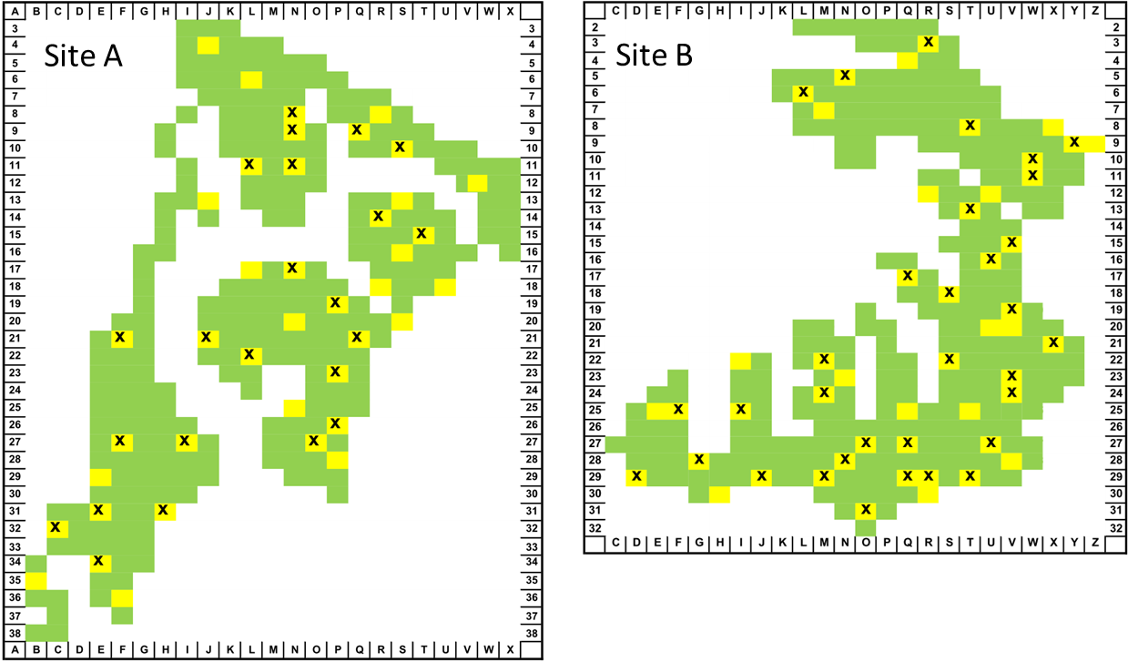
Supplementary Figure 1:
Locations of study plots within the two experimental young forest sites (A and B) of the BEF-China experiment. Study plots, highlighted in yellow, from which cavity-nesting Hymenoptera were collected, are randomly distributed across the sites, surrounded by further plots of the experimental forest in green. Plots with microclimate measurements are labeled with an x. Site A is 18.4 ha and site B 20 ha in size, both sites are approximately 4 km apart. Each plot is 25.8 x 25.8 m, two traps were installed along a SW-NE diagonal at the center of each plot, with 11 m distance between traps.

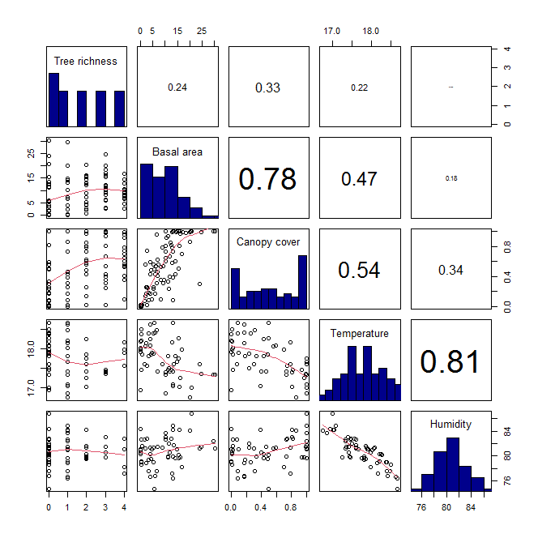Supplementary Figure 2:
Data distribution and correlation coefficients between all pairs of predictor variables. Tree species richness values are log₂ transformed. Lower panel shows scatter plots of individual data points and a smoother for each pair of predictors, diagonal panel shows histograms of data distribution for each predictor, upper-left panel shows spearman correlation coefficients between pairs of predictors (increasing font indicates increasing correlation between pairs).
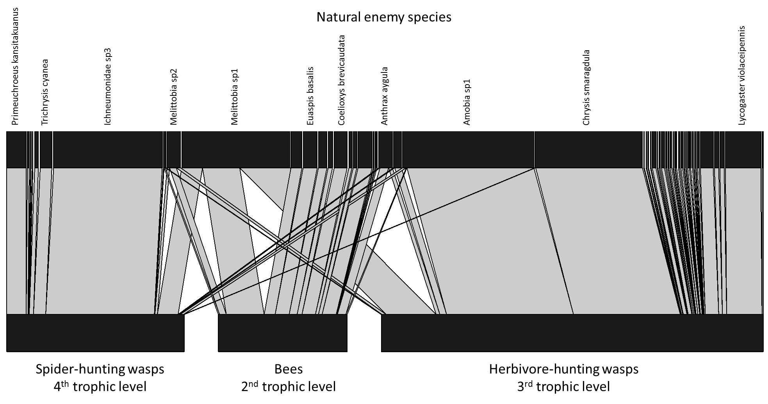
Supplementary Figure 3:
Bipartite interaction network between natural enemies (upper boxes) and hosts grouped by trophic position (lower boxes). Natural enemies form distinct clusters with few (7 out of 59) species attacking hosts at different trophic levels. In SEM analysis (Fig. 3), each natural enemy individual was assigned one trophic level higher than its host individual. Connecting links represent the frequency of interactions between natural enemy species and host groups. The underlying abundance of hosts is not shown and only common natural enemies are labeled (see Supplementary Table 2 for the full species list). The width of boxes and links represents the relative abundance and frequency of individuals or interactions. The graph was plotted with the bipartite package in R (Dormann et al. 2009).
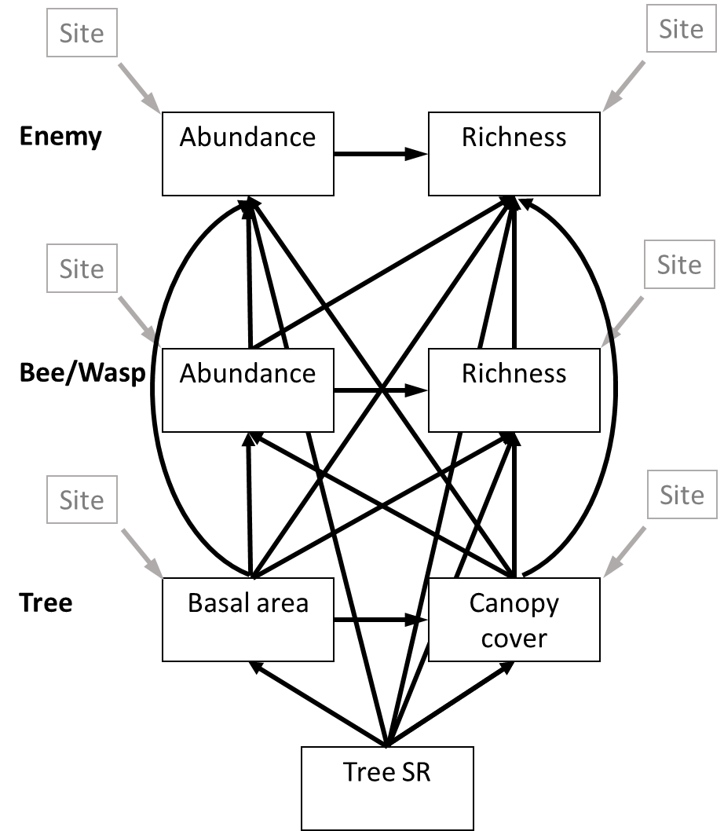
Supplementary Figure 4:
Example full SEM including all path from below to top and from left to right parameters (basal area to canopy cover and abundance to species richness) and the effect of site on all parameters. The same approach was used for the climate data model on the subset data and on SEMs for the individual host (bee and wasp) groups.
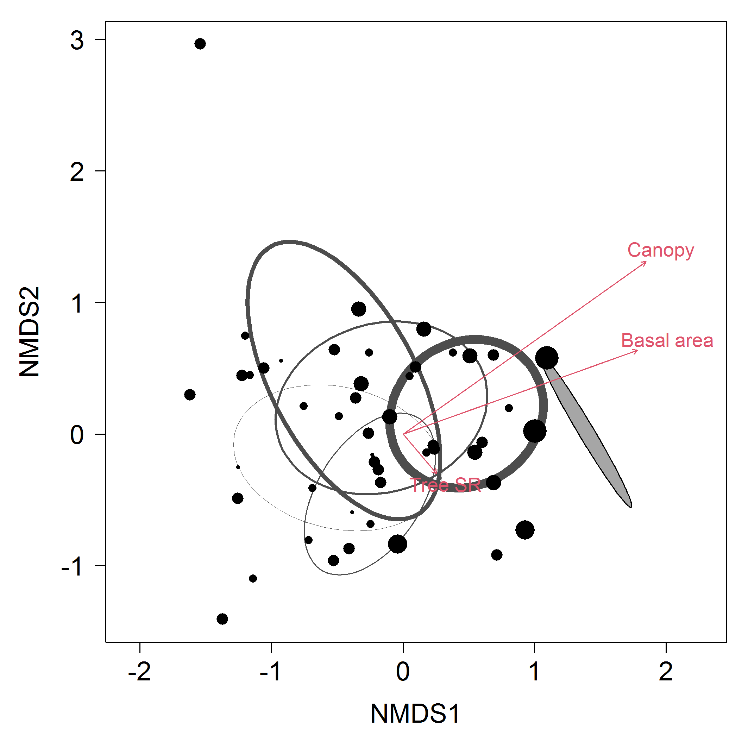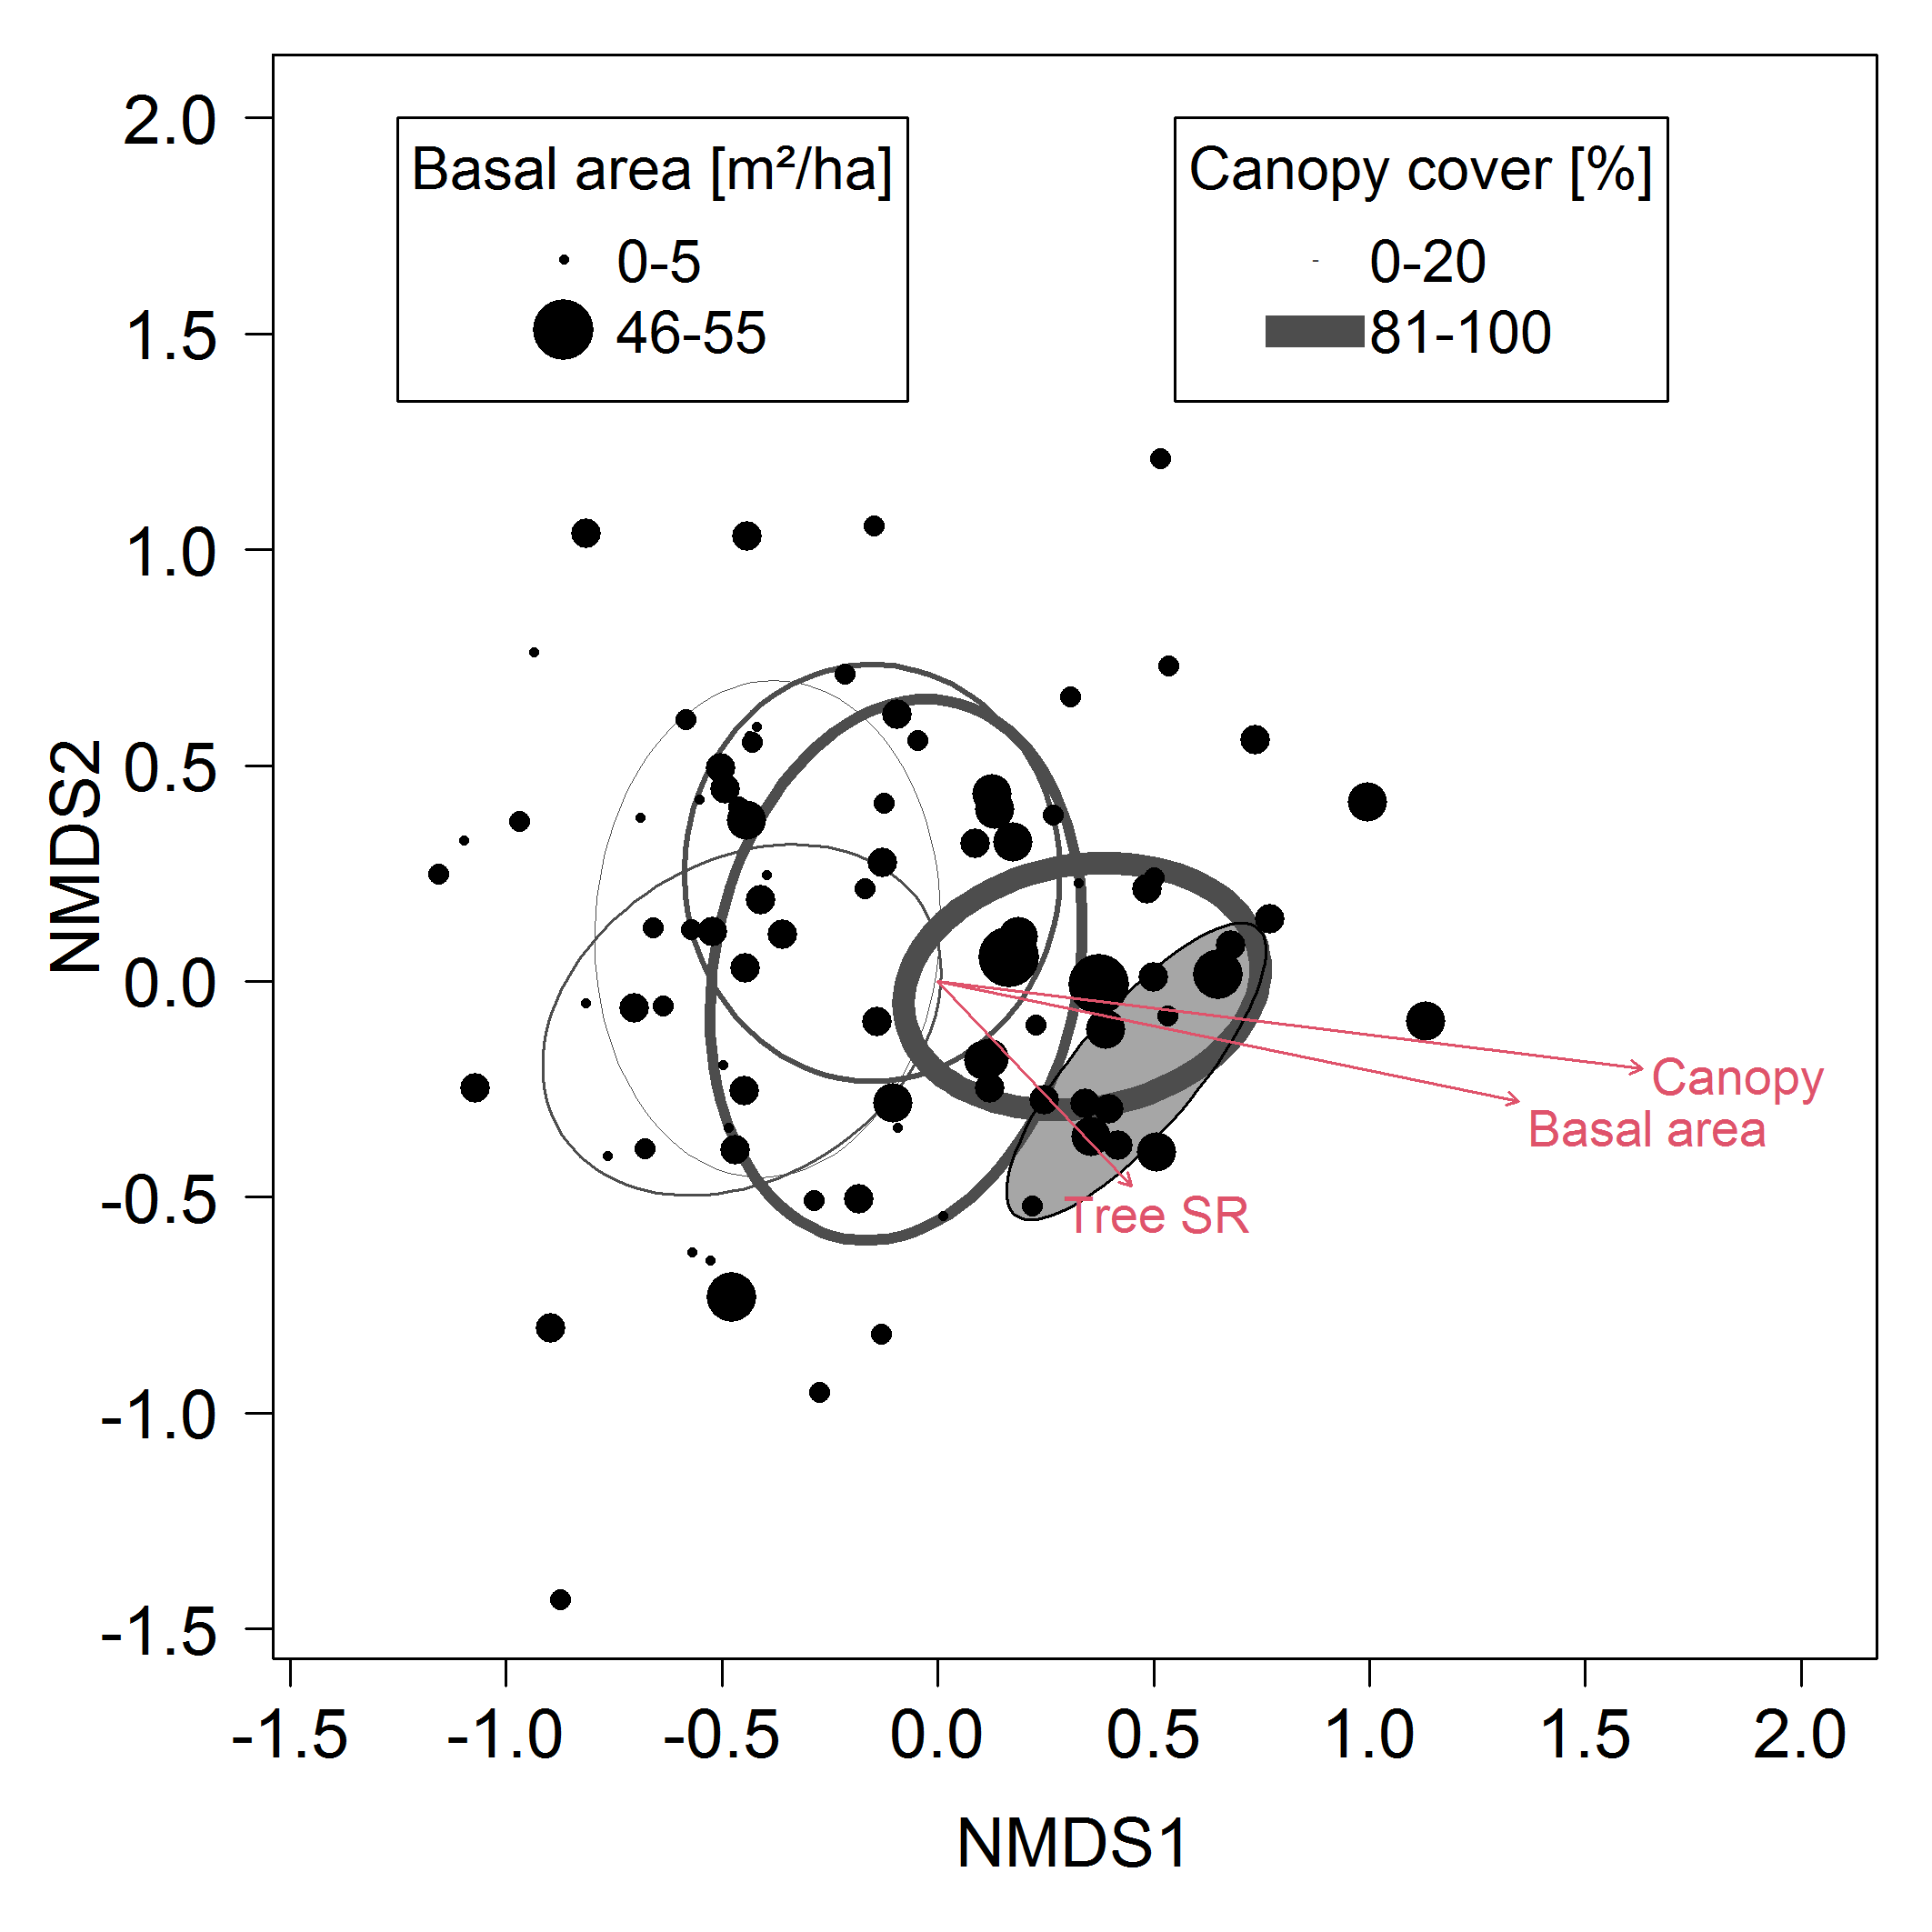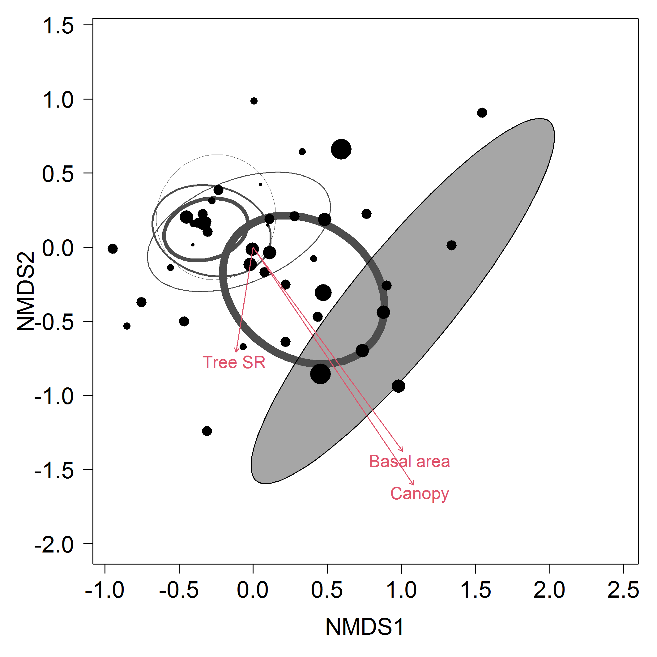
a
c
b
Supplementary Figure 5:
Non-metric multidimensional scaling (NMDS) showing the first two dimensions of ordinations of the cavity-nesting species community matrix for A) bees (stress = 0.105, k = 2), B) herbivore-hunting wasps (stress = 0.180, k = 3) and C) spider-hunting wasps (stress = 0.079, k = 3). Ellipses show 95% confidence intervals of communities grouped by canopy cover. With increasing line thickness (canopy cover) and point size (basal area) the bee and wasp communities changed. The shaded ellipse represents the respective insect communities of a nearby natural forest (CSPs) which were not used for environmental variable fitting. Red arrows indicate the post-hoc correlations with canopy cover, basal area and tree species richness (bees, basal area P < 0.001, canopy cover P < 0.001, tree richness P = 0.757; herbivore-hunting wasps, basal area P < 0.001, canopy cover P < 0.001, tree richness P = 0.120; spider-hunting wasps, basal area P < 0.001, canopy cover P < 0.001, tree richness P = 0.643).
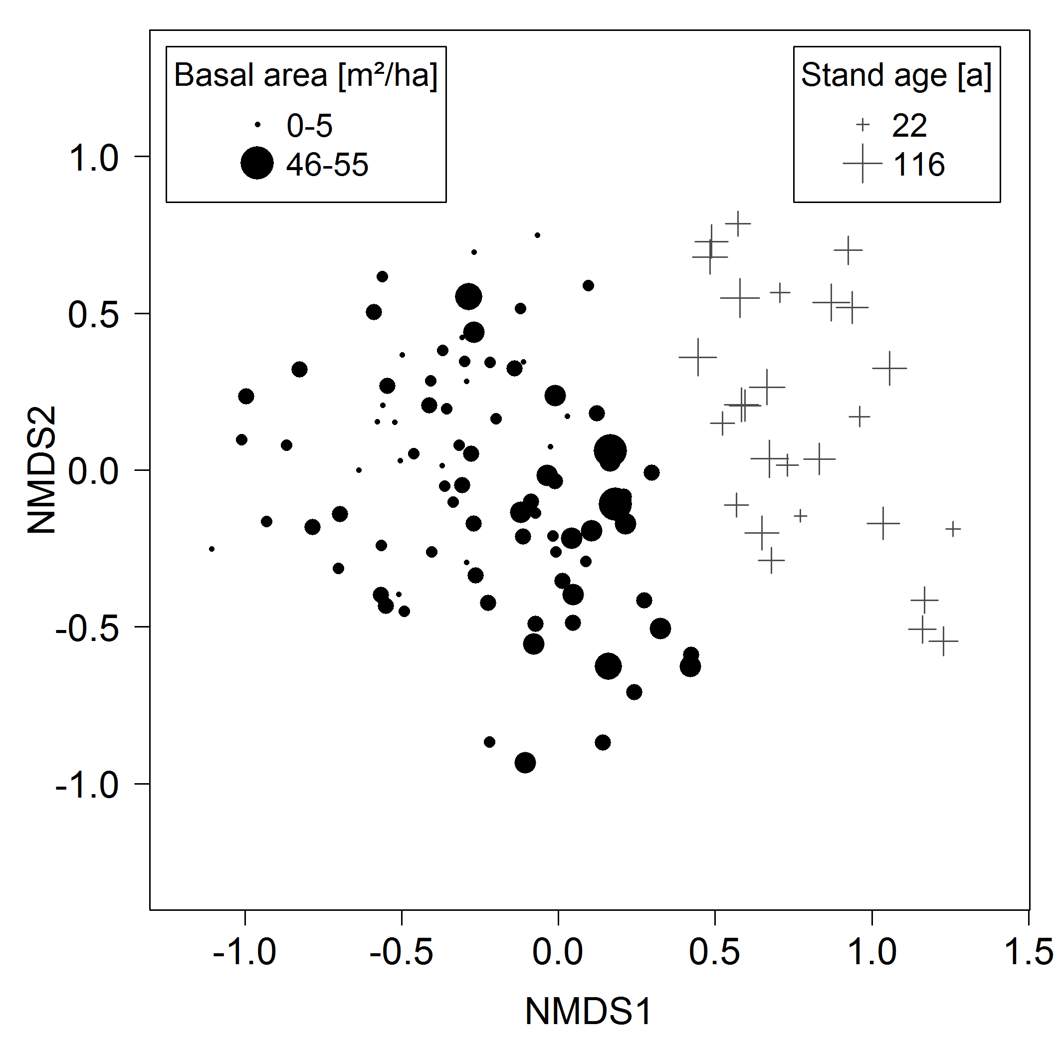
Supplementary Figure 6:
Replicate of Main Fig 1 but with visualization of the individual bee and wasp communities of the CSP natural forest plots (+), where increasing symbol size indicates the stand age of a plot. An analysis of the natural forest communities showed no correlation of reference community dissimilarity and stand age, ranging from plots with maximum 22 to plots with maximum 116 year old trees (stand age is the age of the fifth largest tree in a plot (Bruelheide et al. 2011)). The point size (dots) of the young, experimental forests corresponds to plot mean basal area.
Supplementary References:
Bruelheide H, Böhnke M, Both S, et al (2011) Community assembly during secondary forest succession in a Chinese subtropical forest. Ecol Monogr 81:25–41. https://doi.org/10.1890/09-2172.1
Dormann CF, Fründ J, Blüthgen N, Gruber B (2009) Indices, graphs and null models: analyzing bipartite ecological networks. Open Ecol J 2:7–24. https://doi.org/10.2174/1874213000902010007
Supplementary Data 1:
Predictor variables, canopy cover, basal area and tree species richness (SR) of all 88 experimental plots. Canopy cover represents the vegetation-covered area of hemispherical pictures taken at each trap position, basal area in m² ha⁻¹, see Methods 2.4.
Site | Plot | Canopy cover | Basal area | Tree SR |  | Site | Plot | Canopy cover | Basal area | Tree SR
A | B35 | 0.58 | 21.17 | 4 |  | B | D29 | 0.00 | 0.00 | 1
A | C32 | 1.00 | 49.06 | 2 |  | B | E25 | 0.92 | 17.66 | 16
A | E29 | 0.98 | 30.78 | 8 |  | B | F25 | 0.35 | 13.94 | 8
A | E31 | 0.26 | 8.90 | 1 |  | B | G28 | 1.00 | 17.02 | 2
A | E34 | 1.00 | 34.62 | 1 |  | B | H30 | 0.56 | 9.06 | 4
A | F21 | 0.08 | 5.34 | 1 |  | B | I22 | 0.65 | 16.97 | 16
A | F27 | 1.00 | 25.90 | 4 |  | B | I25 | 0.23 | 18.97 | 1
A | F36 | 0.09 | 13.80 | 16 |  | B | J29 | 0.40 | 20.02 | 8
A | H31 | 1.00 | 24.89 | 2 |  | B | L6 | 0.36 | 15.91 | 16
A | I27 | 0.08 | 21.68 | 2 |  | B | M22 | 0.79 | 14.59 | 4
A | J13 | 0.85 | 20.28 | 4 |  | B | M24 | 0.73 | 16.87 | 2
A | J21 | 0.46 | 11.84 | 2 |  | B | M29 | 0.43 | 23.80 | 2
A | J4 | 0.41 | 11.52 | 16 |  | B | M7 | 0.59 | 6.50 | 1
A | L11 | 0.33 | 18.76 | 1 |  | B | N23 | 0.43 | 10.15 | 8
A | L17 | 1.00 | 26.84 | 8 |  | B | N28 | 0.01 | 0.41 | 1
A | L22 | 0.70 | 27.84 | 16 |  | B | N5 | 0.56 | 3.31 | 1
A | L6 | 0.56 | 12.38 | 16 |  | B | O27 | 0.39 | 21.82 | 2
A | N11 | 0.50 | 9.19 | 1 |  | B | O31 | 0.81 | 26.34 | 4
A | N17 | 0.19 | 5.40 | 1 |  | B | Q17 | 0.81 | 16.78 | 8
A | N20 | 1.00 | 34.10 | 4 |  | B | Q25 | 0.54 | 15.33 | 16
A | N25 | 0.99 | 33.39 | 8 |  | B | Q27 | 1.00 | 22.56 | 1
A | N8 | 0.73 | 22.03 | 4 |  | B | Q29 | 0.08 | 2.83 | 1
A | N9 | 0.79 | 21.15 | 16 |  | B | Q5 | 0.54 | 10.71 | 8
A | O27 | 1.00 | 50.37 | 1 |  | B | R12 | 0.31 | 15.27 | 8
A | P19 | 0.98 | 27.00 | 4 |  | B | R29 | 0.23 | 8.66 | 1
A | P23 | 0.86 | 33.28 | 2 |  | B | R3 | 0.43 | 6.86 | 4
A | P26 | 0.31 | 10.84 | 2 |  | B | R30 | 0.53 | 13.49 | 16
A | P28 | 0.67 | 19.59 | 8 |  | B | S18 | 0.02 | 1.01 | 4
A | Q21 | 0.17 | 6.43 | 2 |  | B | S22 | 0.09 | 7.60 | 16
A | Q9 | 0.17 | 3.76 | 2 |  | B | T13 | 0.01 | 0.00 | 1
A | R14 | 0.17 | 10.12 | 1 |  | B | T25 | 0.60 | 23.83 | 4
A | R18 | 1.00 | 21.16 | 16 |  | B | T29 | 0.02 | 0.42 | 1
A | R8 | 1.00 | 25.88 | 8 |  | B | T8 | 0.74 | 4.73 | 16
A | S10 | 1.00 | 40.81 | 8 |  | B | U12 | 0.60 | 17.13 | 16
A | S13 | 0.99 | 28.43 | 8 |  | B | U16 | 0.50 | 25.60 | 1
A | S16 | 0.26 | 4.63 | 4 |  | B | U20 | 0.62 | 11.84 | 4
A | S20 | 0.95 | 10.81 | 16 |  | B | U27 | 0.00 | 0.90 | 2
A | T15 | 0.94 | 18.72 | 8 |  | B | V15 | 0.02 | 0.18 | 2
A | U18 | 0.99 | 24.32 | 16 |  | B | V19 | 0.26 | 3.78 | 2
A | W12 | 0.49 | 7.04 | 4 |  | B | V20 | 0.25 | 5.04 | 8
 |  |  |  |  |  | B | V23 | 1.00 | 21.74 | 2
 |  |  |  |  |  | B | V24 | 0.82 | 20.75 | 1
 |  |  |  |  |  | B | V28 | 0.02 | 4.66 | 8
 |  |  |  |  |  | B | W10 | 0.00 | 0.55 | 1
 |  |  |  |  |  | B | W11 | 0.30 | 39.85 | 1
 |  |  |  |  |  | B | X21 | 0.00 | 0.19 | 1
 |  |  |  |  |  | B | X8 | 0.14 | 3.62 | 4
 |  |  |  |  |  | B | Y9 | 0.01 | 0.00 | 1

