Supplementary Materials

Room-temperature dislocation plasticity in SrTiO₃ tuned by defect chemistry
Stephan Stich¹, Kuan Ding¹, Qaisar Khushi Muhammad¹, Lukas Porz¹, Christian Minnert¹, Wolfgang Rheinheimer^{1,2}, Karsten Durst¹, Jürgen Rödel¹, Till Frömling¹, Xufei Fang¹*
¹Department of Materials and Earth Sciences, Technical University of Darmstadt, 64287 Darmstadt, Germany
²Current address: Forschungszentrum Jülich GmbH, Wilhelm-Johnen-Straße, 52428 Jülich, Germany
--------------------------
*Corresponding author:
Email: fang@ceramics.tu-darmstadt.de (Dr. Xufei Fang)
Phone (Office): +49 6151 16-21694

Contents
S1. Effect of thermal treatment in air on pop-in behavior
S2. Surface slip traces on the bulk samples
S3. Estimation of the plastic zone size and dislocations under different tip radii
S4. Effect of oxygen vacancy concentration gradient on the pop-in behavior
S5. Dislocations induced due to wire saw cutting

S1. Effect of thermal treatment in air on pop-in behavior
A clear change of the pop-in stress has been observed in Fig. 3 in the reference sample and reduced samples as compared to the reference sample. Considering the fact that the reduced samples were thermally treated at 700 °C (24 h) and then cooled to room temperature prior to the indentation tests. It is necessary to rule out the possibility that the pop-in behavior was affected by a possible surface change caused by the thermal treatment. To this end, further indentation tests on another sample annealed at 700 °C for 24 h in the air denoted as STO-An with a slightly blunted Berkovich indenter were carried out. The pop-in statistics for STO-Ref and STO-An overlap well with each other (Fig. S1), verifying that the thermal treatment at 700 °C in air is not changing the near-surface mechanical properties. In comparison with Fig. 3, the maximum shear stress is generally lower compared to Fig. 3 due to some tip wear and blunting, which yields a much larger effective tip radius (R = 220 nm) and hence lower values for maximum shear stress [1]. Note that the all the tests in Fig. 3 have the same tip radius of R = 80 nm.
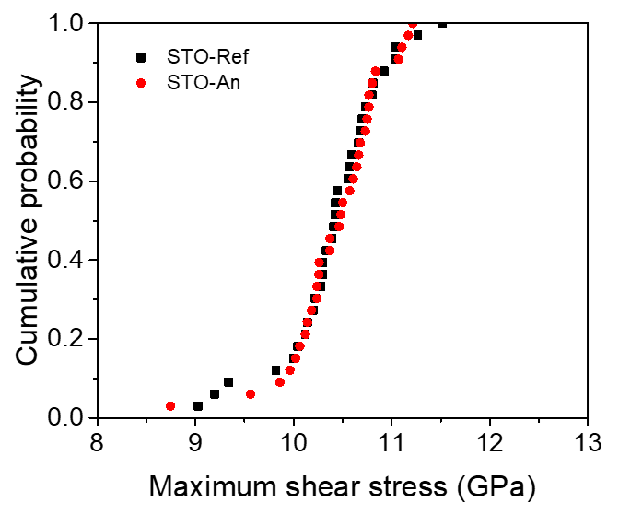
Fig. S1 Cumulative probability of maximum shear stress showing identical behavior by comparing the sample with thermal annealing in air at 700 °C (red) and reference sample (black).

S2. Surface slip traces on the bulk samples
The overview of the samples subjected to bulk compression tests is presented in Fig. S2, where two reference and two reduced samples with the surface slip patterns are revealed. Note that some of the sample edges exhibit a serrated line due to the wire saw cutting.
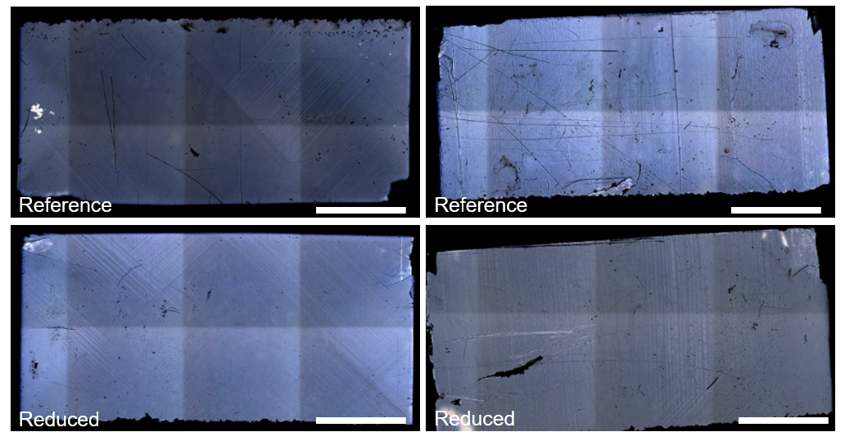
Fig. S2 Surface slip bands revealed for two samples macroscopically deformed to ~1% plastic strain for reference samples and reduced samples (in forming gas). The scale bar for all four images is 1 mm.

S3. Estimation of the plastic zone size and dislocations under different tip radii
For R = 80 nm and a pop-in depth of 10 nm, the contact radius is ~40 nm. Based on the dislocation density of ~10¹⁰ m⁻² in the present case and convert it to volume density according to Ref. [2], the stressed volume contains mathematically less than 0.005 (i.e., practically zero) pre-existing dislocations being probed. In this case, homogeneous dislocation nucleation is the dominating mechanism if the point defects (vacancies) are not considered. For the case of R = 25 μm, and a pop-in depth of h = 300 nm, we find R = Rcosα+h and α=arccos((R-h)/R)=arccos((25-0.3)/25)=9°. Then, the contact radius is estimated as a_{c}=Rsinα=3.9 μm. Considering the sink-in effect, the actual contact radius will be slightly smaller and is assumed to be 3.5 μm, which fits well with the experimental observation. Now consider a sample with a dislocation density of ~10¹⁰ m⁻², which translates to 0.01 μm⁻². Using the similar approach as in Ref. [2], approximately 6 pre-existing dislocations in this region can be activated to accommodate the incipient plasticity. In this case, plasticity is mainly dominated by heterogeneous nucleation or activation of pre-existing dislocations. Furthermore, according to the Hertzian theory [3], the maximum shear stress underneath the indenter tip is about 0.5a_{c} . For sharp indenter, the estimation above gives a depth of ~20 nm where the maximum shear stress is present. For the large spherical tip, this depth is estimated to be about ~2 μm.
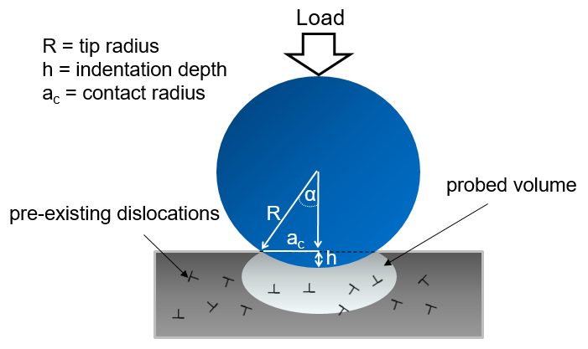
Fig.S3 Estimation of the number of dislocations being probed in the stressed volume with different indenter radii.

S4. Effect of oxygen vacancy concentration gradient on the pop-in behavior
Fick’s diffusion law suggests that a gradient in the concentration of oxygen vacancies might form in the samples depending on the time and sample thickness at given temperature. For reduction treatment at 700 °C for 24h, take the oxygen vacancy diffusivity at 700 °C = ~10⁻⁶ cm² s⁻¹ [4], the average diffusion distance of oxygen vacancy can be estimated by , giving a value of about 3 mm. Consider that the bulk sample has a geometry of about 2 mm x 2 mm x 4 mm, it is therefore possible that a gradient in the local oxygen vacancy concentration exists for the bulk samples. For nanoindentation pop-in tests, the gradient effect can be neglected as only the near surface region (~20 nm for the tip radius R = 80 nm, and ~ 2 μm for R = 25 μm, see estimation above in Sec. S3) is probed. A possible gradient, however, could affect the bulk deformation, as shown in Sec. 3.4. To this end, one bulk sample (4 mm x 4 mm x 8 mm) was reduced under the same condition as described in Sec. 2 and then cut into two symmetric halves along the sample length (Fig. S4a). The inside surface received vibrational polishing to reduce the surface deformation layer before the pop-in tests were performed. Then different locations (starting from the surface edge to the interior of the sample, Fig. S4b) were tested with multiple indentations. According to the results in Fig. 3, the pop-in stresses in different regions (from the surface to the inner region of a bulk) can be correlated to the oxygen vacancy concentrations qualitatively.
A gradient is demonstrated by the pop-in data in Fig. S4c, with the lowest stress values in the near surface region (corresponding to higher oxygen vacancy concentration), while the interior region approaching the sample’s center shows almost an identical mechanical response with respect to the reference sample. Again, the cross-section pop-in tests support that the reduction treatment is effective in modifying the local dislocation nucleation, although dependent on the location. The overall pop-in stress values are lower here than those presented in Fig. 3, which is mainly due to the tip wear. Here, the tip radius R has been determined to be about 120 nm, which is larger than the original R = 80 nm.
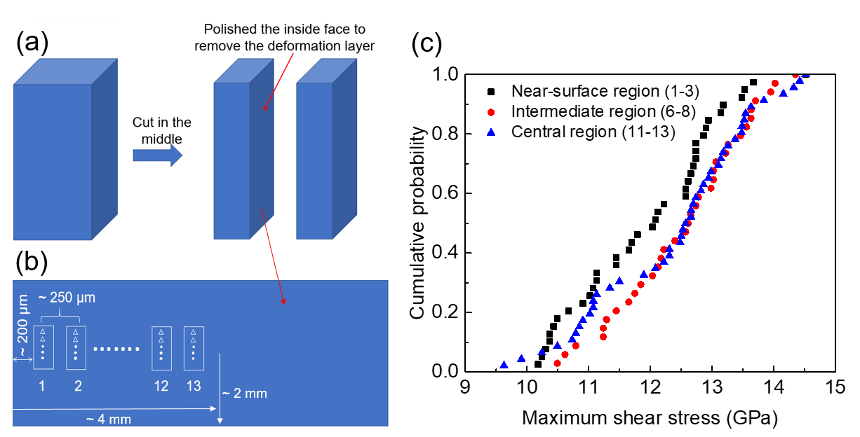
Fig. S4 Gradient of the oxygen vacancy concentration evidenced by the pop-in stress in different regions: (a) schematic illustration of sample preparation; (b) nanoindentation tests in different positions, i.e., near-surface, intermediate, and central region on the surface; (c) pop-in stress distribution corresponding to different positions. For better comparison, each distribution is averaged over three indentation positions.

S5. Dislocations induced due to wire saw cutting
The wire saw cutting is found to produce surface dislocations on the cut surfaces, as revealed by the etching method in Fig. S5. The right bright side indicates the surface which is cut, and the etch pit patterns on the surface displays a dislocation density gradient from the cut surface to the interior of the sample.
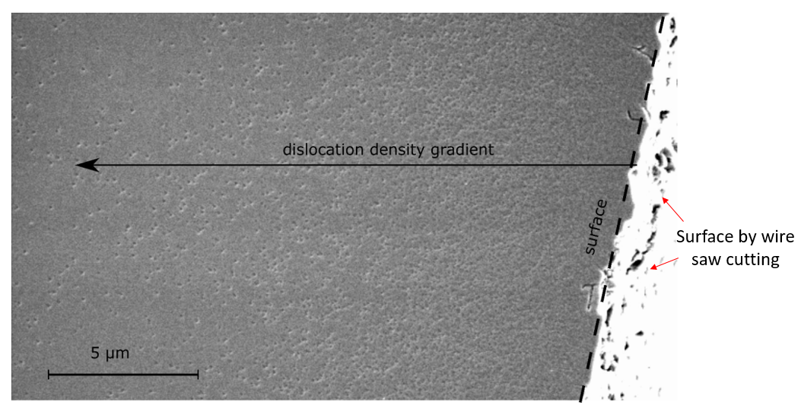
Fig. S5 Dislocations generated underneath the surface due to wire saw cutting. Chemical etching revealed the abundant dislocations on the surface that is perpendicular to the surface that has been cut. Image adopted from Ref. [5].

References
[1] J.R. Morris, H. Bei, G.M. Pharr, E.P. George, Size Effects and Stochastic Behavior of Nanoindentation Pop In, Physical Review Letters, 106 (2011) 165502.
[2] X. Fang, L. Porz, K. Ding, A. Nakamura, Bridging the Gap between Bulk Compression and Indentation Test on Room-Temperature Plasticity in Oxides: Case Study on SrTiO₃, Crystals, 10 (2020) 933-947.
[3] K.L. Johnson, Contact Mechanics, Cambridge University Press, Cambridge, London, 1985.
[4] R.A. De Souza, Oxygen Diffusion in SrTiO₃ and Related Perovskite Oxides, Advanced Functional Materials, 25 (2015) 6326-6342.
[5] L. Porz, Mechanics and Electrical Conductivity of Dislocation-Tuned Ceramics, Department of Materials and Earth Sciences, TU Darmstadt, 2021.

