Supporting Information
Lithium Metal Penetration Induced by Electrodeposition through Solid Electrolytes: Example in Single-Crystal Li₆La₃ZrTaO₁₂ Garnet
Tushar Swamy¹, Richard Park², Brian W. Sheldon³, Daniel Rettenwander⁴, Lukas Porz⁵, Stefan Berendts⁶, Reinhard Uecker⁷, W. Craig Carter² and Yet-Ming Chiang^{2, *}
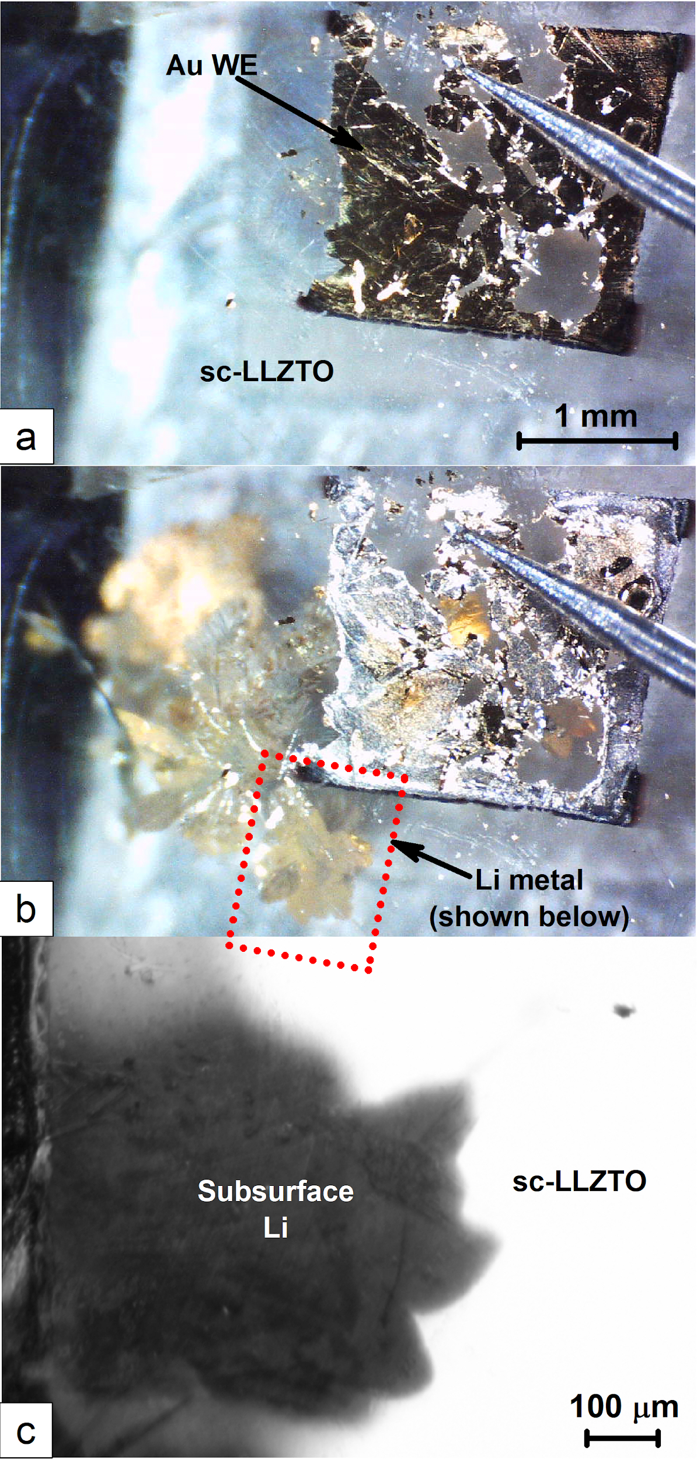
Figure S1. In-situ optical microscopy images (a) prior to the experiment, and (b) post short-circuit, of a sc-LLZTO with sputtered gold WE during galvanostatic deposition of Li metal beneath the gold WE at 10 mA⋅cm⁻² current density. Li filaments propagated through the SSE until short circuit occurred 43 seconds into the experiment, and (c) ex-situ optical microscopy image of the region marked in S1(b), focused on the surface of the gold working electrode.
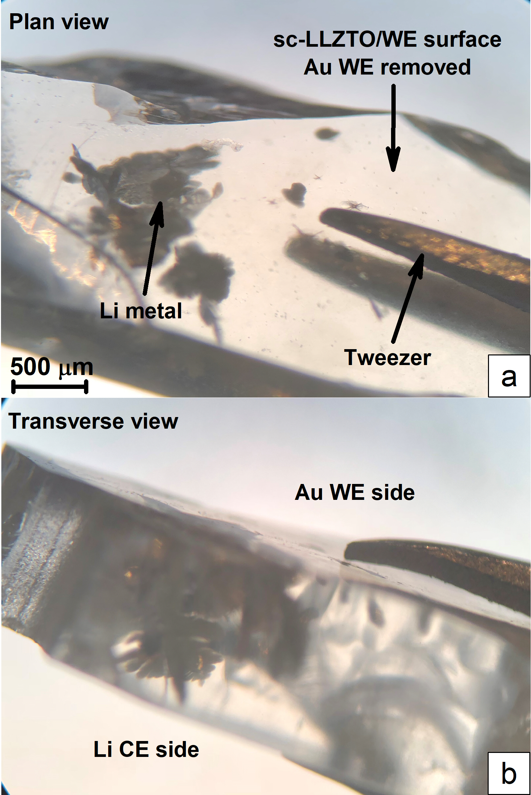
Figure S2. (a) Plan and (b) transverse views of the solid electrolyte showing the leaf-like morphology of the lithium metal filaments that have penetrated into, or completely through, the sc-LLZTO.

Video S1. Recording of Operando chronoamperometric experiment – attached as a video file

Video S2. Plan and Transverse views of shorted sc-LLZTO - attached as a video file

