Supplementary materials

Quantitative mapping of nanotwin variants in the bulk

Jan Schultheiß^{1,2,*}, Lukas Porz¹, Lalitha Kodumudi Venkataraman¹, Marion Höfling¹, Can Yildirim³, Phil Cook³, Carsten Detlefs³, Semën Gorfman⁴, Jürgen Rödel¹, and Hugh Simons⁵

¹ Department of Materials and Earth Sciences, Technical University of Darmstadt, 64287, Darmstadt, Germany
² Department of Materials Science and Engineering, Norwegian University of Science and Technology (NTNU), 7034, Trondheim, Norway
³ European Synchrotron Radiation Facility, 71 avenue des Martyrs, CS40220, 38043, Grenoble Cedex 9, France
⁴ Department of Materials Science and Engineering, Faculty of Engineering, Tel Aviv University, 69978, Tel Aviv, Israel
⁵ Department of Physics, Technical University of Denmark, 2800 Kgs. Lyngby, Denmark
*jan.schultheiss@ntnu.no

Sample preparation: Polycrystalline 0.6Ba(Zr_{0.2}Ti_{0.8})O₃-0.4(Ba_{0.7}Ca_{0.3})TiO₃ (BZT-BCT) was prepared using solid-state synthesis by mixing BaCO₃ (99.8%), CaCO₃ (99.5%), ZrO₂ (99.5%), and TiO₂ (99.6%) stoichiometrically, followed by milling and drying (all powders by Alfa Aesar GmbH, Karlsruhe, Germany). Calcination and sintering were done at 1300 °C for 2 hrs and 1500 °C for 2 hrs, respectively (relative density: 97%, mean grain size: 28.1$±$5.9 µm). Details on the preparation, including their characterization, can be found in Ref. [1].

Strain and polarization measurement: The strain and polarization measurements (Figure 2a and b) were performed with a modified Sawyer-Tower setup using a reference capacitor (10 µF), equipped with an optical displacement sensor (Philtec Inc., MD, USA), controlled by a customized LabView program. A triangular wave signal with a frequency of 0.1 Hz was applied with a voltage amplifier (Trek Model 20/20C, NY, USA).

Mapping of density of twin variants: The number of individual peaks, n, in each local RSM was quantified by a MatLab program using a peak finder function. This affords the calculation of the density of twin variants (Figure 1a), $δ=n/V$, for each individual subvolume V. Since the geometry of the twins is unknown in 3D, stripe-like lamellar structures with two short axes of length D and one long axis of length L were assumed in order to estimate the size of the twin variants in the one subvolume.^{[2]} The length of the short axis (referred to as D), is calculated as $D=\sqrt{V/{(n⋅L)}}$, where L is approximated as the length of a cube with volume V.

Calculation of elastic stresses: In ferroelectric/ferroelastic materials, the electric field induced piezoelectric lattice expansion and domain switching adds to the residual elastic strain. To take this into account, we calculated the local elastic stresses by encompassing the related strains. The axial lattice strain, $ε_{111}^{tot}$, along the scattering vector for all applied electric fields was computed based on $ε_{111}^{tot}=-\left(θ-θ_{0}\right)\cot{θ}$^{[3]} for each electric field step with $θ_{0}$ as the averaged centroid position of the 2$θ$ intensity distribution of the 111 Bragg peaks in the virgin state (electric field state 1 in Figure 2a) and $θ$ obtained from local $α/2θ$ maps (averaged over all subvolumes). The calculated $ε_{111}^{tot}$ are given with reference to the virgin state, since a reference stress-free single crystalline material in the monodomain state is unavailable.^{[4]} Please also note that within this analysis, we average over possible strain inhomogeneities in $θ_{0}$ related for example to chemistry inhomogeneities of the complex phase equilibria. The total electric field dependent strain $ε_{111}^{tot}$ is comprised of a summation of piezoelectric strain ($ε_{111}^{int}$), switching strain (switching between 111 and $11\overline{1}$ rhombohedral domain variants, $ε_{111}^{swi}$), and elastic strain, $ε_{111}^{ela}$. The piezoelectric strain was evaluated using $ε_{111}^{int}=d_{31}^{int}⋅E$ (assuming monodomain single crystalline behavior), where $d_{31}^{int}$ is the intrinsic piezoelectric coefficient. The switching strain is defined as $ε_{111}^{swi}=m⋅Δη_{111}(E)⋅δ_{r}$, where $Δη_{111}(E)$ is the field-dependent change in domain switching fraction^{[5]}, $δ_{r}$ is the spontaneous strain of one switching event^{[6]} and $m=4$ is the number of polar directions^{[7]}. Details on the calculation of $ε_{111}^{swi}$ are provided in Figure S2. The piezoelectric strain and the switching strain do not generate an elastic stress in the {111} lattice planes for the R3m crystal structure.^{[8]} The local elastic stress (Figure 2d) was therefore computed by subtracting the latter two from experimentally measured $ε_{111}^{tot}$. Using Hooke’s law in plane strain condition, the local elastic stress was evaluated as $σ_{111}^{ela}=\frac{E_{Y}}{1-ν^{2}}(ε_{111}^{tot}-ε_{111}^{int}-ε_{111}^{swi})$, while the local elastic energy (Figure 2e) was calculated as $U_{111}^{ela}=\frac{1}{2}E_{Y}({ε_{111}^{tot}-ε_{111}^{int}-ε_{111}^{swi})}^{2}$. Isotropic Young’s modulus was evaluated by interpolating between BZT-38.5BCT and BZT-42BCT (E_{Y} = 172 GPa^{[9]}) and $ν$ was taken from BaTiO₃ as 0.35^{[10]}. Please note that we assume a simplified uniaxial stress state for the calculation of $σ_{111}^{ela}$ and $U_{111}^{ela}$, since domains extend and contract in <111> direction under electric field application. Also, E_{Y} and $ν$ are taken from bulk values, since the full tensorial information is not available to calculate the respective elastic parameters for the investigated crystallographic orientation of the grain. The intrinsic piezoelectric coefficient $d_{31}^{int}$ was calculated from intrinsic $d_{33}^{int}$ for a BZT-BCT polycrystal (under saturated domain switching conditions)^{[11]} assuming volume preservation as $d_{31}^{int}=-1/2d_{33}^{int}=-60 pm V^{-1}$.
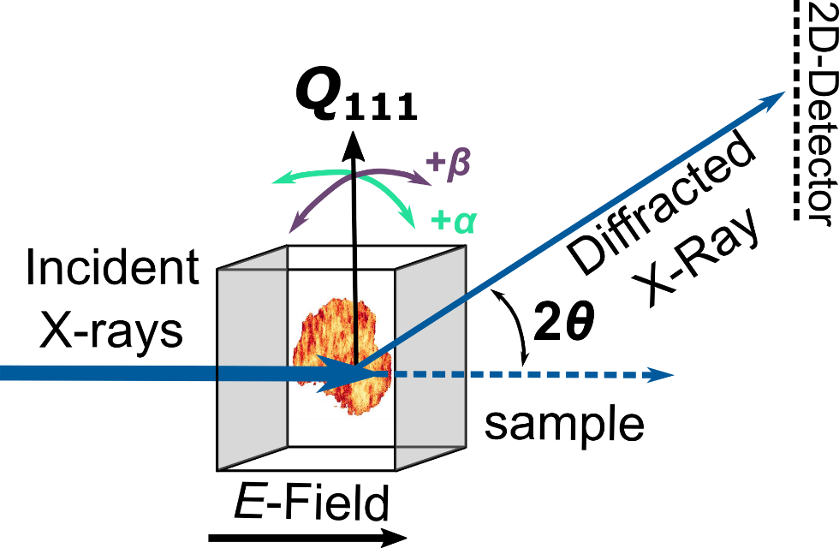
Figure S1. Schematic of the dark-field X-ray microscopy (DFXM) setup to obtain reciprocal space maps ($α$/$β$) and strain maps ($α$/$2θ$) from nanoscale subvolumes of a cross section of a grain in the bulk. The angles $α$ and $β$ describe the grain tilt around the scattering vector $Q_{111}$, while $2θ$ represents the scattering angle. The electric field (E) is applied externally between two electrodes (displayed in gray).

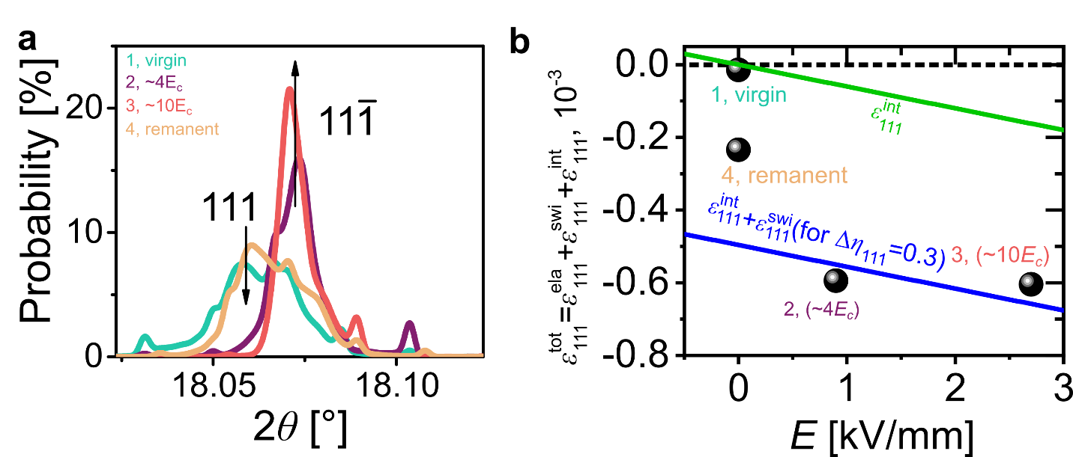
Figure S2. Estimation of the elastic strain, $ε_{111}^{ela}$ from DFXM strain ($α/2θ$) maps for grain 1. A histogram of the centroid positions of the 2$θ$ intensity distribution obtained from strain maps is displayed in a. The change in intensity ratios between the 111 and $11\overline{1}$ peak with the electric field application allows to quantify the volume fraction of the material, which has been reoriented through the application of the electric field as $η_{111}=\frac{\frac{I_{111}}{I_{111}^{'}}}{\frac{I_{111}}{I_{111}^{'}}+3\left(\frac{I_{11\overline{1}}}{{I^{'}}_{11\overline{1}}}\right)}-\frac{1}{4}$, while the spontaneous strain of one switching event, $δ_{r}$, was calculated from the 111 and $11\overline{1}$ peak positions as $δ_{r}={θ_{111}}/{θ_{11\overline{1}}}-1$. The data points quantify the electric field dependence of the total strain, $ε_{111}^{tot}$, from strain maps in b. The reference strain (1, virgin) is denoted as a dashed line. The estimated field-dependence of the intrinsic piezoelectric strain, $ε_{111}^{int}$, and the switching strain, $ε_{111}^{swi}$, which is used to calculate the elastic strain component, $ε_{111}^{ela},$ is also provided. Please note that the switching strain was calculated for a domain switching fraction ($Δη_{111}=0.3$) obtained from a.
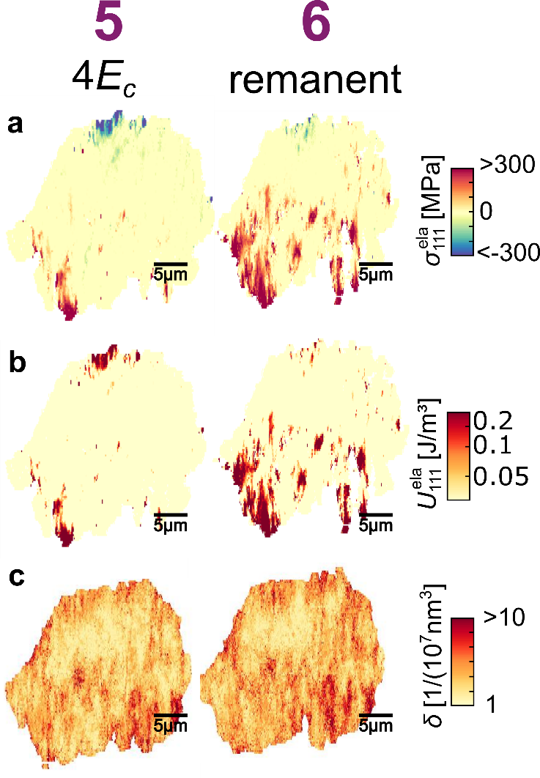
Figure S3. Results obtained from the local scans of a polycrystalline BZT-BCT material, grain 2: (a) elastic stress ($σ_{111}^{ela}$), (b) elastic energy ($U_{111}^{ela}$), and (c) density of twin variants. The numbers 5 and 6 refer to the respective electric field in Figure 2a. Please note that the elastic stress and elastic mechanical energy were calculated with reference to the remanent state of this grain, since information on the virgin state is not available. A movie of the strain evolution of grain 2 is available (Supplementary Video 2).

Supplementary Video 1. Intensity images showing the evolution of strain at a fixed $α, β$, and $2θ$ position in reciprocal space during in situ electric field application starting from a poled state from 0 kV/mm to 2.2 kV/mm with a frequency of 0.004 Hz for grain 1. Changes in the local intensities are related to twins entering and exiting the Bragg condition because of their lattice orientation and strain change due to the electric field.

Supplementary Video 2. As above for grain 2. The highest field was 1.8 kV/mm, the frequency was 0.0024 Hz.

References
[1] V. Rojas, J. Koruza, E. A. Patterson, M. Acosta, X. J. Jiang, N. Liu, C. Dietz, J. Rödel, J. Am. Ceram. Soc. 2017, 100, 4699.
[2] J. J. Gao, H. Zhang, L. Xie, J. D. Yu, G. H. Wang, Y. Q. Gu, H. L. He, J. S. Bai, J. Eur. Ceram. Soc. 2017, 37, 985.
[3] B. D. Cullity, Elements of X-ray Diffraction, Vol. 2, Addison-Wesley Publishing Company INC., 1978.
[4] P. Veber, F. Benabdallah, H. R. Liu, G. Buse, M. Josse, M. Maglione, Materials 2015, 8, 7962.
[5] A. Pramanick, D. Damjanovic, J. E. Daniels, J. C. Nino, J. L. Jones, J. Am. Ceram. Soc. 2011, 94, 293.
[6] N. Uchida, T. Ikeda, Jpn. J. Appl. Phys. 1967, 6, 1079.
[7] J. L. Jones, E. B. Slamovich, K. J. Bowman, J. Appl. Phys. 2005, 97, 034113.
[8] D. A. Hall, A. Steuwer, B. Cherdhirunkorn, T. Mori, P. J. Withers, Acta Mater. 2006, 54, 3075.
[9] D. R. J. Brandt, M. Acosta, J. Koruza, K. G. Webber, J. Appl. Phys. 2014, 115, 204107.
[10] M. Marutake, J. Phys. Soc. Jpn. 1956, 11, 807.
[11] M. Acosta, N. Novak, G. A. Rossetti, J. Rödel, Appl. Phys. Lett. 2015, 107, 142906

