Supplementary Materials
for

Nanoindentation pop-in in oxides at room temperature: dislocation activation or crack formation?
Xufei Fang^{1*}, Hanna Bishara², Kuan Ding¹, Hanna Tsybenko², Lukas Porz¹, Marion Höfling¹, Enrico Bruder¹, Yingwei Li³, Gerhard Dehm², Karsten Durst¹
¹Department of Materials and Earth Sciences, Technical University of Darmstadt, 64287 Darmstadt, Germany
²Max-Planck-Institut für Eisenforschung GmbH, Max-Planck-Str. 1, 40237 Düsseldorf, Germany
³School of Civil Engineering and State Key Laboratory of Water Resources and Hydropower Engineering Science, Wuhan University, 430072, Wuhan, China

*Corresponding author
Email: fang@ceramics.tu-darmstadt.de (Xufei Fang)

This file contains:
1. Pre-existing dislocation density checked using etch pit for single-crystal SrTiO₃
2. Sample information and surface characterization of Al₂O₃, BaTiO₃, and TiO₂
3. Deformation results and representative load-displacement curves from indentation pop-in stop tests of Al₂O₃, BaTiO₃, and TiO₂
1. Pre-existing dislocation density in SrTiO₃
The pre-existing dislocation density is revealed by chemical etching, which gives a dislocation density of ~10¹⁰ m⁻².
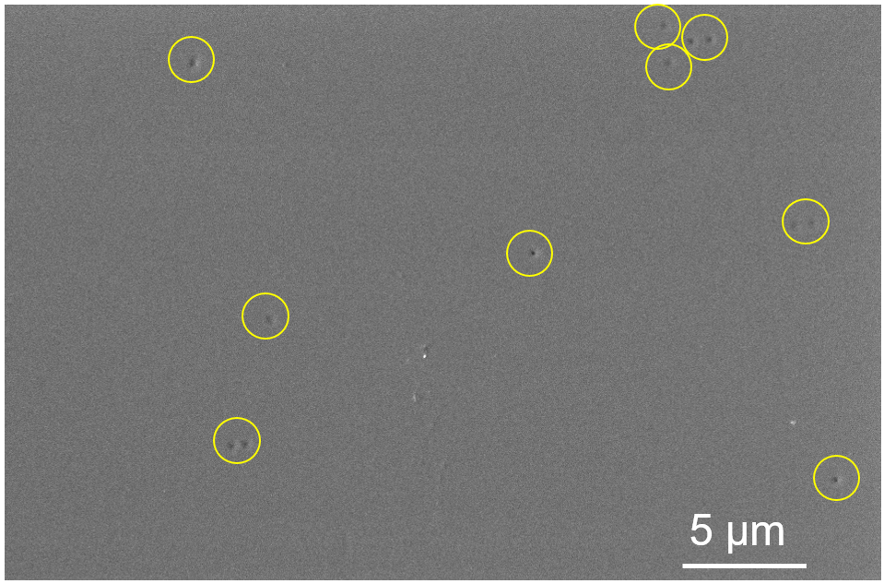
Fig. S1. SEM image showing the pre-existing dislocation in SrTiO₃ checked using etch pit study. The tiny black dots highlighted by the yellow circles correspond to the pre-existing dislocations.

2. Sample preparation and characterization of Al₂O₃, BaTiO₃, and TiO₂
The single-crystal alpha-Al₂O₃ (sapphire) sample with (0001) surface was used. The ferroelectric tetragonal BaTiO₃ single crystal (FEE GmbH, a division of EOT, Idar-Oberstein, Germany) was grown with the top-seeded solution growth method and the (001) surface was indented. Prior to indentation test, the ferroelectric BaTiO₃ sample was electrically poled at 1 kV/mm to gain a defined spontaneous polarization orientation (out-of-plane). Tests on rutile TiO₂ single crystals (CrysTech GmbH, Berlin, Germany) were directly carried out on the (001) polished surface (as-received sample). The characterization of indents traces in the TiO₂ sample was carried out with ECCI through a backscatter electron (BSE) detector in a Zeiss Merlin SEM. A beam current of 2 nA, acceleration voltages of 30 kV, and a working distance of 7.5 mm. In order to capture the surface dislocations on BaTiO₃, ECCI (MIRA3-XM SEM, TESCAN, Brno, Czech Republic) measurement was performed with an accelerating voltage of 20 kV and a beam current of 500 to 600 pA. Furthermore, in order to minimize the surface damage during sample preparation on the pop-in study, the sample surfaces were all finally polished using vibrational polishing with colloidal silica to remove the surface mechanical deformation layer, similar to the case in SrTiO₃.

3. Deformation results and representative load-displacement curves from indentation pop-in stop tests of Al₂O₃, BaTiO₃, and TiO₂
3.1 Single crystal α-Al₂O₃
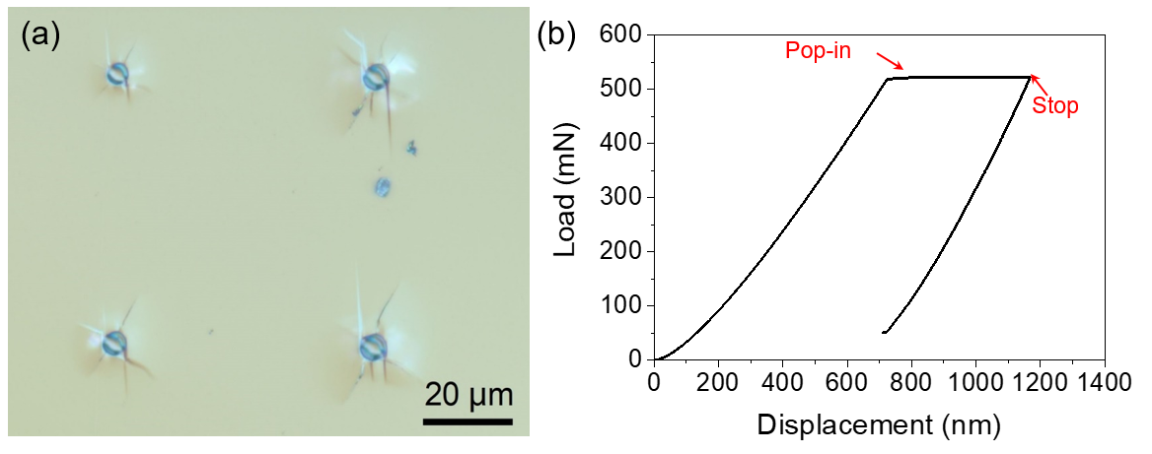
Fig. S2 (a) Optical microscope image showing cracks initiated right after the pop-in stop test on sapphire with R = 5 μm; (b) Representative load-displacement curve for Al₂O₃ with the tip radius of R = 5 μm, demonstrating the pop-in stop test.
For indentation on Al₂O₃, the previous work by Page et al. [1] showed that only dislocations were activated the surface was indented with Berkovich tip at a very low load (e.g., corresponding to a maximum indentation depth of 250 nm), as revealed by the TEM image in their work. Unlike the widely extended dislocation arms in SrTiO₃, the dislocations shown by Page et al. [1] are confined in a very limited region near the indent imprint, suggesting a much higher lattice friction stress in Al₂O₃, as suggested by the Peierls stress analysis by Kamimura et al. [2]. The extremely high lattice friction stress greatly limits the dislocation motion and thus plastic deformation. In addition, the limited slip systems in oxides further facilitates dislocation pileups. Such dislocation pileups could further activate crack initiation based on the Zener-Stroh theory [3, 4]. In comparison, the lattice friction stress of SrTiO₃ has been reported to be less than 100 MPa [5, 6], which is a very low value for an oxide material.

This indentation result by Page et al. [1] is consistent with the in situ TEM indentation study by Miao et al. [7], who recently showed that only dislocations without cracks formation were induced when a sharp tip was indented into the surface of a single crystal Al₂O₃. On the other hand, it is understandable that crack occurs when in situ TEM indentation was performed at the grain boundary of a bi-crystal Al₂O₃ due to the weak bonding at the grain boundary, as reported by Kondo et al. [8].
In contrast, cracks start to initiate right after the pop-in stop test with R = 5 μm. The irregular pattern of the cracks in Fig. S2a indicates a stochastic behavior of the crack formation, which is probably due to: i) the stochastic distribution of the pre-existing flaws/cracks; ii) the instable dynamic crack propagation coupled with the machine dynamics during pop-in event [9].
3.2 Single crystal BaTiO₃
As the evidence of dislocations under Berkovich tip has been found above in SrTiO₃ and α-Al₂O₃, here we perform directly spherical indentation with R = 2 μm and R = 25 μm in one domain on the (001) surface of a single crystal BaTiO₃. Similarly, the indentation were stopped right after the pop-in events to prevent local materials from being further deformed. Figure. S3 clearly demonstrated the indentation size effect on the material deformation behavior. The ECCI measurement on an indent imprint with R = 2 μm in Fig. S3(a) features the dislocations (white lines with tails around the indenter imprint) and some domain structures (yellow arrows) induced by local high stress, while no cracks were visible. The white arrows indicate representatively the indentation induced slip patterns, which agree with the room-temperature slip system {110}<110> in BaTiO₃ [10].
In contrast, the light microscope for an indent imprint with tip radius R = 25 μm in Fig. S3b shows clearly the crack formation right after pop-in. The crack pattern seems irregular and does not follow a specific plane as the crack pattern and length in ferroelectric materials can be modified with the ferroelectric domain structure [11]. The exact underlying mechanisms for crack formation can be complex [12] and are beyond the scope of this work. To eliminate a strong influence of the domain patterns, the sample was electrically poled.
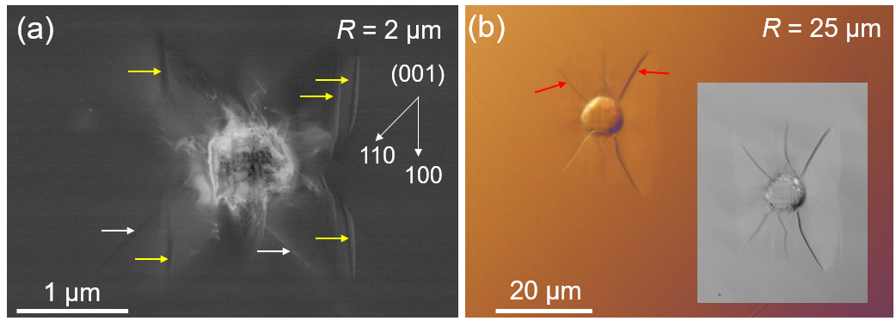
Fig. S3 Images taken on indented regions where pop-in stop tests were carried out: (a) ECCI measurement shows numerous dislocations without a crack in the indented region with 2 μm spherical tip. The white arrows indicate the slip planes, the yellow arrows indicate the domain structures induced by local stress; (b) optical image with differential interference contrast mode showing cracks under 25 μm spherical tip. The red arrows indicate the cracks. The inset image shows the corresponding location observed by a laser microscope.
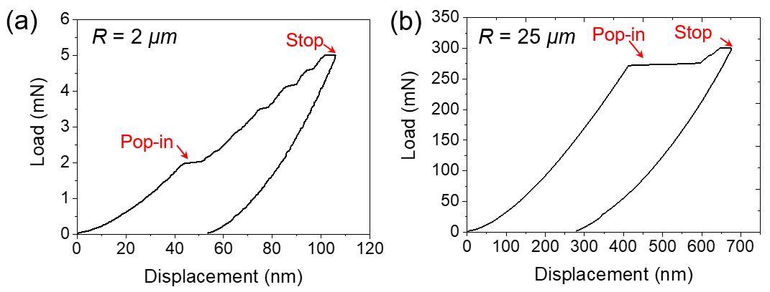
Fig. S4 Representative load-displacement curves for BaTiO₃ with different tip radii, demonstrating the pop-in stop tests.
Gaillard et al. [10] performed indentation using Berkovich tip up to a load of 22 mN on (001) surface of BaTiO₃ and used AFM to characterize the surface morphology. It was demonstrated that the deformation is accommodated by mechanical twinning and domain switching. Here in Fig. S3a, the ECCI result shows direct evidence of the dislocations without crack formation. The slip patterns revealed by ECCI resembles that by AFM on (001) BaTiO₃ after indentation with 1 μm (± 0.2 μm) spherical tip by Liu et al. [13].
3.3 Single crystal TiO₂
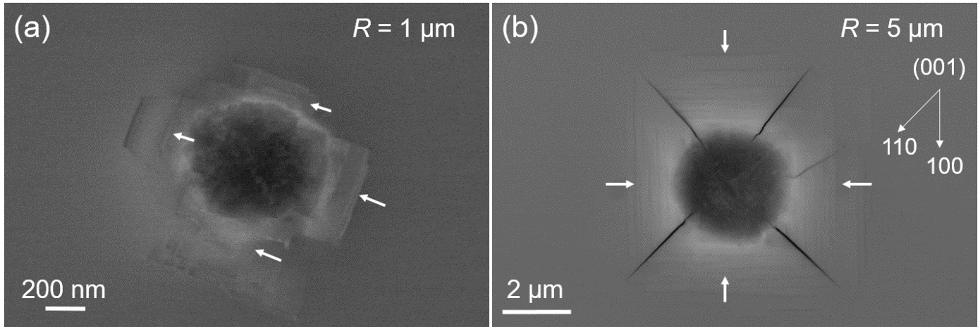
Fig. S5 Images taken on indented regions on (001) TiO₂ where pop-in stop tests were carried out: (a) ECCI measurement showing no crack induced but features of (partial) dislocations which are not yet developed to twins [14] in the indented region and pileups (white arrows) with R = 1 μm; (b) ECCI measurement showing cracks initiated mainly on (110) planes, together with slip lines (white arrows) on all four systems with R = 5 μm.
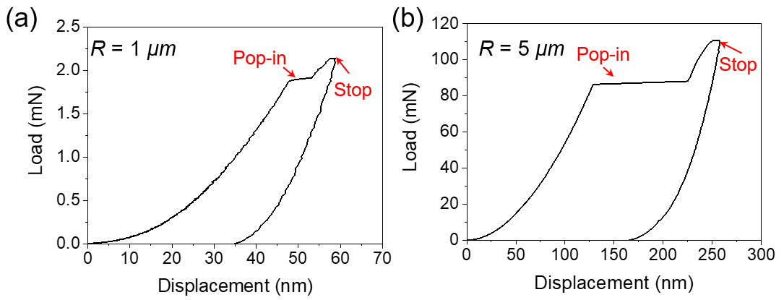
Fig. S6 Representative load-displacement curves for TiO₂ with different tip radii, demonstrating the pop-in stop tests.
The ECCI observation in Fig. S5 shows again compelling evidence that small tip (R = 1 μm, Fig. S5a) induces plastic deformation dominated by dislocations, while larger tip (R = 5 μm, Fig. S5b) induced both slips and crack formation during the pop-in. The pileup pattern around the indent imprint is analogous to that of a single-crystal Si after indentation [15]. The slip and crack patterns in Fig. S5b resemble the results by Ashbee et al. [16] using a pyramid diamond tip in air at room temperature.
Table S1 Summary of the maximum shear stress and maximum tensile stress under the smallest tip (without inducing cracks at pop-in) used for corresponding oxides and theoretical shear strength and fracture strength. The comparison shows that the maximum shear stress is reached much more easily before the maximum tensile stress, so that dislocation nucleation is more strongly favored.
 | Al₂O₃  (Berkovich [1]) | BaTiO₃  (Spherical, R = 2 μm) | TiO₂  (Spherical, R = 1 μm)
Young’s modulus, E (GPa | 390 [1] | ~120 [17] | ~349 [18]
Poission’s ratio | 0.25 [1] | 0.3 [17] | 0.25 [18]
Shear modulus, G (GPa) | ~156 | ~55 [13] | ~140
Theo. shear strength (G/2π, GPa) | ~24 | ~9 | ~22
Theo. fracture strength (E/10, GPa) | ~37 | ~14 | ~35
Pop-in load (mN) | ~7 [1] | 2.0 | 1.9
Max. shear stress (GPa) | ~8.5 [1] | ~3.8 | ~9.5
Max. tensile stress (GPa) | ~3.6 | ~1.6 | ~4.1
*Note the calculation of the max. shear stress and max. tensile stress is made according to Eq. (3) and Eq. (5) in the main text. The relation between shear modulus, Young’s modulus, and Poisson’s ratio is estimated by G=E/2(1+v) for isotropic behavior for simplicity. The value may differ slightly from the bulk values.

References:
[1] T.F. Page, W.C. Oliver, C.J. McHargue, The deformation behavior of ceramic crystals subjected to very low load (nano)indentations, Journal of Materials Research 7(2) (2011) 450-473.
[2] Y. Kamimura, K. Edagawa, S. Takeuchi, Experimental evaluation of the Peierls stresses in a variety of crystals and their relation to the crystal structure, Acta Materialia 61(1) (2013) 294-309.
[3] A.N. Stroh, A theory of the fracture of metals, Advances in Physics 6(24) (1957) 418-465.
[4] X. Fang, K. Ding, C. Minnert, A. Nakamura, K. Durst, Dislocation-based crack initiation and propagation in single-crystal SrTiO₃, Journal of Materials Science 56 (2021) 5479-5492.
[5] F. Javaid, K.E. Johanns, E.A. Patterson, K. Durst, Temperature dependence of indentation size effect, dislocation pile-ups, and lattice friction in (001) strontium titanate, Journal of the American Ceramic Society 101(1) (2018) 356-364.
[6] E.A. Patterson, M. Major, W. Donner, K. Durst, K.G. Webber, J. Rödel, Temperature-Dependent Deformation and Dislocation Density in SrTiO₃ (001) Single Crystals, Journal of the American Ceramic Society 99(10) (2016) 3411-3420.
[7] B. Miao, S. Kondo, E. Tochigi, J. Wei, B. Feng, N. Shibata, Y. Ikuhara, The core structure of 60° mixed basal dislocation in alumina (α-Al₂O₃) introduced by in situ TEM nanoindentation, Scripta Materialia 163 (2019) 157-162.
[8] S. Kondo, A. Ishihara, E. Tochigi, N. Shibata, Y. Ikuhara, Direct observation of atomic-scale fracture path within ceramic grain boundary core, Nature communications 10(1) (2019) 2112.
[9] P. Sudharshan Phani, W.C. Oliver, Critical examination of experimental data on strain bursts (pop-in) during spherical indentation, Journal of Materials Research 35(8) (2020) 1028-1036.
[10] Y. Gaillard, A.H. Macías, J. Muñoz-Saldaña, M. Anglada, G. Trápaga, Nanoindentation of BaTiO₃: dislocation nucleation and mechanical twinning, Journal of Physics D: Applied Physics 42(8) (2009).
[11] F. Fang, W. Yang, Indentation-induced cracking and 90 degree domain switching pattern in barium titanate ferroelectric single crystals under different poling, Materials Letters 57 (2002) 198-202.
[12] M.J. Busche, K.J. Hsia, Fracutre and domain switching by indentation in barrium titanate single crystals, Scripta Materialia 44 (2001) 207-212.
[13] D. Liu, M. Chelf, K.W. White, Indentation plasticity of barium titanate single crystals: Dislocation influence on ferroelectric domain walls, Acta Materialia 54(17) (2006) 4525-4531.
[14] S. Takeuchi, T. Hashimoto, Deformation mechanisms in titanium dioxide single crystals, Journal of Materials Science 25 (1990) 417-423.
[15] A. Gouldstone, N. Chollacoop, M. Dao, J. Li, A. Minor, Y. Shen, Indentation across size scales and disciplines: Recent developments in experimentation and modeling, Acta Materialia 55(12) (2007) 4015-4039.
[16] K.H.G. Ashbee, R.E. Smallman, The Fracture of Titanium Dioxide Single Cryst,als with Particular Reference to Non-Stoiehiometry, phys. stat. sol. 4 (1964) 289-298.
[17] B. Jaffe, J. William R. Cook, H. Jaffe, Piezoelectric Ceramics, Academic Press1971.
[18] S. Basu, O.A. Elshrief, R. Coward, B. Anasori, M.W. Barsoum, Microscale deformation of (001) and (100) rutile single crystals under spherical nanoindentation, Journal of Materials Research 27(1) (2011) 53-63.

