Supporting Information

Synthesis of Perovskite-Type High-Entropy Oxides as Potential Candidates for Oxygen Evolution
Simon Schweidler^{1,}*, Yushu Tang¹, Ling Lin¹, Guruprakash Karkera², Alaa Alsawaf¹, Lucile Bernadet³, Ben Breitung¹, Horst Hahn^{1,4}, Maximilian Fichtner^{1,2}, Albert Tarancón^{3,5} and Miriam Botros^{1,}*

¹Institute of Nanotechnology, Karlsruhe Institute of Technology (KIT), Hermann-von-Helmholtz-Platz 1, 76344 Eggenstein Leopoldshafen, Germany
²Helmholtz Institute Ulm (HIU), for Electrochemical Energy Storage, Helmholtzstr. 11, 89081 Ulm, Germany
³Department of Advanced Materials for Energy, Catalonia Institute for Energy Research-IREC, C/Jardins de les Dones de Negre, 1, Planta 2 E-08930, Sant Adrià del Besòs, Barcelona, Spain
⁴KIT-TUD Joint Research Laboratory Nanomaterials Institute of Materials Science, Technische Universität Darmstadt (TUD), 64206 Darmstadt, Germany
⁵Catalan Institution for Research and Advanced Studies (ICREA), Passeig Lluís Companys 23, 08010 Barcelona, Spain

*corresponding authors:
simon.schweidler@kit.edu, miriam.botros@kit.edu

Table S1.Refined structural parameters a, b, c, V for HEO-La and HEO-Sr perovskite materials prepared by ball milling or Pechini method.
 | HEO-La_BM | HEO-Sr_BM | HEO-La_PM; 900°C | HEO-Sr_PM; 900 °C | HEO-La_PM; 1200 °C | HEO-Sr_PM; 1200 °C
Space group | Pbnm | Pbnm | Pbnm | Pbnm | Pbnm | Pbnm
a / Å | 5.3748(6) | 5.3554(4) | 5.3660(6) | 5.3211(7) | 5.3596(3) | 5.3310(9)
b / Å | 5.5534(7) | 5.5610(8) | 5.5057(5) | 5.4989(7) | 5.5007(3) | 5.4909(8)
c / Å | 7.6697(8) | 7.647(1) | 7.6382(7) | 7.584(1) | 7.6291(4) | 7.596(1)
V / Å³ | 228.93 (5) | 227.75(6) | 225.66(4) | 221.92(5) | 224.92(2) | 222.34(6)

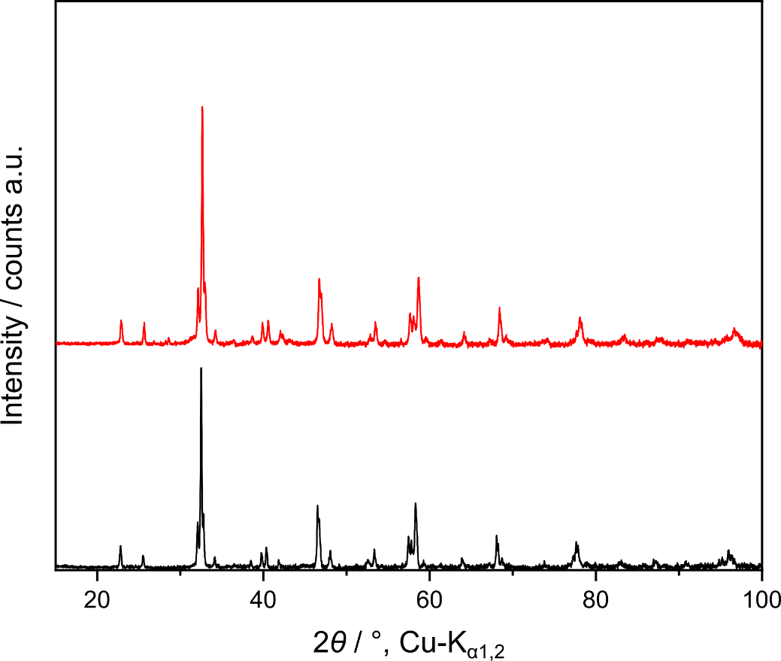
Figure S1. XRD patterns of HEO-La_BM and HEO-Sr_BM after calcination of the ball-milled synthesized materials at 1200 °C for 12 h.

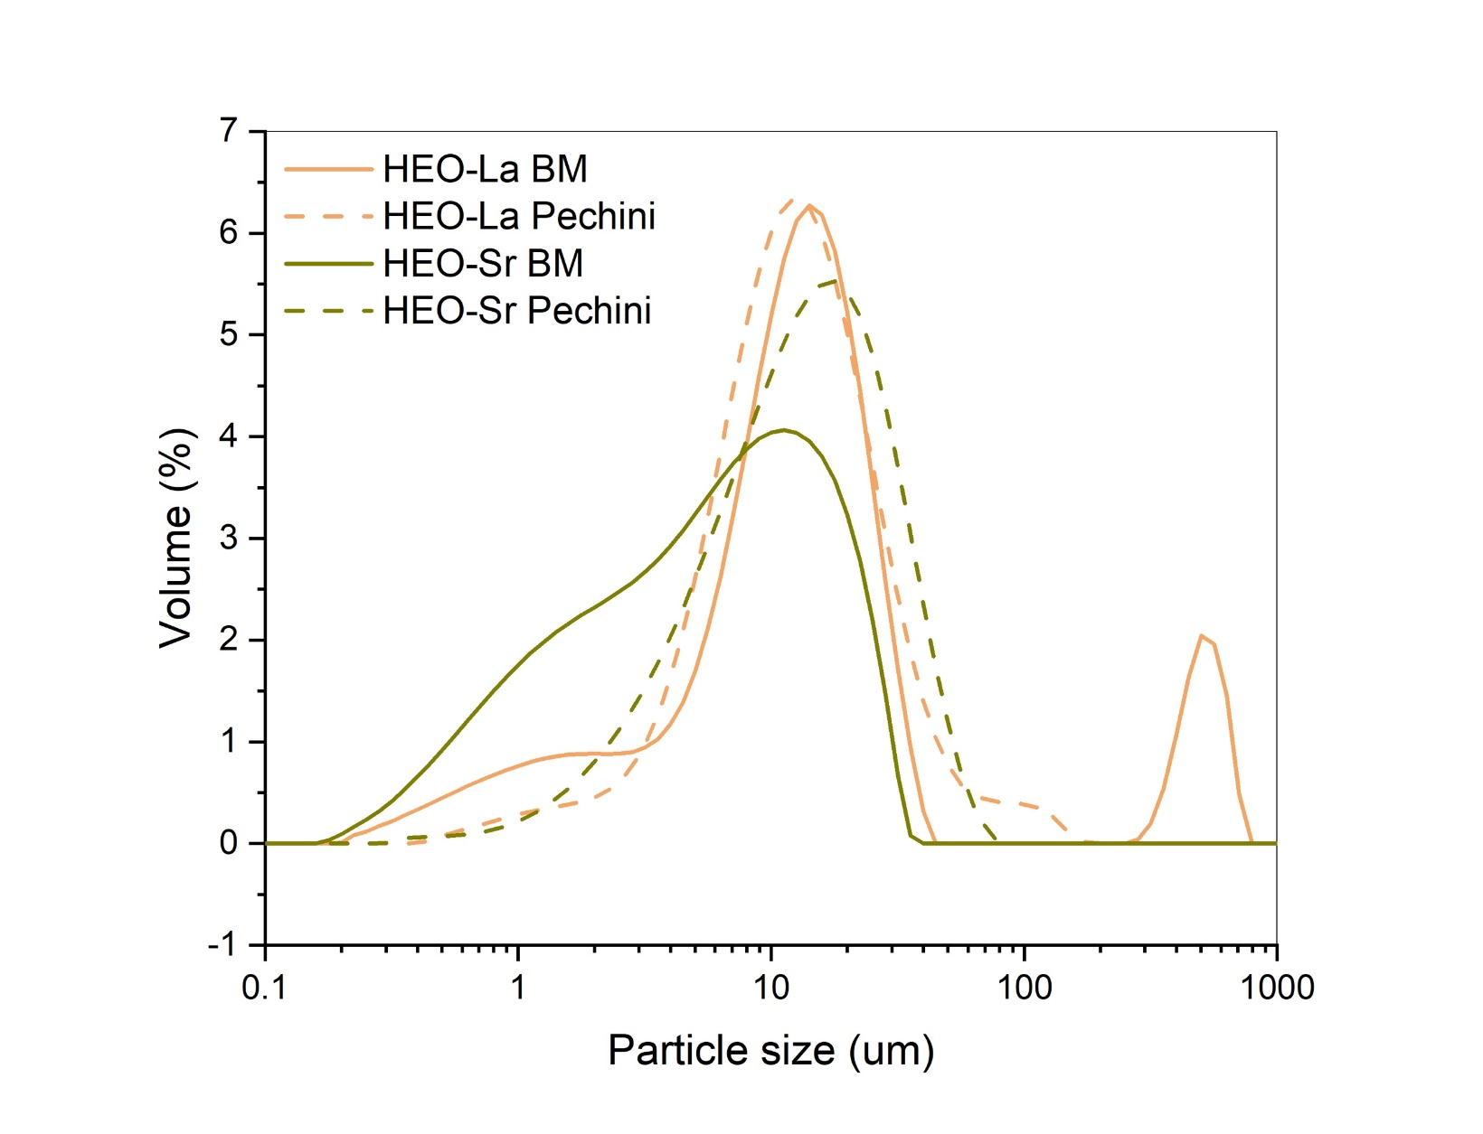
Figure S2. Particle size distribution of HEO-La and HEO-Sr powders synthesized by ball milling and Pechini method.

Table S2. ICP-OES results for HEO-La synthesized using ball milling and Pechini method (SD = standard deviation).
Element | Mass (Pechini) [wt.%] | n  [mol] | SD  [%] | Mass (BM) [wt.%] | n  [mol] | SD  [%]
Gd | 14.01 | 0.21 | 0.09 | 13.43 | 0.21 | 0.15
La | 11.90 | 0.21 | 0.02 | 11.36 | 0.19 | 0.06
Nd | 12.16 | 0.20 | 0.07 | 10.08 | 0.17 | 0.11
Sm | 14.92 | 0.24 | 0.09 | 14.17 | 0.23 | 0.15
Co | 4.99 | 0.20 | 0.02 | 4.73 | 0.19 | 0.04
Cr | 4.53 | 0.21 | 0.01 | 3.68 | 0.17 | 0.04
Fe | 4.70 | 0.20 | 0.02 | 4.52 | 0.19 | 0.07
Mn | 4.91 | 0.21 | 0.03 | 4.68 | 0.20 | 0.04
Ni | 5.15 | 0.21 | 0.02 | 5.07 | 0.21 | 0.05
Y | 7.96 | 0.22 | 0.02 | 7.53 | 0.20 | 0.06

Table S3. ICP-OES results for HEO-Sr synthesized using ball milling and Pechini method (SD = standard deviation).
Element | Mass (Pechini) [wt.%] | n [mol] | SD  [%] | Mass (BM) [wt.%] | n  [mol] | SD  [%]
Gd | 14.84 | 0.22 | 0.10 | 14.26 | 0.20 | 0.28
Sr | 7.74 | 0.20 | 0.10 | 7.41 | 0.19 | 0.25
Nd | 12.91 | 0.21 | 0.12 | 10.90 | 0.17 | 0.34
Sm | 15.83 | 0.24 | 0.14 | 15.02 | 0.23 | 0.42
Co | 5.28 | 0.21 | 0.04 | 5.23 | 0.20 | 0.30
Cr | 4.78 | 0.21 | 0.02 | 2.99 | 0.13 | 0.14
Fe | 4.99 | 0.21 | 0.10 | 4.96 | 0.20 | 0.30
Mn | 5.07 | 0.21 | 0.05 | 4.88 | 0.20 | 0.09
Ni | 5.40 | 0.21 | 0.06 | 5.35 | 0.21 | 0.17
Y | 7.91 | 0.20 | 0.06 | 7.44 | 0.19 | 0.20

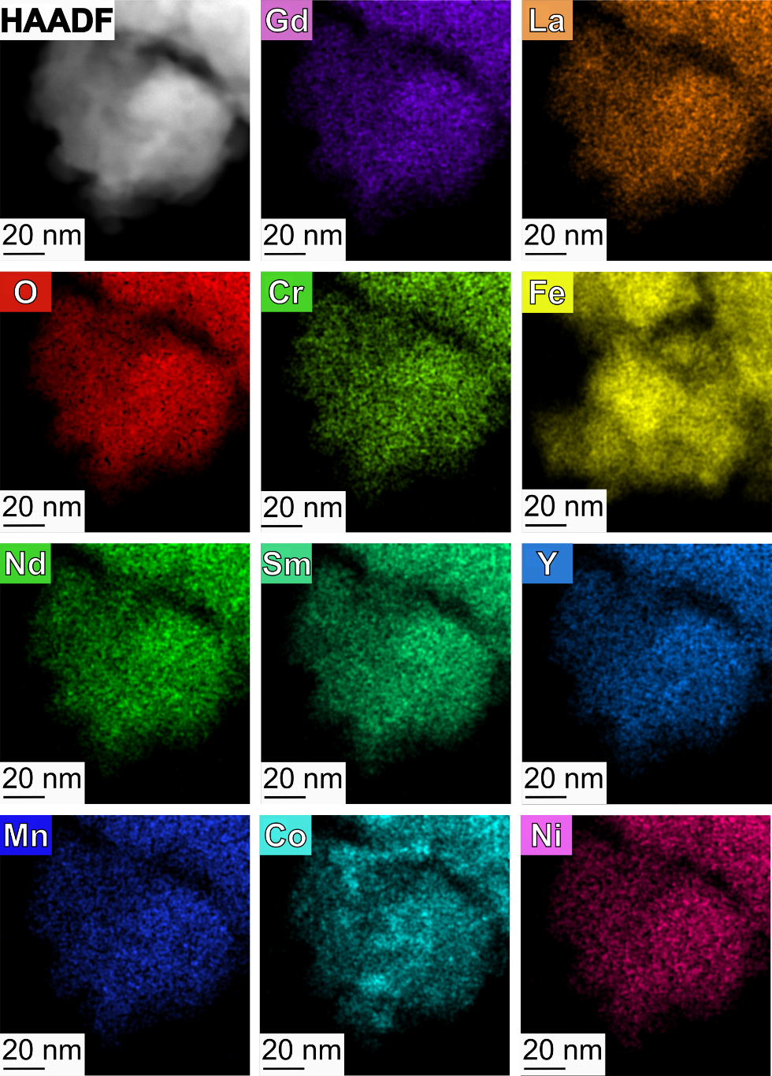
Figure S3. HAADF images and EDX analysis HEO-La_BM.

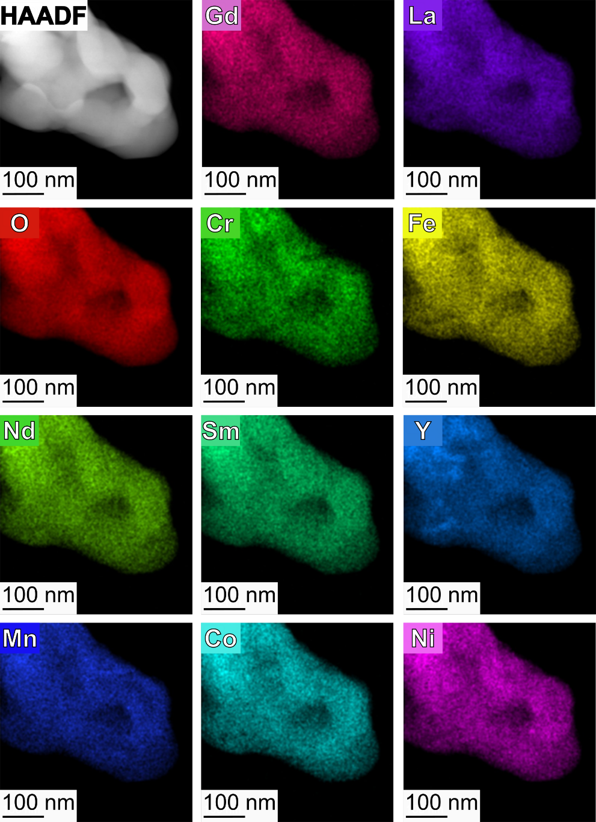
Figure S4. HAADF images and EDX analysis HEO-La_PM. HEO-La_PM was calcined at 1200 °C for 12 h.

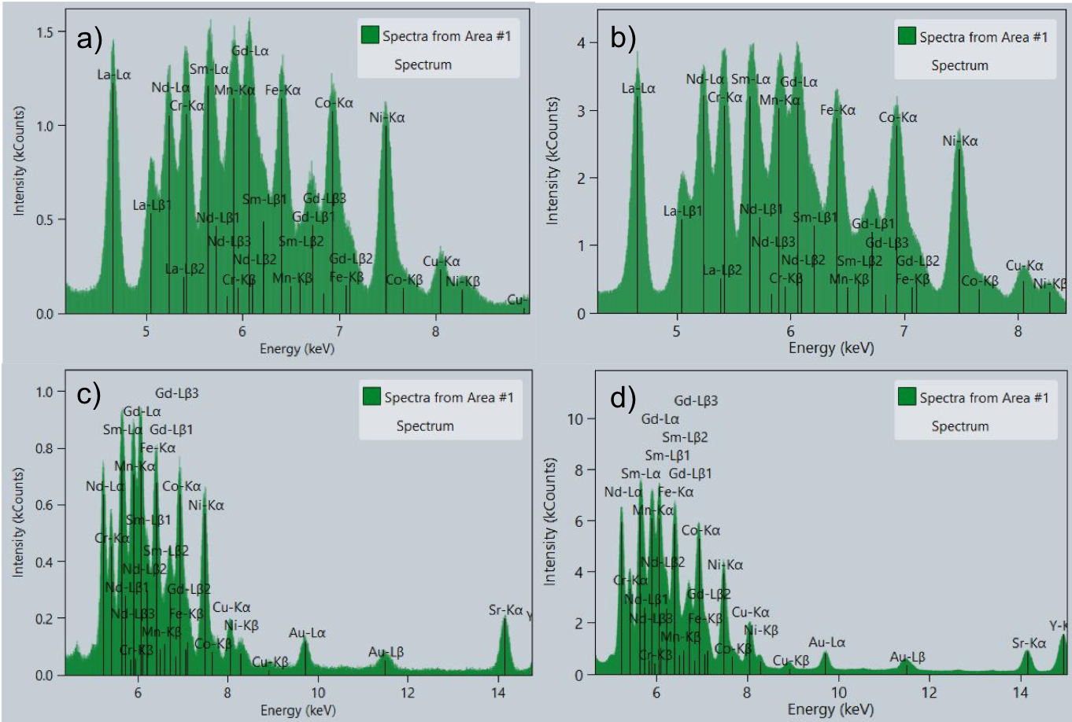
Figure S5. EDX spectra for a) HEO-La_BM, b) HEO-La_PM, c) HEO-Sr_BM and d) HEO-Sr_PM.
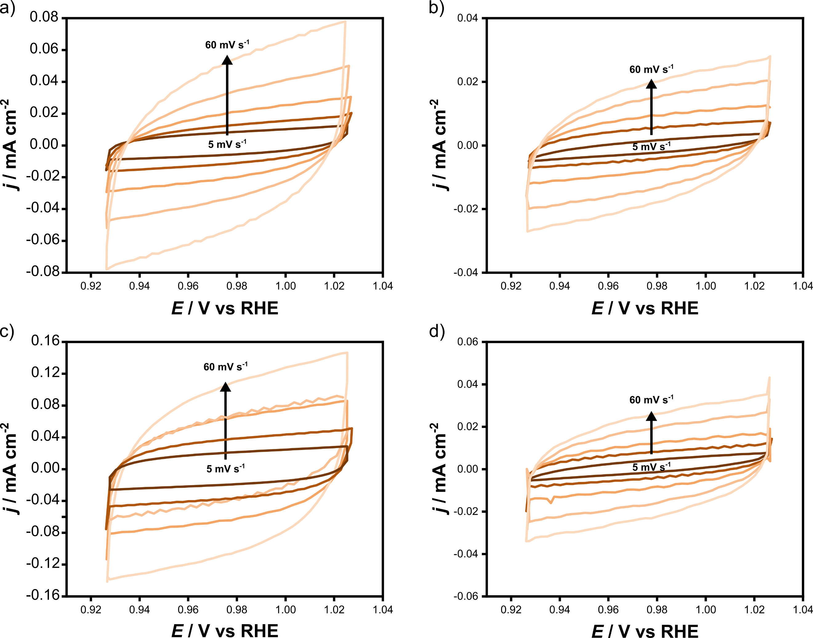
Figure S6. CV curves at different scan rates (5, 10, 20, 40, 60 mV s⁻¹) of a) HEO-La_BM, b) HEO-La_PM, c) HEO-Sr_BM, and d) HEO-Sr_PM

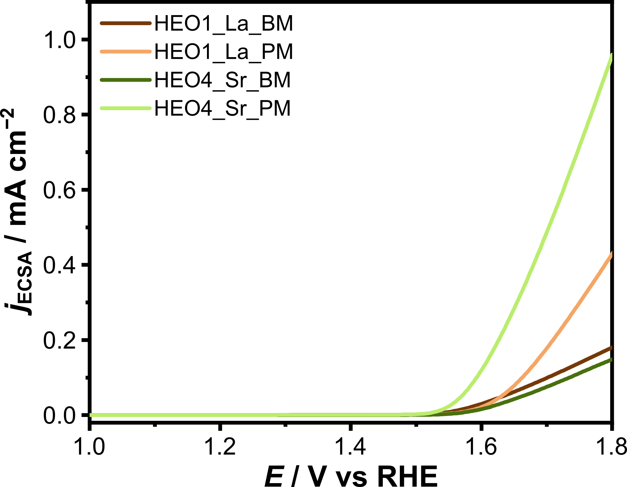
Figure S7. LSV curves normalized to the ECSA.

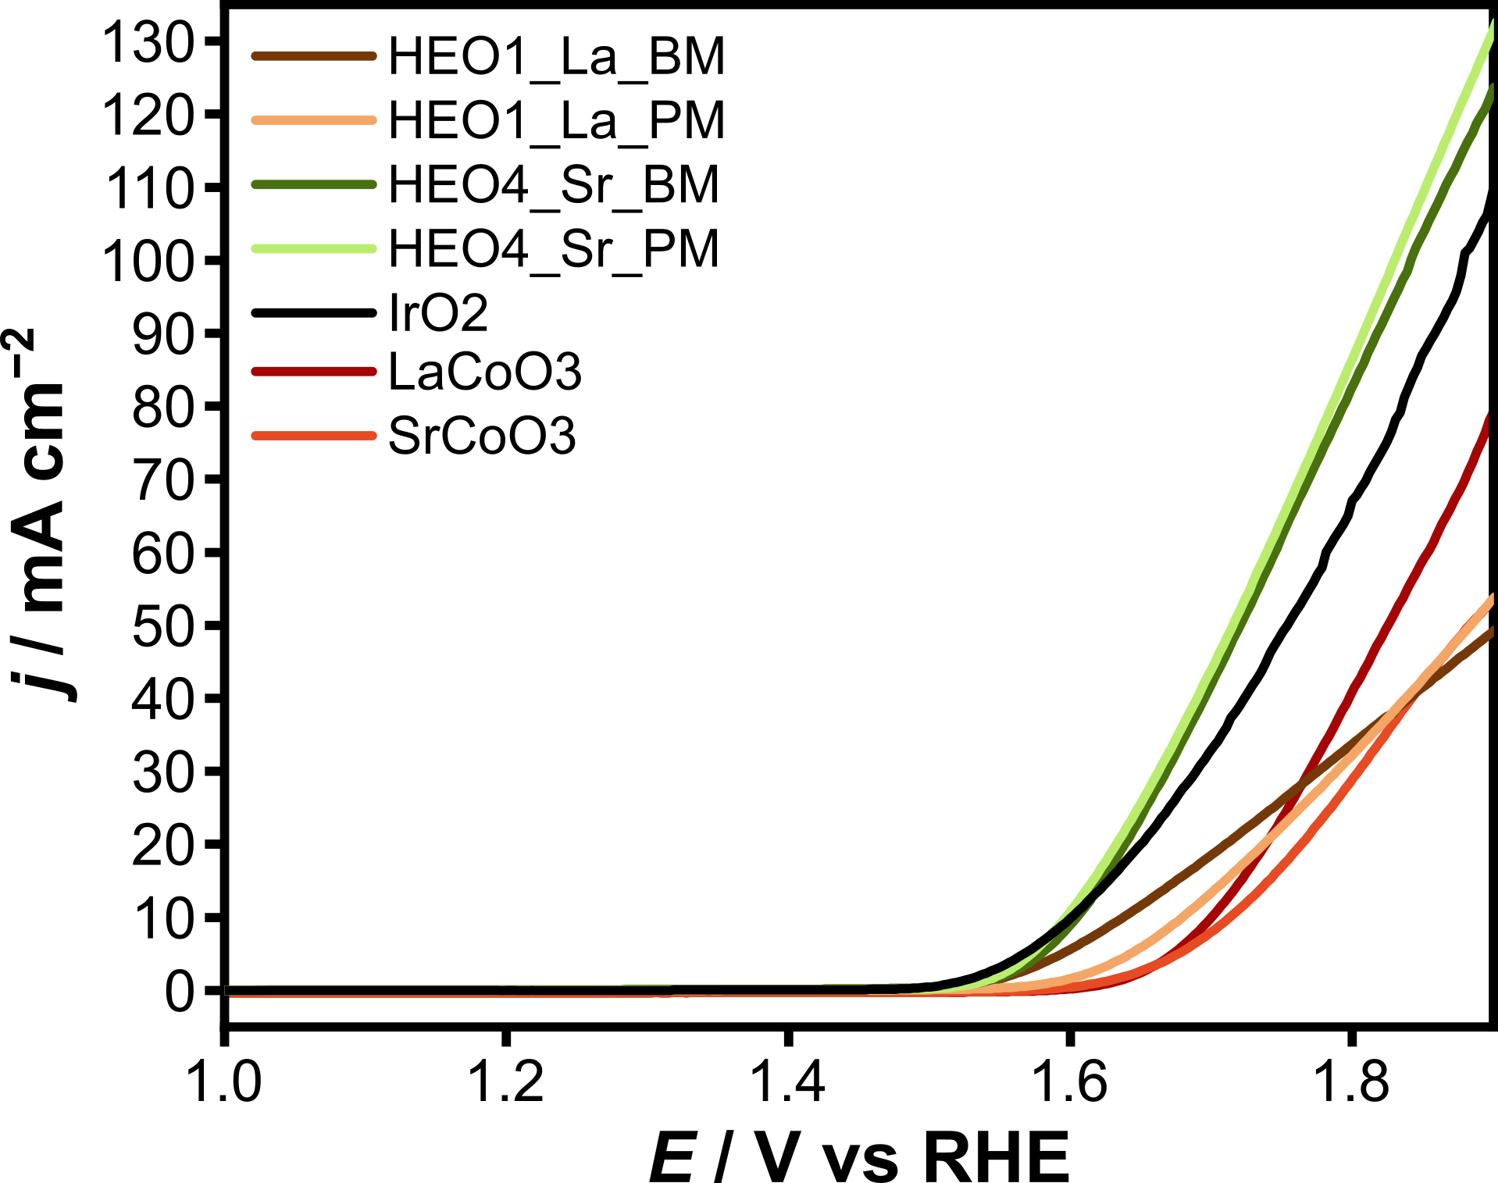
Figure S8. LSV polarization plot toward the OER for different electrocatalysts in 1 M KOH at a scan rate of 5 mV s⁻¹.

