Supporting information

Negative effects of forest gaps on dung removal in a full-factorial experiment

Michael Staab, Rafael Achury, Christian Ammer, Martin Ehbrecht, Veronika Irmscher, Hendrik Mohr, Peter Schall, Wolfgang W. Weisser, Nico Blüthgen

Contents
Table S1. Dung beetle species list and community summary…………………………………………….……….2
Table S2. Pairwise contrasts among treatments……………..………………………………………..…………………3
Table S3. Detailed results for path model……………………………………………………………………………...……4
Figure S1. Schematic illustration of sampling……………………………………………………………………………5
Figure S2. No relationship between dung removal and initial deadwood volume....……………………6
Figure S3. Correlation between total biomass and A. stercorosus biomass……………......………………7
Figure S4. Species composition analyses………………………………………………………………………….……….8
References cited in supplementary material…………………………………………………………………..……...……9

Table S1. Number of individuals of each dung beetle species collected per experimental treatment. Nomenclature follows Rössner (2012). Species-specific individual biomass (in g) and habitat preferences (both taken from Frank et al. 2017) are also given. Summaries of communities per treatment are included at the bottom of the table.
Species | Gap | Gap+  Deadwood | Deadwood | Control | Biomass | Habitat
Geotrupidae
Anoplotrupes stercorosus (Scriba, 1791) | 178 | 159 | 253 | 383 | 0.12915 | forest
Trypocopris vernalis (Linnaeus, 1758) | 25 | 32 | 15 | 21 | 0.23114 | forest
Scarabaeidae
Aphodius depressus (Kugelann, 1792) | 2 | 1 | 28 | 41 | 0.0059 | forest
Aphodius erraticus (Linnaeus, 1758) | 0 | 2 | 0 | 0 | 0.0153 | open land
Aphodius fimetarius (Linnaeus, 1758) | 0 | 0 | 0 | 1 | 0.00898 | indifferent
Aphodius maculatus Sturm, 1800 | 6 | 1 | 15 | 9 | 0.0032 | forest
Aphodius pusillus (Herbst, 1789) | 3 | 6 | 10 | 8 | 0.00385 | forest
Aphodius rufipes (Linnaeus, 1758) | 3 | 6 | 10 | 31 | 0.0405 | forest
Aphodius rufus (Moll, 1782) | 0 | 2 | 1 | 1 | 0.00704 | forest
Aphodius spec. | 1 | 0 | 0 | 0 | 0.0026 | NA
Aphodius sticticus (Panzer, 1798) | 1 | 2 | 4 | 3 | 0.00372 | forest
Aphodius zenkeri Germar, 1813 | 7 | 10 | 19 | 11 | 0.00295 | forest
Onthophagus coenobita (Herbst, 1783) | 0 | 2 | 1 | 1 | 0.02161 | open land
Onthophagus fracticornis (Preyssler, 1790) | 7 | 4 | 1 | 3 | 0.02046 | open land
Onthophagus ovatus (Linnaeus, 1767) | 2 | 0 | 0 | 0 | 0.00282 | open land
Onthophagus similis (Scriba, 1790) | 0 | 0 | 0 | 1 | 0.01105 | open land
Onthophagus verticicornis (Laicharting, 1781) | 1 | 0 | 0 | 2 | 0.0278 | open land
Number of individuals | 236 | 227 | 357 | 516
Species number | 12 | 12 | 11 | 14
Expected species number (Jackknife1 ± SE) | 16±2 | 16±2 | 14±2 | 18±2
Biomass [g], total, mean±SD | 29.1  1.0±1.3 | 28.4  1.0±1.1 | 36.9  1.3±1.6 | 56.1  2.0±3.3
Dung removal [%], mean±SD | 48.5±37.8 | 48.5±39.6 | 56.9±39.7 | 61.9±36.4

Table S2. Pairwise contrasts for comparisons of dung beetle diversity, dung beetle biomass and dung removal among experimental treatments. P-values are Tukey-corrected for multiple comparisons and based on Kenward-Roger-approximated degrees of freedom. Significant contrasts (P<0.05) are printed in bold.
Contrast | Estimate ± SE | t-ratio | P-value
Dung beetle diversity (F=3.202, P(F)=0.027)
Gap – Gap+Deadwood | -0.180 ± 0.232 | -0.774 | 0.866
Gap – Deadwood | -0.286 ± 0.232 | -1.230 | 0.610
Gap – Control | -0.693 ± 0.232 | -2.986 | 0.019
Gap+Deadwood – Deadwood | -0.106 ± 0.232 | -0.456 | 0.968
Gap+Deadwood – Control | -0.514 ± 0.232 | -2.212 | 0.129
Deadwood – Control | -0.408 ± 0.232 | -1.756 | 0.302
Dung beetle biomass (F=3.928, P(F)=0.011)
Gap – Gap+Deadwood | -0.032 ± 0.111 | -0.291 | 0.991
Gap – Deadwood | -0.149 ± 0.111 | -1.340 | 0.541
Gap – Control | -0.344 ± 0.111 | -3.099 | 0.014
Gap+Deadwood – Deadwood | -0.116 ± 0.111 | -1.049 | 0.721
Gap+Deadwood – Control | -0.312 ± 0.111 | -2.809 | 0.031
Deadwood – Control | -0.195 ± 0.111 | -1.759 | 0.300
Dung removal (F=13.703, P(F)<0.001)
Gap – Gap+Deadwood | -0.002 ± 0.026 | -0.060 | 0.999
Gap – Deadwood | -0.087 ± 0.026 | -3.394 | 0.004
Gap – Control | -0.135 ± 0.026 | -5.307 | <0.001
Gap+Deadwood – Deadwood | -0.086 ± 0.026 | -3.341 | 0.005
Gap+Deadwood – Control | -0.134 ± 0.025 | -5.257 | <0.001
Deadwood – Control | -0.048 ± 0.026 | -1.883 | 0.237

Table S3. Full results of the path model (Fisher’s C=8.702, P=0.069) (see Figure 3). Estimates give standardized path coefficients ± SE. Significant paths are shown in bold.
Response | Predictor | Estimate ± SE |  | Critical value | P-value
Causal path
Dung removal | ~ Gap | -0.242 ± 0.067 |  | 13.211 | <0.001
Dung removal | ~ Deadwood | -0.044 ± 0.063 |  | 0.472 | 0.494
Dung removal | ~ Dung beetle diversity | -0.059 ± 0.043 |  | 1.850 | 0.178
Dung removal | ~ Dung beetle biomass | 0.196 ± 0.052 |  | 13.422 | <0.001
Dung removal | ~ Forest cover | -0.012 ± 0.062 |  | 0.037 | 0.850
Dung removal | ~ Canopy openness | -0.192 ± 0.053 |  | 12.870 | 0.001
Dung beetle diversity | ~ Gap | -0.347 ± 0.060 |  | 33.716 | <0.001
Dung beetle diversity | ~ Deadwood | -0.122 ± 0.060 |  | 4.176 | 0.042
Dung beetle diversity | ~ Precipitation | -0.346 ± 0.133 |  | 5.347 | 0.030
Dung beetle diversity | ~ Temperature | 0.005 ± 0.104 |  | 0.002 | 0.964
Dung beetle diversity | ~ Forest cover | -0.130 ± 0.108 |  | 1.248 | 0.275
Dung beetle diversity | ~ Canopy openness | 0.176 ± 0.098 |  | 2.971 | 0.099
Dung beetle biomass | ~ Gap | -0.276 ± 0.045 |  | 37.796 | <0.001
Dung beetle biomass | ~ Deadwood | -0.097 ± 0.044 |  | 4.912 | 0.027
Dung beetle biomass | ~ Precipitation | 0.091 ± 0.139 |  | 0.383 | 0.542
Dung beetle biomass | ~ Temperature | 0.425 ± 0.105 |  | 16.180 | <0.001
Dung beetle biomass | ~ Forest cover | 0.134 ± 0.111 |  | 1.370 | 0.254
Dung beetle biomass | ~ Canopy openness | -0.233 ± 0.010 |  | 5.271 | 0.032
Dung beetle biomass | ~ Dung beetle diversity | 0.150 ± 0.032 |  | 22.620 | <0.001
Correlated error
Temperature | ~~ Precipitation | -0.426 |  | -11.084 | <0.001
D-separation test
Dung depletion ~ Gap + Deadwood + Dung beetle diversity + Dung beetle biomass + Forest cover + Canopy openness + Precipitation |  |  |  | 2.915 | 0.101
Dung depletion ~ Gap + Deadwood + Dung beetle diversity + Dung beetle biomass + Forest cover + Canopy openness + Temperature |  |  |  | 2.474 | 0.128

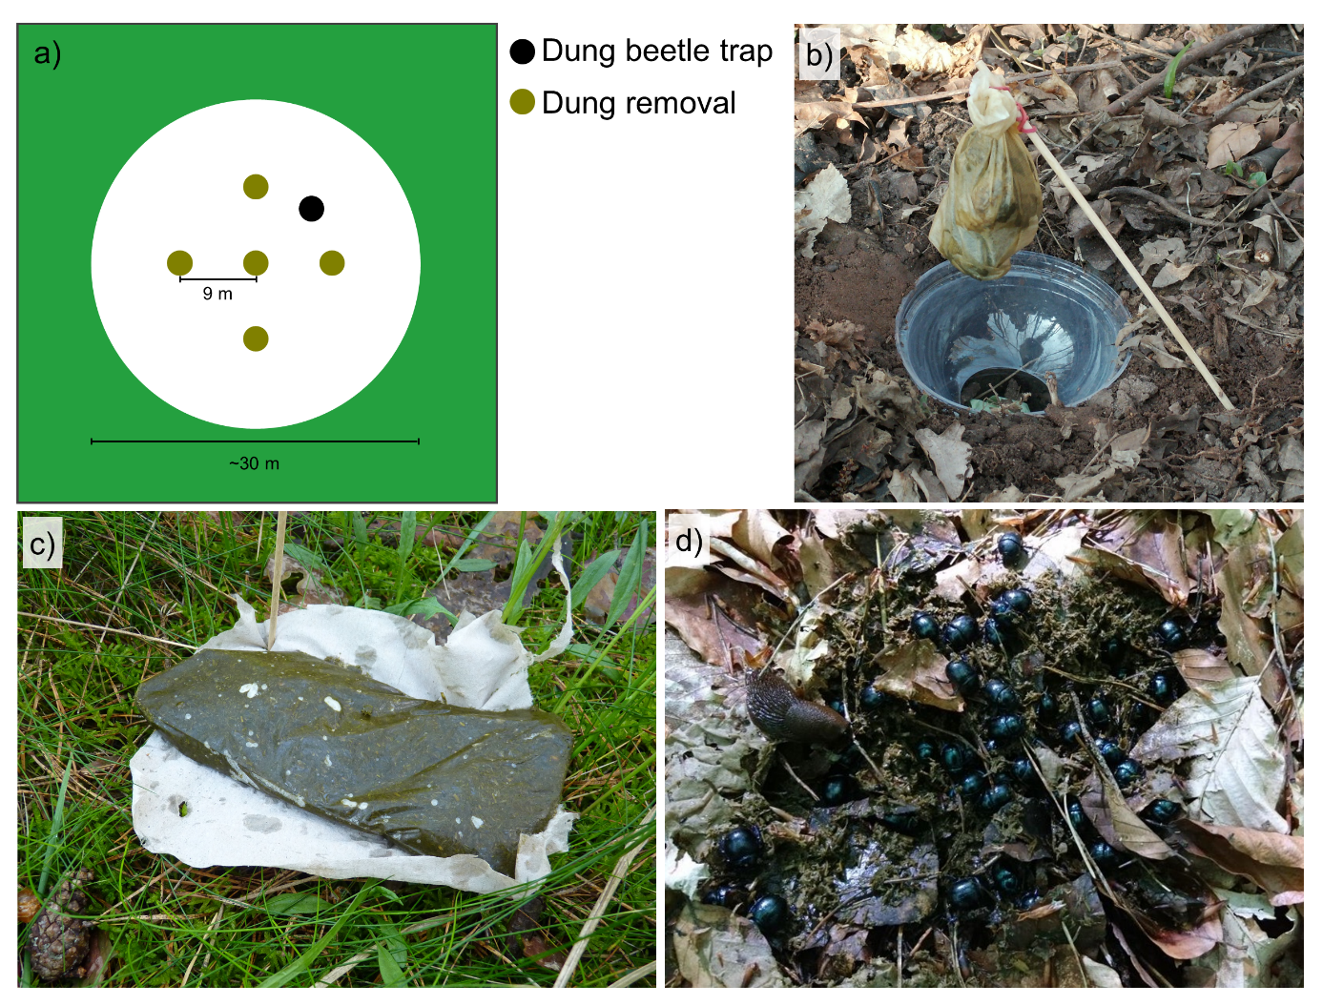
Figure S1. Schematic illustration of dung beetle sampling and measurement of dung removal. a) Per plot (here exemplified by a Gap), one dung beetle trap and five dung removal measurements were placed. b) Dung beetle traps consisted of plastic cups (9 cm diameter, 13 cm height) dug into the ground, covered by a lid with a hole (4 cm diameter) serving as a funnel; a teabag filled with about 35 g cattle dung was attached with a rubber band to a wooden skewer to function as bait. c) For measuring dung removal about 170 g of frozen cattle dung were placed on cellulose paper. d) In some cases, no dung could be retrieved after 48 h as dung was completely buried by dung beetles, especially Anoplotrupes stercorosus (shown). All pictures by Michael Staab.

Figure S2. Dung removal was not related to the initial volume of deadwood (per site) before creating gaps. The dashed line indicates the non-significant prediction of a linear mixed-effects model (response: dung removal; fixed effect: initial deadwood volume; random effect: plot-in-site-in-region; t=0.471, P=0.643). Note that the x-axis is on a square-root scale.

Figure S3. The biomass of all dung beetles was strongly related (Spearman’s ρ=0.933) to the biomass of Anoplotrupes stercorosus, the most common species in the sampling. Note that both axes are on a square-root scale.
Figure S4. The creation of gaps had no influence on dung beetle community composition. a) Two-dimensional NMDS ordination based on biomass (stress=0.21). Composition overlaps (PERMANOVA; F=1.186, P=0.310) between open (Gap, Gap+Deadwood) and covered plots (Deadwood, Control). b) Relative contributions to species and c) biomass are dominated by species preferring forests (using the classification of Frank et al. 2017) with no difference between open and covered plots (ANOVA; proportion forest species: F=1.340, P=0.251; proportion biomass forest species: F=1.479, P=0.229). Data in b) and c) are shown as violin plots, fusing boxplots with kernel densities.
References cited in supplementary material
Frank K, Hülsmann M, Assmann T, Schmitt T, Blüthgen N (2017) Land use affects dung beetle communities and their ecosystem service in forests and grasslands. Agriculture Ecosystems & Environment 243: 114–122. https://doi.org/10.1016/j.agee.2017.04.010
Rössner E (2012) Die Hirschkäfer und Blatthornkäfer Ostdeutschlands (Coleoptera: Scarabaeoidea). Verein der Freunde und Förderer des Naturkundemuseums Erfurt, Erfurt, Germany.

