Progress in Earth and Planetary Science

Metal contamination in a sediment core from Osaka Bay during the last 400 years

Kai Nils Nitzsche, Toshihiro Yoshimura, Naoto F. Ishikawa, Hiroto Kajita, Hodaka Kawahata, Nanako O. Ogawa, Katsuhiko Suzuki, Yusuke Yokoyama, and Naohiko Ohkouchi

Email contact: kai.nitzsche@jamstec.go.jp
License: CC BY 4.0 International - Creative Commons, Attribution

Table S1. Cu, Zn. Pb, Co and Ni concentrations in the exchangeable fraction extracted by 1M NH₄Cl and their proportion (%) in the acid-soluble fraction extracted two times with 0.11M acetic acid (Hac) of ten selected samples.
Core depth | Year (AD) | Cu | Zn | Co | Ni | Pb | Cu_{NH4Cl} | Zn_{NH4Cl} | Co_{NH4Cl} | Ni_{NH4Cl} | Pb_{NH4Cl}
(cm) |  | (µg g⁻¹) | (µg g⁻¹) | (µg g⁻¹) | (µg g⁻¹) | (µg g⁻¹) | (%, HAc) | (%, HAc) | (%, HAc) | (%, HAc) | (%, HAc)
2 to 4 | 1991 | 0.7 | 3.6 | 0.02 | 0.2 | 0.08 | 28 | 7 | 2 | 6 | 10
12 to 14 | 1972 | 0.8 | 5.5 | 0.02 | 0.2 | 0.06 | 25 | 7 | 1 | 6 | 6
18 to 20 | 1960 | 1.1 | 6.1 | 0.00 | 0.2 | 0.06 | 29 | 6 | 0 | 6 | 31
32 to 34 | 1933 | 0.6 | 0.8 | 0.02 | 0.1 | 0.05 | 25 | 4 | 1 | 5 | 6
42 to 44 | 1898 | 0.3 | 0.1 | 0.00 | 0.2 | 0.05 | 26 | 1 | 0 | 7 | 12
290 to 292 | 959 | 0.1 | 0.5 | 0.01 | 0.2 | 0.03 | 40 | 16 | 1 | 8 | 2
390 to 392 | 680 | 0.1 | 0.6 | 0.01 | 0.2 | 0.02 | 31 | 17 | 0 | 8 | 2
480 to 482 | 497 | 0.1 | 0.5 | 0.01 | 0.2 | 0.08 | 47 | 12 | 1 | 8 | 1
630 to 632 | 190 | 0.1 | 0.6 | 0.01 | 0.2 | 0.02 | 54 | 18 | 1 | 9 | 2
830 to 832 | -225 | 0.1 | 0.3 | 0.03 | 0.2 | 0.03 | 33 | 10 | 2 | 8 | 4

Table S2. Bulk Cu, Zn, Pb, Co and Ni concentrations and δ⁶⁶Zn values of samples analyzed for Zn stable isotopes of the core OS5B. *ND: not determined
Core depth | Year (AD) | δ⁶⁶Zn | 2σ | Co | Ni | Cu | Zn | Pb
(cm) |  | (‰) | (‰) | (µg g⁻¹)
2 to 4 | 1991 | 0.22 | 0.03 | 14.4 | 41 | 39 | 223 | 40
4 to 6 | 1988 | 0.22 | 0.02 | 13.7 | 41 | 39 | 208 | 38
6 to 8 | 1984 | 0.19 | 0.02 | 14.8 | 40 | 37 | 211 | 38
8 to 10 | 1980 | 0.22 | 0.02 | 13.4 | 38 | 38 | 204 | 38
10 to 12 | 1976 | 0.20 | 0.03 | 13.2 | 38 | 35 | 220 | 39
12 to 14 | 1972 | 0.22 | 0.07 | 13.6 | 41 | 40 | 251 | 46
14 to 16 | 1968 | 0.23 | 0.03 | 13.5 | 39 | 38 | 245 | 43
16 to 18 | 1964 | 0.22 | 0.02 | 14.9 | 41 | 44 | 270 | 49
18 to 20 | 1960 | 0.23 | 0.03 | 15.4 | 44 | 46 | 289 | 49
20 to 22 | 1956 | 0.22 | 0.03 | 14.7 | 41 | 44 | 256 | 47
22 to 24 | 1952 | 0.24 | 0.04 | 13.8 | 41 | 39 | 211 | 40
24 to 26 | 1949 | 0.24 | 0.03 | 13.9 | 42 | 38 | 211 | 38
26 to 28 | 1945 | 0.26 | 0.02 | 14.0 | 47 | 38 | 194 | 39
28 to 30 | 1941 | 0.24 | 0.01 | 14.3 | 48 | 38 | 204 | 39
30 to 32 | 1937 | 0.26 | 0.02 | 13.1 | 49 | 36 | 148 | 34
32 to 34 | 1933 | ND* |  | 12.9 | 49 | 34 | 142 | 33
34 to 36 | 1924 | 0.25 | 0.02 | 12.8 | 46 | 34 | 141 | 33
36 to 38 | 1918 | 0.25 | 0.02 | 12.7 | 53 | 31 | 130 | 31
38 to 40 | 1911 | 0.36 | 0.02 | 12.6 | 41 | 32 | 135 | 31
40 to 42 | 1904 | 0.26 | 0.01 | 12.7 | 41 | 31 | 125 | 30
42 to 44 | 1898 | 0.26 | 0.01 | 12.4 | 41 | 27 | 114 | 29
44 to 46 | 1891 | ND |  | 12.5 | 41 | 29 | 118 | 32
46 to 48 | 1884 | 0.27 | 0.02 | 12.4 | 42 | 26 | 110 | 28
48 to 50 | 1878 | 0.26 | 0.03 | 12.2 | 41 | 27 | 118 | 29
50 to 52 | 1871 | 0.27 | 0.02 | 12.3 | 41 | 25 | 111 | 28
52 to 54 | 1864 | 0.29 | 0.02 | 11.9 | 41 | 25 | 107 | 27
66 to 68 | 1817 | 0.32 | 0.03 | 11.7 | 39 | 24 | 105 | 26
80 to 82 | 1763 | 0.27 | 0.03 | 12.2 | 40 | 24 | 107 | 26
96 to 98 | 1707 | 0.31 | 0.02 | 11.8 | 39 | 22 | 104 | 25
Figure S1. Catchment of Osaka Bay (bold black line) with prefectural boundaries (thin black lines) and location of the sediment cores collected at station OS5B.

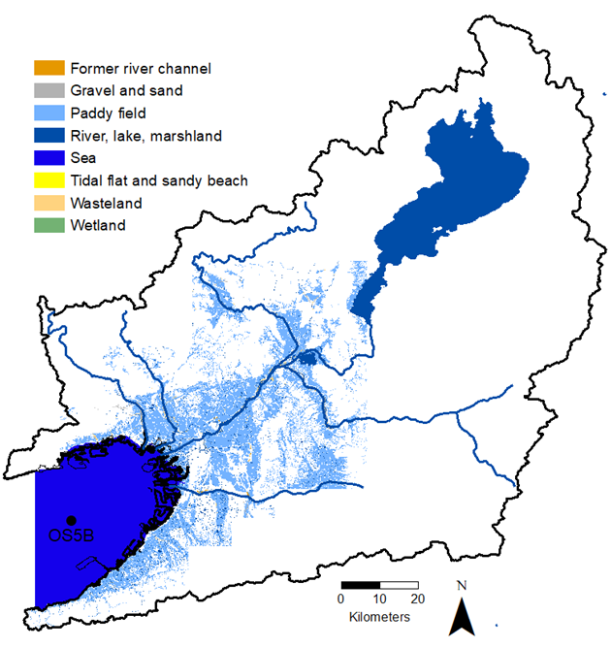
Figure S2. Swampy lowlands during the early Meiji era. Source: Technical Report of the Geospatial Information Authority of Japan (Technical Report D1-No.633, Marsh data in the early Meiji Era (Kinki District)).

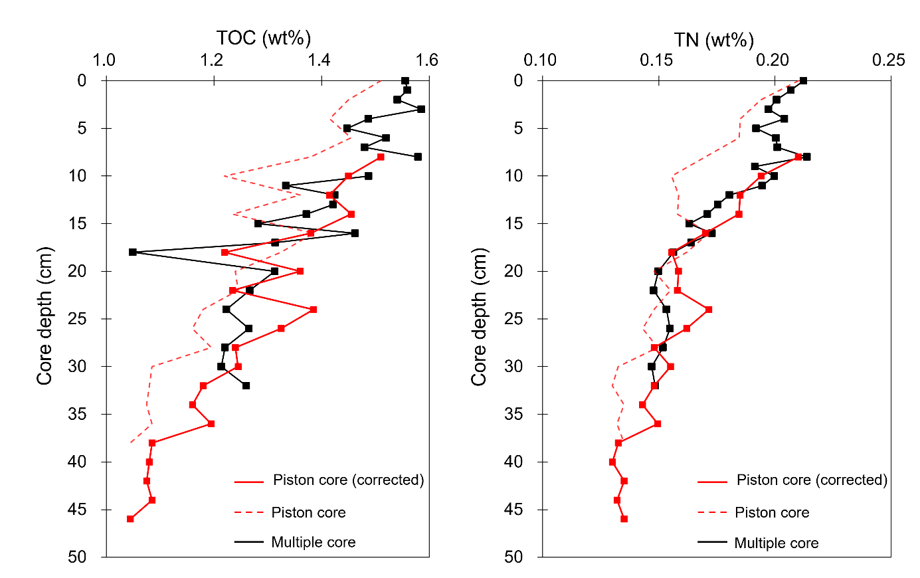
Figure S3. Comparison of total organic carbon (TOC) and total nitrogen (TN) concentrations between the piston core and the multi core.

Figure S4. Time profiles of the enrichment factor (EF) of Zn, Cu, Pb, Ni and Co in the piston core during the last 2300 years. *Azuchi-Momoyama period.

Figure S5. Time profiles of the chemical index of alteration (CIA) calculated from the residual fraction (F4). *Azuchi-Momoyama period.

Figure S6. Biplots of trace metal concentrations against chemical index of alteration (CIA) calculated from the residual fraction (F4).

Figure S7. Time profiles of the Zn contribution estimated based on a simple binary mixing model following equation (3).

