Supplementary File 1
Identification of adjustment variables using Directed Acyclic Graphs (DAGs)

Basic adjustment:
Matching group, age at recruitment, birth year

Identified adjustment variables using Directed Acyclic Graphs (DAGs):
Outcome | Adjustment variables
BMI | Ethnicity, ISCED, cancer therapy
Physical activity | ISCED
Soft drinks | ISCED
Alcohol | Ethnicity, ISCED, cancer therapy
Smoking | ISCED, cancer therapy
Pack years | ISCED, cancer therapy
Passive smoking | Cancer therapy
Medication | Cancer therapy
Comorbidities | Genetic family, cancer therapy
Health Score | Ethnicity, genetic family

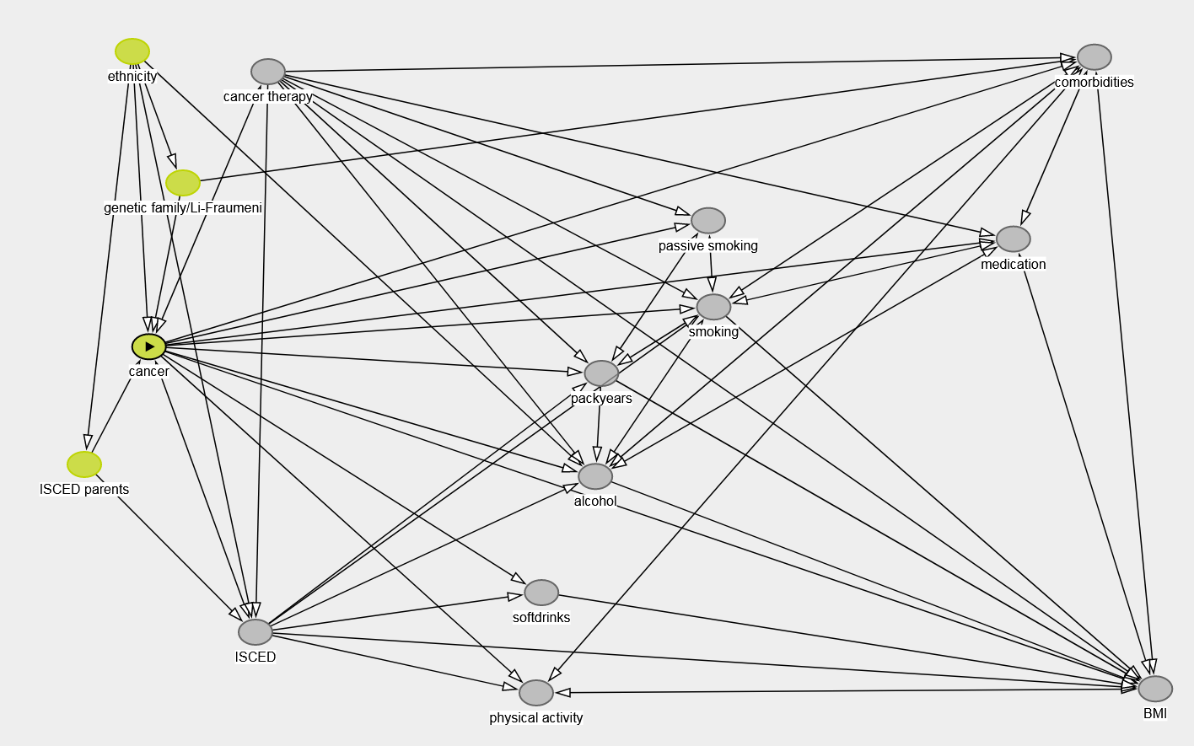
Supplementary Figure 1: DAG on the association between cancer in childhood and late adverse health effects as well as lifestyle parameters

Code DAGs:
dag {
"ISCED parents" [pos="-1.909,0.417"]
"cancer therapy" [pos="-1.367,-1.542"]
"genetic family/Li-Fraumeni" [pos="-1.618,-0.987"]
"passive smoking" [pos="-0.068,-0.799"]
"physical activity" [pos="-0.576,1.556"]
BMI [pos="1.251,1.536"]
ISCED [pos="-1.404,1.253"]
alcohol [pos="-0.401,0.477"]
cancer [exposure,pos="-1.718,-0.170"]
comorbidities [pos="1.071,-1.614"]
ethnicity [pos="-1.767,-1.642"]
medication [pos="0.832,-0.707"]
packyears [pos="-0.383,-0.037"]
smoking [pos="-0.052,-0.368"]
softdrinks [pos="-0.560,1.056"]
"ISCED parents" -> ISCED
"ISCED parents" -> cancer
"cancer therapy" -> "passive smoking"
"cancer therapy" -> BMI
"cancer therapy" -> ISCED
"cancer therapy" -> alcohol
"cancer therapy" -> comorbidities
"cancer therapy" -> medication
"cancer therapy" -> packyears
"cancer therapy" -> smoking
"cancer therapy" <-> cancer
"genetic family/Li-Fraumeni" -> cancer
"genetic family/Li-Fraumeni" -> comorbidities
"passive smoking" <-> packyears
"passive smoking" <-> smoking
"physical activity" <-> BMI
"physical activity" <-> comorbidities
BMI <-> comorbidities
BMI <-> medication
ISCED -> "physical activity"
ISCED -> BMI
ISCED -> alcohol
ISCED -> packyears
ISCED -> smoking
ISCED -> softdrinks
ISCED <-> cancer
alcohol -> BMI
alcohol <-> comorbidities
alcohol <-> medication
alcohol <-> smoking
cancer -> "passive smoking"
cancer -> "physical activity"
cancer -> BMI
cancer -> alcohol
cancer -> comorbidities
cancer -> medication
cancer -> packyears
cancer -> smoking
cancer -> softdrinks
comorbidities <-> medication
comorbidities <-> smoking
ethnicity -> "ISCED parents"
ethnicity -> "genetic family/Li-Fraumeni"
ethnicity -> ISCED
ethnicity -> alcohol
ethnicity -> cancer
medication <-> smoking
packyears -> BMI
packyears -> alcohol
packyears <-> smoking
smoking -> BMI
softdrinks -> BMI
}
Supplementary File 2
Sensitivity analyses on lifestyle of childhood cancer survivors stratified by cancer site of first primary neoplasm and living situation

Supplementary Table 1: Stratified adjusted logistic regression on cancer status and risk of late effects¹
Cancer status | Leukemia |  |  | Lymphoma |  |  | Living with a partner
 | OR (95% CI) | OR (95% CI) | OR (95% CI) | OR (95% CI) | OR (95% CI) | OR (95% CI) | OR (95% CI) | OR (95% CI) | OR (95% CI)
Body Mass Index
 | overweight vs. normal weight | obesity vs. normal weight |  | overweight vs. normal weight | obesity vs. normal weight |  | overweight vs. normal weight | obesity vs. normal weight
CO | Ref.² | Ref.² |  | Ref.² | Ref.² |  | Ref.² | Ref.²
FPN and SPN | 0.565 (0.304; 1.052) | 0.563 (0.271; 1.171) |  | 0.603 (0.29; 1.256) | 0.388 (0.134; 1.121) |  | 0.466 (0.178; 1.223) | 0.473 (0.131; 1.717)
FPN | Ref.³ | Ref.³ |  | Ref.³ | Ref.³ |  | Ref.³ | Ref.³
SPN | 0.954 (0.274; 3.319) | 0.71 (0.162; 3.116) |  | 2.35 (0.847; 6.523) | 1.393 (0.245; 7.914) |  | - ( -; -) | - ( -; -)
Physical activity (hours per week)
 | 1-2 hours vs. 0 hours | 3-4 hours vs. 0 hours | 5+ hours vs. 0 hours | 1-2 hours vs. 0 hours | 3-4 hours vs. 0 hours | 5+ hours vs. 0 hours | 1-2 hours vs. 0 hours | 3-4 hours vs. 0 hours | 5+ hours vs. 0 hours
CO | Ref.⁴ | Ref.⁴ | Ref.⁴ | Ref.⁴ | Ref.⁴ | Ref.⁴ | Ref.⁴ | Ref.⁴ | Ref.⁴
FPN and SPN | - ( -; -) | - ( -; -) | - ( -; - ) | - ( -; -) | - ( -; -) | - ( -; - ) | - ( -; -) | - ( -; -) | - ( -; - )
FPN | Ref.⁴ | Ref.⁴ | Ref.⁴ | Ref.⁴ | Ref.⁴ | Ref.⁴ | Ref.⁴ | Ref.⁴ | Ref.⁴
SPN | - ( -; -) | - ( -; -) | - ( -; - ) | - ( -; -) | - ( -; -) | - ( -; - ) | - ( -; -) | - ( -; -) | - ( -; - )
Consumption of soft drinks per day
 | <1 vs. 0 | 1+ vs. 0 |  | <1 vs. 0 | 1+ vs. 0 |  | <1 vs. 0 | 1+ vs. 0
CO | Ref.⁴ | Ref.⁴ |  | Ref.⁴ | Ref.⁴ |  | Ref.⁴ | Ref.⁴
FPN and SPN | 0.334 (0.156; 0.712) | 0.467 (0.172; 1.268) |  | 0.537 (0.227; 1.268) | 1.807 (0.629; 5.194) |  | 0.474 (0.145; 1.54) | 0.636 (0.144; 2.804)
FPN | Ref.⁴ | Ref.⁴ |  | Ref.⁴ | Ref.⁴ |  | Ref.⁴ | Ref.⁴
SPN | 0.556 (0.23; 1.343) | 0.343 (0.082; 1.43) |  | 1.813 (0.568; 5.78) | 1.272 (0.324; 4.999) |  | 0.591 (0.209; 1.667) | 0.473 (0.096; 2.317)
Alcoholic beverages per day
 | <1 vs. 0 | 1+ vs. 0 |  | <1 vs. 0 | 1+ vs. 0 |  | <1 vs. 0 | 1+ vs. 0
CO | Ref.² | Ref.² |  | Ref.² | Ref.² |  | Ref.² | Ref.²
FPN and SPN | 0.881 (0.459; 1.691) | 0.207 (0.064; 0.67) |  | 0.808 (0.386; 1.691) | 0.523 (0.16; 1.709) |  | 0.808 (0.306; 2.138) | 0.121 (0.025; 0.574)
FPN | Ref.³ | Ref.³ |  | Ref.³ | Ref.³ |  | Ref.³ | Ref.³
SPN | 0.294 (0.111; 0.776) | 0.218 (0.012; 3.983) |  | 0.858 (0.255; 2.889) | 1.072 (0.175; 6.585) |  | - ( -; -) | - ( - ; -)
Table continues

Supplementary Table 1: Continued
Smoking status
 | former vs. never | current vs. never |  | former vs. never | current vs. never |  | former vs. never | current vs. never
CO | Ref.⁴ | Ref.⁴ |  | Ref.⁴ | Ref.⁴ |  | Ref.⁴ | Ref.⁴
FPN and SPN | 0.249 (0.112; 0.554) | 0.416 (0.179; 0.966) |  | 0.346 (0.178; 0.675) | 0.355 (0.159; 0.79) |  | 0.106 (0.038; 0.298) | 0.262 (0.114; 0.604)
FPN | Ref.⁵ | Ref.⁵ |  | Ref.⁵ | Ref.⁵ |  | Ref.⁵ | Ref.⁵
SPN | 1.951 (0.53; 7.18) | 1.642 (0.537; 5.024) |  | 0.584 (0.17; 2.002) | 0.75 (0.215; 2.617) |  | - ( -; -) | - ( - ; -)
Pack years
 | <5 vs. never smoked | 5+ vs. never smoked |  | <5 vs. never smoked | 5+ vs. never smoked |  | <5 vs. never smoked | 5+ vs. never smoked
CO | Ref.⁴ | Ref.⁴ |  | Ref.⁴ | Ref.⁴ |  | Ref.⁴ | Ref.⁴
FPN and SPN | 0.773 (0.321; 1.859) | 0.149 (0.049; 0.459) |  | 0.979 (0.427; 2.247) | 0.191 (0.077; 0.472) |  | 0.58 (0.188; 1.793) | 0.078 (0.033; 0.185)
FPN | Ref.⁵ | Ref.⁵ |  | Ref.⁵ | Ref.⁵ |  | Ref.⁵ | Ref.⁵
SPN | 1.868 (0.509; 6.859) | 1.921 (0.48; 7.689) |  | 0.239 (0.037; 1.539) | 1.472 (0.431; 5.029) |  | - ( -; -) | - ( - ; -)
Passive smoking
 | yes vs. no |  |  | yes vs. no |  |  | yes vs. no
CO | Ref.⁶ |  |  | Ref.⁶ |  |  | Ref.⁶
FPN and SPN | 0.422 (0.212; 0.843) |  |  | 0.463 (0.198; 1.08) |  |  | 0.336 (0.144; 0.784)
FPN | Ref.⁷ |  |  | Ref.⁷ |  |  | Ref.⁷
SPN | 0.284 (0.034; 2.383) |  |  | 3.826 (1.044; 14.02) |  |  | 0.523 (0.085; 3.205)

Adjustment variables were selected using directed acyclic graphs
Abbreviations: confidence interval (CI), cancer-free control (CO), first primary neoplasm (FPN), International Standard Classification for Education (ISCED), odds ratio (OR), second primary neoplasm (SPN)
¹ Missing values are shown but not included in the analysis
² Additionally adjusted for ISCED and ethnicity
³ Additionally adjusted for ISCED, ethnicity, and therapy of FPN
⁴ Additionally adjusted for ISCED
⁵ Additionally adjusted for ISCED and therapy of FPN
⁶ DAGs identified no additional adjustment variables for this model
⁷ Additionally adjusted for therapy of FPN

