Global Distribution of Oxygenated Polycyclic Aromatic Hydrocarbons (OPAHs) in Mineral Topsoils

Wolfgang Wilcke¹, Moritz Bigalke², Chong Wei^{3,4}, Yongming Han^{4,5}, Benjamin A. Musa Bandowe⁶

¹ Institute of Geography and Geoecology, Karlsruhe Institute of Technology (KIT), Reinhard-Baumeister-Platz 1, 76131 Karlsruhe, Germany
² Institute of Geography, University of Bern, Hallerstrasse 12, 3012 Bern, Switzerland
³ Shanghai Carbon Data Research Center, Key Laboratory of Low-carbon Conversion Science and Engineering, Shanghai Advanced Research Institute, Chinese Academy of Science, Shanghai 201210, China
⁴ State Key Laboratory of Loess and Quaternary Geology, Institute of Earth Environment, Chinese Academy of Sciences, Xi’an 710061, China
⁵ School of Human Settlements and Civil Engineering, Xi’an Jiaotong University. Xi’an 710049, China
⁶ Department of Multiphase Chemistry, Max Planck Institute for Chemistry, Hahn-Meitner-Weg 1, 55128 Mainz, Germany

This file includes supporting information: Text SI, Table S1, Table S2 (in a separate Microsoft Excel file), and Figures S1-S5.

Corresponding Author: W. Wilcke, Email: wolfgang.wilcke@kit.edu
License: CC BY 4.0 International - Creative Commons, Attribution
Text SI: Quality control
The quality control measures adopted during the analysis of the soil samples have been outlined in previous work (Bandowe and Wilcke, 2010; Bandowe et al., 2010; 2011; 2014; 2019a, b; Wilcke et al., 2014a, b). High purity “picograde”, HPLC-grade, or pesticide residue grade organic solvents were used during the analytical procedure. All labware were cleaned in a dish washer and dried in an oven. Non-volumetric glass and metalware were baked at 250°C or 300 °C for 12 to 24 hrs. Glassware were rinsed with high purity “picograde” or HPLC-grade organic solvents before use. After use, glassware were rinsed with technical-grade acetone and water subsequent to being washed in a dishwasher. Aliquots of known mass of the European Reference Material (ERM-CC013a: Polycyclic Aromatic Hydrocarbons in Soil) from the Federal Institute for Materials Research and Testing [BAM], Berlin, Germany and several blanks (made up of the inert bulk sorbent, HM-N, Biotage, Sweden or diatomaceous earth, Dionex, Sunnyvale, CA, U.S.A.) were transferred into Accelerated Solvent Extractor (ASE) cells, spiked with known amounts of deuterated internal standards, extracted, and analyzed together with the soil samples using the same laboratory procedures. Identification of the target polycyclic aromatic compounds (PACs: OPAHs and PAHs) in extracts was based on a comparison of their retention time and mass spectra (target and qualifier ions) to those of authentic standards (used for calibration) that were measured on the GC/MS together with the extracts of soil samples in the measurement sequence. For a PAC to be identified in the chromatogram of an extract of a sample, the retention time must not have been different from that of the same compound in the calibration standard by ±0.02 minutes, while the ratio of the target to qualifier ion must have been within ±20% of that of the same OPAH in the calibration standard. Quantification of the target compounds in extracts of soil samples, ERM-CC013a, and blanks was based on the internal standard technique. The amounts of the target PACs in the blanks were generally low or even below the limit of determination (LOD). If a target compound was detected in the blank, its amount was subtracted from the amount of the same compound before calculating its concentration. The accuracy of the analytical procedure was checked by comparing the concentrations of the PAHs determined with our analytical procedure for ERM-CC013a with the certified and indicator concentration values provided by the BAM. The recovery (mean±standard deviation) from the ERM-CC013a of the sum of PAHs for which they are certified or given as indicator concentrations was 79±4%. The relative standard deviation (RSD) of the sum of PAH concentrations was 5.2% while the RSD of the recoveries of individual PAH ranged from 0.3 to 17%. Since there are no reference soils with certified concentration values for OPAHs, the accuracy of the OPAH determinations was checked by comparing the concentrations determined with our procedure to the grand mean of the concentrations reported for this same material in a recent intercomparison experiment (Bandowe et al., 2019a; Lundstedt et al., 2014). The recovery (mean±standard deviation) of the sum of OPAH concentrations which were measured in the intercomparison was 120±8%, with a RSD of 7%. The recovery of the replicates of individual OPAHs had a RSD from 3 to 24%. The RSD of the concentration measurements of the Σ15OPAHs in the three soil samples with replicate measurements was 3%, 7% and 11% (Bandowe et al., 2019a). In some studies, the recoveries of target compounds determined in spike and recovery experiments and deuterated standards (benzophenone-D₅, anthraquinone-D₈) spiked to samples before extraction and used as internal standards for OPAH quantification were used as a check of the accuracy of the determination of OPAHs (Bandowe and Wilcke, 2010; 2010; 2011; 2014; 2019b; Wilcke et al., 2014a, b). The limit of detection (LOD) was defined as the mass of target compound that produced a signal which is three times higher than the background noise. The LOD values are reported in Table S1.
Table S1 List of target compounds, abbreviations, limits of detection (LOD), and log-transformed octanol-water partition coefficients (log K_{OW}) according to the US EPA KOWWINTM module. The 16EPA-PAHs and the seven OPAHs, which were measured in all soils are italicized.
Full name of PAH | Abbreviation | LOD (pg) | Log K_{OW}
1,2,3,4-Tetrahydronaphthalene | 1,2,3,4-THNAPH | 0.08 | 3.96
Naphthalene | NAPH | 0.11 | 3.17
2-Methylnaphthalene | 2-MNAPH | 0.09 | 3.72
1-Methylnapthalene | 1-MNAPH | 0.33 | 3.72
Biphenyl | BP | 0.41 | 3.76
1,3-Dimethylnaphthalene | 1,3-DMNAPH | 0.51 | 4.26
Acenaphthylene | ACENY | 0.17 | 3.94
Acenaphthene | ACEN | 0.30 | 4.15
Fluorene | FLUO | 0.23 | 4.02
Phenanthrene | PHEN | 0.44 | 4.35
Anthracene | ANTH | 0.33 | 4.35
2-Methylphenanthrene | 2-MPHEN | 0.49 | 4.89
3,6-Dimethylphenanthrene | 3,6-DMPHEN | 0.42 | 5.44
Fluoranthene | FLUA | 0.17 | 4.93
Pyrene | PYR | 0.32 | 4.93
Retene | RETENE | 1.52 | 6.35
Benzo[a]anthracene | B(A)A | 0.38 | 5.52
Chrysene+Triphenylene | CHRY+TRY | 0.22 | 5.52
Benzo[b+j+k]fluoranthene | B(BJK) | 0.64 | 6.11
Benzo[e]pyrene | B(E)P | 0.26 | 6.11
Benzo[a]pyrene | B(A)P | 0.20 | 6.11
Perylene | PERY | 0.47 | 6.11
Indeno[1,2,3-cd]pyrene | IND | 0.54 | 6.70
Dibenz[a,h]anthracene | DIBE | 0.79 | 6.70
Benzo[ghi]perylene | B(GHI) | 0.45 | 6.70
Coronene | COR | 0.86 | 7.28
Full name of OPAH | Abbreviation
1-Indanone | 1-INDA | 8.5 | 2.11
1,4-Naphthoquinone | 1,4-NQ | 35 | 1.66
1-Naphthaldehyde | 1-NLD | 10 | 2.89
2-Biphenylcarboxaldehyde | 2-BPCD | 3.8 | 3.47
9-Fluorenone | 9-FLO | 4.3 | 3.55
1,2-Acenaphthenequinone | 1,2-ACQ | 27 | 2.97
9,10-Anthraquinone | 9,10-ANQ | 7.0 | 3.34
4H-Cyclopenta[d,e,f]phenanthrene-4-one | CPHENone | 14 | 4.14
1,8-Naphthalic anhydride | 1,8-NAA | 27 | 3.24
2-Methyl-9,10-anthracenedione | 2-MANQ | 15 | 3.89
Benzo[a]fluorenone | B(A)FLUone | 2.3 | 4.73
7H-Benz[d,e]anthracene-7-one | BANTone | 8.3 | 4.73
Benzo[a]anthracene-7,12-dione | 7,12-B(A)Dione | 5.7 | 4.52
5,12-Naphthacenedione | 5,12-NACQ | 6.2 | 4.52
6H-Benzo[c,d]pyrene-6-one | BPYRone | 20 | 5.31
Table S2 Locations, soil properties, and concentrations of oxygenated polycyclic aromatic hydrocarbons (OPAHs) and polycyclic aromatic hydrocarbons (PAHs) in the 195 topsoil samples considered in this study. Published in the data repository DRYAD.

Figure S1 Relationship of (A) latitude and (B) longitude of the 195 studied soils with the sum of seven oxygenated polycyclic aromatic hydrocarbons concentrations (Σ7OPAHs). Mind the logarithmic scaling of the Y axes.

Figure S2 Contributions of the individual oxygenated polycyclic aromatic hydrocarbons (OPAHs) to the (A) Σ7OPAHs and (B) Σ15OPAHs concentrations.

Figure S3 Relationship of the concentrations of 9,10-anthraquinone with those of the sum of seven or 15 oxygenated polycyclic aromatic hydrocarbon (Σ7OPAHs, circles or Σ15OPAHs, triangles).

Figure S4 Relationships of the regional mean concentrations of the Σ16EPA-PAHs of all study sites with the same climate with those of the (A) Σ7OPAHs and (B) Σ15OPAHs (see Table 1 for a list of regions and number of sampled sites; each site in Argentina had a different climate and is therefore included individually). Error bars show standard deviations. The Angren region, Uzbekistan was omitted from the regression line in (A). Furthermore, we omitted the chemical waste dump from the calculation of the means and standard deviations of Bratislava in (A). Mind the different scales of the X axes.

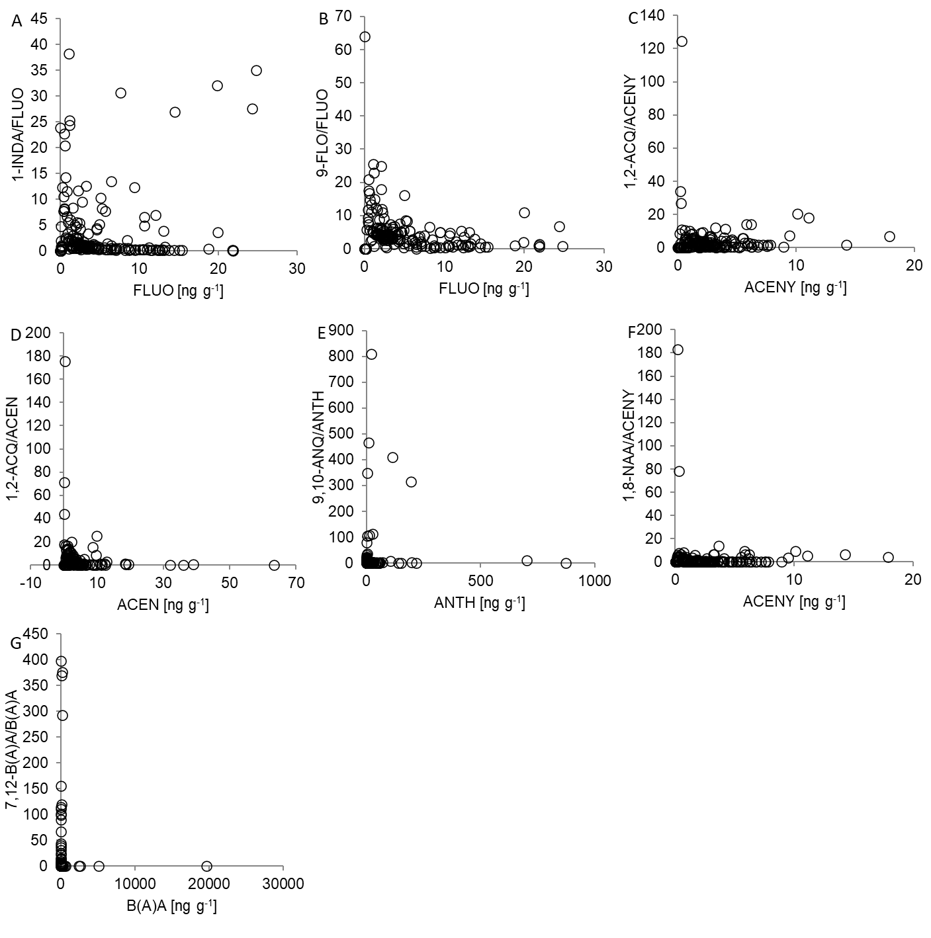
Figure S5 Relationship of the parent-PAH concentrations with the concentration ratios of the parent PAH/derived OPAH for seven individual OPAHs. See Table S1 for the compound abbreviations.
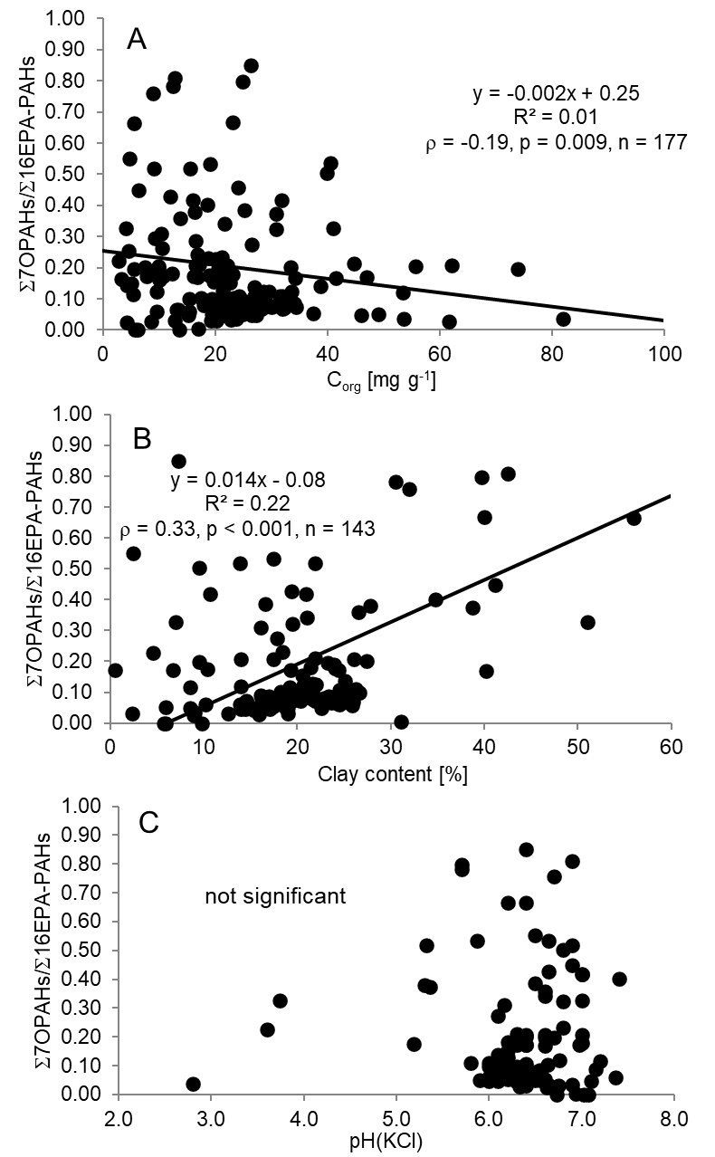
Figure S6 Relationships of the (A) organic C concentrations (C_{org}), (B) clay contents, (C) pH in 1 M KCl with the Σ7OPAHs/Σ16EPA-PAHs concentration ratios in all individual soil samples for which data were available. To roughly convert pH values to the pH in 1 M KCl, we lowered the pH in H₂O by 1 unit and the pH in 0.01 M CaCl₂ by 0.5 units accounting for the different ionic strength of the various commonly used equilibrium solutions.
References
Bandowe, B. A. M., & Wilcke, W. (2010). Analysis of polycyclic aromatic hydrocarbons and their oxygen-containing derivatives and metabolites in soils. Journal of Environmental Quality, 39, 1349-1358. https://doi.org/10.2134/jeq2009.0298
Bandowe, B. A. M., Shukurov, N., Kersten, M., & Wilcke, W. (2010). Polycyclic aromatic hydrocarbons (PAHs) and their oxygen-containing derivatives (OPAHs) in soils from the Angren industrial area, Uzbekistan. Environmental Pollution, 158, 2888-2899. https://doi.org/10.1016/j.envpol.2010.06.012
Bandowe, B. A. M., Sobocka, J., & Wilcke, W. (2011). Oxygen-containing polycyclic aromatic hydrocarbons (OPAHs) in urban soils of Bratislava, Slovakia: patterns, relation to PAHs and vertical distribution. Environmental Pollution, 159, 539-549. https://doi.org/10.1016/j.envpol. 2010.10.011
Bandowe, B. A. M., Lueso, M. G., & Wilcke, W. (2014). Oxygenated polycyclic aromatic hydrocarbons and azaarenes in urban soils: A comparison of a tropical city (Bangkok) with two temperate cities (Bratislava and Gothenburg). Chemosphere, 107, 407-414. https://doi.org/10.1016/j.chemosphere.2014.01.017
Bandowe, B. A. M., Leimer, S., Meusel, H., Velescu, A., Hoffmann, T., Oelmann, Y., & Wilcke, W. (2019a). Plant diversity accelerates the natural attenuation of polycyclic aromatic compounds (PAHs and oxygenated PAHs) in grassland soils. Soil Biology and Biochemistry, 129, 60-70. https://doi.org10.1016/j.soilbio.2018.10.017/
Bandowe, B.A.M., C. Wei, Y.M. Han, J.J. Cao, C.L. Zhan & W. Wilcke (2019b): Polycyclic aromatic compounds (PAHs, oxygenated PAHs, nitrated PAHs and azaarenes) in soils from China and their relationship with geographic location, land use and soil carbon fractions. Sci. Tot. Environ. 690, 1268-1276, published online on 03/07/2019, https://doi.org/10.1016/j.scitotenv.2019.07.022.
Lundstedt, S., Bandowe, B., Wilcke, W., Boll, E., Christensen, J. H., Vila, J., Grifoll, M., … Lorgeoux, C. (2014). First intercomparison study on the analysis of oxygenated polycyclic aromatic hydrocarbons (oxy-PAHs) and nitrogen heterocyclic polycyclic aromatic compounds (N-PACs) in contaminated soil. Trends in Analytical Chemistry, 57, 83-92. https://doi.org/10.1016/j.trac.2014.01.007
Wilcke, W., Bandowe, B.A.M., Gomez Lueso, M., Ruppenthal, M., del Valle, H., & Oelmann, Y. (2014a). Polycyclic aromatic hydrocarbons (PAHs) and their polar derivatives (oxygenated PAH, azaarenes) in soils along a climosequence in Argentina. Science of the Total Environment, 473-474, 317-325. https://doi.org/10.1016/j.scitotenv.2013.12.037
Wilcke, W., Kiesewetter, M., & Bandowe, B. A. M. (2014b). Microbial formation and degradation of oxygen-containing polycyclic aromatic hydrocarbons (OPAHs) in soil during short-term incubation. Environmental Pollution, 184, 385-390. https://doi.org/10.1016/j.envpol.2013.09.020

