Appendix A. Supplementary data

Sample Name | Mn  conc. mg/g DW | Mn  ref. values (mg/g DW) | Mn recovery rate (%) | Fe  conc. mg/g DW | Fe  ref. values (mg/g DW) | Fe recovery rate (%)
S1_batch1 | 0.513 | 0.529 | 97.1 | 31.6 | 33.6 | 94.0
S2_batch2 | 0.528 | 0.529 | 99.9 | 32.3 | 33.6 | 96.1
S3_batch3 | 0.504 | 0.529 | 95.5 | 30.8 | 33.6 | 91.8
S4_batch4 | 0.486 | 0.529 | 92.0 | 29.6 | 33.6 | 88.2
S5_batch5 | 0.520 | 0.529 | 98.4 | 32.2 | 33.6 | 95.8
S6_batch6 | 0.498 | 0.529 | 94.2 | 30.4 | 33.6 | 90.4
S7_batch7 | 0.485 | 0.529 | 91.7 | 29.8 | 33.6 | 88.6
S8_batch8 | 0.491 | 0.529 | 92.9 | 30.0 | 33.6 | 89.2
Table S1: Calculated recovery rates of total Fe and Mn digestion of the San Joaquin Soil certified reference material (SRM2709a) per samples’ batch run.

Table S2: Average relative standard deviation (RSD) of the triplicate measurements made for every fraction, and the concentration range of all the samples’ concentrations in ppm. The ICP-MS detection limits are >0.00004 ppm for Mn and >0.00018 ppm for Fe.
Element |  | F1 | F2 | F3 | F4 | F5 | F6 | F7
Fe | RSD av. (%) | 5.71 | 3.86 | 7.75 | 5.17 | 5.79 | 5.90 | 6.73
 | Range (ppm) | 0.06-16 | 3-97 | 0.03-660 | 29-2484 | 6-597 | 2-164 | 0.1-113
Mn | RSD av. (%) | 10.3 | 4.15 | 7.06 | 4.24 | 7.30 | 8.26 | 8.15
 | Range (ppm) | 0.002-3 | 2-349 | 0.003-160 | 8-609 | 0.023-3 | 0.003-1 | 0.003-0.7

License: CC BY 4.0 International - Creative Commons, Attribution

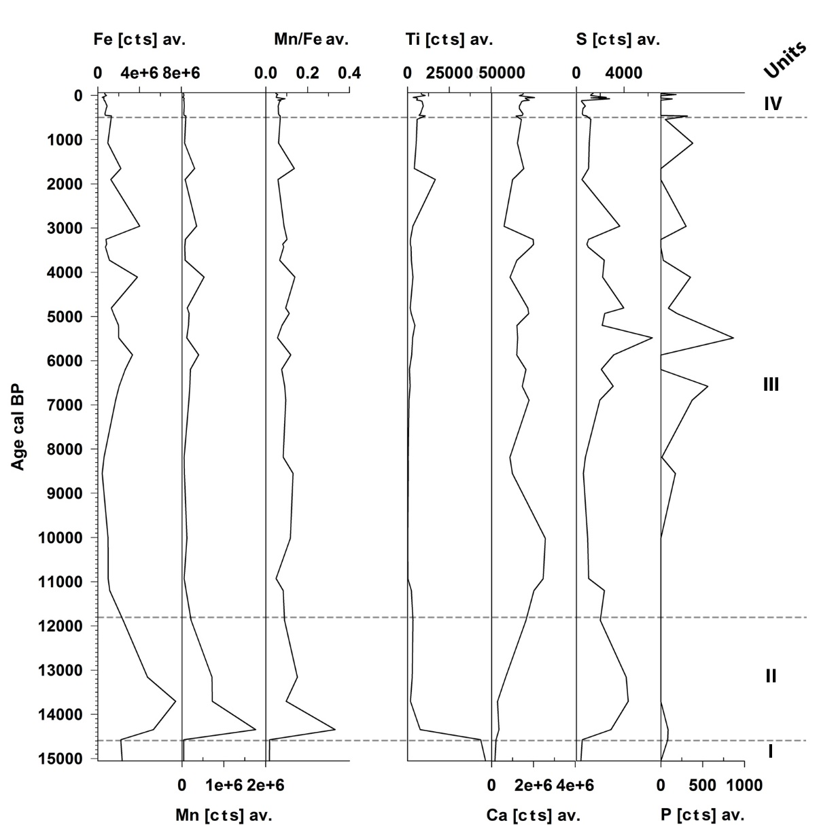
Fig. S1: XRF element counts (averaged values) of the 43 freeze-dried samples used for the sequential extraction.

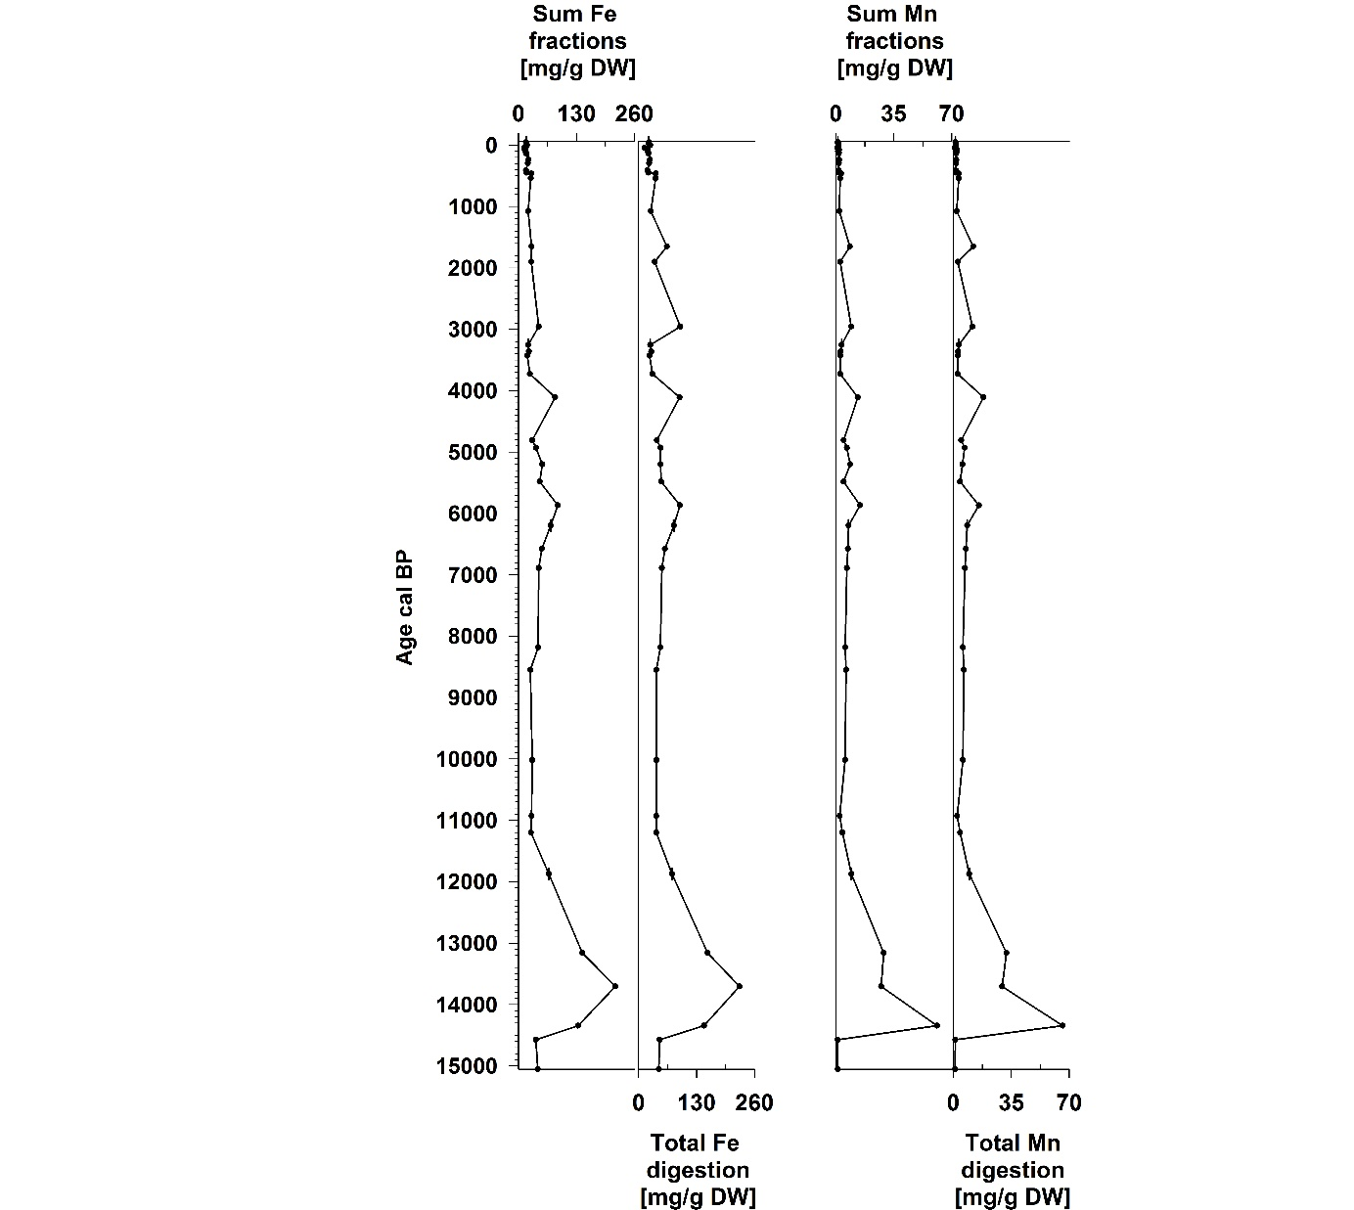
Fig. S2: The distributions and total Fe and Mn concentrations after sequential extraction (sum of the seven fractions) and total digestion.

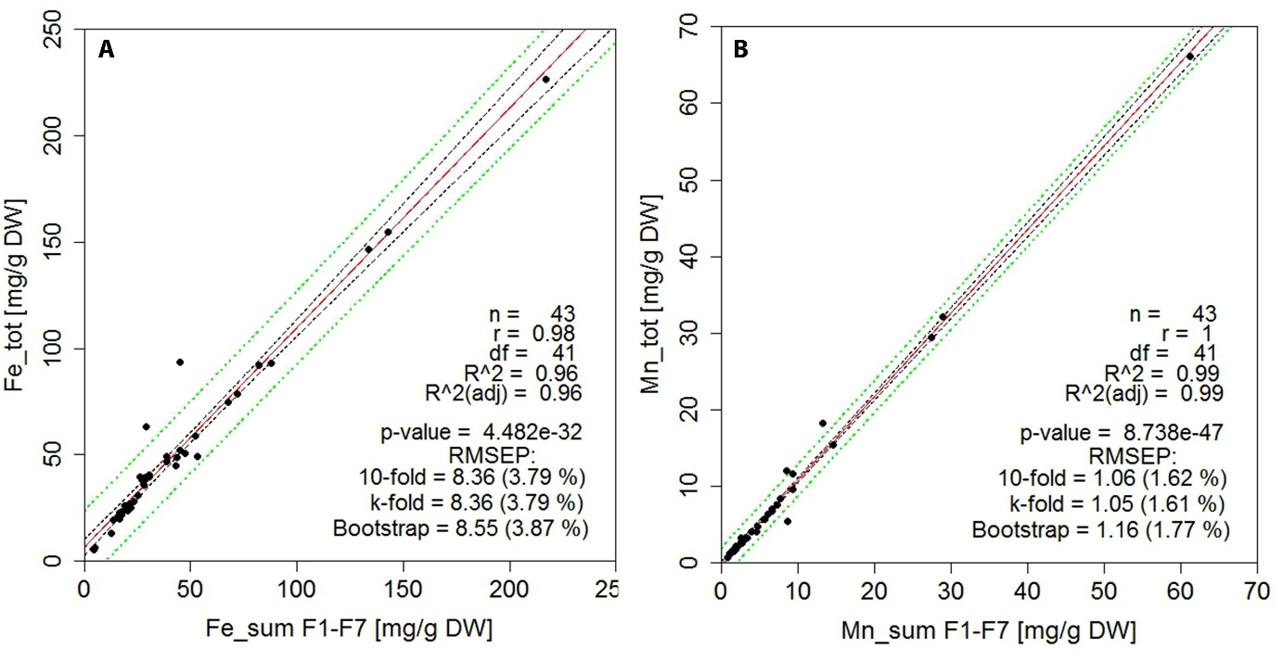
Fig. S3: Linear regression between the sum of fractions after sequential extraction and the concentrations after total digestion of (a) iron and (b) manganese, indicating strong correlation between the variables and 8% error for Fe, 1% for Mn.

Fig. S4: Normalization of XRF Fe and Mn with Ti counts, indicating the phases of higher detrital input when the ratio in lowest.

