A 250-year record of mercury and trace elements deposition in lakes from Cajas National Park, SW Ecuadorian Andes
Supplementary data
Tobias Schneider^{1,2,3}*, Benjamin A. Musa Bandowe^{1,2,4}, Moritz Bigalke², Adrien Mestrot², Henrietta Hampel^{5,6}, Pablo V. Mosquera^{7,8}, Lea Fränkl^{1,2}, Giulia Wienhues^{1,2}, Hendrik Vogel^{1,9}, Wojciech Tylmann¹⁰, Martin Grosjean^{1,2}
1 Oeschger Centre for Climate Change Research, University of Bern, Hochschulstrasse 4, 3012 Bern, Switzerland
2 Institute of Geography, University of Bern, Hallerstrasse 12, 3012 Bern, Switzerland
3 Department of Geosciences, University of Massachusetts Amherst, 611 North Pleasant Street, Amherst, MA 01003-9297, USA
4 Multiphase Chemistry Department, Max Planck Institute for Chemistry, Hahn-Meitner-Weg 1, 55128 Mainz, Germany
5 Facultad de Ciencias Químicas, Universidad de Cuenca, Cuenca, Ecuador
6 Laboratorio de Ecología Acuática, Departamento de Recursos Hídricos y Ciencias Ambientales, Universidad de Cuenca, Cuenca, Ecuador
7 Subgerencia de Gestión Ambiental, Empresa Pública Municipal de Telecomunicaciones, Agua potable, Alcantarillado y Saneamiento (ETAPA EP), Cuenca, Ecuador
8 Departament de Biologia Evolutiva, Ecologia i Ciències Ambientals, Universitat de Barcelona, Barcelona, Spain
9 Institute of Geological Sciences, University of Bern, Baltzerstrasse 1+3, 3012 Bern, Switzerland
10 Institute of Geography, Faculty of Oceanography and Geography, University of Gdansk, Bazynskiego 4, 80309 Gdansk, Poland

*Corresponding author
Dr. Tobias Schneider
Department of Geosciences
627 North Pleasant Street
233 Morrill Science Center
University of Massachusetts
Amherst, MA 01003-9297

Email: tobias.schneider@giub.unibe.ch, tobiasschnei@umass.edu,
ORCID: http://orcid.org/0000-0002-1593-0273
License: CC BY 4.0 International - Creative Commons, Attribution
Co-authors email addresses & ORCIDs
Benjamin A. Musa Bandowe: Benjamin.Bandowe@mpic.de, https://orcid.org/0000-0003-0605-2285
Moritz Bigalke: moritz.bigalke@giub.unibe.ch, https://orcid.org/0000-0002-6793-6159
Adrien Mestrot: adrien.mestrot@giub.unibe.ch, https://orcid.org/0000-0002-4387-3886
Henrietta Hampel: hennihampel@gmail.com, https://orcid.org/0000-0003-2249-5369
Pablo V. Mosquera: bmosquer@etapa.net.ec, http://orcid.org/0000-0002-3974-6489
Lea Fränkl: lea.fraenkl@gmail.com, --
Giulia Wienhues: giulia.wienhues@giub.unibe.ch, https://orcid.org/0000-0002-4282-488X
Hendrik Vogel: hendrik.vogel@geo.unibe.ch, https://orcid.org/0000-0002-9902-8120
Wojciech Tylmann: wojciech.tylmann@ug.edu.pl, https://orcid.org/0000-0003-1749-5882
Martin Grosjean: martin.grosjean@oeschger.unibe.ch, http://orcid.org/0000-0002-3553-8842

Number of pages: 13
Number of figures: 4
Number of tables: 10

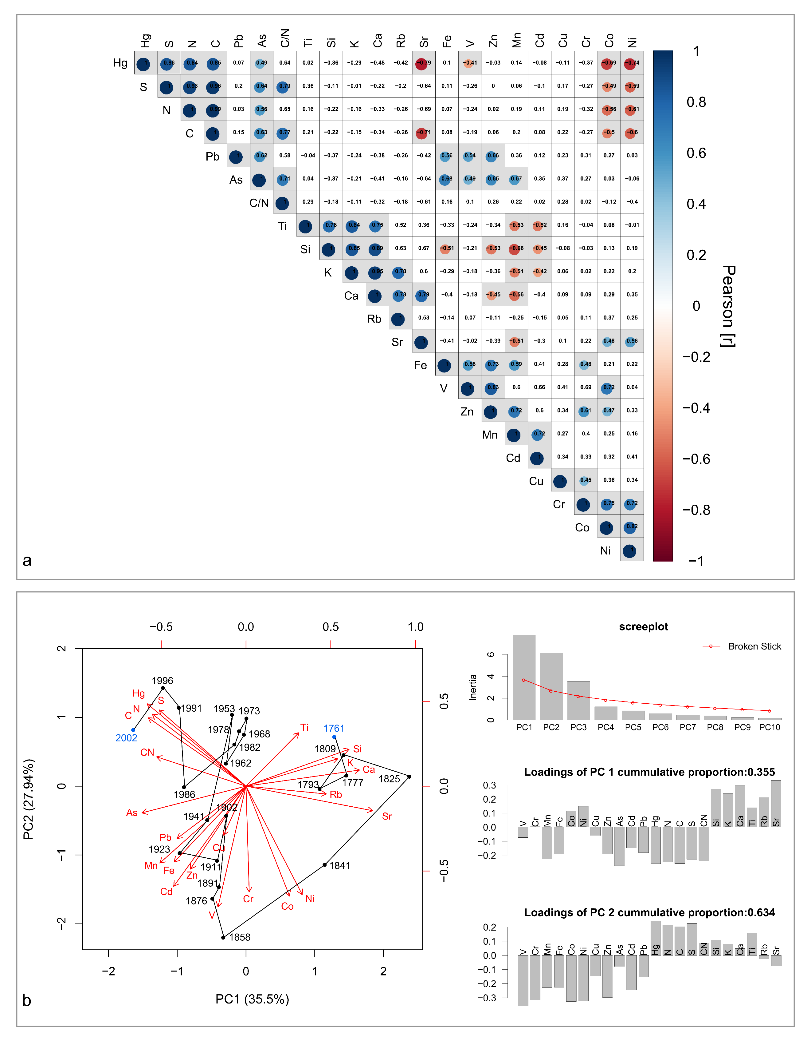
Fig. S1 Pearson correlations matrix and PCA for trace elements of Lake Fondococha. [a] Pearson correlation matrix (α= 0.05) of all elements (concentrations), C, N, S and C/N, and XRF data (Si, K, Ca, Ti, Rb, Sr) of Lake Fondococha. Blank squares are not significantly correlated. [b] Principal component analysis conducted on centered values (the same elements as for the correlation matrix) of Lake Fondococha. Left panel shows the Biplot of PC1 and PC2, blue numbers highlight the start/end of the time series, the black line connects all samples chronologically. The right panel shows the screeplot, and the loadings of PC1 and PC2. PC3 is also significant, but not shown in the biplot
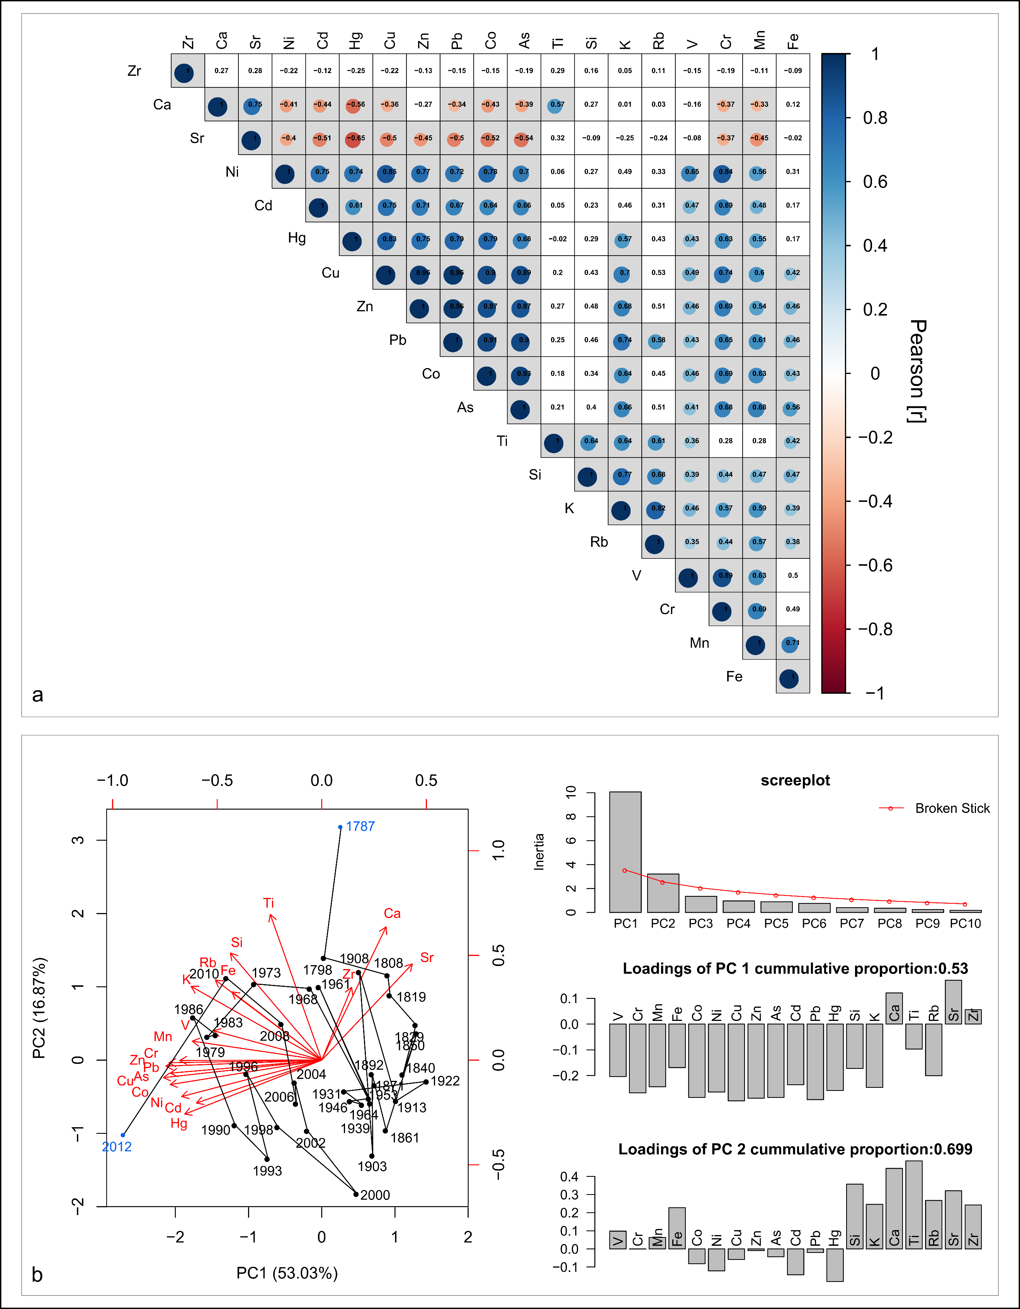
Fig. S2 Pearson correlations matrix and PCA for trace elements of Lake Llaviucu. [a] Pearson correlation matrix (α= 0.05) of all elements (concentrations) and XRF data (Si, K, Ca, Ti, Rb, Sr, Zr) of Lake Llaviucu. Blank squares are not significantly correlated. [b] Principal component analysis conducted on centered values (the same elements as for the correlation matrix) of Lake Llaviucu. Left panel shows the Biplot of PC1 and PC2, blue numbers highlight the start/end of the time series, the black line connects all samples chronologically. The right panel shows the screeplot, and the loadings of PC1 and PC2
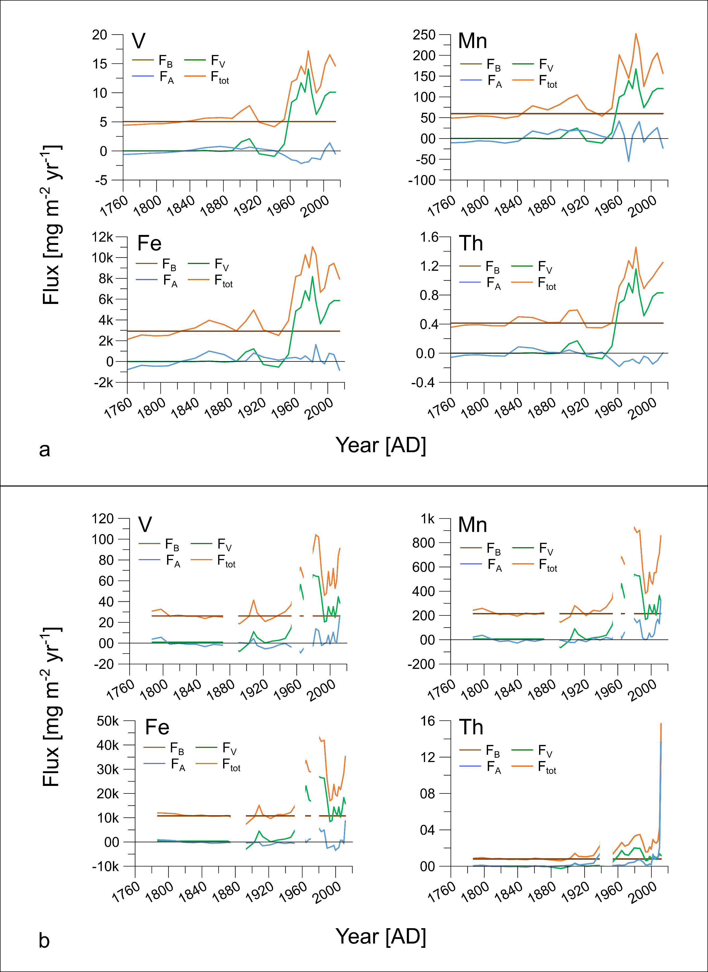
Fig. S3 Background (pre-1900) fluxes (F_{B}), erosion-related fluxes (F_{V}), airborne fluxes (F_{A}), and total fluxes (F_{tot}) of other elements (please refer to the plots) measured in [a] Lake Fondococha ca. 1760 – 2014 and [b] Lake Llaviucu ca. 1785 – 2014. Please note that white gaps refer to the outliers presented in Fig. 3 b. These samples were excluded from the calculations
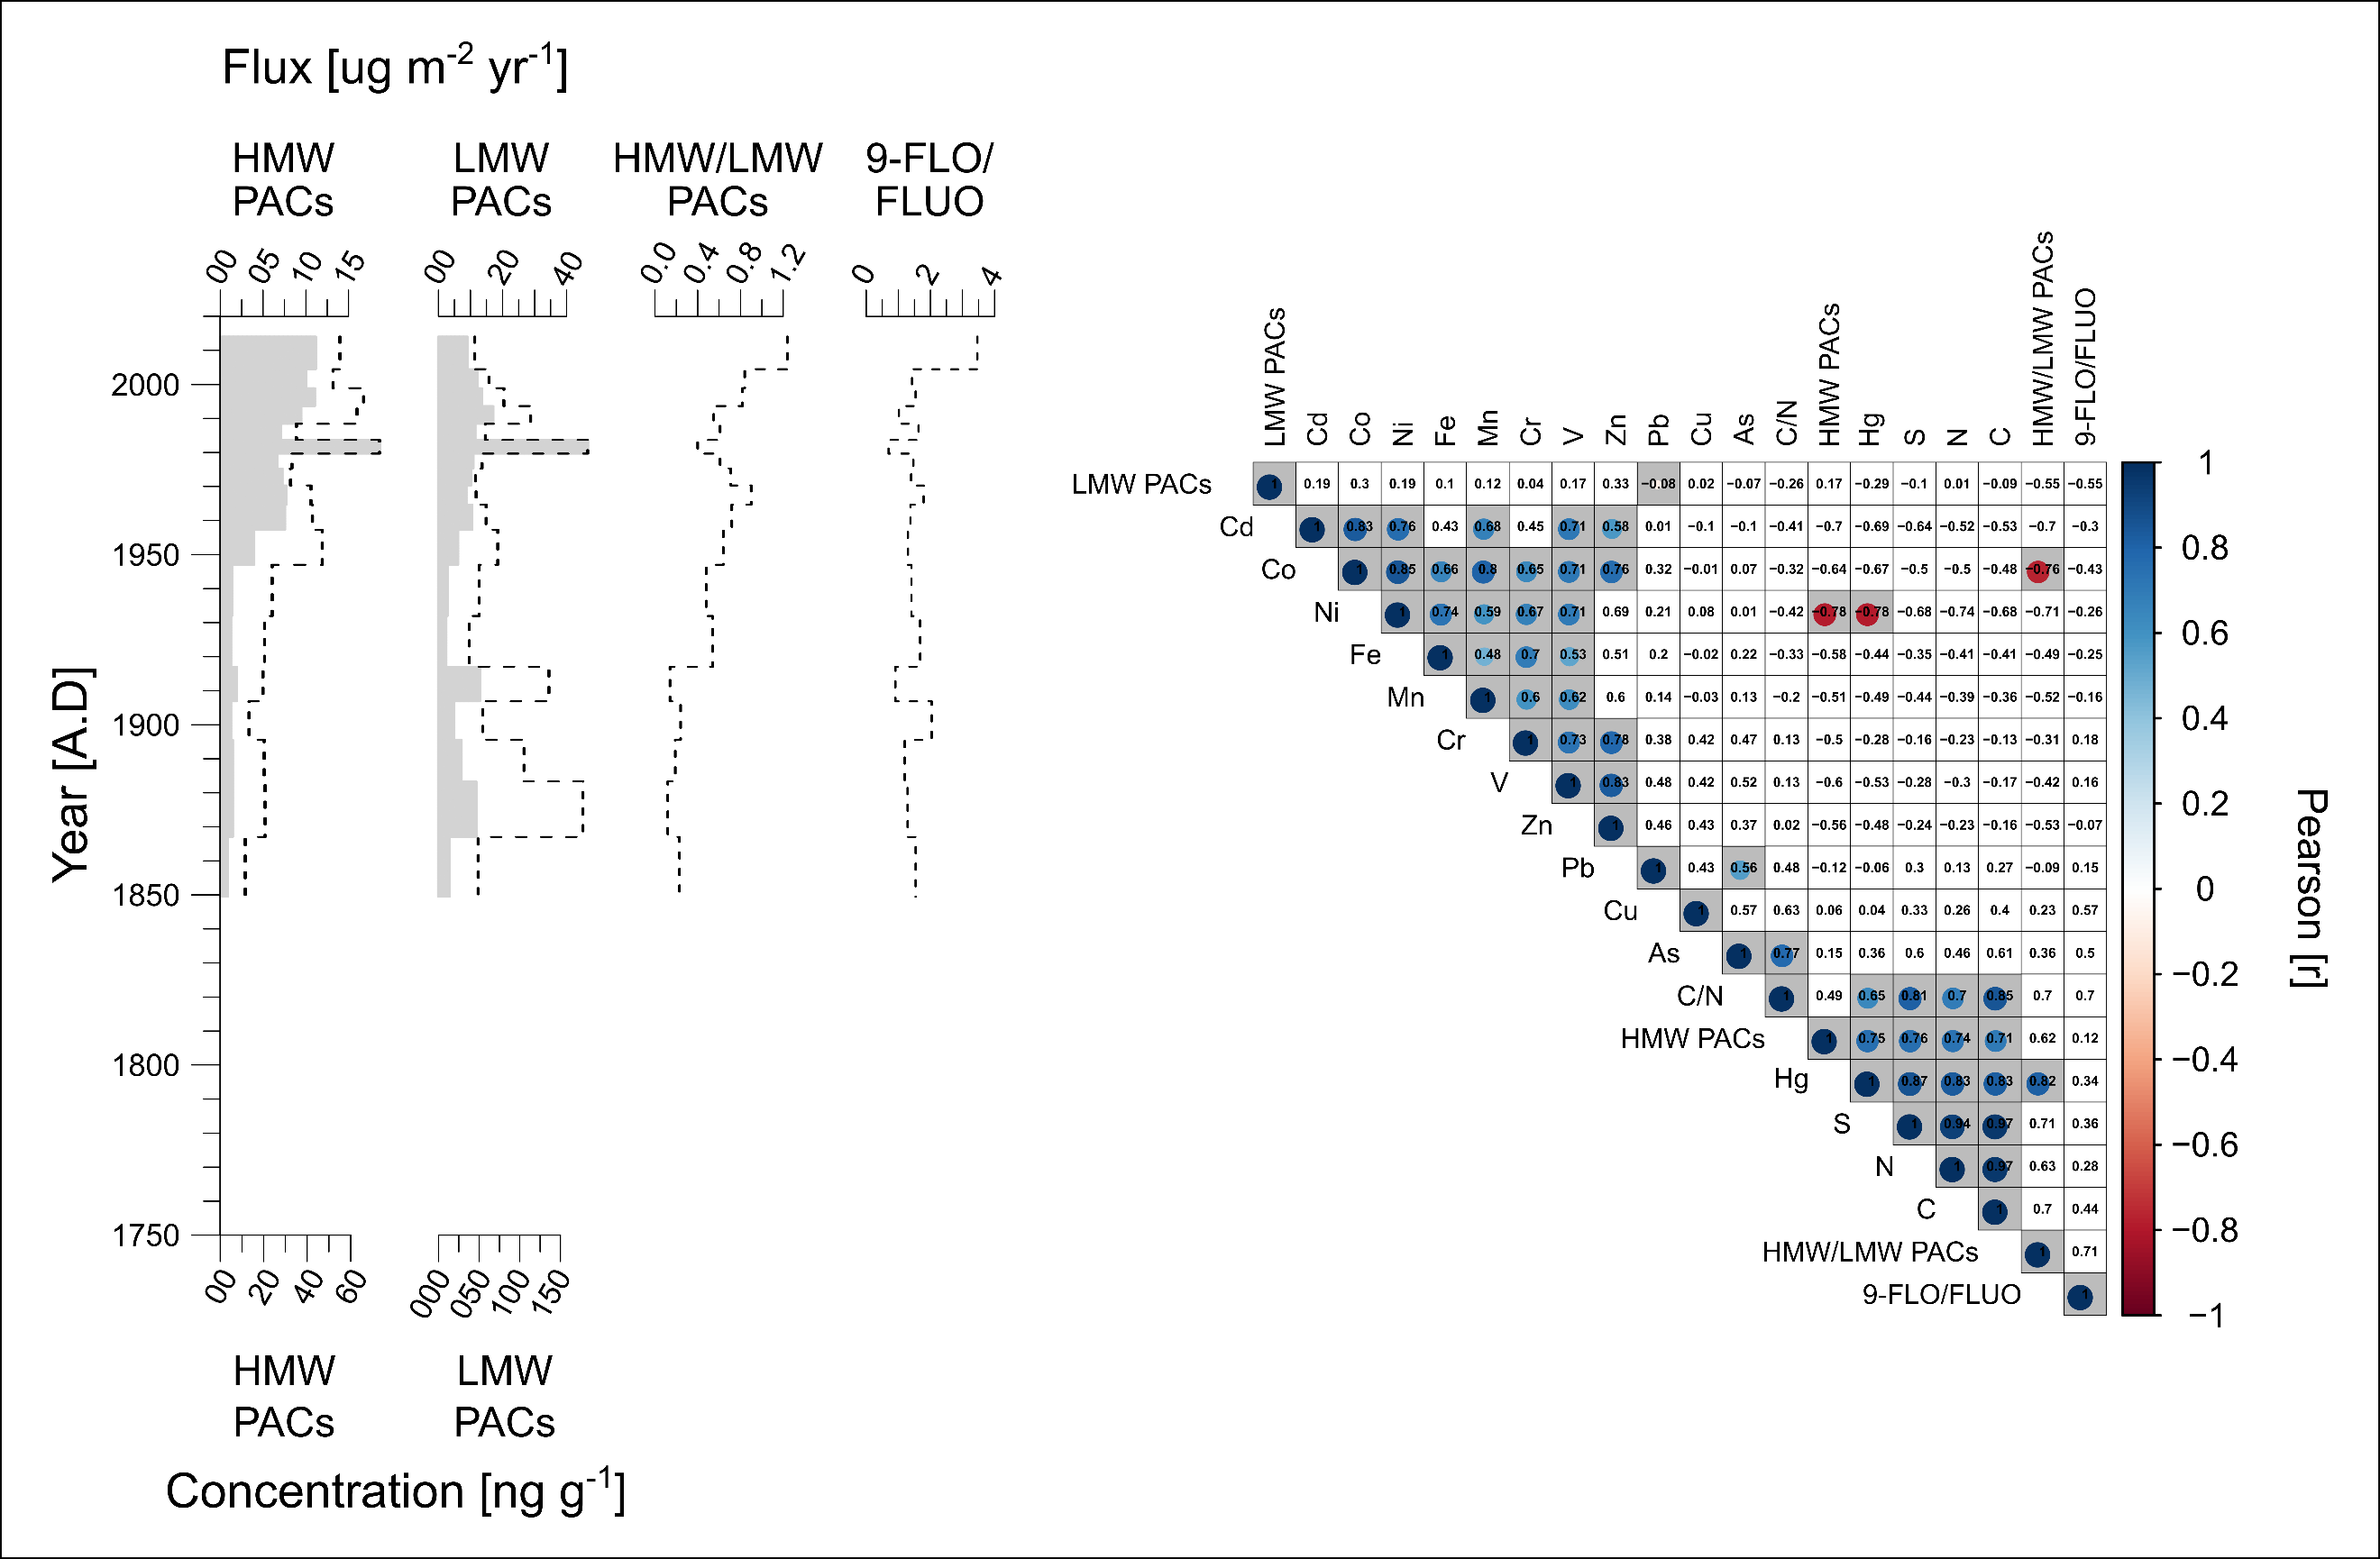
Fig. S4 Polycyclic aromatic compounds (PACs) stratigraphy and ratios, and correlation matrix with trace elements and PACs for Lake Fondococha. Left panel: HMW: high molecular weight PACs, indicative of high temperature combustion (vehicles, industry); LMW: low molecular weight PACs, indicative of lower temperature combustion (biomass burning); HMW/LMW: ratio between the two sources, increase towards recent times indicates higher relative contribution of high temperature combustion derived compounds, resp. a relative decrease in the contribution of low temperature combustion derived PACs; 9-FLO/FLUO: ratio between 9-fluorenone/fluorene, higher values indicate higher contribution of long range transported PACs. Right panel: correlation matrix showing Pearson correlation matrix (α= 0.05) of standardized trace element and PACs data. Blank squares indicate not significantly correlated correlations. The dataset includes trace elements and PACs from ca. 1850 through 2014 and is shorter than the one in Fig. S1. The PACs-data is taken, incorporated, and replotted from Bandowe et al. (2018)
Tab. S1 Microwave program used for the trace element sample digestion for both lakes.
Step | Time [min] | Power [W] | Temperature [°C]
1 | 5 | 300 | 120
2 | 10 | 700 | 200
3 | 30 | 450 | 200

Tab. S2 ICP-MS operating parameters shown for both, trace element measurements and Hg measurement.
Parameter | Multi-element |  | Mercury
Gas mode | No Gas | He | No Gas | He
Rf Power [W] | 1550 | 1550 | 1550 | 1550
Carrier Gas Flow Rate [l/min] | 1.05 | 1.03 | 1.05 | 1.05
Nebulizer Pump [revolution/s] | 0.1 | 0.1 | 0.1 | 0.1
Spray Chamber Temperature [°C] | 2 | 2 | 2 | 2
Make Up Gas | 0 | 0 | 0 | 0
Lences
Extract 1 [V] | 0 | 0 | 0 | 0
Extract 2 [V] | -180 | -200 | -180 | -160
Omega Bias [V] | -95 | -100 | -95 | -95
Omega Lens [V] | 9.3 | 10 | 9.3 | 8.4
Cell Entrance [V] | -30 | -40 | -30 | -40
Cell Exit [V] | -50 | -60 | -50 | -60
Deflect [V] | 14.2 | 1 | 14.2 | 2.2
Plate Bias [V] | -40 | -60 | -40 | -60
Cell
He Flow [ml/min] | 0 | 4.3 | 0 | 4.3
H₂ Flow [ml/min] | 0 | 0 | 0 | 0
Octp Bias [V] | -8 | -8 | -8 | -18
Octp Rf [V] | 200 | 180 | 200 | 190
Energy Discrimination [V] | 5 | 5 | 5 | 3

Tab. S3 Limit of detection (LOD) calculated from maximum blank values per trace element for both studied Lakes. LOD = detect. Limit [ug/l] * solution [l] * dilution coefficient (20) / sample weight [g] ug/g = mg/kg. 0.1g was taken as the sample weight (in-weight per real sample).
Trace  Element | Lake Fondococha |  |  | Lake Llaviucu
 | Max. Blank [ug/l] | LOD  [ug/l] | LOD  [mg/kg] | Max. Blank  [ug/l] | LOD  [ug/l] | LOD  [mg/kg]
Al | 20.6861 | 20.6861 | 82.7445 | <0.128 | 0.1280 | 0.5120
V | <0.023 | 0.0230 | 0.0920 | 0.0057 | 0.0057 | 0.0230
Cr | <0.055 | 0.0550 | 0.2200 | 0.1320 | 0.1320 | 0.5279
Mn | <0.092 | 0.0920 | 0.3680 | <0.003 | 0.0030 | 0.0120
Fe | <0.472 | 0.4720 | 1.8880 | <0.397 | 0.3970 | 1.5880
Co | <0.028 | 0.0280 | 0.1120 | 0.0014 | 0.0014 | 0.0056
Ni | <0.102 | 0.1020 | 0.4080 | 0.0206 | 0.0206 | 0.0823
Cu | <0.724 | 0.7240 | 2.8960 | 0.5282 | 0.5282 | 2.1128
Zn | <0.159 | 0.1590 | 0.6360 | 1.1264 | 1.1264 | 4.5057
As | <0.047 | 0.0470 | 0.1880 | <0.009 | 0.0090 | 0.0360
Cd | <0.065 | 0.0650 | 0.2600 | <0.003 | 0.0030 | 0.0120
Pb | <0.045 | 0.0450 | 0.1800 | <0.012 | 0.0120 | 0.0480
Th | 0.0548 | 0.0548 | 0.2193 | 0.0240 | 0.0240 | 0.0959
Hg | <0.004 | 0.0040 | 0.0080 | <0.004 | 0.0040 | 0.0080

Tab. S4 Relative standard deviation (RSD) in percentage per trace element for Lake Fondococha based on triplicate (FON-06, and FON-20) and duplicate (FON-02, FON-03, and FON-14) measurements (one outlier FON-14c removed).
Parameter | FON-02 | FON-03 | FON-06 | FON-14 | FON-20 | MEAN
from [cm] | 0.00 | 0.50 | 2.00 | 6.00 | 9.10 | -
to [cm] | 0.50 | 1.00 | 2.50 | 6.50 | 9.60 | -
midpoint [cm] | 0.25 | 0.75 | 2.25 | 6.25 | 9.35 | -
in weight [mg] | 100.35 | 101.00 | 102.63 | 101.35 | 103.77 | 101.82
Al [RSD%] | 13.00 | 20.83 | 9.04 | 1.03 | 3.84 | 9.55
V [RSD%] | 12.35 | 19.72 | 8.69 | 2.88 | 3.32 | 9.39
Cr [RSD%] | 15.93 | 23.31 | 28.94 | 3.70 | 6.45 | 15.67
Mn [RSD%] | 12.77 | 19.93 | 16.69 | 5.43 | 3.04 | 11.57
Fe [RSD%] | 12.98 | 20.87 | 15.61 | 4.28 | 2.96 | 11.34
Co [RSD%] | 10.51 | 18.89 | 15.37 | 8.17 | 1.57 | 10.90
Ni [RSD%] | 11.93 | 17.99 | 15.96 | 8.87 | 4.82 | 11.92
Cu [RSD%] | 10.98 | 19.88 | 15.63 | 8.40 | 3.75 | 11.73
Zn [RSD%] | 10.59 | 16.93 | 13.09 | 7.32 | 0.94 | 9.77
As [RSD%] | 8.83 | 19.03 | 15.69 | 6.22 | 2.08 | 10.37
Cd [RSD%] | NA | 12.26 | 17.54 | 24.96 | 7.62 | 15.59
Pb [RSD%] | 0.73 | 6.08 | 6.41 | 17.81 | 5.36 | 7.28
Th [RSD%] | 1.90 | 4.96 | 4.24 | 15.75 | 4.30 | 6.23

Tab. S5 Recovery shown for the different trace elements per microwave batch (R1 – R7) and lake (LLA: Lake Llaviucu; FON: Lake Fondococha). The last column provides the certified concentrations [mg/kg] per element of the CRM that were used for the recovery calculation: 100/C_{CRM}*C_{measured}, where C: Concentration. The following CRM was used: 2709a San Joaquin Soil, National Institute of Standards and Technology (Mackey et al., 2010).
Trace  Element | FON  R1 | FON  R2 | FON  R3 | FON  R4 | FON  R5 | FON  R6 | FON  R7 | FON  Mean | LLA  R1 | LLA  R2 | LLA  R3 | LLA  R4 | LLA  R5 | LLA  Mean | CRM  [mg/kg]
Al [%] | 61.96 | 61.86 | 78.37 | 71.93 | 74.04 | 65.76 | 69.05 | 69.00 | 52.20 | 46.93 | 43.07 | 51.33 | 50.45 | 48.79 | 73700
V [%] | 91.90 | 91.28 | 119.62 | 110.34 | 108.61 | 102.36 | 107.11 | 104.46 | 78.68 | 71.25 | 67.16 | 79.44 | 74.62 | 74.23 | 110
Cr [%] | 81.21 | 82.80 | 104.26 | 93.40 | 93.10 | 93.30 | 93.55 | 91.66 | 72.90 | 63.07 | 59.04 | 70.09 | 66.68 | 66.36 | 130
Mn [%] | 97.72 | 96.75 | 134.23 | 122.91 | 120.75 | 123.80 | 130.58 | 118.11 | 87.58 | 85.85 | 84.06 | 85.05 | 83.71 | 85.25 | 529
Fe [%] | 99.16 | 99.07 | 132.32 | 122.61 | 120.10 | 121.46 | 126.41 | 117.31 | 87.72 | 87.18 | 84.23 | 87.46 | 85.91 | 86.50 | 33600
Co [%] | 97.72 | 96.99 | 130.65 | 119.53 | 114.67 | 117.87 | 122.96 | 114.34 | 83.59 | 81.27 | 79.04 | 85.22 | 80.88 | 82.00 | 12.8
Ni [%] | 92.96 | 92.02 | 123.16 | 113.55 | 107.95 | 116.68 | 116.02 | 108.91 | 79.13 | 76.78 | 75.46 | 80.47 | 76.86 | 77.74 | 85
Cu [%] | 88.24 | 87.62 | 118.18 | 109.83 | 103.02 | 107.58 | 111.75 | 103.75 | 80.24 | 76.94 | 75.05 | 79.44 | 75.42 | 77.42 | 33.9
Zn [%] | 90.77 | 95.01 | 119.15 | 109.23 | 105.23 | 109.33 | 114.03 | 106.10 | 81.91 | 80.24 | 79.77 | 80.24 | 77.55 | 79.94 | 103
As [%] | 91.49 | 95.19 | 123.97 | 115.07 | 111.86 | 111.24 | 116.47 | 109.33 | 81.08 | 78.49 | 74.58 | 82.81 | 77.06 | 78.80 | 10.5
Cd [%] | NA | NA | 82.25 | NA | NA | 77.66 | NA | NA | 82.91 | 72.82 | 77.18 | 80.50 | 80.55 | 78.79 | 0.371
Pb [%] | 70.72 | 67.39 | 87.34 | 79.41 | 68.19 | 79.38 | 72.05 | 74.93 | 60.42 | 57.07 | 55.06 | 60.36 | 57.87 | 58.15 | 17.3
Th [%] | 81.02 | 77.42 | 98.46 | 93.56 | 77.51 | 87.23 | 80.44 | 85.09 | 81.88 | 78.10 | 76.06 | 103.68 | 87.57 | 85.46 | 10.9
Hg [%] | 127.34 | 115.93 | 118.77 | 104.70 | NA | NA | NA | 116.69 | 65.35 | 62.06 | 58.73 | 60.42 | 60.48 | 61.41 | 0.9
NA: not available
Tab. S6 Percentage of trace elements contributing sources to the total flux (F_{tot} = 100%) in discussed time periods presented for Lake Fondococha. F_{B}= background proportion, F_{V}= lithogenic fraction, F_{A}= atmospheric and point sources.
Element | Fraction | post-1950 [%] | pre-1950 [%] | 1970 – 1990 [%] | 1996 – 2014 [%]
V | F_{B} | 38.89 | 94.80 | 36.65 | 35.31
V | F_{V} | 69.41 | 3.19 | 75.85 | 65.27
V | F_{A} | -8.31 | 2.01 | -12.50 | -0.58
Cr | F_{B} | 40.12 | 98.47 | 36.42 | 37.57
Cr | F_{V} | 71.61 | 3.32 | 75.39 | 69.46
Cr | F_{A} | -11.73 | -1.79 | -11.81 | -7.03
Mn | F_{B} | 34.48 | 89.93 | 32.25 | 33.88
Mn | F_{V} | 61.55 | 3.03 | 66.76 | 62.63
Mn | F_{A} | 3.97 | 7.04 | 0.99 | 3.48
Fe | F_{B} | 34.58 | 93.44 | 30.89 | 34.72
Fe | F_{V} | 61.71 | 3.15 | 63.94 | 64.18
Fe | F_{A} | 3.71 | 3.42 | 5.17 | 1.10
Co | F_{B} | 43.97 | 98.93 | 39.73 | 43.66
Co | F_{V} | 78.48 | 3.33 | 82.23 | 80.70
Co | F_{A} | -22.46 | -2.26 | -21.95 | -24.36
Ni | F_{B} | 47.02 | 100.47 | 41.81 | 48.47
Ni | F_{V} | 83.92 | 3.38 | 86.55 | 89.60
Ni | F_{A} | -30.94 | -3.85 | -28.36 | -38.08
Cu | F_{B} | 35.75 | 97.09 | 35.11 | 29.61
Cu | F_{V} | 63.81 | 3.27 | 72.67 | 54.74
Cu | F_{A} | 0.43 | -0.36 | -7.78 | 15.65
Zn | F_{B} | 36.02 | 94.53 | 32.70 | 34.40
Zn | F_{V} | 64.30 | 3.18 | 67.68 | 63.58
Zn | F_{A} | -0.32 | 2.29 | -0.38 | 2.02
As | F_{B} | 31.11 | 93.58 | 30.78 | 25.91
As | F_{V} | 55.52 | 3.15 | 63.71 | 47.89
As | F_{A} | 13.37 | 3.27 | 5.51 | 26.20
Cd | F_{B} | 39.92 | 91.67 | 36.30 | 43.14
Cd | F_{V} | 71.25 | 3.09 | 75.14 | 79.74
Cd | F_{A} | -10.37 | 5.24 | -11.44 | -20.61
Pb | F_{B} | 35.03 | 94.12 | 32.83 | 30.81
Pb | F_{V} | 62.51 | 3.17 | 67.95 | 56.96
Pb | F_{A} | 2.46 | 2.71 | -0.77 | 12.23
Th | F_{B} | 39.27 | 95.97 | 35.25 | 37.56
Th | F_{V} | 70.09 | 3.23 | 72.96 | 69.44
Th | F_{A} | -9.36 | 0.80 | -8.21 | -7.00
Hg | F_{B} | 20.75 | 91.06 | 19.84 | 18.19
Hg | F_{V} | 37.03 | 3.07 | 41.06 | 33.63
Hg | F_{A} | 42.23 | 5.87 | 39.10 | 48.18

Tab. S7 Percentage of trace elements contributing sources to the total flux (F_{tot} = 100%) in discussed time periods presented for Lake Llaviucu. F_{B}= background proportion, F_{V}= lithogenic fraction, F_{A}= atmospheric and point sources.
Element | Fraction | post-1950 [%] | pre-1950 [%] | 1970 – 1990 [%] | 1996 – 2014 [%]
V | F_{B} | 43.00 | 108.01 | 36.14 | 53.48
V | F_{V} | 49.46 | -6.18 | 53.30 | 35.71
V | F_{A} | 7.54 | -1.83 | 10.55 | 10.81
Cr | F_{B} | 42.49 | 107.54 | 34.54 | 54.09
Cr | F_{V} | 48.87 | -6.15 | 50.94 | 36.12
Cr | F_{A} | 8.64 | -1.39 | 14.53 | 9.79
Mn | F_{B} | 40.10 | 107.55 | 32.46 | 50.36
Mn | F_{V} | 46.12 | -6.15 | 47.87 | 33.62
Mn | F_{A} | 13.78 | -1.40 | 19.68 | 16.02
Fe | F_{B} | 43.06 | 107.22 | 33.55 | 59.43
Fe | F_{V} | 49.52 | -6.13 | 49.48 | 39.68
Fe | F_{A} | 7.42 | -1.08 | 16.97 | 0.90
Co | F_{B} | 33.87 | 103.60 | 25.47 | 47.22
Co | F_{V} | 38.96 | -5.93 | 37.56 | 31.53
Co | F_{A} | 27.17 | 2.33 | 36.96 | 21.24
Ni | F_{B} | 42.44 | 106.01 | 33.50 | 54.52
Ni | F_{V} | 48.81 | -6.06 | 49.41 | 36.40
Ni | F_{A} | 8.75 | 0.06 | 17.09 | 9.07
Cu | F_{B} | 33.14 | 101.88 | 22.55 | 45.29
Cu | F_{V} | 38.11 | -5.83 | 33.26 | 30.24
Cu | F_{A} | 28.75 | 3.95 | 44.19 | 24.48
Zn | F_{B} | 34.61 | 106.20 | 23.13 | 49.61
Zn | F_{V} | 39.80 | -6.07 | 34.11 | 33.12
Zn | F_{A} | 25.59 | -0.12 | 42.76 | 17.27
As | F_{B} | 29.86 | 102.05 | 21.03 | 43.68
As | F_{V} | 34.35 | -5.84 | 31.01 | 29.16
As | F_{A} | 35.79 | 3.79 | 47.97 | 27.16
Cd | F_{B} | 38.91 | 107.74 | 26.87 | 49.38
Cd | F_{V} | 44.75 | -6.16 | 39.63 | 32.97
Cd | F_{A} | 16.34 | -1.57 | 33.49 | 17.65
Pb | F_{B} | 21.50 | 101.16 | 12.82 | 32.23
Pb | F_{V} | 24.73 | -5.79 | 18.90 | 21.52
Pb | F_{A} | 53.77 | 4.63 | 68.28 | 46.26
Th | F_{B} | 31.41 | 59.17 | 31.26 | 27.21
Th | F_{V} | 36.12 | -3.38 | 46.10 | 18.17
Th | F_{A} | 32.47 | 44.21 | 22.64 | 54.62
Hg | F_{B} | 27.65 | 96.61 | 21.28 | 33.90
Hg | F_{V} | 31.81 | -5.53 | 31.38 | 22.63
Hg | F_{A} | 40.54 | 8.91 | 47.34 | 43.47

Tab. S8 Lake Fondococha: TE (trace element), concentrations [µg g⁻¹_{ds}] and fluxes [mg m⁻² yr⁻¹] (pre-1950 and post-1950, recovery corrected values, for not recovery corrected values refer to Tab. 1), Factor (average in post-1950 sediments relative to the average in pre-1950 sediments), Recent (2 top samples, mean year: AD 2007), comparison with threshold effect concentrations (LEL: Low Effect Level, Persaud et al. 1993; ERL: Effect Range-Low, Long and Morgan 1991) from sediment quality guidelines (SQG) in MacDonald et al. (2000), and comparison with threshold values in agricultural soils (TAS) after Toth et al. (2016) for trace elements in Lake Fondococha (bold: concentrations exceed LEL values of SQG; italics: concentrations exceed ERL values of SQG)
TE | This study  Concentration [µg g⁻¹_{ds}] |  |  |  | SQGs-LEL  [µg g⁻¹_{ds}] |  | TAS  [µg g⁻¹_{ds}] | This study  Flux [mg m⁻² yr⁻¹]
 | Pre-1950* | 1950 –2014 | Factor | Recent | LEL | ERL |  | Pre-1950* | 1950 –2014 | Factor | Recent
Cr | 17.61 | 18.03 | 1.02 | 19.6 | 26 | 80 | 100 | 1.21 | 3.38 | 2.79 | 3.94
Ni | 8.04 | 7.33 | 0.91 | 6.88 | 16 | 30 | 200 | 0.55 | 1.37 | 2.47 | 1.38
Cu | 23.46 | 27.43 | 1.17 | 36.64 | 16 | 70 | 100 | 1.62 | 5.13 | 3.17 | 7.36
Zn | 69.85 | 78.45 | 1.12 | 80.65 | 120 | 120 | 200 | 4.82 | 14.70 | 3.05 | 16.21
As | 12.52 | 16.55 | 1.32 | 19.6 | 6 | 33 | 5.0 | 0.87 | 3.09 | 3.57 | 3.94
Cd | 0.59 | NA | NA | NA | 0.6 | 5 | 1.0 | 0.04 | NA | NA | NA
Pb | 29.00 | 32.46 | 1.12 | 34.1 | 31 | 35 | 60 | 2.00 | 6.05 | 3.02 | 6.85
Hg | 0.081 | 0.124 | 1.53 | 0.13 | 0.2 | 0.15 | 0.5 | 0.006 | 0.023 | 4.12 | 0.03
C** | 79.95 | 102.44 | 1.3 | 117.89 |  |  |  | 6.07 | 19.04 | 3.1 | 23.7
*Includes data points pre 1850; **multiplied by 1000; NA: not available

Tab. S9 Lake Llaviucu: TE (trace element), concentrations [µg g⁻¹_{ds}] and fluxes [mg m⁻² yr⁻¹] (pre-1950 and post-1950, recovery corrected values, for not recovery corrected values refer to Tab. 2), Factor (average in post-1950 sediments relative to the average in pre-1950 sediments), Recent (2 top samples, mean year: AD 2011), comparison with threshold effect concentrations (LEL: Low Effect Level, Persaud et al. 1993; ERL: Effect Range-Low, Long and Morgan 1991) from sediment quality guidelines (SQG) in MacDonald et al. (2000), and comparison with threshold values in agricultural soils (TAS) after Toth et al. (2016) for trace elements in Lake Llaviucu (bold: concentrations exceed LEL values of SQG; italics: concentrations exceed ERL values of SQG)
TE | This study  Concentration [µg g⁻¹_{ds}] |  |  |  | SQGs-LEL  [µg g⁻¹_{ds}] |  | TAS  [µg g⁻¹_{ds}] | This study  Flux [mg m⁻² yr⁻¹]
 | Pre-1950* | 1950 –2014 | Factor | Recent | LEL | ERL |  | Pre-1950* | 1950 – 2014 | Factor | Recent
Cr | 41.04 | 45.06 | 1.10 | 47.2 | 26 | 80 | 100 | 13.16 | 34.30 | 2.61 | 36.93
Ni | 10.39 | 11.52 | 1.11 | 12.66 | 16 | 30 | 200 | 3.32 | 8.72 | 2.63 | 9.9
Cu | 41.22 | 52.21 | 1.27 | 57.77 | 16 | 70 | 100 | 13.22 | 39.97 | 3.02 | 45.15
Zn | 225.82 | 280.23 | 1.24 | 309.72 | 120 | 120 | 200 | 72.29 | 215.53 | 2.98 | 242.17
As | 32.94 | 45.55 | 1.38 | 52.09 | 6 | 33 | 5.0 | 10.55 | 35.21 | 3.34 | 40.65
Cd | 2.65 | 3.37 | 1.27 | 3.55 | 0.6 | 5 | 1.0 | 0.85 | 2.56 | 3.03 | 2.78
Pb | 132.01 | 244.97 | 1.86 | 286.96 | 31 | 35 | 60 | 42.35 | 191.16 | 4.51 | 224.21
Hg | 0.185 | 0.259 | 1.40 | 0.29 | 0.2 | 0.15 | 0.5 | 0.060 | 0.194 | 3.24 | 0.23
C** | 101.69 | 87.45 | 0.9 | 95.22 |  |  |  | 53.84 | 70.08 | 1.3 | 43.63
*Includes data points pre 1850; **Includes values from 1940 – 2014 and was multiplied by 1000
Tab. S10 Sediment trap data shown for Lakes Fondococha and Llaviucu. The sediment traps were deployed between summer 2014 and summer 2015. Details can be found in the main manuscript.
Trace | Lake Fondococha |  | Lake Llaviucu
Element | Conc. [mg kg⁻¹] | Flux [mg m⁻² yr⁻¹] | Conc. [mg kg⁻¹] | Flux [mg m⁻² yr⁻¹]
V | 79.28 | 26.59 | 110.10 | 47.37
Cr | 22.58 | 7.57 | 33.75 | 14.52
Mn | 6634.93 | 2224.94 | 3197.90 | 1375.88
Fe | 91648.38 | 30733.15 | 72993.63 | 31405.25
Co | 15.13 | 5.07 | 22.82 | 9.82
Ni | 9.74 | 3.27 | 12.26 | 5.28
Cu | 70.49 | 23.64 | 80.61 | 34.68
Zn | 158.99 | 53.32 | 261.53 | 112.52
As | 49.15 | 16.48 | 98.12 | 42.22
Cd | 0.32 | 0.11 | 2.23 | 0.96
Pb | 22.99 | 7.71 | 76.39 | 32.87
Th | 4.22 | 1.42 | 1.91 | 0.82

