Supplementary Material

Materials and Methods (detailed information)

Agricultural inputs and outputs
Prior to liquid cattle manure sampling, the manure storage container was mixed for 30 minutes. A 5-m long tube was used to take a homogeneous sample over the whole depth of the storage container. The whole length of the tube was filled several times with liquid manure and poured into a 10-L bucket. The manure in the bucket was mixed again and two samples were taken with a 1-L beaker and stored in acid cleaned 1-L bottles. The samples were stored at -20 °C. In NE, dry horse manure was spread on the field in 2014. The manure was not sampled. At TA and EB, cow and pig manure were sampled from different containers, at EP only cow manure was sampled.
Different plant species were grown on the arable fields. During the first season, winter wheat was grown at OE (Triticum aestivum L. cv. Zinal) and NE (Triticum aestivum L. cv. Mulan) and summer wheat at WI (Triticum aestivum L. cv. Fiorina). During the second season, winter barley was grown at OE (Hordeum vulgare L. cv. Meridian), WI (Hordeum vulgare L. cv. Classic) and NE (Hordeum vulgare L. cv. Caravan). The plants were sampled at the time of harvest.
At the grassland sites, aboveground biomass was sampled in triplicates at each site, every fourth week during the growing season. Thereto, the 10x10 m plot was subdivided into 100 subplots (0.1x0.1 m). For each sample, aboveground biomass was cut at 10 randomly chosen subplots with a plastic knife at the soil surface and combined into one sample.

Laboratory analysis
Soil samples were dried at 40 °C for 48 h and sieved to <2 mm. The six core samples were used to determine bulk density and coarse soil content (>2 mm) and afterwards pooled to three samples. For all other soil analyses we used the area-mixed samples for the upper two depth layers (0-10 cm and 10-20 cm) and with the three pooled core samples for the deeper three depth layers (20-50 cm, 50-75 cm and >75 cm). Sandstone and moraine material were broken with a jaw crusher (Lab.-Backenbrecher 1961, Fuchs-Maschinen AG, Granges-Paccot, Switzerland) and ground to gravel-size particles with a disc-mill (bico pulverizer UA54, Burbank, CA, USA). Aboveground biomass samples were dried at 60 °C for 48 h and hackled with a knife mill (GM 200, Retsch, Haan, Germany). Thawed manure samples were mixed with a blender and dried at 60 °C for two weeks. Dry weight of the samples was determined by weighing before and after drying and subtracting the residual water content, determined by drying aliquots at 105 °C for 24 h. Sieved soil samples, pre-ground sandstone, C horizons, hackled aboveground biomass samples and manure samples were further ground with a planetary ball mill with agate beakers (PM 200, Retsch, Haan, Germany).
Soil pH was measured with a pH electrode (soil:solution ratio 1:2.5 in 0.1 M CaCl₂). Bulk density of the soils was calculated by weighing the core samples before and after drying (at 40 °C); furthermore, an aliquot of the cores was dried at 105 °C to determine the residual water content of the samples. Water content of the soils was determined by weight loss after drying at 105 °C, bulk density by drying and weighing the core samples. Effective cation-exchange capacity (ECEC) was calculated as the charge equivalents of Al, Ca, K, Mg, Na, and Mn extracted with 1 M NH₄NO₃ (soil:solution ratio 1:20, 1 hour shaking). The texture of the soils was measured with laser diffraction (Mastersizer 2000, Malvern Instruments GmbH, Herrenberg, Germany) after destruction of organic matter by boiling in H₂O₂ and dispersion of the sample with Na hexametaphosphate. Inorganic and organic C, N, and S concentrations were determined by dry combustion and analysis of released gases with a CNS analyzer (vario EL Cube, Elementar Analysensysteme, Langenselbold, Germany) with and without prior burning of the organic matter in a muffle oven (2 h at 550 °C). Conductivity and pH of bulk deposition and seepage water were measured directly after sampling (in this sequence) and the aliquot of the solution used for pH measurement discarded, because of the KCl contamination from the pH electrode. U mass balances
License: CC BY 4.0 International - Creative Commons, Attribution
The U mass balances were set up for the upper soil layer (0-10 and 0-20 cm, Figure 3). We considered U inputs from weathering (weathering of the coarse rock fragments >2 mm in the soil, which we deemed to belong to the parent material and not to the soil), atmospheric deposition, mineral P fertilizer and manure and U outputs with seepage water and biomass harvest.
- U stocks. The U stocks were calculated based on the U concentrations in the fine earth (<2mm; mg kg⁻¹), the bulk density of the soils (Mg m⁻³) and corrected with the gravel content (>2mm, weight %, table S2).
- Bulk deposition from the atmosphere. The measured U concentrations of the biweekly sampled bulk deposition (which contains the wet deposition and the soluble part of the coarse particulate dry deposition which sediments into the open collector) were multiplied with the cumulative rainfall during the respective periods to receive the U inputs.
- Mineral P fertilizer. Fertilization data from the last 3-5 years were analyzed for each site individually. The measured U concentrations were multiplied with the application rate of the respective fertilizer to calculate the U flux in the 3-5 year interval and divided by the number of years to calculate the mean annual U flux by fertilization.
- Manure. Data on the times and amounts of applied manure were provided by the Swiss Soil Monitoring Network. We took liquid manure samples directly from the storage container and analyzed dry weights and U concentrations. For the mass budgets, the concentrations of the samples, which were temporally closest to the manure application dates were used.
- Weathering. Weathering was calculated according to Albertsen (1980). whocalculated the metal inputs to soils from silicate weathering based on the reported Na release from a soil. This approach was modified here: the soil layer was set to 50 cm depth, the silicate content in (Albertsen 1980) was replaced by the coarse soil concentrations in our soils (Table S4), and the U concentrations of the respective parent materials was used as original U concentration of the coarse soil, assuming that coarse soil is unweathered parent material. Following this approach, the weathering of coarse soil fragments (>2 mm) in the soil will enhance the fine soil fraction (<2 mm) and thereby also the U stock in the fine soil. The U release by weathering calculated according to this approach provides results that are of the same order of magnitude as calculations which estimate the coarse soil weathering from silicate weathering rates per area (White and Buss 2014, Buss et al. 2008). Because weathering rates of carbonate rocks were by three orders of magnitude higher (Emmanuel and Levenson 2014) than weathering rates of silicate rocks, we applied a factor of 1000 to estimate the weathering input at OE, NE and TA.
- Seepage water. Meteorological data (rainfall, temperature, atmospheric pressure, relative humidity, solar and wind speed, one-hour resolution) were provided by MeteoSwiss (2016). For the water balances, data from the meteorological stations Wynau (OE, WI), Basel, Binningen (NE), Aadorf/Tänikon (for TA), Luzern (for EB) and Posieux/Fribourg (for EP) were used. The FAO Penman-Monteith method was used to calculate the reference evapotranspiration ET₀ (Allen 1998). Plant growth was monitored during biweekly sampling and used to calculate the crop evapotranspiration ET_{c} with the dual crop coefficient method, using the growth stages and heights of the plants. The precipitation, crop evapotranspiration and changes in the soil water content allowed daily calculations of the seepage water flux (Equation S1), using a one-box model of the 0-50 cm depth layer (Leimer et al. 2014). The measured U concentrations of the biweekly sampled seepage water were multiplied with the calculated cumulative seepage amounts during the respective periods to receive the U outputs.
$$Equation S1: SW= P-{ET}_{c}- ∆S$$
SW: Seepage water
P: Precipitation
E_{Tc}: Crop evapotranspiration
∆S: Soil water content change (>0 = sink; <0 = source)
- Aboveground biomass. The amounts of the harvested biomass were supplied by the Swiss Soil Monitoring Network . U concentrations of the aboveground biomass samples were determined with our samples and attributed to the respective harvests.

Calculation of τ values
First, the τ value was calculated using Ti as an immobile element in the surface (Ci,w) and subsurface (Ci,p) soil and corrected for mass loss during weathering by accounting for the changes of bulk density in the surface (pw) and subsurface (pp) soil according to equation S2 (Brimhall et al. 1992).
Equation S2: $Ɛ=\frac{p_{p}C_{i,p}}{p_{w}C_{i,w}}-1$
The enrichment and depletion of Cd and U were calculated using metal concentrations in the surface (Cj,w) and subsurface (Cj,p) soil according to equation S3.
Equation S3: $τ=\frac{p_{w}C_{j,w}}{p_{p}C_{j,p}}\left(Ɛ+1\right)-1$
The calculation of τ values usually relies on parent material samples. However, for the soils for which no parent material was available, we used C horizons as references. The weathering loss and fertilizer input will be much lower in the C than A horizon. A τ value of 0 points at no change of the concentration of an element during weathering, while a value of e.g. 0.5 points at 50% enrichment and a value of -0.5 points at 50% depletion. The general assumption behind the τ value approach is that topsoil and subsoil are derived from the same bedrock with initially identical concentrations and densities. The method, however, cannot be used for soils developed on layered substrates. This is why no τ valus were calculated for EB.

Supplementary figures and tables

Supplementary Table S1: Soil properties, elemental concentrations and τ values of P, Cd and U. Some of the data are taken from Imseng et al. (2018, 2019b)
 | Depth | Bulk density | pH | ECEC* | Base saturation | organic C | C/N | Clay | Silt | Sand | P | Cd | U | τ_{P} | τ_{Cd} | τ_{U}
 | cm | g cm⁻³ |  | mmol_{c} kg⁻¹ | % | % |  | % | % | % | mg kg⁻¹ | mg kg⁻¹ | mg kg⁻¹
OE | 0-20 | 0.9 | 6.0 | 212 | 100 | 2.5 | 8.7 | 14 | 71 | 16 | 1290 | 0.55 | 3.15 | 1.6 | 0.9 | 0.3
 | 20-50 | 1.2 | 7.2 | 456 | 100 | 1.5 | 8.9 | 14 | 72 | 14 | 824 | 0.40 | 2.46 | 0.7 | 0.4 | 0.1
 | 50-73 | 1.4 | 7.2 | 284 | 100 | 1.1 | 9.5 | 15 | 72 | 13 | 628 | 0.35 | 2.51 | 0.2 | 0.1 | 0.0
 | 73-77 | 1.5 | 7.0 | 258 | 100 | 1.0 | 9.9 | 16 | 71 | 14 | 507 | 0.30 | 2.42 | 0.0 | 0.0 | 0.0
WI | 0-20 | 1.2 | 5.5 | 24 | 96 | 1.4 | 9.3 | 7 | 32 | 61 | 581 | 0.21 | 1.47 | 1.9 | 0.5 | 0.1
 | 20-50 | 1.3 | 5.0 | 50 | 97 | 0.7 | 9.0 | 8 | 39 | 53 | 286 | 0.14 | 1.56 | 0.3 | -0.1 | 0.0
 | 50-73 | 1.4 | 4.4 | 48 | 83 | 0.2 | 5.7 | 6 | 41 | 53 | 236 | 0.20 | 1.77 | -0.1 | 0.1 | 0.0
 | 73-77 | 1.9 | 4.3 | 47 | 77 | 0.1 | 5.3 | 5 | 35 | 60 | 275 | 0.19 | 1.85 | 0.0 | 0.0 | 0.0
NE | 0-20 | 1.2 | 6.9 | 188 | 100 | 2.1 | 9.0 | 10 | 73 | 17 | 758 | 1.66 | 2.58 | 1.0 | 0.3 | 0.0
 | 20-50 | 1.3 | 7.3 | 343 | 100 | 1.0 | 7.5 | 11 | 73 | 15 | 568 | 1.54 | 2.61 | 0.4 | 0.1 | 0.0
 | 50-65 | 1.4 | 7.4 | 434 | 100 | 0.6 | 6.9 | 11 | 72 | 17 | 572 | 1.21 | 2.54 | 0.5 | -0.1 | 0.0
 | 65-69 | 1.3 | 7.4 | 401 | 100 | 0.5 | 7.4 | 10 | 66 | 23 | 382 | 1.28 | 2.47 | 0.0 | 0.0 | 0.0
TA | 0-10 | 0.7 | 6.3 | 233 | 100 | 6.0 | 9.1 | 14 | 61 | 26 | 1800 | 0.53 | 2.36 | 1.1 | 0.4 | -0.2
 | 10-20 | 0.9 | 6.4 | 223 | 100 | 4.1 | 8.2 | 15 | 64 | 21 | 1440 | 0.41 | 2.45 | 0.6 | 0.1 | -0.2
 | 20-50 | 1.1 | 6.5 | 215 | 100 | 1.4 | 6.8 | 14 | 58 | 27 | 815 | 0.43 | 2.54 | -0.1 | 0.1 | -0.2
 | 50-72 | 1.0 | 6.7 | 229 | 100 | 1.3 | 9.8 | 15 | 56 | 29 | 653 | 0.29 | 2.71 | -0.2 | -0.2 | -0.1
 | 72-77 | 1.1 | - | - | - | 0.8 | 6.0 | - | - | - | 716 | 0.31 | 2.48 | 0.0 | 0.0 | 0.0
EB | 0-10 | 1.0 | 5.7 | 69 | 99 | 3.9 | 9.2 | 9 | 51 | 40 | - | 0.24 | 1.67 | - | - | -
 | 10-20 | 1.3 | 5.3 | 30 | 97 | 2.4 | 7.8 | 9 | 50 | 40 | - | 0.21 | 1.88 | - | - | -
 | 20-50 | 1.2 | 5.3 | 12 | 86 | 1.2 | 7.0 | 9 | 49 | 41 | - | 0.16 | 2.14 | - | - | -
 | 50-74 | 1.4 | 5.4 | 8 | 84 | 0.7 | 6.4 | 10 | 53 | 37 | - | 0.16 | 2.15 | - | - | -
 | 74-79 | 1.0 | - | - | - | 0.4 | 5.1 | - | - | - | - | 0.19 | 2.36 | - | - | -
EP | 0-10 | 0.9 | 5.3 | 69 | 97 | 4.3 | 8.5 | 10 | 60 | 30 | 1330 | 0.29 | 1.92 | 1.5 | 0.6 | 0.0
 | 10-20 | 1.3 | 5.2 | 43 | 98 | 2.2 | 7.2 | 10 | 56 | 33 | 1020 | 0.30 | 1.91 | 0.9 | 0.6 | 0.0
 | 20-50 | 1.3 | 5.5 | 17 | 98 | 0.9 | 6.8 | 9 | 55 | 36 | 590 | 0.21 | 1.93 | 0.0 | 0.1 | -0.1
 | 50-75 | 1.6 | 5.5 | 16 | 98 | 0.9 | 6.5 | 10 | 54 | 36 | 520 | 0.19 | 1.94 | 0.0 | 0.0 | 0.0
 | 75-78 | 1.4 | - | - | - | 0.7 | 7.0 | - | - | - | 559 | 0.19 | 2.06 | 0.0 | 0.0 | 0.0
* effective cation-exchange capacity
Supplementary Table S2: Coarse soil fraction at the different study sites
Study site | Depth | Coarse soil content
 | [cm] | Weight-%
Oensingen | 0-20 | 0.2
 | 20-50 | 0.4
Wiedlisbach | 0-20 | 6.5
 | 20-50 | 8.3
Nenzlingen | 0-20 | 4.6
 | 20-50 | 9.2
Tänikon | 0-10 | 2.0
 | 10-20 | 8.3
 | 20-50 | 15.7
Ebikon | 0-10 | 0.6
 | 10-20 | 3.1
 | 20-50 | 2.1
Ependes | 0-10 | 1.0
 | 10-20 | 2.2
 | 20-50 | 9.2

Supplementary Table S3: Chemical properties of the soil solution including pH and concentrations of major ions, dissolved organic carbon (DOC) and total dissolved Nitrogen (TN). Some of the data are taken from the literature (Imseng et al. 2018, 2019a, 2019b).
 |  | pH* | Cl⁻ | NO₂⁻ | NO₃⁻ | SO₄²⁻ | Na⁺ | NH₄⁺ | K⁺ | Mg²⁺ | Ca²⁺ | DOC | Total N
 |  |  | ------------------------------------------------------------------------ mg L⁻¹ --------------------------------------------------------------------
OE | Mean | 7.79 | 0.25 | 0.25 | 21.5 | 37.7 | 3.27 | 0.09 | 0.06 | 3.64 | 105 | 3.11 | 6.36
 | Min | 8.20 | 0.06 | 0.06 | 0.23 | 2.14 | 1.67 | 0.00 | 0.01 | 2.78 | 43.9 | 0.58 | 0.24
 | Max | 7.28 | 0.59 | 0.59 | 114 | 64.2 | 7.39 | 0.32 | 0.14 | 4.61 | 183 | 4.48 | 34.7
WI | Mean | 6.04 | 0.43 | 0.43 | 62.9 | 14.9 | 5.59 | 0.06 | 4.66 | 2.41 | 26.1 | 4.55 | 21.1
 | Min | 7.50 | 0.03 | 0.03 | 6.42 | 1.76 | 2.16 | 0.01 | 2.69 | 0.82 | 8.42 | 3.10 | 2.22
 | Max | 5.57 | 0.92 | 0.92 | 242 | 25.5 | 10.4 | 0.11 | 7.97 | 7.26 | 84.3 | 7.59 | 69.0
NE | Mean | 6.32 | 0.03 | 0.03 | 20.9 | 17.4 | 2.98 | 0.05 | 0.16 | 2.28 | 88.1 | 2.80 | 6.50
 | Min | 8.44 | 0.02 | 0.02 | 0.12 | 2.42 | 0.19 | 0.01 | 0.00 | 0.15 | 7.85 | 2.10 | 0.38
 | Max | 5.00 | 0.05 | 0.05 | 81.1 | 25.1 | 7.05 | 0.10 | 0.31 | 3.13 | 159 | 5.01 | 27.6
TA | Mean | 7.90 | 0.23 | 0.23 | 11.8 | 1.05 | 7.26 | 0.31 | 0.35 | 17.9 | 77.4 | 6.57 | 3.45
 | Min | 8.24 | 0.02 | 0.02 | 0.11 | 0.20 | 1.25 | 0.00 | 0.01 | 4.03 | 21.0 | 4.05 | 0.85
 | Max | 7.54 | 1.85 | 1.85 | 64.3 | 3.40 | 22.9 | 3.26 | 4.52 | 27.6 | 113 | 14.6 | 19.5
EB | Mean | 6.49 | 0.18 | 0.18 | 4.50 | 4.73 | 12.2 | 0.07 | 0.71 | 2.34 | 17.5 | 5.09 | 1.50
 | Min | 6.90 | 0.18 | 0.18 | 0.15 | 1.50 | 7.24 | 0.02 | 0.46 | 1.52 | 12.1 | 4.07 | 0.57
 | Max | 6.18 | 0.18 | 0.18 | 21.9 | 9.42 | 22.7 | 0.18 | 1.03 | 3.05 | 23.8 | 10.5 | 5.12
EP | Mean | 7.00 | 0.04 | 0.04 | 8.78 | 3.07 | 2.48 | 0.09 | 0.83 | 1.57 | 24.3 | 5.49 | 2.40
 | Min | 7.98 | 0.02 | 0.02 | 0.17 | 0.37 | 0.38 | 0.01 | 0.04 | 0.37 | 5.96 | 4.48 | 0.68
 | Max | 5.91 | 0.11 | 0.11 | 24.9 | 8.77 | 6.25 | 0.59 | 1.86 | 2.34 | 35.5 | 6.97 | 5.69
*the mean pH was calculated from the mean H⁺ activity and then retransformed to pH values

Supplementary Table S4: Chemical properties of the soil solution including trace metal and metalloid concentrations Some of the data are taken from the literature literature (Imseng et al. 2018, 2019a, 2019b).
 |  | Al | V | Cr | Mn | Fe | Co | Ni | Cu | Zn | As | Se | Rb | Sr | Cd | Ba | Pb | U
 |  | --------------------------------------------------------------------------mg kg⁻¹--------------------------------------------------------------------------
OE | Mean | 2.86 | 0.09 | 0.24 | 0.32 | 44.5 | 0.06 | 0.66 | 1.55 | 4.04 | 0.12 | 0.22 | 0.10 | 205 | 0.01 | 18.0 | 0.02 | 0.255
 | Min | 0.39 | 0.06 | 0.04 | 0.03 | 6.18 | 0.05 | 0.43 | 0.79 | 0.34 | 0.08 | 0.09 | 0.04 | 30.6 | 0.00 | 5.27 | 0.01 | 0.208
 | Max | 24.1 | 0.39 | 0.50 | 2.48 | 92.5 | 0.18 | 1.44 | 6.01 | 18.3 | 0.24 | 0.31 | 0.47 | 272 | 0.11 | 27.3 | 0.07 | 0.358
WI | Mean | 45.4 | 0.13 | 0.16 | 10.8 | 12.2 | 0.18 | 1.37 | 5.60 | 47.5 | 0.25 | 0.29 | 2.67 | 63.4 | 0.15 | 38.5 | 0.04 | 0.004
 | Min | 21.8 | 0.06 | 0.09 | 3.57 | 3.96 | 0.15 | 0.81 | 3.52 | 18.6 | 0.13 | 0.17 | 1.33 | 20.5 | 0.06 | 14.0 | 0.01 | 0.001
 | Max | 87.5 | 0.21 | 0.29 | 29.0 | 34.3 | 0.24 | 2.71 | 9.12 | 127 | 0.36 | 0.43 | 4.64 | 179 | 0.40 | 110 | 0.15 | 0.011
NE | Mean | 1.90 | 0.25 | 0.42 | 0.21 | 39.0 | 0.07 | 0.61 | 1.89 | 10.2 | 0.17 | 0.19 | 0.07 | 83.7 | 0.01 | 9.34 | 0.03 | 0.607
 | Min | 0.39 | 0.12 | 0.26 | 0.01 | 9.94 | 0.06 | 0.20 | 0.41 | 1.76 | 0.12 | 0.08 | 0.04 | 69.2 | 0.00 | 5.50 | 0.01 | 0.313
 | Max | 12.2 | 0.41 | 0.56 | 1.54 | 80.8 | 0.09 | 5.46 | 14.6 | 75.1 | 0.26 | 0.23 | 0.13 | 118 | 0.03 | 14.2 | 0.14 | 0.728
TA | Mean | 3.58 | 0.35 | 0.23 | 2.25 | 33.0 | 0.16 | 1.69 | 5.66 | 20.7 | 0.31 | 0.23 | 0.10 | 205 | 0.01 | 19.4 | 0.03 | 0.433
 | Min | 1.48 | 0.11 | 0.14 | 0.07 | 16.6 | 0.09 | 0.90 | 2.99 | 2.41 | 0.09 | 0.12 | 0.03 | 88.9 | 0.00 | 11.8 | 0.01 | 0.005
 | Max | 8.07 | 0.70 | 0.58 | 27.9 | 51.2 | 0.35 | 3.31 | 10.1 | 95.2 | 0.76 | 0.30 | 1.10 | 301 | 0.04 | 38.4 | 0.09 | 0.837
EB | Mean | 31.5 | 0.39 | 0.22 | 17.9 | 10.6 | 0.20 | 0.65 | 3.15 | 2.54 | 0.26 | 0.23 | 0.67 | 45.3 | 0.04 | 7.82 | 0.02 | 0.004
 | Min | 24.1 | 0.28 | 0.16 | 0.61 | 5.77 | 0.14 | 0.44 | 2.30 | 0.48 | 0.19 | 0.16 | 0.40 | 30.6 | 0.02 | 4.62 | 0.01 | 0.001
 | Max | 59.8 | 0.64 | 0.65 | 192 | 21.2 | 0.50 | 1.08 | 4.86 | 12.9 | 0.41 | 0.33 | 1.08 | 72.2 | 0.23 | 12.1 | 0.12 | 0.009
EP | Mean | 8.08 | 0.14 | 0.24 | 2.68 | 11.7 | 0.14 | 1.53 | 3.67 | 31.6 | 0.20 | 0.13 | 0.08 | 90.0 | 0.01 | 13.2 | 0.04 | 0.003
 | Min | 4.79 | 0.09 | 0.13 | 0.31 | 6.52 | 0.11 | 1.14 | 2.23 | 4.45 | 0.17 | 0.05 | 0.04 | 53.6 | 0.01 | 6.72 | 0.01 | 0.001
 | Max | 15.1 | 0.24 | 0.42 | 29.1 | 20.7 | 0.18 | 3.80 | 9.51 | 120 | 0.26 | 0.22 | 0.12 | 129 | 0.03 | 20.2 | 0.12 | 0.007

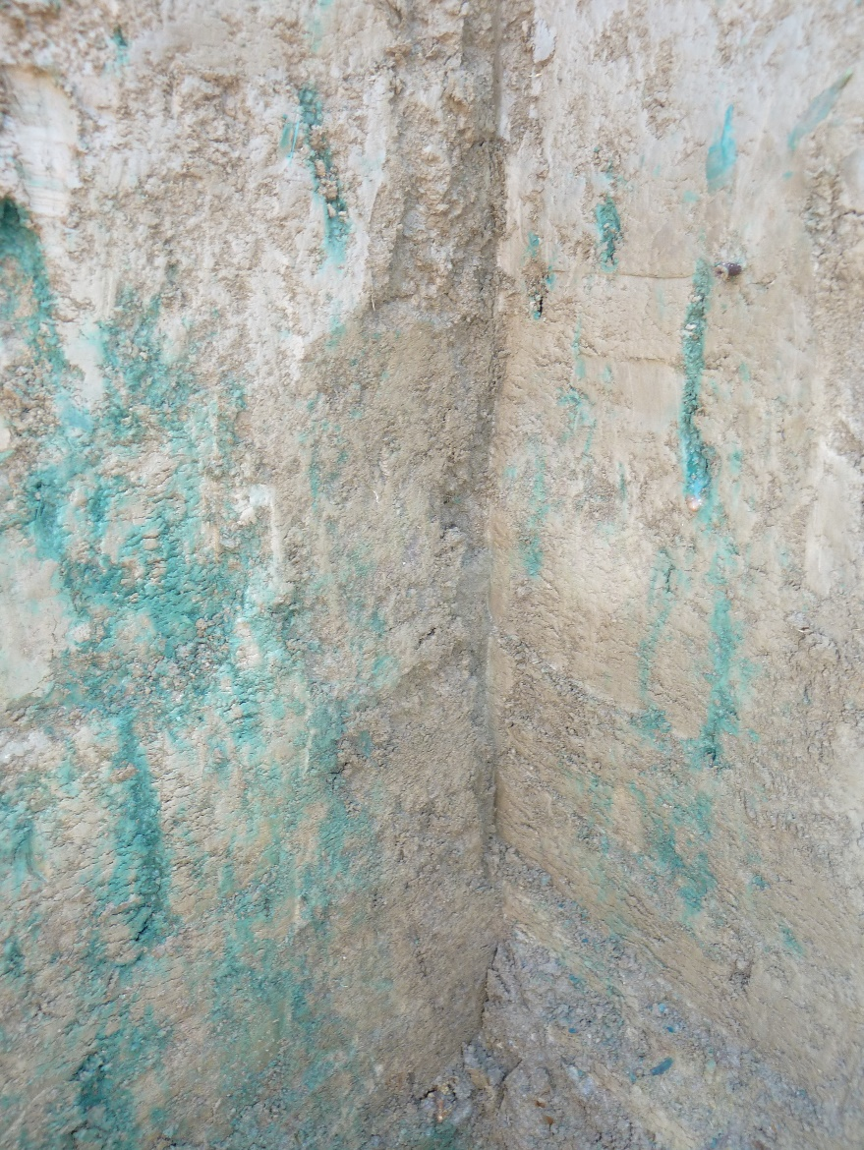
Supplementary Figure S1: Preferential flow paths in the soil at Landquart stained with Brilliant Blue.

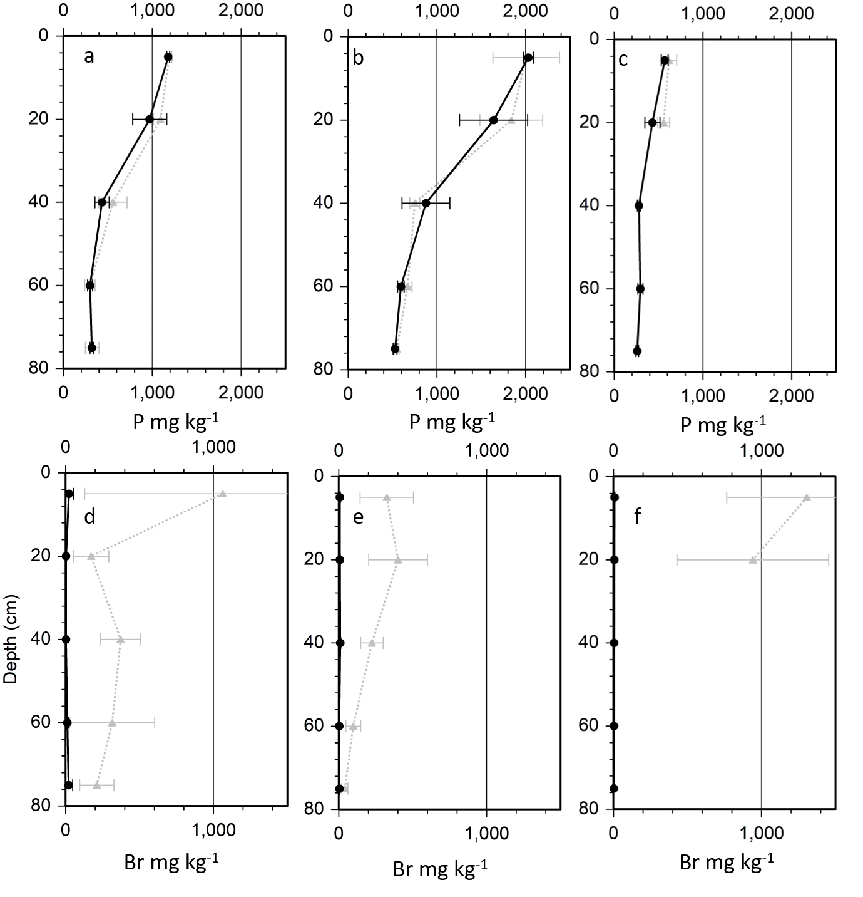
Supplementary Figure S2: P concentrations (HNO₃ digest) at a) LQ b) OE and c) WI and Br concentrations (HNO₃ digest) at d) LQ, e) OE and f) WI. The straight black lines represent the concentrations in the matrix soil, while the dotted grey lines represent the concentrations along the preferential flow path. Error bars represent the standard deviation of each five replicate samples per sampling depth.

Literature
Albertsen, M. 1980. Quantifizierung von Verwitterungsvorgängen.
Allen, R. G. 1998. Crop evapotranspiration. Guidelines for computing crop water requirements, Rome.
Brimhall, G. H., O. A. Chadwick, C. J. Lewis, W. Compston, I. S. Williams, K. J. Danti, W. E. Dietrich, M. E. Power, D. Hendricks, and J. Bratt. 1992. Deformational Mass-Transport and Invasive Processes in Soil Evolution. Science 255:695–702.
Buss, H. L., P. B. Sak, S. M. Webb, and S. L. Brantley. 2008. Weathering of the Rio Blanco quartz diorite, Luquillo Mountains, Puerto Rico: Coupling oxidation, dissolution, and fracturing. Geochimica Et Cosmochimica Acta 72:4488–4507.
Emmanuel, S., and Y. Levenson. 2014. Limestone weathering rates accelerated by micron-scale grain detachment. Geology 42:751–754.
Imseng, M., M. Wiggenhauser, A. Keller, M. Muller, M. Rehkamper, K. Murphy, K. Kreissig, E. Frossard, W. Wilcke, and M. Bigalke. 2018. Fate of Cd in Agricultural Soils. A Stable Isotope Approach to Anthropogenic Impact, Soil Formation, and Soil-Plant Cycling. Environmental Science & Technology 52:1919–1928.
Imseng, M., M. Wiggenhauser, A. Keller, M. Muller, M. Rehkamper, K. Murphy, K. Kreissig, E. Frossard, W. Wilcke, and M. Bigalke. 2019a. Towards an understanding of the Cd isotope fractionation during transfer from the soil to the cereal grain. Environmental Pollution 244:834–844.
Imseng, M., M. Wiggenhauser, M. Mueller, A. Keller, E. Frossard, W. Wilcke, and M. Bigalke. 2019b. The Fate of Zn in Agricultural Soils: A Stable Isotope Approach to Anthropogenic Impact, Soil Formation, and Soil-Plant Cycling. Environmental Science & Technology 53:4140–4149.
Leimer, S., Y. Kreutziger, S. Rosenkranz, H. Bessler, C. Engels, A. Hildebrandt, Y. Oelmann, W. W. Weisser, C. Wirth, and W. Wilcke. 2014. Plant diversity effects on the water balance of an experimental grassland. ECOHYDROLOGY 7:1378–1391.
MeteoSwiss. Federal Office of Meteorology and Climatology MeteoSwiss www.meteoswiss.admin.ch (accessed Mar 1, 2016).
White, A. F., and H. L. Buss. 2014. Natural weathering rates of silicate minerals. Treatise on Geochemistry:115–155.

